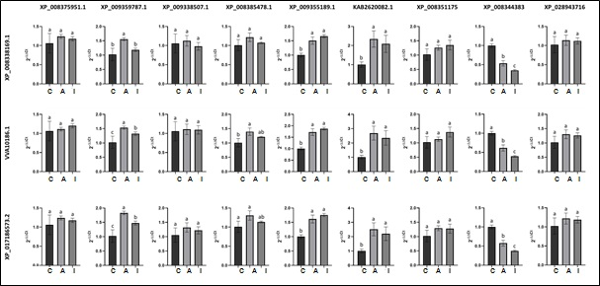
Sup. Figure 2. Expression results of genes whose gene expression couldnt confirmed by qRT-PCR. XP_008338169.1, VVA10186.1 and XP_017186573.2, represent 3 different internal control gene; XP_008375951.1, XP_009359787.1, XP_009338507.1, XP_008385478.1, XP_009355189.1, KAB2620082.1, XP_008351175, XP_008344383 and XP_028943716 is represents the target genes. The expression levels of genes were converted to 2^{-ΔΔCt} format compared to the control and presented using fold change values. C: Non-inoculated 60 days old photinia microshoots as control, A: 10⁶ active PGB_invit inoculated 60 days old photinia microshoots, I: 10⁶ inactive PGB_invit inoculated 60 days old photinia microshoots. Bars represent the standard error, and the different letters represent significant differences for each group (P<0.05).

