Supplemental Materials for

Title: Patterns of human social contact and mask wearing in representative high-risk groups in China.

Author: Bo Zheng^{1†}, Wenlong Zhu^{1†}, Jinhua Pan¹, Weibing Wang^{1,2*}

1 School of Public Health, Shanghai Institute of Infectious Disease and Biosecurity, Fudan University, 138 Yi Xue Yuan Road, Shanghai 200032, China.
2 Key Laboratory of Public Health Safety of Ministry of Education, Fudan University, 138 Yi Xue Yuan Road, Shanghai 200032, China.

† These authors contributed equally to this work.

* Corresponding author:
Dr. Weibing Wang
School of Public Health, Shanghai Institute of Infectious Disease and Biosecurity, Key Laboratory of Public Health Safety of Ministry of Education, Fudan University, 138 Yi Xue Yuan Road, Shanghai 200032, China (e-mail: wwb@fudan.edu.cn).

* Corresponding authors:

This file includes:
Figure S1 to Figure S9
Table S1 to Table S2

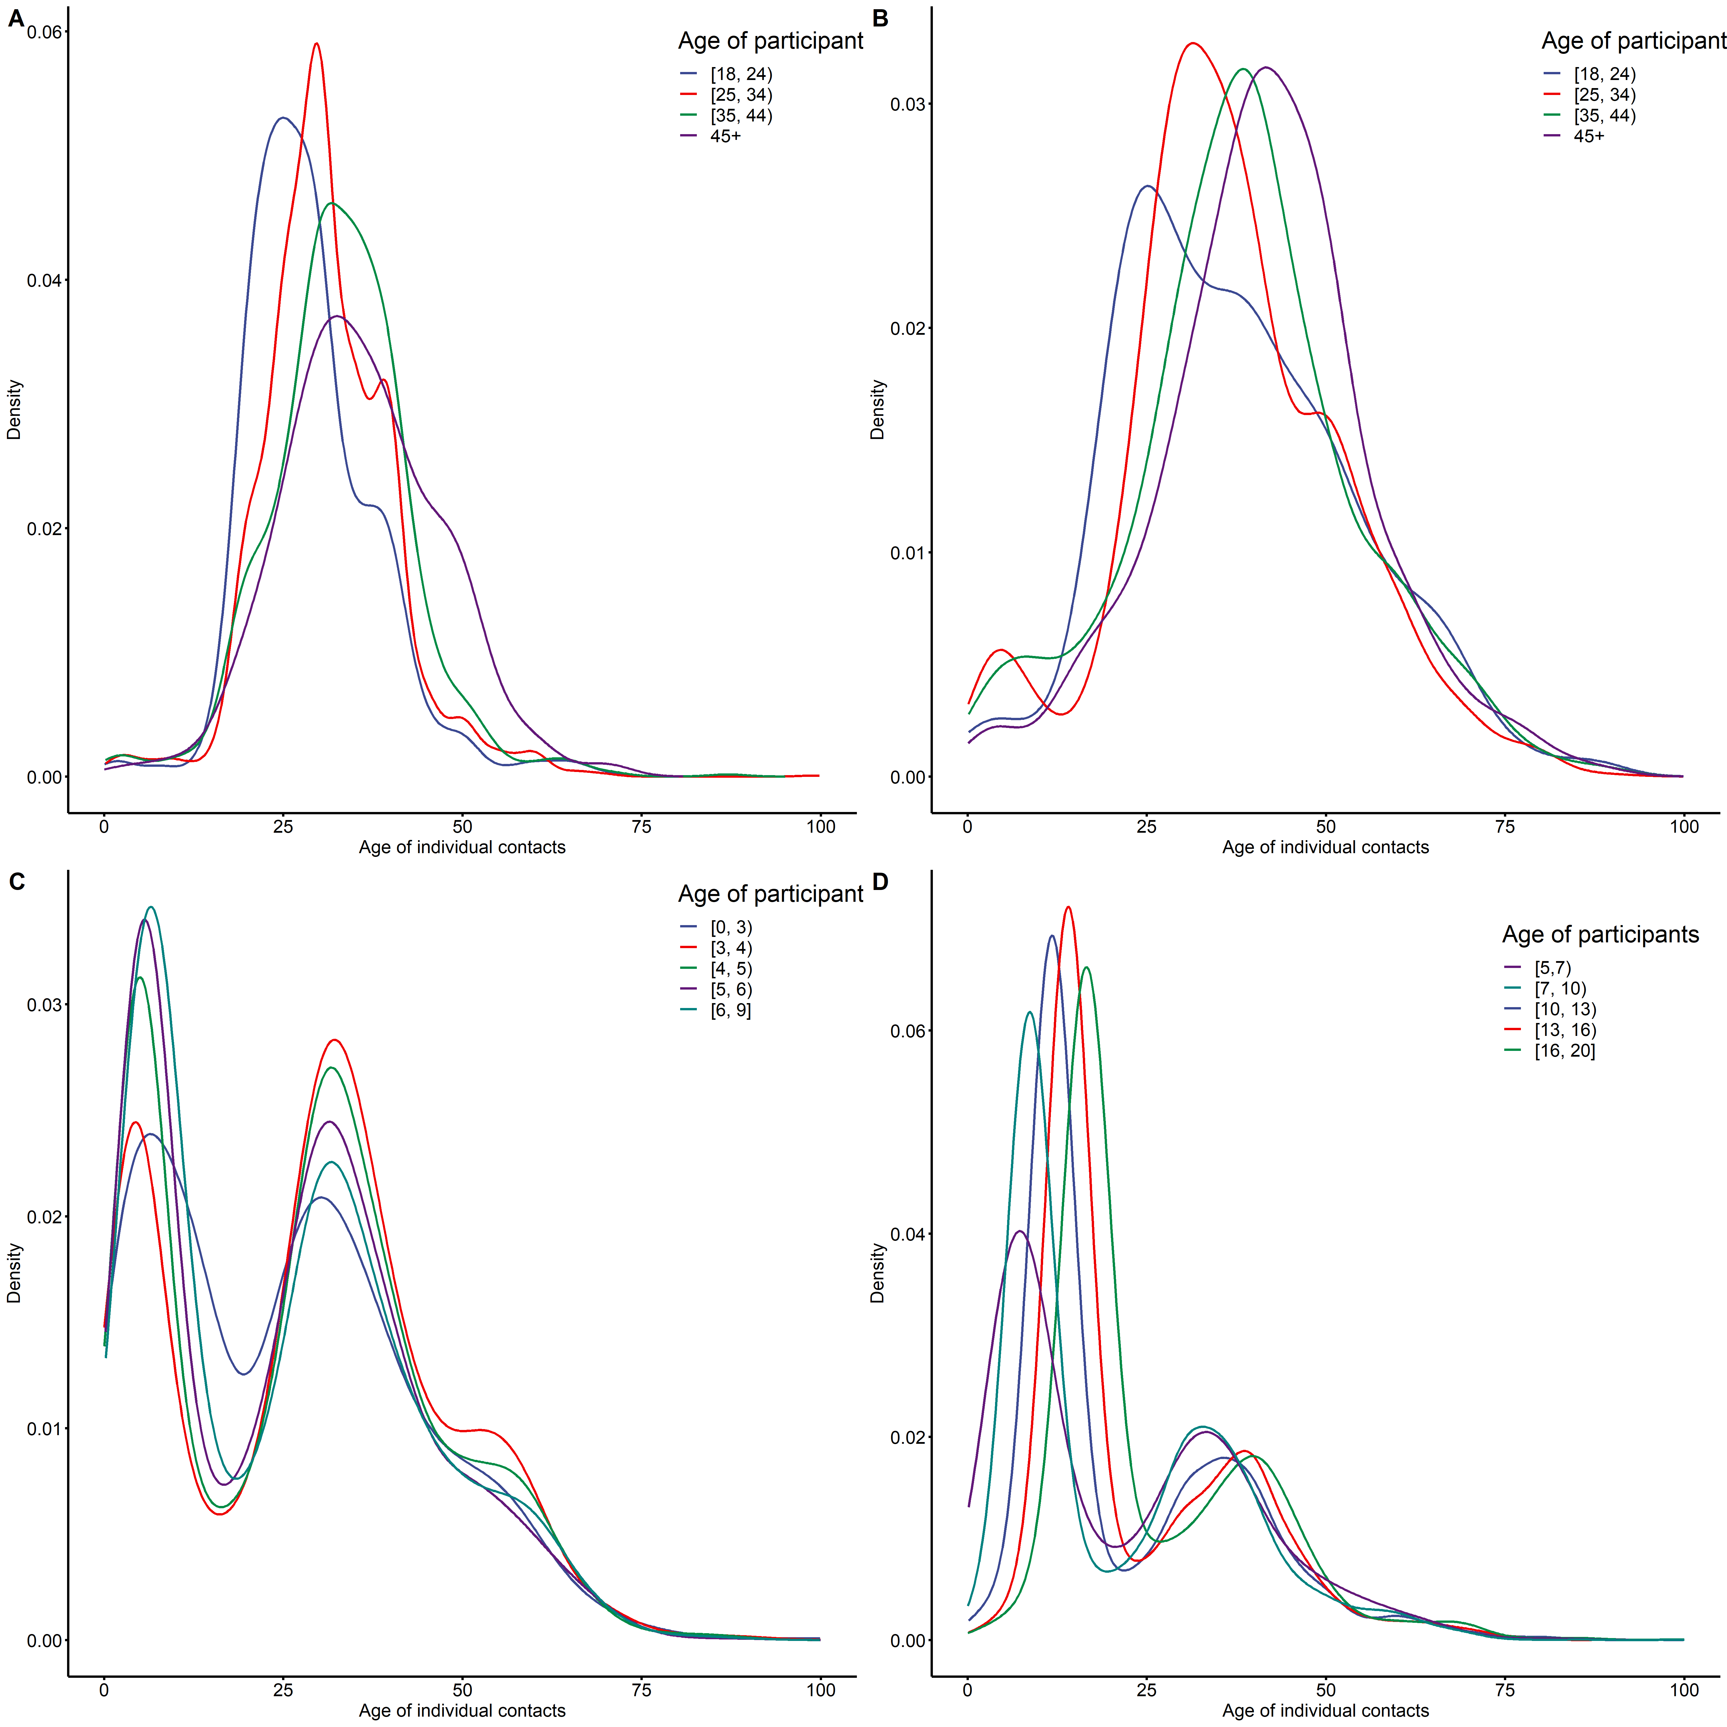
Figure S1. The distributions of contacts’ age crossing different occupation (A: Delivery workers, B: medical workers, C: preschoolers, D: students) participants age groups. The distributions were fitted with Kernel density functions.

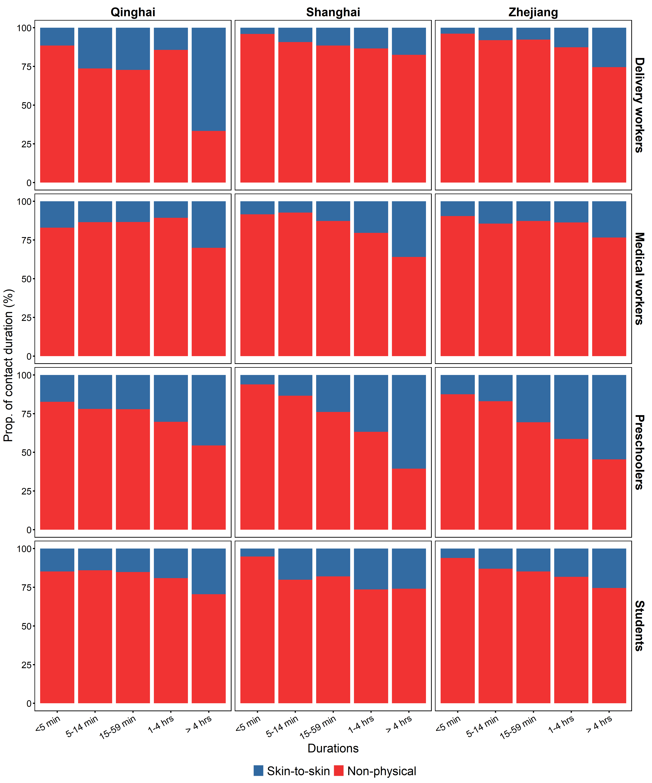Figure S2. The proportion of reporting physical contacts in different contact durations stratified by province and occupation groups.

Figure S3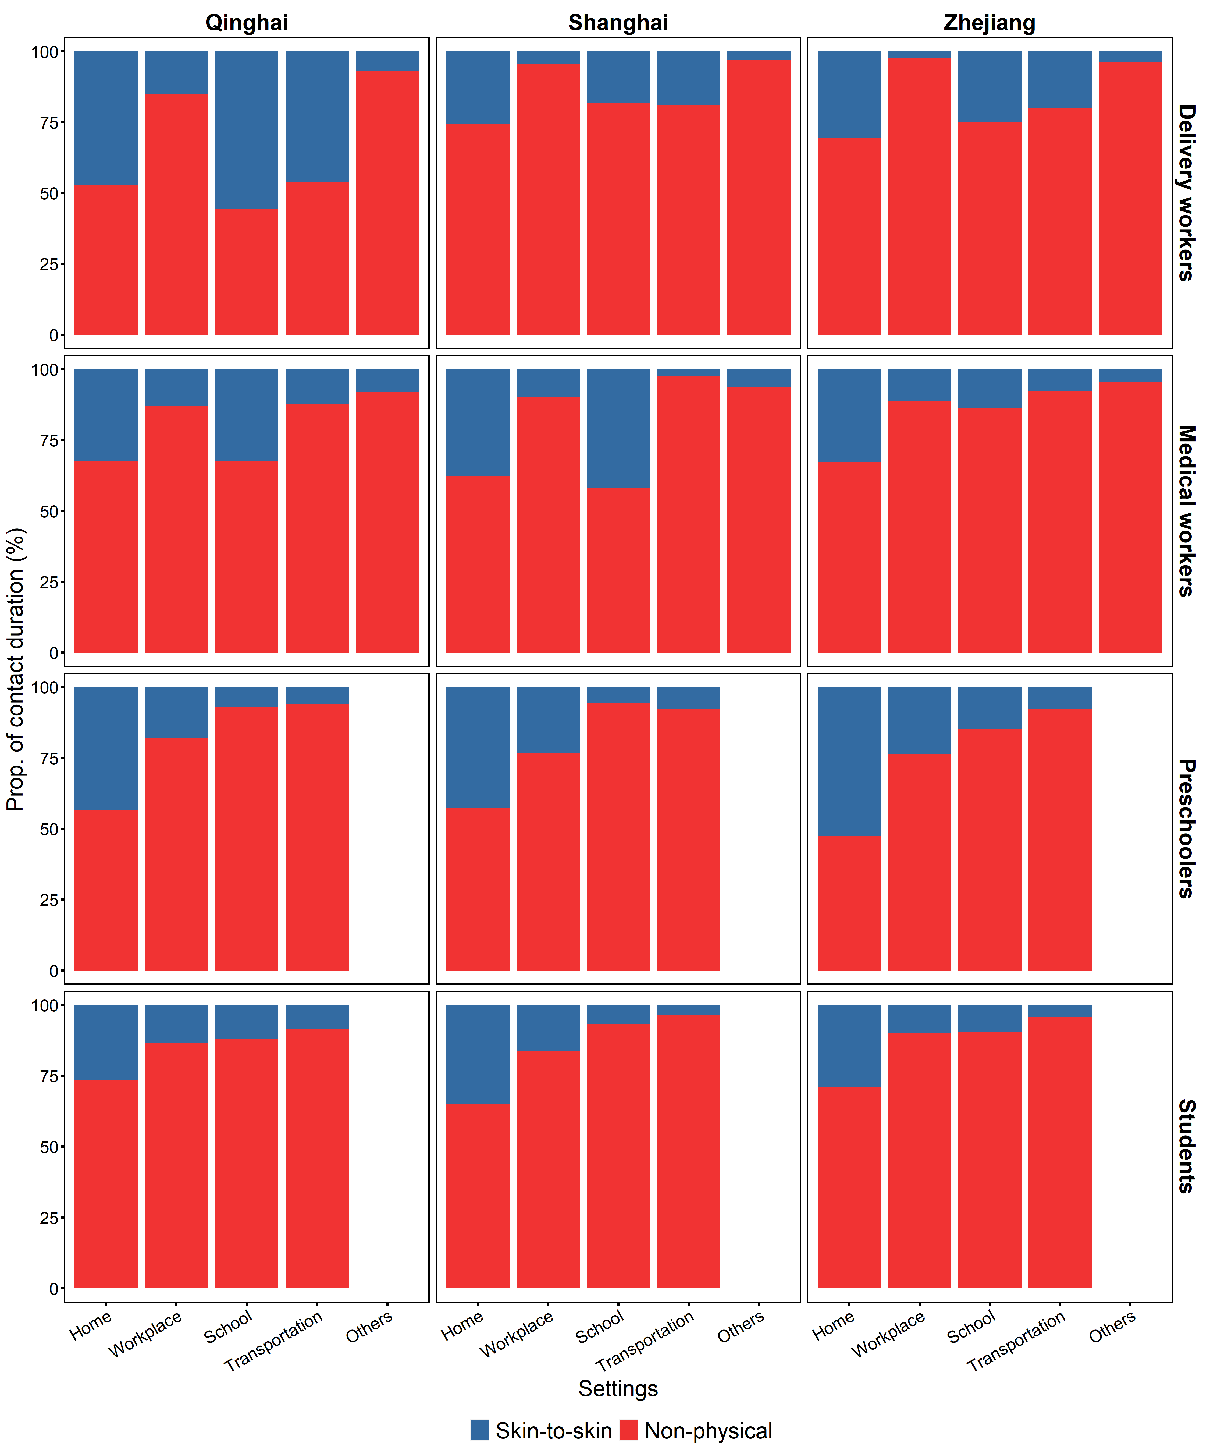 Figure S3. The proportion of reporting physical contacts in different contact settings stratified by province and occupation groups.

Figure S4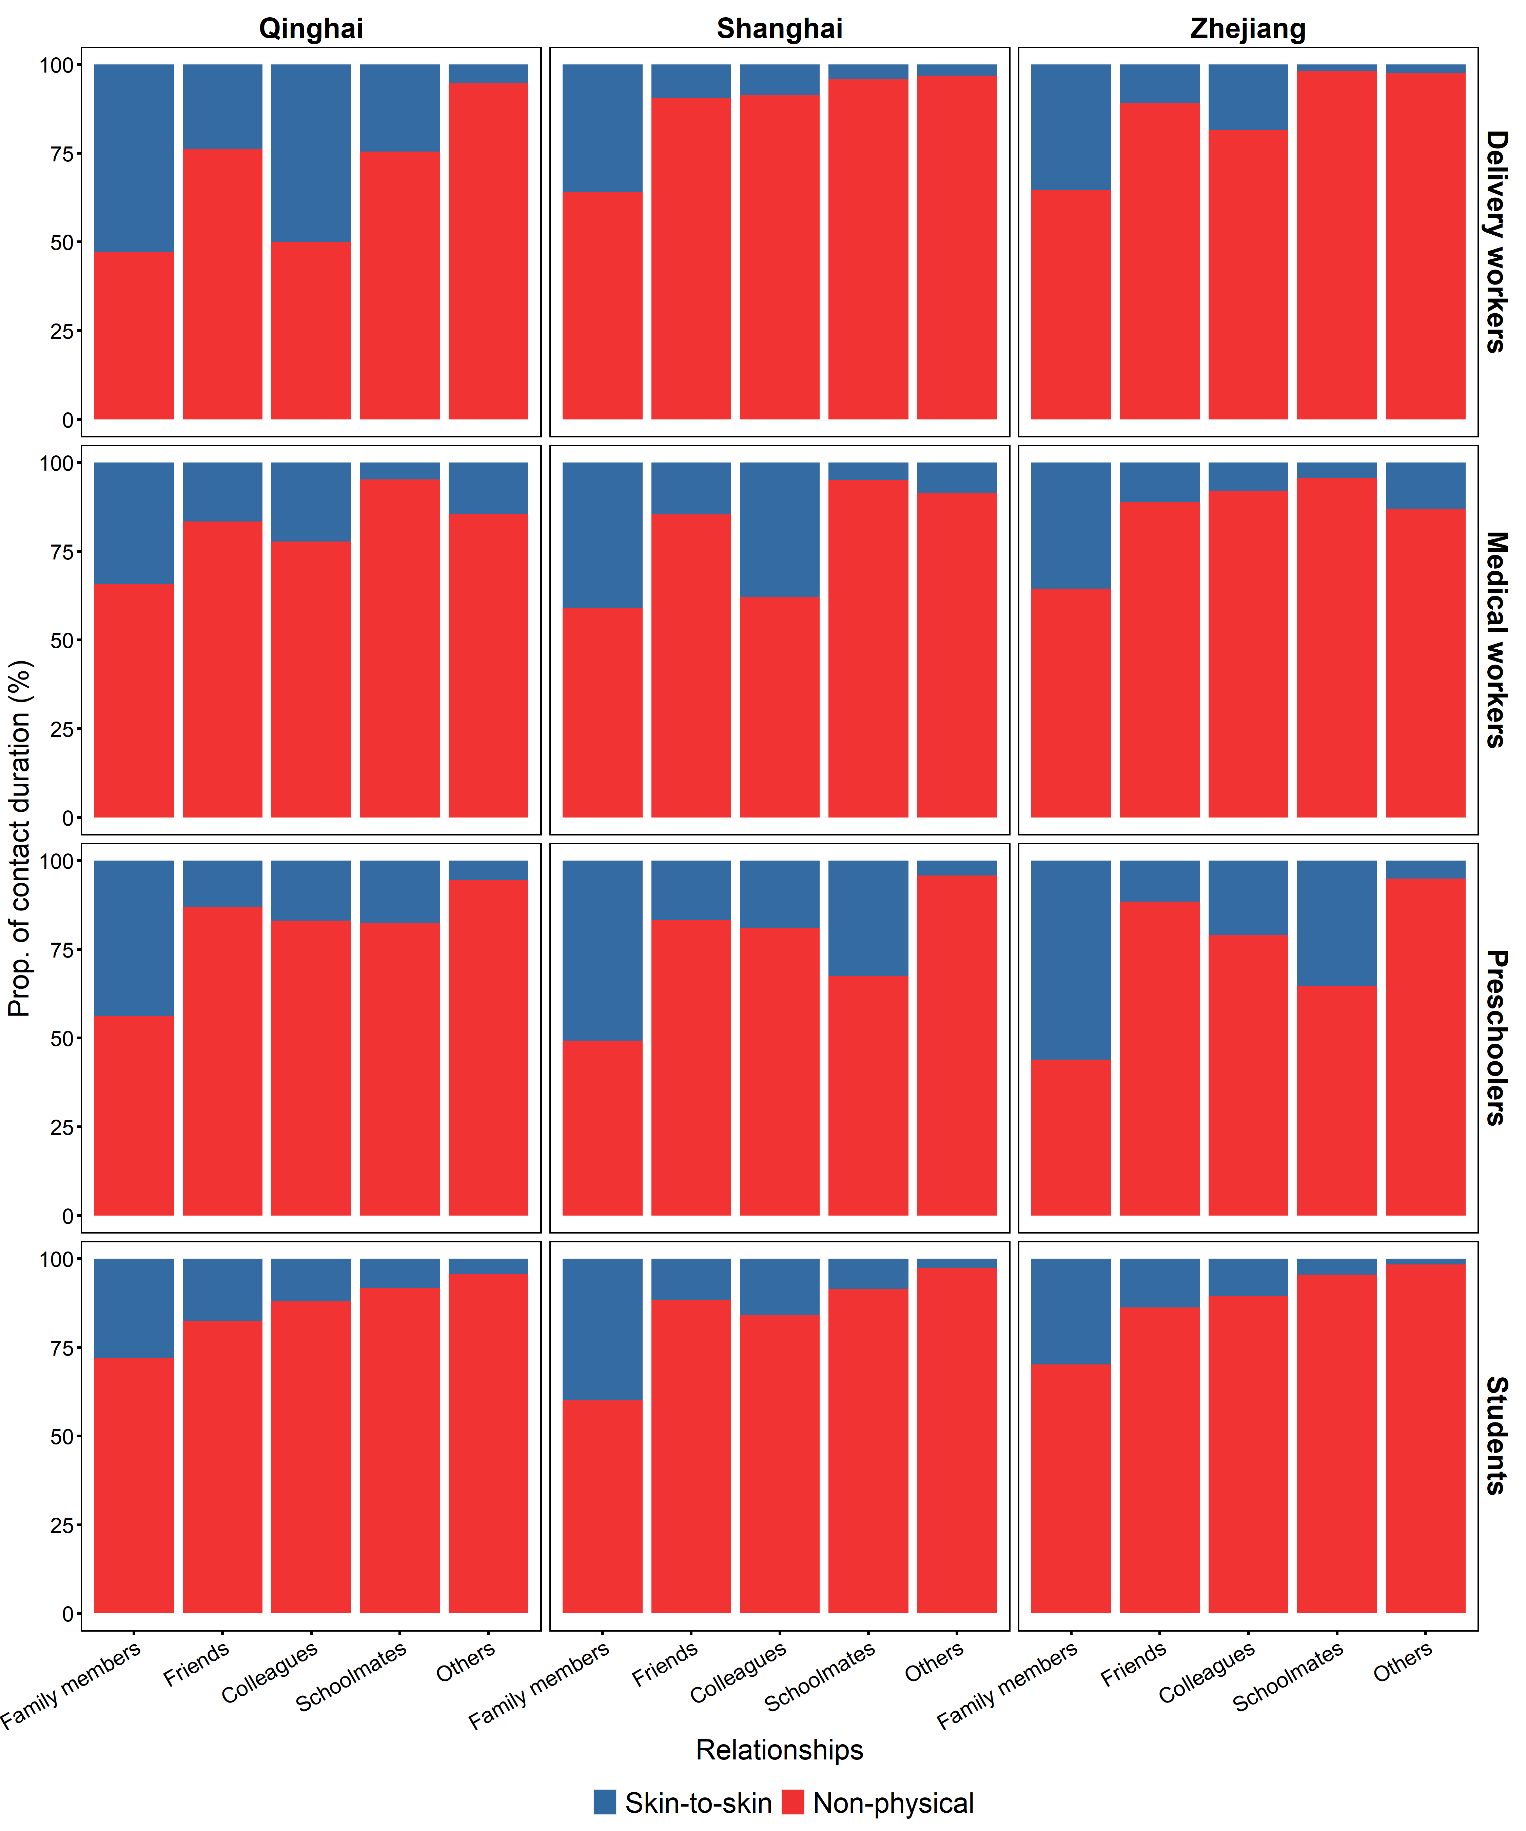 Figure S4. The proportion of reporting physical contacts in different contact relations stratified by province and occupation groups.

Figure S5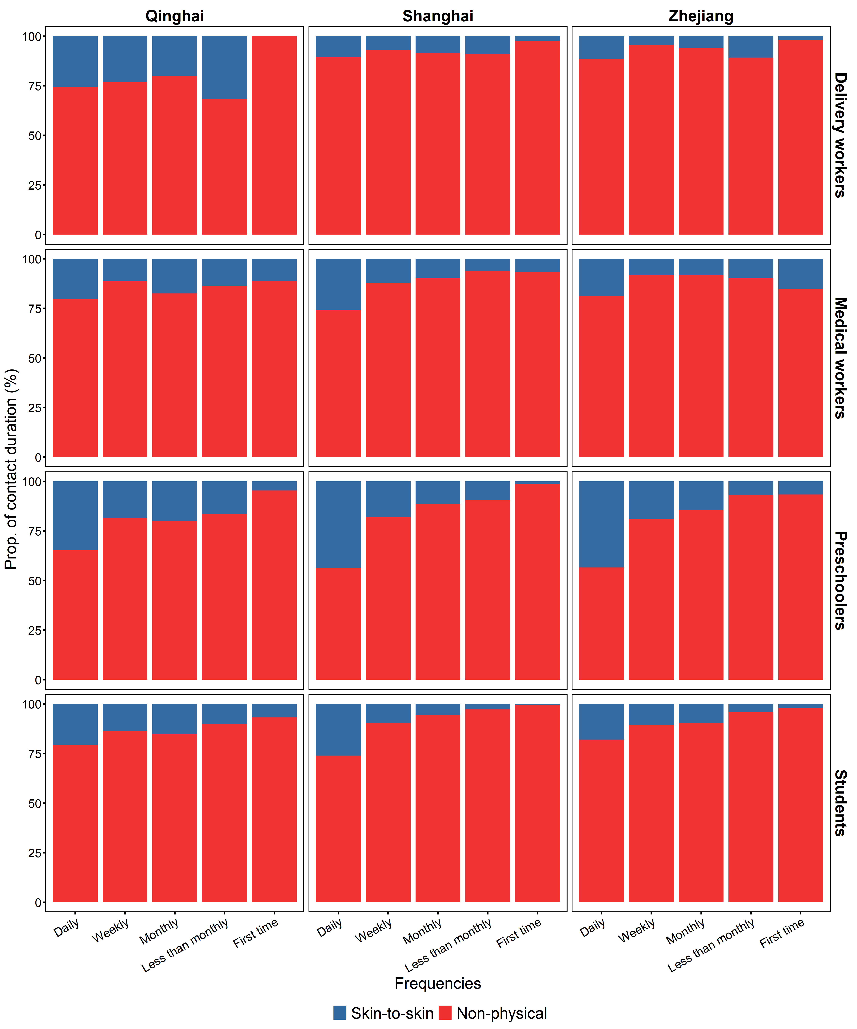 Figure S5. The proportion of reporting physical contacts in different contact frequency stratified by province and occupation groups.

Figure S6. Individual contact matrices of different province and occupations.

Figure S7. Total contact matrices of different province and occupations.

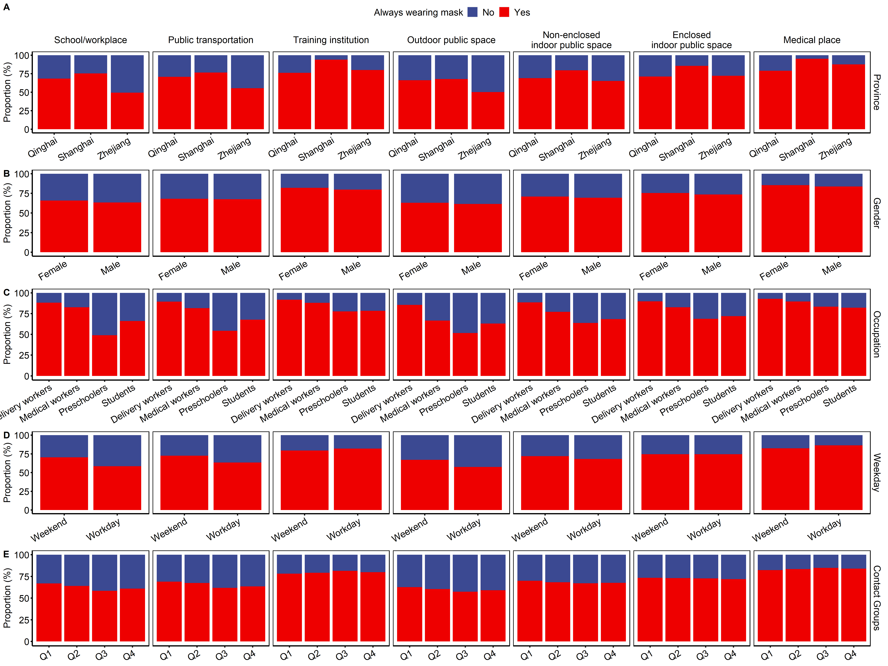Figure S8. Proportion of always wearing masks in different places stratified by different characteristics.

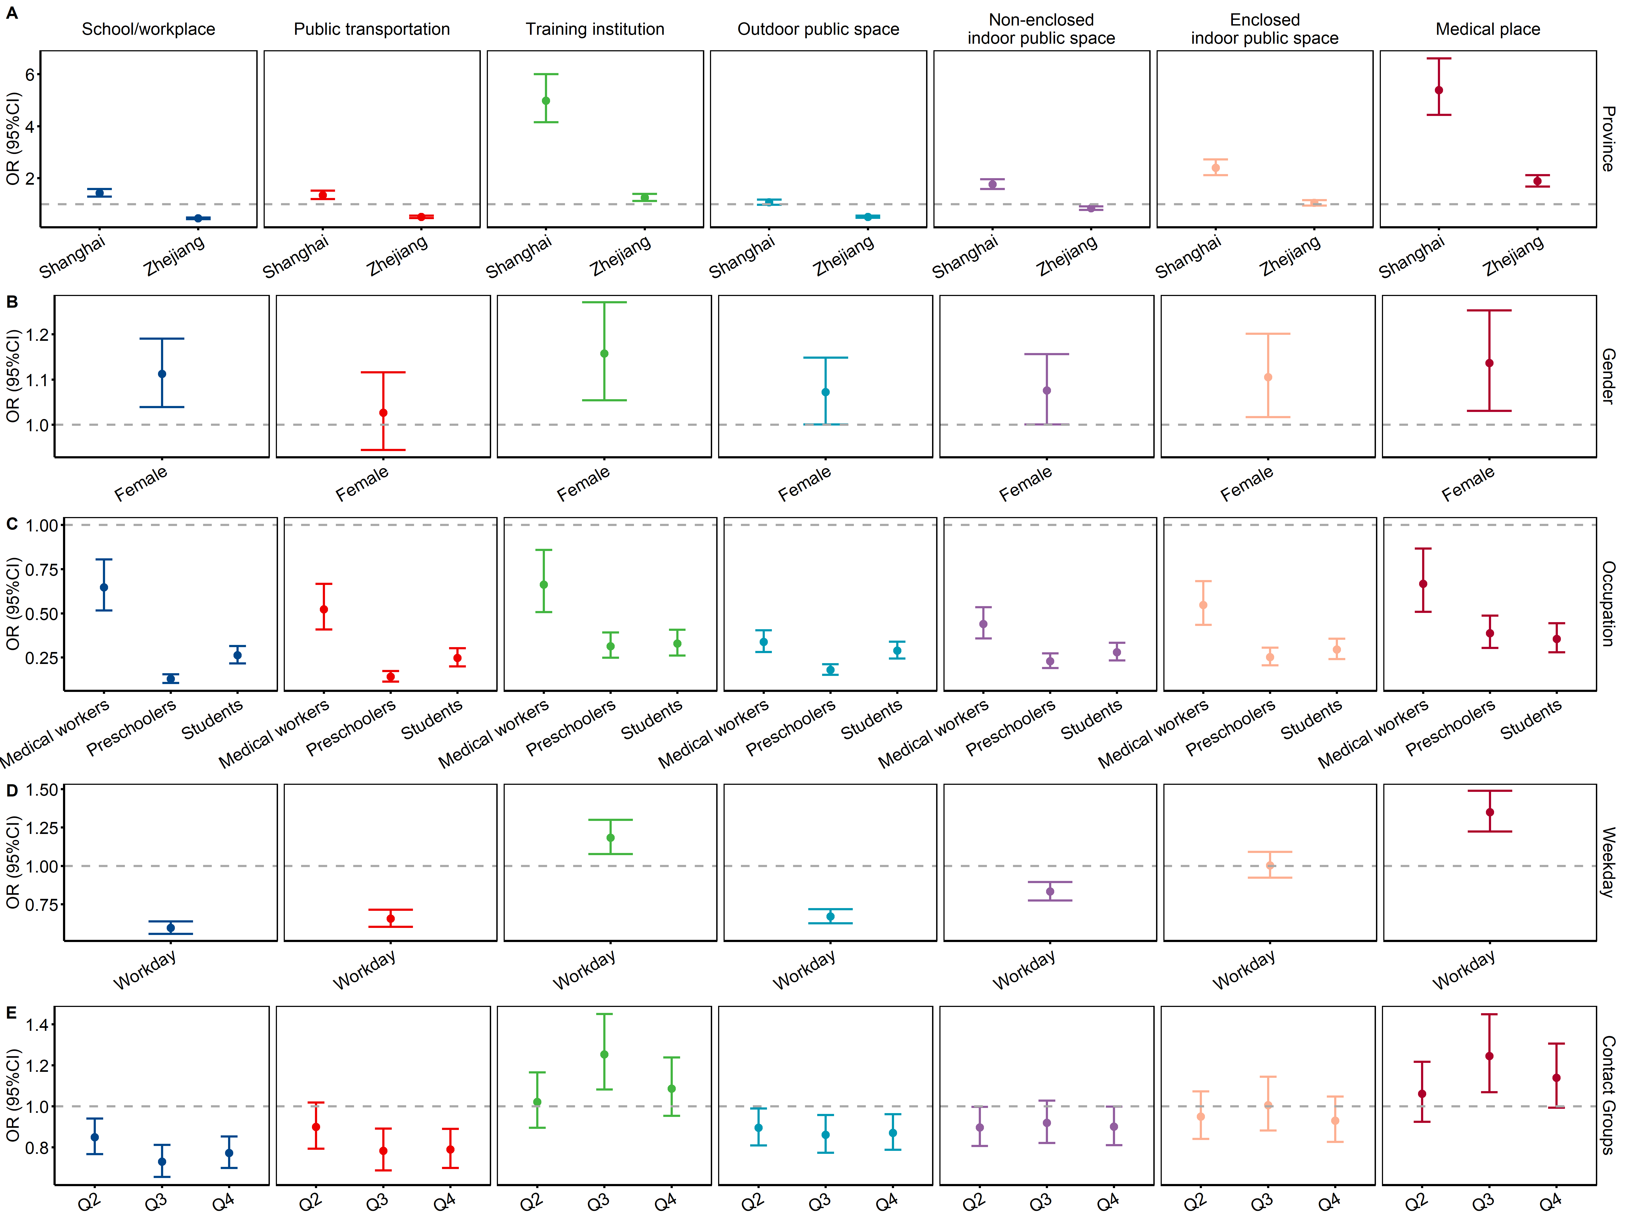
Figure S9. The association of always wearing masks and different characteristics of participants. OR (dots) and 95%CI (error bars) was calculated from univariate logistics regression.

