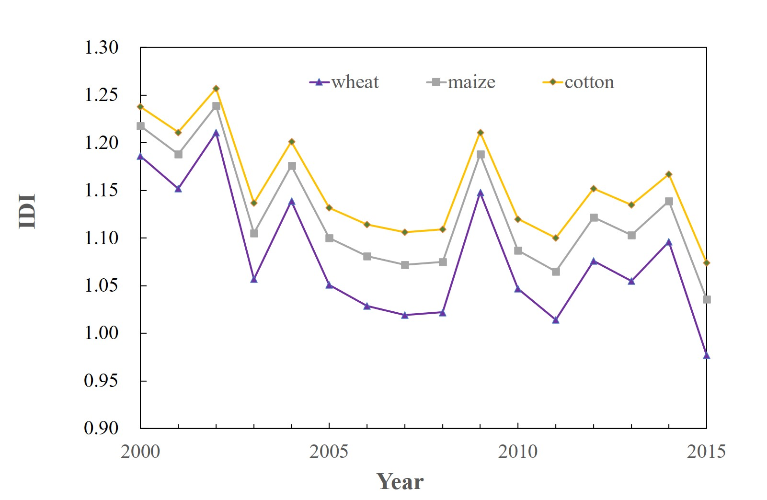
Supplementary Figures
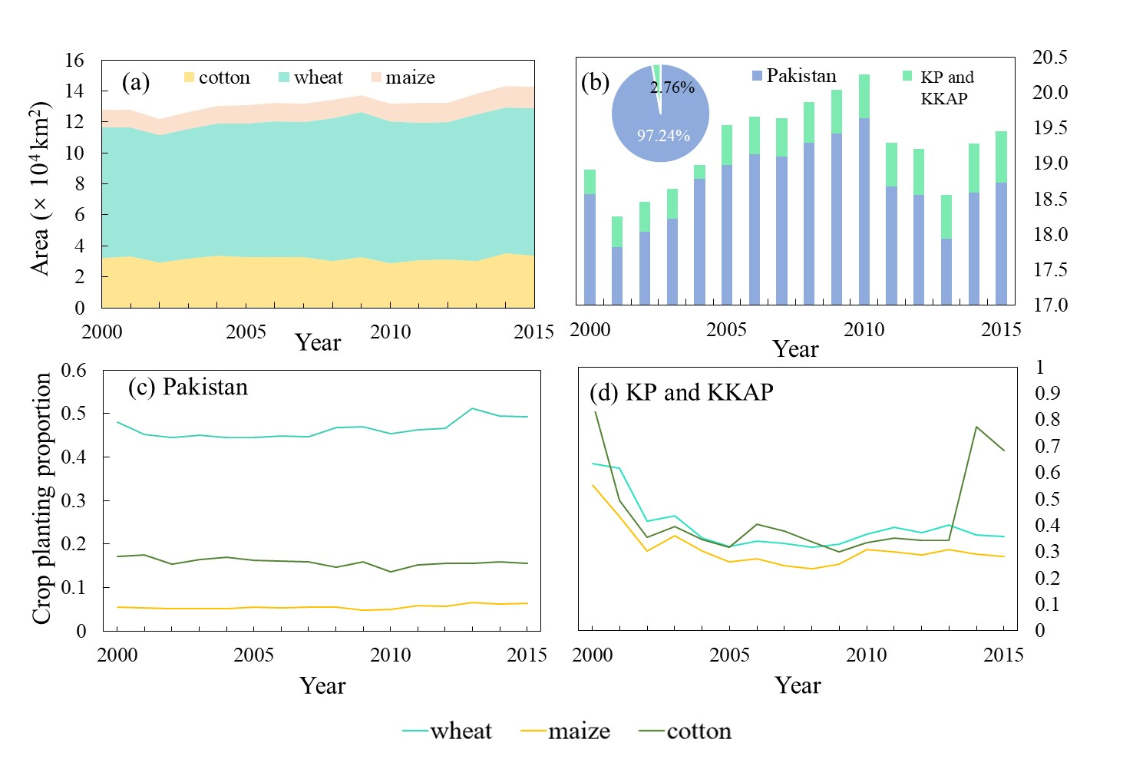
Supplementary Figure S1. Inter-annual variation trends of IDI of wheat, maize and cotton in irrigated areas of the China–Pakistan Economic Corridor (CPEC) from 2000 to 2015.
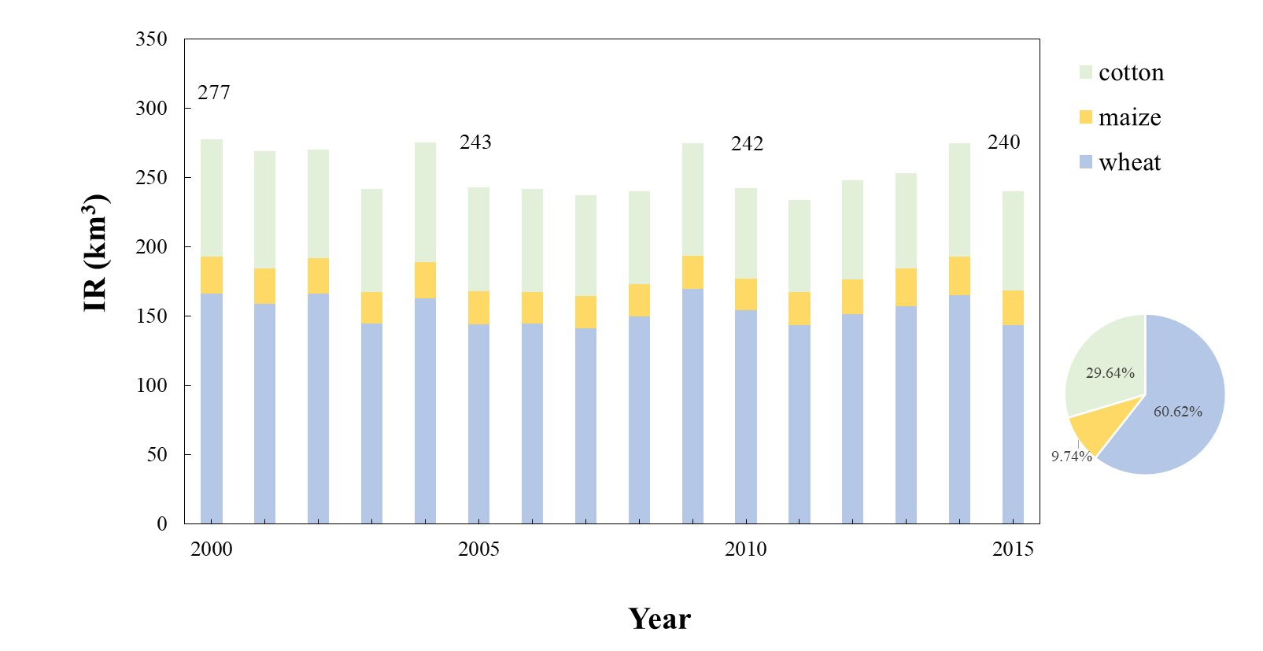
Supplementary Figure S2. Changes in irrigated agricultural land of the China–Pakistan Economic Corridor (CPEC) from 2000 to 2015. (a) Crop acreage distribution of the CPEC;(b) Interannual change of actual irrigated cultivated land area of the CPEC; Proportion of three crops (wheat, maize, and cotton) planted in Pakistan (c) and Xinjiang (KP and KKAP) (d). KP: Kashgar Prefecture; KKAP: Kizilsu Kirgiz Autonomous Prefecture.
Supplementary Figure S3. Inter-annual variation trend of IR of main crops in the China–Pakistan Economic Corridor (CPEC) from 2000 to 2015.
Supplementary Figure S4. Bayesian Network of the CPEC regional irrigation water use conditional probability calculation (2000-2015)
Supplementary Figure S5. Sensitivity analysis of some variables. VB: variance of belief; MI: mutual information.

Supplementary Figure S6. Changes in the number of tube wells and percentage of population using safe drinking water (%) in Pakistan.

Supplementary Tables
Supplementary Table S1. Data description and sources
Data | Time range | Description and resolution | Source
Precipitation and temperature | 2000-2015 | Interpolated meteorological data set of 65 stations in CPEC,  daily scale,  0.25°×0.25°grid | A daily meteorological dataset of the China-Pakistan Economic Corridor from 1961 to 2015  (http://www.dx.doi.org/10.11922/sciencedb.j00001.00189)
Agriculture | 2000-2015 | Crop planting area, irrigated area and yield, etc.  Annual scale and state scale | Pakistan Statistical Yearbook, Pakistan Bureau of Statistics, Xinjiang Statistical Yearbook
Water use | 2000-2015 | Statistical bulletin,  annual scale and state scale | Pakistan Statistical Yearbook, Pakistan Bureau of Statistics, the Economic Survey of Pakistan, Xinjiang Statistical Yearbook and Xinjiang Water Resources Bulletin
Social economy | 2000-2015 | Statistical bulletin,  annual scale and state scale | Pakistan Statistical Yearbook, Xinjiang Statistical Yearbook, Pakistan Bureau of Statistics, the Economic Survey of Pakistan, World Bank database ( https://data.worldbank.org.cn/ )
Water and food security | 2000-2015 | Proportion of population with safe drinking water and undernourished population,  annual scale | FAO database ( http://www.fao.org/faostat/zh/#data )

Supplementary Table S2. Detailed explanations and status discretization of some important variables
Variables | Explanation | Status discretization | Unit
Effective precipitation | CPEC | 230-330，330-370,370-410 | mm
Groundwater use | Used in agriculture | 700-719,719-724,724-756 | 10⁸ m³
IR of main crops | Wheat, rice, maize, sugarcane and cotton | 352-365,365-390,390-420 | km³
IR of major grain crops | Wheat, rice, maize | 260-267,267-289,289-312 | km³
IR of major cash crops | Sugarcane and cotton | 87-96,96-105,105-111 | km³
Effective irrigated area | CPEC | 18200-19000,19000-19500,  19500-20300 | 1000ha
Output of major grain crops | Wheat, rice, maize | 23900-30100,30100-33900,3390-38100 | 1000tons
Output of major cash crops | Sugarcane and cotton | 45000-52000,52000-61000,  61000-70000 | 1000tons
Applying quantity of chemical fertilizer | Total amount of potassium, phosphorus and nitrogen fertilizer | 10000-27000,27000-32000,  32000-38000 | 1000tons
Saline-alkali land area | Pakistan | 1.69-2.1，2.1-2.4,2.4-2.7 | km²
Proportion of population with safe drinking water | Pakistan | 35.8-36.8,36.8-37.8,37.8-38 | percent
Undernourished population | Pakistan | 24-28,28-31,31-33.2 | million
Population | CPEC | 14600-15800,15800-17700,  17700-19500 | ten thousand people
Number of tube well | Pakistan | 6.5-10,10-10.9,10.9-13.4 | 10⁵
Agricultural water consumption | CPEC | 700-719,719-724,724-756 | 10⁸ m³
GAP | CPEC | 9-10，10-10.8,10.8-13.5 | 10⁸CNY

