Supplementary Information

Metal-to-metal charge transfer driven by electropositive species for stable anionic redox

Min-Ho Kim^{1,3}, Haeseong Jang^{1,2,3}, Eun Ryeol Lee^{1,3}, Jaehyun Park¹, Taewon Kim¹, Jeongwoo Seo¹, Young Hwa Jung², Seok Ju Kang¹, Jaephil Cho¹, Min Gyu Kim^{2,*}, Dong-Hwa Seo^{1,*}, Hyun-Wook Lee^{1,*}

Table of contents
Part I: Supplementary Notes
Supplementary Note 1. | Methods for computational modeling
Part II: Supplementary Figures 1-29 (Al doped sample: Suppl. Fig. 22-28)
Synchrotron XRD investigation: Suppl. Fig. 1, 2, 22
Electrochemical evaluation at high temp. (60 ℃): Suppl. Fig. 3, 23
Operando XANES analysis: Suppl. Fig. 4, 5, 6, 7, 8, 9
Operando EXAFS analysis: Suppl. Fig. 11, 12, 13, 14, 27
Calculation: Suppl. Fig. 10, 15, 16, 17, 18, 28
TEM analysis: Suppl. Fig. 19, 20, 21, 24
EELS analysis: Suppl. Fig. 21
TOF-SIMS mapping: Suppl. Fig. 26
Part III: Supplementary Tables
Supplementary Table 1. | Rietveld refinement results of Li_{1.22}Al_{0.05}Ni_{0.12}Ru_{0.61}O₂
Supplementary Table 2. | Magnetic moments of Li_{1.22}Ni_{0.17}Ru_{0.61}O₂

Supplementary Note 1 | Method for computational modeling
To compare the computational results between Li₂RuO₃ and Li_{1.22}Ni_{0.17}Ru_{0.61}O₂, we designed its structural modeling as follows. A cell size is minimized to evaluate a cost-expensive electronic structure. The size of supercell is 2 x 2 x 2, consisting of 8 Li, 4 Ru and 12 O atoms for LRO and 2 x 4 x 3, consisting of 15 Li, 2 Ni, 7 Ru and 24 O atoms for LNRO, respectively. Reciprocal-space k-point meshes were 5 x 2 x 4 for LRO and 5 x 5 x 2 for LNRO. We employed the HSE06 hybrid functional with a general hybrid mixing parameter (HFSCREEN=0.2) to evaluate an accurate electronic structure for LRO and LNRO in various a state of charge (SOC), pristine, middle of the charge (before over-oxidation of Ru, Ru^{5+/6+}), fully charged state (after over-oxidation of Ru, Ru^{5+/6+}). A proper Li configuration in charged state is determined, based on the obtained results with GGA+U calculation for thirty stable orderings evaluated by Ewald-summation methods. Bader charge analysis are adopted to relatively compare a charge density of Ru atom with and without neighboring Ni atoms. Note that the bader charge only enables to expect a relative distribution of charge around Ru atom depending on a neighboring environment, not a formal oxidation state. Local Orbital Basis Suite Towards Electronic-Structure Reconstruction (LOBSTER) program is performed to analyze a chemical bonding based on plane-wave and paw output. The electronic results obtained by HSE06 calculation in VASP are used as an input file for LOBSTER program. Meanwhile, we evaluate an extent of a covalency in a chemical bond with Integrated Crystal Orbital Overlap Population (Integrated COOP) which is one of output files calculated by LOBSTER program. Electron Localization Function (ELF) is carried out to visualize an extent of a covalency in a chemical bond with a charge density. The isosurface level is commonly fixed at 0.10 for an accurate comparison in LRO and LNRO modeled structures.
To compare the computational results between Li_{1.22}Ni_{0.17}Ru_{0.61}O₂ and Li_{1.22}Al_{0.05}Ni_{0.12}Ru_{0.61}O₂, we designed its structural modeling as follows. A cell size is extended in b- and c-direction to consider a various atomic ordering in a TM-slab, focusing on dynamics of Ni and Al atoms. We evaluate the most stable TM ordering in TM-slab via Ewald-summation based on an electrostatic force, followed by GGA+U calculation. Furthermore, a layer in a-direction is duplicated, containing two Li layers and two TM layers to exclude a self-interaction of a slab. The size of supercell is 4 x 6 x 4, consisting of 60 Li, 28 Ru, 8 Ni and 96 O for LNRO and 60 Li, 28 Ru, 6 Ni, 2 Al and 96 O for LANRO, respectively. Reciprocal-space k-point meshes were commonly 4 x 1 x 2. A thermodynamical preference for TM migration is evaluated with the site energy (E_{final}-E_{initial}). To exclude an effect of Li ordering onto a site energy, we generally remove Li ions in a super cell. However, we leave a single Li ion far from Ni and Al because a complete absence of Li ions in Li-slab induces a severe instability of lattice oxygen between TM-slab, which reduces a reliability of a site energy. To study a kinetic barrier of Al and Ni migration into tetrahedral site, we carry out the Nudged Elastic Band (NEB) simulation. The number of NEB images between the fixed endpoints is five and the spring constant is set to -5.0 eV/Å² between images.

Supplementary Fig. 1 | Synchrotron XRD pattern and Le bail fitting of Li_{2-x}RuO₃ (a) and Li_{1.22-x}Ni_{0.17}Ru_{0.61}O₂ (b). Almost all XRD pattern of both samples are refined with C_{2/c} space group.

Supplementary Fig. 2 | The comparison of synchrotron XRD patterns before and after cycling. a, the comparison of XRD patterns depending on the state-of-charge and after 50th cycle. The green shaded regions represent the superstructure peaks of Li_{1/3}TM_{2/3} honeycomb-phase, demonstrating that corresponding peaks of LNRO is well-maintained even at charge state and after 50th cycle, compared to LRO. b, XRD patterns of LRO and LNRO with normalized intensity by (001) area before and after formation process. The insets manifest the degree of dissipation of honeycomb phase during the formation process, which corresponds to integrated superstructure peaks within the 16°–38° range.
Supplementary Fig. 3 | Electrochemical evaluation during 50 cycles at 60 ℃ of LRO (a) and LNRO (b). LRO exhibits significant voltage drop and capacity decay due to its unstable Ru^{5+/6+} redox, accompanying severe lattice oxygen evolution. On the contrary, LNRO exhibits quite superior performances, compared with LRO. Especially, it is noticeable that LNRO delivers high capacities without constant-voltage step, demonstrating that LNRO is controlled by temperature-dependent kinetic hinderance.

Supplementary Fig. 4 | Operando Ru K-edge XANES variation of Li_{2-x}RuO₃ during the 1st cycle. LRO exhibits typical change in XANES plot shape depending on the SOC (1st, 2nd highest peak and pre-edge peak), demonstrating its stable Ru^{4+/5+} redox and unstable Ru^{5+/6+} with severe structural distortion.

Supplementary Fig. 5 | Operando Ru K-edge XANES variation of Li_{1.22-x}Ni_{0.17}Ru_{0.61}O₂ during the 1st cycle. Ru K-edge spectra of LNRO does not show evolution of pre-edge peak, meaning that local structure distortion is suppressed. Instead, within high-voltage region, Ru energy is shifted backwards, which might be due to pi back-bonding from neighbouring oxygen ligands.

Supplementary Fig. 6 | Operando Ni K-edge XANES variation of Li_{1.22-x}Ni_{0.17}Ru_{0.61}O₂ during the 1st cycle. a, Ni K-edge spectra of LNRO show consecutive energy shift during the whole charge and discharge process. Insets indicate pre-edge peak evolution (black dotted box). However, as considering the energy of reference data, Ni is seemingly oxidized from approximately 2+ to approximately 3+, not to 4+. b, the change in oxidation number of Ni on delithiated LNRO is also confirmed for whiteline, half-maximum intensity, and edge peak at 0.5 a.u., with respect to reference.

Supplementary Fig. 7 | Operando Ru K-edge XANES 2D contour plot of Li_{2-x}RuO₃ during the 1st cycle (a) and 50th cycle (b).

Supplementary Fig. 8 | Operando Ru K-edge XANES 2D contour plot of Li_{1.22-x}Ni_{0.17}Ru_{0.62}O₂ during the 1st cycle (a) and 50th cycle (b).

Supplementary Fig. 9 | Operando Ni K-edge XANES 2D contour plot of Li_{1.22-x}Ni_{0.17}Ru_{0.62}O₂ during the 1st cycle (a) and 50th cycle (b).

Supplementary Fig. 10 | Internal charge transfer within the Metal-Ligand-Metal backbones. Bader charge analysis of Ru of LNRO depending on the number of neighboring Ni. It indicates that Ru has larger electron population as more Ni atoms are located around Ru.

Supplementary Fig. 11 | Schematic diagram of scattering paths in the TM atomic arrangements and interatomic distances between TM sites and Li sites.

Supplementary Fig. 12 | Operando Ru K-edge EXAFS of Li_{2-x}RuO₃ during the 1st cycle (a) and 50th cycle (b).
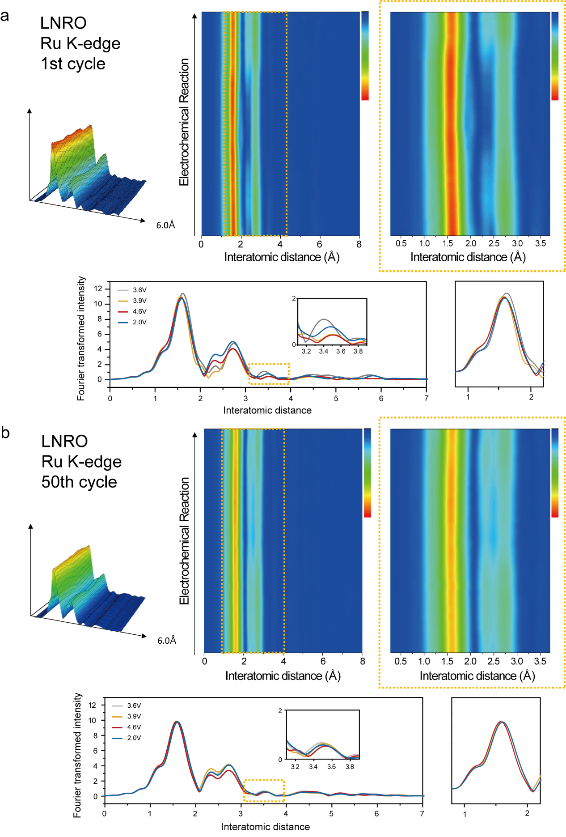
Supplementary Fig. 13 | Operando Ru K-edge EXAFS of Li_{1.22-x}Ni_{0.17}Ru_{0.6}O₂ during the 1st cycle (a) and 50th cycle (b).
Supplementary Fig. 14 | Operando Ni K-edge EXAFS of Li_{1.22-x}Ni_{0.17}Ru_{0.6}O₂ during the 1st cycle (a) and 50th cycle (b), and change in coordination number (c)
Supplementary Fig. 15 | Partial charge densities of Li₂RuO₃ (a, b) and Li_{1.22}Ni_{0.17}Ru_{0.61}O₂ (c, d) at pristine states and charged states until Ru⁵⁺. Labile electrons indicate electrons located in the fermi energy level during following oxidation. The results demonstrate that charge compensation during following oxidation after Ru^{4+/5+} originates from Ru^{5+/6+}, not non-mixed O_{2p}. Moreover, HV-redox of LNRO is TM-dominant, with respect to that of LRO.

Supplementary Fig. 16 | Ni migration pathways in LNRO and corresponding site energies. a, The in-plane cationic arrangements before and after 1st Ni migration. b, schematic drawings of 2nd Ni migration. c, DFT calculations for energies of sites toward which each equivalent Ni can be migrated.

Supplementary Fig. 17 | Calculation for expected oxidation number of migrated Ni toward Li layer at the charged state. These results demonstrate that a few Ni atoms are not fully oxidized to 4+ in Li_{1.22-x}Ni_{0.17}Ru_{0.61}O₂, thermodynamically. a, Total magnetic moment of Ni²⁺, Ni³⁺, and Ni⁴⁺, respectively, to compare with our computational results. b, total magnetic moments of migrated Ni toward Li layer during charging. The results demonstrate that migrated Ni is electronically stabilized at approximately 2+ oxidation number, irrelatively on Td sites or Oh sites.
Supplementary Fig. 18 | The comparison of covalency between Ru and O. a, electron localization function (ELF). b, integrated crystal orbital overlap population (ICOOP). Both computational results consistently demonstrate that LNRO has much stronger covalency between Ru and O than LRO.

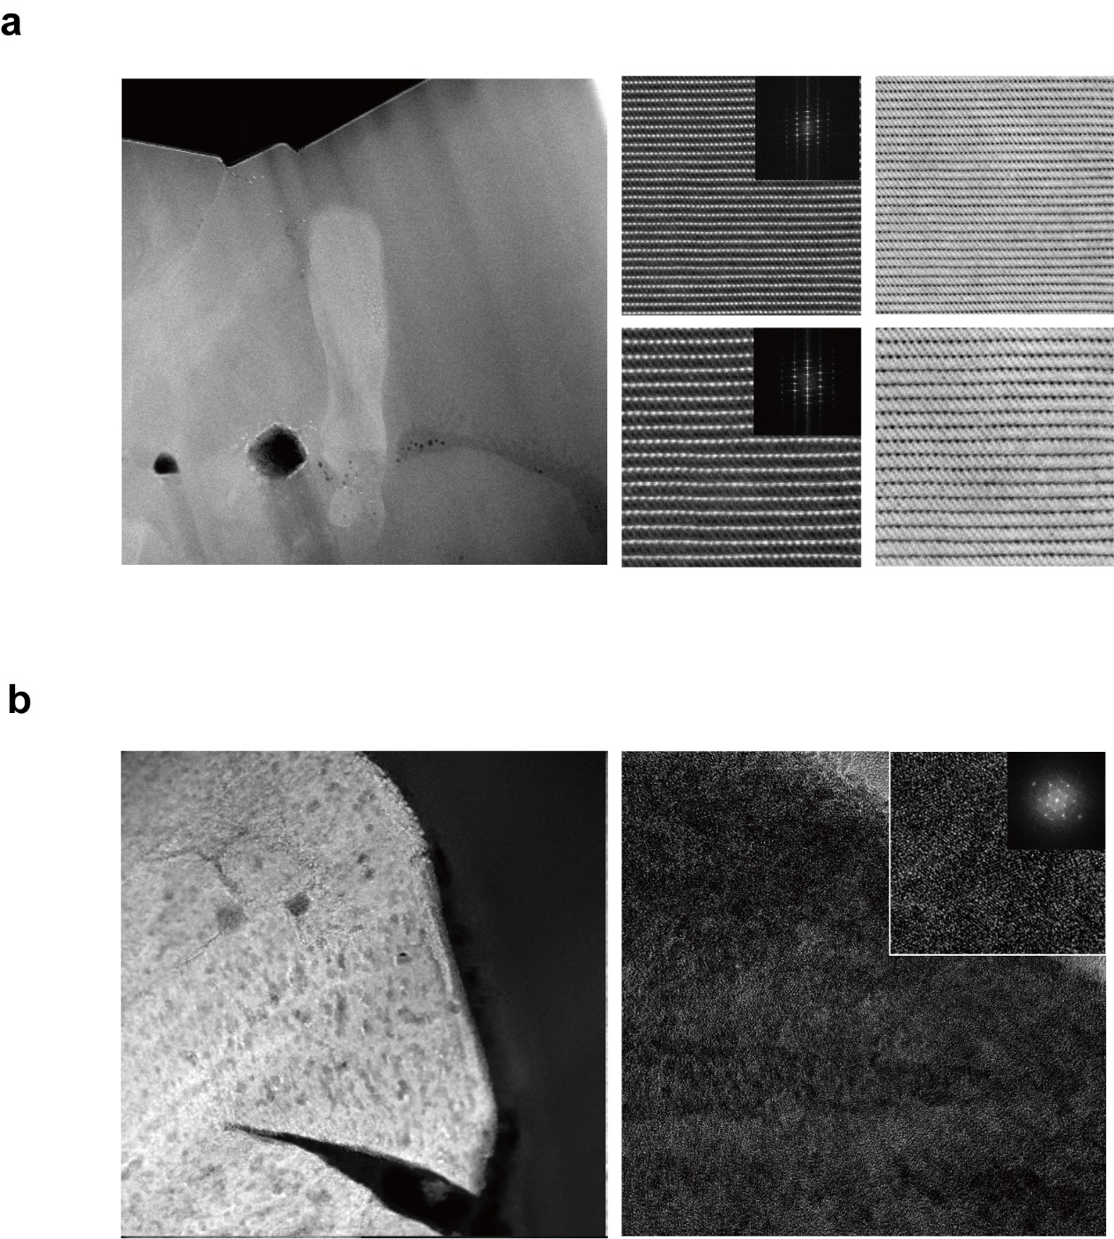
Supplementary Fig. 19 | TEM images of Li₂RuO₃ before (a) and after cycling (b). Pristine Li2RuO3 shows clear TM layers, but after cycling, numerous voids and severe crack is observed with unrecognized TM layers.

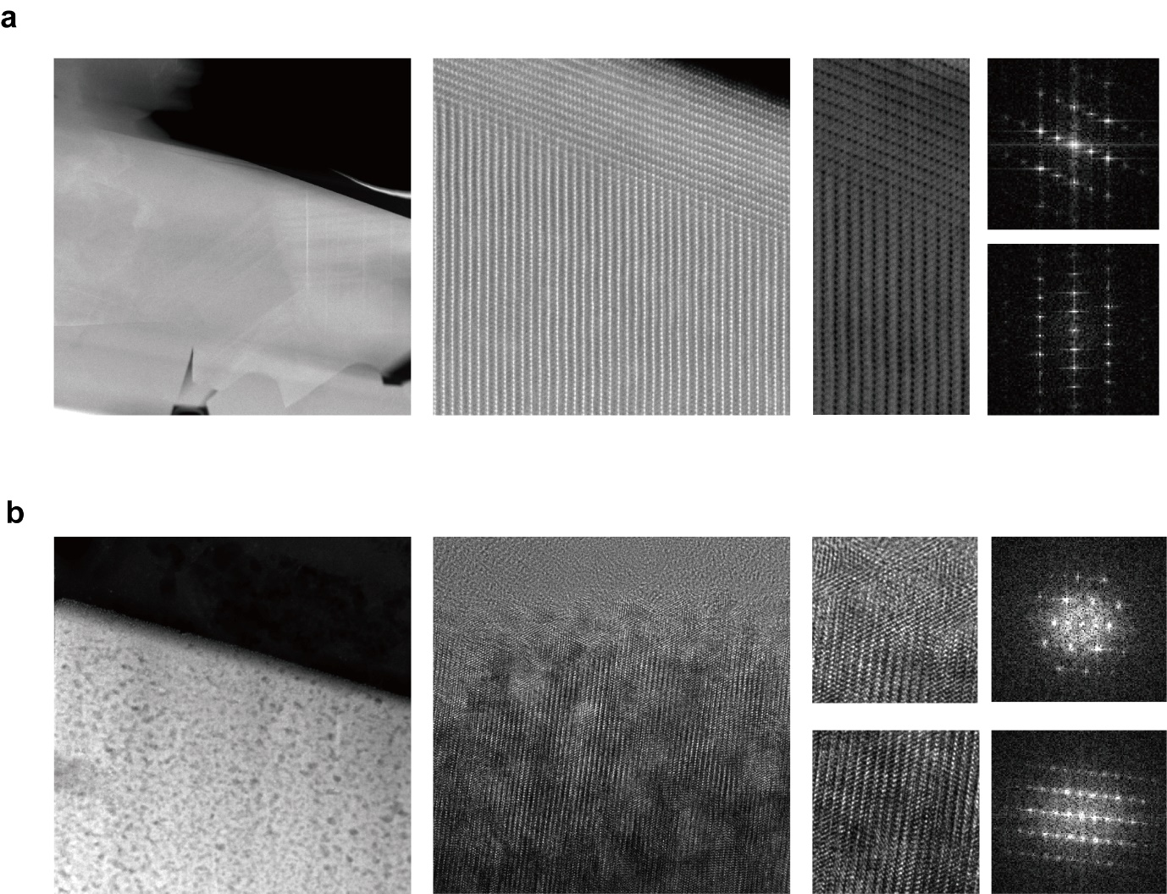
Supplementary Fig. 20 | TEM images of LNRO before (a) and after cycling (b). Pristine LNRO shows clear TM layers with surface disordered layer. However, after cycling, surface layers are destroyed, and numerous voids are formed.

Supplementary Fig. 21 | EELS spectra of the pristine (a) and cycled LNRO (b). H AADF-STEM images show corresponding scanning points of each EELS spectra. As note energy of L2 edge, layered region consists of Ni3+ whereas surface region consists of Ni2+, which is consistent with previous research that unstable Ni³⁺ is often reduced to Ni²⁺ in the surface region.

Supplementary Fig. 22 | Synchrotron XRD patterns of Li_{1.22}Al_{0.05}Ni_{0.12}Ru_{0.61}O₂ before and after cycling. a, Rietveld refinement of LANRO, which is fitted to C_{2/C} space group, with slight peak broadening due to defect. b, synchrotron XRD depending on the SOC and after 50th cycle. Shaded regions represent honeycomb-type cationic arrangement of Li_{1/3}TM_{2/3}. It clearly demonstrates that Ni and Al aids structural integrity of lithium ruthenate even at charge state and after cycling.
Supplementary Fig. 23 | Electrochemical evaluation during 50 cycles at 60 ℃ of LRO (a), LNRO (b), and LANRO (c). It confirms that Al doping is significantly effective in enhancing the cyclability, even at high temperature.

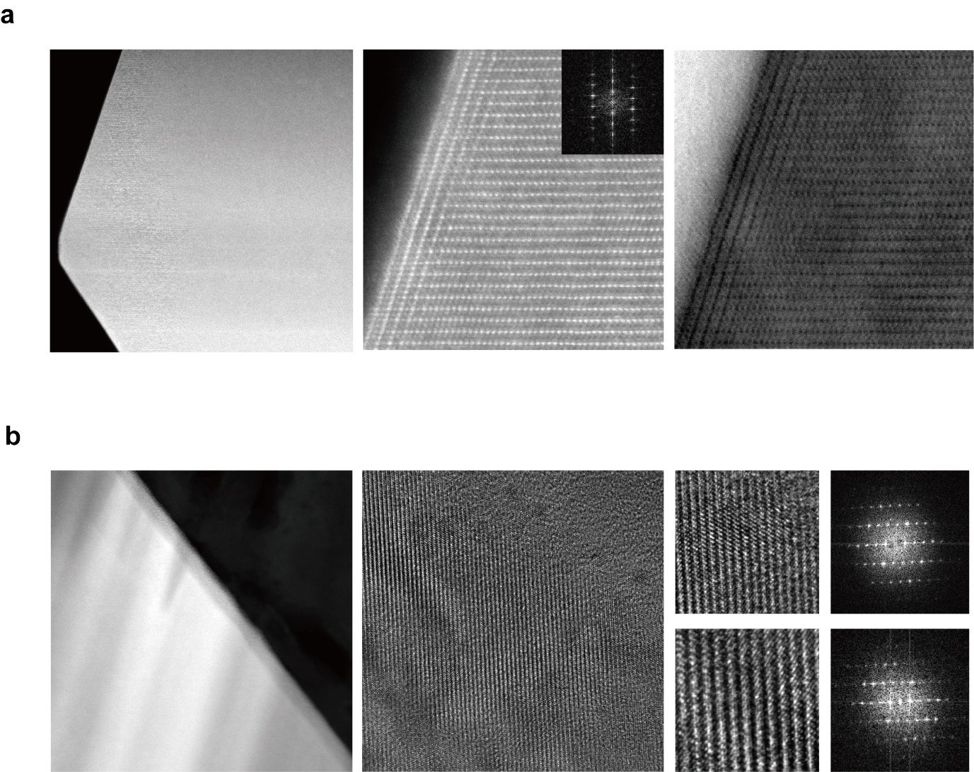
Supplementary Fig. 24 | TEM images of LNRO before (a) and after cycling (b). a, Pristine LANRO shows clear TM layers with surface disordered layer, which is identical to pristine LNRO. However, it shows significantly reduced thickness of surface layer, compared to that of LNRO. b, Cycled LANRO still show recognizable TM layers.

Supplementary Fig. 25 | Structural characterization using TEM before and after cycling.

Supplementary Fig. 26 | Quantification of TM dissolution toward anode side during cycling. Without Ni substitution, Ru dissolution is severe because crack or vacancy is evolved due to lattice-oxygen evolution. On the contrary, as Ni substitution stabilizes its high-voltage redox, Ru dissolution is significantly mitigated, but Ni dissolution is still active. TOF-SIMS results of LANRO demonstrates that Al doping is effective in suppressing the Ni dissolution.

Supplementary Fig. 27 | 3d contour maps for operando EXAFS data of LANRO during 1st cycle, 2nd cycle, and 50th cycle. These EXAFS results shows that LANRO exhibits almost no atomic evolution of Ru species, which is main redox species during HV-redox, whereas it does reversible change of Ni species.

Supplementary Fig. 28 | Atomic distribution of Ni around Al. a, As most stable 15 crystal structures are examined, in 9 of 15 structures, all Ni ions are located on TM sites adjacent to Al within the second nearest neighbouring Oh sites in TM layer. And 5 structures hold two-thirds of Ni in the identical range. It means that most Ni atoms are located near Al dopants and its migration is significantly affected by Al doping. b, a migration of 3rd neighboring Ni has scarcely been disrupted from Al_{tet}. That is why we note atomic distribution within 2nd neighboring shell around Al.
Supplementary Fig. 29 | Schematic illustration of RIXS signature for anionic redox and correlated oxygen species with holes.

Supplementary Table 1 | Rietveld refinement results of the LANRO
LANRO-pristine
Space group C2/c, a = 5.0244(3) Å, b = 8.7396(3) Å, c = 9.8502(3) Å, β = 99.862(5) °, V = 426.15(3) Å³.
Li1-O1 × 2 = 2.00(5) Å, Li1-O2 × 2 = 2.07(2) Å, Li1-O3 × 2 = 2.07(5) Å.
Li2-O1 × 2 = 2.08(5) Å, Li2-O2 × 2 = 2.11(6) Å, Li2-O3 × 2 = 2.22(2) Å.
Li3-O1 × 2 = 2.04(1) Å, Li3-O2 × 2 = 2.17(5) Å, Li3-O3 × 2 = 2.18(6) Å.
Li4/Ru1-O1 × 2 = 2.10(1) Å, Li4/Ru1-O2 × 2 = 2.12(2) Å, Li4/Ru1-O3 × 2 = 2.20(2) Å.
Ni1/Al1/Ru2-O1 = 1.98(2) Å, Ni1/Al1/Ru2-O1 = 2.08(2) Å, Ni1/Al1/Ru2-O2 = 1.98(2) Å,
Ni1/Al1/Ru2-O2 = 2.11(2) Å, Ni1/Al1/Ru2-O3 = 1.91(2) Å, Ni1/Al1/Ru2-O3 = 1.96(2) Å.
atom | Site | x | y | z | Occupancy | B (Å²)
Li1 | 4e | 0 | 0.101(8) | 0.25 | 1 | 0.63
Li2 | 4e | 0 | 0.404(9) | 0.25 | 1 | 0.63
Li3 | 4e | 0 | 0.748(8) | 0.25 | 1 | 0.63
Li4/Ru1 | 4d | 0.25 | 0.25 | 0.5 | 0.78(1)/0.22(1) | 0.63
Ni1/Al1/Ru2 | 8f | 0.242(1) | 0.082(1) | 0.002(1) | 0.27/0.13/0.6 | 0.71(3)
O1 | 8f | 0.137(2) | 0.246(2) | 0.121(1) | 1 | 1.4(3)
O2 | 8f | 0.132(4) | 0.571(2) | 0.122(2) | 1 | 2.3(6)
O3 | 8f | 0.097(3) | 0.933(2) | 0.119(2) | 1 | 0.63
Reliability factors |  | R_{p} = 9.79 %, R_{wp} = 12.9 %, GOF = 2.09, R_{B} = 7.11 %, R_{F} = 6.75 %.

Supplementary Table 2 | Magnetic moments of LNRO during delithiation
 | Element | Magnetization | Expected  oxidation number
Li₁₅Ni₂Ru₇O₂₄ | Ni(1) | 1.763 | 2+
Li₁₅Ni₂Ru₇O₂₄ | Ni(2) | 1.772 | 2+
Li₁₅Ni₂Ru₇O₂₄ | Ru(1) | 1.667 | 4+
Li₁₅Ni₂Ru₇O₂₄ | Ru(2) | 1.676 | 4+
Li₁₅Ni₂Ru₇O₂₄ | Ru(3) | 1.676 | 4+
Li₁₅Ni₂Ru₇O₂₄ | Ru(4) | 1.668 | 4+
Li₁₅Ni₂Ru₇O₂₄ | Ru(5) | 2.281 | 5+
Li₁₅Ni₂Ru₇O₂₄ | Ru(6) | 1.67 | 4+
Li₁₅Ni₂Ru₇O₂₄ | Ru(7) | 1.692 | 4+

 | Element | Magnetization | Expected  oxidation number
Li₇Ni₂Ru₇O₂₄ | Ni(1) | 1.792 | 2+
Li₇Ni₂Ru₇O₂₄ | Ni(2) | 0.057 | 4+
Li₇Ni₂Ru₇O₂₄ | Ru(1) | 2.255 | 5+
Li₇Ni₂Ru₇O₂₄ | Ru(2) | 2.271 | 5+
Li₇Ni₂Ru₇O₂₄ | Ru(3) | 2.27 | 5+
Li₇Ni₂Ru₇O₂₄ | Ru(4) | 2.26 | 5+
Li₇Ni₂Ru₇O₂₄ | Ru(5) | 2.221 | 5+
Li₇Ni₂Ru₇O₂₄ | Ru(6) | 2.268 | 5+
Li₇Ni₂Ru₇O₂₄ | Ru(7) | 2.299 | 5+

 | Element | Magnetization | Expected  oxidation number
Li₅Ni₂Ru₇O₂₄ | Ni(1) | 1.675 | (2+x)+
Li₅Ni₂Ru₇O₂₄ | Ni(2) | 0.176 | 4+
Li₅Ni₂Ru₇O₂₄ | Ru(1) | 1.955 | (5+x)+
Li₅Ni₂Ru₇O₂₄ | Ru(2) | 2.214 | 5+
Li₅Ni₂Ru₇O₂₄ | Ru(3) | 2.242 | 5+
Li₅Ni₂Ru₇O₂₄ | Ru(4) | 2.196 | 5+
Li₅Ni₂Ru₇O₂₄ | Ru(5) | 1.614 | 6+
Li₅Ni₂Ru₇O₂₄ | Ru(6) | 2.175 | 5+
Li₅Ni₂Ru₇O₂₄ | Ru(7) | 2.255 | 5+

 | Element | Magnetization | Expected  oxidation number
Li₄Ni₂Ru₇O₂₄ | Ni(1) | 1.69 | (2+x)+
Li₄Ni₂Ru₇O₂₄ | Ni(2) | 0.028 | 4+
Li₄Ni₂Ru₇O₂₄ | Ru(1) | 1.699 | 6+
Li₄Ni₂Ru₇O₂₄ | Ru(2) | 2.192 | 5+
Li₄Ni₂Ru₇O₂₄ | Ru(3) | 1.806 | (5+x)+
Li₄Ni₂Ru₇O₂₄ | Ru(4) | 2.059 | 5+
Li₄Ni₂Ru₇O₂₄ | Ru(5) | 1.554 | 6+
Li₄Ni₂Ru₇O₂₄ | Ru(6) | 2.177 | 5+
Li₄Ni₂Ru₇O₂₄ | Ru(7) | 2.241 | 5+
*Computation value: Ni (2+/3+/4+) = ~1.78/~0.89/~0.00, Ru (4+/5+/6+) = ~1.67/~2.27/~1.60

