Epidemic analysis of Peste des petits ruminants in India

Supplementary date
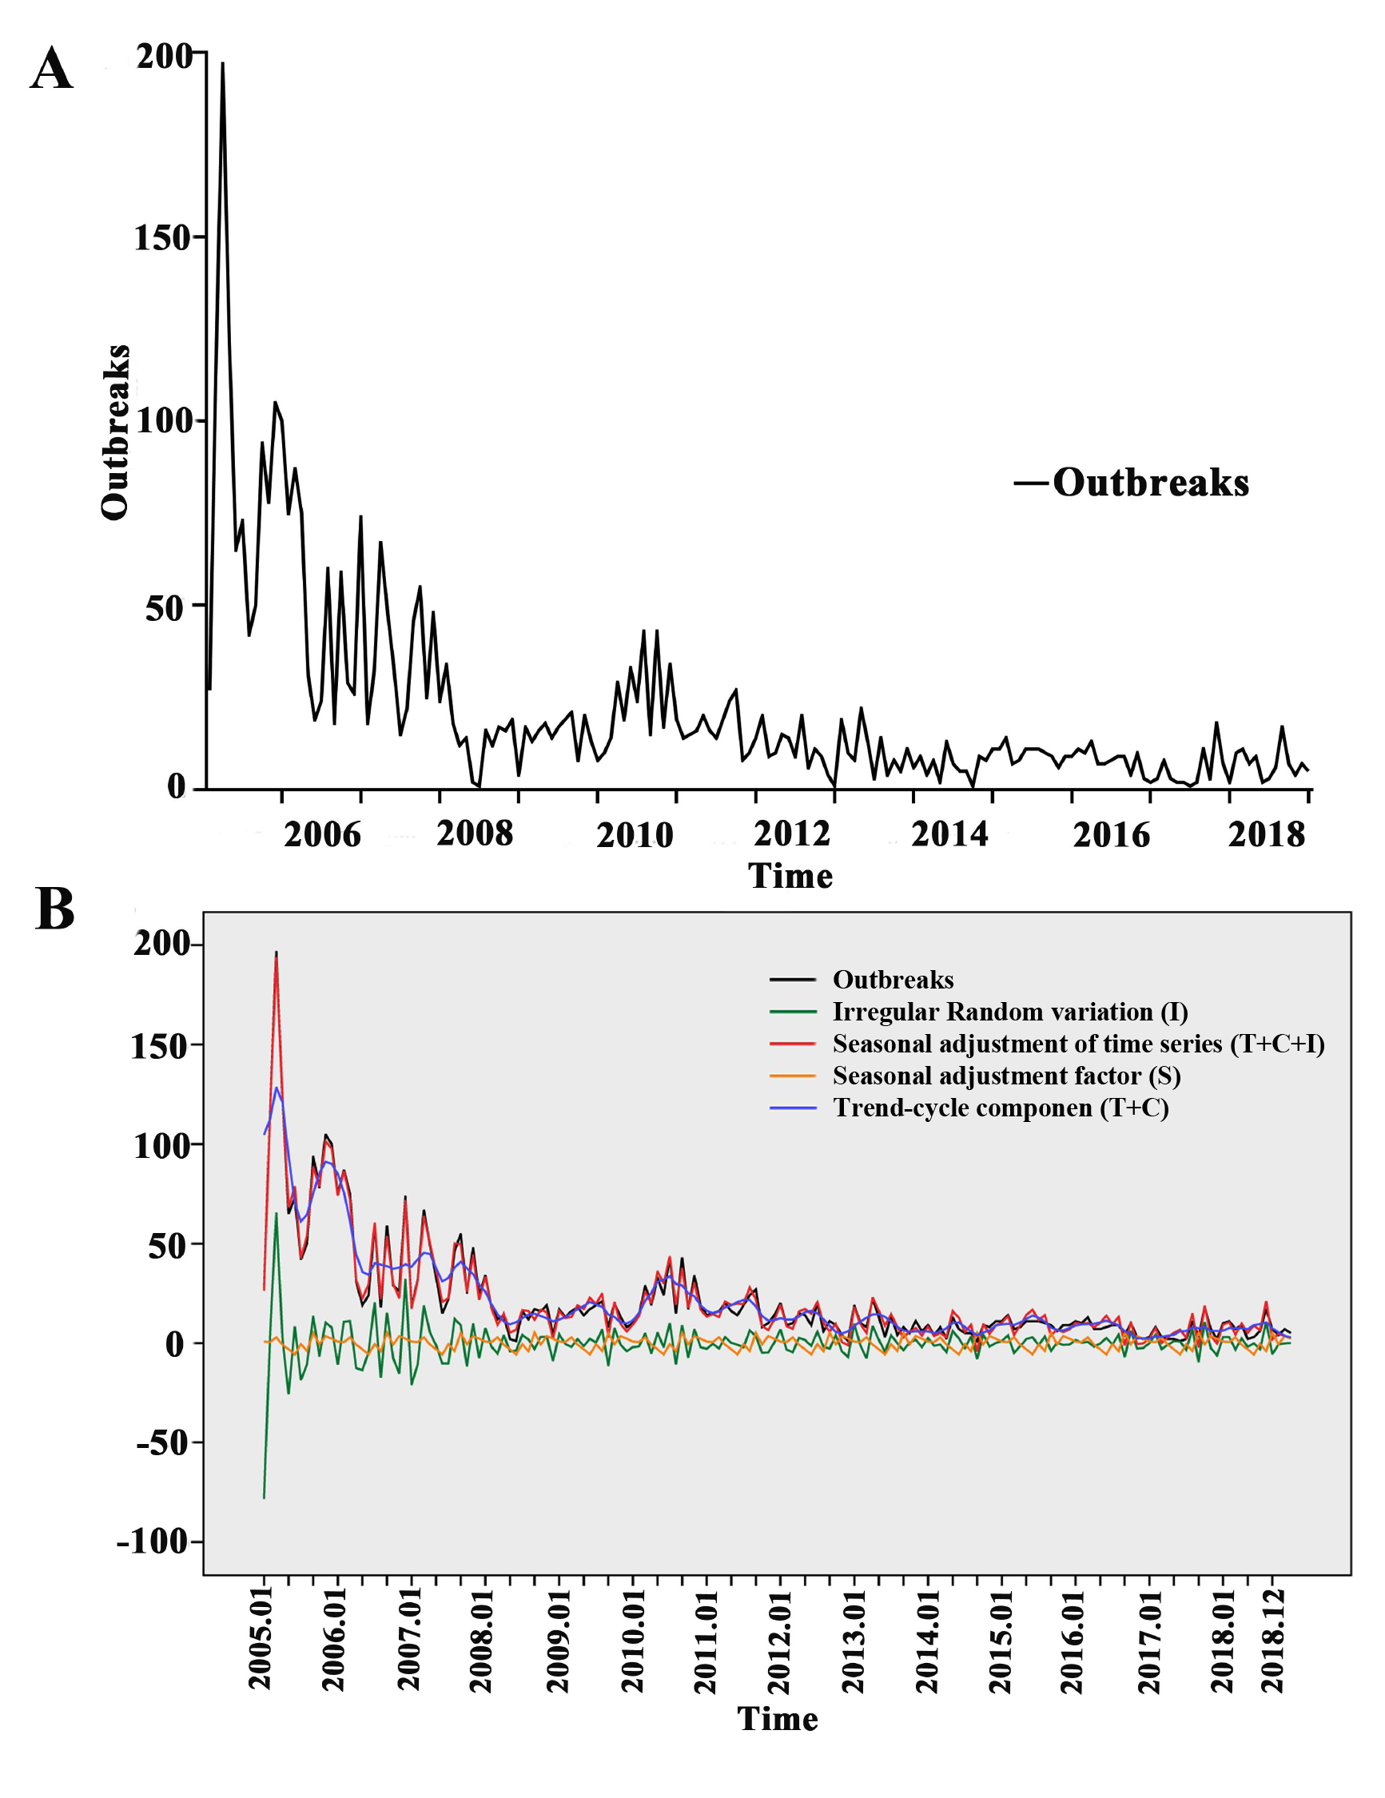
S1 Fig. Time series curve. Note A: outbreak time series; B: seasonal decomposition curve

Table S1. Comparison of time series modeling results
Model | Stationary R² | R² | RMSE | BIC | P | White noise sequence
Winters multiplication | 0.704 | 0.75 | 13.5 | 5.297 | 0 | No
ARIMA(2,0,1)(0,0,0) | 0.652 | 0.593 | 17.271 | 5.82 | 0.106 | Yes
Winters addition | 0.527 | 0.651 | 15.93 | 5.628 | 0.021 | No
ARIMA(2,1,1)(0,0,0) | 0.158 | 0.609 | 16.968 | 5.785 | 0.011 | No
ARIMA(1,0,1)(0,0,0) | 0.645 | 0.566 | 17.776 | 5.847 | 0.009 | No
Note RMSE: Root Mean Squared Error; BIC: Bayesian Information Criterion

Table S2. Prediction of the two time series models
Time | Winters multiplication |  |  | ARIMA(2,0,1)(0,0,0)
Time | Predictive value | LCL | UCL | Predictive value | LCL | UCL
2020.01 | 6 | -25 | 37 | 11 | 0 | 38
2020.02 | 9 | -27 | 45 | 11 | 0 | 39
2020.03 | 12 | -32 | 56 | 11 | 0 | 39
2020.04 | 8 | -28 | 45 | 11 | 0 | 40
2020.05 | 6 | -26 | 38 | 11 | 1 | 41
2020.06 | 5 | -27 | 37 | 11 | 1 | 42
2020.07 | 7 | -29 | 42 | 12 | 1 | 42
2020.08 | 5 | -28 | 39 | 12 | 1 | 43
2020.09 | 9 | -35 | 53 | 12 | 1 | 44
2020.1 | 6 | -31 | 43 | 12 | 1 | 45
2020.11 | 8 | -36 | 52 | 12 | 1 | 45
2020.12 | 8 | -36 | 52 | 12 | 1 | 46
Note LCL: Lower confidence limit; UCL: Upper confidence limit

