TREM2 promotes natural killer cell development in CD3⁻CD122⁺NK1.1⁺ pNK cells
Hwa-Youn Lee^{1,a}, Eun-Hee Lee^{2,a}, Jawoon Yi³, Kon-Young Ji⁴, Su-Man Kim³, Ha-Rim Choi⁵, Hyung-Sik Kang^{3,*}, and Eun-Mi Kim^{6,*}

¹ Chemicals Registration & Evaluation Team, National Institute of Environmental Research, Hwangyeong-ro 42, Seo-gu, Incheon 22689, Korea
² Medical Device Development Center, Daegu-Gyeongbuk Medical Innovation Foundation, 80 Cheombok-ro, Dong-gu, Daegu 41061, Korea
³ School of Biological Sciences and technology, Chonnam National University, 77 Yongbong-ro, Buk-gu, Gwangju 61186, Korea
⁴ Herbal Medicine Research Division, Korea Institute of Oriental Medicine, 461-24 Jeonmin-dong, Yuseong-gu, Daejeon 34054, Korea
⁵ Department of Nursing, Nambu University, 23 Chumdan Jungang-ro, Gwangsan-gu, Gwangju 62271, Korea
⁶ Department of Predictive Toxicology, Korea Institute of Toxicology, 141 Gajeong-ro, Yuseong-gu, Daejeon 34114, Korea

*Corresponding authors: HS Kang, Ph.D., School of Biological Sciences and Technology, Chonnam National University, 77 Youngbong-ro, Buk-gu, Gwangju 61186, Republic of Korea; Email: kanghs@jnu.ac.kr; Tel: +82-62-530-2195.
Eun-Mi Kim, Ph.D., Department of Predictive Toxicology, Korea Institute of Toxicology, 141 Gajeong-ro, Yuseong-gu, Daejeon 34114, Republic of Korea; Email: eunmi.kim@kitox.re.kr; Tel: +82-42-610-8263

This file includes:

Figures S1 to S9

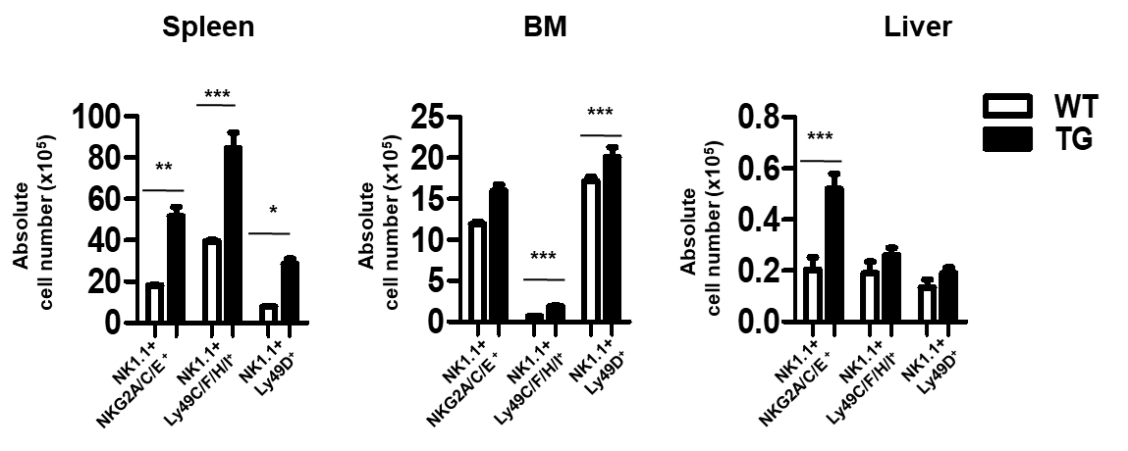
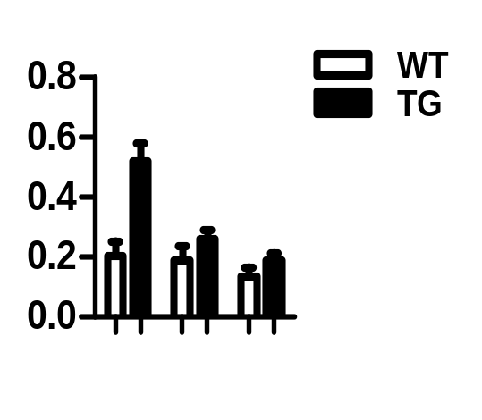
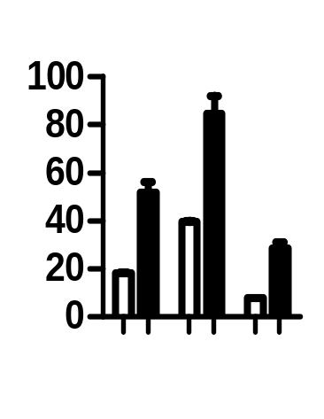
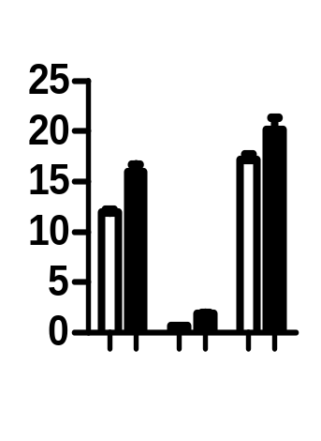
Fig. S1. In TREM2-TG mice, the number of cells expressing the NK cell-receptor is elevated. Graphs show the absolute number of cells that express the NK cell-receptors in the spleen, BM, and liver of WT (opened bar) and TREM2-TG mice (solid bar). Data are shown as means ± SD of three independent experiments. *P < 0.05, **P <0.01 and ***P < 0.001 by Student’s t-test.
Liver
NK1.1+
NKG2A/C/E ⁺
NK1.1+
Ly49C/F/H/I⁺
NK1.1+
Ly49D⁺
**
***
*
***
***
***
NK1.1+
NKG2A/C/E ⁺
NK1.1+
Ly49C/F/H/I⁺
NK1.1+
Ly49D⁺
NK1.1+
NKG2A/C/E ⁺
NK1.1+
Ly49C/F/H/I⁺
NK1.1+
Ly49D⁺
Absolute
cell number (x10⁵)
Absolute
cell number (x10⁵)
Absolute
cell number (x10⁵)
Spleen
BM

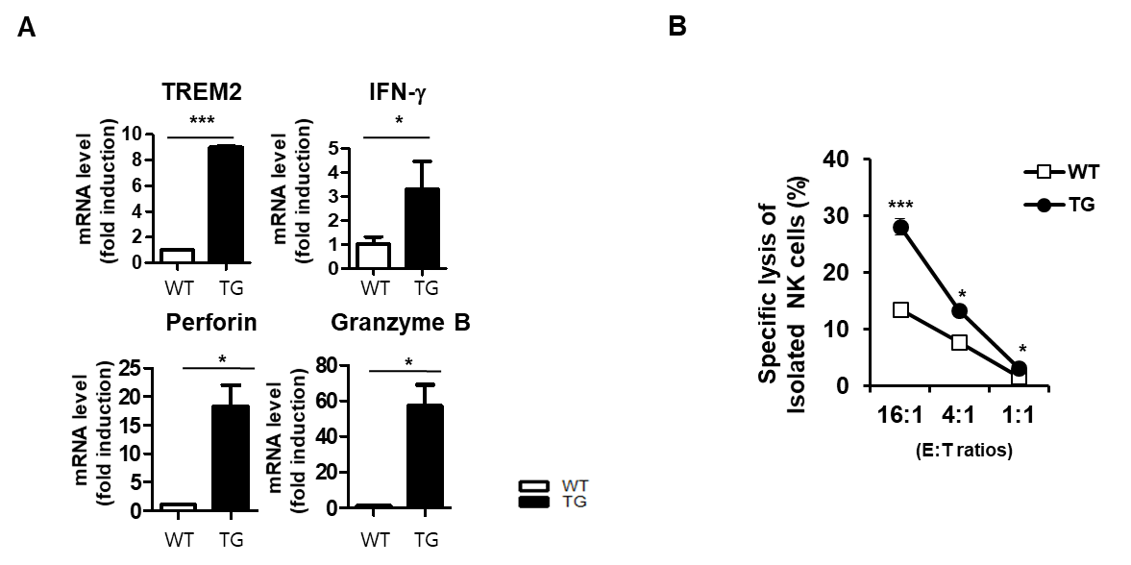
Fig. S2. TREM2-TG mice show enhanced NK cell cytotoxicity. (A) Real-time qPCR analysis to determine expression of the TREM2, IFN- γ, Perforin, and Granzyme B mRNAs in splenic NK1.1+ cells of WT or TREM2-TG mice. (B) LDH assay to measure cytotoxicity of NK1.1+ cells purified from splenocytes harvested from WT (open square) and TREM2-TG (solid circle) mice. Three independent experiments repeated (A-B). *P < 0.05, **P <0.01 and ***P < 0.001 by Student’s t-test

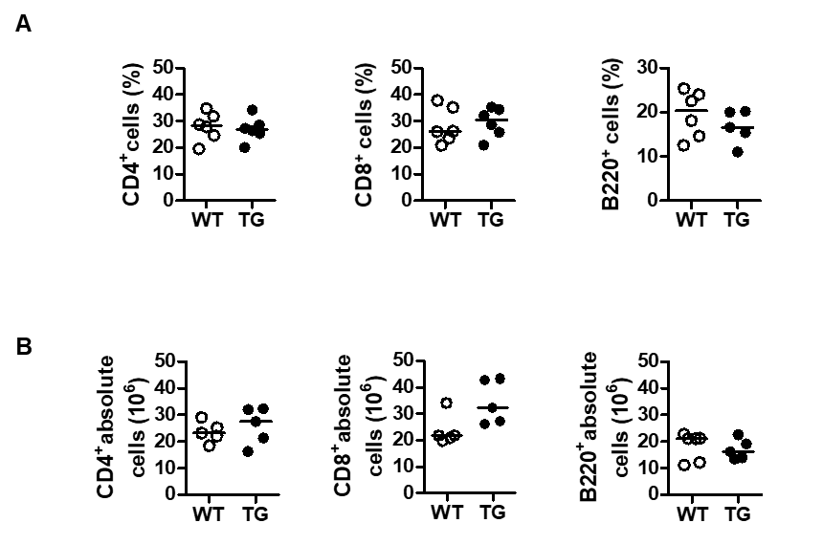
Fig. S3. The numbers of T cells and B cells in WT and TREM2-TG mice to not differ. The percentage (A) and absolute numbers (B) of CD4 cells, CD8 T cells and B cells in spleens of WT or TREM2-TG mice as determined by flow cytometric analysis (N=5). Three independent experiments repeated, however no significant difference was observed between WT and TG mice group.

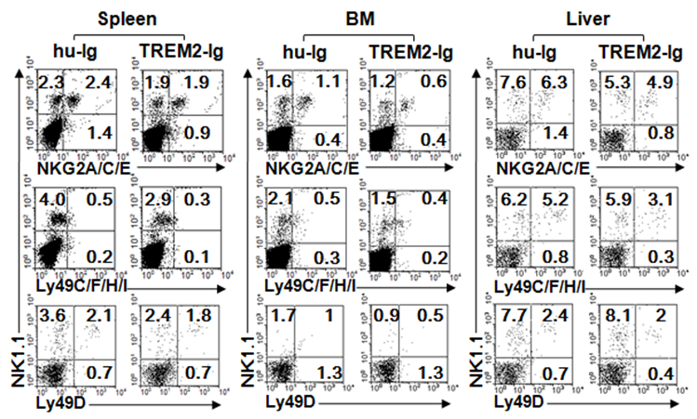

Fig. S4. Inhibition of TREM2 signaling reduces the NK cell pool in vivo. Representative flow cytometry plots of expression of NK cell-specific receptors on surface of cells isolated from the spleen, BM, and liver of WT mice injected (i.p.) with 100 µg of TREM2-Ig or hu-Ig (control) twice per week for 4 weeks intraperitoneally.

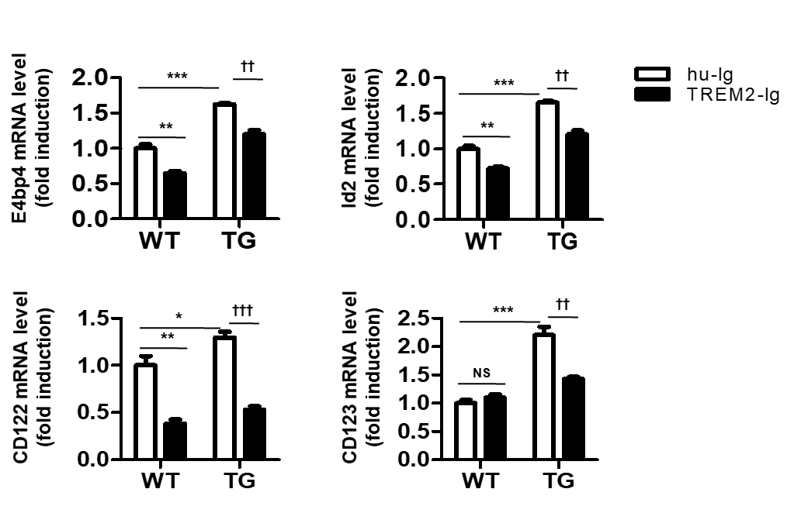
Fig. S5. TREM2 signaling enhances NK cell-related gene expression in differentiated NK cells in vitro. Quantitative real-time PCR analysis of NK cell associated genes using mRNA isolated from mNK cells derived from WT or TREM2-TG HSCs. Data are shown as means ± SD of three independent experiments. *P < 0.05, **P < 0.01, ***P < 0.001 vs. WT+ hu-Ig, and †P < 0.05, ††P < 0.01, †††P < 0.01 vs. TG+hu-Ig, based on two-way ANOVA analysis with Bonferroni post-hoc test.

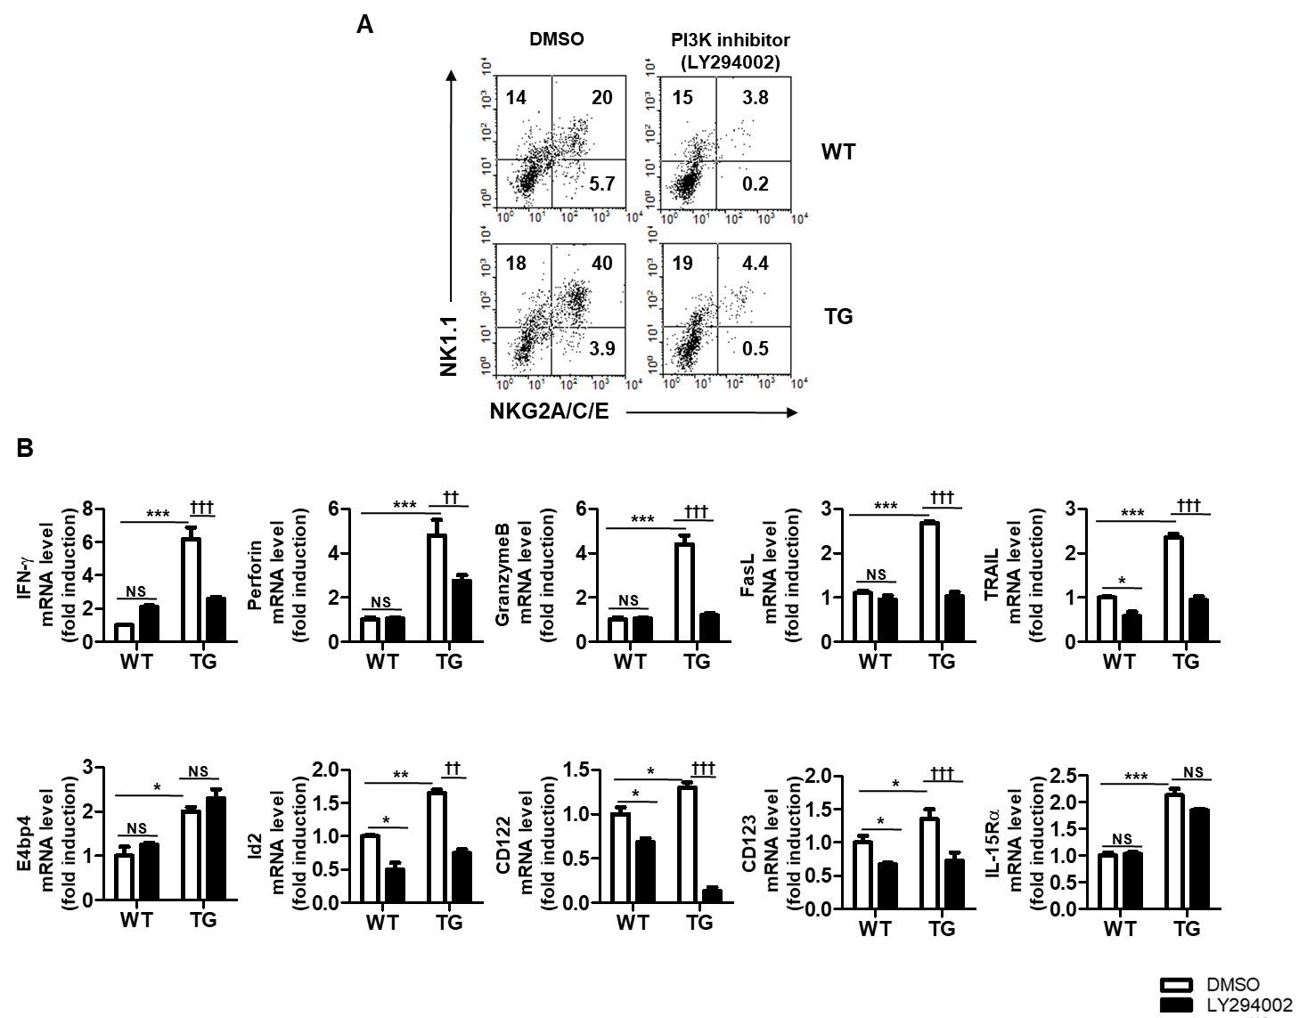
Fig. S6. The development and cytotoxicity of NK cells regulate by TREM2 via PI3K signaling. (A) Representative flow cytometry plots showing the relative ratio of mNK cells developed in vitro from pNK cells of WT-HSCs and TREM2-HSCs treated with DMSO or LY294002 (1uM). (B) Quantitative real-time PCR analysis of the indicated genes using mRNA isolated from mNK cells differentiated from WT-HSCs or TREM2-TG-HSCs treated with DMSO (opened bar) or LY294002 (solid bar). *P < 0.05, **P < 0.01, ***P < 0.001 vs. WT+ DMSO, and †P < 0.05, ††P < 0.01 vs. TG+DMSO, based on two-way ANOVA analysis with Bonferroni post-hoc test.

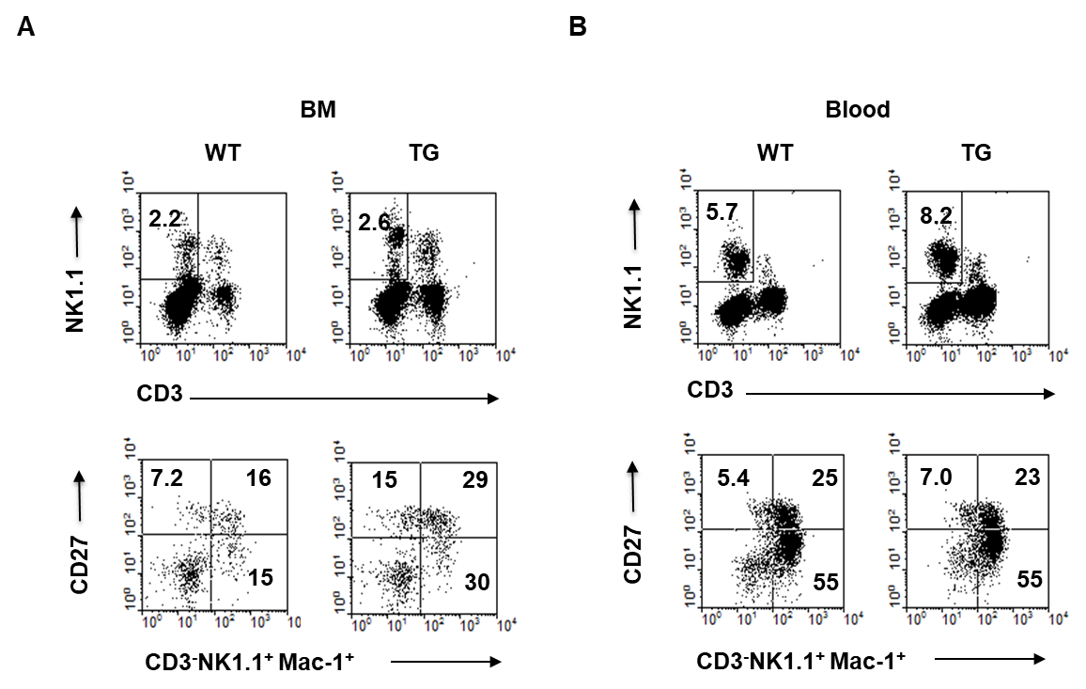
Fig. S7. The CD3⁻NK1.1⁺Mac-1⁺CD27⁺ NK cell subset is reduced in the peripheral blood of TREM2-K/O mice. Representative flow cytometry plots show the NK cell subsets (CD3-NK1.1+Mac-1lowCD27high, CD3⁻NK1.1+Mac-1high CD27high, CD3⁻NK1.1+Mac-1high CD27low, and CD3-NK1.1+Mac-1lowCD27high) in the peripheral blood (A) or BM (B) of WT and TREM2-TG mice. Three independent experiments repeated.

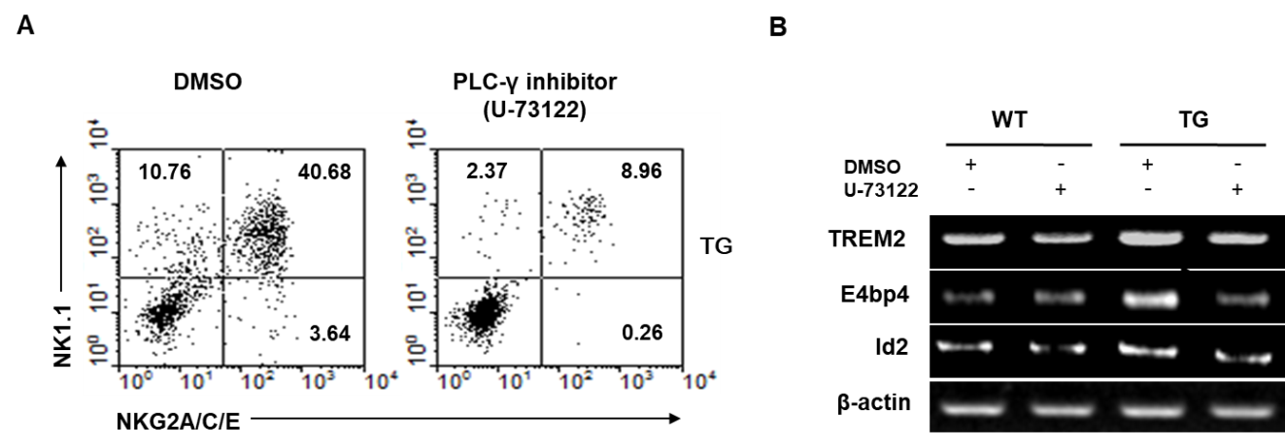
Fig. S8. TREM2 regulate NK cell differentiation through the PLC-γ signaling pathway. (A) Representative flow cytometry analysis data showed that NK1.1 and NKG2A/C/E expression on the differentiated NK cells derived from TG-HSCs treated with DMSO (control) or U-73122 (PLC-γ inhibitor) during pNK to mNK cell differentiation stage. (B) RT-PCR analysis of the indicated genes on mNK cells differentiated from WT-HSCs or TREM2 TG-HSCs treated with DMSO (control) or U-73122 (PLC-γ inhibitor). β-actin (housekeeping gene) was used as a control. The cropped images from the different parts were displayed. The full-length gels are presented in Fig. S9.

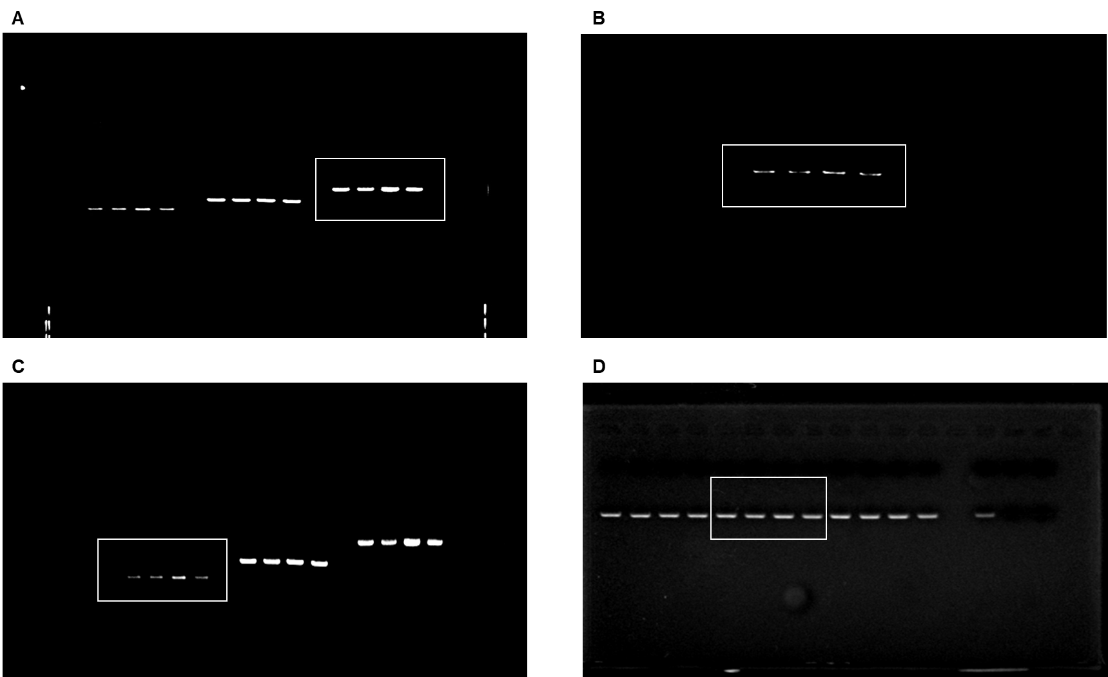

Fig. S9. Display of full-length gel images of cropped gel images. (A) Full-length gel associated to Fig. S8B, TREM2. (B) Full-length gel associated to S8B, E4BP4. (C) Full-length gel associated to Fig. S8B, Id2. (D) Full-length gel associated to Fig. S8B, β-actin.

