Supplemental Material
Figure S1
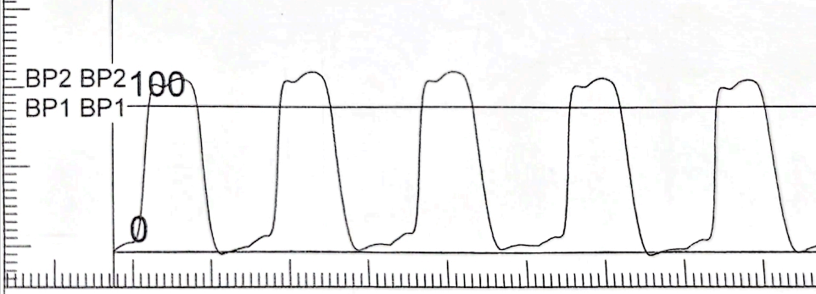
(A) 45-years-old; male; T:25.21

(B) 60-years-old; male; T:31.48
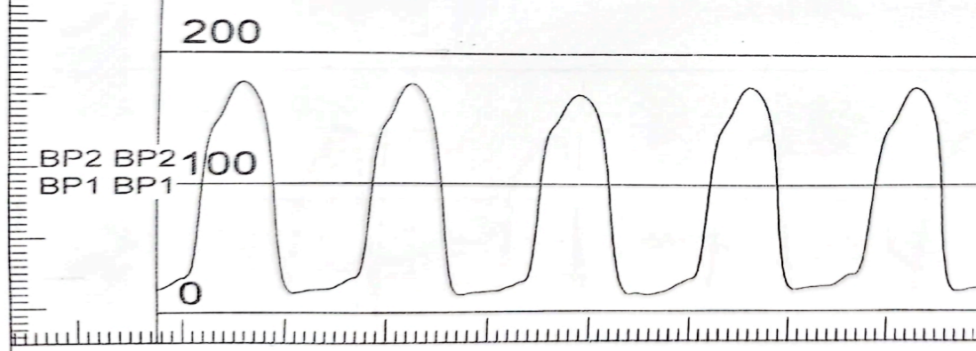

(C) 66-years-old; male; T:31.93
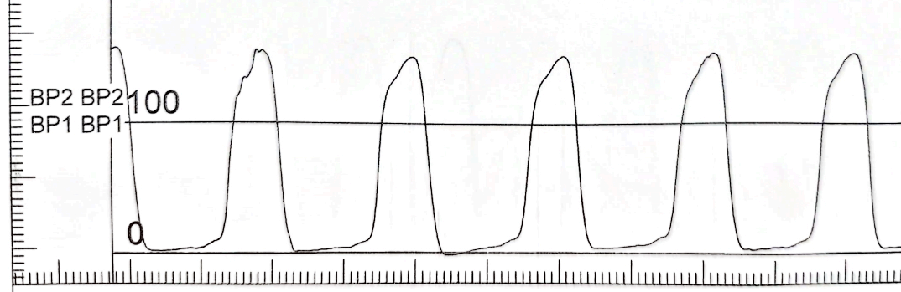

(D) 76-years-old; male; T:35.63
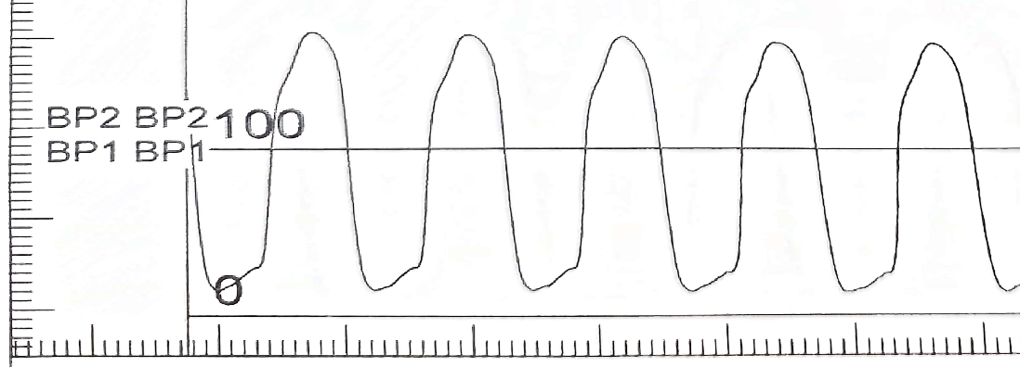

(E) 85-years-old; male; T:47.04
