Supplement Figure S1
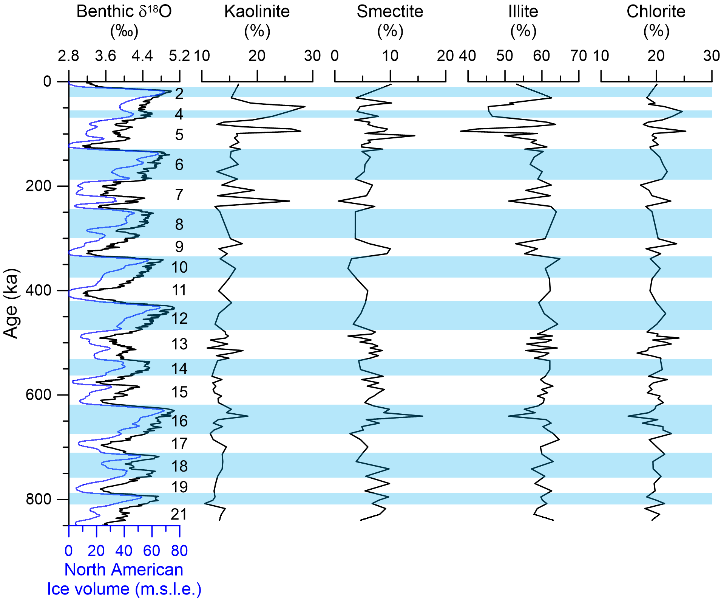

Downcore variation of the contents of the four major clay minerals (kaolinite, smectite, illite, and chlorite) of core ARC5-MA01 along with global benthic δ¹⁸O values¹ and North American ice volume (m.s.l.e.)³⁰. Marine isotope stages (MIS) are indicated with blue shadings of glacial periods.

