Supplementary file,
Active constituents of Zanthoxylum nitidum from Yunnan Province against leukemia
Ying Deng^{1, 2,3}, Tongtong Ding¹, Lulu Deng^{1, 3}, Xiaojiang Hao^{1, 3}, Shuzhen Mu^{1, 3*}
¹ State Key Laboratory of Functions and Applications of Medicinal Plants, Guizhou Medical University, Guiyang 550014, China.
² College of Pharmacy, Guizhou University, Guiyang 550025, China.
³ Key Laboratory of Chemistry for Natural Products of Guizhou Province and Chinese Academy of Sciences, Guiyang 550002, China.
* Correspondence: e-mail: muzi0558@126.com; Tel.: 13765801160

Supporting Information List of Contents
No. | Content | Page
1 | Fig S1. 1H-NMR spectrum of compound 4 in CDCl3. | 3
2 | FigS2. 13C-NMR spectrum and DEPT of compound 4 in CDCl3. | 3
3 | Fig S3. HSQC spectrum of compound 4 in CDCl3. | 4
4 | Fig S4. HMBC spectrum of compound 4 in CDCl3. | 4
5 | Fig S5. 1H- 1H COSY spectrum of compound 4 in in CDCl3. | 5
6 | Fig S6. IR spectrum of compound 4. | 5
7 | Fig S7. HR-ESI-MS spectrum of compound 4. | 6
8 | Fig S8. UV-Vis spectrum of compound 4 in CH3OH. | 6
9 | Fig S9. 1H-NMR spectrum of compound 5 in CDCl3. | 7
10 | Fig S10. 13C-NMR spectrum and DEPT of compound 5 in CDCl3. | 7
11 | Fig S11. HSQC spectrum of compound 5 in CDCl3. | 8
12 | Fig S12. HMBC spectrum of compound 5 in CDCl3. | 8
13 | Fig S13. 1H- 1H COSY spectrum of compound 5 in CDCl3. | 9
14 | Fig S14. IR spectrum of compound 5. | 9
15 | Fig S15. HR-ESI-MS spectrum of compound 5. | 10
16 | Fig S16. UV-Vis spectrum of compound 5 in CH3OH. | 10
17 | Fig S17. 1H-NMR spectrum of compound 6 in CDCl3. | 11
18 | Fig S18. 13C-NMR spectrum and DEPT of compound 6 in CDCl3. | 11
19 | Fig S19. HSQC spectrum of compound 6 in CDCl3. | 12
20 | Fig S20. HMBC spectrum of compound 6 in CDCl3. | 12
21 | Fig S21. 1H- 1H COSY spectrum of compound 6 in CDCl3. | 13
22 | Fig S22. IR spectrum of compound 6. | 13
23 | Fig S23. HR-ESI-MS spectrum of compound 6. | 14
24 | Fig S24. UV-Vis spectrum of compound 6 in CH3OH. | 14
25 | Fig S25. 1H-NMR spectrum of compound 16 in Pyridine-d5. | 15
26 | Fig S26. 13C-NMR spectrum and DEPT of compound 16 in Pyridine-d5. | 15
27 | Fig S27. HSQC spectrum of compound 16 in Pyridine-d5. | 16
28 | Fig S28. HMBC spectrum of compound 16 in Pyridine-d5. | 16
29 | Fig S29. 1H- 1H COSY spectrum of compound 16 in Pyridine-d5. | 17
30 | Fig S30. IR spectrum of compound 16. | 17
31 | Fig S31. HR-ESI-MS spectrum of compound 16. | 18
32 | Fig S32. UV-Vis spectrum of compound 16 in CH3OH. | 18

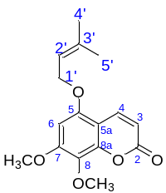
Fig S1 ¹H-NMR spectrum of compound 4 in CDCl₃ (600 MHz).
Fig S2 ¹³C-NMR spectrum and DEPT of compound 4 in CDCl₃ (151 MHz).

Fig S3 HSQC spectrum of compound 4 in CDCl₃.
Fig S4 HMBC spectrum of compound 4 in CDCl₃.
Fig S5 ¹H- ¹H COSY spectrum of compound 4 in in CDCl₃.
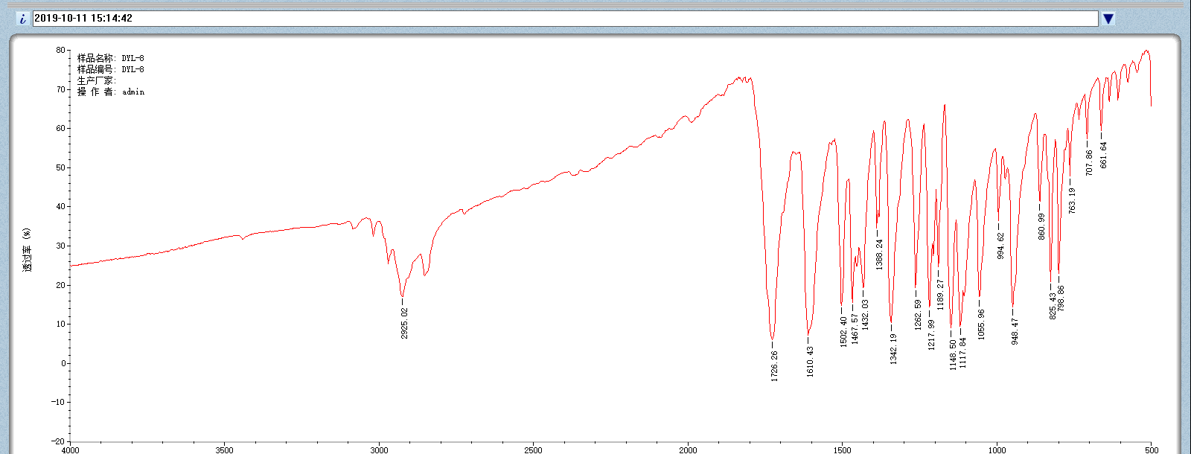
Fig S6 IR spectrum of compound 4.
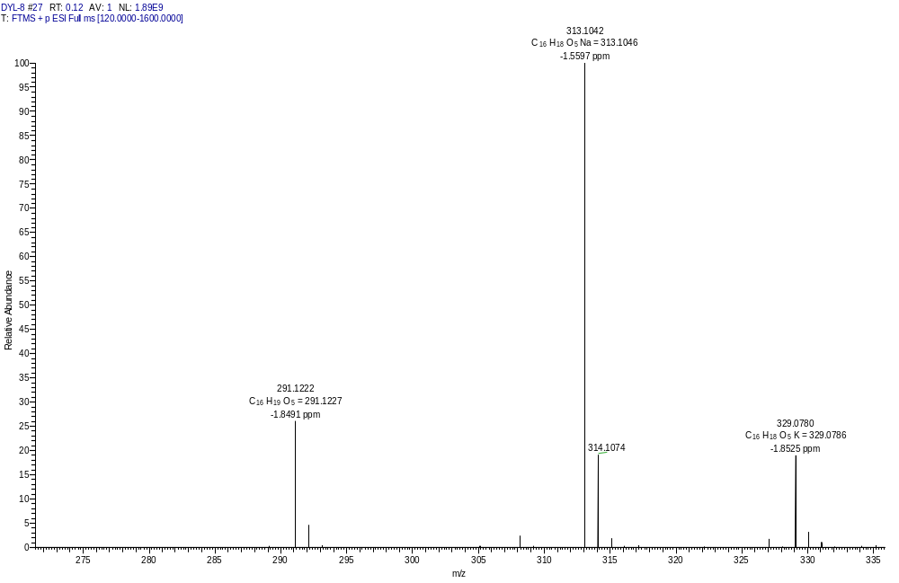
Fig S7 HR-ESI-MS spectrum of compound 4.

Fig S8 UV-Vis spectrum of compound 4 in CH₃OH.

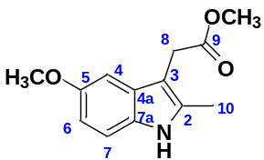
Fig S9 ¹H-NMR spectrum of compound 5 in CDCl₃ (600 MHz).
Fig S10 ¹³C-NMR spectrum and DEPT of compound 5 in CDCl₃ (151 MHz).
Fig S11 HSQC spectrum of compound 5 in CDCl₃.

Fig S12 HMBC spectrum of compound 5 in CDCl₃.

Fig S13 ¹H- ¹H COSY spectrum of compound 5 in CDCl₃.

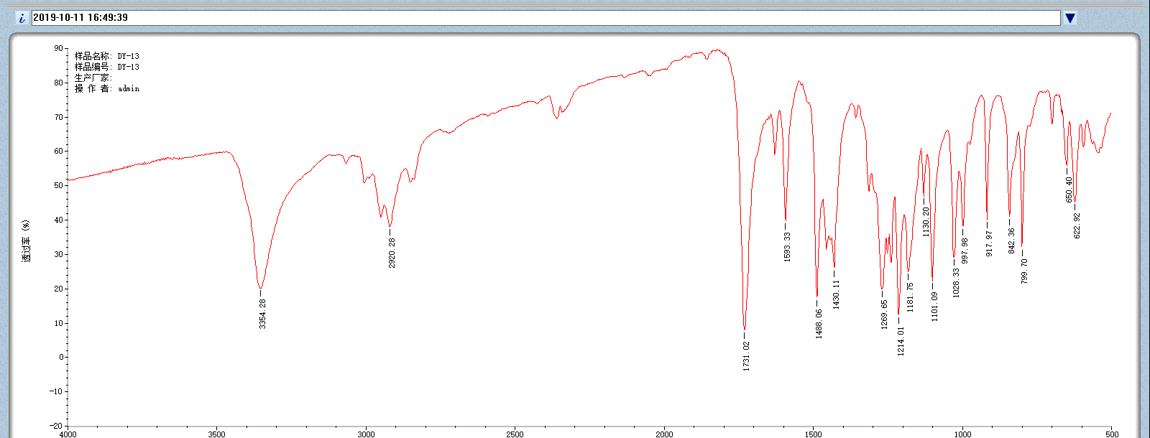
Fig S14 IR spectrum of compound 5.
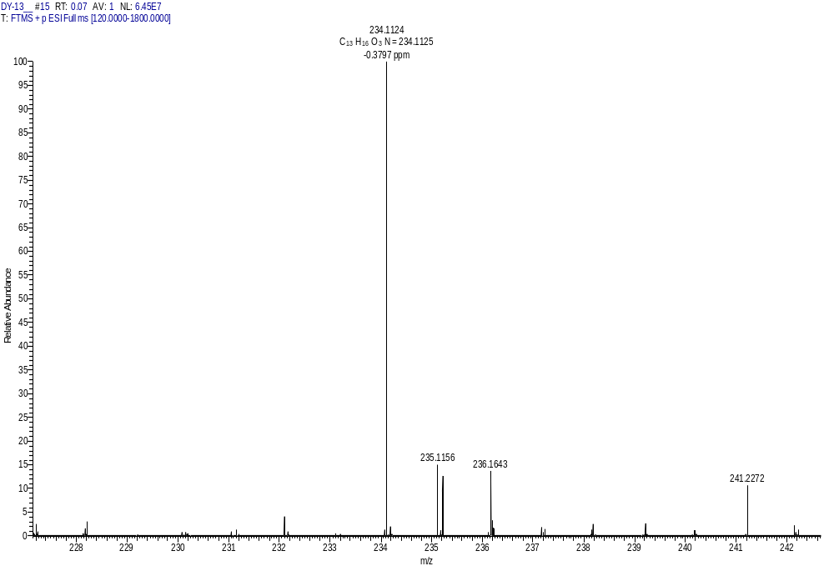
Fig S15 HR-ESI-MS spectrum of compound 5.
Fig S16 UV-Vis spectrum of compound 5 in CH₃OH.

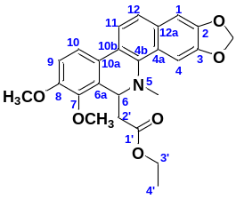
Fig S17 ¹H-NMR spectrum of compound 6 in CDCl₃ (600 MHz).
Fig S18 ¹³C-NMR spectrum and DEPT of compound 6 in CDCl₃ (151 MHz).
Fig S19 HSQC spectrum of compound 6 in CDCl₃.
Fig S20 HMBC spectrum of compound 6 in CDCl₃.
Fig S21 ¹H- ¹H COSY spectrum of compound 6 in CDCl₃.
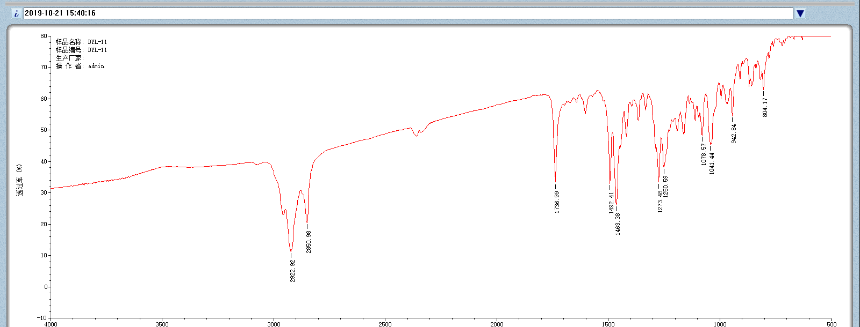
Fig S22 IR spectrum of compound 6.
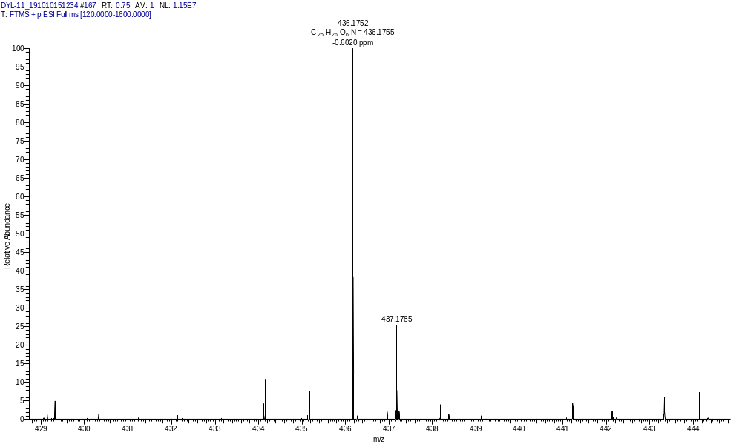
Fig S23 HR-ESI-MS spectrum of compound 6.
Fig S24 UV-Vis spectrum of compound 6 in CH₃OH.
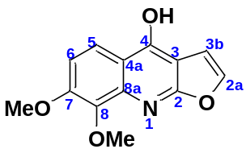
Fig S25 ¹H-NMR spectrum of compound 16 in Pyridine-d₅ (600 MHz).
Fig S26 ¹³C-NMR spectrum and DEPT of compound 16 in Pyridine-d₅ (151 MHz).

Fig S27 HSQC spectrum of compound 16 in Pyridine-d₅
Fig S28 HMBC spectrum of compound 16 in Pyridine-d₅.
Fig S29 ¹H- ¹H COSY spectrum of compound 16 in Pyridine-d₅.
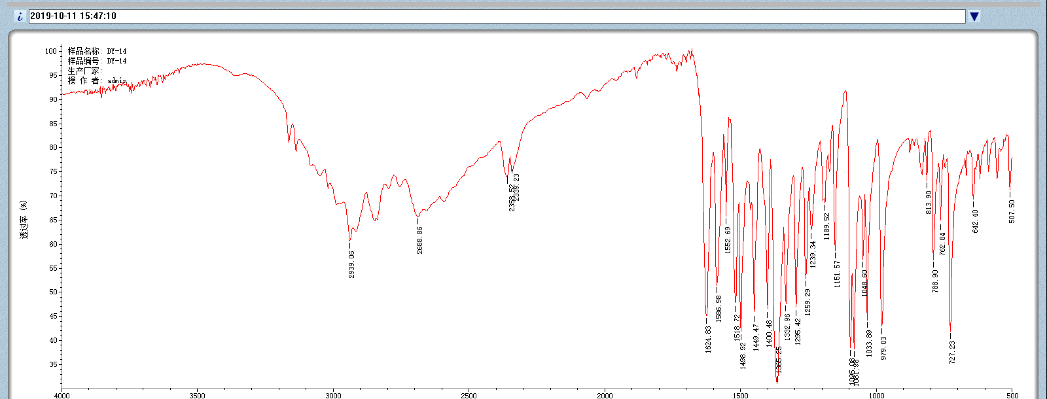
Fig S30 IR spectrum of compound 16.
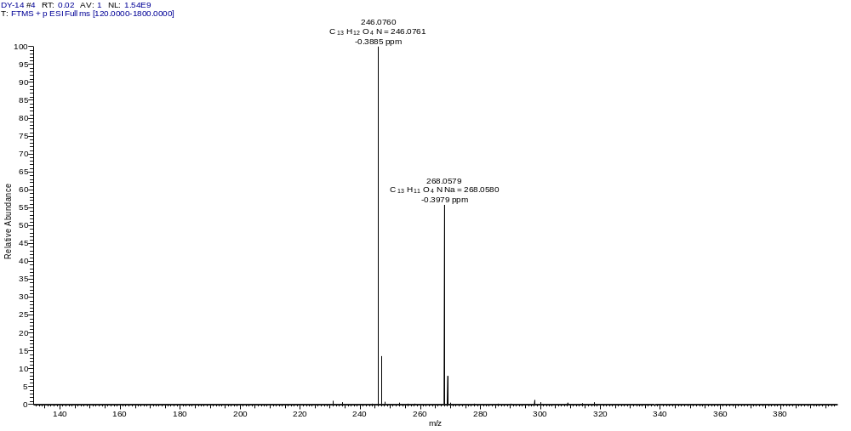
Fig S31 HR-ESI-MS spectrum of compound 16.
Fig S32 UV-Vis spectrum of compound 16 in CH₃OH.

