Table 7 3D topography of the grinding surface
Grinding speed V_{s}/（m/min） | 350 | 650
Without ultrasonic vibration | 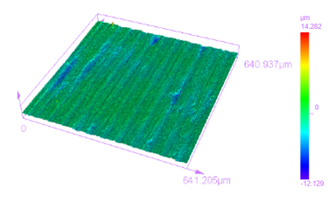 | 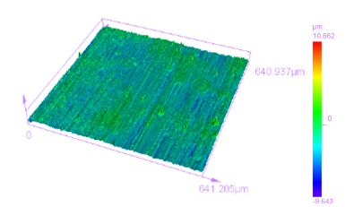
With ultrasonic vibration | 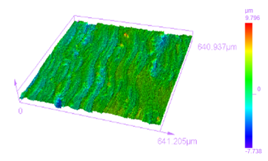 | 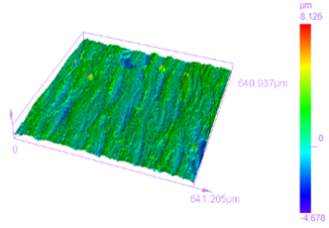

Table 8 The comparison of shapes of wear debris with and without ultrasonic vibration
Grinding speed V_{s}/（m/min） | 350 | 650
Without ultrasonic vibration | 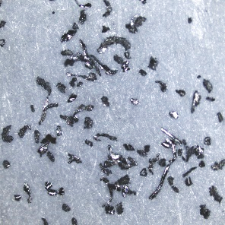 | 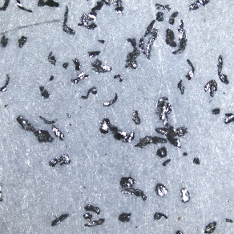
With ultrasonic vibration | 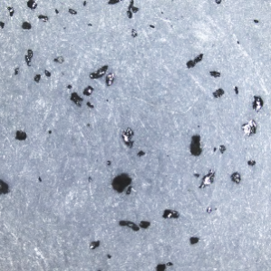 | 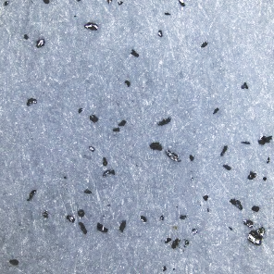

Table 9 The surface topography of the workpiece after machining
Grinding speed V_{s}/（m/min） | 350 | 650
Without ultrasonic vibration | 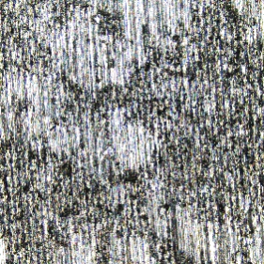 | 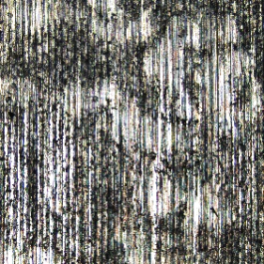
With ultrasonic vibration | 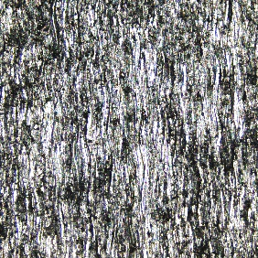 | 