Crystal and Electronic Structure Engineering of Tin Monoxide by External Pressure
Kun Li ^{a, b}, Junjie Wang ^{a, b, *}, Vladislav A. Blatov ^{c,b,d}, Yutong Gong ª, Naoto Umezawa ^{e}, Tomofumi Tada ^{f}, Hideo Hosono ^{f}, Artem R. Oganov ^{g, a, b, h}

ªState Key Laboratory of Solidification Processing, Northwestern Polytechnical University, Xi'an, Shaanxi 710072, People's Republic of China.
^{b}International Center for Materials Discovery, School of Materials Science and Engineering, Northwestern Polytechnical University, Xi'an, Shaanxi 710072, People's Republic of China.
^{c}Samara Center for Theoretical Materials Science (SCTMS), Samara State Technical University, Molodogvardeyskaya St. 244, Samara, 443100, Russia.
^{d}Samara Center for Theoretical Materials Science (SCTMS), Samara University, Ac. Pavlov St. 1, Samara 443011, Russia.
^{e}Semiconductor R&D Center, Samsung Electronics, 1, Samsungjeonja-ro, Hwaseong-si, Gyeonggi-do 18448, South Korea.
^{f}Materials Research Center for Element Strategy, Tokyo Institute of Technology, 4259 Nagatsuta-cho, Midori-ku, Yokohama, Kanagawa 226-8503, Japan.
^{g}Skolkovo Institute of Science and Technology, 3 Nobel Street, Moscow 143026, Russia.
^{h}Moscow Institute of Physics and Technology, 9 Institutskiy Lane, Dolgoprudny city, Moscow Region 141700, Russia.
Corresponding Author
*Email: wang.junjie@nwpu.edu.cn
Topological analysis of SnO
The topological analysis of the SnO crystal structures using ToposPro [1] indicates that the coordination number of tin atoms in the $α$- and $β$-SnO at 20 GPa are four (average bond length of around 2.16 Å) and three (average bond length of around 2.11 Å), respectively. The coordination number of tin in the Pnma-SnO at 20GPa can be represented as 4+4 to reflect the difference between four stronger and four weaker Sn-O bonds with distances of about 2.23 Å and 3.16 Å, respectively. If one considers only the four strongest bonds, the resulting topology is sra.
Reconstructive phase transition is always accompanied by breaking existed bonds and creating new ones. Therefore, from the topological point of view [2], different topologies A and B cannot directly transform to each other if they possess the same coordination numbers of atoms. This means that topology A must first transform to a subnet or supernet shared by A and B with a smaller or bigger coordination number and then can pass to topology B after creating or breaking some bonds, and vice versa, topology B can transform to A through the same subnet or supernet. Therefore, the direct phase transition at 20 GPa from the high-pressure Pnma-SnO to $α$-SnO or vice versa is topologically unfeasible if all strong Sn-O bonds are retained; at least one strong bond should be broken and one strong bond should be created, which corresponds to formation of a common subnet and supernet of the high-pressure Pnma-SnO and $α$-SnO. It is the fes topology of the three-coordinated $β$-SnO phase that represents a common subnet of sra and sql. The topological analysis shows that the highest symmetry of the fes subnet in the sra net is P2₁/c that corresponds to the symmetry of $β$-SnO. The sql topology has also a fes subnet of the P2₁/c symmetry. Therefore, the following transition sequences can be proposed at increasing pressure: $α$-SnO (P4/nmm; sql) → $β$-SnO (P2₁/c; fes) → Pnma-SnO (Pnma; sra), i.e. the symmetry of the initial four-coordinated $α$-SnO decreases down to P2₁/c, then some Sn-O bonds are broken yielding three-coordinated $β$-SnO, then some new Sn-O bonds are created giving rise to the high-pressure four-coordinated phase (Fig. 3d).
This transition reflects the easiest geometrical transformation: indeed, the extra bond that is formed in the nia-5,5-P2₁/c transition state corresponds to one of the four weak bonds of the high-pressure Pnma-SnO. Thus the transition can also be treated as strengthening one of the four weak bonds and weakening one of the four strong bonds in the 4+4 coordination of tin atoms of the Pnma-SnO phase.
TABLE 1. Experimental lattice parameters a, b and c (in Å) of α-SnO [3].
pressure | a | b | c
0 | 3.8 | 3.8 | 4.836
0.4 | 3.796 | 3.796 | 4.796
2 | 3.781 | 3.781 | 4.682
2.6 | 3.773 | 3.773 | 4.614
3.3 | 3.764 | 3.764 | 4.558
4.7 | 3.749 | 3.749 | 4.483
5.1 | 3.747 | 3.747 | 4.455
5.7 | 3.735 | 3.735 | 4.439
6.6 | 3.727 | 3.727 | 4.4
7.6 | 3.713 | 3.713 | 4.363
8.7 | 3.703 | 3.703 | 4.326
11.5 | 3.674 | 3.674 | 4.264
12.1 | 3.67 | 3.67 | 4.249
12.8 | 3.663 | 3.663 | 4.241
14.3 | 3.657 | 3.657 | 4.202
17.4 | 3.634 | 3.634 | 4.159
20 | 3.618 | 3.618 | 4.127
21.9 | 3.601 | 3.601 | 4.103
27.1 | 3.575 | 3.575 | 4.035
30.8 | 3.556 | 3.556 | 3.975
35 | 3.531 | 3.531 | 3.925
37.8 | 3.525 | 3.525 | 3.905
41.2 | 3.507 | 3.507 | 3.867
44.2 | 3.499 | 3.499 | 3.848
47.3 | 3.486 | 3.486 | 3.819
49.5 | 3.478 | 3.478 | 3.813
50.9 | 3.475 | 3.475 | 3.805

TABLE 2. Calculated lattice parameters a and c (in Å), c/a ratio and volume of unit cell (in Å³) of α-SnO at 0 GPa. The values in the parentheses are the percentage changes with respect to the experimental values.
 |  | 0 GPa
 | a | c | a/c | Volume
PBE | 3.869(1.82) | 5.067(4.78) | 0.764(-2.83) | 75.857(8.63)
DFT-D2 | 3.843(1.14) | 4.833(-0.05) | 0.795(1.19) | 71.394(2.24)
DFT-D3 | 3.853(1.38) | 4.843(0.15) | 0.795(1.24) | 71.885(2.94)
DFT-D3-BJ | 3.841(1.08) | 4.763(-1.52) | 0.806(2.63) | 70.261(0.61)
DFT-TS | 3.861(1.60) | 4.781(-1.14) | 0.808(2.77) | 71.261(2.05)
DFT-TS-SCS | 3.869(1.82) | 4.839(0.06) | 0.8(1.76) | 72.44(3.73)
HSE06 | 3.802(0.05) | 5.018(3.76) | 0.758(-3.58) | 72.523(3.85)
HSE06-MBD-212 | 3.785(-0.39) | 4.744(-1.89) | 0.798(1.53) | 67.971(-2.66)
HSE06-TS | 3.786(-0.37) | 4.756(-1.66) | 0.796(1.32) | 68.171(-2.38)
HSE06-TS-SCS | 3.803(0.08) | 4.806(-0.62) | 0.791(0.70) | 69.503(-0.47)
MBD-202 | 3.841(1.08) | 4.773(-1.31) | 0.805(2.42) | 70.42(0.84)
MBD-212 | 3.846(1.21) | 4.773(-1.30) | 0.806(2.54) | 70.597(1.10)
optB86b | 3.84(1.05) | 4.811(-0.51) | 0.798(1.57) | 70.949(1.60)
revPBE | 3.926(3.32) | 5.382(11.29) | 0.729(-7.17) | 82.958(18.80)
rPW86 | 3.963(4.30) | 5.459(12.88) | 0.726(-7.60) | 85.75(22.80)
Experiment | 3.8 | 4.836 | 0.786 | 69.832

TABLE 3. Calculated lattice parameters a and c (in Å), c/a ratio and volume of unit cell (in Å³) of α-SnO at 10 GPa. The values in the parentheses are the percentage changes with respect to the experimental values.
10 GPa
 | a | c | a/c | volume
PBE | 3.749(1.60) | 4.371(1.80) | 0.858(-0.20) | 61.446(5.08)
DFT-D2 | 3.756(1.77) | 4.263(-0.70) | 0.881(2.48) | 60.138(2.84)
DFT-D3 | 3.721(0.82) | 4.33(0.85) | 0.859(-0.03) | 59.948(2.52)
DFT-D3-BJ | 3.716(0.69) | 4.316(0.52) | 0.861(0.17) | 59.596(1.92)
DFT-TS | 3.711(0.56) | 4.36(1.55) | 0.851(-0.97) | 60.052(2.70)
DFT-TS-SCS | 3.747(1.52) | 4.276(-0.41) | 0.876(1.94) | 60.024(2.65)
HSE06 | 3.695(0.13) | 4.374(1.87) | 0.845(-1.71) | 59.728(2.14)
HSE06-MBD-212 | 3.696(0.14) | 4.368(1.73) | 0.846(-1.56) | 59.661(2.03)
HSE06-TS | 3.657(-0.92) | 4.373(1.85) | 0.836(-2.72) | 58.465(-0.02)
HSE06-TS-SCS | 3.685(-0.16) | 4.273(-0.48) | 0.862(0.32) | 58.013(-0.79)
MBD-202 | 3.72(0.79) | 4.319(0.61) | 0.861(0.18) | 59.764(2.20)
MBD-212 | 3.725(0.93) | 4.297(0.09) | 0.867(0.84) | 59.619(1.96)
optB86b | 3.73(1.07) | 4.304(0.24) | 0.867(0.83) | 59.88(2.40)
revPBE | 3.802(3.03) | 4.443(3.48) | 0.856(-0.44) | 64.235(9.85)
rPW86 | 3.859(4.55) | 4.505(4.94) | 0.857(-0.36) | 67.079(14.71)
Experiment | 3.691 | 4.293 | 0.86 | 58.475

TABLE 4. Calculated lattice parameters a and c (in Å), c/a ratio and volume of unit cell (in Å³) of α-SnO at 30 GPa . The values in the parentheses are the percentage changes with respect to the experimental values.
30 GPa
 | a | c | a/c | volume
PBE | 3.604(1.22) | 4.05(1.49) | 0.89(-0.27) | 52.596(3.97)
DFT-D2 | 3.615(1.55) | 3.969(-0.55) | 0.911(2.11) | 51.885(2.57)
DFT-D3 | 3.587(0.76) | 4.033(1.05) | 0.889(-0.29) | 51.894(2.58)
DFT-D3-BJ | 3.585(0.69) | 4.008(0.43) | 0.894(0.26) | 51.508(1.82)
DFT-TS | 3.568(0.21) | 4.066(1.89) | 0.877(-1.65) | 51.757(2.31)
DFT-TS-SCS | 3.602(1.17) | 4.001(0.24) | 0.9(0.93) | 51.906(2.61)
HSE06 | 3.558(-0.07) | 4.07(1.98) | 0.874(-2.01) | 51.512(1.83)
HSE06-MBD-212 | 3.558(-0.07) | 4.067(1.89) | 0.875(-1.93) | 51.473(1.75)
HSE06-TS | 3.523(-1.03) | 4.071(2.01) | 0.865(-2.99) | 50.545(-0.08)
HSE06-TS-SCS | 3.557(-0.09) | 4.012(0.52) | 0.887(-0.60) | 50.759(0.34)
MBD-202 | 3.591(0.87) | 4.009(0.44) | 0.896(0.43) | 51.697(2.19)
MBD-212 | 3.59(0.82) | 4.013(0.54) | 0.895(0.28) | 51.703(2.21)
optB86b | 3.59(0.83) | 4.011(0.50) | 0.895(0.33) | 51.689(2.18)
revPBE | 3.646(2.41) | 4.076(2.13) | 0.895(0.28) | 54.187(7.12)
rPW86 | 3.716(4.37) | 4.068(1.93) | 0.913(2.39) | 56.169(11.03)
Experiment | 3.56 | 3.991 | 0.892 | 50.587

TABLE 5. Calculated lattice parameters a and c (in Å), c/a ratio and volume of unit cell (in Å³) of α-SnO at 40 GPa. The values in the parentheses are the percentage changes with respect to the experimental values.
40 GPa
 | a | c | a/c | volume
PBE | 3.56(1.38) | 3.953(1.93) | 0.901(-0.54) | 50.111(4.76)
DFT-D2 | 3.567(1.56) | 3.903(0.65) | 0.914(0.90) | 49.654(3.80)
DFT-D3 | 3.533(0.61) | 3.956(2.00) | 0.893(-1.37) | 49.387(3.24)
DFT-D3-BJ | 3.533(0.60) | 3.931(1.36) | 0.899(-0.75) | 49.072(2.58)
DFT-TS | 3.515(0.09) | 3.976(2.52) | 0.884(-2.36) | 49.132(2.71)
DFT-TS-SCS | 3.55(1.07) | 3.925(1.21) | 0.904(-0.14) | 49.454(3.38)
HSE06 | 3.509(-0.08) | 3.981(2.64) | 0.882(-2.65) | 49.025(2.49)
HSE06-MBD-212 | 3.511(-0.02) | 3.978(2.57) | 0.883(-2.53) | 49.04(2.52)
HSE06-TS | 3.48(-0.91) | 3.983(2.69) | 0.874(-3.51) | 48.234(0.83)
HSE06-TS-SCS | 3.51(-0.07) | 3.938(1.54) | 0.891(-1.59) | 48.506(1.40)
MBD-202 | 3.538(0.75) | 3.933(1.41) | 0.9(-0.66) | 49.236(2.93)
MBD-212 | 3.537(0.72) | 3.935(1.47) | 0.899(-0.73) | 49.24(2.94)
optB86b | 3.548(1.04) | 3.92(1.08) | 0.905(-0.05) | 49.36(3.19)
revPBE | 3.603(2.60) | 3.973(2.43) | 0.907(0.16) | 51.579(7.83)
rPW86 | 3.649(3.90) | 3.986(2.79) | 0.915(1.08) | 53.075(10.95)
Experiment | 3.512 | 3.878 | 0.906 | 47.835

TABLE 6. Calculated lattice parameters a and c (in Å), c/a ratio and volume of unit cell (in Å³) of α-SnO at 50 GPa. The values in the parentheses are the percentage changes with respect to the experimental values.
50 GPa
 | a | c | a/c | volume
PBE | 3.513(1.01) | 3.897(2.30) | 0.901(-1.26) | 48.078(4.37)
DFT-D2 | 3.513(1.01) | 3.863(1.43) | 0.909(-0.41) | 47.672(3.49)
DFT-D3 | 3.496(0.52) | 3.892(2.17) | 0.898(-1.62) | 47.552(3.23)
DFT-D3-BJ | 3.494(0.47) | 3.87(1.60) | 0.903(-1.12) | 47.24(2.55)
DFT-TS | 3.482(0.13) | 3.899(2.35) | 0.893(-2.17) | 47.268(2.61)
DFT-TS-SCS | 3.507(0.85) | 3.869(1.58) | 0.906(-0.72) | 47.589(3.31)
HSE06 | 3.47(-0.23) | 3.924(3.01) | 0.884(-3.14) | 47.238(2.54)
HSE06-MBD-212 | 3.472(-0.17) | 3.922(2.97) | 0.885(-3.05) | 47.269(2.61)
HSE06-TS | 3.446(-0.90) | 3.916(2.82) | 0.88(-3.62) | 46.512(0.97)
HSE06-TS-SCS | 3.47(-0.23) | 3.885(2.00) | 0.893(-2.18) | 46.773(1.54)
MBD-202 | 3.498(0.58) | 3.874(1.70) | 0.903(-1.10) | 47.397(2.89)
MBD-212 | 3.498(0.59) | 3.873(1.69) | 0.903(-1.08) | 47.399(2.89)
optB86b | 3.506(0.81) | 3.859(1.33) | 0.908(-0.51) | 47.435(2.97)
revPBE | 3.559(2.34) | 3.896(2.28) | 0.914(0.06) | 49.35(7.13)
rPW86 | 3.597(3.43) | 3.916(2.81) | 0.918(0.60) | 50.661(9.98)
Experiment | 3.478 | 3.809 | 0.913 | 46.066

TABLE 7. Calculated lattice parameters for the relaxed $β$-SnO.
Method | a(Å) | b(Å) | c(Å) | $$α$$ | $$β$$ | $$γ$$ | Pressure （GPa） | Atomic coordinates
HSE06 | 4.916 | 5.577 | 5.828 | 101.394 | 90 | 90 | 0 | Sn(0.4949, 0.2438, 0.2159)  O(0.1850, 0.1032, 0.3897)
DFT-D3-BJ | 4.849 | 5.519 | 5.950 | 103.560 | 90 | 90 | 0 | Sn(0.5021, 0.2523, 0.2234)  O(0.1794, 0.1146, 0.3919)
DFT-D3-BJ | 4.739 | 5.449 | 5.933 | 104.159 | 90 | 90 | 1 | Sn(0.5090, 0.2572, 0.2256)  O(0.1785, 0.1196, 0.3931)
DFT-D3-BJ | 4.647 | 5.406 | 5.916 | 104.578 | 90 | 90 | 2 | Sn(0.5151, 0.2605, 0.2271)  O(0.1779, 0.1233, 0.3939)
DFT-D3-BJ | 4.582 | 5.369 | 5.897 | 104.836 | 90 | 90 | 3 | Sn(0.5199, 0.2630, 0.2281)  O(0.1786, 0.1253, 0.3950)
DFT-D3-BJ | 4.514 | 5.347 | 5.884 | 105.119 | 90 | 90 | 4 | Sn(0.5248, 0.2648, 0.2290)  O(0.1788, 0.1272, 0.3958)
DFT-D3-BJ | 4.453 | 5.329 | 5.871 | 105.333 | 90 | 90 | 5 | Sn(0.5295, 0.2663, 0.2297)  O(0.1801, 0.1285, 0.3970)
DFT-D3-BJ | 4.394 | 5.316 | 5.861 | 105.565 | 90 | 90 | 6 | Sn(0.5344, 0.2674, 0.2303)  O(0.1815, 0.1296, 0.3982)
DFT-D3-BJ | 4.329 | 5.314 | 5.858 | 105.849 | 90 | 90 | 7 | Sn(0.5397, 0.2683, 0.2308)  O(0.1835, 0.1305, 0.3998)
DFT-D3-BJ | 4.269 | 5.311 | 5.855 | 106.134 | 90 | 90 | 8 | Sn(0.5447, 0.2690, 0.2314)  O(0.1853, 0.1313, 0.4012)
DFT-D3-BJ | 4.205 | 5.318 | 5.855 | 106.475 | 90 | 90 | 9 | Sn(0.5502, 0.2695, 0.2320)  O(0.1876, 0.1319, 0.4028)
DFT-D3-BJ | 4.125 | 5.332 | 5.866 | 106.925 | 90 | 90 | 10 | Sn(0.5573, 0.2698, 0.2324)  O(0.1911, 0.1323, 0.4049)
DFT-D3-BJ | 4.083 | 5.329 | 5.856 | 107.044 | 90 | 90 | 11 | Sn(0.5613, 0.2704, 0.2328)  O(0.1913, 0.1330, 0.4050)
DFT-D3-BJ | 4.004 | 5.345 | 5.873 | 107.422 | 90 | 90 | 12 | Sn(0.5696, 0.2704, 0.2321)  O(0.1965, 0.1336, 0.4076)
DFT-D3-BJ | 3.951 | 5.349 | 5.876 | 107.645 | 90 | 90 | 13 | Sn(0.5756, 0.2706, 0.2321)  O(0.1989, 0.1342, 0.4088)
DFT-D3-BJ | 3.899 | 5.357 | 5.881 | 107.845 | 90 | 90 | 14 | Sn(0.5818, 0.2706, 0.2320)  O(0.2008, 0.1350, 0.4097)
DFT-D3-BJ | 3.853 | 5.364 | 5.884 | 108.061 | 90 | 90 | 15 | Sn(0.5875, 0.2706, 0.2322)  O(0.2024, 0.1357, 0.4105)
DFT-D3-BJ | 3.805 | 5.376 | 5.888 | 108.378 | 90 | 90 | 16 | Sn(0.5938, 0.2705, 0.2329)  O(0.2038, 0.1364, 0.4114)
DFT-D3-BJ | 3.768 | 5.376 | 5.889 | 108.477 | 90 | 90 | 17 | Sn(0.5994, 0.2707, 0.2325)  O(0.2057, 0.1370, 0.4120)
DFT-D3-BJ | 3.710 | 5.402 | 5.903 | 108.998 | 90 | 90 | 18 | Sn(0.6073, 0.2704, 0.2341)  O(0.2068, 0.1378, 0.4133)
DFT-D3-BJ | 3.680 | 5.406 | 5.902 | 109.196 | 90 | 90 | 19 | Sn(0.6120, 0.2705, 0.2347)  O(0.2077, 0.1382, 0.4139)
DFT-D3-BJ | 3.672 | 5.385 | 5.884 | 109.000 | 90 | 90 | 20 | Sn(0.6144, 0.2709, 0.2337)  O(0.2092, 0.1385, 0.4139)

TABLE 8. Calculated Sn-O bond for the relaxed $α$-SnO
$α$-SnO
Pressure (GPa) | shortest Sn-O bond (Å)
0 | 2.24
10 | 2.20
20 | 2.16
30 | 2.14
40 | 2.12
50 | 2.10
60 | 2.09
70 | 2.07
80 | 2.06
90 | 2.05
100 | 2.04
110 | 2.03
120 | 2.02
130 | 2.01
140 | 2.00
150 | 2.00

TABLE 8. Calculated top 6 shortest Sn-O bond for the relaxed $β$-SnO
 | $β$-SnO
Pressure (GPa) | top 6 shortest Sn-O bonds (Å)
0 | 2.13 | 2.09 | 2.16 | 4.42 | 3.57 | 3.81
10 | 2.11 | 2.07 | 2.13 | 3.61 | 2.97 | 3.55
20 | 2.14 | 2.08 | 2.12 | 3.06 | 2.63 | 3.58
30 | 2.17 | 2.10 | 2.11 | 2.80 | 2.46 | 3.59
40 | 2.28 | 2.28 | 2.11 | 2.28 | 2.28 | 4.32
50 | 2.25 | 2.25 | 2.10 | 2.25 | 2.25 | 4.26
60 | 2.23 | 2.23 | 2.09 | 2.23 | 2.23 | 4.20
70 | 2.22 | 2.21 | 2.08 | 2.22 | 2.21 | 4.16
80 | 2.20 | 2.20 | 2.07 | 2.20 | 2.20 | 4.12
90 | 2.19 | 2.18 | 2.06 | 2.18 | 2.18 | 4.08
100 | 2.17 | 2.17 | 2.05 | 2.17 | 2.17 | 4.05
110 | 2.16 | 2.16 | 2.04 | 2.16 | 2.16 | 4.03
120 | 2.15 | 2.15 | 2.03 | 2.15 | 2.15 | 4.00
130 | 2.14 | 2.14 | 2.03 | 2.14 | 2.14 | 3.97
140 | 2.13 | 2.13 | 2.01 | 2.13 | 2.13 | 3.95
150 | 2.12 | 2.12 | 2.01 | 2.12 | 2.12 | 3.93

TABLE 9. Calculated top 6 shortest Sn-O bond for the relaxed Pnma-SnO
 | Pnma-SnO
Pressure (GPa) | top 8 shortest Sn-O bonds (Å)
0 | 2.47 | 2.22 | 2.47 | 2.13 | 3.69 | 3.59 | 3.40 | 3.69
10 | 2.37 | 2.21 | 2.37 | 2.11 | 3.40 | 3.24 | 3.19 | 3.40
20 | 2.31 | 2.20 | 2.31 | 2.10 | 3.24 | 3.07 | 3.09 | 3.24
30 | 2.27 | 2.20 | 2.27 | 2.08 | 3.13 | 2.96 | 3.02 | 3.13
40 | 2.24 | 2.19 | 2.24 | 2.07 | 3.04 | 2.89 | 2.98 | 3.04
50 | 2.21 | 2.18 | 2.21 | 2.06 | 2.98 | 2.83 | 2.94 | 2.98
60 | 2.19 | 2.17 | 2.19 | 2.05 | 2.92 | 2.78 | 2.91 | 2.92
70 | 2.17 | 2.16 | 2.17 | 2.05 | 2.88 | 2.74 | 2.88 | 2.88
80 | 2.15 | 2.15 | 2.15 | 2.04 | 2.84 | 2.71 | 2.86 | 2.84
90 | 2.14 | 2.14 | 2.14 | 2.03 | 2.81 | 2.68 | 2.84 | 2.81
100 | 2.12 | 2.13 | 2.12 | 2.02 | 2.78 | 2.65 | 2.82 | 2.78
110 | 2.11 | 2.12 | 2.11 | 2.02 | 2.75 | 2.62 | 2.81 | 2.75
120 | 2.10 | 2.11 | 2.10 | 2.01 | 2.72 | 2.60 | 2.79 | 2.72
130 | 2.09 | 2.11 | 2.09 | 2.00 | 2.70 | 2.58 | 2.78 | 2.70
140 | 2.08 | 2.10 | 2.08 | 2.00 | 2.68 | 2.56 | 2.77 | 2.68
150 | 2.07 | 2.09 | 2.07 | 1.99 | 2.66 | 2.54 | 2.75 | 2.66

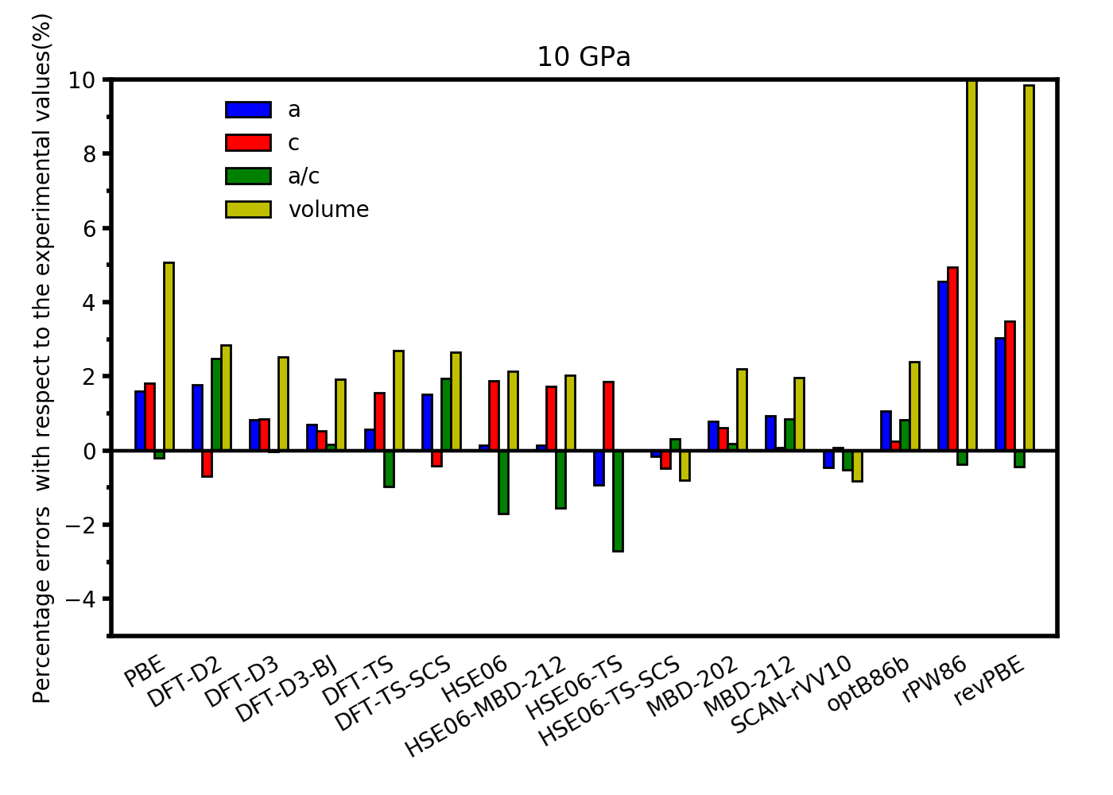
Fig. 1 Percentage errors of a and c (in Å), a/c ratio and volume of the unit cell of α-SnO with respect to the experimental values at 10 GPa.
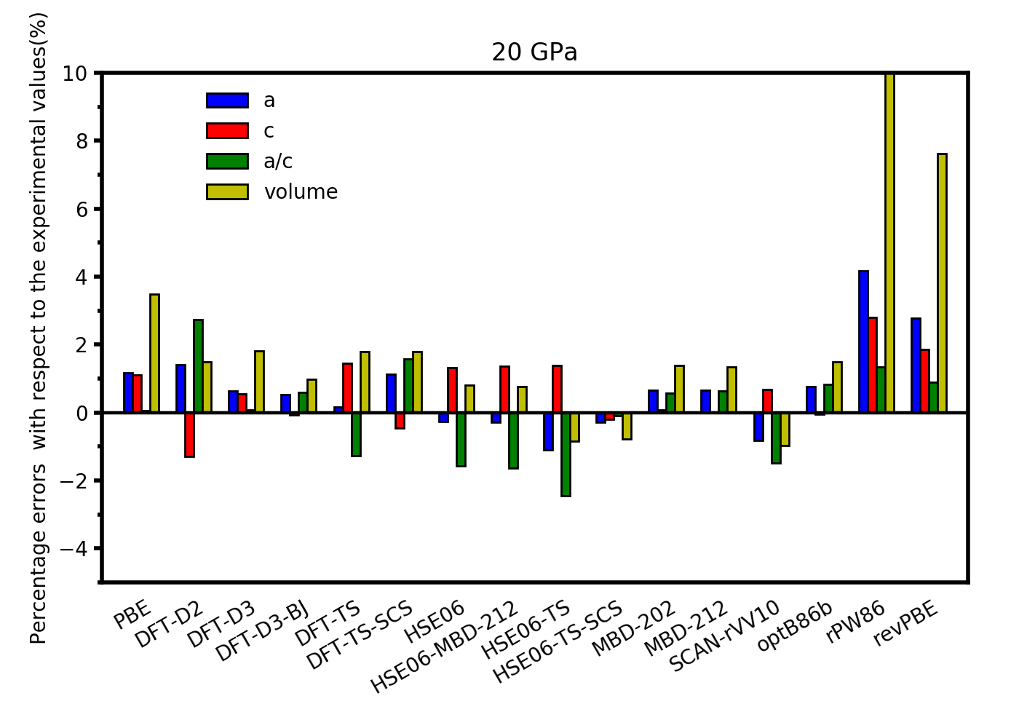
Fig. 2 Percentage errors of a and c (in Å), a/c ratio and volume of the unit cell of α-SnO with respect to the experimental values at 20 GPa
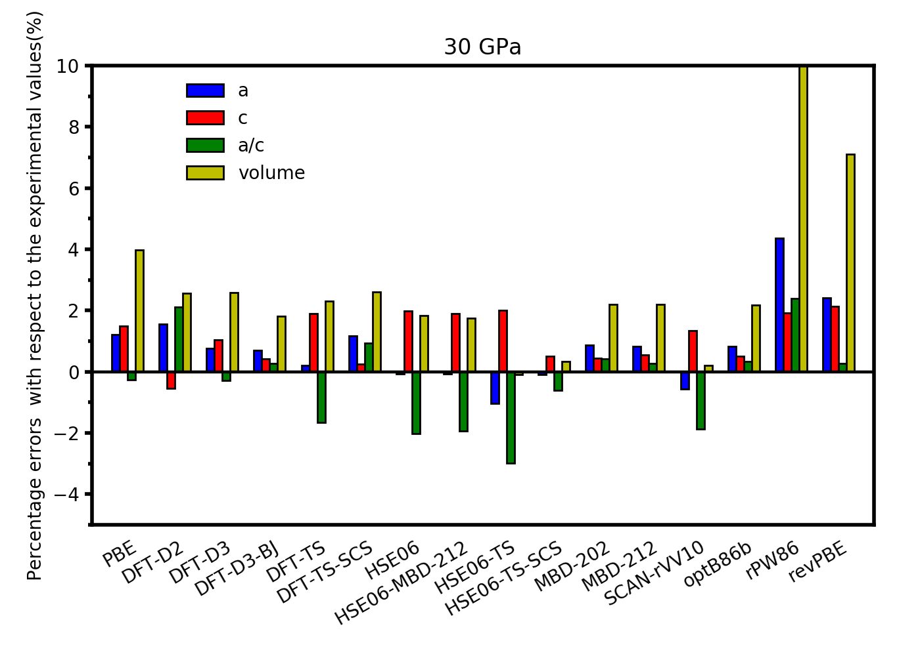
Fig. 3 Percentage errors of a and c (in Å), a/c ratio and volume of the unit cell of α-SnO with respect to the experimental values at 30 GPa

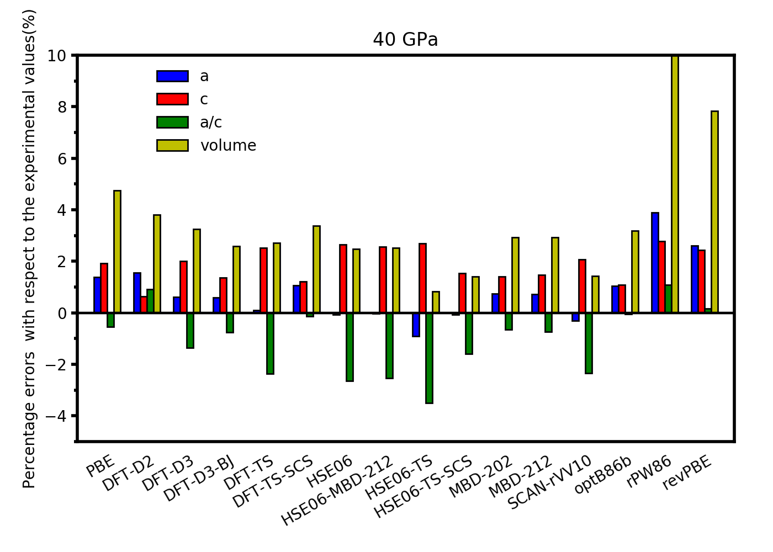
Fig. 4 Percentage errors of a and c (in Å), a/c ratio and volume of the unit cell of α-SnO with respect to the experimental values at 40 GPa

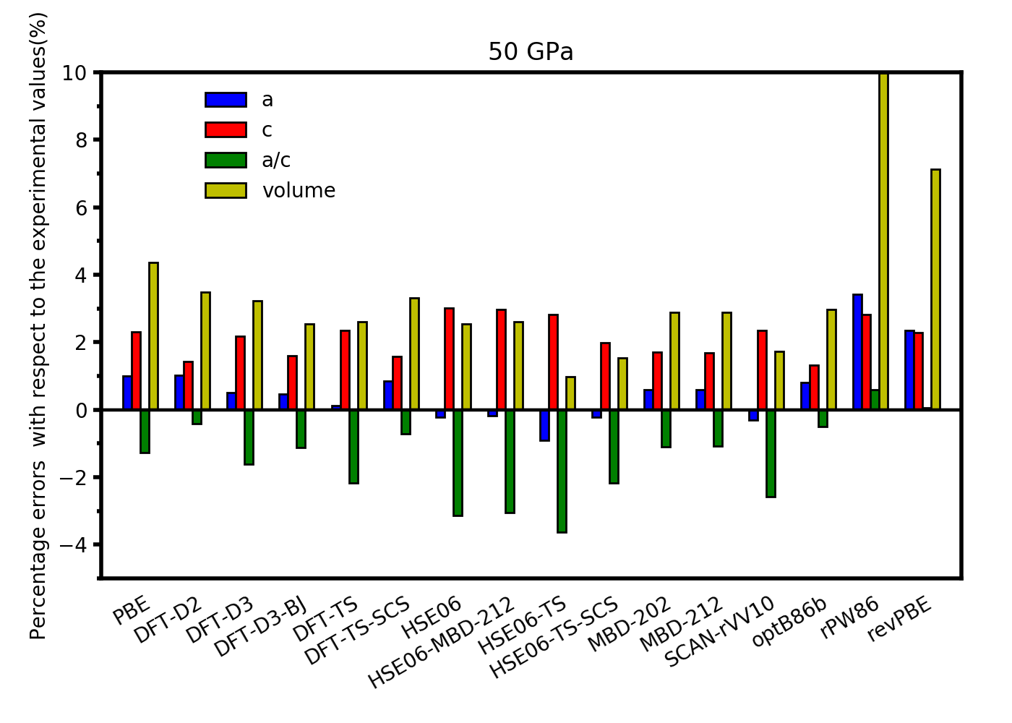
Fig. 5 Percentage errors of a and c (in Å), a/c ratio and volume of the unit cell of α-SnO with respect to the experimental values at 50 GPa
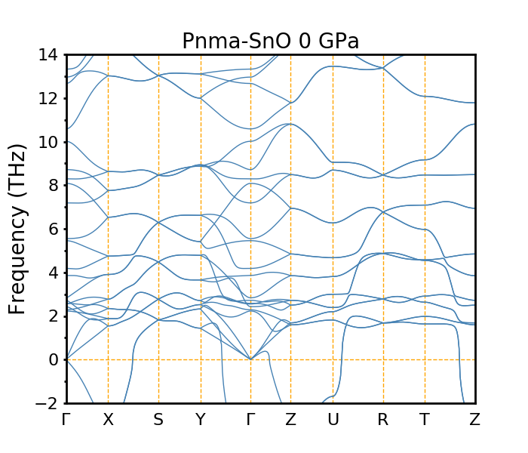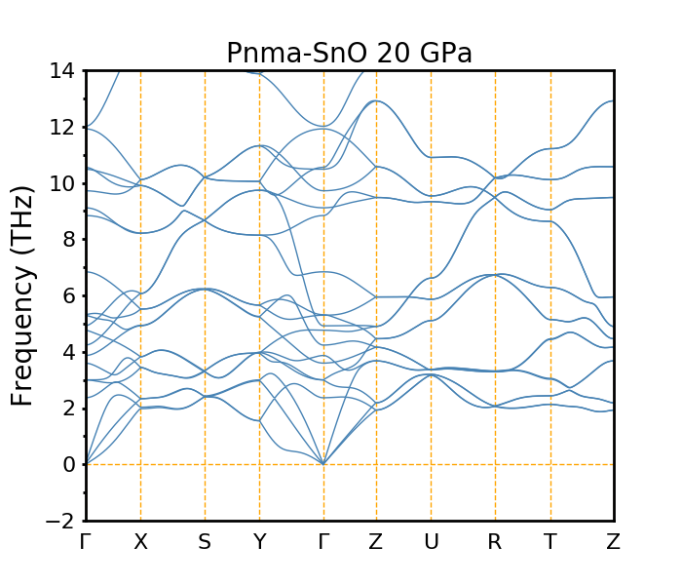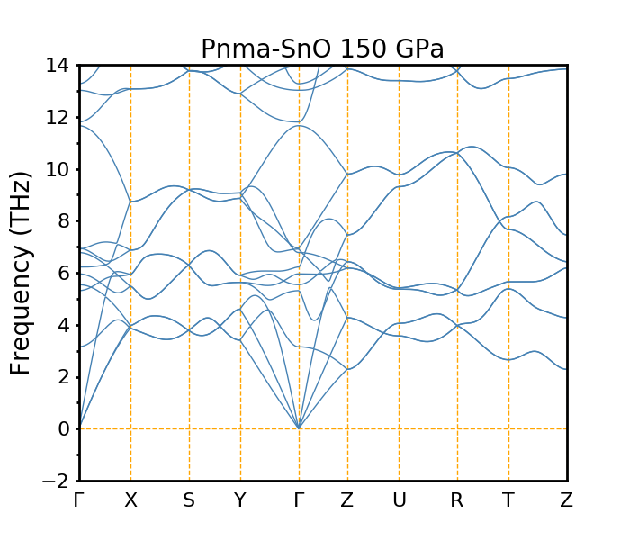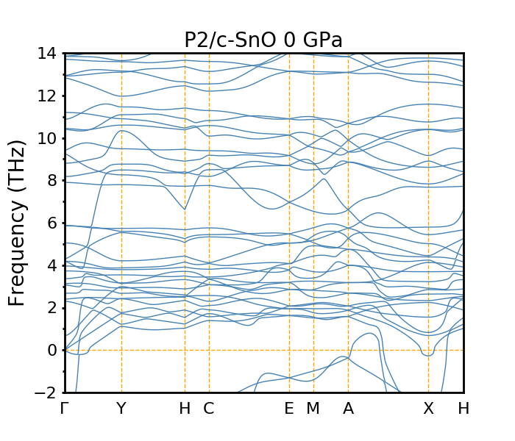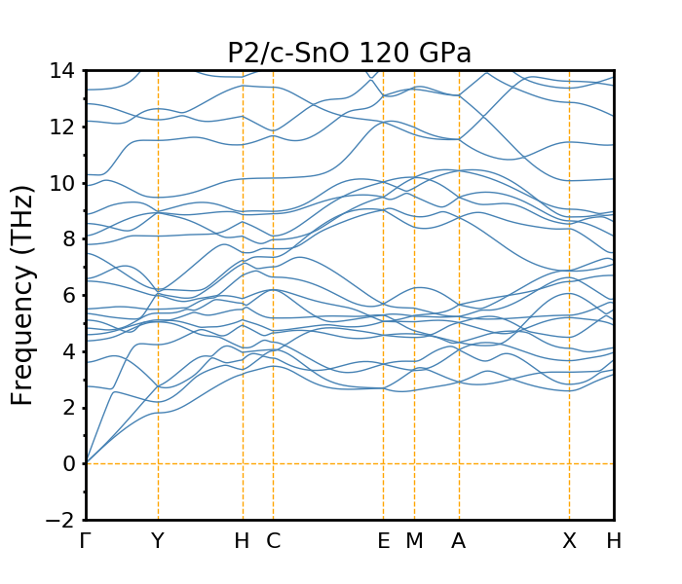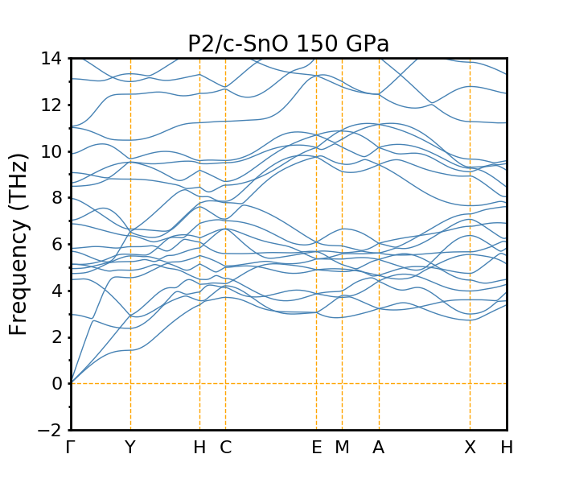
Fig. 6 Calculated phonon band structures of Pnma- and P2/c-SnO at different GPa

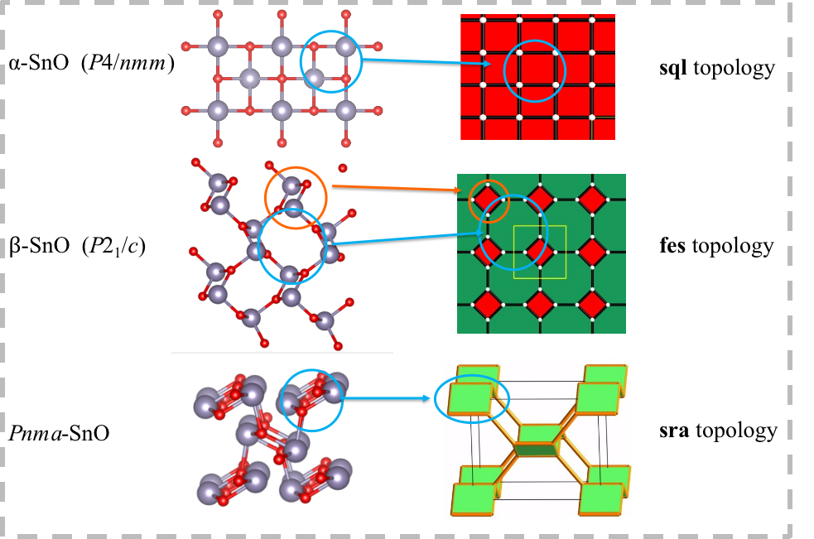
Fig. 7 The schematic diagram of sql, fes and sra topologies

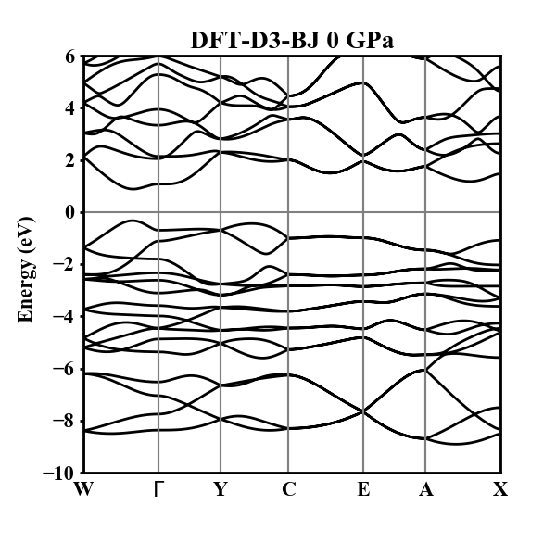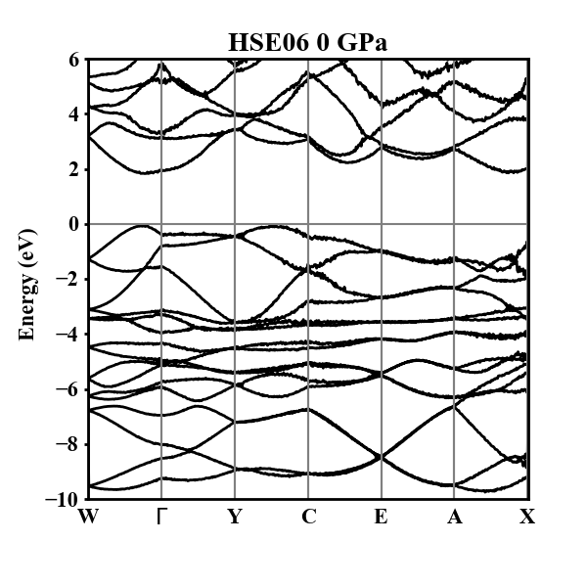

Fig. 8 Calculated band structures of $β$-SnO at 0 GPa using functionals DFT-D3-BJ and HSE06.
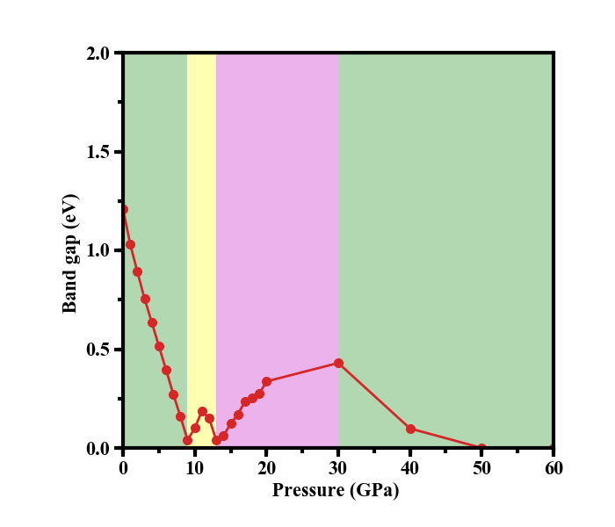
Fig. 9 The variation of calculated band gaps as a function of pressure in the range of 0-60 GPa.
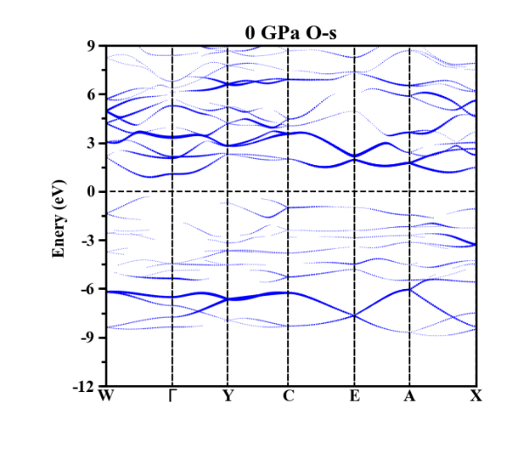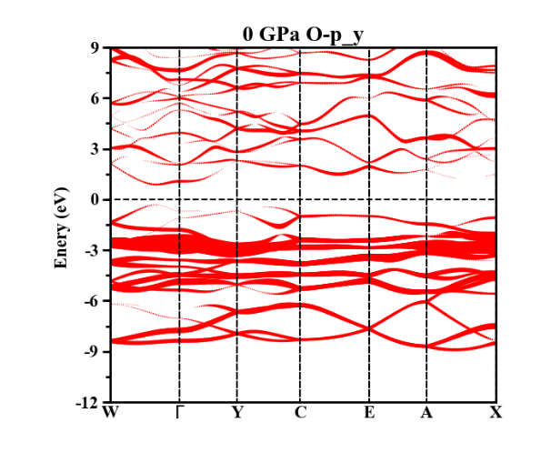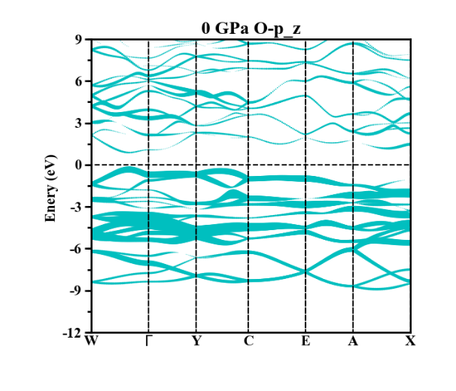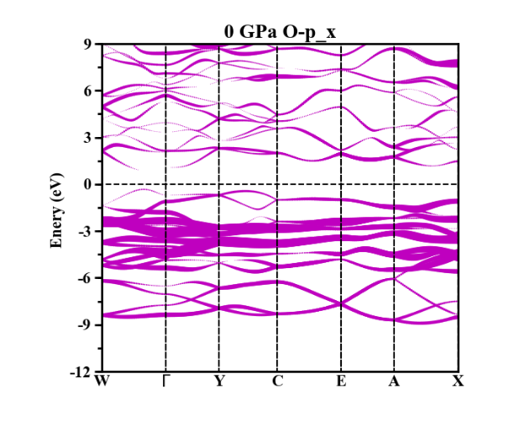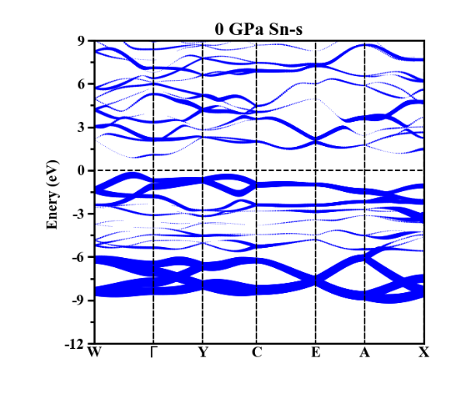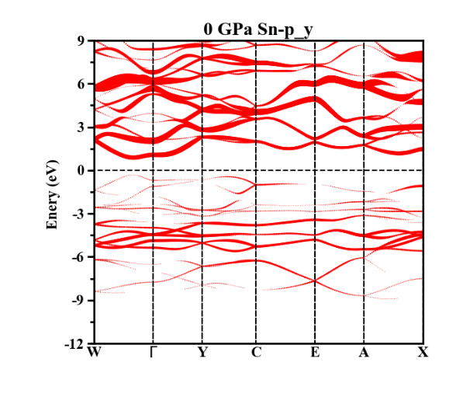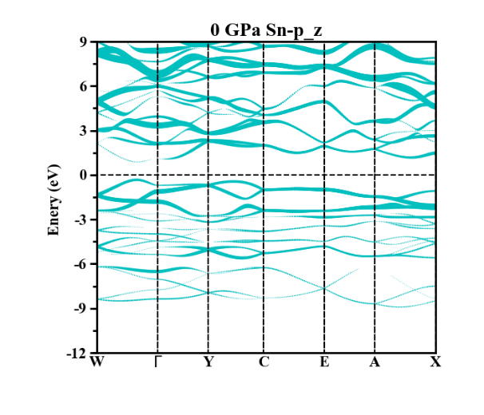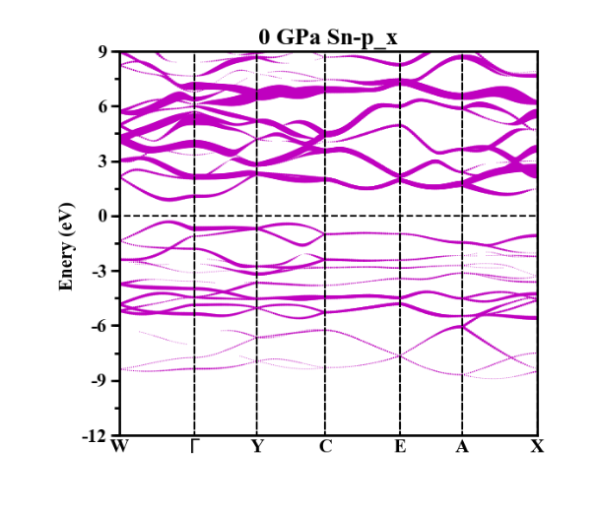
Fig. 10 Calculated decomposed band structures of $β$-SnO.
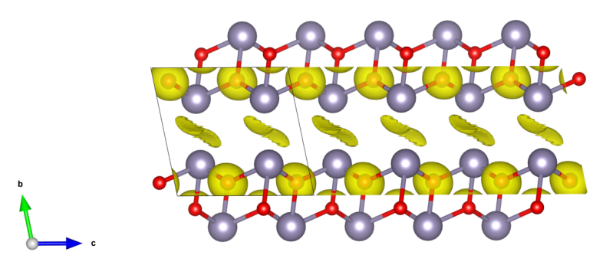
Fig. 11 Calculated electron localization function (ELF) of $β$-SnO. The value for the isosurface of ELF is 0.65.
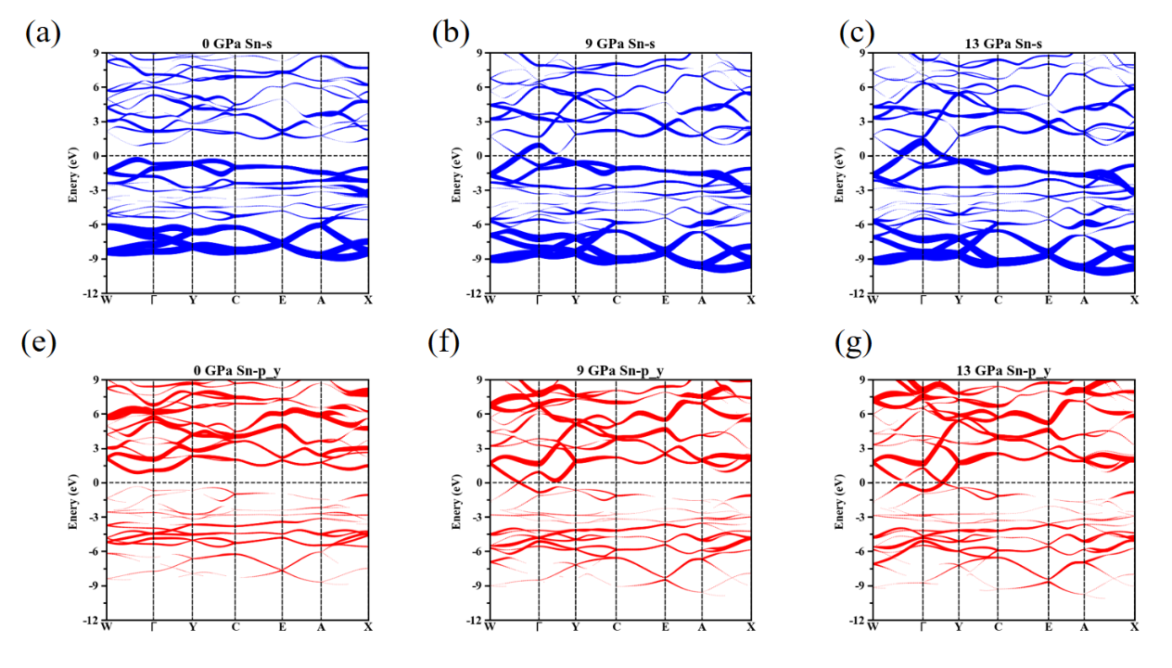
Fig. 12 Calculated decomposed band structures of β-SnO. The orbit Sn(s) is gradually shifted to the high level with the increase of pressure, making less contribution to the valence band than before. Conversely, the orbit Sn(p_{y}) is occupied by more electrons below the fermi level, signaling that the electrons are transferred from the orbit Sn(s) to Sn(p_{y}).

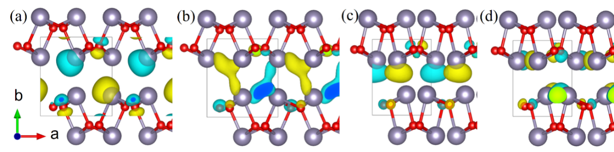
Fig. 13 Calculated wave-function character of (a)VB-WΓ and (b)CB-WΓ at 0 GPa and (c)VB-ΓY and (d)CB-ΓY at 13 GPa.
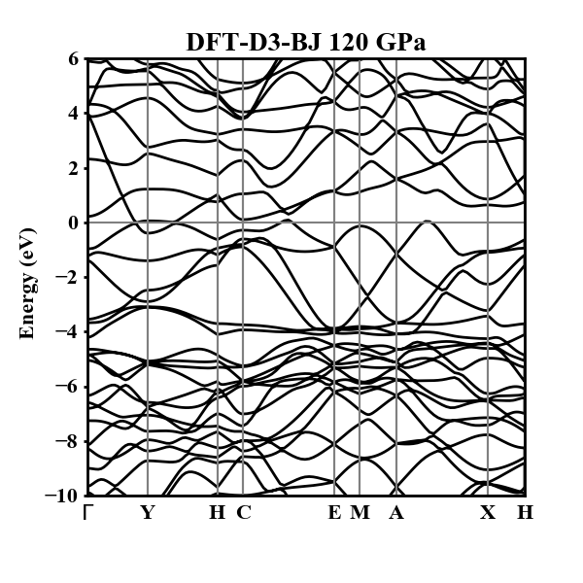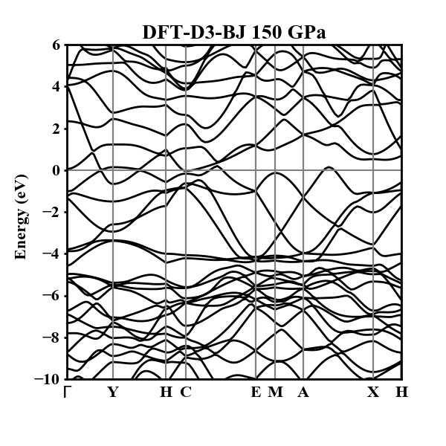
Fig. 14. Calculated band structures of P2/c-SnO at 120 and 150 GPa

[1] Blatov VA, Shevchenko AP, Proserpio DM. Applied topological analysis of crystal structures with the program package ToposPro. Crystal Growth & Design 2014, 14: 3576-3586.
[2] Blatov VA, Golov AA, Yang C, et al. Network topological model of reconstructive solid-state transformations. Scientific Reports 2019, 9: 6007.
[3] Wang J, Hanzawa K, Hiramatsu H, et al. Exploration of stable strontium phosphide-based electrides: Theoretical structure prediction and experimental validation. Journal of the American Chemical Society 2017, 139: 15668-15680.

