Appendix A. Supplementary data

Supplementary Fig. 1. Effects of WNT7B knockdown on OSCC cell proliferation and cell cycle.
- Detection of cell proliferation by CCK8 assay for the indicated OSCC cell lines and days. (B) Cell cycle detection by flow cytometry of wild-type and WNT7B stable knockdown OSCC cells after cell cycle synchronization. The cells released after cell cycle synchronization at 0 or 24 hours were used for experiments. (C) Normalized G1 ratio of indicated cell lines. Each measurement was performed in three biological replicates.
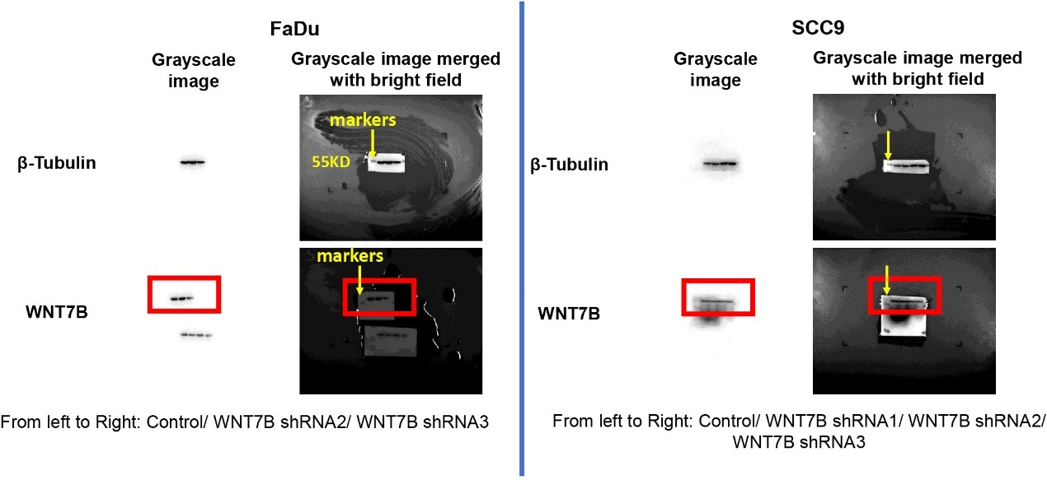Supplementary Fig. 2. Full-length uncropped blots for Fig. 7B.

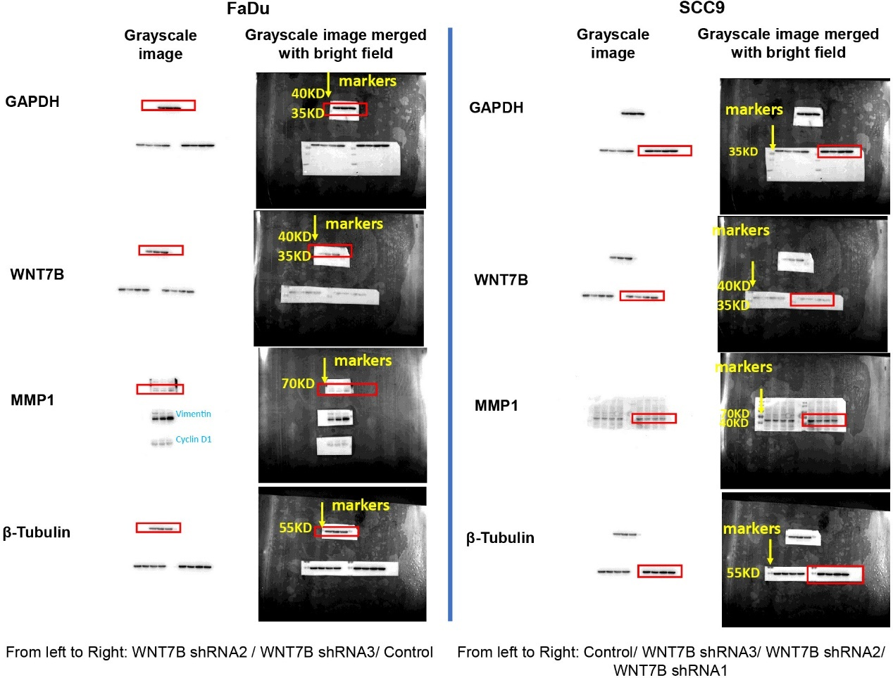
Supplementary Fig. 3. Full-length uncropped blots for Fig. 7G.

