Supporting Information
Hydrogeochemical modeling evaluating health risk of potentially toxic elements, and principal component analysis integrating groundwater pollution indexing: Insights of GIS-based and geostatistical approaches
Abdur Rashid ^{a*}, Muhammad Ayub ^{b}, Sardar Khan ^{c}, Xubo Gao ª, Zahid Ullah ª, Liaqat Ali ^{d}, Atta Rasool ^{e}, Chengcheng Li ª, Hamed A. El-Serehy ^{f}, Prashant Kaushik ^{g}
ª School of Environmental Studies, China University of Geosciences, Wuhan, 430074, P.R. China
^{b} Department of Botany Hazara University PO 21300 Pakistan
^{c} Department of Environmental Sciences, University of Peshawar, PO 25120, Pakistan
^{d} National Centre of Excellence in Geology, University of Peshawar, 25130, Pakistan
^{e} Department of Environmental Sciences, COMSATS University, Islamabad (CUI), Vehari 61100, Pakistan, Vehari, Pakistan
^{f} Department of Zoology, College of Science, King Saud University, Riyadh l1451, Saudi Arabia
^{g} Instituto de Conservación y Mejora de la Agrodiversidad Valenciana, Universitat Politècnica de València, 46022 Valencia, Spain
Corresponding author E-mail address: abdur.rashid@bs.qau.edu.pk

Table S1 Key parameters used to calculate human health risk through ingestion pathway
Exposure parameters | Children 3–14 years old | Adult male >18 years old | Adult female >18 years old
IR L/day | 1.5 | 3.5 | 3
ED years | 12 | 30 | 30
EF days/year | 365 | 365 | 365
BW Kg | 20 | 64 | 70
AT days | 4,380 | 10,950 | 10,950

Table S2 Represents Pearson correlation values of major chemical elements in groundwater of Dargai, and Batkhela region, northern Pakistan
 | Groundwater of Dargai region (n=24)
Variable | pH | Depth | EC | TSS | TDS | Sal | Turb | Cl | PO4 | SO4 | NO3 | HCO3 | Na | K | Mg | Ca | Cd | Cu | Co | Fe | Pb | Zn
pH | 1.00
Depth | 0.08 | 1.00
EC | 0.17 | -0.01 | 1.00
TSS | 0.18 | -0.24 | 0.03 | 1.00
TDS | 0.06 | 0.13 | 0.96 | 0.01 | 1.00
Sal | -0.55 | 0.16 | 0.18 | 0.22 | -0.13 | 1.00
Turb | 0.12 | -0.21 | 0.05 | 0.04 | 0.03 | -0.58 | 1.00
Cl | 0.21 | 0.07 | 0.25 | 0.10 | 0.30 | -0.01 | 0.12 | 1.00
PO₄ | -0.27 | 0.11 | 0.12 | 0.29 | 0.20 | -0.23 | 0.28 | 0.03 | 1.00
SO₄ | -0.21 | -0.38 | -0.07 | 0.26 | -0.15 | -0.04 | 0.23 | -0.11 | 0.38 | 1.00
NO₃ | 0.13 | 0.16 | 0.33 | -0.06 | 0.31 | -0.05 | 0.20 | -0.28 | 0.43 | 0.17 | 1.00
HCO₃ | 0.83 | -0.20 | 0.17 | -0.04 | 0.05 | -0.52 | 0.24 | 0.13 | -0.36 | -0.29 | 0.11 | 1.00
Na | 0.74 | -0.01 | 0.25 | -0.14 | 0.14 | -0.24 | 0.18 | 0.17 | -0.33 | -0.45 | 0.15 | 0.90 | 1.00
K | -0.20 | -0.09 | 0.18 | 0.27 | 0.18 | 0.02 | -0.09 | -0.29 | -0.06 | -0.34 | -0.19 | -0.10 | -0.01 | 1.00
Mg | -0.27 | -0.09 | 0.01 | 0.32 | 0.07 | 0.05 | 0.15 | 0.16 | 0.35 | 0.64 | 0.14 | -0.45 | -0.63 | -0.34 | 1.00
Ca | -0.53 | -0.25 | -0.24 | 0.19 | -0.20 | -0.02 | -0.05 | -0.01 | 0.27 | 0.58 | -0.29 | -0.60 | -0.84 | -0.21 | 0.56 | 1.00
Cd | -0.22 | 0.23 | 0.03 | -0.12 | 0.15 | -0.05 | 0.39 | -0.05 | 0.51 | 0.31 | 0.46 | -0.17 | -0.15 | -0.21 | 0.28 | 0.09 | 1.00
Cu | 0.04 | -0.05 | 0.07 | 0.33 | 0.03 | 0.04 | 0.42 | 0.20 | 0.03 | 0.33 | 0.06 | -0.11 | -0.11 | 0.07 | 0.35 | 0.04 | -0.01 | 1.00
Co | -0.21 | 0.20 | -0.26 | -0.19 | -0.19 | 0.45 | -0.35 | 0.17 | -0.22 | -0.14 | -0.21 | -0.22 | -0.05 | -0.27 | 0.12 | -0.16 | -0.05 | -0.13 | 1.00
Fe | -0.51 | -0.10 | -0.10 | -0.17 | -0.06 | 0.02 | 0.21 | -0.24 | 0.24 | 0.36 | -0.09 | -0.39 | -0.40 | 0.10 | 0.21 | 0.34 | 0.59 | -0.11 | -0.18 | 1.00
Pb | 0.16 | -0.13 | -0.08 | 0.00 | -0.10 | -0.38 | 0.45 | 0.25 | 0.00 | 0.29 | -0.10 | 0.20 | 0.02 | -0.38 | 0.08 | 0.36 | 0.54 | 0.52 | -0.26 | -0.02 | 1.00
Zn | -0.29 | -0.27 | 0.23 | -0.12 | 0.17 | 0.20 | 0.14 | 0.04 | 0.10 | 0.03 | 0.06 | 0.02 | 0.18 | 0.14 | -0.26 | -0.10 | 0.01 | -0.04 | -0.02 | 0.55 | -0.07 | 1.00
 | Groundwater of Batkhela region (n=24)
pH | 1.00
Depth | -0.18 | 1.00
EC | 0.05 | -0.15 | 1.00
TSS | -0.41 | -0.25 | -0.07 | 1.00
TDS | 0.11 | -0.05 | 0.97 | -0.09 | 1.00
Salnity | -0.05 | 0.29 | -0.06 | 0.09 | -0.02 | 1.00
Turbidity | -0.11 | 0.07 | -0.01 | -0.08 | 0.05 | -0.30 | 1.00
Cl | 0.14 | -0.41 | 0.04 | 0.28 | 0.04 | 0.09 | -0.22 | 1.00
PO₄ | 0.09 | -0.32 | 0.07 | 0.05 | 0.02 | -0.33 | -0.12 | -0.10 | 1.00
SO₄ | 0.14 | 0.36 | -0.51 | -0.21 | -0.52 | 0.09 | -0.30 | 0.15 | -0.13 | 1.00
NO₃ | 0.18 | 0.22 | -0.04 | -0.51 | 0.03 | -0.11 | 0.37 | -0.37 | -0.18 | -0.18 | 1.00
HCO₃ | 0.89 | -0.31 | 0.11 | -0.27 | 0.17 | 0.05 | -0.14 | 0.43 | -0.05 | 0.07 | 0.05 | 1.00
Na | 0.95 | -0.09 | 0.04 | -0.41 | 0.09 | -0.01 | -0.19 | 0.21 | -0.04 | 0.25 | 0.08 | 0.91 | 1.00
K | 0.50 | 0.05 | -0.14 | -0.21 | -0.13 | -0.07 | -0.07 | -0.28 | 0.11 | 0.09 | -0.12 | 0.36 | 0.50 | 1.00
Mg | -0.80 | -0.07 | -0.19 | 0.25 | -0.26 | -0.01 | 0.33 | -0.11 | 0.03 | -0.16 | 0.02 | -0.79 | -0.87 | -0.50 | 1.00
Ca | -0.84 | 0.02 | 0.06 | 0.47 | 0.06 | 0.15 | 0.13 | 0.07 | -0.08 | -0.19 | -0.21 | -0.70 | -0.90 | -0.57 | 0.75 | 1.00
Cd | 0.05 | 0.08 | 0.22 | -0.22 | 0.13 | -0.44 | 0.03 | -0.14 | 0.19 | 0.03 | 0.05 | -0.11 | 0.07 | -0.02 | -0.10 | -0.17 | 1.00
Cu | -0.11 | -0.04 | 0.32 | -0.13 | 0.19 | -0.29 | -0.01 | 0.02 | 0.06 | -0.17 | 0.04 | -0.12 | -0.06 | -0.04 | 0.06 | -0.02 | 0.84 | 1.00
Co | 0.03 | -0.02 | 0.13 | -0.15 | 0.00 | -0.03 | -0.07 | -0.04 | -0.11 | -0.28 | 0.08 | -0.06 | 0.07 | -0.03 | -0.07 | -0.15 | 0.58 | 0.62 | 1.00
Fe | -0.12 | 0.23 | 0.28 | -0.31 | 0.18 | -0.32 | 0.17 | -0.24 | -0.11 | -0.12 | 0.30 | -0.26 | -0.11 | -0.08 | 0.14 | -0.09 | 0.76 | 0.81 | 0.50 | 1.00
Pb | 0.16 | 0.04 | 0.56 | -0.42 | 0.46 | -0.25 | -0.01 | -0.20 | 0.14 | -0.36 | 0.29 | 0.04 | 0.13 | 0.14 | -0.13 | -0.26 | 0.62 | 0.70 | 0.52 | 0.73 | 1.00
Zn | -0.07 | 0.02 | 0.22 | -0.01 | 0.11 | -0.10 | -0.21 | 0.09 | 0.00 | 0.03 | -0.20 | 0.01 | 0.04 | 0.13 | -0.07 | 0.01 | 0.59 | 0.80 | 0.37 | 0.52 | 0.47 | 1.00
Note: Values in bold are different from 0 with a significance level alpha=0.05

Table S3 Describe the groundwater quality indexing (GWQI) for each groundwater sample (n=48) collected from northern, Pakistan
 | Mean | SD | wi | Wi = wi / ∑wi | WHO | QiD = (Ci / Si) x 100 | WQI (Dargai) | Water Quality | QiB = (Ci / Si) x 100 | WQI (Batkhela) | Water Quality
pH | 7.68 | 0.26 | 4 | 0.073 | 8.5 | 98.61 | 176.79 | Unfit water | 102.4 | 190.65 | Unfit water
EC | 771.6 | 240.06 | 4 | 0.073 | 400 | 179.24 | 584.12 | Unfit water | 192.9 | 676.55 | Unfit water
TSS | 10.36 | 7.84 | 2 | 0.036 | 5 | 146.96 | 392.66 | Unfit water | 207.2 | 780.58 | Unfit water
TDS | 516.6 | 169.82 | 4 | 0.093 | 1000 | 44.53 | 56.05 | Good water | 51.66 | 51.52 | Good water
Salinity | 0.304 | 0.13 | 3 | 0.071 | 5 | 6.87 | 0.86 | Excellent water | 6.08 | 0.67 | Excellent water
Turbidity | 6.736 | 2.78 | 2 | 0.036 | 5 | 124.61 | 282.32 | Unfit water | 134.7 | 329.99 | Unfit water
Cl | 111.2 | 15.96 | 3 | 0.055 | 250 | 43.37 | 54.21 | Good water | 44.48 | 35.97 | Excellent water
PO₄ | 3.492 | 1.73 | 2 | 0.036 | 0.1 | 4342 | 342808 | Unfit water | 3492 | 221710 | Unfit water
SO₄ | 165.2 | 19.34 | 4 | 0.073 | 500 | 32.09 | 18.72 | Excellent water | 33.04 | 19.85 | Excellent water
NO₃ | 17.76 | 3.54 | 5 | 0.091 | 50 | 37.46 | 75.51 | Poor water | 35.53 | 72.95 | Poor water
HCO₃ | 339 | 79.02 | 3 | 0.055 | 250 | 107.30 | 209.35 | Unfit water | 135.6 | 334.32 | Unfit water
Na | 142.8 | 70.22 | 4 | 0.073 | 200 | 35.39 | 22.77 | Excellent water | 71.4 | 92.69 | Excellent water
K | 9.78 | 1.96 | 1 | 0.018 | 12 | 80.80 | 118.69 | Unfit water | 81.5 | 120.77 | Unfit water
Mg | 27.92 | 10.24 | 2 | 0.036 | 50 | 82.87 | 124.86 | Unfit water | 55.84 | 56.69 | Good water
Ca | 48.64 | 26.37 | 2 | 0.036 | 100 | 69.87 | 88.76 | Poor water | 48.64 | 80.02 | Poor water
Note: SD represents standard deviation, wi= weight, Wi= relative weight, Ci= concentration, and Si is WHO guidelines.

Table S4 Describe the groundwater quality (GWQI) for each groundwater sample (n=48) collected from northern, Pakistan
Sample No | WQI | Type of Water
S1 | 56.45 | Good water
S2 | 79.61 | Poor water
S3 | 75.54 | Poor water
S4 | 48.51 | Excellent water
S5 | 75.71 | Poor water
S6 | 115.51 | Unfit water
S7 | 75.71 | Poor water
S8 | 69.51 | Good water
S9 | 69.54 | Good water
S10 | 101.21 | Unfit water
S11 | 102.42 | Unfit water
S12 | 54.61 | Good water
S13 | 110.51 | Unfit water
S14 | 61.51 | Good water
S15 | 60.51 | Good water
S16 | 160.76 | Unfit water
S17 | 105.51 | Unfit water
S18 | 93.51 | Poor water
S19 | 66.51 | Good water
S20 | 67.82 | Good water
S21 | 76.41 | Poor water
S22 | 78.45 | Poor water
S23 | 69.76 | Good water
S24 | 53.45 | Good water
S25 | 77.42 | Poor water
S26 | 75.73 | Poor water
S27 | 115.51 | Unfit water
S28 | 68.51 | Good water
S29 | 52.51 | Good water
S30 | 53.51 | Good water
S31 | 57.32 | Good water
S32 | 79.51 | Poor water
S33 | 68.51 | Good water
S34 | 52.65 | Good water
S35 | 112.51 | Unfit water
S36 | 90.87 | Poor water
S37 | 76.87 | Poor water
S38 | 78.51 | Poor water
S39 | 76.51 | Poor water
S40 | 161.56 | Unfit water
S41 | 92.51 | Poor water
S42 | 44.51 | Excellent water
S43 | 104.98 | Unfit water
S44 | 61.51 | Good water
S45 | 60.51 | Good water
S46 | 110.45 | Unfit water
S47 | 115.23 | Unfit water
S48 | 103.81 | Unfit water

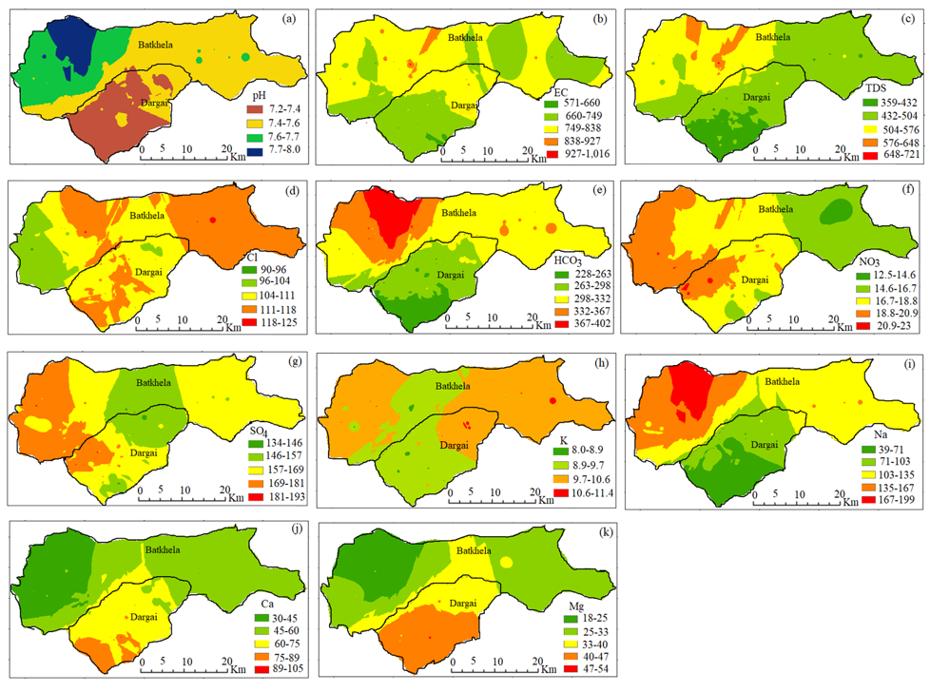
Fig. S1 Spatial distribution maps viz. a) pH, b) EC, c) TDS, d) Cl, e) HCO₃, f) NO₃, g) SO₄, h) K, i) Na, j) Ca, k) Mg, l) in the groundwater
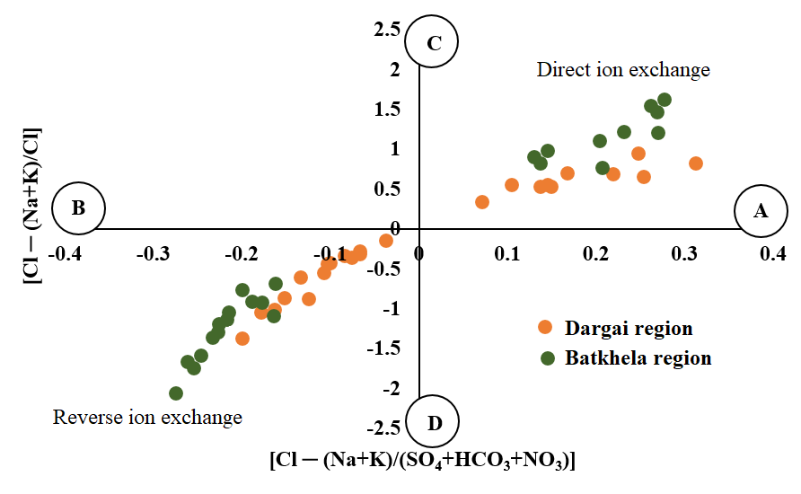
Fig. S2 CAI 1 versus CAI 2 plot indicates the mechanism of ion exchange processes in groundwater samples of the two regions viz. Dargai, and Batkhela, northern Pakistan
(b)

(a)
Fig. S3a) Represents overall loading factors of groundwater of the Dargai, and b) Batkhela region, northern Pakistan

