Supplementary data
Molecular Biology Reports Journal

Comprehensive characterization and screening of different Trichoderma isolates as plant growth promoters: Insight to metal solubilization, enzymatic activity, and antagonistic effect
Omar A. Hewedy^{1,4}*, Abdelaziz Mansour², Mostafa G. Ali³, Khalid S. Abdel Lateif⁴, Mohamed H. Ismaiel⁴, Rasha M. El-Meihy⁵
1 Department of Plant Agriculture, University of Guelph, 50 Stone Road East, Guelph, ON N1G 2W1, Canada
2 Department of Economic Entomology and Pesticides, Faculty of Agriculture, Cairo University, 12613 Giza, Egypt
3 Botany and Microbiology Department, Faculty of Science, Benha University, Benha, 13518, Egypt.
4 Department of Genetics, Faculty of Agriculture, Menoufia University, Shibin El-Kom 32514, Egypt
5 Department of Agricultural Microbiology, Faculty of Agriculture, Benha University, Moshtohor 13736, Egypt
*Correspondence: ohewedy@uoguelph.ca, hewedy.omar@gmail.com

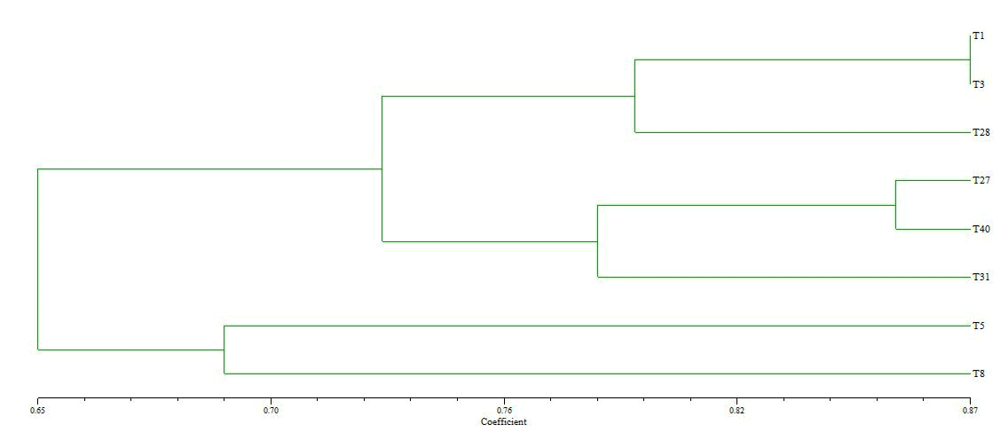 Fig. S1 Phylogenetic tree analysis of the eight Trichoderma isolates based on ISSR data; (T1: T. asperelloides, T3: T. harzianum, T5: T. harzianum, T8: T. harzianum, T27: T. viride, T28: Trichoderma sp., T31: T. afroharzianum, T40: T. atrobrunneum)

Fig. S2 Representative strains showing the morphological characteristics of T. viride (A, B, C) and T. atrobrunneum (D, E, F) in PDB, PDA, and under the light microscope, respectively. for 7 days

