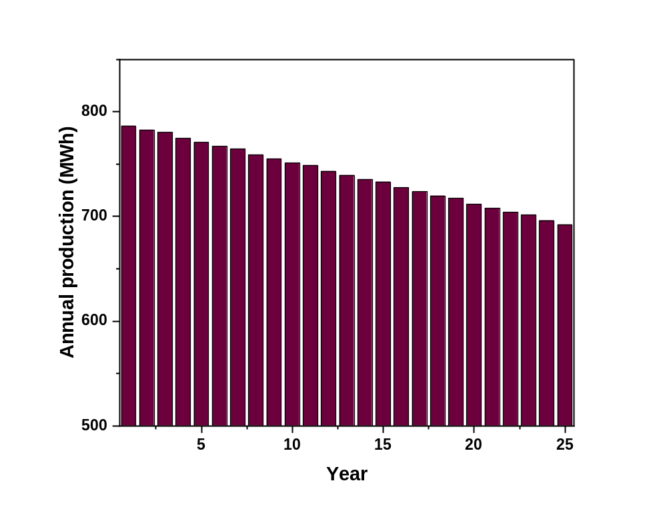
Supplementary Information
Fig. (1)
Annual energy yield over the system lifetime
Table (1)
The inverters specification
Name | TRINERGY PLUS 25KW
Manufacturer | AEC
Max Power | 25
Min Power | 0
Max Voltage | 1,000
Min Voltage | 280
Max MPPT Voltage | 800
Min MPPT Voltage | 480
At Voltage (640, 25 kW) | Efficiency 98%

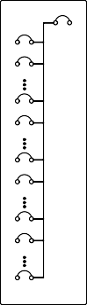
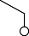
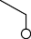
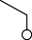
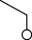
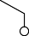
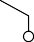
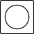

10 AWG Copper
10 AWG Copper
String count: 4
Module count: 64
Disconnect
TRINERGY PLUS 25KW
LR4-72HPH-460M
10 AWG Copper
10 AWG Copper
String count: 5
Module count: 65
Disconnect
TRINERGY PLUS 25KW
Typical of 4 Inverters
LR4-72HPH-460M
10 AWG Copper
10 AWG Copper
Meter
Grid
String count: 5
Module count: 65
20A
AC Disconnect
Service Panel
20A
Disconnect
TRINERGY PLUS 25KW
Typical of 9 Inverters
20A
LR4-72HPH-460M
20A
20A
10 AWG Copper
20A
20A

20A
String count: 2
Module count: 34
10 AWG Copper
20A
21-circuit Interconnect
LR4-72HPH-460M
10 AWG Copper
TRINERGY PLUS 25KW
Typical of 5 Inverters
Disconnect
String count: 2
Module count: 32
LR4-72HPH-460M
10 AWG Copper
10 AWG Copper
String count: 4
Module count: 60
Disconnect
TRINERGY PLUS 25KW
Typical of 2 Inverters

15

2

1

15

2

1

16

2

1
16
2
1

17

2

1

17

2

1

13

2

1

13

2

1

13

2

1

13

2

1

16

2

1

16

2

1
LR4-72HPH-460M

Fig. (2)
Single line diagram of the PV model

