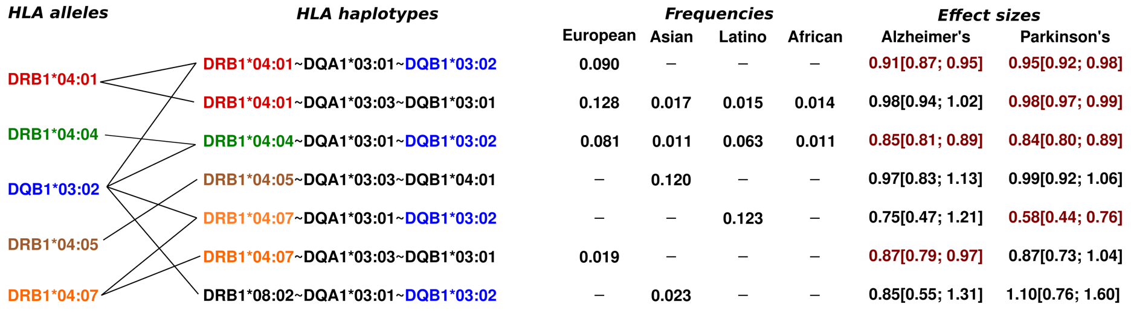

Extended Data Figure 1. Haplotypes harboring key HLA-DRB1*04 subtypes and/or HLA-DQB1*03:02. Effect sizes highlighted in red were nominally significant (p < 0.05).

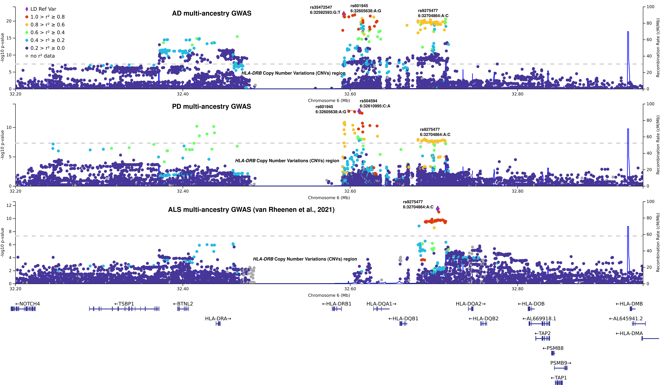
Extended Data Figure 2. Locuszoom plots of the local-HLA GWAS in multi-ancestry AD, PD, and ALS analyses. The lead variants in the AD and PD GWAS are missing in the summary statistics of the latest ALS GWAS¹¹, therefore the colocalization is imperfect.

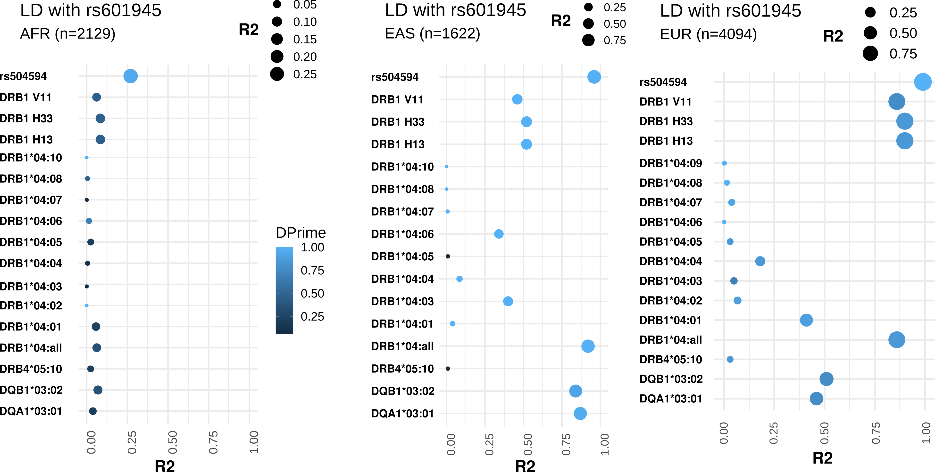

Extended Data Figure 3. Linkage disequilibrium of the lead SNP with HLA-DRB1 amino acids and HLA-DRB1*04 allele subtypes.

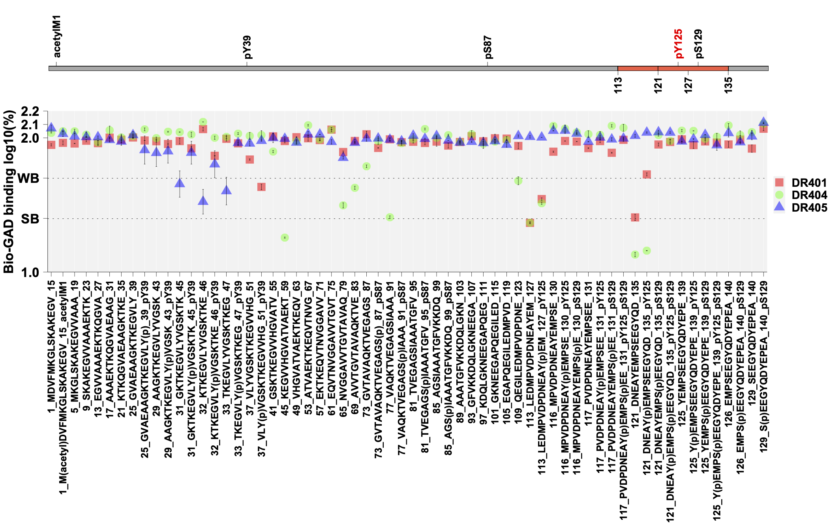
Extended Data Figure 4. HLA-DRB1*04 subtypes do not show increased to α-synuclein common PTMs. Note that HLA-DRB1*04:04 and HLA-DRB1*04:01 strongly bind to the reference in the region 121-135 but their binding efficiency decreases in the presence of PTMs pY125 and/or pS129. Because PTMs reduce central tolerance, this is unlikely to facilitate immune responses. See methods for details.

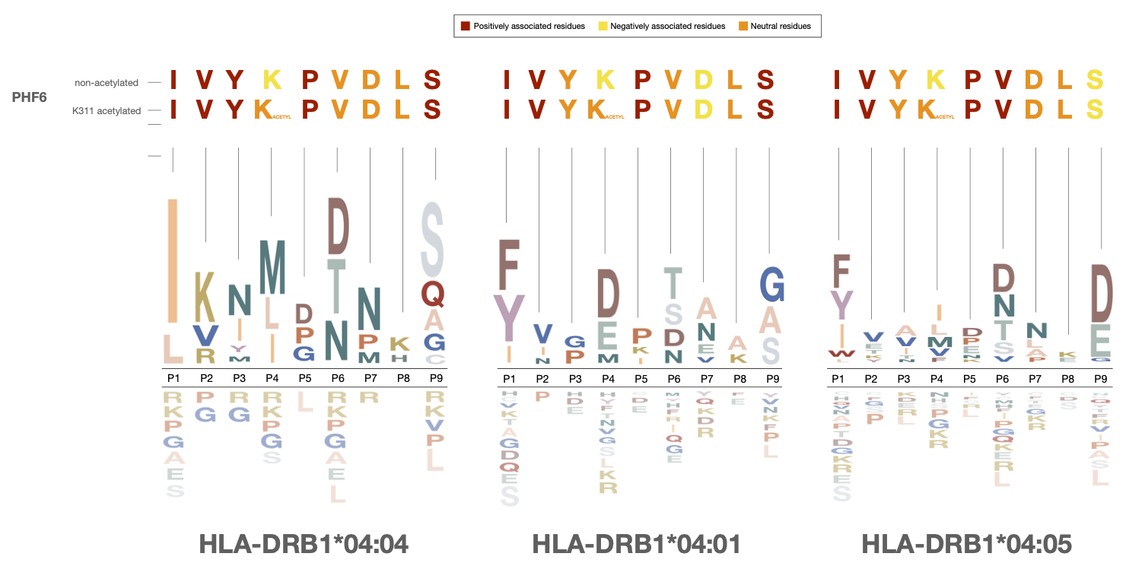

Extended Data Figure 5. HLA-DRB1*04 binding motifs and PHF6 sensitivity. Residues of PHF6 in their unacetylated or PHF6-K311-acetylated forms are shown and their association with the binding motifs of (a) HLA-DRB1*04:04, (b) HLA-DRB1*04:01 and (c) HLA-DRB1*04:05. Motifs are adapted from Scally et al., 2013⁴² (HLA-DRB1*04:01 and HLA-DRB1*04:04) and Ting et al., 2018⁴³ (HLA-DRB1*04:05)

Extended Data Figure 6. HLA binding predictions for PHF6. Predictions were made using NetMHCIIPan 4.0⁷⁴ (left) using Mixed MHC pred 2 Server⁷⁵ (right). Cmap indicates a percentile rank generated by comparing the peptide's score against the scores of five million random 15 mers selected from SWISSPROT database (best score = 0%; worst score = 100%). 15mer sequences incorporating 15mer sequences incorporating PHF6 in its unacetylated (bottom) or K311 mimic acetylated (top) form. Annotations within heat map show the position of the lysines of interest (K311 for PHF6, see highlighted sequences) within the 9mer core that is predicted to bind to the HLA molecule. 9mer cores excluding the lysine of interest were not predicted for binding and left blank. Note prediction of PHF6 binding to HLA-DRB1*04 subtypes associated with neurodegeneration, confirmed by our in vitro experiments and the absence of binding to predicted to other common HLA DR and DQ subtypes. One exception is prediction of binding of the PHF6 sequence to HLA-DRB4*01 alleles for both acetylated and non-acetylated PHF6 sequences. Accessory HLA-DRB4 genes are more weakly expressed than HLA-DRB1. These genes are present not only on HLA-DRB1*04 haplotypes, but also on most HLA-DRB1*07:01 and HLA-DRB1*09:01 haplotypes. As HLA-DRB1*07:01 and HLA-DRB1*09:01 haplotypes are not associated with AD or PD (Supplementary Table 7), HLA-DRB4*01 is unlikely to be involved in disease predisposition, maybe because of low expression and binding to both acetylated and non-acetylated sequences resulting in central tolerance. The significance of this prediction, not verified through in vitro analysis is unknown.

