Global transportation infrastructure exposure to the change of precipitation in a warmer world

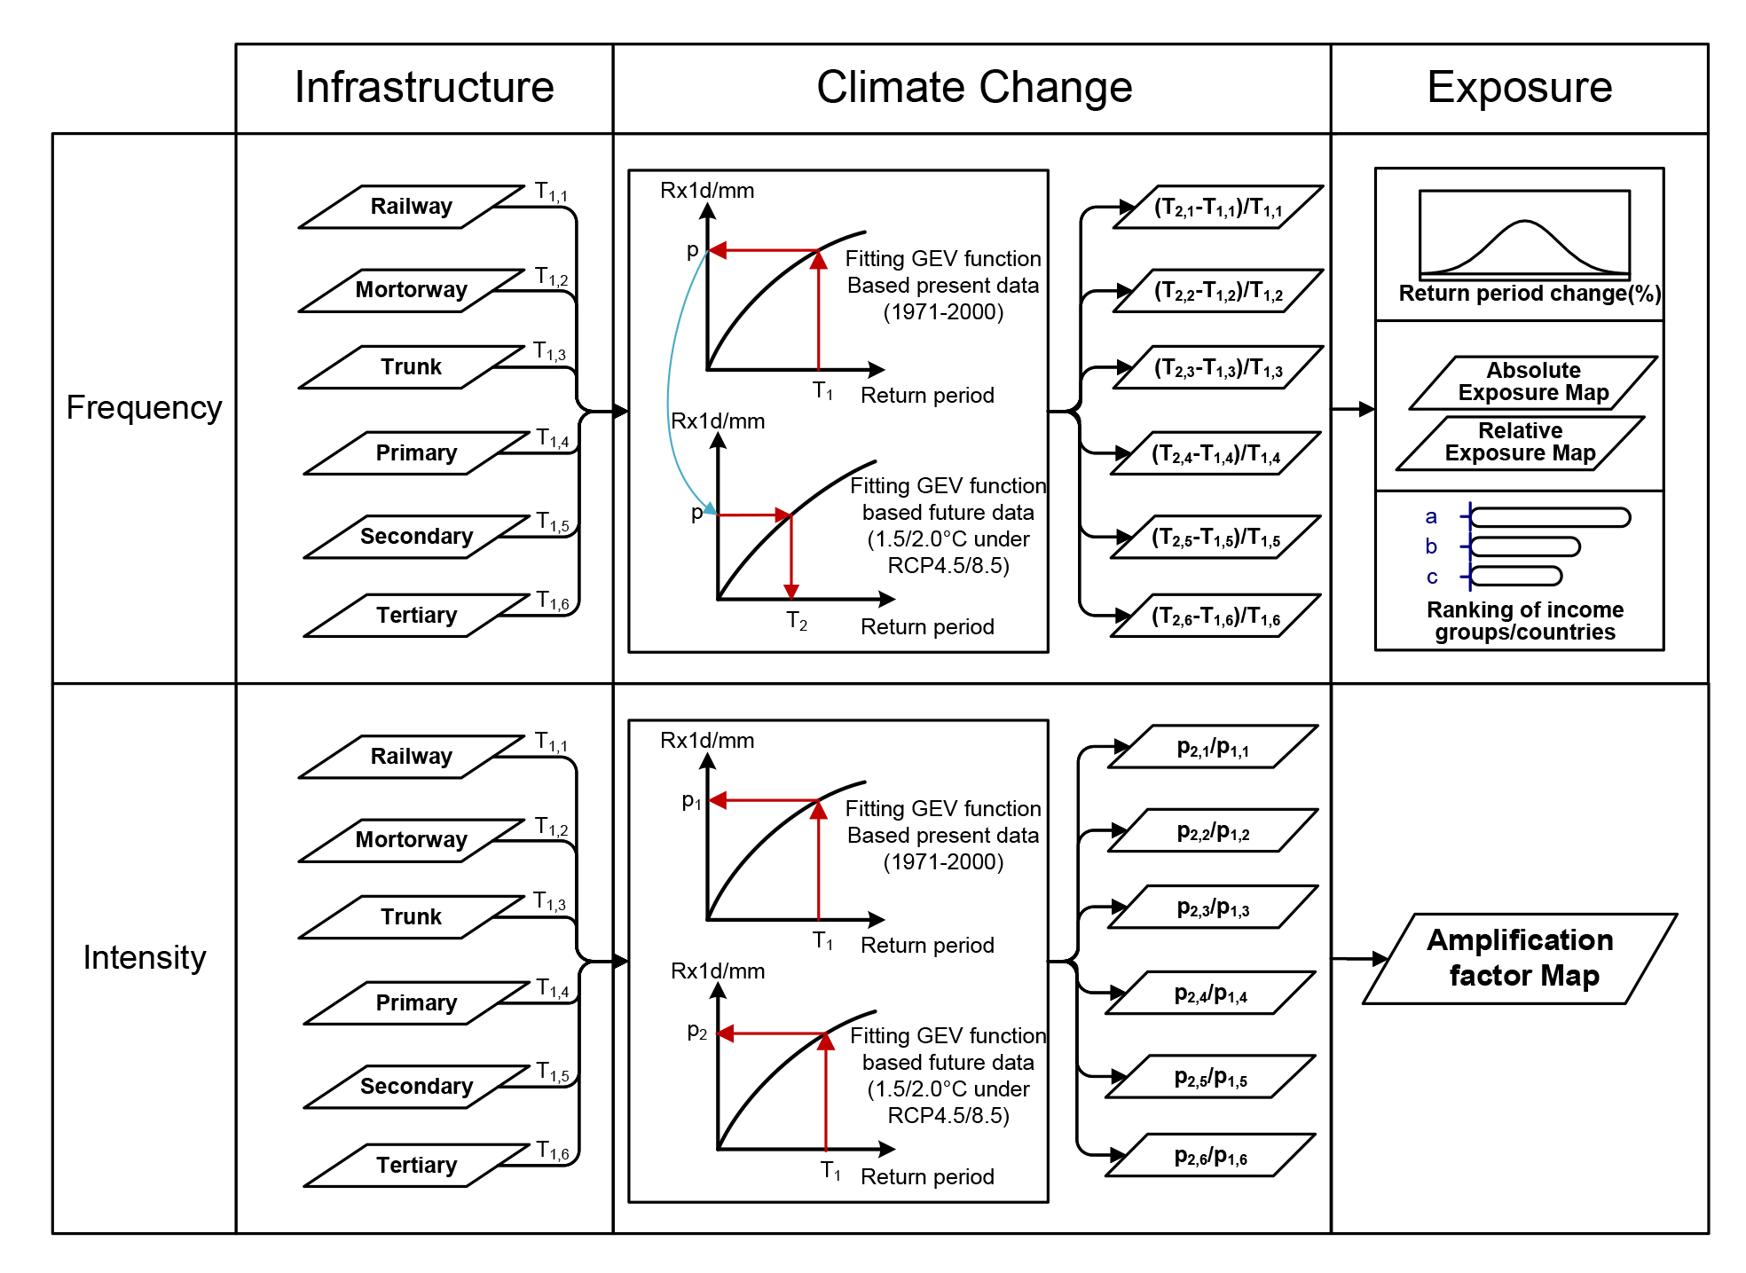
Figure S1 Methodology

Table S1 Design return periods of drainage system of transportation infrastructure
Income groups | Motorway/Trunk/  Primary/Secondary | Tertiary | Railway
Low&Low middle income | 2(5) | 0(0) | 10(20)
Upper middle income | 5(10) | 2(5) | 20(30)
High income | 10(20) | 5(10) | 30(50)
*The assets with design return period of 0 are not be included in further calculation.

Table S2 Year in which model data reached the warming target
Models | 1.5°C |  | 2.0°C
Models | RCP4.5 | RCP8.5 | RCP4.5 | RCP8.5
ACCESS1-0 | 2032 | 2027 | 2053 | 2041
CNRM-CM5 | 2035 | 2029 | 2055 | 2045
CSIRO-Mk3-6-0 | 2035 | 2036 | 2049 | 2045
CanESM2 | 2020 | 2010 | 2030 | 2027
GFDL-CM3 | 2025 | 2026 | 2037 | 2035
GFDL-ESM2G | 2047 | 2037 | - | 2056
GFDL-ESM2M | 2042 | 2036 | 2073 | 2051
inmcm4 | 2060 | 2044 | - | 2059
IPSL-CM5A-LR | 2013 | 2010 | 2032 | 2030
IPSL-CM5A-MR | 2020 | 2013 | 2030 | 2031
MIROC-ESM-CHEM | 2024 | 2019 | 2038 | 2028
MIROC-ESM | 2021 | 2021 | 2034 | 2032
MIROC5 | 2033 | 2028 | 2055 | 2043
MPI-ESM-LR | 2016 | 2014 | 2033 | 2033
MPI-ESM-MR | 2026 | 2017 | 2047 | 2040
MRI-CGCM3 | 2050 | 2043 | 2081 | 2055
Note: “-” indicates the time exceeds 2100 and out of consideration

Table S3 Transportation assets used in this study
Category | Class | Description | Length (km)
Road | Motorway | A restricted access major divided highway, normally with 2 or more running lanes plus emergency hard shoulder. Equivalent to the Freeway, Autobahn, etc.. | 1,080,680
Road | Trunk | The most important roads in a country's system that aren't motorways. (Need not necessarily be a divided highway.) | 1,799,080
Road | Primary | The next most important roads in a country's system. (Often link larger towns.) | 3,035,180
Road | Secondary | The next most important roads in a country's system. (Often link towns.) | 4,487,574
Road | Tertiary | The next most important roads in a country's system. (Often link smaller towns and villages) | 8,574,914
Railway | Rail | Full sized passenger or freight trains in the standard gauge for the country or state. | 2,654,041

Figure S2 Spatial distribution of each category of transportation assets (left panel) and their change of return period (right panel) (a-b) railway (c-d) motorway (e-f) trunk (g-h) primary road (i-j) secondary road (k-l) tertiary road

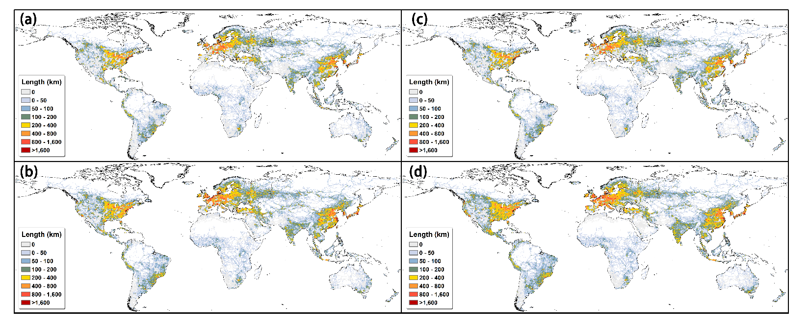
Figure S3. Absolute global transport infrastructure exposure exceeding 25% change in precipitation return periods (based higher current design standards assumption). a) 1.5 ºC warming under RCP4.5 scenario b) 2 ºC warming under RCP4.5 scenario c) 1.5 ºC warming under RCP8.5 scenario d) 2 ºC warming under RCP8.5 scenario

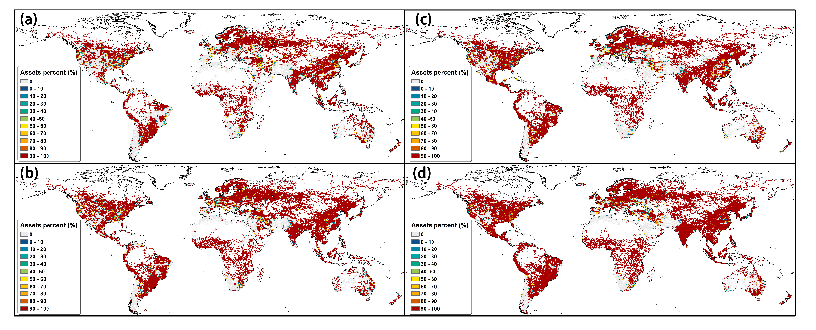
Figure S3. Relative global transport infrastructure exposure exceeding 25% change in precipitation return periods change (based higher current design standards assumption). a) 1.5 ºC warming under RCP4.5 scenario b) 2 ºC warming under RCP4.5 scenario c) 1.5 ºC warming under RCP8.5 scenario d) 2 ºC warming under RCP8.5 scenario

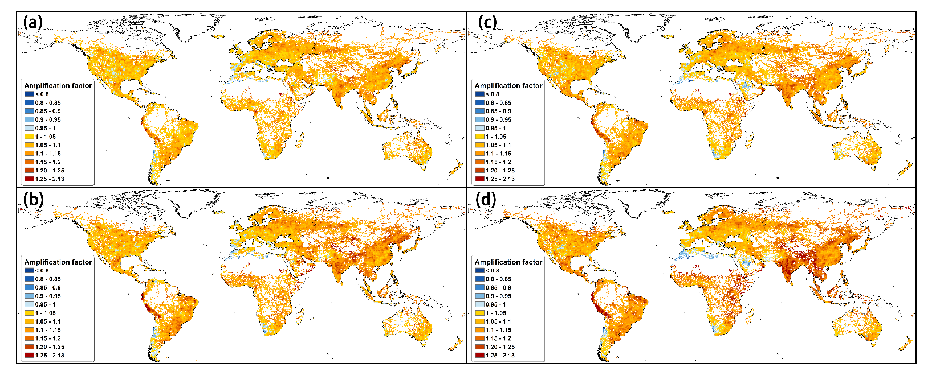
Figure S4. Amplification factor to current design standards (based higher current design standards assumption). a) 1.5 ºC warming under RCP4.5 scenario b) 2 ºC warming under RCP4.5 scenario c) 1.5 ºC warming under RCP8.5 scenario d) 2 ºC warming under RCP8.5 scenario

