Supplementary Figures and figure legends

Irisin enhances chondrogenic differentiation of human mesenchymal stem cells via Rap1/PI3K/AKT axis.

Fig. S1
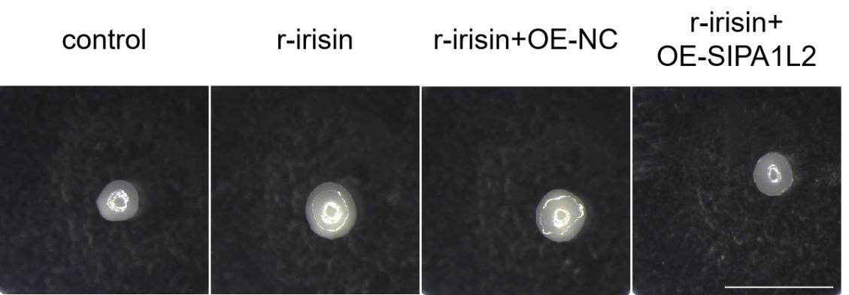
Fig. S1 Macro-images of induced-cartilage tissues were taken on Day-7. (Magnification: ×15, scale bar: 2mm).

Fig. S2
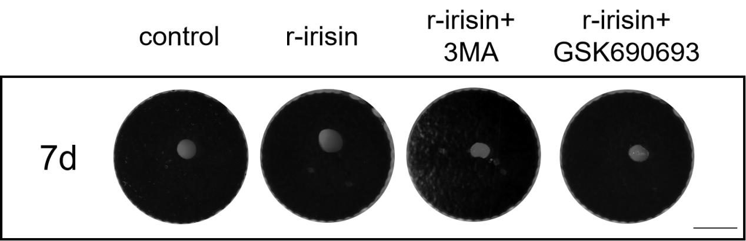
Fig. S2 Macro-images of induced-cartilage tissues were taken on Day-7. (Magnification: ×15, scale bar: 2mm).

Table S1. Primers’ sequences for real time PCR.
Gene primer names | Primer sequence(5’-3’)
GAPDH-F  GAPDH-R  COL2A1-F  COL2A1-R  ACAN-F  ACAN-R  SOX9-F  SOX9-R  Rap1A-F  RAP1A-R  RAP1B-F  RAP1B-R  RAP1GAP-F  RAP1GAP-R  RASGRP2-F  RASGRP2-R  SIPA1L2-F  SIPA1L2-R  miR-26b-F  miR-26b-R  miR-27b-3p-F  miR-27b-3p-R  miR-27b-5p-F  miR-27b-5p-R  miR-10b-F  miR-10b-R  miR-125b-5p-F  miR-125b-5p-R  miR-132-F  miR-132-R  miR-23a-3p-F  miR-23a-3p-R | AGAAAAACCTGCCAAATATGATGAC  TGGGTGTCGCTGTTGAAGTC  GGCAATAGCAGGTTCACGTACA  GAACATCGACCAACTCTACTCCG  ACTCTGGGTTTTCGTGACTCT  ACACTCAGCGAGTTGTCATGG  AGCGAACGCACATCAAGAC  GCTGTAGTGTGGGAGGTTGAA  CGTGAGTACAAGCTAGTGGTCC  CCAGGATTTCGAGCATACACTG  AGCAAGACAATGGAACAACTGT  TGCCGCACTAGGTCATAAAAG  GAGGAGGACTACATTCCATACCC  GCTGGTGATTTCGTGGTTGG  ACAATCCCGGAAGGACAACTC  GTCTATGTCGATTAGGCTGCTG  GACCCAAGGCAGTCACAAGAA  TAGGAGGCCATTCAGACACCC  CCGGGACCCAGTTCAAGTAA  CCCCGAGCCAAGTAATGGAG  GCTCTAGATTGCCAGGGATTACCACGCAA  CGGGATCCCTAGCATTCCCAGCAGGAGACAG  GACCTAGCACCATTTGAAATCA  GTCCAGGTTTTTTTTTTTTTTTTA  TACCCTGTAGAACCGAATTTGT  GTGCAGGGTCCGAGGT  GGGTCCCTGAGACCCTAAC  CAGTGCGTGTCGTGGAGT  TGGATCCCCCCCAGTCCCCGTCCCTCAG  TGAATTCGGATACCTTGGCCGGGAGGAC  GCGATCACATTGCCAGGG  AGTGCAGGGTCCGAGGTATT

