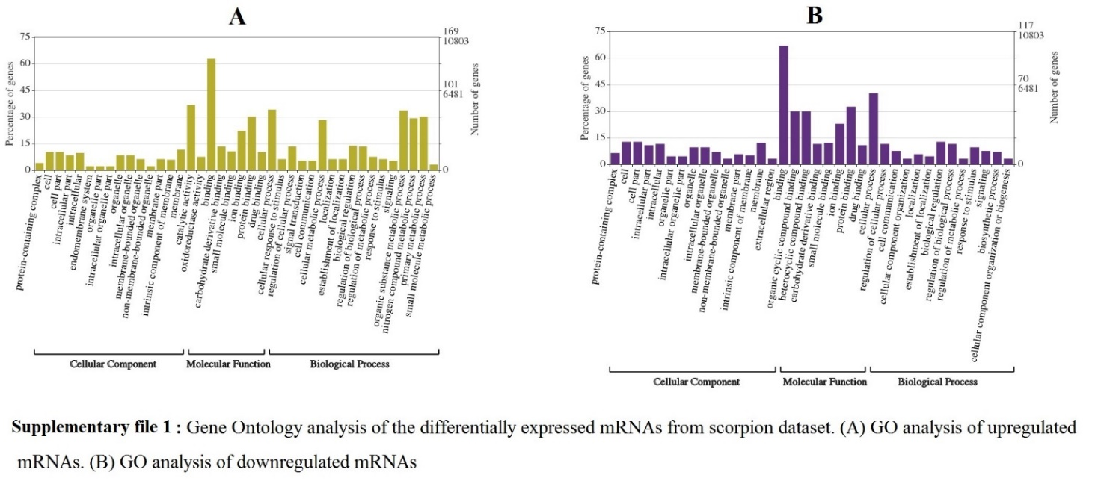

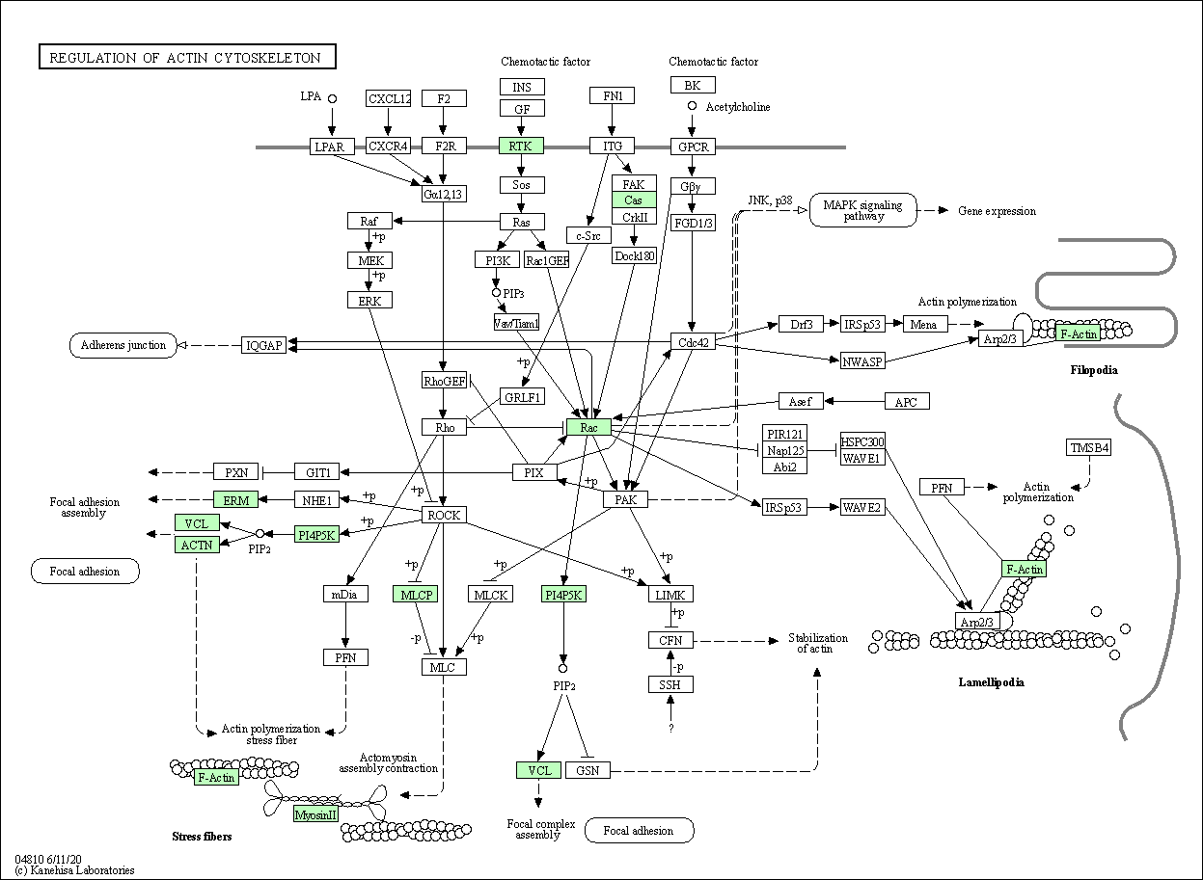
Supplementary file 2. Regulation of actin cytoskeleton pathway. The up-regulated genes MYH, RDX, ACTN, VCL, PIP5K, PP1C, RAC1 and the down-regulated gene FGFR (Fibroblast growth factor receptor) were enriched in scorpion cytoskeleton development. Green color indicates up-regulated genes of adults.

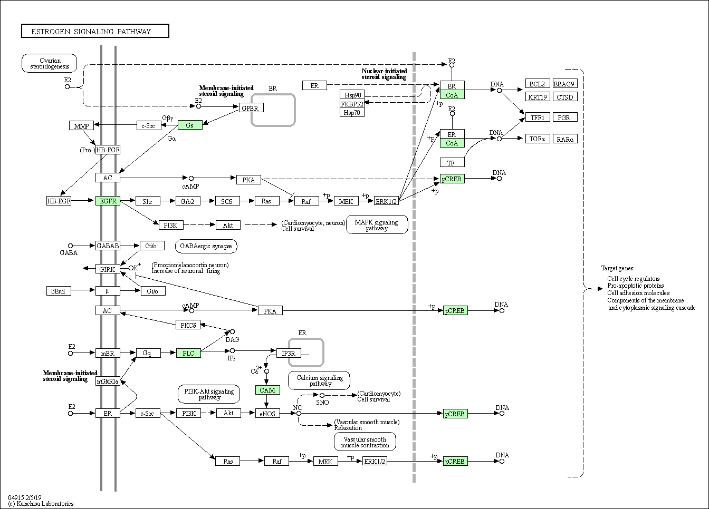
Supplementary file 3. Estrogen signaling pathway. The up-regulated genes GNAS, EGFR, CREB, CoA, PLCB and CALM the down-regulated gene PKA were enriched in scorpion estrogen signaling pathway. Green color indicates up-regulated genes of adults.

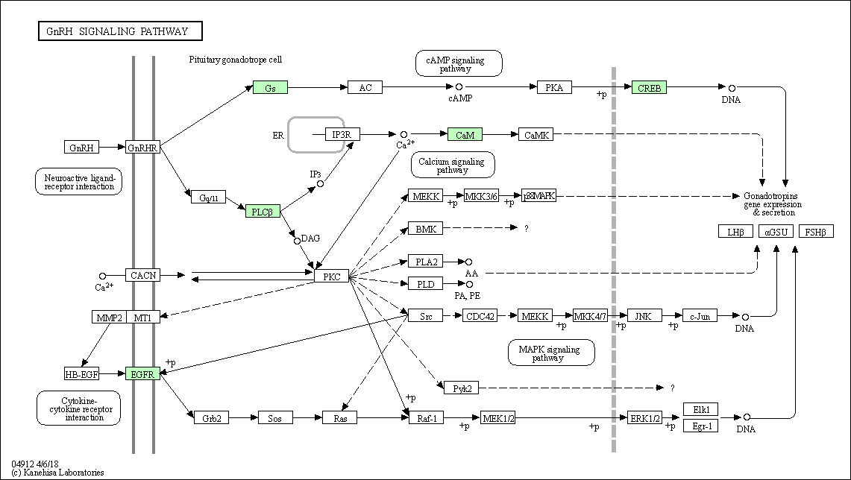
Supplementary file 4. GnRH signaling pathway. The up-regulated genes of Gs (GNAS), EGFR, CREB, PLCß and CaM (CALM), and the down-regulated gene of CACNA were enriched in scorpion GnRH signaling pathway. Green color indicates up-regulated genes of adults.

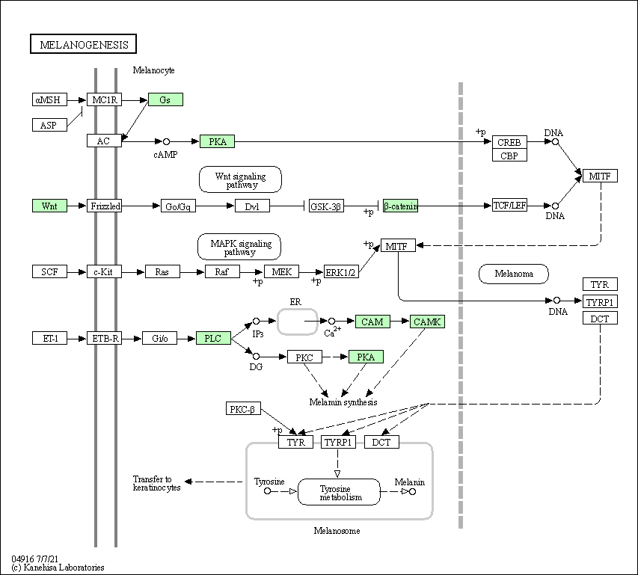
Supplementary file 5. Melanogenesis pathway. The up-regulated genes of GNAS, EGFR, CALM and PLCB, and the down-regulated genes of PKA and CAMK were enriched in Melanogenesis pathway.

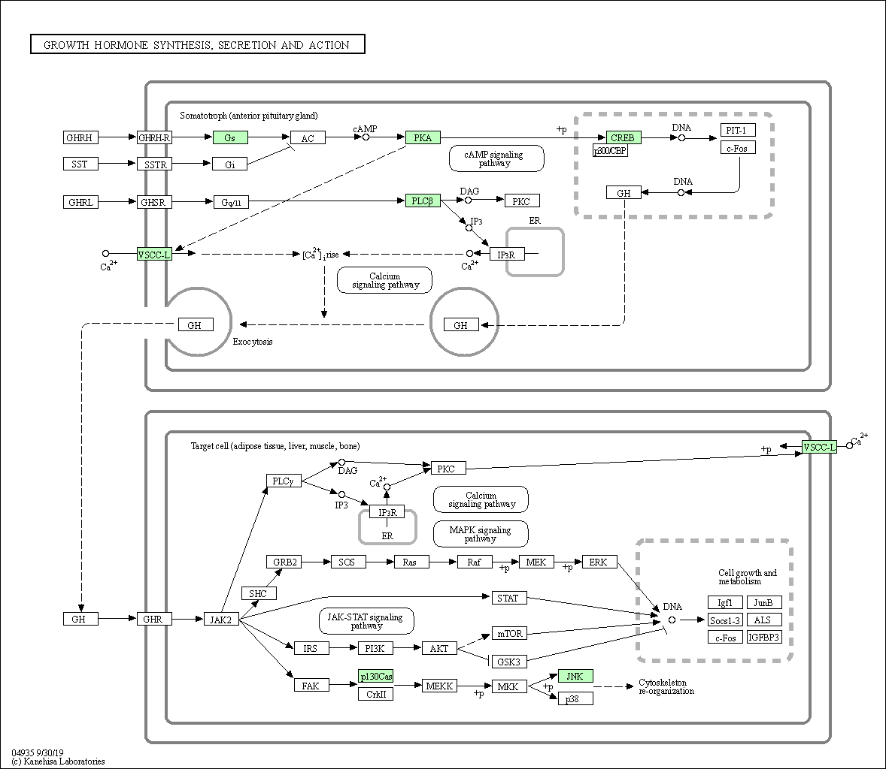
Supplementary file 6. Growth hormone synthesis, secretion and action pathway. The up-regulated genes of GNAS, CREB and PLCB, and the down-regulated genes of CACNA and PKA were enriched in scorpion growth hormone signaling pathway.

Supplementary file 7. Classification of up-regulated mRNAs into venom components.
Supplementary file 8. Classification of down-regulated mRNAs into venom components.

