Supplementary Information
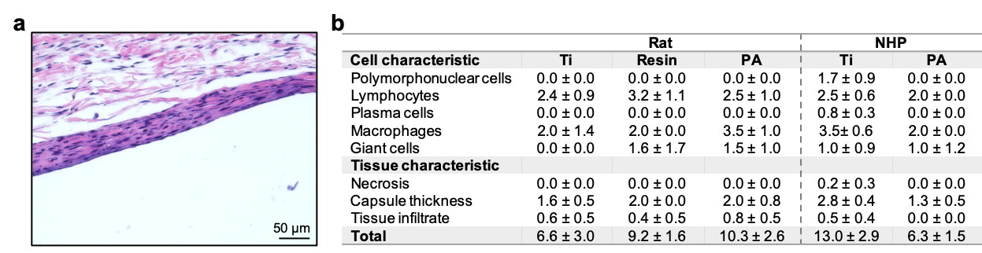
Supplementary Fig. 1 Tissue reactivity scoring. a Representative H&E staining showing the fibrotic capsule formed around a titanium (Ti) device implanted in rats for 6 weeks. b Tissue reactivity scoring to Ti, resin, and nylon (PA) devices implanted in rats and nonhuman primates.
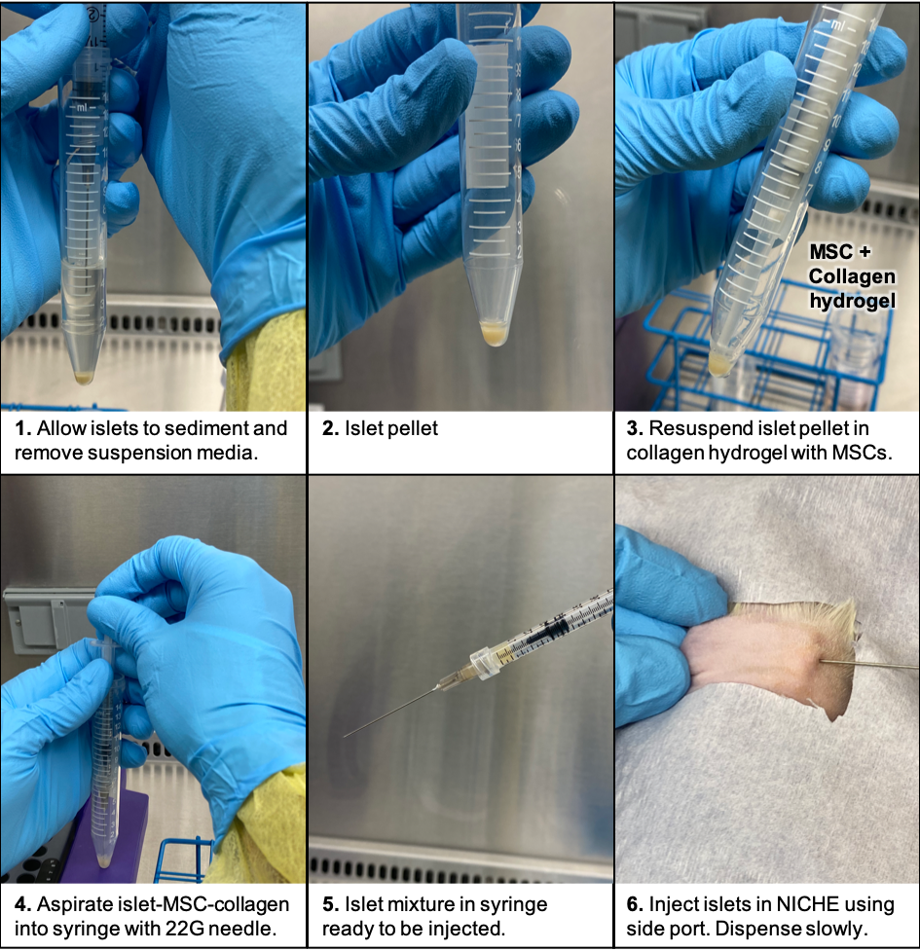
Supplementary Fig 2 Islet-MSCs transplantation procedure into the NICHE. Photographs showing the procedure for islet and MSCs loading into the NICHE with collagen hydrogel as a carrier.
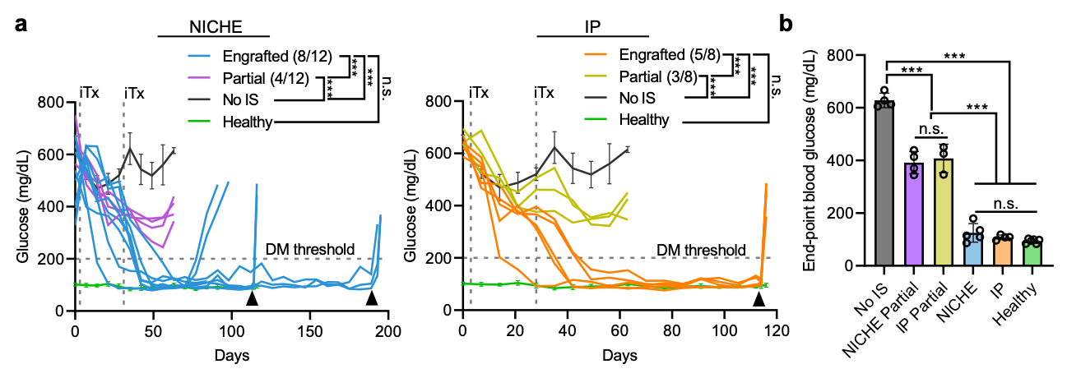
Supplementary Fig. 3 Blood glucose profiles after islet transplantation. a Blood glucose (BG) measurements of diabetic F344 rats transplanted with islets in NICHE cell reservoir. Individual BG plots for NICHE and IP rats with engrafted (diabetes reversal was achieved) and partial engraftment (glycemic benefit but no diabetes reversal achieved) are shown. No immunosuppression (No IS; n = 4 to day 63), and healthy controls (n = 6 to day 116, n = 1 to day 195) included for reference, mean ± SD. b BG at endpoint of No IS (n = 4 on day 63), IP partial (n = 3 on day 63), NICHE partial (n = 4 on day 63), and healthy (n = 5 on day 115 and n = 1 on day 193); or prior to explant of NICHE engrafted (n = 2 on day 115, n = 3 on day 193) and IP engrafted (n = 4 on day 115). Mean ± SD, one-way ANOVA with Tukey’s multiple comparisons test (n.s. p = 0.9618 NICHE versus IP; n.s. p = 0.5768 NICHE versus healthy; n.s. p = 0.9792 IP versus healthy; n.s. p = 0.9842 IP partial vs NICHE partial; ***p<0.001 No IS versus NICHE, IP, NICHE partial, IP partial, and healthy; ***p<0.001 NICHE partial and IP partial versus NICHE, IP, and healthy).
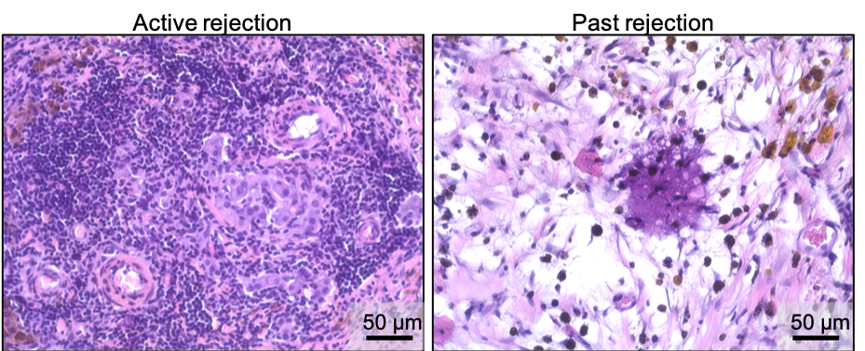
Supplementary Fig. 4 Rejected islet grafts in NICHE. Representative H&E micrographs showing islet grafts in NICHE with active and past rejection.
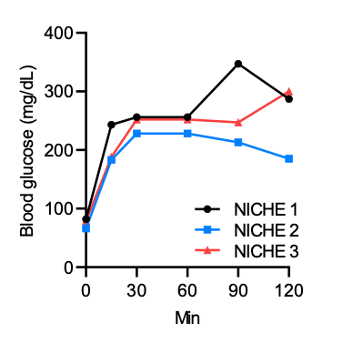
Supplementary Fig. 5 Graft destabilization. Blood glucose curves during intraperitoneal glucose tolerance test in NICHE rats on day 151 show graft destabilization.
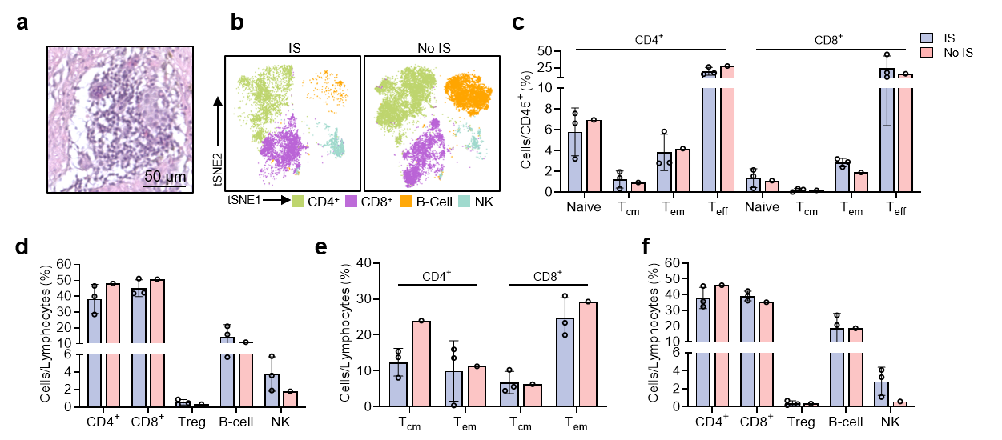
Supplementary Fig. 6 Mass cytometry (CyTOF) analysis of NICHE in nonhuman primates (NHPs). a Representative H&E staining of IS group cell reservoir tissue 14 days after islet transplantation showing leukocytic infiltration in the graft. b tSNE plots of NHP CyTOF data. c CyTOF quantification of CD4⁺ and CD8⁺ memory T cell populations. d Flow cytometry data of peripheral blood immune cell populations and e memory T cells 14 days after islet transplantation, and f of peripheral blood immune cell populations pre-transplantation.

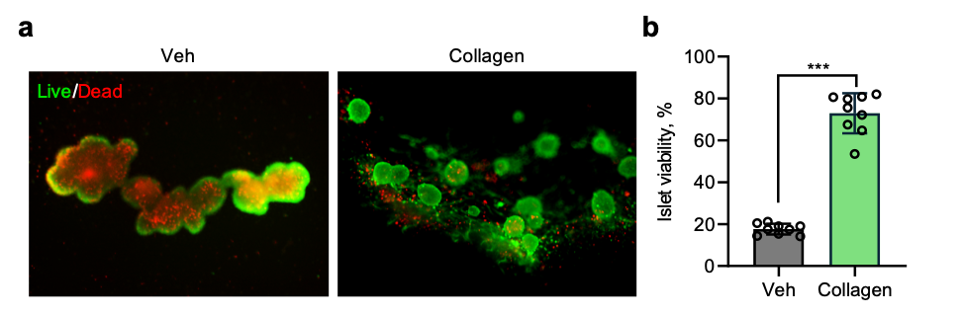
Supplementary Fig. 7 Islet viability in collagen matrix. a Live/Dead staining of islets after 5 days incubated in media (Veh) or collagen hydrogel used for transplantation and b quantification expressed as percent of live islet area (n = 9), mean ± SD, unpaired two-tailed student’s t-test ***p < 0.001.

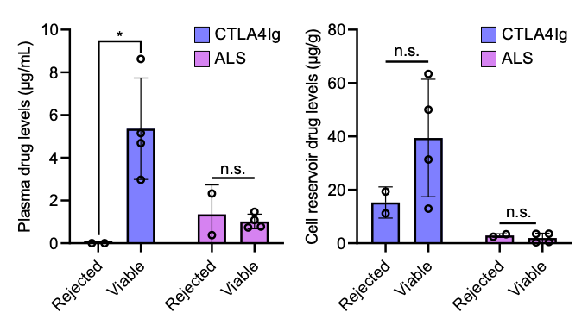
Supplementary Fig. 8 Immunosuppressant biodistribution in rats with viable and rejected grafts. Quantification of ALS and CTLA4Ig levels in plasma and cell reservoir tissue at endpoint of NICHE rats that rejected their grafts unexpectedly (n = 2) and rats that remained euglycemic with viable grafts (n = 4), mean ± SD, unpaired two-tailed student’s t-test between viable and rejected grafts for each drug (*p < 0.05; n.s. p = 0.6362 Rejected vs viable plasma ALS; p = 0.2215 rejected versus viable cell reservoir CTLA4Ig; p = 0.5488 rejected versus viable cell reservoir ALS.

 | Score
Cell characteristic | 0 | 1 | 2 | 3 | 4 | Reactive inflammation multiplier (m_{j,r})
Polymorphonuclear cells | 0/HPF | Rare,  1-5/HPF | 5-10/HPF | Heavy infiltrate | Packed | 2
Lymphocytes | 0/HPF | Rare,  1-5/HPF | 5-10/HPF | Heavy infiltrate | Packed | 2
Plasma cells | 0/HPF | Rare,  1-5/HPF | 5-10/HPF | Heavy infiltrate | Packed | 2
Macrophages | 0/HPF | Rare,  1-5/HPF | 5-10/HPF | Heavy infiltrate | Packed | 2
Giant cells | 0/HPF | Rare,  1-5/HPF | 5-10/HPF | Heavy infiltrate | Packed | 2
Tissue characteristic
Necrosis | 0 | Minimal | Mild | Moderate | Severe | 2
Capsule thickness | 0 | Narrow (<5 cells) | Moderate (5-10 cells) | Thick (10-20 cells) | Extensive thick | 1
Tissue inflammatory infiltrate | 0 | Minimal, focal in local tissue | Mild or multifocal in adjacent tissues | Moderate in adjacent tissues | Marked in adjacent tissues | 1
Supplementary table 1. Scoring system used to assess implant reactivity. Reprinted with permission from Su et al.⁷⁵ under the Creative Commons Attribution 4.0 International license.

Metal | Target
Gd156 | CD45
Nd143 | CD3
Nd145 | CD4
Nd146 | CD8
Tb159 | CD68
Yb171 | Insulin
Er168 | Glucagon
Sm147 | Alpha smooth muscle actin
Dy164 | Myeloperoxidase (MPO)
Er167 | Ki-67
Pr141 | GranzymeB (GramZB)
Dy161 | Arginase 1 (Arg1)
Gd160 | Foxp3
Supplementary table 2. Markers used for IMC

Cell population | Gating strategy
CD4 T-Cell | CD45⁺CD3⁺CD20⁻CD4⁺CD8⁻
CD8 T-Cell | CD45⁺CD3⁺CD20⁻CD4⁻CD8⁺
Tem | CCR7⁻CD45RA⁻
Tcm | CCR7⁺CD45RA⁻
T-Naive | CCR7⁺CD45RA⁺
T-Effector | CCR7⁻CD45RA⁺
Treg | CD45⁺CD3⁺CD20⁻CD4⁺CD8⁻Foxp3⁺
B-Cell | CD45⁺CD20⁺CD3⁻
NK | CD45⁺CD3⁻CD20⁻CD56⁺
Supplementary table 3. CyTOF gating strategy

Marker | Fluorophore | Clone | Make
CD45 | FITC | OX-1 | BD Biosciences
CD3 | PE | G4.18 | eBioscience
CD4 | BV421 | OX-35 | BD Biosciences
CD8a | APC | OX8 | eBioscience
CD44 | BV711 | OX49 | BD Biosciences
CD62L | BV650 | HLR1 | BD Biosciences
CD25 | BV711 | OX-39 | eBioscience
FOXP3 | APC | FJK-16s | BD Biosciences
Viability Dye | eFluor780 | n/a | eBioscience
Supplementary table 4. Antibodies used for flow cytometry in rat model.

Marker | Fluorophore | Clone | Make
CD4 | FITC | M-T477 | BD Biosciences
CD28 | PE | CD28.2 | BD Biosciences
CD8 | PerCP-Cy5.5 | RPA-T8 | BD Biosciences
CD3 | PE-Cy7 | SP34-2 | BD Biosciences
CD16 | APC | 3G8 | BD Biosciences
CD20 | APC | 2H7 | BD Biosciences
CD25 | BV421 | BC96 | Biolegend
FOXP3 | APC | PCH101 | eBioscience
CD95 | PacBlue | DX2 | Biolegend
Viability Dye | Fixable NIR | n/a | ThermoFisher
Supplementary table 5. Antibodies used for flow cytometry in NHP model.

