Supplementary Materials for

Afforestation alters functions of soil and microbiome but does not drive soil carbon accumulation in two decades

Wenhua Qi^{1, 2, 3#}, Quanfa Zhang^{1,2#}, Youchao Chen^{1,2#}, Xinshuai Li^{1, 2, 3}, Xiaoli Cheng⁴, Chen Ye^{1,2}, Fei Lu⁵, Haishan Dang^{1,2}, Kerong Zhang^{1,2*}

1 CAS Key Laboratory of Aquatic Botany and Watershed Ecology, Wuhan Botanical Garden, Chinese Academy of Sciences, Wuhan 430074, P.R. China
2 Center of Plant Ecology, Core Botanical Garden, Chinese Academy of Sciences, Wuhan 430074, P.R. China
3 University of the Chinese Academy of Sciences, Chinese Academy of Sciences, Beijing 100101, P.R. China
4 School of Ecology and Environmental Science, Yunnan University, Kunming 650091, P. R. China
5 State Key Laboratory of Urban and Regional Ecology, Research Center for Eco-Environmental Sciences, Chinese Academy of Sciences, Beijing 100085, P. R. China
# These authors contributed equally to this work.

*Corresponding author: Kerong Zhang, Email: kerongzhang@wbgcas.cn
CAS Key Laboratory of Aquatic Botany and Watershed Ecology, Wuhan Botanical Garden, Chinese Academy of Sciences, Wuhan 430074, P. R. China
Phone: +86 27 87700866 Fax: +86 27 87510251

This file includes:

Figures. S1, S2, S3, S4, S5, S6, S7, S8；

Tables S1, S2, S3, S4, S5, S6, S7, S8, S9, S10, S11, S12, S13, S14.

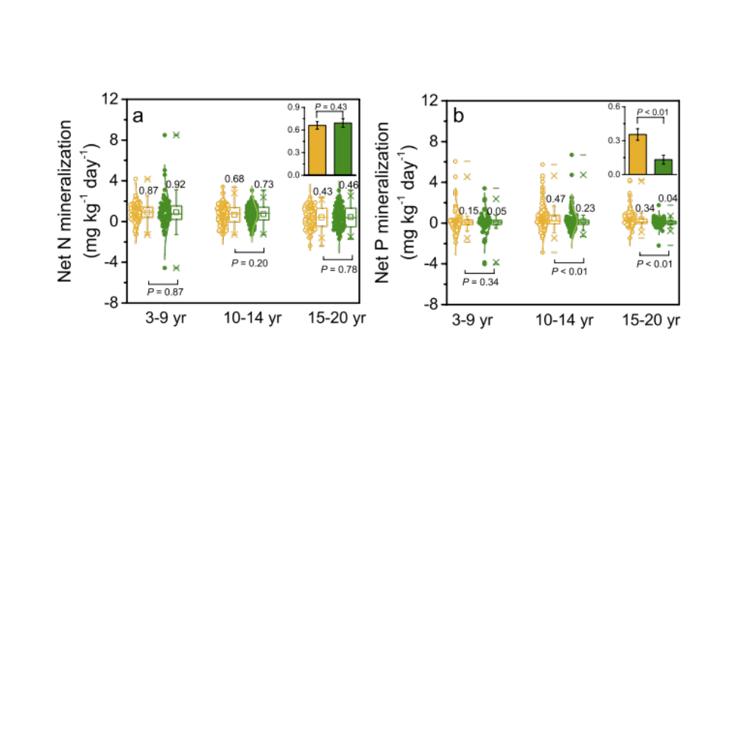

Fig. S1. The net N mineralization (a) and net P mineralization (b) rates of unforested lands (yellow) and planted forest (green) at various age categories. The inserted panels show the mean values of sites. The P values of paired t test are presented beside the boxplots. The numbers above the boxplots are the mean values of the rates.

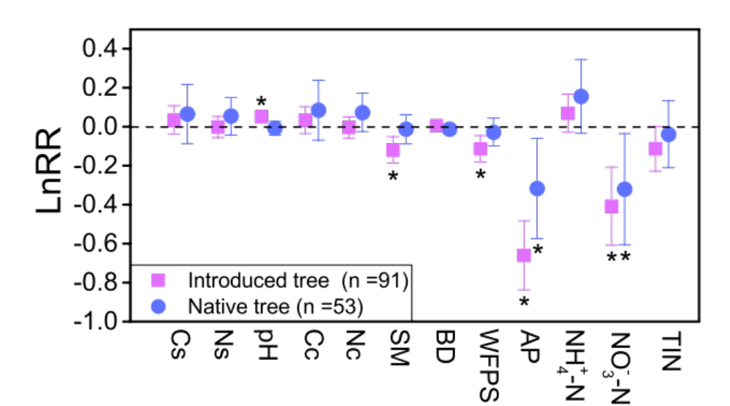
Fig. S2 The response ratio (Ln RR) of soil properties to afforestation at different tree type categories. The error bars indicate the 95% confidence interval (CI). If the CI did not overlap with zero, a response was considered to be significant and labelled with “*”. Cs, carbon stock; Ns, nitrogen stock; Cc, carbon concentration; Nc, nitrogen concentration; SM, soil moisture, BD, bulk density; WFPS, water filled pore space; AP, available phosphorus; TIN, total inorganic nitrogen (NH+ 4-N + NO- 3-N).

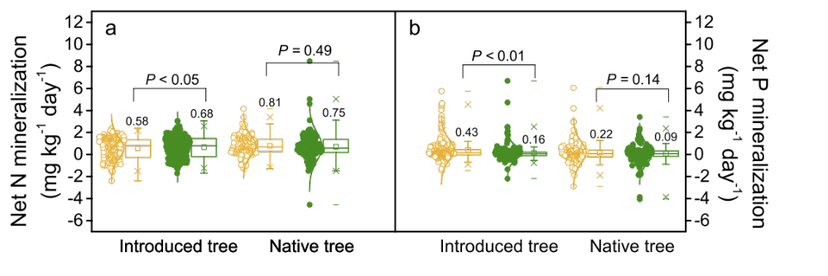
Fig. S3 The net N mineralization (a) and net P mineralization (b) rates of unforested lands (yellow) and planted forest (green) at different tree type categories. The P values of paired t test are presented beside the boxplots. The numbers above the boxplots are the mean values of the rates

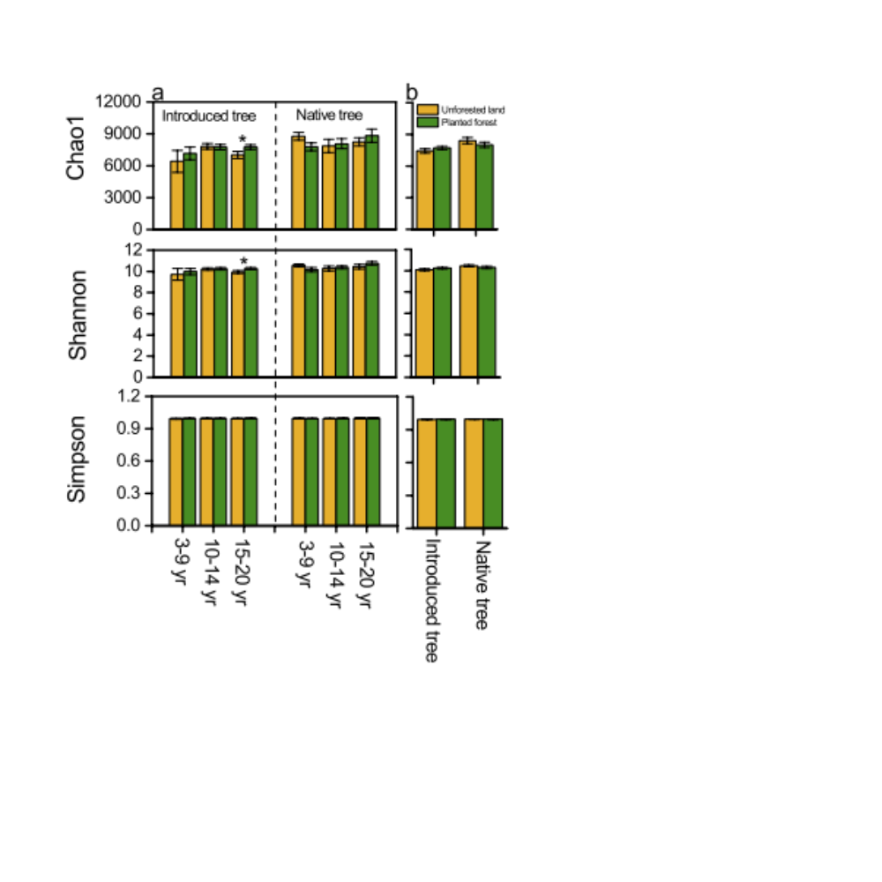
Fig. S4 Soil prokaryotic diversity in unforested land and planted forest at various age and tree type categories (a). Panel b shows the mean values of diversity at different tree type categories. “*” indicates the difference between unforested land and planted forest is significant (P < 0.05)

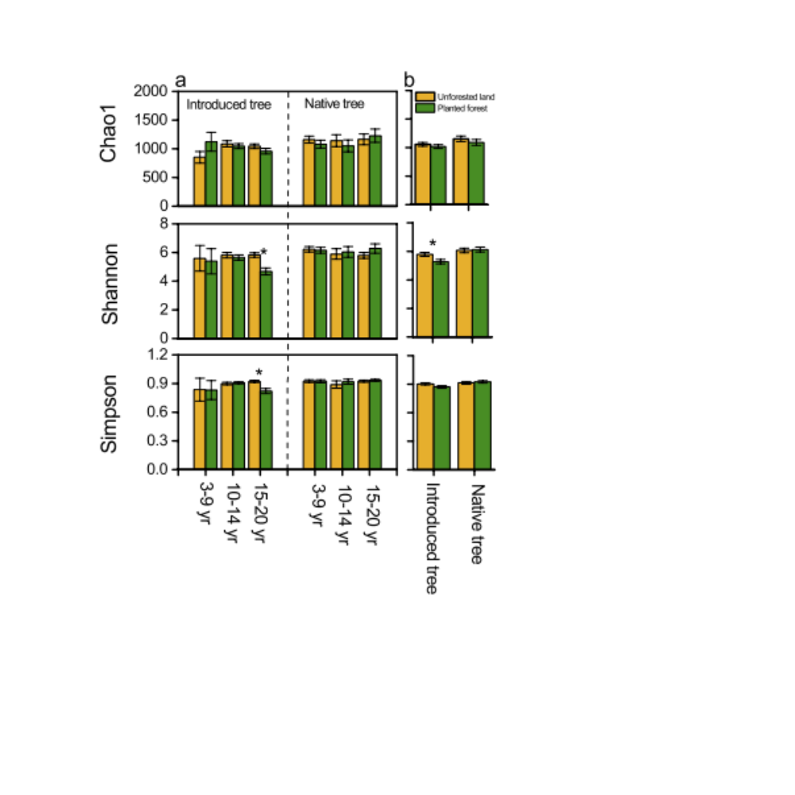
Fig. S5 Soil fungal diversity in unforested land and planted forest at various age and tree type categories (a). Panel b shows the mean values of diversity at different tree type categories. “*” indicates the difference between unforested land and planted forest is significant (P < 0.05)

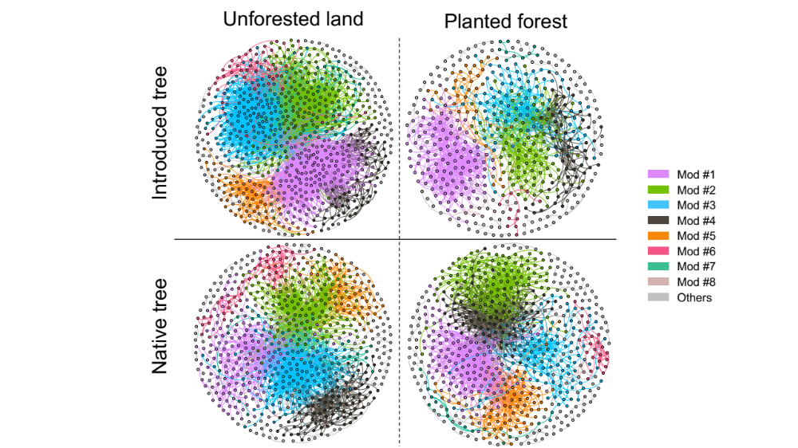
Fig. S6 The co-occurrence network interactions of prokaryote in soils from unforested land and planted forest at different tree type categories. The nodes in the eight major modules are highlighted with color. The nodes in the other modules are all shown in grey.

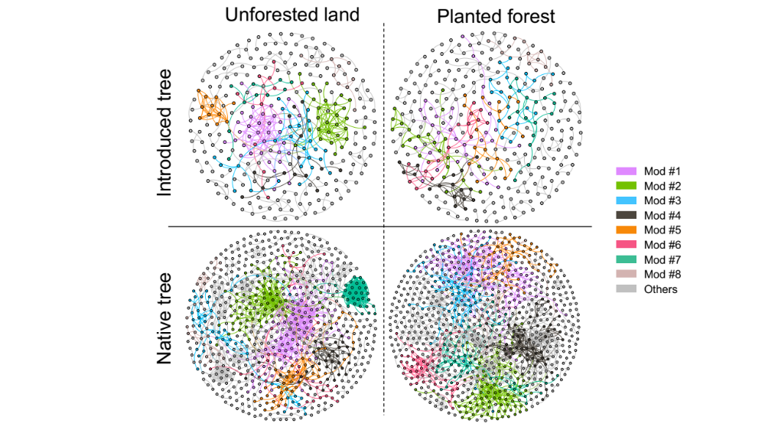
Fig. S7 The co-occurrence network interactions of fungi in soils from unforested land and planted forest at different tree type categories. The nodes in the eight major modules are highlighted with color. The nodes in the other modules are all shown in grey.

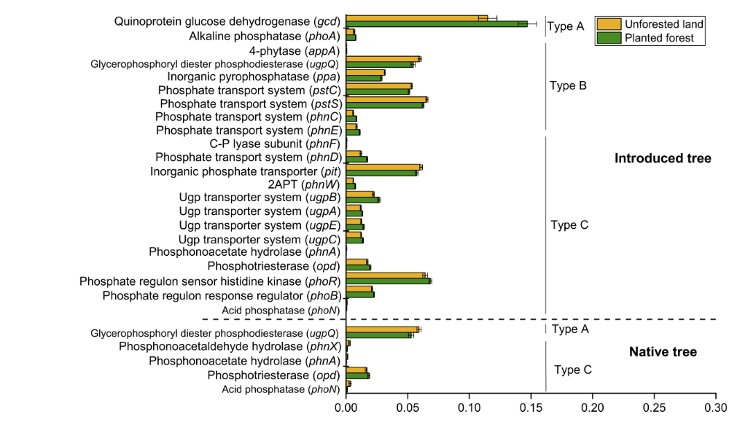
Fig. S8 Relative abundance (%) of representative genes responsible for microbial (Type A) P-starvation response regulation, (Type B) inorganic P-solubilization and organic P-mineralization, and (Type C) P-uptake and transport in soil of unforested land and planted forest at different tree type categories. Only the genes that differed significantly (P < 0.05) between unforested land and planted forest are shown.

Table S1 ADONIS variation test of microbial community composition and C-, N-, P-related gene composition between unforested lands and planted forests at various stand age categories.
 | Prokaryote  (genus level) |  | Fungi  (genus level) |  | Prokaryote (OTU level) |  | Fungi  (OUT level) |  | FUNGuild  group |  |  |  |  | C-related genes |  |  |  |  | N-related genes |  |  |  |  | P-related genes |  |  |  |  | Cazyfamily
 | F | P | F | P | F | P | F | P | F | P |  | F |  |  | P |  | F |  |  | P |  | F |  |  | P |  | F |  |  | P
3-9 yr | 0.84 | 0.58 | 1.65 | <0.05 | 0.97 | 0.42 | 1.26 | <0.05 | 2.46 |  | <0.01 |  | 0.77 |  |  | 0.58 |  | 0.66 |  |  | 0.60 |  | 1.23 |  |  | 0.28 |  | 0.41 |  |  | 0.86
10-14 yr | 4.32 | <0.01 | 4.16 | <0.01 | 3.02 | <0.01 | 2.35 | <0.01 | 2.46 | <0.01 |  | 6.92 |  |  | <0.01 |  | 6.50 |  |  | <0.01 |  | 6.64 |  |  | <0.01 |  | 5.34 |  |  | <0.01
15-20 yr | 6.20 | <0.01 | 4.82 | <0.01 | 3.51 | <0.01 | 2.75 | <0.01 | 2.46 | <0.01 |  | 4.72 |  |  | <0.01 |  | 4.50 |  |  | <0.01 |  | 2.91 |  |  | <0.05 |  | 2.46 |  |  | <0.05
All | 8.69 | <0.01 | 7.53 | <0.01 | 5.43 | <0.01 | 4.27 | <0.01 | 15.47 | <0.01 |  | 5.19 |  |  | <0.01 |  | 7.07 |  |  | <0.01 |  | 5.54 |  |  | <0.01 |  | 5.03 |  |  | <0.01

Table S2 ADONIS variation test of microbial community composition and C-, N-, P-related gene composition between unforested land and planted forest at different tree type categories.
 | Prokaryote (genus level) |  | Fungi (genus level) |  | Prokaryote (OTU level) |  | Fungi  (OTU level) |  |  | FUNGuild  group |  | C-related  genes |  |  | N-related genes |  |  | P-related genes |  |  | Cazyfamily
 | F | P | F | P | F | P | F | P | F |  | P |  | F | P |  | F | P |  | F | P |  | F | P
Introduced tree | 8.45 | <0.01 | 8.98 | <0.01 | 5.23 | <0.01 | 4.18 | <0.01 | 19.38 |  | <0.01 |  | 5.08 | <0.01 |  | 7.89 | <0.01 |  | 7.84 | <0.01 |  | 6.02 | <0.01
Native tree | 2.23 | <0.05 | 2.13 | <0.01 | 1.97 | <0.05 | 1.90 | <0.01 | 2.93 |  | <0.01 |  | 2.07 | 0.11 |  | 2.04 | 0.10 |  | 1.57 | 0.15 |  | 0.97 | 0.41

Table S3 Relative abundances (%) of dominant soil prokaryotic genera in unforested lands and planted forests. Only the genera that differed significantly (P < 0.05, Paired T-test) between unforested land and planted forest are shown.
Genus | Unforested land |  | Planted forest |  | Paired T-test  P.adj
 | Mean | SE | Mean | SE | Paired T-test  P.adj
f__uncultured_Unclassified | 5.191702128 | 0.37715 | 4.261277 | 0.3057 | 0.007
RB41 | 5.052907801 | 0.33994 | 7.275035 | 0.41239 | 5.39E-06
Sphingomonas | 3.882198582 | 0.241634 | 1.77539 | 0.097448 | 1.18E-14
f__Xanthobacteraceae_Unclassified | 1.628510638 | 0.08154 | 1.816383 | 0.083435 | 0.022
f__Ambiguous_taxa_Unclassified | 1.606808511 | 0.083391 | 2.010284 | 0.072936 | 1.45E-05
MND1 | 1.574468085 | 0.085558 | 1.852908 | 0.088173 | 0.002
Gemmatimonas | 1.093049645 | 0.095252 | 0.711348 | 0.06324 | 1.24E-05
metagenome | 0.922765957 | 0.030574 | 1.034184 | 0.030362 | 0.001
f__TRA3.20_Unclassified | 0.856666667 | 0.047404 | 1.115461 | 0.066479 | 1.02E-05
f__Blastocatellaceae_Unclassified | 0.840212766 | 0.050431 | 0.71773 | 0.043734 | 0.024
f__Micropepsaceae_Unclassified | 0.762765957 | 0.083009 | 0.548227 | 0.072932 | 0.015
Flavisolibacter | 0.698156028 | 0.051767 | 0.252553 | 0.026632 | 1.64E-13
Acidibacter | 0.697375887 | 0.04663 | 0.482979 | 0.02574 | 2.31E-05
Dongia | 0.685744681 | 0.038396 | 0.847021 | 0.046169 | 0.002
f__Roseiflexaceae_Unclassified | 0.579361702 | 0.031331 | 0.758865 | 0.055047 | 0.002
f__bacteriap25_Unclassified | 0.554255319 | 0.041956 | 0.688511 | 0.041605 | 0.000634
f__Microscillaceae_Unclassified | 0.540283688 | 0.038203 | 0.405319 | 0.026955 | 0.000943
Ramlibacter | 0.503262411 | 0.032436 | 0.339858 | 0.021814 | 1.75E-06
Lysobacter | 0.446453901 | 0.036477 | 0.31 | 0.02898 | 0.000268
f__Sphingomonadaceae_Unclassified | 0.445106383 | 0.03817 | 0.343121 | 0.036962 | 0.039
Occallatibacter | 0.393262411 | 0.063183 | 0.110426 | 0.0265 | 6.37E-06
f__uncultured_Acidobacteria_bacterium_Unclassified | 0.384397163 | 0.029904 | 0.520142 | 0.036576 | 0.000999
f__Acidobacteriaceae__.Subgroup_1._Unclassified | 0.353262411 | 0.062624 | 0.148014 | 0.033963 | 0.001
mle1.7 | 0.344609929 | 0.021562 | 0.49078 | 0.026465 | 4.85E-09
f__Diplorickettsiaceae_Unclassified | 0.335886525 | 0.030977 | 0.269645 | 0.023299 | 0.047
Granulicella | 0.32141844 | 0.062169 | 0.102482 | 0.0242 | 0.000361
Candidatus_Koribacter | 0.306666667 | 0.04751 | 0.173901 | 0.030016 | 0.00056
Microvirga | 0.295177305 | 0.033892 | 0.20695 | 0.020444 | 0.01
f__Methyloligellaceae_Unclassified | 0.273049645 | 0.014678 | 0.342837 | 0.016887 | 5.33E-05
Pseudomonas | 0.263191489 | 0.030937 | 0.353546 | 0.038069 | 0.033
f__A4b_Unclassified | 0.255673759 | 0.016193 | 0.295957 | 0.018623 | 0.046
f__KF.JG30.B3_Unclassified | 0.231843972 | 0.012523 | 0.347518 | 0.015045 | 8.28E-11
f__uncultured_Holophagae_bacterium_Unclassified | 0.231347518 | 0.024785 | 0.485177 | 0.049562 | 3.62E-07
Candidatus_Udaeobacter | 0.231276596 | 0.022774 | 0.406525 | 0.041177 | 1.27E-05
f__JG30.KF.AS9_Unclassified | 0.230992908 | 0.031683 | 0.100922 | 0.018282 | 1.99E-05
f__A21b_Unclassified | 0.225035461 | 0.025351 | 0.311844 | 0.026187 | 0.004
f__Desulfarculaceae_Unclassified | 0.210780142 | 0.014579 | 0.322199 | 0.017252 | 5.85E-09
f__Acetobacteraceae_Unclassified | 0.204751773 | 0.026284 | 0.126312 | 0.019331 | 0.003
f__Longimicrobiaceae_Unclassified | 0.196737589 | 0.029531 | 0.05773 | 0.007622 | 6.31E-07
Pseudolabrys | 0.187092199 | 0.01552 | 0.112199 | 0.014283 | 0.000104
Nocardioides | 0.181276596 | 0.01142 | 0.128511 | 0.00926 | 9.93E-05
Massilia | 0.18 | 0.019972 | 0.050567 | 0.006338 | 2.88E-09
Nordella | 0.173687943 | 0.010604 | 0.231277 | 0.011822 | 3.99E-06
Tumebacillus | 0.173546099 | 0.032664 | 0.067589 | 0.010415 | 0.000217
f__0319.6G20_Unclassified | 0.171489362 | 0.010123 | 0.124752 | 0.008073 | 2.52E-05
f__uncultured_Chloroflexi_bacterium_Unclassified | 0.163758865 | 0.008742 | 0.133617 | 0.012508 | 0.04
f__Nitrososphaeraceae_Unclassified | 0.160212766 | 0.012619 | 0.18844 | 0.015065 | 0.036
Stenotrophobacter | 0.156241135 | 0.023956 | 0.095177 | 0.012837 | 0.001
f__AKYH767_Unclassified | 0.15177305 | 0.011721 | 0.211986 | 0.012122 | 9.12E-05
Devosia | 0.133829787 | 0.010161 | 0.082482 | 0.012677 | 0.001
Phenylobacterium | 0.131276596 | 0.00849 | 0.095674 | 0.005611 | 0.000176
Pedomicrobium | 0.127446809 | 0.010598 | 0.178511 | 0.014323 | 0.000263
Conexibacter | 0.125390071 | 0.020615 | 0.079858 | 0.007726 | 0.025
Bdellovibrio | 0.125106383 | 0.008187 | 0.10227 | 0.006512 | 0.007
ADurb.Bin063.1 | 0.116170213 | 0.012763 | 0.157872 | 0.014491 | 0.006
Adhaeribacter | 0.113971631 | 0.012124 | 0.068369 | 0.007115 | 0.000609
f__Entotheonellaceae_Unclassified | 0.111347518 | 0.010776 | 0.181348 | 0.01407 | 6.84E-07
f__Caldilineaceae_Unclassified | 0.110851064 | 0.009111 | 0.08461 | 0.005756 | 0.002
Ohtaekwangia | 0.107801418 | 0.01082 | 0.074043 | 0.010403 | 0.021
Flavitalea | 0.106595745 | 0.008669 | 0.073404 | 0.007851 | 0.001
Mizugakiibacter | 0.106453901 | 0.033063 | 0.007234 | 0.002525 | 0.003
Nitrosospira | 0.105106383 | 0.017084 | 0.034113 | 0.003475 | 7.26E-05
Rhodoplanes | 0.104113475 | 0.00751 | 0.174184 | 0.011449 | 9.19E-10
f__Vermiphilaceae_Unclassified | 0.098297872 | 0.010191 | 0.17078 | 0.014139 | 1.78E-05
f__Ilumatobacteraceae_Unclassified | 0.093971631 | 0.006394 | 0.117234 | 0.007965 | 0.007

Table S4 Relative abundances (%) of dominant soil fungal genera in unforested lands and planted forests. Only the genera that differed significantly (P < 0.05, Paired T-test) between unforested land and planted forest are shown.
Genus | Unforested land |  | Planted forest |  | Paired T-test  P.adj
 | Mean | SE | Mean | SE | Paired T-test  P.adj
Fusarium | 3.232837 | 0.25498 | 1.895816 | 0.159454 | 8.54E-07
Inocybe | 2.740213 | 0.86634 | 8.658227 | 1.394689 | 0.000061
Humicola | 1.261915 | 0.109411 | 0.826312 | 0.100909 | 0.003
Penicillium | 1.121631 | 0.27353 | 0.521418 | 0.118447 | 0.026
Verticillium | 1.036383 | 0.162717 | 0.695532 | 0.105226 | 0.036
f__Microascaceae_Unclassified | 0.808794 | 0.279422 | 0.18227 | 0.043266 | 0.026
Rhizopus | 0.673475 | 0.16478 | 0.025106 | 0.01205 | 0.000137
f__Lasiosphaeriaceae_Unclassified | 0.59305 | 0.115469 | 0.283475 | 0.049987 | 0.015
Geomyces | 0.437447 | 0.056048 | 0.247943 | 0.032813 | 0.002
Tuber | 0.413688 | 0.297346 | 1.413546 | 0.476987 | 0.036
Spizellomyces | 0.361418 | 0.0679 | 0.060213 | 0.013689 | 1.62E-05
Glomus | 0.358794 | 0.05827 | 1.02766 | 0.145862 | 2.37E-05
Myrothecium | 0.35305 | 0.052021 | 0.109078 | 0.019106 | 0.00001
Colletotrichum | 0.333972 | 0.070469 | 0.150496 | 0.018762 | 0.013
Fusicolla | 0.313475 | 0.080604 | 0.137589 | 0.023854 | 0.027
Rhizophlyctis | 0.243333 | 0.097716 | 0.033901 | 0.015444 | 0.032
f__Glomeraceae_Unclassified | 0.221986 | 0.040193 | 0.599504 | 0.097511 | 0.000483
Kochiomyces | 0.216596 | 0.05947 | 0.015957 | 0.006926 | 0.001
Leptosphaeria | 0.195745 | 0.0338 | 0.10766 | 0.022218 | 0.025
Stachybotrys | 0.183901 | 0.034839 | 0.074043 | 0.012583 | 0.003
Chaetomium | 0.159716 | 0.032238 | 0.051773 | 0.007673 | 0.001
Volutella | 0.150355 | 0.024037 | 0.294113 | 0.047295 | 0.004
Geopora | 0.131489 | 0.074 | 0.52156 | 0.174818 | 0.04
f__Thelephoraceae_Unclassified | 0.080284 | 0.025364 | 2.12305 | 0.607136 | 0.001
f__Exidiaceae_Unclassified | 0.030426 | 0.016794 | 0.150142 | 0.046062 | 0.016
Clavulina | 0.001418 | 0.000445 | 1.148936 | 0.495008 | 0.022
Cenococcum | 0.000213 | 0.000122 | 0.399787 | 0.195311 | 0.043

Table S5 Summary of the FUNGuild categories that differed significantly in relative abundance (%) between unforested lands and planted forests at various stand age categories.
Group | Classification | Unforested land |  | Planted forest |  | Paired  T-test  P.adj
Group | Classification | Mean | SE | Mean | SE | Paired  T-test  P.adj
3-9 yr | Plant Pathogen-Plant Saprotroph | 0.000093 | 0.000093 | 0.000840 | 0.000589 | 0.003
3-9 yr | Animal Pathogen-Endophyte-Lichen Parasite-Plant Pathogen-Soil Saprotroph-Wood Saprotroph | 3.703797 | 0.667219 | 2.270686 | 0.336273 | 0.039
3-9 yr | Arbuscular Mycorrhizal | 1.168200 | 0.317540 | 3.487892 | 0.992171 | 0.039
10-14yr | Ectomycorrhizal | 7.232994 | 2.258553 | 18.773021 | 2.664528 | 2.06E-04
10-14yr | Arbuscular Mycorrhizal | 1.185842 | 0.159526 | 2.366364 | 0.310603 | 0.001
10-14yr | Ectomycorrhizal-Undefined Saprotroph | 0.145570 | 0.051409 | 3.362205 | 1.154613 | 0.007
10-14yr | Plant Pathogen-Plant Saprotroph | 0.000607 | 0.000607 | 0.002940 | 0.001405 | 0.007
10-14yr | Animal Pathogen-Endophyte-Epiphyte-Plant Pathogen-Undefined Saprotroph | 0.003034 | 0.000893 | 0.000840 | 0.000309 | 0.014
10-14yr | Dung Saprotroph-Ectomycorrhizal-Soil Saprotroph-Wood Saprotroph | 0.258236 | 0.071591 | 1.313444 | 0.420920 | 0.017
10-14yr | Animal Pathogen-Endophyte-Lichen Parasite-Plant Pathogen-Soil Saprotroph-Wood Saprotroph | 2.818009 | 0.313015 | 2.008250 | 0.246014 | 0.018
10-14yr | Plant Pathogen-Wood Saprotroph | 0.106319 | 0.020461 | 0.109026 | 0.014499 | 0.021
10-14yr | Undefined Saprotroph | 10.818898 | 1.266983 | 7.588588 | 0.645677 | 0.022
10-14yr | Leaf Saprotroph-Wood Saprotroph | 0.002054 | 0.001272 | 0.012041 | 0.004259 | 0.027
10-14yr | Animal Pathogen-Endophyte-Plant Pathogen-Undefined Saprotroph | 0.658169 | 0.225854 | 0.161672 | 0.054201 | 0.028
10-14yr | Dung Saprotroph-Leaf Saprotroph | 0.001914 | 0.000883 | 0.000093 | 0.000066 | 0.035
10-14yr | Animal Pathogen-Endophyte-Plant Pathogen-Wood Saprotroph | 0.306542 | 0.099657 | 0.087697 | 0.039696 | 0.036
10-14yr | Endophyte-Plant Pathogen | 0.545642 | 0.102732 | 0.338885 | 0.045754 | 0.036
10-14yr | Fungal Parasite-Litter Saprotroph-Undefined Saprotroph | 0.000467 | 0.000223 | 0.000000 | 0.000000 | 0.04
15-20yr | Animal Pathogen-Endophyte-Lichen Parasite-Plant Pathogen-Soil Saprotroph-Wood Saprotroph | 3.546565 | 0.460424 | 1.373885 | 0.236817 | 1.16E-05
15-20yr | Ectomycorrhizal | 5.938556 | 2.577499 | 27.950337 | 4.595890 | 8.01E-05
15-20yr | Animal Pathogen-Dung Saprotroph-Endophyte-Epiphyte-Plant Saprotroph-Wood Saprotroph | 0.957154 | 0.248306 | 0.152093 | 0.036006 | 0.002
15-20yr | Arbuscular Mycorrhizal | 0.642226 | 0.107740 | 1.755380 | 0.379944 | 0.01
15-20yr | Undefined Saprotroph | 10.793579 | 1.213665 | 6.084139 | 1.071092 | 0.01
15-20yr | Undefined Saprotroph-Wood Saprotroph | 1.591405 | 0.207190 | 1.006794 | 0.172797 | 0.016
15-20yr | Animal Pathogen-Soil Saprotroph | 0.176995 | 0.045472 | 0.056231 | 0.018622 | 0.018
15-20yr | Ectomycorrhizal-Endophyte-Plant Pathogen-Wood Saprotroph | 0.066322 | 0.021435 | 0.014566 | 0.003383 | 0.019
15-20yr | Plant Pathogen-Plant Saprotroph | 0.000000 | 0.000000 | 0.000814 | 0.000462 | 0.028
15-20yr | Dung Saprotroph-Undefined Saprotroph | 0.230134 | 0.069649 | 0.074053 | 0.023567 | 0.038

Table S6 Topological properties of prokaryotic and fungal co-occurrence networks in unforested land and planted forest soil at various stand age categories.
 |  | Age category | Node number | Edge number | Empirical network |  |  |  |  | Random network
 |  |  |  |  | Average degree | Average  Clustering Coefficient | Average  path length | modularity |  | Average Clustering Coefficient | Average path length | modularity
Bacteria | Unforested land | All | 563 | 3475 | 12.35 | 0.54 | 3.75 | 0.53 |  | 0.02 | 2.78 | 0.25
Bacteria | Planted forest | All | 309 | 623 | 4.03 | 0.46 | 4.69 | 0.66 |  | 0.001 | 4.21 | 0.49
Bacteria | Unforested land | 3-9 yr | 928 | 5240 | 11.29 | 0.44 | 4.47 | 0.55 |  | 0.01 | 3.07 | 0.26
Bacteria | Planted forest | 3-9 yr | 895 | 4507 | 10.07 | 0.45 | 4.98 | 0.68 |  | 0.01 | 3.20 | 0.28
Bacteria | Unforested land | 10-14 yr | 784 | 6933 | 17.69 | 0.50 | 3.50 | 0.50 |  | 0.02 | 2.63 | 0.20
Bacteria | Planted forest | 10-14 yr | 556 | 1705 | 6.13 | 0.42 | 4.86 | 0.65 |  | 0.01 | 3.68 | 0.38
Bacteria | Unforested land | 15-20 yr | 980 | 13725 | 28.01 | 0.51 | 3.45 | 0.42 |  | 0.03 | 2.41 | 0.15
Bacteria | Planted forest | 15-20 yr | 727 | 2198 | 6.04 | 0.38 | 5.73 | 0.66 |  | 0.008 | 3.86 | 0.39
Fungi | Unforested land | All | 195 | 283 | 2.90 | 0.65 | 4.85 | 0.85 |  | 0.01 | 4.83 | 0.59
Fungi | Planted forest | All | 225 | 196 | 1.74 | 0.55 | 7.82 | 0.96 |  | 0.007 | 7.76 | 0.78
Fungi | Unforested land | 3-9 yr | 907 | 2913 | 6.42 | 0.36 | 5.94 | 0.76 |  | 0.007 | 3.86 | 0.37
Fungi | Planted forest | 3-9 yr | 980 | 3537 | 7.22 | 0.36 | 5.59 | 0.77 |  | 0.007 | 3.70 | 0.34
Fungi | Unforested land | 10-14 yr | 506 | 806 | 3.19 | 0.44 | 5.80 | 0.89 |  | 0.006 | 5.36 | 0.59
Fungi | Planted forest | 10-14 yr | 520 | 805 | 3.10 | 0.49 | 7.23 | 0.90 |  | 0.006 | 5.50 | 0.60
Fungi | Unforested land | 15-20 yr | 699 | 1924 | 5.57 | 0.38 | 6.22 | 0.72 |  | 0.007 | 4.02 | 0.41
Fungi | Planted forest | 15-20 yr | 591 | 1147 | 3.88 | 0.37 | 7.64 | 0.82 |  | 0.006 | 4.80 | 0.52
Note: r.cutoff = 0.8 and P.cutoff = 0.01 for prokaryote; r.cutoff = 0.6 and P.cutoff = 0.05 for fungi.

Table S7 Topological properties of prokaryotic and fungal co-occurrence networks in unforested land and planted forest soil at different tree type categories.
 |  |  |  |  | Empirical network |  |  |  |  | Random network
 |  | Tree type | Node number | Edge number | Average degree | Average Clustering Coefficient | Average path length | modularity |  | Average Clustering Coefficient | Average path length | modularity
Prokaryote | Unforested land | Introduced tree | 721 | 6288 | 17.44 | 0.53 | 3.53 | 0.5 |  | 0.02 | 2.61 | 0.2
Prokaryote | Planted forest | Introduced tree | 486 | 1316 | 5.42 | 0.39 | 4.55 | 0.67 |  | 0.01 | 3.84 | 0.41
Prokaryote | Unforested land | Native tree | 672 | 2462 | 7.32 | 0.4 | 4.59 | 0.61 |  | 0.01 | 3.49 | 0.34
Prokaryote | Planted forest | Native tree | 627 | 2109 | 6.73 | 0.42 | 4.33 | 0.62 |  | 0.01 | 3.58 | 0.36
Fungi | Unforested land | Introduced tree | 298 | 388 | 2.6 | 0.49 | 5.75 | 0.87 |  | 0.009 | 5.71 | 0.66
Fungi | Planted forest | Introduced tree | 324 | 367 | 2.27 | 0.49 | 6.54 | 0.92 |  | 0.006 | 6.52 | 0.71
Fungi | Unforested land | Native tree | 679 | 1543 | 4.55 | 0.43 | 8.23 | 0.86 |  | 0.007 | 4.45 | 0.47
Fungi | Planted forest | Native tree | 808 | 1641 | 4.06 | 0.34 | 8.08 | 0.83 |  | 0.005 | 4.89 | 0.51
Note: r.cutoff = 0.8 and P.cutoff = 0.01 for prokaryote; r.cutoff = 0.6 and P.cutoff = 0.05 for fungi

Table S8 Summary of the C cycling-related genes that differed significantly in relative abundance (%) between unforested lands and planted forests at various stand age categories
Group | KO number | Gene | Unforested land |  | Planted forest |  | Paired  T-test | Classification | Description
Group | KO number | Gene | Mean | SE | Mean | SE | P.adj | Classification | Description
3-9 yr | K00025 | MDH1 | 0.000012 | 0.000012 | 0.000169 | 0.000044 | 0.003 | CFO | malate dehydrogenase [EC:1.1.1.37]
3-9 yr | K00026 | MDH2 | 0.000000 | 0.000000 | 0.000088 | 0.000021 | 0.003 | CFO | malate dehydrogenase [EC:1.1.1.37]
3-9 yr | K00033 | PGD, gnd, gntZ | 0.066215 | 0.002834 | 0.072860 | 0.001410 | 0.028 |  | 6-phosphogluconate dehydrogenase [EC:1.1.1.44 1.1.1.343]
3-9 yr | K00116 | mqo | 0.007609 | 0.001669 | 0.003865 | 0.000803 | 0.041 |  | malate dehydrogenase (quinone) [EC:1.1.5.4]
3-9 yr | K00126 | fdsD | 0.000968 | 0.000207 | 0.000280 | 0.000035 | 0.014 | CH₄ | formate dehydrogenase subunit delta [EC:1.2.1.2]
3-9 yr | K00320 | mer | 0.021599 | 0.001928 | 0.029719 | 0.002553 | 0.031 | CH₄ | 5,10-methylenetetrahydromethanopterin reductase [EC:1.5.98.2]
3-9 yr | K01676 | E4.2.1.2A, fumA, fumB | 0.044259 | 0.002716 | 0.036537 | 0.003207 | 0.018 | CFP | fumarate hydratase, class I [EC:4.2.1.2]
3-9 yr | K01690 | edd | 0.015518 | 0.001652 | 0.010475 | 0.001352 | 0.042 |  | phosphogluconate dehydratase [EC:4.2.1.12]
3-9 yr | K05606 | MCEE, epi | 0.016416 | 0.000900 | 0.019314 | 0.000883 | 0.046 | CFP | methylmalonyl-CoA/ethylmalonyl-CoA epimerase [EC:5.1.99.1]
3-9 yr | K06859 | pgi1 | 0.000475 | 0.000252 | 0.001067 | 0.000251 | 0.048 |  | glucose-6-phosphate isomerase, archaeal [EC:5.3.1.9]
3-9 yr | K10946 | pmoC-amoC | 0.002130 | 0.000274 | 0.001430 | 0.000335 | 0.044 | CH₄ | methane/ammonia monooxygenase subunit C
10-14 yr | K00027 | ME2, sfcA, maeA | 0.060438 | 0.001760 | 0.065633 | 0.001918 | 0.047 |  | malate dehydrogenase (oxaloacetate-decarboxylating) [EC:1.1.1.38]
10-14 yr | K00030 | IDH3 | 0.032009 | 0.000923 | 0.036476 | 0.000878 | 0.000421 |  | isocitrate dehydrogenase (NAD+) [EC:1.1.1.41]
10-14 yr | K00058 | serA, PHGDH | 0.142088 | 0.002399 | 0.154799 | 0.001374 | 0.00000547 | CH₄ | D-3-phosphoglycerate dehydrogenase [EC:1.1.1.95]
10-14 yr | K00122 | FDH | 0.030452 | 0.001582 | 0.037890 | 0.001295 | 0.0000252 | CH₄ | formate dehydrogenase [EC:1.2.1.2]
10-14 yr | K00123 | fdoG, fdhF, fdwA | 0.208120 | 0.002997 | 0.218399 | 0.003819 | 0.023 | CH₄ | formate dehydrogenase major subunit [EC:1.2.1.2]
10-14 yr | K00148 | fdhA | 0.009366 | 0.000528 | 0.007376 | 0.000435 | 0.004 | CH₄ | glutathione-independent formaldehyde dehydrogenase [EC:1.2.1.46]
10-14 yr | K00150 | gap2 | 0.003875 | 0.000490 | 0.005847 | 0.000454 | 0.000114 | CFO | glyceraldehyde-3-phosphate dehydrogenase (NAD(P)) [EC:1.2.1.59]
10-14 yr | K00161 | PDHA, pdhA | 0.087192 | 0.001985 | 0.082082 | 0.001149 | 0.041 |  | pyruvate dehydrogenase E1 component alpha subunit [EC:1.2.4.1]
10-14 yr | K00162 | PDHB, pdhB | 0.065788 | 0.001626 | 0.060081 | 0.001063 | 0.013 |  | pyruvate dehydrogenase E1 component beta subunit [EC:1.2.4.1]
10-14 yr | K00164 | OGDH, sucA | 0.190054 | 0.005275 | 0.174494 | 0.002761 | 0.007 |  | 2-oxoglutarate dehydrogenase E1 component [EC:1.2.4.2]
10-14 yr | K00169 | porA | 0.013846 | 0.001104 | 0.018136 | 0.001247 | 0.002 | CH₄ ,CFP | pyruvate ferredoxin oxidoreductase alpha subunit [EC:1.2.7.1]
10-14 yr | K00170 | porB | 0.011826 | 0.000837 | 0.014528 | 0.000889 | 0.008 | CH₄, CFP | pyruvate ferredoxin oxidoreductase beta subunit [EC:1.2.7.1]
10-14 yr | K00171 | porD | 0.002510 | 0.000306 | 0.004994 | 0.000206 | 0.000000286 | CH₄ ,CFP | pyruvate ferredoxin oxidoreductase delta subunit [EC:1.2.7.1]
10-14 yr | K00174 | korA, oorA, oforA | 0.113648 | 0.003525 | 0.124628 | 0.002949 | 0.003 | CFP | 2-oxoglutarate/2-oxoacid ferredoxin oxidoreductase subunit alpha [EC:1.2.7.3 1.2.7.11]
10-14 yr | K00175 | korB, oorB, oforB | 0.064310 | 0.002300 | 0.071668 | 0.002010 | 0.002 | CFP | 2-oxoglutarate/2-oxoacid ferredoxin oxidoreductase subunit beta [EC:1.2.7.3 1.2.7.11]
10-14 yr | K00200 | fwdA, fmdA | 0.009199 | 0.000453 | 0.011190 | 0.000417 | 0.0000256 | CH₄ | formylmethanofuran dehydrogenase subunit A [EC:1.2.99.5]
10-14 yr | K00201 | fwdB, fmdB | 0.005609 | 0.000218 | 0.006436 | 0.000360 | 0.028 | CH₄ | formylmethanofuran dehydrogenase subunit B [EC:1.2.99.5]
10-14 yr | K00202 | fwdC, fmdC | 0.003447 | 0.000171 | 0.004148 | 0.000327 | 0.050000 | CH₄ | formylmethanofuran dehydrogenase subunit C [EC:1.2.7.12]
10-14 yr | K00203 | fwdD, fmdD | 0.000219 | 0.000041 | 0.000332 | 0.000042 | 0.044 | CH₄ | formylmethanofuran dehydrogenase subunit D [EC:1.2.99.5]
10-14 yr | K00242 | sdhD, frdD | 0.008041 | 0.000330 | 0.006612 | 0.000249 | 0.002 | CFP | succinate dehydrogenase / fumarate reductase, membrane anchor subunit
10-14 yr | K00244 | frdA | 0.025688 | 0.001940 | 0.035102 | 0.001921 | 0.0000487 | CFP | fumarate reductase flavoprotein subunit [EC:1.3.5.4]
10-14 yr | K00245 | frdB | 0.008730 | 0.000639 | 0.011615 | 0.000803 | 0.00053 | CFP | fumarate reductase iron-sulfur subunit [EC:1.3.5.4]
10-14 yr | K00246 | frdC | 0.003087 | 0.000244 | 0.004025 | 0.000270 | 0.008 | CFP | fumarate reductase subunit C
10-14 yr | K00261 | GLUD1_2, gdhA | 0.063615 | 0.001579 | 0.068817 | 0.001494 | 0.024 |  | glutamate dehydrogenase (NAD(P)+) [EC:1.4.1.3]
10-14 yr | K00320 | mer | 0.025389 | 0.001282 | 0.030312 | 0.001123 | 0.004 | CH₄ | 5,10-methylenetetrahydromethanopterin reductase [EC:1.5.98.2]
10-14 yr | K00577 | mtrA | 0.001147 | 0.000150 | 0.001616 | 0.000163 | 0.007 | CH₄ | tetrahydromethanopterin S-methyltransferase subunit A [EC:2.1.1.86]
10-14 yr | K00605 | gcvT, AMT | 0.102207 | 0.003256 | 0.115824 | 0.002648 | 0.000982 |  | aminomethyltransferase [EC:2.1.2.10]
10-14 yr | K00616 | E2.2.1.2, talA, talB | 0.073478 | 0.002266 | 0.066155 | 0.001822 | 0.003 |  | transaldolase [EC:2.2.1.2]
10-14 yr | K00625 | E2.3.1.8, pta | 0.016152 | 0.001231 | 0.019406 | 0.001126 | 0.003 | CH₄, CFP | phosphate acetyltransferase [EC:2.3.1.8]
10-14 yr | K00627 | DLAT, aceF, pdhC | 0.103125 | 0.002493 | 0.093737 | 0.001342 | 0.000153 |  | pyruvate dehydrogenase E2 component (dihydrolipoamide acetyltransferase) [EC:2.3.1.12]
10-14 yr | K00658 | DLST, sucB | 0.080958 | 0.001249 | 0.077047 | 0.000839 | 0.024 |  | 2-oxoglutarate dehydrogenase E2 component (dihydrolipoamide succinyltransferase) [EC:2.3.1.61]
10-14 yr | K00672 | ftr | 0.005148 | 0.000236 | 0.006435 | 0.000261 | 0.000303 | CH₄ | formylmethanofuran--tetrahydromethanopterin N-formyltransferase [EC:2.3.1.101]
10-14 yr | K00830 | AGXT | 0.037118 | 0.001792 | 0.043984 | 0.001601 | 0.000614 | CH₄ | alanine-glyoxylate transaminase / serine-glyoxylate transaminase / serine-pyruvate transaminase [EC:2.6.1.44 2.6.1.45 2.6.1.51]
10-14 yr | K00831 | serC, PSAT1 | 0.041294 | 0.001169 | 0.036771 | 0.000888 | 0.002 | CH₄ | phosphoserine aminotransferase [EC:2.6.1.52]
10-14 yr | K00844 | HK | 0.000276 | 0.000081 | 0.000595 | 0.000137 | 0.028 |  | hexokinase [EC:2.7.1.1]
10-14 yr | K00845 | glk | 0.072845 | 0.003500 | 0.062493 | 0.002840 | 0.007 |  | glucokinase [EC:2.7.1.2]
10-14 yr | K00850 | pfkA, PFK | 0.009246 | 0.000501 | 0.011439 | 0.000692 | 0.000226 | CH₄ | 6-phosphofructokinase 1 [EC:2.7.1.11]
10-14 yr | K00851 | E2.7.1.12, gntK, idnK | 0.018664 | 0.001355 | 0.015499 | 0.000998 | 0.003 |  | gluconokinase [EC:2.7.1.12]
10-14 yr | K00873 | PK, pyk | 0.082271 | 0.001277 | 0.079257 | 0.000751 | 0.018 |  | pyruvate kinase [EC:2.7.1.40]
10-14 yr | K00886 | ppgK | 0.014241 | 0.000637 | 0.012908 | 0.000412 | 0.023 |  | polyphosphate glucokinase [EC:2.7.1.63]
10-14 yr | K00927 | PGK, pgk | 0.064576 | 0.000851 | 0.061285 | 0.000677 | 0.005 | CFO | phosphoglycerate kinase [EC:2.7.2.3]
10-14 yr | K01006 | ppdK | 0.156262 | 0.004479 | 0.169854 | 0.001910 | 0.007 | CFP,CFO | pyruvate, orthophosphate dikinase [EC:2.7.9.1]
10-14 yr | K01053 | gnl, RGN | 0.066957 | 0.002937 | 0.096457 | 0.002373 | 1.88E-10 |  | gluconolactonase [EC:3.1.1.17]
10-14 yr | K01057 | PGLS, pgl, devB | 0.025430 | 0.001474 | 0.020770 | 0.000995 | 0.00099 |  | 6-phosphogluconolactonase [EC:3.1.1.31]
10-14 yr | K01070 | frmB, ESD, fghA | 0.006097 | 0.000563 | 0.002676 | 0.000145 | 0.0000131 | CH₄ | S-formylglutathione hydrolase [EC:3.1.2.12]
10-14 yr | K01079 | serB, PSPH | 0.017664 | 0.000615 | 0.012856 | 0.000504 | 0.00000854 | CH₄ | phosphoserine phosphatase [EC:3.1.3.3]
10-14 yr | K01455 | E3.5.1.49 | 0.011427 | 0.000611 | 0.014741 | 0.000803 | 0.000639 |  | formamidase [EC:3.5.1.49]
10-14 yr | K01491 | folD | 0.049920 | 0.001018 | 0.045324 | 0.000842 | 0.002 | CFP | methylenetetrahydrofolate dehydrogenase (NADP+) / methenyltetrahydrofolate cyclohydrolase [EC:1.5.1.5 3.5.4.9]
10-14 yr | K01499 | mch | 0.004956 | 0.000229 | 0.005857 | 0.000214 | 0.007 | CH₄ | methenyltetrahydromethanopterin cyclohydrolase [EC:3.5.4.27]
10-14 yr | K01595 | ppc | 0.070068 | 0.001378 | 0.066763 | 0.001573 | 0.009 | CH₄, CFP,CFO | phosphoenolpyruvate carboxylase [EC:4.1.1.31]
10-14 yr | K01602 | rbcS, cbbS | 0.001363 | 0.000130 | 0.001085 | 0.000151 | 0.048 | CFO | ribulose-bisphosphate carboxylase small chain [EC:4.1.1.39]
10-14 yr | K01622 | K01622 | 0.003028 | 0.000378 | 0.004476 | 0.000331 | 0.000248 | CH₄ | fructose 1,6-bisphosphate aldolase/phosphatase [EC:4.1.2.13 3.1.3.11]
10-14 yr | K01623 | ALDO | 0.030320 | 0.000978 | 0.033787 | 0.000583 | 0.002 | CH₄, CFO | fructose-bisphosphate aldolase, class I [EC:4.1.2.13]
10-14 yr | K01624 | FBA, fbaA | 0.026713 | 0.001144 | 0.020818 | 0.000910 | 0.001 | CH₄, CFO | fructose-bisphosphate aldolase, class II [EC:4.1.2.13]
10-14 yr | K01625 | eda | 0.013213 | 0.000646 | 0.011714 | 0.000375 | 0.032 |  | 2-dehydro-3-deoxyphosphogluconate aldolase / (4S)-4-hydroxy-2-oxoglutarate aldolase [EC:4.1.2.14 4.1.3.42]
10-14 yr | K01677 | E4.2.1.2AA, fumA | 0.009735 | 0.000515 | 0.011916 | 0.000406 | 0.003 | CFP | fumarate hydratase subunit alpha [EC:4.2.1.2]
10-14 yr | K01678 | E4.2.1.2AB, fumB | 0.001076 | 0.000138 | 0.002147 | 0.000155 | 0.0000151 | CFP | fumarate hydratase subunit beta [EC:4.2.1.2]
10-14 yr | K01690 | edd | 0.013781 | 0.001005 | 0.009049 | 0.000513 | 0.000325 |  | phosphogluconate dehydratase [EC:4.2.1.12]
10-14 yr | K01715 | crt | 0.020102 | 0.000766 | 0.024330 | 0.000732 | 0.000431 |  | enoyl-CoA hydratase [EC:4.2.1.17]
10-14 yr | K01754 | E4.3.1.19, ilvA, tdcB | 0.133621 | 0.002971 | 0.123636 | 0.002327 | 0.01 |  | threonine dehydratase [EC:4.3.1.19]
10-14 yr | K01782 | fadJ | 0.045710 | 0.001367 | 0.042155 | 0.001372 | 0.013 |  | 3-hydroxyacyl-CoA dehydrogenase / enoyl-CoA hydratase / 3-hydroxybutyryl-CoA epimerase [EC:1.1.1.35 4.2.1.17 5.1.2.3]
10-14 yr | K01783 | rpe, RPE | 0.038978 | 0.000888 | 0.036192 | 0.000644 | 0.000962 | CFO | ribulose-phosphate 3-epimerase [EC:5.1.3.1]
10-14 yr | K01803 | TPI, tpiA | 0.041963 | 0.000494 | 0.038252 | 0.000861 | 0.000155 | CFO | triosephosphate isomerase (TIM) [EC:5.3.1.1]
10-14 yr | K01810 | GPI, pgi | 0.068988 | 0.001039 | 0.064868 | 0.001179 | 0.01 |  | glucose-6-phosphate isomerase [EC:5.3.1.9]
10-14 yr | K01834 | PGAM, gpmA | 0.020918 | 0.000693 | 0.016734 | 0.000554 | 0.0000364 | CH₄ | 2,3-bisphosphoglycerate-dependent phosphoglycerate mutase [EC:5.4.2.11]
10-14 yr | K01848 | E5.4.99.2A, mcmA1 | 0.141114 | 0.003500 | 0.159307 | 0.002736 | 0.000207 | CFP | methylmalonyl-CoA mutase, N-terminal domain [EC:5.4.99.2]
10-14 yr | K01849 | E5.4.99.2B, mcmA2 | 0.015144 | 0.000356 | 0.016130 | 0.000294 | 0.026 | CFP | methylmalonyl-CoA mutase, C-terminal domain [EC:5.4.99.2]
10-14 yr | K01895 | ACSS1_2, acs | 0.245553 | 0.004480 | 0.257710 | 0.002867 | 0.027 | CH₄, CFP | acetyl-CoA synthetase [EC:6.2.1.1]
10-14 yr | K01900 | LSC2 | 0.000040 | 0.000012 | 0.000009 | 0.000006 | 0.044 |  | succinyl-CoA synthetase beta subunit [EC:6.2.1.4 6.2.1.5]
10-14 yr | K01938 | fhs | 0.049890 | 0.002477 | 0.059799 | 0.001471 | 0.0000846 | CFP | formate--tetrahydrofolate ligase [EC:6.3.4.3]
10-14 yr | K01958 | PC, pyc | 0.028228 | 0.002244 | 0.022087 | 0.000987 | 0.008 | CFP | pyruvate carboxylase [EC:6.4.1.1]
10-14 yr | K01962 | accA | 0.051401 | 0.000813 | 0.048380 | 0.000875 | 0.001 | CFP | acetyl-CoA carboxylase carboxyl transferase subunit alpha [EC:6.4.1.2]
10-14 yr | K01964 | K01964 | 0.000025 | 0.000008 | 0.000078 | 0.000018 | 0.025 | CFP | acetyl-CoA/propionyl-CoA carboxylase [EC:6.4.1.2 6.4.1.3]
10-14 yr | K02160 | accB, bccP | 0.015605 | 0.000647 | 0.013506 | 0.000495 | 0.01 | CFP | acetyl-CoA carboxylase biotin carboxyl carrier protein
10-14 yr | K03518 | coxS | 0.073289 | 0.002329 | 0.088958 | 0.001317 | 0.00000151 | CH₄, CFP | carbon-monoxide dehydrogenase small subunit [EC:1.2.7.4]
10-14 yr | K03519 | coxM, cutM | 0.083024 | 0.002497 | 0.098410 | 0.001804 | 0.0000102 | CH₄, CFP | carbon-monoxide dehydrogenase medium subunit [EC:1.2.7.4]
10-14 yr | K03520 | coxL, cutL | 0.307750 | 0.011611 | 0.404434 | 0.008534 | 1.34E-08 | CH₄, CFP | carbon-monoxide dehydrogenase large subunit [EC:1.2.7.4]
10-14 yr | K03737 | por, nifJ | 0.054052 | 0.004724 | 0.077228 | 0.005734 | 0.000484 | CFP | pyruvate-ferredoxin/flavodoxin oxidoreductase [EC:1.2.7.1 1.2.7.-]
10-14 yr | K03738 | aor | 0.019913 | 0.001858 | 0.035126 | 0.001662 | 0.000000367 |  | aldehyde:ferredoxin oxidoreductase [EC:1.2.7.5]
10-14 yr | K03841 | FBP, fbp | 0.010940 | 0.000539 | 0.009404 | 0.000492 | 0.029 | CH₄, CFO | fructose-1,6-bisphosphatase I [EC:3.1.3.11]
10-14 yr | K05299 | fdhA | 0.003763 | 0.000416 | 0.004954 | 0.000268 | 0.008 | CH₄, CFP | formate dehydrogenase alpha subunit [EC:1.2.1.43]
10-14 yr | K05606 | MCEE, epi | 0.017526 | 0.000394 | 0.018893 | 0.000418 | 0.014 | CFP | methylmalonyl-CoA/ethylmalonyl-CoA epimerase [EC:5.1.99.1]
10-14 yr | K07404 | pgl | 0.011706 | 0.000644 | 0.017758 | 0.000395 | 2.57E-08 |  | 6-phosphogluconolactonase [EC:3.1.1.31]
10-14 yr | K07514 | EHHADH | 0.000060 | 0.000023 | 0.000109 | 0.000018 | 0.036 |  | enoyl-CoA hydratase / 3-hydroxyacyl-CoA dehydrogenase / 3,2-trans-enoyl-CoA isomerase [EC:4.2.1.17 1.1.1.35 5.3.3.8]
10-14 yr | K08692 | mtkB | 0.002569 | 0.000267 | 0.002934 | 0.000224 | 0.033 | CH₄ | malate-CoA ligase subunit alpha [EC:6.2.1.9]
10-14 yr | K10713 | fae | 0.004805 | 0.000236 | 0.006164 | 0.000211 | 0.0000845 | CH₄ | 5,6,7,8-tetrahydromethanopterin hydro-lyase [EC:4.2.1.147]
10-14 yr | K10714 | mtdB | 0.001536 | 0.000145 | 0.002049 | 0.000155 | 0.008 | CH₄ | methylene-tetrahydromethanopterin dehydrogenase [EC:1.5.1.-]
10-14 yr | K10944 | pmoA-amoA | 0.001033 | 0.000114 | 0.001484 | 0.000148 | 0.003 | CH₄ | methane/ammonia monooxygenase subunit A [EC:1.14.18.3 1.14.99.39]
10-14 yr | K11263 | bccA, pccA | 0.058054 | 0.002721 | 0.049903 | 0.002053 | 0.029 |  | acetyl-CoA/propionyl-CoA carboxylase, biotin carboxylase, biotin carboxyl carrier protein [EC:6.4.1.2 6.4.1.3 6.3.4.14]
10-14 yr | K11395 | kdpgA | 0.000321 | 0.000088 | 0.000055 | 0.000028 | 0.004 |  | 2-dehydro-3-deoxy-phosphogluconate/2-dehydro-3-deoxy-6-phosphogalactonate aldolase [EC:4.1.2.55]
10-14 yr | K11517 | HAO | 0.002832 | 0.000236 | 0.003888 | 0.000305 | 0.005 |  | (S)-2-hydroxy-acid oxidase [EC:1.1.3.15]
10-14 yr | K11645 | fbaB | 0.016505 | 0.000432 | 0.020090 | 0.000625 | 0.000000357 | CH₄, CFO | fructose-bisphosphate aldolase, class I [EC:4.1.2.13]
10-14 yr | K11942 | icmF | 0.036796 | 0.002546 | 0.030931 | 0.002080 | 0.02 |  | methylmalonyl-CoA mutase [EC:5.4.99.2]
10-14 yr | K13831 | hps-phi | 0.000474 | 0.000052 | 0.000763 | 0.000074 | 0.003 | CH₄ | 3-hexulose-6-phosphate synthase / 6-phospho-3-hexuloisomerase [EC:4.1.2.43 5.3.1.27]
10-14 yr | K14067 | mtkA | 0.003322 | 0.000327 | 0.004080 | 0.000291 | 0.008 | CH₄ | malate-CoA ligase subunit beta [EC:6.2.1.9]
10-14 yr | K14080 | mtaA | 0.000339 | 0.000065 | 0.000677 | 0.000078 | 0.000511 | CH₄ | [methyl-Co(III) methanol-specific corrinoid protein]:coenzyme M methyltransferase [EC:2.1.1.246]
10-14 yr | K14084 | mttC | 0.000048 | 0.000012 | 0.000108 | 0.000023 | 0.043 | CH₄ | trimethylamine corrinoid protein
10-14 yr | K14446 | ccr | 0.017731 | 0.001087 | 0.021412 | 0.000972 | 0.008 |  | crotonyl-CoA carboxylase/reductase [EC:1.3.1.85]
10-14 yr | K14448 | mcd | 0.012509 | 0.000982 | 0.016160 | 0.000817 | 0.000389 |  | (2S)-methylsuccinyl-CoA dehydrogenase [EC:1.3.8.12]
10-14 yr | K14449 | mch, mcd | 0.004554 | 0.000341 | 0.005677 | 0.000447 | 0.007 | CFP | 2-methylfumaryl-CoA hydratase [EC:4.2.1.148]
10-14 yr | K14465 | K14465 | 0.000130 | 0.000027 | 0.000272 | 0.000040 | 0.003 | CFP | succinate semialdehyde reductase (NADPH) [EC:1.1.1.-]
10-14 yr | K14469 | K14469 | 0.000370 | 0.000070 | 0.000913 | 0.000087 | 0.00000702 | CFP | acrylyl-CoA reductase (NADPH) / 3-hydroxypropionyl-CoA dehydratase / 3-hydroxypropionyl-CoA synthetase [EC:1.3.1.84 4.2.1.116 6.2.1.36]
10-14 yr | K14534 | abfD | 0.004808 | 0.000283 | 0.005530 | 0.000304 | 0.047 | CFP | 4-hydroxybutyryl-CoA dehydratase / vinylacetyl-CoA-Delta-isomerase [EC:4.2.1.120 5.3.3.3]
10-14 yr | K15016 | K15016 | 0.003014 | 0.000298 | 0.003736 | 0.000316 | 0.016 | CFP | enoyl-CoA hydratase / 3-hydroxyacyl-CoA dehydrogenase [EC:4.2.1.17 1.1.1.35]
10-14 yr | K15019 | K15019 | 0.002854 | 0.000378 | 0.004092 | 0.000361 | 0.007 | CFP | 3-hydroxypropionyl-coenzyme A dehydratase [EC:4.2.1.116]
10-14 yr | K15232 | ccsA | 0.006888 | 0.000492 | 0.008365 | 0.000396 | 0.018 | CFP | citryl-CoA synthetase large subunit [EC:6.2.1.18]
10-14 yr | K15634 | gpmB | 0.055934 | 0.002110 | 0.051231 | 0.001858 | 0.009 | CH₄ | probable phosphoglycerate mutase [EC:5.4.2.12]
10-14 yr | K15635 | apgM | 0.009162 | 0.000658 | 0.013664 | 0.000834 | 0.000169 | CH₄ | 2,3-bisphosphoglycerate-independent phosphoglycerate mutase [EC:5.4.2.12]
10-14 yr | K15918 | GLYK | 0.000531 | 0.000125 | 0.000174 | 0.000034 | 0.003 |  | D-glycerate 3-kinase [EC:2.7.1.31]
10-14 yr | K16306 | K16306 | 0.002066 | 0.000308 | 0.003093 | 0.000270 | 0.003 | CH₄ | fructose-bisphosphate aldolase / 2-amino-3,7-dideoxy-D-threo-hept-6-ulosonate synthase [EC:4.1.2.13 2.2.1.10]
10-14 yr | K17829 | ccrA | 0.012641 | 0.000933 | 0.009564 | 0.000446 | 0.012 |  | crotonyl-CoA reductase [EC:1.3.1.86]
10-14 yr | K17865 | croR | 0.002634 | 0.000157 | 0.003229 | 0.000177 | 0.029 |  | 3-hydroxybutyryl-CoA dehydratase [EC:4.2.1.55]
10-14 yr | K18020 | cutA | 0.000021 | 0.000009 | 0.000092 | 0.000024 | 0.004 |  | glyceraldehyde dehydrogenase large subunit [EC:1.2.99.8]
10-14 yr | K18122 | cat2, abfT | 0.000766 | 0.000072 | 0.001430 | 0.000113 | 0.0000454 |  | 4-hydroxybutyrate CoA-transferase [EC:2.8.3.-]
10-14 yr | K18472 | accD6 | 0.006756 | 0.000442 | 0.003994 | 0.000359 | 0.000306 |  | acetyl-CoA/propionyl-CoA carboxylase carboxyl transferase subunit [EC:6.4.1.2 6.4.1.3]
10-14 yr | K19243 | azf | 0.000319 | 0.000042 | 0.000159 | 0.000030 | 0.002 |  | NAD+ dependent glucose-6-phosphate dehydrogenase [EC:1.1.1.388]
15-20 yr | K00026 | MDH2 | 0.000062 | 0.000017 | 0.000149 | 0.000031 | 0.022 | CFO | malate dehydrogenase [EC:1.1.1.37]
15-20 yr | K00030 | IDH3 | 0.032444 | 0.001157 | 0.037013 | 0.001094 | 0.01 |  | isocitrate dehydrogenase (NAD+) [EC:1.1.1.41]
15-20 yr | K00058 | serA, PHGDH | 0.142868 | 0.002401 | 0.154842 | 0.001390 | 0.0000143 | CH₄ | D-3-phosphoglycerate dehydrogenase [EC:1.1.1.95]
15-20 yr | K00116 | mqo | 0.005336 | 0.001043 | 0.003390 | 0.000335 | 0.048 |  | malate dehydrogenase (quinone) [EC:1.1.5.4]
15-20 yr | K00122 | FDH | 0.031853 | 0.001477 | 0.037750 | 0.001281 | 0.0000255 | CH₄ | formate dehydrogenase [EC:1.2.1.2]
15-20 yr | K00123 | fdoG, fdhF, fdwA | 0.200671 | 0.004955 | 0.222772 | 0.004357 | 0.001 | CH₄ | formate dehydrogenase major subunit [EC:1.2.1.2]
15-20 yr | K00140 | mmsA, iolA, ALDH6A1 | 0.090328 | 0.002851 | 0.084586 | 0.001393 | 0.024 |  | malonate-semialdehyde dehydrogenase (acetylating) / methylmalonate-semialdehyde dehydrogenase [EC:1.2.1.18 1.2.1.27]
15-20 yr | K00169 | porA | 0.015076 | 0.001590 | 0.018941 | 0.001331 | 0.014 | CH₄, CFP | pyruvate ferredoxin oxidoreductase alpha subunit [EC:1.2.7.1]
15-20 yr | K00170 | porB | 0.012284 | 0.001134 | 0.014997 | 0.001000 | 0.015 | CH₄, CFP | pyruvate ferredoxin oxidoreductase beta subunit [EC:1.2.7.1]
15-20 yr | K00171 | porD | 0.003070 | 0.000298 | 0.004824 | 0.000281 | 0.000277 | CH₄, CFP | pyruvate ferredoxin oxidoreductase delta subunit [EC:1.2.7.1]
15-20 yr | K00174 | korA, oorA, oforA | 0.112472 | 0.003490 | 0.126533 | 0.003527 | 0.001 | CFP | 2-oxoglutarate/2-oxoacid ferredoxin oxidoreductase subunit alpha [EC:1.2.7.3 1.2.7.11]
15-20 yr | K00175 | korB, oorB, oforB | 0.063878 | 0.002106 | 0.071476 | 0.002139 | 0.003 | CFP | 2-oxoglutarate/2-oxoacid ferredoxin oxidoreductase subunit beta [EC:1.2.7.3 1.2.7.11]
15-20 yr | K00200 | fwdA, fmdA | 0.009349 | 0.000603 | 0.011553 | 0.000464 | 0.002 | CH₄ | formylmethanofuran dehydrogenase subunit A [EC:1.2.99.5]
15-20 yr | K00201 | fwdB, fmdB | 0.005509 | 0.000415 | 0.006971 | 0.000404 | 0.01 | CH₄ | formylmethanofuran dehydrogenase subunit B [EC:1.2.99.5]
15-20 yr | K00242 | sdhD, frdD | 0.008140 | 0.000318 | 0.006366 | 0.000211 | 0.000331 | CFP | succinate dehydrogenase / fumarate reductase, membrane anchor subunit
15-20 yr | K00244 | frdA | 0.027364 | 0.001810 | 0.034036 | 0.002322 | 0.001 | CFP | fumarate reductase flavoprotein subunit [EC:1.3.5.4]
15-20 yr | K00245 | frdB | 0.009336 | 0.000759 | 0.011445 | 0.000787 | 0.008 | CFP | fumarate reductase iron-sulfur subunit [EC:1.3.5.4]
15-20 yr | K00246 | frdC | 0.003163 | 0.000266 | 0.003985 | 0.000377 | 0.024 | CFP | fumarate reductase subunit C
15-20 yr | K00261 | GLUD1_2, gdhA | 0.064523 | 0.002143 | 0.069947 | 0.001658 | 0.047 |  | glutamate dehydrogenase (NAD(P)+) [EC:1.4.1.3]
15-20 yr | K00297 | metF, MTHFR | 0.052641 | 0.000814 | 0.050612 | 0.000792 | 0.032 | CFP | methylenetetrahydrofolate reductase (NADPH) [EC:1.5.1.20]
15-20 yr | K00320 | mer | 0.025588 | 0.001075 | 0.030443 | 0.001063 | 0.007 | CH₄ | 5,10-methylenetetrahydromethanopterin reductase [EC:1.5.98.2]
15-20 yr | K00605 | gcvT, AMT | 0.105624 | 0.003301 | 0.116026 | 0.002402 | 0.012 |  | aminomethyltransferase [EC:2.1.2.10]
15-20 yr | K00625 | E2.3.1.8, pta | 0.015164 | 0.001344 | 0.019716 | 0.001656 | 0.006 | CH₄, CFP | phosphate acetyltransferase [EC:2.3.1.8]
15-20 yr | K00672 | ftr | 0.005043 | 0.000254 | 0.006186 | 0.000258 | 0.002 | CH₄ | formylmethanofuran--tetrahydromethanopterin N-formyltransferase [EC:2.3.1.101]
15-20 yr | K00830 | AGXT | 0.036298 | 0.001675 | 0.043822 | 0.001831 | 0.000346 | CH₄ | alanine-glyoxylate transaminase / serine-glyoxylate transaminase / serine-pyruvate transaminase [EC:2.6.1.44 2.6.1.45 2.6.1.51]
15-20 yr | K00831 | serC, PSAT1 | 0.041065 | 0.001413 | 0.037496 | 0.001076 | 0.036 | CH₄ | phosphoserine aminotransferase [EC:2.6.1.52]
15-20 yr | K00844 | HK | 0.000221 | 0.000069 | 0.000463 | 0.000113 | 0.029 |  | hexokinase [EC:2.7.1.1]
15-20 yr | K00851 | E2.7.1.12, gntK, idnK | 0.019120 | 0.001459 | 0.016209 | 0.001116 | 0.04 |  | gluconokinase [EC:2.7.1.12]
15-20 yr | K00863 | DAK, TKFC | 0.001265 | 0.000209 | 0.000667 | 0.000121 | 0.004 | CH₄ | triose/dihydroxyacetone kinase / FAD-AMP lyase (cyclizing) [EC:2.7.1.28 2.7.1.29 4.6.1.15]
15-20 yr | K01006 | ppdK | 0.157781 | 0.004793 | 0.174717 | 0.002377 | 0.012 | CFP,CFO | pyruvate, orthophosphate dikinase [EC:2.7.9.1]
15-20 yr | K01053 | gnl, RGN | 0.071376 | 0.002702 | 0.093292 | 0.002889 | 0.00000221 |  | gluconolactonase [EC:3.1.1.17]
15-20 yr | K01057 | PGLS, pgl, devB | 0.024543 | 0.001468 | 0.021440 | 0.001122 | 0.003 |  | 6-phosphogluconolactonase [EC:3.1.1.31]
15-20 yr | K01070 | frmB, ESD, fghA | 0.005683 | 0.000778 | 0.002510 | 0.000189 | 0.000579 | CH₄ | S-formylglutathione hydrolase [EC:3.1.2.12]
15-20 yr | K01079 | serB, PSPH | 0.017372 | 0.000938 | 0.012138 | 0.000378 | 0.00000791 | CH₄ | phosphoserine phosphatase [EC:3.1.3.3]
15-20 yr | K01491 | folD | 0.048991 | 0.001308 | 0.044433 | 0.000962 | 0.005 | CFP | methylenetetrahydrofolate dehydrogenase (NADP+) / methenyltetrahydrofolate cyclohydrolase [EC:1.5.1.5 3.5.4.9]
15-20 yr | K01499 | mch | 0.004808 | 0.000259 | 0.006054 | 0.000234 | 0.0000516 | CH₄ | methenyltetrahydromethanopterin cyclohydrolase [EC:3.5.4.27]
15-20 yr | K01623 | ALDO | 0.031622 | 0.000912 | 0.034331 | 0.000444 | 0.005 | CH₄, CFO | fructose-bisphosphate aldolase, class I [EC:4.1.2.13]
15-20 yr | K01624 | FBA, fbaA | 0.026464 | 0.001222 | 0.021929 | 0.000811 | 0.003 | CH₄, CFO | fructose-bisphosphate aldolase, class II [EC:4.1.2.13]
15-20 yr | K01677 | E4.2.1.2AA, fumA | 0.009744 | 0.000512 | 0.012400 | 0.000314 | 0.0000255 | CFP | fumarate hydratase subunit alpha [EC:4.2.1.2]
15-20 yr | K01678 | E4.2.1.2AB, fumB | 0.001518 | 0.000213 | 0.002253 | 0.000175 | 0.006 | CFP | fumarate hydratase subunit beta [EC:4.2.1.2]
15-20 yr | K01690 | edd | 0.013067 | 0.001356 | 0.008437 | 0.000643 | 0.00062 |  | phosphogluconate dehydratase [EC:4.2.1.12]
15-20 yr | K01715 | crt | 0.020257 | 0.000764 | 0.024246 | 0.000661 | 0.0000472 |  | enoyl-CoA hydratase [EC:4.2.1.17]
15-20 yr | K01803 | TPI, tpiA | 0.041505 | 0.000855 | 0.037811 | 0.000917 | 0.000167 | CFO | triosephosphate isomerase (TIM) [EC:5.3.1.1]
15-20 yr | K01834 | PGAM, gpmA | 0.020362 | 0.000788 | 0.016375 | 0.000774 | 0.000442 | CH₄ | 2,3-bisphosphoglycerate-dependent phosphoglycerate mutase [EC:5.4.2.11]
15-20 yr | K01846 | glmS, mutS, mamA | 0.000361 | 0.000050 | 0.000762 | 0.000125 | 0.003 |  | methylaspartate mutase sigma subunit [EC:5.4.99.1]
15-20 yr | K01848 | E5.4.99.2A, mcmA1 | 0.144550 | 0.004852 | 0.162470 | 0.002702 | 0.015 | CFP | methylmalonyl-CoA mutase, N-terminal domain [EC:5.4.99.2]
15-20 yr | K01895 | ACSS1_2, acs | 0.248421 | 0.004413 | 0.262448 | 0.002870 | 0.026 | CH₄, CFP | acetyl-CoA synthetase [EC:6.2.1.1]
15-20 yr | K01900 | LSC2 | 0.000056 | 0.000018 | 0.000017 | 0.000008 | 0.022 |  | succinyl-CoA synthetase beta subunit [EC:6.2.1.4 6.2.1.5]
15-20 yr | K01938 | fhs | 0.050488 | 0.002462 | 0.059283 | 0.001529 | 0.000313 | CFP | formate--tetrahydrofolate ligase [EC:6.3.4.3]
15-20 yr | K01958 | PC, pyc | 0.027910 | 0.002131 | 0.020803 | 0.001071 | 0.002 | CFP | pyruvate carboxylase [EC:6.4.1.1]
15-20 yr | K01961 | accC | 0.093567 | 0.001983 | 0.099151 | 0.002066 | 0.023 | CFP | acetyl-CoA carboxylase, biotin carboxylase subunit [EC:6.4.1.2 6.3.4.14]
15-20 yr | K01962 | accA | 0.051082 | 0.001143 | 0.047783 | 0.000802 | 0.007 | CFP | acetyl-CoA carboxylase carboxyl transferase subunit alpha [EC:6.4.1.2]
15-20 yr | K03518 | coxS | 0.074498 | 0.002479 | 0.090067 | 0.001062 | 0.00000409 | CH₄, CFP | carbon-monoxide dehydrogenase small subunit [EC:1.2.7.4]
15-20 yr | K03519 | coxM, cutM | 0.083702 | 0.003197 | 0.100034 | 0.002068 | 0.0000634 | CH₄, CFP | carbon-monoxide dehydrogenase medium subunit [EC:1.2.7.4]
15-20 yr | K03520 | coxL, cutL | 0.316640 | 0.011626 | 0.412818 | 0.009670 | 0.000000025 | CH₄, CFP | carbon-monoxide dehydrogenase large subunit [EC:1.2.7.4]
15-20 yr | K03737 | por, nifJ | 0.057976 | 0.005441 | 0.074287 | 0.005745 | 0.001 | CFP | pyruvate-ferredoxin/flavodoxin oxidoreductase [EC:1.2.7.1 1.2.7.-]
15-20 yr | K03738 | aor | 0.023751 | 0.002138 | 0.033670 | 0.001779 | 0.000242 |  | aldehyde:ferredoxin oxidoreductase [EC:1.2.7.5]
15-20 yr | K04041 | fbp3 | 0.000898 | 0.000106 | 0.001271 | 0.000153 | 0.027 | CH₄, CFO | fructose-1,6-bisphosphatase III [EC:3.1.3.11]
15-20 yr | K05299 | fdhA | 0.004171 | 0.000359 | 0.005423 | 0.000295 | 0.005 | CH₄, CFP | formate dehydrogenase alpha subunit [EC:1.2.1.43]
15-20 yr | K07404 | pgl | 0.012817 | 0.000855 | 0.016736 | 0.000855 | 0.005 |  | 6-phosphogluconolactonase [EC:3.1.1.31]
15-20 yr | K10713 | fae | 0.005061 | 0.000357 | 0.006032 | 0.000224 | 0.017 | CH₄ | 5,6,7,8-tetrahydromethanopterin hydro-lyase [EC:4.2.1.147]
15-20 yr | K11517 | HAO | 0.003117 | 0.000247 | 0.004220 | 0.000346 | 0.004 |  | (S)-2-hydroxy-acid oxidase [EC:1.1.3.15]
15-20 yr | K11645 | fbaB | 0.016507 | 0.000566 | 0.018905 | 0.000586 | 0.003 | CH₄, CFO | fructose-bisphosphate aldolase, class I [EC:4.1.2.13]
15-20 yr | K13788 | pta | 0.010382 | 0.001137 | 0.006906 | 0.000612 | 0.018 | CH₄, CFP | phosphate acetyltransferase [EC:2.3.1.8]
15-20 yr | K13831 | hps-phi | 0.000540 | 0.000072 | 0.000814 | 0.000091 | 0.018 | CH₄ | 3-hexulose-6-phosphate synthase / 6-phospho-3-hexuloisomerase [EC:4.1.2.43 5.3.1.27]
15-20 yr | K14080 | mtaA | 0.000390 | 0.000069 | 0.000602 | 0.000075 | 0.029 | CH₄ | [methyl-Co(III) methanol-specific corrinoid protein]:coenzyme M methyltransferase [EC:2.1.1.246]
15-20 yr | K14446 | ccr | 0.018627 | 0.000841 | 0.022124 | 0.000909 | 0.006 |  | crotonyl-CoA carboxylase/reductase [EC:1.3.1.85]
15-20 yr | K14448 | mcd | 0.013978 | 0.001085 | 0.016454 | 0.000945 | 0.02 |  | (2S)-methylsuccinyl-CoA dehydrogenase [EC:1.3.8.12]
15-20 yr | K14449 | mch, mcd | 0.004605 | 0.000438 | 0.005888 | 0.000480 | 0.007 | CFP | 2-methylfumaryl-CoA hydratase [EC:4.2.1.148]
15-20 yr | K14465 | K14465 | 0.000170 | 0.000039 | 0.000271 | 0.000052 | 0.011 | CFP | succinate semialdehyde reductase (NADPH) [EC:1.1.1.-]
15-20 yr | K14469 | K14469 | 0.000462 | 0.000077 | 0.000706 | 0.000093 | 0.042 | CFP | acrylyl-CoA reductase (NADPH) / 3-hydroxypropionyl-CoA dehydratase / 3-hydroxypropionyl-CoA synthetase [EC:1.3.1.84 4.2.1.116 6.2.1.36]
15-20 yr | K14470 | mct | 0.003372 | 0.000461 | 0.002421 | 0.000224 | 0.041 | CFP | 2-methylfumaryl-CoA isomerase [EC:5.4.1.3]
15-20 yr | K15052 | K15052 | 0.003052 | 0.000175 | 0.003578 | 0.000160 | 0.018 | CFP | propionyl-CoA carboxylase [EC:6.4.1.3]
15-20 yr | K15634 | gpmB | 0.057944 | 0.002391 | 0.052157 | 0.002538 | 0.035 | CH₄ | probable phosphoglycerate mutase [EC:5.4.2.12]
15-20 yr | K15918 | GLYK | 0.000514 | 0.000168 | 0.000169 | 0.000059 | 0.034 |  | D-glycerate 3-kinase [EC:2.7.1.31]
15-20 yr | K17829 | ccrA | 0.013001 | 0.000996 | 0.009898 | 0.000474 | 0.019 |  | crotonyl-CoA reductase [EC:1.3.1.86]
15-20 yr | K18020 | cutA | 0.000031 | 0.000009 | 0.000097 | 0.000028 | 0.021 |  | glyceraldehyde dehydrogenase large subunit [EC:1.2.99.8]
15-20 yr | K18122 | cat2, abfT | 0.000800 | 0.000130 | 0.001215 | 0.000094 | 0.011 |  | 4-hydroxybutyrate CoA-transferase [EC:2.8.3.-]
15-20 yr | K18472 | accD6 | 0.006375 | 0.000461 | 0.004317 | 0.000321 | 0.002 |  | acetyl-CoA/propionyl-CoA carboxylase carboxyl transferase subunit [EC:6.4.1.2 6.4.1.3]
15-20 yr | K19243 | azf | 0.000351 | 0.000070 | 0.000192 | 0.000031 | 0.008 |  | NAD+ dependent glucose-6-phosphate dehydrogenase [EC:1.1.1.388]
15-20 yr | K19312 | pccB | 0.000322 | 0.000050 | 0.000613 | 0.000086 | 0.007 |  | acetyl-CoA/propionyl-CoA carboxylase carboxyl transferase subunit [EC:6.4.1.2 6.4.1.3]
Note: CFO, carbon fixation in photosynthetic organisms; CH₄, methane metabolism; CFP, carbon fixation pathways in prokaryotes; Mean and SE is the mean value and standard error of the relative abundance of gene, respectively.

Table S9 Summary of the C cycling-related genes that differed significantly in relative abundance (%) between unforested lands and planted forests at different tree type categories
Tree type | KO number | Gene | Unforested land |  | Planted forest |  | p.adj | Classification | Description
Tree type | KO number | Gene | Mean | SE | Mean | SE | p.adj | Classification | Description
Introduced tree | K00018 | hprA | 0.00348 | 0.00022 | 0.00425 | 0.00029 | 0.012 | CH₄ | glycerate dehydrogenase [EC:1.1.1.29]
Introduced tree | K00030 | IDH3 | 0.0332 | 0.00079 | 0.0373 | 0.00085 | 4.60E-04 |  | isocitrate dehydrogenase (NAD+) [EC:1.1.1.41]
Introduced tree | K00033 | PGD, gnd, gntZ | 0.07274 | 0.00123 | 0.06869 | 0.00154 | 0.001 |  | 6-phosphogluconate dehydrogenase [EC:1.1.1.44 1.1.1.343]
Introduced tree | K00058 | serA, PHGDH | 0.1442 | 0.00191 | 0.15521 | 0.00118 | 4.46E-07 | CH₄ | D-3-phosphoglycerate dehydrogenase / 2-oxoglutarate reductase [EC:1.1.1.95 1.1.1.399]
Introduced tree | K00122 | FDH | 0.03077 | 0.0013 | 0.03597 | 0.00103 | 4.06E-06 | CH₄ | formate dehydrogenase [EC:1.17.1.9]
Introduced tree | K00123 | fdoG, fdhF, fdwA | 0.20931 | 0.00296 | 0.21779 | 0.00305 | 0.028 | CH₄ | formate dehydrogenase major subunit [EC:1.17.1.9]
Introduced tree | K00140 | mmsA, iolA, ALDH6A1 | 0.08619 | 0.00189 | 0.08138 | 0.00132 | 0.043 |  | malonate-semialdehyde dehydrogenase (acetylating) / methylmalonate-semialdehyde
Introduced tree | K00148 | fdhA | 0.00933 | 0.00043 | 0.00695 | 0.00056 | 9.60E-05 | CH₄ | glutathione-independent formaldehyde dehydrogenase [EC:1.2.1.46]
Introduced tree | K00150 | gap2 | 0.00435 | 0.00046 | 0.00542 | 0.0004 | 0.023 | CFP | glyceraldehyde-3-phosphate dehydrogenase (NAD(P)) [EC:1.2.1.59]
Introduced tree | K00161 | PDHA, pdhA | 0.08939 | 0.00149 | 0.0839 | 0.0013 | 0.009 |  | pyruvate dehydrogenase E1 component alpha subunit [EC:1.2.4.1]
Introduced tree | K00162 | PDHB, pdhB | 0.06645 | 0.0013 | 0.06116 | 0.00089 | 0.001 |  | pyruvate dehydrogenase E1 component beta subunit [EC:1.2.4.1]
Introduced tree | K00164 | OGDH, sucA | 0.18794 | 0.00329 | 0.1721 | 0.00246 | 5.09E-04 |  | 2-oxoglutarate dehydrogenase E1 component [EC:1.2.4.2]
Introduced tree | K00169 | porA | 0.01672 | 0.00113 | 0.0215 | 0.00101 | 8.87E-04 | CFP | pyruvate ferredoxin oxidoreductase alpha subunit [EC:1.2.7.1]
Introduced tree | K00170 | porB | 0.01365 | 0.00083 | 0.01714 | 0.00072 | 0.001 | CFP | pyruvate ferredoxin oxidoreductase beta subunit [EC:1.2.7.1]
Introduced tree | K00171 | porD | 0.00282 | 0.00027 | 0.00526 | 0.00029 | 1.89E-06 | CFP | pyruvate ferredoxin oxidoreductase delta subunit [EC:1.2.7.1]
Introduced tree | K00174 | korA, oorA, oforA | 0.11545 | 0.00284 | 0.12765 | 0.00316 | 2.24E-04 | CFP | 2-oxoglutarate/2-oxoacid ferredoxin oxidoreductase subunit alpha [EC:1.2.7.3 1.2.
Introduced tree | K00175 | korB, oorB, oforB | 0.06513 | 0.00175 | 0.07292 | 0.00205 | 2.14E-04 | CFP | 2-oxoglutarate/2-oxoacid ferredoxin oxidoreductase subunit beta [EC:1.2.7.3 1.2.7
Introduced tree | K00200 | fwdA, fmdA | 0.00924 | 0.00044 | 0.01136 | 0.00039 | 2.94E-05 | CH₄ | formylmethanofuran dehydrogenase subunit A [EC:1.2.7.12]
Introduced tree | K00201 | fwdB, fmdB | 0.00549 | 0.00029 | 0.00684 | 0.00036 | 0.003 | CH₄ | formylmethanofuran dehydrogenase subunit B [EC:1.2.7.12]
Introduced tree | K00203 | fwdD, fmdD | 0.00019 | 0.00004 | 0.00035 | 0.00005 | 0.006 | CH₄ | formylmethanofuran dehydrogenase subunit D [EC:1.2.7.12]
Introduced tree | K00241 | sdhC, frdC | 0.03222 | 0.0006 | 0.03016 | 0.00096 | 0.013 | CFP | succinate dehydrogenase / fumarate reductase, cytochrome b subunit
Introduced tree | K00242 | sdhD, frdD | 0.00794 | 0.00026 | 0.0062 | 0.00021 | 3.30E-05 | CFP | succinate dehydrogenase / fumarate reductase, membrane anchor subunit
Introduced tree | K00244 | frdA | 0.02625 | 0.00163 | 0.03446 | 0.00208 | 1.74E-05 | CFP | fumarate reductase flavoprotein subunit [EC:1.3.5.4]
Introduced tree | K00245 | frdB | 0.00949 | 0.00063 | 0.01186 | 0.00075 | 6.02E-04 | CFP | fumarate reductase iron-sulfur subunit [EC:1.3.5.4]
Introduced tree | K00246 | frdC | 0.0032 | 0.00022 | 0.00425 | 0.0003 | 7.49E-04 | CFP | fumarate reductase subunit C
Introduced tree | K00261 | GLUD1_2, gdhA | 0.06554 | 0.00148 | 0.07155 | 0.00131 | 0.005 |  | glutamate dehydrogenase (NAD(P)+) [EC:1.4.1.3]
Introduced tree | K00281 | GLDC, gcvP | 0.07757 | 0.0026 | 0.07182 | 0.0022 | 0.034 |  | glycine dehydrogenase [EC:1.4.4.2]
Introduced tree | K00297 | metF, MTHFR | 0.05369 | 0.0006 | 0.0508 | 0.00065 | 3.23E-04 | CFP | methylenetetrahydrofolate reductase (NADH) [EC:1.5.1.54]
Introduced tree | K00320 | mer | 0.02621 | 0.001 | 0.03163 | 0.00096 | 0.001 | CH₄ | 5,10-methylenetetrahydromethanopterin reductase [EC:1.5.98.2]
Introduced tree | K00382 | DLD, lpd, pdhD | 0.17573 | 0.0027 | 0.16474 | 0.00219 | 0.005 |  | dihydrolipoamide dehydrogenase [EC:1.8.1.4]
Introduced tree | K00605 | gcvT, AMT | 0.10569 | 0.00265 | 0.11691 | 0.00231 | 2.46E-04 |  | aminomethyltransferase [EC:2.1.2.10]
Introduced tree | K00615 | E2.2.1.1, tktA, tktB | 0.1987 | 0.00178 | 0.19434 | 0.00225 | 0.048 | CFP | transketolase [EC:2.2.1.1]
Introduced tree | K00616 | E2.2.1.2, talA, talB | 0.07464 | 0.00191 | 0.06805 | 0.00197 | 0.001 |  | transaldolase [EC:2.2.1.2]
Introduced tree | K00625 | E2.3.1.8, pta | 0.01582 | 0.00117 | 0.02062 | 0.00143 | 5.06E-04 | CFP | phosphate acetyltransferase [EC:2.3.1.8]
Introduced tree | K00627 | DLAT, aceF, pdhC | 0.10444 | 0.00183 | 0.09972 | 0.00168 | 0.019 |  | pyruvate dehydrogenase E2 component (dihydrolipoamide acetyltransferase) [EC:2.3.1
Introduced tree | K00640 | cysE | 0.02128 | 0.00041 | 0.0192 | 0.00044 | 1.27E-04 |  | serine O-acetyltransferase [EC:2.3.1.30]
Introduced tree | K00658 | DLST, sucB | 0.08157 | 0.00114 | 0.07614 | 0.00093 | 3.88E-04 |  | 2-oxoglutarate dehydrogenase E2 component (dihydrolipoamide succinyltransferase) [EC:2.3
Introduced tree | K00672 | ftr | 0.0051 | 0.00022 | 0.00624 | 0.00021 | 2.29E-04 | CH₄ | formylmethanofuran--tetrahydromethanopterin N-formyltransferase [EC:2.3.1.101]
Introduced tree | K00830 | AGXT | 0.03611 | 0.00125 | 0.04317 | 0.00165 | 5.85E-06 | CH₄ | alanine-glyoxylate transaminase / serine-glyoxylate transaminase / serine-pyruvate transaminas
Introduced tree | K00831 | serC, PSAT1 | 0.0399 | 0.00087 | 0.03603 | 0.00089 | 6.58E-04 | CH₄ | phosphoserine aminotransferase [EC:2.6.1.52]
Introduced tree | K00844 | HK | 0.00024 | 0.00005 | 0.00055 | 0.00011 | 0.008 |  | hexokinase [EC:2.7.1.1]
Introduced tree | K00845 | glk | 0.07522 | 0.00325 | 0.06673 | 0.00308 | 0.007 |  | glucokinase [EC:2.7.1.2]
Introduced tree | K00850 | pfkA, PFK | 0.01029 | 0.0007 | 0.01239 | 0.00083 | 0.011 | CH₄ | 6-phosphofructokinase 1 [EC:2.7.1.11]
Introduced tree | K00851 | idnK, gntK | 0.01917 | 0.00112 | 0.01678 | 0.00099 | 0.008 |  | gluconokinase [EC:2.7.1.12]
Introduced tree | K00873 | PK, pyk | 0.08084 | 0.00112 | 0.07833 | 0.00064 | 0.033 |  | pyruvate kinase [EC:2.7.1.40]
Introduced tree | K00927 | PGK, pgk | 0.06443 | 0.00055 | 0.06221 | 0.00062 | 0.008 | CFP | phosphoglycerate kinase [EC:2.7.2.3]
Introduced tree | K01006 | ppdK | 0.15947 | 0.0035 | 0.17348 | 0.0018 | 0.002 | CFP | pyruvate, orthophosphate dikinase [EC:2.7.9.1]
Introduced tree | K01053 | gnl, RGN | 0.07068 | 0.0023 | 0.09579 | 0.00225 | 1.84E-09 |  | gluconolactonase [EC:3.1.1.17]
Introduced tree | K01057 | PGLS, pgl, devB | 0.02593 | 0.00115 | 0.022 | 0.0009 | 5.86E-05 |  | 6-phosphogluconolactonase [EC:3.1.1.31]
Introduced tree | K01070 | frmB, ESD, fghA | 0.00557 | 0.00053 | 0.00227 | 0.00014 | 1.66E-06 | CH₄ | S-formylglutathione hydrolase [EC:3.1.2.12]
Introduced tree | K01079 | serB, PSPH | 0.01737 | 0.00068 | 0.01195 | 0.00038 | 1.59E-08 | CH₄ | phosphoserine phosphatase [EC:3.1.3.3]
Introduced tree | K01455 | E3.5.1.49 | 0.01119 | 0.00054 | 0.01354 | 0.00058 | 0.002 |  | formamidase [EC:3.5.1.49]
Introduced tree | K01491 | folD | 0.05017 | 0.00097 | 0.0451 | 0.00068 | 1.41E-04 | CFP | methylenetetrahydrofolate dehydrogenase (NADP+) / methenyltetrahydrofolate cyclohydrolase [EC:
Introduced tree | K01499 | mch | 0.0049 | 0.00019 | 0.00597 | 0.00019 | 2.05E-04 | CH₄ | methenyltetrahydromethanopterin cyclohydrolase [EC:3.5.4.27]
Introduced tree | K01595 | ppc | 0.07157 | 0.00139 | 0.0683 | 0.00142 | 0.045 | CFP | phosphoenolpyruvate carboxylase [EC:4.1.1.31]
Introduced tree | K01622 | K01622 | 0.00356 | 0.00035 | 0.00452 | 0.0003 | 0.002 | CH₄ | fructose 1,6-bisphosphate aldolase/phosphatase [EC:4.1.2.13 3.1.3.11]
Introduced tree | K01623 | ALDO | 0.03155 | 0.0007 | 0.03403 | 0.0005 | 3.37E-04 | CH₄ | fructose-bisphosphate aldolase, class I [EC:4.1.2.13]
Introduced tree | K01624 | FBA, fbaA | 0.02675 | 0.00098 | 0.02093 | 0.00072 | 2.81E-05 | CH₄ | fructose-bisphosphate aldolase, class II [EC:4.1.2.13]
Introduced tree | K01625 | eda | 0.01332 | 0.00044 | 0.01194 | 0.00033 | 0.012 |  | 2-dehydro-3-deoxyphosphogluconate aldolase / (4S)-4-hydroxy-2-oxoglutarate aldolase [EC:4.1.2.1
Introduced tree | K01677 | E4.2.1.2AA, fumA | 0.01058 | 0.00033 | 0.0126 | 0.00034 | 9.48E-05 | CFP | fumarate hydratase subunit alpha [EC:4.2.1.2]
Introduced tree | K01678 | E4.2.1.2AB, fumB | 0.00146 | 0.00016 | 0.00236 | 0.00017 | 2.57E-04 | CFP | fumarate hydratase subunit beta [EC:4.2.1.2]
Introduced tree | K01690 | edd | 0.01211 | 0.00087 | 0.0077 | 0.0004 | 1.13E-05 |  | phosphogluconate dehydratase [EC:4.2.1.12]
Introduced tree | K01715 | crt | 0.02063 | 0.0005 | 0.02501 | 0.00069 | 3.96E-05 |  | enoyl-CoA hydratase [EC:4.2.1.17]
Introduced tree | K01754 | E4.3.1.19, ilvA, tdcB | 0.13457 | 0.00266 | 0.12916 | 0.00208 | 0.025 |  | threonine dehydratase [EC:4.3.1.19]
Introduced tree | K01783 | rpe, RPE | 0.03894 | 0.00074 | 0.03693 | 0.00049 | 0.005 | CFP | ribulose-phosphate 3-epimerase [EC:5.1.3.1]
Introduced tree | K01803 | TPI, tpiA | 0.04235 | 0.00052 | 0.03882 | 0.00072 | 4.43E-06 | CFP | triosephosphate isomerase (TIM) [EC:5.3.1.1]
Introduced tree | K01810 | GPI, pgi | 0.06733 | 0.00091 | 0.06472 | 0.00082 | 0.043 |  | glucose-6-phosphate isomerase [EC:5.3.1.9]
Introduced tree | K01834 | PGAM, gpmA | 0.01969 | 0.00048 | 0.01622 | 0.00062 | 2.23E-05 | CH₄ | 2,3-bisphosphoglycerate-dependent phosphoglycerate mutase [EC:5.4.2.11]
Introduced tree | K01846 | glmS, mutS, mamA | 0.00048 | 0.00006 | 0.00078 | 0.00009 | 0.002 |  | methylaspartate mutase sigma subunit [EC:5.4.99.1]
Introduced tree | K01848 | E5.4.99.2A, mcmA1 | 0.14747 | 0.00323 | 0.16195 | 0.00231 | 0.003 | CFP | methylmalonyl-CoA mutase, N-terminal domain [EC:5.4.99.2]
Introduced tree | K01849 | E5.4.99.2B, mcmA2 | 0.01541 | 0.00027 | 0.01634 | 0.00029 | 0.039 | CFP | methylmalonyl-CoA mutase, C-terminal domain [EC:5.4.99.2]
Introduced tree | K01895 | ACSS1_2, acs | 0.24881 | 0.00392 | 0.26006 | 0.00199 | 0.026 | CFP | acetyl-CoA synthetase [EC:6.2.1.1]
Introduced tree | K01900 | LSC2 | 0.00005 | 0.00001 | 0.00001 | 0.00001 | 0.007 |  | succinyl-CoA synthetase beta subunit [EC:6.2.1.4 6.2.1.5]
Introduced tree | K01938 | fhs | 0.0499 | 0.00201 | 0.05873 | 0.0014 | 7.63E-06 | CFP | formate--tetrahydrofolate ligase [EC:6.3.4.3]
Introduced tree | K01958 | PC, pyc | 0.02604 | 0.00175 | 0.0199 | 0.00077 | 8.83E-04 | CFP | pyruvate carboxylase [EC:6.4.1.1]
Introduced tree | K01961 | accC | 0.09306 | 0.00155 | 0.09977 | 0.00171 | 3.29E-04 | CFP | acetyl-CoA carboxylase, biotin carboxylase subunit [EC:6.4.1.2 6.3.4.14]
Introduced tree | K01962 | accA | 0.05023 | 0.00083 | 0.0475 | 0.00073 | 0.004 | CFP | acetyl-CoA carboxylase carboxyl transferase subunit alpha [EC:6.4.1.2 2.1.3.15]
Introduced tree | K01964 | K01964 | 0.00002 | 0.00001 | 0.00006 | 0.00001 | 0.039 | CFP | acetyl-CoA/propionyl-CoA carboxylase [EC:6.4.1.2 6.4.1.3]
Introduced tree | K01965 | PCCA, pccA | 0.03034 | 0.00124 | 0.0265 | 0.00095 | 0.002 |  | propionyl-CoA carboxylase alpha chain [EC:6.4.1.3]
Introduced tree | K02160 | accB, bccP | 0.01478 | 0.00066 | 0.01341 | 0.00031 | 0.05 | CFP | acetyl-CoA carboxylase biotin carboxyl carrier protein
Introduced tree | K03737 | por, nifJ | 0.06298 | 0.00436 | 0.08703 | 0.005 | 2.51E-05 | CFP | pyruvate-ferredoxin/flavodoxin oxidoreductase [EC:1.2.7.1 1.2.7.-]
Introduced tree | K03738 | aor | 0.02261 | 0.00183 | 0.03678 | 0.0022 | 1.29E-05 |  | aldehyde:ferredoxin oxidoreductase [EC:1.2.7.5]
Introduced tree | K04041 | fdhA | 0.00083 | 0.00009 | 0.0012 | 0.00011 | 0.004 | CH₄ | formate dehydrogenase (NADP+) alpha subunit [EC:1.17.1.10]
Introduced tree | K06859 | pgi1 | 0.00046 | 0.00012 | 0.00022 | 0.00005 | 0.041 |  | glucose-6-phosphate isomerase, archaeal [EC:5.3.1.9]
Introduced tree | K07404 | pgl | 0.01181 | 0.00052 | 0.0175 | 0.00057 | 7.88E-09 |  | 6-phosphogluconolactonase [EC:3.1.1.31]
Introduced tree | K09709 | meh | 0.00581 | 0.00021 | 0.00671 | 0.00033 | 0.011 | CFP | 3-methylfumaryl-CoA hydratase [EC:4.2.1.153]
Introduced tree | K10713 | fae | 0.00488 | 0.00022 | 0.0059 | 0.00019 | 5.78E-04 | CH₄ | 5,6,7,8-tetrahydromethanopterin hydro-lyase [EC:4.2.1.147]
Introduced tree | K10714 | mtdB | 0.00162 | 0.00015 | 0.00218 | 0.00018 | 0.006 | CH₄ | methylene-tetrahydromethanopterin dehydrogenase [EC:1.5.1.-]
Introduced tree | K11263 | bccA, pccA | 0.06081 | 0.00201 | 0.05144 | 0.00272 | 0.004 |  | acetyl-CoA/propionyl-CoA carboxylase, biotin carboxylase, biotin carboxyl carrier protei
Introduced tree | K11395 | kdpgA | 0.00037 | 0.00009 | 0.0001 | 0.00003 | 0.001 |  | 2-dehydro-3-deoxy-phosphogluconate/2-dehydro-3-deoxy-6-phosphogalactonate aldolase [EC:4.1.2.
Introduced tree | K11517 | HAO | 0.00315 | 0.00022 | 0.00436 | 0.00028 | 1.95E-04 |  | (S)-2-hydroxy-acid oxidase [EC:1.1.3.15]
Introduced tree | K11645 | fbaB | 0.01689 | 0.00039 | 0.01993 | 0.00062 | 1.29E-05 | CH₄ | fructose-bisphosphate aldolase, class I [EC:4.1.2.13]
Introduced tree | K13788 | pta | 0.00933 | 0.00074 | 0.00703 | 0.0005 | 0.003 | CFP | phosphate acetyltransferase [EC:2.3.1.8]
Introduced tree | K13831 | hps-phi | 0.0005 | 0.00005 | 0.00079 | 0.00008 | 0.017 | CH₄ | 3-hexulose-6-phosphate synthase / 6-phospho-3-hexuloisomerase [EC:4.1.2.43 5.3.1.27]
Introduced tree | K14028 | mdh1, mxaF | 0.00071 | 0.00009 | 0.00095 | 0.00008 | 0.001 | CH₄ | methanol dehydrogenase (cytochrome c) subunit 1 [EC:1.1.2.7]
Introduced tree | K14446 | ccr | 0.01841 | 0.00082 | 0.02036 | 0.00054 | 0.037 |  | crotonyl-CoA carboxylase/reductase [EC:1.3.1.85]
Introduced tree | K14448 | mcd | 0.01252 | 0.00078 | 0.01523 | 0.00066 | 0.031 |  | (2S)-methylsuccinyl-CoA dehydrogenase [EC:1.3.8.12]
Introduced tree | K14449 | mch, mcd | 0.00448 | 0.00031 | 0.00549 | 0.00037 | 3.76E-04 | CFP | 2-methylfumaryl-CoA hydratase [EC:4.2.1.148]
Introduced tree | K14465 | K14465 | 0.00014 | 0.00002 | 0.00028 | 0.00004 | 0.007 | CFP | succinate semialdehyde reductase (NADPH) [EC:1.1.1.-]
Introduced tree | K14469 | K14469 | 0.00046 | 0.00006 | 0.00083 | 0.00008 | 9.75E-04 | CFP | acrylyl-CoA reductase (NADPH) / 3-hydroxypropionyl-CoA dehydratase / 3-hydroxypropionyl-CoA
Introduced tree | K14470 | mct | 0.00315 | 0.00032 | 0.00226 | 0.00018 | 0.002 | CFP | 2-methylfumaryl-CoA isomerase [EC:5.4.1.3]
Introduced tree | K15024 | K15024 | 0.00015 | 0.00003 | 0.00007 | 0.00001 | 0.014 | CFP | putative phosphotransacetylase [EC:2.3.1.8]
Introduced tree | K15052 | K15052 | 0.00317 | 0.00016 | 0.00363 | 0.00013 | 0.016 | CFP | propionyl-CoA carboxylase [EC:6.4.1.3 2.1.3.15]
Introduced tree | K15634 | gpmB | 0.06002 | 0.00182 | 0.05435 | 0.00199 | 0.005 | CH₄ | 2,3-bisphosphoglycerate-dependent phosphoglycerate mutase [EC:5.4.2.11]
Introduced tree | K15635 | apgM | 0.01114 | 0.00094 | 0.01496 | 0.00079 | 0.001 | CH₄ | 2,3-bisphosphoglycerate-independent phosphoglycerate mutase [EC:5.4.2.12]
Introduced tree | K15918 | GLYK | 0.00053 | 0.00011 | 0.00017 | 0.00004 | 0.004 |  | D-glycerate 3-kinase [EC:2.7.1.31]
Introduced tree | K17829 | ccrA | 0.01259 | 0.00074 | 0.00898 | 0.00032 | 2.46E-04 |  | crotonyl-CoA reductase [EC:1.3.1.86]
Introduced tree | K17865 | croR | 0.00271 | 0.00015 | 0.00315 | 0.00017 | 0.044 |  | 3-hydroxybutyryl-CoA dehydratase [EC:4.2.1.55]
Introduced tree | K17989 | SDS, SDH, CHA1 | 0.00033 | 0.0001 | 0.00004 | 0.00002 | 0.005 |  | L-serine/L-threonine ammonia-lyase [EC:4.3.1.17 4.3.1.19]
Introduced tree | K18020 | cutA | 0.00003 | 0.00001 | 0.00015 | 0.00004 | 0.004 |  | glyceraldehyde dehydrogenase large subunit [EC:1.2.99.8]
Introduced tree | K18119 | sucD | 0.00028 | 0.00007 | 0.00047 | 0.00009 | 0.018 |  | succinate-semialdehyde dehydrogenase [EC:1.2.1.76]
Introduced tree | K18122 | cat2, abfT | 0.00081 | 0.0001 | 0.00138 | 0.00011 | 3.63E-04 |  | 4-hydroxybutyrate CoA-transferase [EC:2.8.3.-]
Introduced tree | K18472 | accD6 | 0.00697 | 0.00039 | 0.00399 | 0.00029 | 2.18E-07 |  | acetyl-CoA/propionyl-CoA carboxylase carboxyl transferase subunit [EC:6.4.1.2 6.4.1.3 2.1.3.1
Introduced tree | K19243 | azf | 0.00035 | 0.00004 | 0.00017 | 0.00002 | 2.31E-05 |  | NAD+ dependent glucose-6-phosphate dehydrogenase [EC:1.1.1.388]
Introduced tree | K19312 | pccB | 0.00034 | 0.00005 | 0.00059 | 0.00007 | 0.005 |  | acetyl-CoA/propionyl-CoA carboxylase carboxyl transferase subunit [EC:6.4.1.2 6.4.1.3 2.1.3.15
Native tree | K00018 | hprA | 0.00429 | 0.0004 | 0.00479 | 0.00027 | 0.04 | CH₄ | glycerate dehydrogenase [EC:1.1.1.29]
Native tree | K00025 | MDH1 | 0.00003 | 0.00002 | 0.00027 | 0.00007 | 0.002 | CFP | malate dehydrogenase [EC:1.1.1.37]
Native tree | K00026 | MDH2 | 0 | 0 | 0.00014 | 0.00003 | 3.32E-04 | CFP | malate dehydrogenase [EC:1.1.1.37]
Native tree | K00030 | IDH3 | 0.03115 | 0.00103 | 0.0357 | 0.001 | 0.006 |  | isocitrate dehydrogenase (NAD+) [EC:1.1.1.41]
Native tree | K00058 | serA, PHGDH | 0.13945 | 0.00237 | 0.15018 | 0.00245 | 0.006 | CH₄ | D-3-phosphoglycerate dehydrogenase / 2-oxoglutarate reductase [EC:1.1.1.95 1.1.1.399]
Native tree | K00116 | mqo | 0.00777 | 0.00119 | 0.00429 | 0.00043 | 0.008 |  | malate dehydrogenase (quinone) [EC:1.1.5.4]
Native tree | K00122 | FDH | 0.03137 | 0.00148 | 0.03778 | 0.00164 | 6.98E-04 | CH₄ | formate dehydrogenase [EC:1.17.1.9]
Native tree | K00123 | fdoG, fdhF, fdwA | 0.19438 | 0.00425 | 0.21498 | 0.00622 | 0.005 | CH₄ | formate dehydrogenase major subunit [EC:1.17.1.9]
Native tree | K00124 | fdoH, fdsB | 0.04008 | 0.00086 | 0.04284 | 0.00109 | 0.025 | CH₄ | formate dehydrogenase iron-sulfur subunit
Native tree | K00126 | fdsD | 0.00088 | 0.00017 | 0.0004 | 0.00003 | 0.015 | CH₄ | formate dehydrogenase subunit delta [EC:1.17.1.9]
Native tree | K00131 | gapN | 0.0012 | 0.00012 | 0.00093 | 0.00007 | 0.043 |  | glyceraldehyde-3-phosphate dehydrogenase (NADP+) [EC:1.2.1.9]
Native tree | K00150 | gap2 | 0.00395 | 0.00039 | 0.00511 | 0.0005 | 0.029 | CFP | glyceraldehyde-3-phosphate dehydrogenase (NAD(P)) [EC:1.2.1.59]
Native tree | K00169 | porA | 0.01103 | 0.0008 | 0.01361 | 0.00086 | 0.034 | CFP | pyruvate ferredoxin oxidoreductase alpha subunit [EC:1.2.7.1]
Native tree | K00171 | porD | 0.00272 | 0.0003 | 0.00446 | 0.00028 | 2.41E-04 | CFP | pyruvate ferredoxin oxidoreductase delta subunit [EC:1.2.7.1]
Native tree | K00174 | korA, oorA, oforA | 0.10807 | 0.00321 | 0.11887 | 0.00273 | 0.007 | CFP | 2-oxoglutarate/2-oxoacid ferredoxin oxidoreductase subunit alpha [EC:1.2.7.3 1.2.
Native tree | K00175 | korB, oorB, oforB | 0.06097 | 0.0021 | 0.06731 | 0.00168 | 0.009 | CFP | 2-oxoglutarate/2-oxoacid ferredoxin oxidoreductase subunit beta [EC:1.2.7.3 1.2.7
Native tree | K00241 | sdhC, frdC | 0.02938 | 0.0006 | 0.03166 | 0.00074 | 0.028 | CFP | succinate dehydrogenase / fumarate reductase, cytochrome b subunit
Native tree | K00242 | sdhD, frdD | 0.00809 | 0.00035 | 0.00694 | 0.00032 | 0.012 | CFP | succinate dehydrogenase / fumarate reductase, membrane anchor subunit
Native tree | K00244 | frdA | 0.02635 | 0.00163 | 0.03205 | 0.00179 | 0.006 | CFP | fumarate reductase flavoprotein subunit [EC:1.3.5.4]
Native tree | K00245 | frdB | 0.00836 | 0.00053 | 0.01042 | 0.00061 | 0.008 | CFP | fumarate reductase iron-sulfur subunit [EC:1.3.5.4]
Native tree | K00317 | dmd-tmd | 0.01375 | 0.0009 | 0.01681 | 0.00118 | 0.042 | CH₄ | dimethylamine/trimethylamine dehydrogenase [EC:1.5.8.1 1.5.8.2]
Native tree | K00320 | mer | 0.02306 | 0.00117 | 0.02853 | 0.00113 | 0.002 | CH₄ | 5,10-methylenetetrahydromethanopterin reductase [EC:1.5.98.2]
Native tree | K00605 | gcvT, AMT | 0.09951 | 0.00335 | 0.11012 | 0.00332 | 0.049 |  | aminomethyltransferase [EC:2.1.2.10]
Native tree | K00615 | E2.2.1.1, tktA, tktB | 0.19034 | 0.00144 | 0.19892 | 0.00235 | 0.008 | CFP | transketolase [EC:2.2.1.1]
Native tree | K00625 | E2.3.1.8, pta | 0.01557 | 0.00101 | 0.01775 | 0.00094 | 0.026 | CFP | phosphate acetyltransferase [EC:2.3.1.8]
Native tree | K00640 | cysE | 0.02859 | 0.00292 | 0.02148 | 0.00071 | 0.025 |  | serine O-acetyltransferase [EC:2.3.1.30]
Native tree | K00830 | AGXT | 0.03672 | 0.00184 | 0.04138 | 0.0018 | 0.04 | CH₄ | alanine-glyoxylate transaminase / serine-glyoxylate transaminase / serine-pyruvate transaminas
Native tree | K00831 | serC, PSAT1 | 0.04281 | 0.00141 | 0.03832 | 0.00117 | 0.037 | CH₄ | phosphoserine aminotransferase [EC:2.6.1.52]
Native tree | K00844 | HK | 0.00019 | 0.00008 | 0.00044 | 0.00013 | 0.045 |  | hexokinase [EC:2.7.1.1]
Native tree | K00851 | idnK, gntK | 0.0187 | 0.00132 | 0.01592 | 0.00102 | 0.05 |  | gluconokinase [EC:2.7.1.12]
Native tree | K01006 | ppdK | 0.15076 | 0.00482 | 0.16578 | 0.00496 | 0.047 | CFP | pyruvate, orthophosphate dikinase [EC:2.7.9.1]
Native tree | K01053 | gnl, RGN | 0.06713 | 0.00318 | 0.08392 | 0.00426 | 7.64E-04 |  | gluconolactonase [EC:3.1.1.17]
Native tree | K01079 | serB, PSPH | 0.01722 | 0.00069 | 0.01426 | 0.0007 | 0.009 | CH₄ | phosphoserine phosphatase [EC:3.1.3.3]
Native tree | K01601 | rbcL, cbbL | 0.01508 | 0.00207 | 0.01024 | 0.00045 | 0.028 | CFP | ribulose-bisphosphate carboxylase large chain [EC:4.1.1.39]
Native tree | K01623 | ALDO | 0.02947 | 0.00099 | 0.03266 | 0.00065 | 0.009 | CH₄ | fructose-bisphosphate aldolase, class I [EC:4.1.2.13]
Native tree | K01677 | E4.2.1.2AA, fumA | 0.00831 | 0.00046 | 0.01097 | 0.00039 | 0.001 | CFP | fumarate hydratase subunit alpha [EC:4.2.1.2]
Native tree | K01678 | E4.2.1.2AB, fumB | 0.0011 | 0.00015 | 0.00189 | 0.00014 | 3.09E-04 | CFP | fumarate hydratase subunit beta [EC:4.2.1.2]
Native tree | K01690 | edd | 0.01592 | 0.00115 | 0.01075 | 0.00063 | 6.60E-04 |  | phosphogluconate dehydratase [EC:4.2.1.12]
Native tree | K01715 | crt | 0.01895 | 0.0009 | 0.02307 | 0.00071 | 2.18E-04 |  | enoyl-CoA hydratase [EC:4.2.1.17]
Native tree | K01752 | E4.3.1.17, sdaA, sdaB, tdcG | 0.0287 | 0.00121 | 0.02509 | 0.00147 | 0.042 |  | L-serine dehydratase [EC:4.3.1.17]
Native tree | K01834 | PGAM, gpmA | 0.02248 | 0.00084 | 0.01818 | 0.001 | 0.005 | CH₄ | 2,3-bisphosphoglycerate-dependent phosphoglycerate mutase [EC:5.4.2.11]
Native tree | K01848 | E5.4.99.2A, mcmA1 | 0.13448 | 0.004 | 0.15405 | 0.0047 | 0.012 | CFP | methylmalonyl-CoA mutase, N-terminal domain [EC:5.4.99.2]
Native tree | K01938 | fhs | 0.04982 | 0.0024 | 0.05585 | 0.00246 | 0.043 | CFP | formate--tetrahydrofolate ligase [EC:6.3.4.3]
Native tree | K01958 | PC, pyc | 0.02952 | 0.00208 | 0.02478 | 0.00126 | 0.027 | CFP | pyruvate carboxylase [EC:6.4.1.1]
Native tree | K01960 | pycB | 0.00397 | 0.0002 | 0.00469 | 0.00022 | 0.05 | CFP | pyruvate carboxylase subunit B [EC:6.4.1.1]
Native tree | K01962 | accA | 0.05178 | 0.00088 | 0.04907 | 0.00071 | 0.009 | CFP | acetyl-CoA carboxylase carboxyl transferase subunit alpha [EC:6.4.1.2 2.1.3.15]
Native tree | K01964 | K01964 | 0.00002 | 0.00001 | 0.00006 | 0.00002 | 0.046 | CFP | acetyl-CoA/propionyl-CoA carboxylase [EC:6.4.1.2 6.4.1.3]
Native tree | K03738 | aor | 0.02127 | 0.00188 | 0.03046 | 0.00226 | 0.004 |  | aldehyde:ferredoxin oxidoreductase [EC:1.2.7.5]
Native tree | K03841 | FBP, fbp | 0.01339 | 0.00076 | 0.01011 | 0.00069 | 0.005 | CH₄ | fructose-1,6-bisphosphatase I [EC:3.1.3.11]
Native tree | K05606 | MCEE, epi | 0.01647 | 0.00057 | 0.01863 | 0.00043 | 0.005 | CFP | methylmalonyl-CoA/ethylmalonyl-CoA epimerase [EC:5.1.99.1]
Native tree | K08318 | yihU | 0.00115 | 0.00012 | 0.00146 | 0.0001 | 0.009 |  | 4-hydroxybutyrate dehydrogenase / sulfolactaldehyde 3-reductase [EC:1.1.1.61 1.1.1.373]
Native tree | K10713 | fae | 0.00494 | 0.00036 | 0.00592 | 0.00031 | 0.012 | CH₄ | 5,6,7,8-tetrahydromethanopterin hydro-lyase [EC:4.2.1.147]
Native tree | K10944 | pmoA-amoA | 0.00107 | 0.0001 | 0.00146 | 0.00015 | 0.012 | CH₄ | methane/ammonia monooxygenase subunit A [EC:1.14.18.3 1.14.99.39]
Native tree | K11645 | fbaB | 0.01603 | 0.00057 | 0.01821 | 0.00049 | 0.002 | CH₄ | fructose-bisphosphate aldolase, class I [EC:4.1.2.13]
Native tree | K13810 | tal-pgi | 0.03648 | 0.00189 | 0.04179 | 0.00215 | 0.05 |  | transaldolase / glucose-6-phosphate isomerase [EC:2.2.1.2 5.3.1.9]
Native tree | K14067 | mtkA | 0.00344 | 0.00026 | 0.00421 | 0.00038 | 0.045 | CH₄ | malate-CoA ligase subunit beta [EC:6.2.1.9]
Native tree | K14080 | mtaA | 0.00037 | 0.00005 | 0.00063 | 0.00008 | 0.012 | CH₄ | [methyl-Co(III) methanol-specific corrinoid protein]:coenzyme M methyltransferase [EC:2.1.1.24
Native tree | K14446 | ccr | 0.01749 | 0.00091 | 0.02227 | 0.00131 | 0.002 |  | crotonyl-CoA carboxylase/reductase [EC:1.3.1.85]
Native tree | K14449 | mch, mcd | 0.0047 | 0.00044 | 0.00582 | 0.00052 | 0.019 | CFP | 2-methylfumaryl-CoA hydratase [EC:4.2.1.148]
Native tree | K14465 | K14465 | 0.00016 | 0.00004 | 0.00023 | 0.00003 | 0.036 | CFP | succinate semialdehyde reductase (NADPH) [EC:1.1.1.-]
Native tree | K14469 | K14469 | 0.0003 | 0.00006 | 0.00066 | 0.00009 | 2.05E-04 | CFP | acrylyl-CoA reductase (NADPH) / 3-hydroxypropionyl-CoA dehydratase / 3-hydroxypropionyl-CoA
Native tree | K14534 | abfD | 0.0047 | 0.0003 | 0.00537 | 0.00032 | 0.043 | CFP | 4-hydroxybutyryl-CoA dehydratase / vinylacetyl-CoA-Delta-isomerase [EC:4.2.1.120 5.3.3.3]
Native tree | K15016 | K15016 | 0.00276 | 0.00026 | 0.00364 | 0.00034 | 0.018 | CFP | enoyl-CoA hydratase / 3-hydroxyacyl-CoA dehydrogenase [EC:4.2.1.17 1.1.1.35]
Native tree | K15232 | ccsA | 0.00712 | 0.00045 | 0.00884 | 0.00053 | 0.018 | CFP | citryl-CoA synthetase large subunit [EC:6.2.1.18]
Native tree | K17865 | croR | 0.00234 | 0.00018 | 0.00301 | 0.00018 | 0.013 |  | 3-hydroxybutyryl-CoA dehydratase [EC:4.2.1.55]
Native tree | K17989 | SDS, SDH, CHA1 | 0.00383 | 0.00134 | 0.00075 | 0.00017 | 0.025 |  | L-serine/L-threonine ammonia-lyase [EC:4.3.1.17 4.3.1.19]
Native tree | K18118 | aarC, cat1 | 0.00581 | 0.00148 | 0.00257 | 0.0003 | 0.036 |  | succinyl-CoA:acetate CoA-transferase [EC:2.8.3.18]
Native tree | K18122 | cat2, abfT | 0.00078 | 0.00009 | 0.00119 | 0.00011 | 0.003 |  | 4-hydroxybutyrate CoA-transferase [EC:2.8.3.-]
Note: CFO, carbon fixation in photosynthetic organisms; CH₄, methane metabolism; CFP, carbon fixation pathways in prokaryotes; Mean and SE is the mean value and standard error of the relative abundance of gene, respectively.

Table S10 Summary of carbohydrate-active enzyme (CAZy) genes that differed significantly in relative abundance (%) between unforested land and planted forest at various stand age categories.
Group | CAZy (family) | Unforested land |  | Planted forest |  | Paired t-test
Group | CAZy (family) | Mean | SE | Mean | SE | p.adj
3-9 yr | CBM40 | 0.121 | 0.009 | 0.09 | 0.008 | 0.02
3-9 yr | CBM6 | 0.115 | 0.008 | 0.086 | 0.011 | 0.049
3-9 yr | GH121 | 0.136 | 0.01 | 0.103 | 0.012 | 0.017
3-9 yr | GH32 | 0.193 | 0.02 | 0.147 | 0.02 | 0.016
3-9 yr | GH50 | 0.036 | 0.005 | 0.049 | 0.006 | 0.016
3-9 yr | GH67 | 0.136 | 0.013 | 0.115 | 0.015 | 0.018
3-9 yr | GH73 | 0.07 | 0.006 | 0.048 | 0.009 | 0.044
3-9 yr | PL11 | 0.11 | 0.009 | 0.083 | 0.01 | 0.014
10-14 yr | AA3 | 3.015 | 0.051 | 3.185 | 0.064 | 0.025
10-14 yr | AA3_1 | 0.585 | 0.028 | 0.654 | 0.02 | 0.026
10-14 yr | AA5 | 0.817 | 0.051 | 0.994 | 0.031 | 0.001
10-14 yr | AA6 | 0.403 | 0.01 | 0.344 | 0.006 | 1.49E-05
10-14 yr | CBM16 | 0.054 | 0.006 | 0.043 | 0.004 | 0.015
10-14 yr | CBM2 | 0.072 | 0.018 | 0.04 | 0.009 | 0.045
10-14 yr | CBM35 | 0.059 | 0.005 | 0.046 | 0.004 | 0.006
10-14 yr | CBM48 | 0.643 | 0.01 | 0.595 | 0.008 | 5.02E-06
10-14 yr | CBM66 | 0.287 | 0.009 | 0.338 | 0.009 | 3.45E-04
10-14 yr | CBM9 | 0.419 | 0.031 | 0.528 | 0.03 | 0.002
10-14 yr | CE12 | 0.063 | 0.004 | 0.051 | 0.003 | 0.002
10-14 yr | CE13 | 0.021 | 0.002 | 0.029 | 0.003 | 0.005
10-14 yr | CE14 | 0.919 | 0.019 | 0.842 | 0.019 | 0.007
10-14 yr | CE16 | 0.049 | 0.003 | 0.03 | 0.002 | 4.98E-05
10-14 yr | CE3 | 0.596 | 0.014 | 0.545 | 0.012 | 0.009
10-14 yr | CE7 | 1.472 | 0.039 | 1.586 | 0.021 | 0.005
10-14 yr | CE8 | 0.084 | 0.004 | 0.072 | 0.004 | 0.011
10-14 yr | CE9 | 3.045 | 0.129 | 3.629 | 0.074 | 6.16E-06
10-14 yr | GH1 | 0.834 | 0.036 | 0.631 | 0.02 | 4.83E-06
10-14 yr | GH10 | 0.211 | 0.009 | 0.186 | 0.008 | 0.007
10-14 yr | GH106 | 0.183 | 0.01 | 0.145 | 0.009 | 0.004
10-14 yr | GH109 | 2.028 | 0.045 | 2.196 | 0.03 | 1.33E-04
10-14 yr | GH115 | 0.049 | 0.008 | 0.032 | 0.003 | 0.034
10-14 yr | GH119 | 0.476 | 0.016 | 0.564 | 0.028 | 0.004
10-14 yr | GH125 | 0.026 | 0.006 | 0.011 | 0.003 | 0.018
10-14 yr | GH128 | 0.069 | 0.003 | 0.059 | 0.004 | 0.039
10-14 yr | GH13_10 | 0.545 | 0.012 | 0.468 | 0.011 | 4.43E-05
10-14 yr | GH13_26 | 0.351 | 0.008 | 0.324 | 0.008 | 0.013
10-14 yr | GH13_3 | 0.459 | 0.017 | 0.397 | 0.011 | 0.002
10-14 yr | GH13_30 | 0.238 | 0.018 | 0.167 | 0.01 | 0.002
10-14 yr | GH13_33 | 0.036 | 0.003 | 0.046 | 0.004 | 0.025
10-14 yr | GH13_36 | 0.067 | 0.005 | 0.049 | 0.003 | 0.001
10-14 yr | GH13_38 | 0.041 | 0.004 | 0.055 | 0.003 | 7.51E-04
10-14 yr | GH130 | 0.253 | 0.011 | 0.223 | 0.009 | 0.004
10-14 yr | GH133 | 0.289 | 0.014 | 0.35 | 0.009 | 0.002
10-14 yr | GH141 | 0.061 | 0.011 | 0.038 | 0.003 | 0.033
10-14 yr | GH142 | 0.048 | 0.004 | 0.037 | 0.002 | 0.022
10-14 yr | GH15 | 1.748 | 0.038 | 1.611 | 0.057 | 0.041
10-14 yr | GH16 | 0.281 | 0.013 | 0.214 | 0.009 | 1.18E-06
10-14 yr | GH18 | 0.276 | 0.025 | 0.212 | 0.011 | 0.002
10-14 yr | GH2 | 0.841 | 0.046 | 0.723 | 0.034 | 0.01
10-14 yr | GH20 | 0.231 | 0.018 | 0.182 | 0.008 | 0.004
10-14 yr | GH24 | 0.036 | 0.006 | 0.019 | 0.003 | 0.015
10-14 yr | GH25 | 0.153 | 0.015 | 0.105 | 0.006 | 8.34E-04
10-14 yr | GH26 | 0.146 | 0.013 | 0.115 | 0.009 | 0.026
10-14 yr | GH27 | 0.144 | 0.026 | 0.075 | 0.01 | 0.003
10-14 yr | GH28 | 0.163 | 0.015 | 0.115 | 0.006 | 0.002
10-14 yr | GH3 | 1.227 | 0.033 | 1.095 | 0.023 | 2.75E-04
10-14 yr | GH30 | 0.096 | 0.011 | 0.063 | 0.006 | 8.67E-04
10-14 yr | GH31 | 0.476 | 0.026 | 0.372 | 0.012 | 6.92E-04
10-14 yr | GH32 | 0.153 | 0.011 | 0.125 | 0.006 | 0.029
10-14 yr | GH33 | 0.681 | 0.044 | 0.622 | 0.037 | 0.045
10-14 yr | GH35 | 0.089 | 0.014 | 0.036 | 0.003 | 3.98E-04
10-14 yr | GH36 | 0.252 | 0.014 | 0.191 | 0.007 | 1.79E-04
10-14 yr | GH38 | 0.228 | 0.012 | 0.199 | 0.011 | 0.022
10-14 yr | GH39 | 0.733 | 0.039 | 0.584 | 0.029 | 1.89E-04
10-14 yr | GH42 | 0.213 | 0.014 | 0.15 | 0.006 | 7.35E-05
10-14 yr | GH43 | 0.051 | 0.004 | 0.037 | 0.002 | 1.27E-04
10-14 yr | GH43_3 | 0.058 | 0.009 | 0.024 | 0.003 | 1.60E-04
10-14 yr | GH43_30 | 0.058 | 0.007 | 0.028 | 0.003 | 5.67E-05
10-14 yr | GH44 | 0.058 | 0.004 | 0.05 | 0.003 | 0.035
10-14 yr | GH47 | 0.04 | 0.005 | 0.03 | 0.003 | 0.047
10-14 yr | GH5_19 | 0.088 | 0.006 | 0.072 | 0.005 | 0.005
10-14 yr | GH5_40 | 0.035 | 0.007 | 0.017 | 0.002 | 0.014
10-14 yr | GH53 | 0.035 | 0.005 | 0.019 | 0.002 | 0.001
10-14 yr | GH54 | 0.089 | 0.021 | 0.036 | 0.004 | 0.011
10-14 yr | GH55 | 0.164 | 0.012 | 0.131 | 0.009 | 0.032
10-14 yr | GH57 | 0.341 | 0.014 | 0.408 | 0.013 | 0.001
10-14 yr | GH63 | 0.55 | 0.018 | 0.646 | 0.017 | 5.07E-05
10-14 yr | GH67 | 0.133 | 0.005 | 0.117 | 0.006 | 0.003
10-14 yr | GH73 | 0.06 | 0.007 | 0.039 | 0.004 | 0.002
10-14 yr | GH74 | 2.762 | 0.073 | 2.957 | 0.038 | 0.016
10-14 yr | GH76 | 0.148 | 0.009 | 0.125 | 0.006 | 0.005
10-14 yr | GH78 | 0.569 | 0.015 | 0.498 | 0.014 | 5.38E-04
10-14 yr | GH79 | 0.066 | 0.015 | 0.031 | 0.006 | 0.012
10-14 yr | GH89 | 0.018 | 0.005 | 0.003 | 0.001 | 0.003
10-14 yr | GH9 | 0.152 | 0.008 | 0.13 | 0.006 | 3.99E-04
10-14 yr | GH92 | 0.163 | 0.023 | 0.098 | 0.008 | 0.007
10-14 yr | GH94 | 0.944 | 0.057 | 1.193 | 0.069 | 1.65E-04
10-14 yr | GT104 | 0.021 | 0.003 | 0.012 | 0.001 | 0.003
10-14 yr | GT2 | 5.213 | 0.103 | 4.865 | 0.091 | 0.002
10-14 yr | GT26 | 0.182 | 0.01 | 0.153 | 0.007 | 0.009
10-14 yr | GT27 | 0.301 | 0.011 | 0.277 | 0.01 | 0.004
10-14 yr | GT28 | 0.614 | 0.013 | 0.575 | 0.01 | 0.003
10-14 yr | GT35 | 1.201 | 0.069 | 1.346 | 0.057 | 0.013
10-14 yr | GT39 | 0.341 | 0.009 | 0.315 | 0.009 | 0.017
10-14 yr | GT4 | 6.248 | 0.098 | 5.916 | 0.136 | 0.012
10-14 yr | GT41 | 8.282 | 0.269 | 9.425 | 0.194 | 0.002
10-14 yr | GT66 | 0.16 | 0.007 | 0.185 | 0.007 | 0.003
10-14 yr | GT76 | 0.198 | 0.013 | 0.164 | 0.008 | 0.009
10-14 yr | GT81 | 0.367 | 0.009 | 0.416 | 0.009 | 5.40E-04
10-14 yr | GT84 | 0.209 | 0.015 | 0.257 | 0.017 | 0.003
10-14 yr | GT87 | 0.303 | 0.018 | 0.26 | 0.012 | 0.019
10-14 yr | GT89 | 0.077 | 0.005 | 0.094 | 0.005 | 0.015
10-14 yr | GT94 | 0.153 | 0.008 | 0.131 | 0.006 | 0.006
10-14 yr | others | 2.767 | 0.069 | 2.49 | 0.05 | 1.11E-04
10-14 yr | PL1 | 0.045 | 0.003 | 0.056 | 0.004 | 0.047
10-14 yr | PL22 | 1.55 | 0.093 | 1.962 | 0.069 | 4.04E-05
10-14 yr | PL22_1 | 0.371 | 0.016 | 0.42 | 0.016 | 0.014
10-14 yr | PL4 | 0.132 | 0.007 | 0.153 | 0.004 | 0.024
15-20 yr | AA1_3 | 0.03 | 0.007 | 0.018 | 0.002 | 0.046
15-20 yr | AA12 | 0.407 | 0.018 | 0.45 | 0.019 | 0.016
15-20 yr | AA3_3 | 0.137 | 0.008 | 0.165 | 0.01 | 9.48E-04
15-20 yr | AA6 | 0.406 | 0.018 | 0.341 | 0.008 | 5.00E-04
15-20 yr | CBM66 | 0.281 | 0.011 | 0.322 | 0.012 | 0.015
15-20 yr | CBM9 | 0.423 | 0.026 | 0.524 | 0.029 | 0.004
15-20 yr | CE14 | 0.918 | 0.022 | 0.833 | 0.016 | 0.009
15-20 yr | CE16 | 0.038 | 0.004 | 0.024 | 0.002 | 0.002
15-20 yr | CE7 | 1.485 | 0.034 | 1.556 | 0.033 | 0.013
15-20 yr | CE9 | 3.18 | 0.123 | 3.498 | 0.091 | 0.004
15-20 yr | GH1 | 0.811 | 0.035 | 0.665 | 0.031 | 0.001
15-20 yr | GH109 | 2.042 | 0.044 | 2.187 | 0.032 | 0.001
15-20 yr | GH125 | 0.017 | 0.004 | 0.007 | 0.001 | 0.018
15-20 yr | GH13_10 | 0.517 | 0.013 | 0.469 | 0.016 | 0.004
15-20 yr | GH13_13 | 0.08 | 0.008 | 0.058 | 0.004 | 0.012
15-20 yr | GH13_26 | 0.35 | 0.01 | 0.309 | 0.008 | 1.99E-04
15-20 yr | GH13_3 | 0.447 | 0.015 | 0.402 | 0.018 | 0.034
15-20 yr | GH13_30 | 0.232 | 0.018 | 0.17 | 0.01 | 0.011
15-20 yr | GH130 | 0.254 | 0.013 | 0.222 | 0.006 | 0.007
15-20 yr | GH133 | 0.285 | 0.013 | 0.327 | 0.01 | 0.009
15-20 yr | GH16 | 0.272 | 0.018 | 0.227 | 0.011 | 0.028
15-20 yr | GH18 | 0.255 | 0.02 | 0.221 | 0.012 | 0.029
15-20 yr | GH3 | 1.226 | 0.035 | 1.111 | 0.021 | 0.002
15-20 yr | GH30 | 0.086 | 0.012 | 0.064 | 0.006 | 0.041
15-20 yr | GH31 | 0.459 | 0.026 | 0.409 | 0.013 | 0.043
15-20 yr | GH35 | 0.066 | 0.012 | 0.039 | 0.003 | 0.018
15-20 yr | GH36 | 0.226 | 0.014 | 0.187 | 0.01 | 0.011
15-20 yr | GH37 | 0.084 | 0.006 | 0.069 | 0.003 | 0.041
15-20 yr | GH39 | 0.728 | 0.047 | 0.643 | 0.048 | 0.04
15-20 yr | GH42 | 0.203 | 0.014 | 0.16 | 0.007 | 0.003
15-20 yr | GH43_3 | 0.054 | 0.009 | 0.029 | 0.005 | 0.008
15-20 yr | GH43_30 | 0.066 | 0.009 | 0.035 | 0.004 | 0.001
15-20 yr | GH57 | 0.346 | 0.011 | 0.398 | 0.02 | 0.033
15-20 yr | GH6 | 0.112 | 0.01 | 0.086 | 0.008 | 0.012
15-20 yr | GH63 | 0.569 | 0.024 | 0.637 | 0.017 | 0.001
15-20 yr | GH67 | 0.134 | 0.009 | 0.113 | 0.006 | 0.046
15-20 yr | GH73 | 0.058 | 0.008 | 0.037 | 0.003 | 0.016
15-20 yr | GH74 | 2.648 | 0.073 | 3.056 | 0.073 | 9.48E-05
15-20 yr | GH77 | 0.61 | 0.01 | 0.585 | 0.01 | 0.041
15-20 yr | GH78 | 0.572 | 0.017 | 0.515 | 0.015 | 0.003
15-20 yr | GH92 | 0.13 | 0.018 | 0.096 | 0.008 | 0.038
15-20 yr | GT2 | 5.169 | 0.11 | 4.99 | 0.125 | 0.045
15-20 yr | GT20 | 0.931 | 0.025 | 0.881 | 0.019 | 0.031
15-20 yr | GT26 | 0.181 | 0.013 | 0.158 | 0.009 | 0.033
15-20 yr | GT28 | 0.613 | 0.017 | 0.581 | 0.011 | 0.049
15-20 yr | GT35 | 1.211 | 0.059 | 1.32 | 0.063 | 0.036
15-20 yr | GT39 | 0.331 | 0.01 | 0.309 | 0.01 | 0.015
15-20 yr | GT41 | 7.997 | 0.243 | 9.009 | 0.31 | 0.015
15-20 yr | GT76 | 0.189 | 0.011 | 0.167 | 0.01 | 0.042
15-20 yr | GT83 | 1.942 | 0.062 | 2.039 | 0.06 | 0.035
15-20 yr | GT84 | 0.214 | 0.016 | 0.25 | 0.017 | 0.034
15-20 yr | GT87 | 0.281 | 0.014 | 0.257 | 0.011 | 0.017
15-20 yr | GT89 | 0.082 | 0.005 | 0.099 | 0.007 | 0.033
15-20 yr | GT94 | 0.156 | 0.008 | 0.133 | 0.009 | 0.003
15-20 yr | PL22 | 1.683 | 0.092 | 1.919 | 0.056 | 0.003
15-20 yr | PL22_1 | 0.38 | 0.017 | 0.413 | 0.014 | 0.042
15-20 yr | PL4_1 | 0.038 | 0.003 | 0.057 | 0.004 | 0.001

Table S11 Summary of CAZy genes that differed significantly in relative abundance (%) between unforested land and planted forest at different tree type categories.
Tree type | CAZy  (family taxa) | Unforested land |  | Planted forest |  | Paired  T-test
Tree type | CAZy  (family taxa) | Mean | SE | Mean | SE | p.adj
Introduced tree | AA12 | 0.4066 | 0.0126 | 0.4376 | 0.0142 | 0.043
Introduced tree | AA5 | 0.8340 | 0.0359 | 0.9751 | 0.0255 | 0.001
Introduced tree | AA6 | 0.3843 | 0.0065 | 0.3296 | 0.0049 | 0.000
Introduced tree | CBM13 | 0.1655 | 0.0267 | 0.1012 | 0.0067 | 0.023
Introduced tree | CBM2 | 0.0762 | 0.0149 | 0.0416 | 0.0051 | 0.029
Introduced tree | CBM40 | 0.1083 | 0.0065 | 0.1235 | 0.0059 | 0.046
Introduced tree | CBM48 | 0.6257 | 0.0095 | 0.5948 | 0.0093 | 0.035
Introduced tree | CBM66 | 0.2828 | 0.0087 | 0.3407 | 0.0094 | 0.000
Introduced tree | CBM9 | 0.4084 | 0.0253 | 0.5279 | 0.0232 | 0.000
Introduced tree | CE1 | 4.3364 | 0.0288 | 4.2107 | 0.0285 | 0.003
Introduced tree | CE11 | 0.2796 | 0.0139 | 0.3046 | 0.0172 | 0.034
Introduced tree | CE14 | 0.9180 | 0.0133 | 0.8478 | 0.0144 | 0.001
Introduced tree | CE16 | 0.0440 | 0.0031 | 0.0281 | 0.0017 | 0.000
Introduced tree | CE3 | 0.5902 | 0.0136 | 0.5463 | 0.0082 | 0.018
Introduced tree | CE4 | 1.6514 | 0.0344 | 1.7369 | 0.0275 | 0.008
Introduced tree | CE5 | 0.0341 | 0.0032 | 0.0269 | 0.0027 | 0.006
Introduced tree | CE7 | 1.4429 | 0.0291 | 1.5440 | 0.0260 | 0.000
Introduced tree | CE9 | 3.0180 | 0.1044 | 3.4795 | 0.0810 | 0.000
Introduced tree | GH1 | 0.8481 | 0.0303 | 0.6576 | 0.0250 | 0.000
Introduced tree | GH10 | 0.2241 | 0.0089 | 0.2017 | 0.0079 | 0.036
Introduced tree | GH104 | 0.0038 | 0.0009 | 0.0018 | 0.0003 | 0.014
Introduced tree | GH109 | 2.0128 | 0.0386 | 2.1708 | 0.0275 | 0.000
Introduced tree | GH119 | 0.5132 | 0.0147 | 0.5907 | 0.0244 | 0.007
Introduced tree | GH12 | 0.0289 | 0.0064 | 0.0134 | 0.0021 | 0.024
Introduced tree | GH121 | 0.1261 | 0.0073 | 0.1507 | 0.0078 | 0.019
Introduced tree | GH125 | 0.0243 | 0.0045 | 0.0094 | 0.0014 | 0.001
Introduced tree | GH13_10 | 0.5250 | 0.0112 | 0.4523 | 0.0101 | 0.000
Introduced tree | GH13_13 | 0.0732 | 0.0068 | 0.0578 | 0.0035 | 0.028
Introduced tree | GH13_18 | 0.0440 | 0.0035 | 0.0546 | 0.0040 | 0.007
Introduced tree | GH13_26 | 0.3400 | 0.0066 | 0.3036 | 0.0061 | 0.000
Introduced tree | GH13_3 | 0.4399 | 0.0118 | 0.3733 | 0.0131 | 0.001
Introduced tree | GH13_30 | 0.2280 | 0.0142 | 0.1532 | 0.0075 | 0.000
Introduced tree | GH13_31 | 0.1239 | 0.0092 | 0.0997 | 0.0061 | 0.045
Introduced tree | GH13_38 | 0.0415 | 0.0038 | 0.0548 | 0.0042 | 0.000
Introduced tree | GH130 | 0.2652 | 0.0104 | 0.2248 | 0.0050 | 0.000
Introduced tree | GH133 | 0.2901 | 0.0118 | 0.3437 | 0.0090 | 0.001
Introduced tree | GH15 | 1.7949 | 0.0396 | 1.5776 | 0.0631 | 0.002
Introduced tree | GH16 | 0.2889 | 0.0141 | 0.2216 | 0.0104 | 0.000
Introduced tree | GH18 | 0.2694 | 0.0196 | 0.2243 | 0.0095 | 0.006
Introduced tree | GH2 | 0.8472 | 0.0392 | 0.7472 | 0.0327 | 0.006
Introduced tree | GH20 | 0.2192 | 0.0120 | 0.1934 | 0.0066 | 0.044
Introduced tree | GH25 | 0.1588 | 0.0117 | 0.1168 | 0.0059 | 0.001
Introduced tree | GH26 | 0.1541 | 0.0127 | 0.1221 | 0.0105 | 0.008
Introduced tree | GH27 | 0.1286 | 0.0197 | 0.0797 | 0.0069 | 0.013
Introduced tree | GH28 | 0.1553 | 0.0136 | 0.1250 | 0.0053 | 0.036
Introduced tree | GH3 | 1.2618 | 0.0285 | 1.1203 | 0.0194 | 0.000
Introduced tree | GH30 | 0.1014 | 0.0105 | 0.0657 | 0.0054 | 0.000
Introduced tree | GH30_7 | 0.0181 | 0.0050 | 0.0058 | 0.0009 | 0.022
Introduced tree | GH31 | 0.4896 | 0.0212 | 0.4019 | 0.0121 | 0.000
Introduced tree | GH32 | 0.1515 | 0.0100 | 0.1223 | 0.0057 | 0.014
Introduced tree | GH35 | 0.0815 | 0.0112 | 0.0389 | 0.0027 | 0.000
Introduced tree | GH36 | 0.2466 | 0.0124 | 0.1923 | 0.0075 | 0.000
Introduced tree | GH37 | 0.0883 | 0.0052 | 0.0719 | 0.0028 | 0.019
Introduced tree | GH38 | 0.2354 | 0.0107 | 0.2034 | 0.0120 | 0.009
Introduced tree | GH39 | 0.7816 | 0.0377 | 0.6281 | 0.0395 | 0.000
Introduced tree | GH42 | 0.2053 | 0.0115 | 0.1577 | 0.0061 | 0.000
Introduced tree | GH43 | 0.0482 | 0.0033 | 0.0392 | 0.0023 | 0.012
Introduced tree | GH43_3 | 0.0622 | 0.0081 | 0.0274 | 0.0035 | 0.000
Introduced tree | GH43_30 | 0.0700 | 0.0071 | 0.0328 | 0.0029 | 0.000
Introduced tree | GH47 | 0.0388 | 0.0042 | 0.0301 | 0.0030 | 0.020
Introduced tree | GH5_19 | 0.0925 | 0.0063 | 0.0786 | 0.0035 | 0.015
Introduced tree | GH5_40 | 0.0342 | 0.0061 | 0.0191 | 0.0027 | 0.017
Introduced tree | GH53 | 0.0345 | 0.0044 | 0.0201 | 0.0016 | 0.004
Introduced tree | GH54 | 0.0843 | 0.0178 | 0.0452 | 0.0055 | 0.023
Introduced tree | GH55 | 0.1655 | 0.0105 | 0.1376 | 0.0065 | 0.021
Introduced tree | GH57 | 0.3332 | 0.0098 | 0.4103 | 0.0175 | 0.001
Introduced tree | GH6 | 0.1065 | 0.0089 | 0.0822 | 0.0070 | 0.011
Introduced tree | GH63 | 0.5626 | 0.0195 | 0.6304 | 0.0144 | 0.000
Introduced tree | GH67 | 0.1394 | 0.0052 | 0.1230 | 0.0044 | 0.021
Introduced tree | GH73 | 0.0523 | 0.0045 | 0.0339 | 0.0025 | 0.001
Introduced tree | GH74 | 2.7713 | 0.0464 | 3.0748 | 0.0498 | 0.000
Introduced tree | GH76 | 0.1406 | 0.0065 | 0.1201 | 0.0024 | 0.005
Introduced tree | GH77 | 0.6098 | 0.0060 | 0.5847 | 0.0098 | 0.038
Introduced tree | GH78 | 0.5835 | 0.0141 | 0.5128 | 0.0130 | 0.000
Introduced tree | GH79 | 0.0578 | 0.0122 | 0.0296 | 0.0033 | 0.014
Introduced tree | GH87 | 0.0903 | 0.0079 | 0.0724 | 0.0053 | 0.029
Introduced tree | GH89 | 0.0136 | 0.0034 | 0.0035 | 0.0007 | 0.006
Introduced tree | GH92 | 0.1601 | 0.0191 | 0.0963 | 0.0072 | 0.001
Introduced tree | GH94 | 0.9565 | 0.0561 | 1.1772 | 0.0737 | 0.001
Introduced tree | GH95 | 0.1720 | 0.0056 | 0.1886 | 0.0047 | 0.001
Introduced tree | GT1 | 0.5016 | 0.0161 | 0.4619 | 0.0152 | 0.033
Introduced tree | GT104 | 0.0165 | 0.0018 | 0.0118 | 0.0013 | 0.009
Introduced tree | GT14 | 0.0237 | 0.0017 | 0.0176 | 0.0018 | 0.006
Introduced tree | GT2 | 5.2736 | 0.0941 | 5.0268 | 0.0968 | 0.005
Introduced tree | GT20 | 0.9076 | 0.0215 | 0.8540 | 0.0147 | 0.013
Introduced tree | GT21 | 0.2386 | 0.0210 | 0.1951 | 0.0084 | 0.042
Introduced tree | GT26 | 0.1763 | 0.0092 | 0.1510 | 0.0070 | 0.001
Introduced tree | GT27 | 0.3190 | 0.0086 | 0.2962 | 0.0110 | 0.015
Introduced tree | GT28 | 0.5906 | 0.0081 | 0.5655 | 0.0087 | 0.028
Introduced tree | GT35 | 1.1721 | 0.0582 | 1.3231 | 0.0567 | 0.006
Introduced tree | GT39 | 0.3425 | 0.0080 | 0.3222 | 0.0085 | 0.011
Introduced tree | GT4 | 6.3116 | 0.0906 | 6.1093 | 0.1266 | 0.029
Introduced tree | GT41 | 8.1800 | 0.1964 | 9.3729 | 0.2604 | 0.001
Introduced tree | GT5 | 0.5490 | 0.0094 | 0.5830 | 0.0101 | 0.001
Introduced tree | GT76 | 0.2080 | 0.0103 | 0.1688 | 0.0090 | 0.001
Introduced tree | GT8 | 0.0561 | 0.0024 | 0.0478 | 0.0024 | 0.013
Introduced tree | GT84 | 0.2072 | 0.0131 | 0.2586 | 0.0169 | 0.000
Introduced tree | GT87 | 0.3056 | 0.0141 | 0.2632 | 0.0092 | 0.001
Introduced tree | GT89 | 0.0802 | 0.0038 | 0.1040 | 0.0058 | 0.000
Introduced tree | GT94 | 0.1639 | 0.0068 | 0.1366 | 0.0074 | 0.000
Introduced tree | others | 2.7822 | 0.0600 | 2.6041 | 0.0442 | 0.007
Introduced tree | PL1 | 0.0511 | 0.0033 | 0.0603 | 0.0031 | 0.042
Introduced tree | PL11 | 0.0874 | 0.0059 | 0.1045 | 0.0062 | 0.026
Introduced tree | PL22 | 1.6606 | 0.0821 | 2.0131 | 0.0411 | 0.000
Introduced tree | PL22_1 | 0.3897 | 0.0139 | 0.4346 | 0.0105 | 0.002
Introduced tree | PL4 | 0.1346 | 0.0057 | 0.1532 | 0.0047 | 0.015
Introduced tree | PL4_1 | 0.0417 | 0.0025 | 0.0558 | 0.0035 | 0.001
Introduced tree | PL9_2 | 0.0963 | 0.0055 | 0.0846 | 0.0039 | 0.044
Native tree | AA1_3 | 0.0391 | 0.0068 | 0.0223 | 0.0019 | 0.013
Native tree | AA3_3 | 0.1451 | 0.0085 | 0.1719 | 0.0133 | 0.013
Native tree | CBM35 | 0.0583 | 0.0045 | 0.0464 | 0.0039 | 0.002
Native tree | CBM6 | 0.1123 | 0.0058 | 0.0920 | 0.0067 | 0.006
Native tree | CE12 | 0.0636 | 0.0046 | 0.0524 | 0.0033 | 0.016
Native tree | GH1 | 0.7852 | 0.0310 | 0.6940 | 0.0300 | 0.032
Native tree | GH104 | 0.0301 | 0.0115 | 0.0048 | 0.0013 | 0.036
Native tree | GH13_13 | 0.0838 | 0.0093 | 0.0618 | 0.0063 | 0.021
Native tree | GH13_33 | 0.0406 | 0.0035 | 0.0506 | 0.0047 | 0.030
Native tree | GH16 | 0.2664 | 0.0119 | 0.2341 | 0.0091 | 0.008
Native tree | GH17 | 0.0659 | 0.0049 | 0.0781 | 0.0069 | 0.020
Native tree | GH32 | 0.1733 | 0.0146 | 0.1366 | 0.0090 | 0.009
Native tree | GH42 | 0.2100 | 0.0121 | 0.1731 | 0.0107 | 0.018
Native tree | GH63 | 0.5673 | 0.0165 | 0.6339 | 0.0247 | 0.017
Native tree | GH67 | 0.1267 | 0.0078 | 0.1051 | 0.0075 | 0.002
Native tree | GH73 | 0.0721 | 0.0077 | 0.0463 | 0.0043 | 0.003
Native tree | GH9 | 0.1374 | 0.0084 | 0.1206 | 0.0063 | 0.029
Native tree | GT11 | 0.0326 | 0.0101 | 0.0087 | 0.0011 | 0.028
Native tree | GT14 | 0.0561 | 0.0175 | 0.0209 | 0.0023 | 0.048
Native tree | GT8 | 0.0925 | 0.0172 | 0.0550 | 0.0040 | 0.025
Native tree | others | 2.7412 | 0.0808 | 2.5038 | 0.0655 | 0.015
Native tree | PL11 | 0.1070 | 0.0064 | 0.0910 | 0.0068 | 0.043

Table S12 Summary of the N cycling-related genes that differ significantly in relative abundance (%) between unforested land and planted forest at different tree type categories.
Tree type | KO number | Gene | Unforested land |  | Planted forest |  | Paired T-test | Classification | Description
Tree type | KO number | Gene | mean | SE | P.adj | SE | P.adj | Classification | Description
Introduced tree | K00260 | gudB, rocG | 0.00136 | 0.00011 | 0.00195 | 0.00011 | 3.13E-04 | Ammonium assimilation | glutamate dehydrogenase [EC:1.4.1.2]
Introduced tree | K00261 | GLUD1_2, gdhA | 0.06554 | 0.00148 | 0.07155 | 0.00131 | 0.005 | Ammonium assimilation | glutamate dehydrogenase (NAD(P)+) [EC:1.4.1.3]
Introduced tree | K00265 | gltB | 0.18987 | 0.00445 | 0.17663 | 0.004 | 0.007 | Ammonium assimilation | glutamate synthase (NADPH) large chain [EC:1.4.1.13]
Introduced tree | K00284 | GLU, gltS | 0.04702 | 0.00321 | 0.06483 | 0.00168 | 1.70E-06 | Ammonium assimilation | glutamate synthase (ferredoxin) [EC:1.4.7.1]
Introduced tree | K00360 | nasB | 0.00287 | 0.00037 | 0.0018 | 0.00012 | 0.005 | Assimilatory nitrate reduction (ANRA) | assimilatory nitrate reductase electron transfer subunit [EC:1.7.99.4]
Introduced tree | K00366 | nirA | 0.01657 | 0.00069 | 0.01874 | 0.00067 | 0.004 | Assimilatory nitrate reduction (ANRA) | ferredoxin-nitrite reductase [EC:1.7.7.1]
Introduced tree | K00367 | narB | 0.00143 | 0.0001 | 0.00196 | 0.00014 | 8.76E-04 | Assimilatory nitrate reduction (ANRA) | ferredoxin-nitrate reductase [EC:1.7.7.2]
Introduced tree | K00368 | nirK | 0.04496 | 0.00131 | 0.03614 | 0.00113 | 2.12E-06 | Denitrification | nitrite reductase (NO-forming) [EC:1.7.2.1]
Introduced tree | K00370 | narG, narZ, nxrA | 0.07707 | 0.00404 | 0.05626 | 0.00407 | 4.48E-06 | Denitrification | nitrate reductase / nitrite oxidoreductase, alpha subunit [EC:1.7.5.1 1.7.99.4]
Introduced tree | K00371 | narH, narY, nxrB | 0.03272 | 0.00178 | 0.0239 | 0.00171 | 1.77E-05 | Denitrification | nitrate reductase / nitrite oxidoreductase, beta subunit [EC:1.7.5.1 1.7.99.4]
Introduced tree | K00374 | narI, narV | 0.01003 | 0.00073 | 0.00574 | 0.00045 | 7.43E-07 | Denitrification | nitrate reductase gamma subunit [EC:1.7.5.1 1.7.99.4]
Introduced tree | K02305 | norC | 0.00137 | 0.00014 | 0.00238 | 0.00042 | 0.029 | Denitrification | nitric oxide reductase subunit C
Introduced tree | K02575 | NRT, narK, nrtP, nasA | 0.03622 | 0.00173 | 0.02836 | 0.00139 | 1.30E-05 | N transport | MFS transporter, NNP family, nitrate/nitrite transporter
Introduced tree | K03385 | nrfA | 0.00874 | 0.00097 | 0.01317 | 0.00089 | 2.75E-05 | Dissimilatory nitrate reduction (DNRA) | nitrite reductase (cytochrome c-552) [EC:1.7.2.2]
Introduced tree | K04561 | norB | 0.0282 | 0.00074 | 0.02254 | 0.00115 | 9.53E-05 | Denitrification | nitric oxide reductase subunit B [EC:1.7.2.5]
Introduced tree | K15371 | GDH2 | 0.12902 | 0.0039 | 0.11429 | 0.00243 | 0.001 | Ammonium assimilation | glutamate dehydrogenase [EC:1.4.1.2]
Introduced tree | K15576 | nrtA, nasF, cynA | 0.01612 | 0.00181 | 0.02539 | 0.00162 | 2.71E-07 | N transport | nitrate/nitrite transport system substrate-binding protein
Introduced tree | K15577 | nrtB, nasE, cynB | 0.00894 | 0.00105 | 0.01407 | 0.00103 | 5.17E-06 | N transport | nitrate/nitrite transport system permease protein
Introduced tree | K15578 | nrtC, nasD | 0.00908 | 0.00097 | 0.01462 | 0.00097 | 7.14E-07 | N transport | nitrate/nitrite transport system ATP-binding protein [EC:7.3.2.4]
Introduced tree | K15579 | nrtD, cynD | 0.0008 | 0.00013 | 0.00119 | 0.0001 | 0.003 | N transport | nitrate/nitrite transport system ATP-binding protein
Introduced tree | K15876 | nrfH | 0.00208 | 0.00024 | 0.00318 | 0.00023 | 0.001 | Dissimilatory nitrate reduction (DNRA) | cytochrome c nitrite reductase small subunit
Native tree | K00284 | GLU, gltS | 0.04616 | 0.003 | 0.05555 | 0.00372 | 0.026 | Ammonium assimilation | glutamate synthase (ferredoxin) [EC:1.4.7.1]
Native tree | K00362 | nirB | 0.05242 | 0.00313 | 0.04313 | 0.00219 | 0.011 | Dissimilatory nitrate reduction (DNRA) | nitrite reductase (NADH) large subunit [EC:1.7.1.15]
Native tree | K00363 | nirD | 0.00602 | 0.00028 | 0.00504 | 0.00024 | 0.008 | Dissimilatory nitrate reduction (DNRA) | nitrite reductase (NADH) small subunit [EC:1.7.1.15]
Native tree | K00366 | nirA | 0.01463 | 0.00061 | 0.01947 | 0.0009 | 1.35E-04 | Assimilatory nitrate reduction (ANRA) | ferredoxin-nitrite reductase [EC:1.7.7.1]
Native tree | K00370 | narG, narZ, nxrA | 0.05934 | 0.00481 | 0.04623 | 0.00497 | 0.024 | Nitrification | nitrate reductase / nitrite oxidoreductase, alpha subunit [EC:1.7.5.1?1.7.99.-]
Native tree | K00371 | narH, narY, nxrB | 0.02507 | 0.0021 | 0.01976 | 0.00207 | 0.032 | Nitrification | nitrate reductase / nitrite oxidoreductase, beta subunit [EC:1.7.5.1?1.7.99.-]
Native tree | K00374 | narI, narV | 0.0076 | 0.00089 | 0.0052 | 0.00081 | 0.034 | Denitrification | nitrate reductase gamma subunit [EC:1.7.5.1?1.7.99.-]
Native tree | K00376 | nosZ | 0.01403 | 0.00099 | 0.01144 | 0.00098 | 0.032 | Denitrification | nitrous-oxide reductase [EC:1.7.2.4]
Native tree | K02575 | NRT, narK, nrtP, nasA | 0.03254 | 0.00136 | 0.02542 | 0.00133 | 0.003 | N transport | MFS transporter, NNP family, nitrate/nitrite transporter
Native tree | K10944 | pmoA-amoA | 0.00107 | 0.0001 | 0.00146 | 0.00015 | 0.012 | Nitrification | methane/ammonia monooxygenase subunit A [EC:1.14.18.3 1.14.99.39]

Table S13 Pearson correlation coefficients between net N mineralization rates (Nmin) relative abundance (%) of N cycling-related genes in the 10-14 yr and 15-20 yr groups.
KO | Nmin | P-value | n | Gene
K00260 | -0.295** | 0.006 | 86 | gudB, rocG
K00264 | -0.288** | 0.007 | 86 | GLT1
K00284 | -0.292** | 0.006 | 86 | GLU, gltS
K00459 | 0.228* | 0.035 | 86 | ncd2, npd
K01673 | 0.370** | 0.000 | 86 | cynT, can
K01674 | 0.271* | 0.011 | 86 | cah
K01915 | -0.316** | 0.003 | 86 | glnA, GLUL
K03385 | -0.229* | 0.033 | 86 | nrfA
K10534 | -0.220* | 0.042 | 86 | NR; nitrate reductase (NAD(P)H)
K10945 | -0.228* | 0.035 | 86 | pmoB-amoB
K15576 | -0.234* | 0.030 | 86 | nrtA/nasF/cynA
Note: Only the significant relationships (P<0.05) are shown.

Table S14 Pearson correlation coefficients between net P mineralization rates (Pmin) relative abundance (%) of P cycling-related genes in the 10-14 yr and 15-20 yr groups.
KO | Pmin | P-value | n | Gene
K01507 | 0.231* | 0.032 | 86 | ppa
Note: Only the significant relationships (P<0.05) are shown.

