SUPPLEMENTARY FIGURES AND LEGENDS
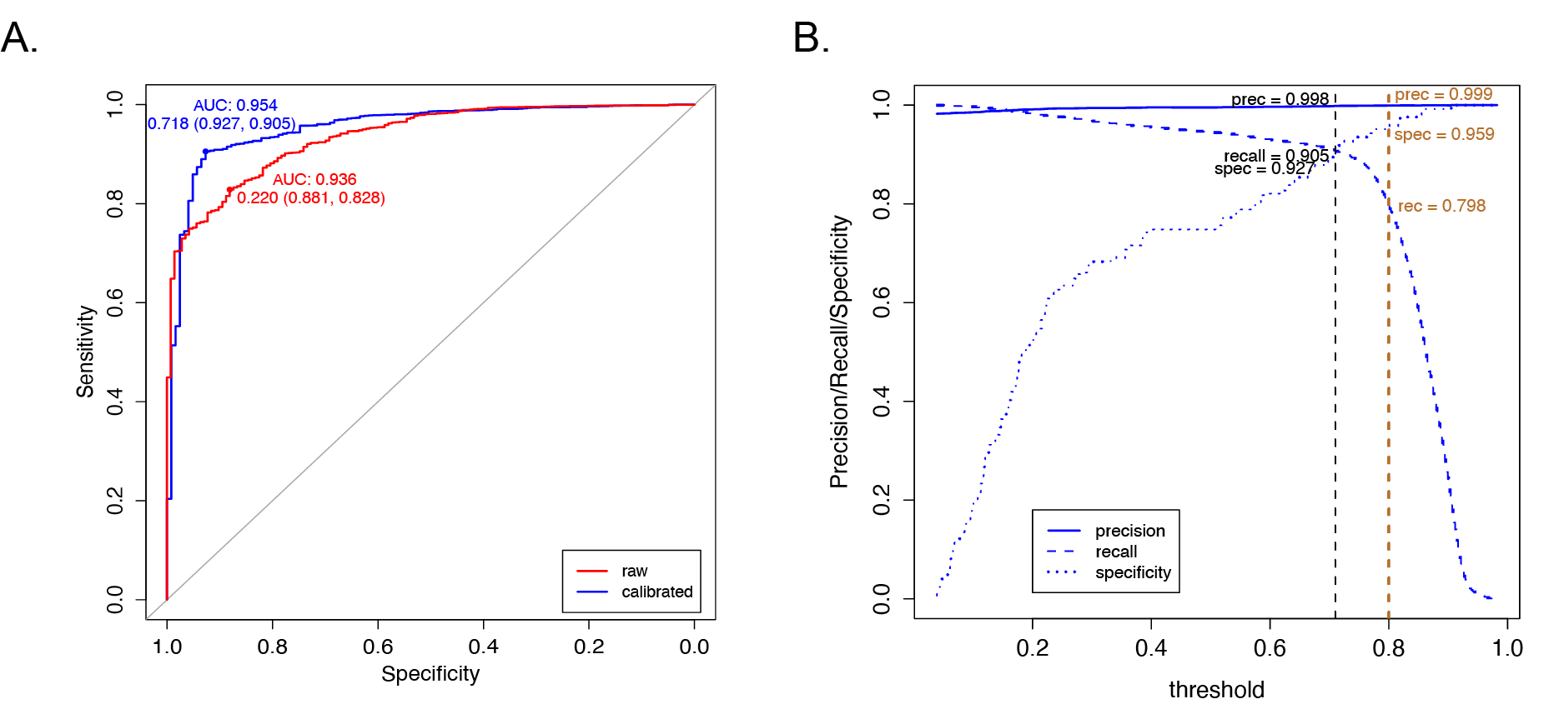
Figure S1. ROC and threshold analysis for classifiable and non-classifiable methylation family (MCF) cases. (A) ROC analysis of maximal aggregated raw (red) and calibrated (blue) predicted scores with the area under the curve (AUC) and the corresponding specificity and sensitivity that maximized the Youden Index. (B) Specificity, sensitivity (recall), and precision at different thresholds using calibrated scores. The black vertical line represents the suggested threshold by the threshold analysis. The gold vertical line represents the suggested threshold (≥ 0.8) for the methylation family (Figure 4).

Figure S2. Training and testing scheme for the supervised classifiers. Thirty percent of GSE90496 (842 samples) data was kept as an independent holdout test set for supervised models and referred to as inductive test sets for SSL models. The first RF model was trained with the 35% GSE90496 data (labeled samples used during the training of the best SETRED-SVM classifier). This model is the baseline model for evaluating SSL pseudo label application. All other RF models were trained using additional SSL labels from the 35% remaining GSE90496 samples +/- SSL labels from the GSE109379 samples with or without threshold constrain. Balanced accuracy and weighted recall were computed for each RF after seven repeated stratified 3-fold cross-validation and after predicting the labels of the inductive testing set. The 70-30 split was resampled seven times to create seven independent holdout test sets to better estimate the supervised classifiers' accuracy and errors. High confidence (HC) labeled samples have calibrated SSL prediction scores of at least 0.8. Low confidence (LC) labeled samples have calibrated SSL prediction scores below 0.8
Figure S3. Boxplots representing the average balanced accuracy of random forest (RF) and neural net (NN) models in predicting methylation family for the seven randomly sampled inductive test sets from the GSE90496 reference data. (A) Balanced accuracy of the RF classifiers for each methylation family. (B) Balanced accuracy of the NN classifiers for each methylation family. The first row in each panel shows the performance of the baseline models trained with 35% of the reference data. Models in other rows were trained in addition of semi-supervised learning predicted labels from GSE90496 and GSE109379 as described in Figure S2. Specifically, the second row shows the performance of RF and NN models trained in addition of all semi-supervised learning predicted labels. The third and fourth rows show the performance of RF and NN models that were additionally trained with low- or high-confidence semi-supervised learning labels.
Figure S4. Boxplots representing the average balanced accuracy of random forest (RF) and neural net (NN) models in predicting methylation subclass for the seven randomly sampled inductive test sets from the GSE90496 reference data. (A) Balanced accuracy of the RF classifiers for each methylation subclass. (B) Balanced accuracy of the NN classifiers for each methylation subclass. The first row in each panel shows the performance of the baseline models trained with 35% of GSE90496 labels. Models in other rows were trained in addition of semi-supervised learning predicted labels from GSE90496 and GSE109379 as described in Figure S2. Specifically, the second row shows the performance of RF and NN models trained in addition of all semi-supervised learning predicted labels. The third and fourth rows show the performance of RF and NN models that were additionally trained with either low confidence or high confidence semi-supervised learning labels, respectively.
SUPPLEMENTARY TABLES

Table S1. The 11 semi-supervised learning models
Methods | Addition Mechanism | Classifiers | Learning paradigm | Teaching | Learner
Self-training | incremental | single | single | self | 1-NN
Self-training | incremental | single | single | self | C5.0
Self-training | incremental | single | single | self | SVM
SETRED | amending | single | single | self | 1-NN
SETRED | amending | single | single | self | C5.0
SETRED | amending | single | single | self | SVM
SNNRCE | amending | single | single | self | 1-NN (fixed)
Tri-training | incremental | multi | single | mutual | 1-NN
Tri-training | incremental | multi | single | mutual | C5.0
Tri-training | incremental | multi | single | mutual | SVM
Democratic-Co | incremental | multi | multi | mutual | 1-NN/SVM/C5.0

