Additional file

1. Additional participant characteristics
Where in England did participants access care? | London | South East | South West | Midlands | North East | North West
 | 24 | 11 | 5 | 3 | 1 | 2

Occupation | Health sector | Charity sector | Arts sector | HR/  Administration | Marketing | Law | Other
 | 7 | 7 | 7 | 4 | 3 | 3 | 15

Ethnicity (self described) | White British | White European | Mixed | Black and White African | Indian | White Jewish | White Other
 | 35 | 4 | 3 | 1 | 1 | 1 | 1

2. Key policies mapped against Covid-19 “waves” in the UK March 2020-March 2021 (measured by number of new hospital admissions)

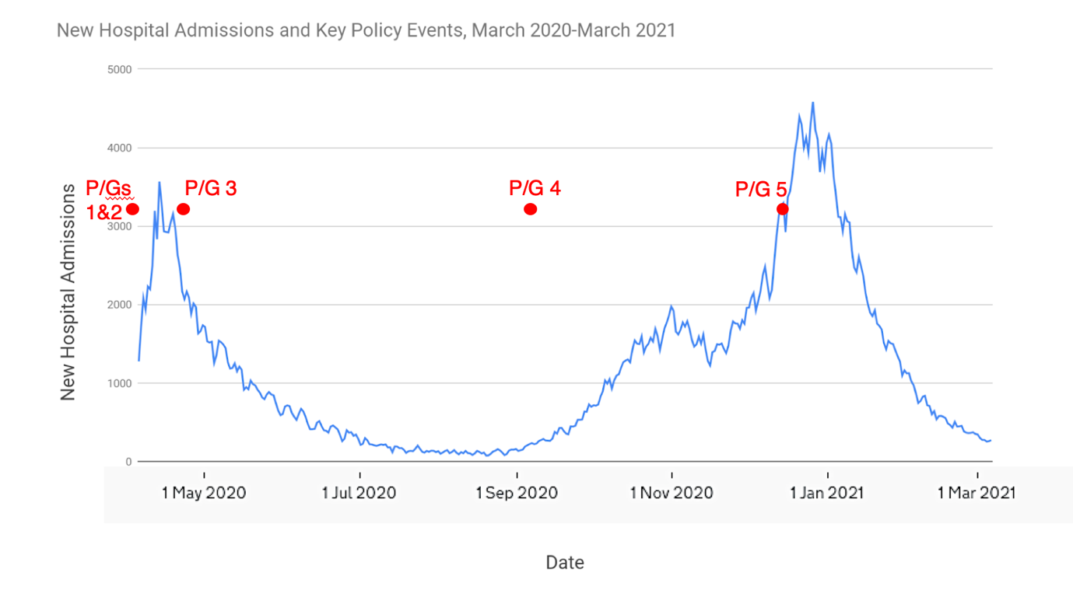
P/G # | Name /title
1 | Research and analysis: Coronavirus in pregnancy and delivery: rapid review and expert consensus, 9 March 2020
2 | Guidance on shielding and protecting people who are clinically extremely vulnerable from COVID-19
3 | NHS England Speciality Guide: Clinical guide for the temporary reorganisation of intrapartum maternity care during the coronavirus pandemic
4 | Framework to assist NHS trusts to reintroduce access for partners, visitors and other supporters of pregnant women in English maternity services
5 | Supporting pregnant women using maternity services during the coronavirus pandemic: Actions for NHS providers
6 | Pregnancy and coronavirus (no date)
7 | Coronavirus: Looking after yourself and your baby in pregnancy (no date)
8 | Coronavirus: Planning your birth (no date)

3. Policy review protocol

A brief literature review was conducted in CINAHL Plus, PubMed and Web of Science using terms related to ‘maternity’ AND ‘policy’ AND ‘COVID-19’ AND ‘UK’, in order to ensure a policy review of some kind regarding maternity and COVID-19 within the UK did not already exist.

Term 1: maternity OR pregnancy OR childbirth OR birth OR labour OR delivery OR antenatal OR prenatal OR obstetric
Term 2: policy or policies or law or laws or legislation
Term 3: covid-19 or coronavirus or 2019-ncov or sars-cov-2 or cov-19
Term 4: uk or united kingdom or britain or england or wales or scotland or northern ireland

Review aim(s)
The aim of the maternity and Covid-19 policy review is to identify guidelines released for pregnant women and maternity healthcare delivery changes over the duration of the Covid-19 pandemic in the UK in order to contextualise experiences/perceptions captured by interview data.

Policy review specific research question(s)
- What maternity recommendations and service changes were made over the duration of the Covid-19 pandemic?
- How do the policies and guidelines contrast with experiences in practice (as reported within interview data)?

Methods
Criteria for considering studies for this review
We will search published policies and guidelines specifically designed to address maternity recommendations or service delivery. We will use the following criteria to select the studies during searching (searching and screening will happen in one stage):

 | Inclusion | Exclusion
Participants | - ‘low-risk’ pregnant women  - AND using NHS maternity services  - AND for pregnancy or delivery  - AND during the Covid-19 pandemic | - ‘High-risk’ women  - OR non-NHS services  - OR post-delivery  - OR pre-Covid-19
Intervention | Policies or guidelines specifically designed for:  - maternity healthcare delivery in response to Covid-19  - OR to advise pregnant women in response to Covid-19 | Policies or guidelines specifically designed to address:  - healthcare in response to Covid-19 with no maternity components
Comparator | N/A
Outcomes | - service delivery in response to Covid-19  - OR maternity recommendations in response to Covid-19 | - simply stating pregnant women as high-risk with regards to Covid-19 without making any reference to recommendations or service delivery
Study design | Not limited based on design
Setting | - United Kingdom (UK)  - AND January-current | - Non-UK  - OR pre-January

Search methods for identification of studies
We will hand search relevant websites using search boxes, or in the instance search boxes do not exist we will search relevant tabs and sections of the website. We will cross-reference hand searching using the HF policy tracker.

Relevant Websites
Level of operation | Name of Organisation | Link
National | UK Government | https://www.gov.uk/
National | NHS | https://www.nhs.uk/
National | Public Health England (PHE) | https://www.gov.uk/government/organisations/public-health-england
National | SAGE | https://www.gov.uk/government/organisations/scientific-advisory-group-for-emergencies

Databases
HF policy tracker | https://www.health.org.uk/news-and-comment/charts-and-infographics/covid-19-policy-tracker

Search strategy
Term 1: Maternity (OR pregnancy OR childbirth OR birth OR labour OR antenatal OR prenatal OR obstetric)
AND Term 2 COVID-19 (OR coronavirus)

