Supplementary information
Promoter Motif and conserved module analysis in DNA and RNA using AlModules

Muharrem Aydinli¹*, Chunguang Liang¹*, Thomas Dandekar^{1,§}
¹ Department of Bioinformatics, Biocenter, Am Hubland, D-97074 University of Würzburg

This supplement evaluates and compares AIModules to alternative software and programs.

Independent 2nd file:
- Data-Supplements.zip (AIModules_vs_Genomatix_Crude_Results in detail are given)

Comparison to Commercial Product
We compared our solution AIModules to a commercial product regarding not only the results for TFBS, but also the results from the module search.

- First we looked at found TFBSs
  - For the cathepsins

Table S 1 Parameters for TFBS search for AIModules and Genomatix (1) for cathepsins.
AIModules | Genomatix (Matinspector)
The log likelihood ratio score was set to six and the maximum log likelihood deficit to eight. Jaspar matrices from vertebrates were selected. | The Matrix Family Library Version 11.1 was used with vertebrates matrices (0.75/Optimized) and General Core Promoter Elements (0.75/Optimized)

One matrix can generate N Hits.
Table S 2 TFBS search with AIModules and Genomatix for cathepsins. We analyzed three cathepsin promoters for TFBSs and AIModules generated much more TFBSs than Genomatix. Both tools share common TFBSs. (sequence names: a = Homo_sapiens_cathepsin_V_transcript_variant-1_promoter, b = Bos_taurus_cathepsin-Z_promoter, c = Mus_musculus_cathepsin-F-transcript-variant-X1_promoter_576-1076)
Sequence name | a | b | c
AIModules TFBS count | 253 | 322 | 492
Genomatix TFBS count | 155 | 224 | 166
Common TFBSs or family | 15 | 21 | 24

AIModules found more TFBS in all cases compared to Genomatix. A small portion of the found TFBSs is shared by both systems.

  - for IL-10
Table S 3 Parameters for TFBS search for AIModules and Genomatix for IL-10.
AIModules | Genomatix (Matinspector)
The log likelihood ratio score was set to six and the maximum log likelihood deficit to eight. Jaspar matrices from vertebrates were selected. | The Matrix Family Library Version 11.1 was used with vertebrates matrices (0.75/Optimized) and General Core Promoter Elements (0.75/Optimized)

One matrix can generate N Hits.
Table S 4 TFBS search with AIModules and Genomatix for IL-10. We analyzed three IL-10 promoters. AIModules found much more TFBS in all the three cases and both applications shared common TFs. (sequence names: a = X73536.1_H.sapiens_promoter_region_of_human_IL-10_gene, b = AY486432.1_Macaca-mulatta_interleukin-10-(IL-10)_gene_promoter_region, c = AF121965.1_Mus-musculus_interleukin-10-(IL10)_gene_promoter_partial_sequence)
Sequence name | a | b | c
AIModules TFBS count | 918 | 963 | 212
Genomatix TFBS count | 289 | 350 | 93
Common TFBSs or family | 36 | 49 | 16

AIModules found more than double the count of TFBSs than Genomatix in all the three cases and a small fraction of the TFBSs is shared between both systems.
With these settings we found for X73536.1_H.sapiens_promoter_region_of_human_IL-10_gene and AY486432.1_Macaca-mulatta_interleukin-10-(IL-10)_gene_promoter_region the TFs MA0519.1 Stat5a::Stat5b, MA0518.1 Stat4, MA0137.3 STAT1 and MA0144.2 STAT3 but not for AF121965.1_Mus-musculus_interleukin-10-(IL10)_gene_promoter_partial_sequence.
Genomatix shows the same picture with no Stat TF for AF121965.1_Mus-musculus_interleukin-10-(IL10)_gene_promoter_partial_sequence. The common TFBSs can be found in Table S 13-Table S 18.
- Second we looked at the modules found
  - For the cathepsins

Table S 5 Parameters for module search for AIModules and Genomatix for cathepsins.
AIModules | Genomatix (ModelInspector)
The log likelihood ratio score was set to six and the maximum log likelihood deficit to eight. Jaspar matrices from vertebrates were selected. The module search checkbox was activated and the threshold for TFs to be valid for module filtering was set to 3 (the amount of user input sequences). | The Vertebrate_Modules Version 6.3 and the Matrix Family Library Version 11.1 were used. Threshold for number of elements: 100.0%  Maximum number of matches: 1000

All counts include modules on the forward and reverse strand.
Table S 6 Module search with AIModules and Genomatix for cathepsins. We analyzed three cathepsin promoters for modules in both, AIModules and Genomatix. AIModules found much more Modules in all three cases compared to Genomatix. There were no common modules. (sequence names: a = Homo_sapiens_cathepsin_V_transcript_variant-1_promoter, b = Bos_taurus_cathepsin-Z_promoter, c = Mus_musculus_cathepsin-F-transcript-variant-X1_promoter_576-1076)
Sequence name | a | b | c
AIModules modules count | 486 | 1,497 | 640
AIModules TFBSs count | 47 | 79 | 60
Genomatix modules count | 15 | 29 | 9
Common modules | 0 | 0 | 0

AIModules found more modules than Genomatix in all three cases – at least by the factor 10. Common modules were not identified by manual comparison.
  - for IL-10

Table S 7 Parameters for modules search for AIModules and Genomatix for IL-10.
AIModules | Genomatix (ModelInspector)
The log likelihood ration score was increased to seven, as the calculation of the modules took long, and the maximum log likelihood deficit was set to eight. Jaspar matrices from vertebrates were selected. The module search checkbox was activated and the threshold for TFs to be valid for module filtering was set to 3 (the amount of user input sequences). | The Vertebrate_Modules Version 6.3 and the Matrix Family Library Version 11.1 were used. Threshold for number of elements: 100.0%  Maximum number of matches: 1000

All counts include modules on the forward and reverse strand.
Table S 8 Module search with AIModules and Genomatix for IL-10. We analyzed interleukin genes for modules in AIModules and Genomatix. AIModules found much more modules than Genomatix. There were no common modules. (sequence names: a = X73536.1_H.sapiens_promoter_region_of_human_IL-10_gene, b = AY486432.1_Macaca-mulatta_interleukin-10-(IL-10)_gene_promoter_region, c = AF121965.1_Mus-musculus_interleukin-10-(IL10)_gene_promoter_partial_sequence)
Sequence name | a | b | c
AIModules modules count | 941 | 1,131 | 502
AIModules TFBSs count | 62 | 80 | 52
Genomatix modules count | 13 | 15 | 3
Common modules | 0 | 0 | 0

AIModules found more modules than Genomatix in all the three cases – at least by the factor 10. Common modules were not identified by manual comparison. The found TFBSs and modules are documented in Supplements.zip.
Since there are no common modules, we will not elaborate the found modules further.

User Interface
We tried to keep the User Interface as simple as possible so any new user can easily use AIModules (see Figure S 2-Figure S 8).

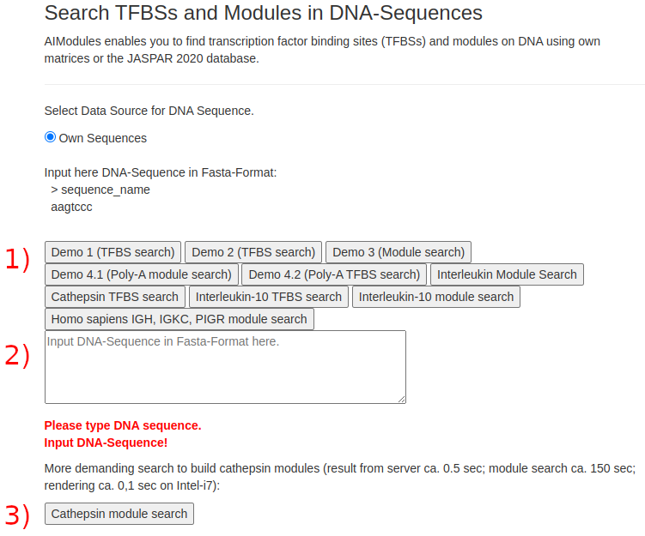
Figure S 1 AIModules. The numbers in RED are inserted to ease the description in this paper. 1) Buttons for different analyses. 2) The text field in which the user can input Fasta formatted DNA sequences and also RNA sequences. In the latter case the Uracil (U) is converted into Thymine (T). 3) A more demanding analysis: The backend responds with the TFBSs in 0.5 sec, and the client calculates the modules in 150 secs and renders the final result in 0.1 sec. (Please note, that the figure states “Jaspar 2020”. However, the database has been updated to Jaspar 2022 without changes to the website. Please visit https://bionifo-wuerz.de/aimodules for the newest version.)

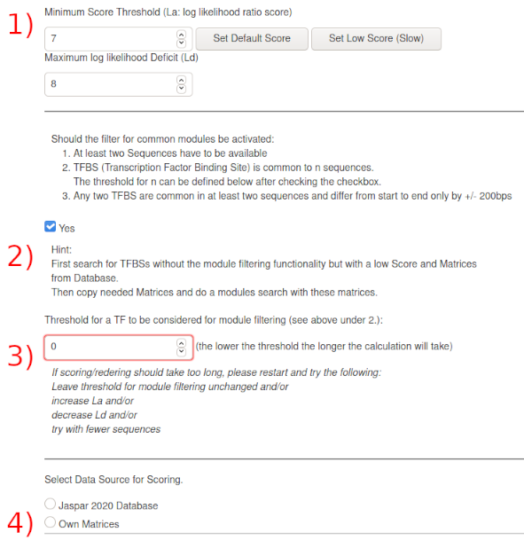
Figure S 2 AIModules continued. The numbers in RED are inserted to ease the description in this paper. 1) The maximum log likelihood Deficit defines a threshold below the maximum log likelihood ratio where results are valid. The maximum log likelihood ratio for a matrix is the consensus sequence, where each position can contribute up to 2 bits to the result. 2) This checkbox activates the module filtering function but is optional for a plain search for TFBSs. 3) When the checkbox is checked a stepper is revealed, which shows the number of sequences the user has input. This parameter can be changed and defines in how many of the user input sequences a TF has to be found to be valid for module filtering. 4) Two radio buttons: The upper one allows for the selection for saved Jaspar Matrices, the lower one activates a text field for the user to input own matrices in Fasta format. (Please note, that the figure states “Jaspar 2020”. However, the database has been updated to Jaspar 2022 without changes to the website. Please visit https://bionifo-wuerz.de/aimodules for the newest version.)

Matrices can either be selected from the database (see Figure S 4) or be input manually (see Figure S 5).
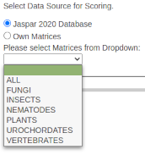
Figure S 3 Matrices from supported phyla can be chosen from...
(Please note, that the figure states “Jaspar 2020”. However, the database has been updated to Jaspar 2022 without changes to the website. Please visit https://bionifo-wuerz.de/aimodules for the newest version.)

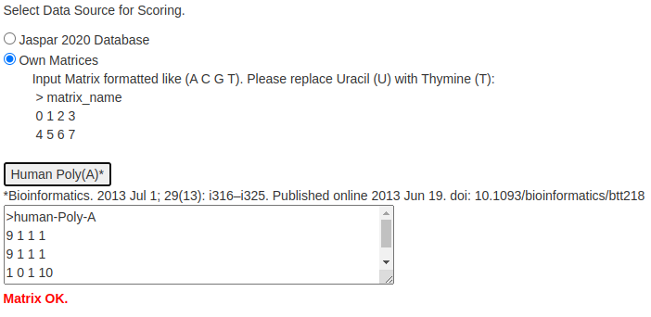
Figure S 4 ...or manually inserted. Furthermore, a matrix from human Poly-A tails is available for selection.
(Please note, that the figure states “Jaspar 2020”. However, the database has been updated to Jaspar 2022 without changes to the website. Please visit https://bionifo-wuerz.de/aimodules for the newest version.)

When the DNA/RNA sequences and the matrices pass the regular expression search pattern, the Score button becomes visible. When it is used the request is send to the backend. The response then is rendered (see Figure S 6).
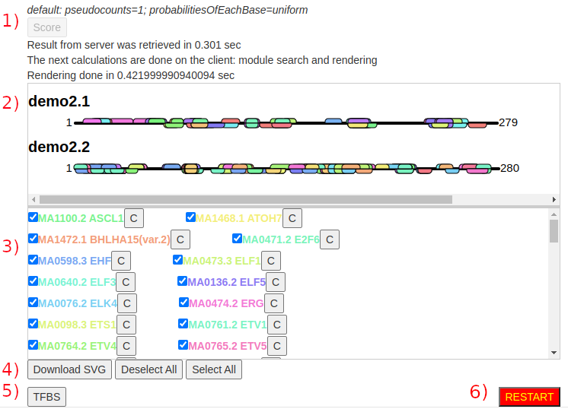
Figure S 5 Result for TFBS search. The numbers in RED only ease the description done here and are not shown on the website. Most of the controls on the website have a mouse-over functionality implemented. 1) After using the Score Button it becomes inactive. Below the button timers start. When the response takes too long, the request has to be altered in a way, that the load for the backend or frontend is reduced, e.g. by using fewer sequences or increasing La or decreasing Ld or reducing the number of the matrices. 2) The result is rendered into a SVG container. The sequence name is depicted. The black line indicates the sequence itself. Above the black line are the TFBS hits for the (+) strand and below for the (-) strand. Each matrix has its own color which corresponds to the list in 3). Here are all the valid results with the colors used in 2). To the right is a button with a C. This button can be used to copy the matrix into the clipboard. Each matrix can be deselected and selected again. This selection has a direct binding to 2). If the user deselects all matrices the resulting picture in 2) will be empty. 2) and 3) can be downloaded as SVG files. For that, the user has to click the button Download SVG. The selection from 3) can be viewed as a table. For that the user has to click the button depicting TFBS (5)). For the next analysis the session has to be restarted (6)).

The timer below the Score button becomes active and indicates that the request has been sent. It stops when the response is retrieved, which is then rendered on the client side. Furthermore, module and rendering timers are also visible. We decided for client side rendering to reduce the load on our servers. If rendering is completed the result is shown in an SVG-container. If either the timer takes too long and does not stop, or the rendering takes too long, then the user may send another request with either less sequences, or higher La, or lower Ld, or less matrices, or a combination of the aforementioned.
The button TFBS opens another browser instance and shows the selected result as a table (see Figure S 7).
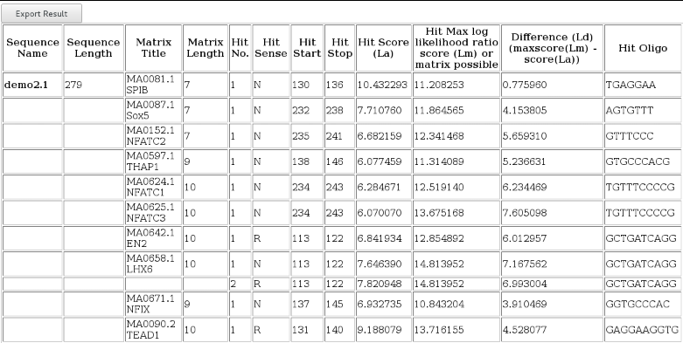
Figure S 6 The TFBS Result Page. The table can be downloaded as an Excel file using the Export Result button.
When the initial analysis to find TFBSs is finished the user can venture towards finding modules. For that the matrices of interest can be selected and be input into the Own Matrices text field (see Figure S 5). For module searches the corresponding checkbox has to be activated. A putative module is an arrangement of two consecutive TFBSs. These have to be (a) common to n input sequences (see Figure S 2 2)-3)), (b) cannot differ from start to end more than +/- 200 base pairs and (c) this arrangement of two TFBSs have to be common to at least two input sequences. When rendering the response is completed the user is presented with an extra button Modules.

Behind this extra button lies the putative modules depicted as a table. The table can be downloaded as an Excel file using the Export Result button as well. Moreover, the user may select and deselect TFBSs to arrange and analyze selected modules.

Furthermore, the web service allows for the conversion of putative homologous TFBSs sequences to a matrix format, that can be used in the web service itself (see Figure S 8).
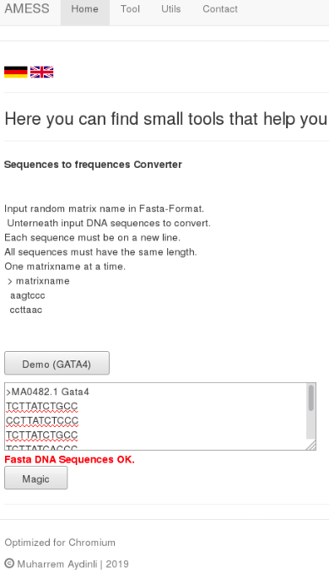
Figure S 7 Matrix Generator. The user can input putative homologous TFBSs with the same length. The tool then calculates the matrix to be used in this web service.

The result is a matrix (see Figure S 9) which can be used to find TFBSs or modules (see Figure S 5).

Matrix Generation
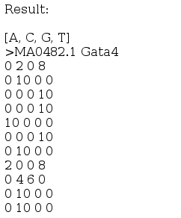
Figure S 8 Result from Matrix Generator.

TFs bind to TFBSs and therefore play a major role in gene expression. They bind promoters and enhancers and can recruit other factors or the RNA-Polymerase, but can also reduce gene transcription by binding to repressors. TFs bind specifically to DNA sequences with the highest similarity to the consensus sequence. Identifying TFBSs suggest that transcription is regulated by the corresponding TF. This task of finding those sites is performed in silico by using a sort of matrix.
A position weight matrix (PWM) is a form of representing a consensus sequence while also taking into account the variability of nucleotides at each position (2) (3). For generating such a PWM, functional related sequences are aligned (Table 1) and the occurrences of each nucleotide in each position are counted (4) (5). In this first step you'll get the position frequency matrix (PFM) with the absolute frequencies of each nucleotide (6) (7).
Table S 9 Sequence alignment.
Sequenz 1 | GAGGTAAAC
Sequenz 2 | TCCGTAAGT
Sequenz 3 | CAGGTTGGA
Sequenz 4 | ACAGTCAGT
Sequenz 5 | TAGGTCATT
Sequenz 6 | TAGGTACTG
Sequenz 7 | ATGGTAACT
Sequenz 8 | CAGGTATAC
Sequenz 9 | TGTGTGAGT
Sequenz 10 | AAGGTAAGT

Position Frequency Matrix (PFM)
$$M=\begin{matrix}A \\ C \\ G \\ T\end{matrix}\left[\begin{matrix}3 & 6 & 1 & 0 & 0 & 6 & 7 & 2 & 1 \\ 2 & 2 & 1 & 0 & 0 & 2 & 1 & 1 & 2 \\ 1 & 1 & 7 & 10 & 0 & 1 & 1 & 5 & 1 \\ 4 & 1 & 1 & 0 & 10 & 1 & 1 & 2 & 6\end{matrix}\right]$$
The PFM can be converted into a position probability matrix (PPM) where the relative frequencies or probabilities are depicted. For that each position in the PFM is divided by the total amount of sequences, or by using the equation from below. Each element in this matrix can be seen as the probability of a nucleotide being found at a specific position in a functional site.
Equation for calculating from a PFM a position probability matrix (PPM)$\begin{aligned}M_{i,j}=\frac{1}{n}\sum_{k=1}^{n}{I_{i}}\left(s_{k,j}\right) \\ with s_{k}=s_{k1},⋯,s_{kl} \\ s_{k,j} an Element of\{A,C,G,T\} \\ i=A,C,G,T \\ j=1,⋯,l \\ The indicator function \\ I_{i}\left(q\right)=\{\begin{matrix}1, if i=q \\ 0,else\end{matrix}\}\end{aligned}$
The PPM is displayed below.
Position Probability Matrix (PPM)
$$M=\begin{matrix}A \\ C \\ G \\ T\end{matrix}\left[\begin{matrix}0.3 & 0.6 & 0.1 & 0.0 & 0.0 & 0.6 & 0.7 & 0.2 & 0.1 \\ 0.2 & 0.2 & 0.1 & 0.0 & 0.0 & 0.2 & 0.1 & 0.1 & 0.2 \\ 0.1 & 0.1 & 0.7 & 1.0 & 0.0 & 0.1 & 0.1 & 0.5 & 0.1 \\ 0.4 & 0.1 & 0.1 & 0.0 & 1.0 & 0.1 & 0.1 & 0.2 & 0.6\end{matrix}\right]$$

The probability of finding a functional site with this PPM of the length nine on a sequence is the product of each probability from the matrix corresponding the nucleotides on the sequence. The ratio between the probability on a real sequence and a random sequence is called the likelihood ratio, the logarithm thereof the log likelihood ratio.
The log likelihood ratio can also be computed and put into a position weight matrix (PWM). PWMs are represented as log likelihoods in the form that the probabilities at each position in the matrix are divided by the background model and the logarithm to the base two is applied to the result of the division. Therefore, the elements of the PPM are transformed with the equation from below.

Equation for calculating from a PPM a position weight matrix (PWM) $\begin{aligned}M_{i,j}=\log_{2}\left({M_{i,j}}/{p_{i}}\right) \\ with first{ M}_{i,j }as the resulting log likelihood of the PWM of nucleotide i at position j \\ second M_{i,j }as the probability of the PPM of nucleotide i atposition j \\ p_{i} as the background model for nucleotide i \left(assuming a uniform distribution: p=0,25\right)\end{aligned}$

The result is the PWM (see below).
Position Weight Matrix (PWM)
$$M=\begin{matrix}A \\ C \\ G \\ T\end{matrix}\left[\begin{matrix}0.26 & 1.26 & -1.32 & -∞ & -∞ & 1.26 & 1.49 & -0.32 & -1.32 \\ -0.32 & -0.32 & -1.32 & -∞ & -∞ & -0.32 & -1.32 & -1.32 & -0.32 \\ -1.32 & -1.32 & 1.49 & 2.00 & -∞ & -1.32 & -1.32 & 1.00 & -1.32 \\ 0.68 & -1.32 & -1.32 & -∞ & 2.00 & -1.32 & -1.32 & -0.32 & 1.26\end{matrix}\right]$$
If the dataset is small -∞ can occur as a result. To avoid this, pseudocounts can be added. When scanning a sequence with a PWM for functional sites the log likelihoods can be summed up, rather than multiplied when using a PPM. The PWM considers the frequencies of each base and the information content compared to a random sequence, hence reducing entropy.
Each position in a PWM (and PPM) is thought to be statistically independent from all other positions. The resulting sequence score shows the tendency of the site to be a functional site. Since a log likelihood score is used: (1) If the score is less than zero, then the site is more likely a result of a random event, (2) if it is greater than zero, then the site is more likely to be a functional one, (3) if it is equal to zero, than the site's probability to be a functional or a random site is equal.
Using PFMs AIModules can predict TFBSs and present them in a graphical form. The PFMs are converted into PWMs during the calculation on the server. Furthermore, the module search functionality can be activated to find putative modules on two or more sequences.

Mathematical Consideration
A matching unambiguous base contributes to the score by the value of two. I.e. that a matrix of six base pairs or length would have a max score of 6*2 = 12 (=Lm). La represents the minimum log likelihood ratio or smoothed log likelihood ratio score. As some PWMs have a low number of sequences as a basis these can be improved by smoothing the estimates, i.e. by adding a small number of pseudocounts to each position in proportion of a background model. Since the Jaspar (8) matrices with less than 20 aligned sequences are not included in this software setup the smoothing of estimates does not play a crucial role and is by default one, i.e. 0.25 for each nucleotide. Lm represents the maximum possible score of a PWM. Therefore, it represents the consensus sequence. Ld represents the maximum log likelihood deficit (Lm-La) and is used to filter the results as the upper threshold. It has to be noted that La and Ld can produce conflicting results as a higher Ld allows for longer PWMs that have poorer scores and a large La will favor longer and prevent short PWMs. For default scoring we use an La of 7 and Ld of 8. These values can be changed to limit the result of the TFBSs or found modules. The result always represents the (+) and (-) strand. Furthermore, the rendering of the result is done on the client side so that it is possible that this step takes long. If it takes too long, then the user may decrease the number of input sequences or matrices and increase La and/or decrease Ld.
The putative binding sites include false negatives and false positives. These can be reduced in number by using short sequences or less matrices or long matrices with many aligned sequences or a combination of the mentioned hints. Furthermore, setting the La and Ld parameters more strictly can help filter out false negatives and false positives. The use of a background model which is found in the backend of AIModules is second in place when it comes to increasing the value of the predictions. I.e., that CG poor input sequences with a uniform background model or a slightly AT rich background model do not produce more reliable results, because AT-rich hits get decreased in significance and GC rich hits increased.
It is better to compare the distribution of the scores to the score distribution of a selected test set specifically assembled for each analyzed promoter. This set should reflect the base content of the input sequences (9). As far as we know this has not yet been implemented in any solution.
The log likelihood ratio score is the sum of all the bases from a PWM, where each base can contribute up to 2 bits. When every base contributes these 2 bits of information, you will get the maximum log likelihood ratio score (Lm) or the consensus sequence (10) (11) (12) (13).
The self-information of an element in a PWM is
$$I\left(i\right)=-p_{i,j}*\log_{2}\left(p_{i,j}\right)$$
and the Information Content (IC) of a PWM
$$I\left(i\right)=-\sum{p_{i,j}}*\log_{2}\left(p_{i,j}\right)$$
and with the background frequency the IC is
$$I\left(i\right)=-\sum{p_{i,j}}*\log_{2}\left({p_{i,j}}/{p_{j}}\right)$$
The IC measures the level of conservation which begins from zero (no conservation of position) and ends with two (strictly conserved position). For completely conserved positions the IC is two bits. To get the total IC of the whole PWM the IC of each position has to be summed up. The next occurence of this PWM appearing next to a found hit is 2^{IC}. That means that longer and stronger PWMs with a high La produce more reliable matches. A perfectly conserved 8-mer would therefore have an IC of 8*2=16.
The backend calculates the score via a smoothed log likelihood ratio score (10) (12).

Using Docker containers
As the backend code is not optimized for data parallelism, we sought a way to handle future high loads on the system. Therefore, we prepared Docker swarm to increase the number of instances per layer as the load increases (see Figure 10). The Docker swarm operates on nodes. These nodes can be physical or virtual servers, i.e. the load of the containers can be shared across many systems.

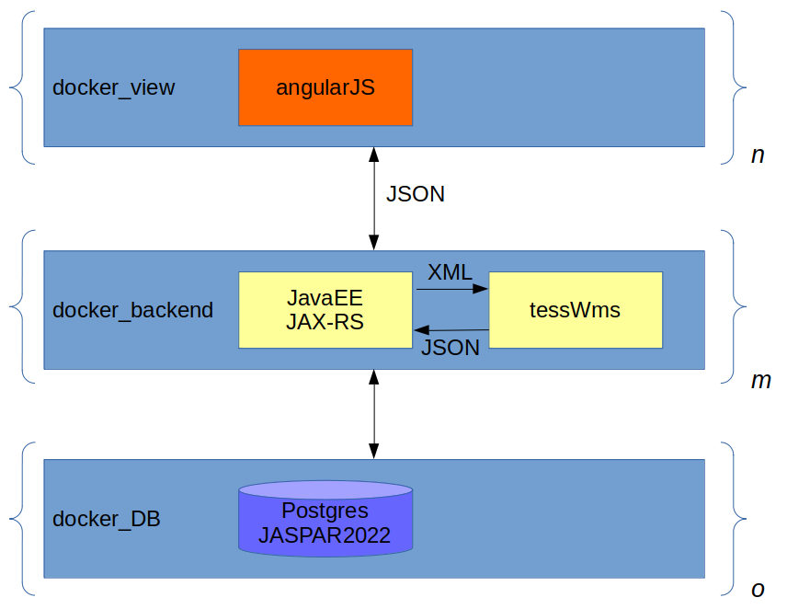
Figure S 9 Architecture of AMESS when Docker swarm is used. Each layer has an image template that can be used to create N containers.

Text field regex Warnings

When the text fields are empty the warnings are:
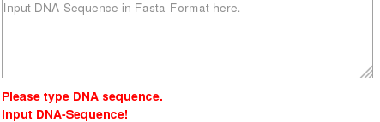

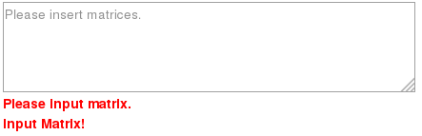
When regex validation fails:

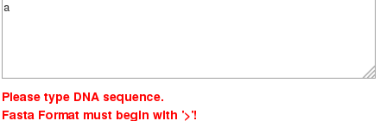
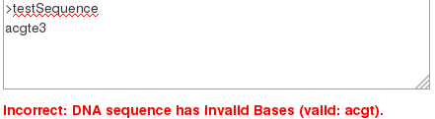
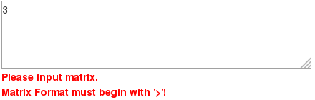

When all the input is correct the user will see this remark:
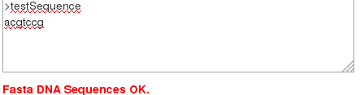

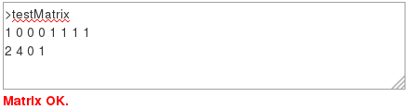

An Overview of the tools for TFBS discovery

MotifMap (14)
MotifMap shows TFBSs for model organisms using not only databases of transcription factor binding motifs, but genome alignments and statistical approaches (see Figure S 11, Figure S 12 and Figure S 13) (15).

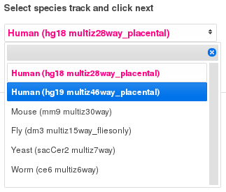
Figure S 10 Model Species can be selected in MotifMap.

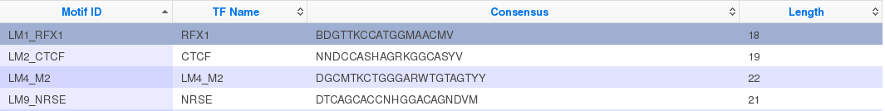
Figure S 11 A motif from that model organism can be selected.

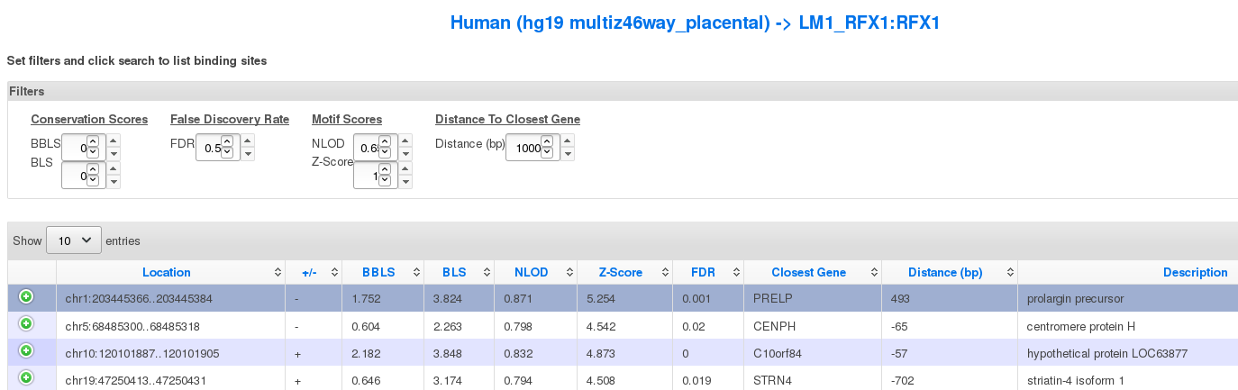
Figure S 12 MotifMap searches for this motif in the model organism's genome.

However, the tool does not support searches for common modules.

Promo (16) (17)
Promo is using the Transfac database to search for TFBSs for different organisms. In the first step you select the factors that should be considered. In the second step you can input DNA sequences to be searched for TFBSs, which are shown on the result page (see Figure S 14 to Figure S 19). Common Modules cannot be detected.

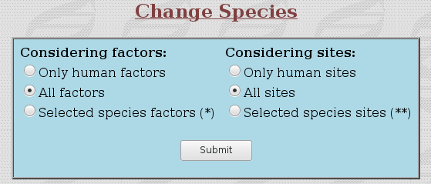
Figure S 13 Step one: What to consider for the analysis.

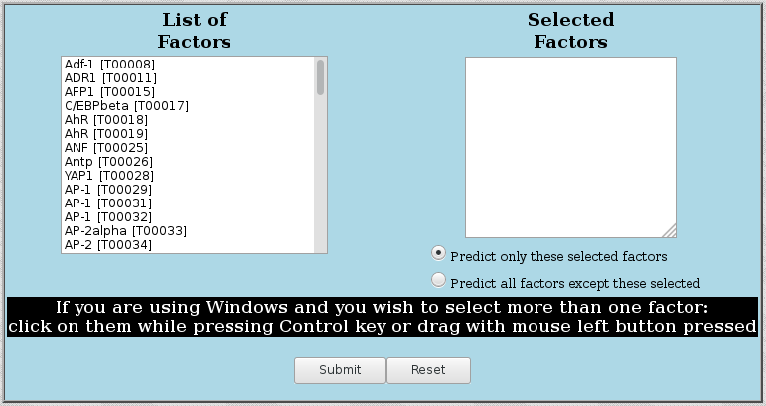
Figure S 14 Matrices can also be directly selected for analysis.

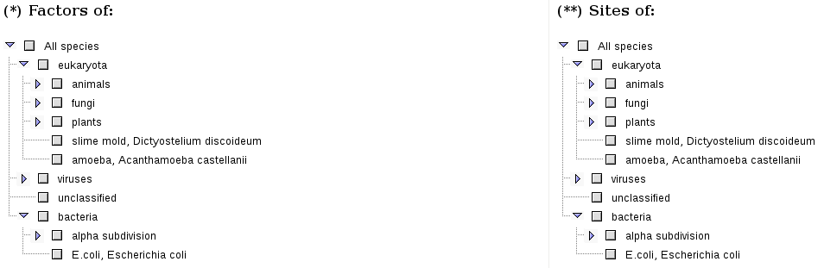
Figure S 15 Factors and sites to consider can be selected via checkboxes.

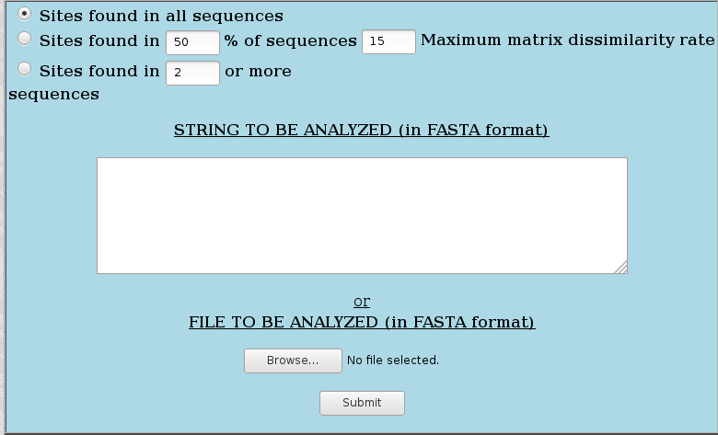
Figure S 16 ...or multiple sequences.

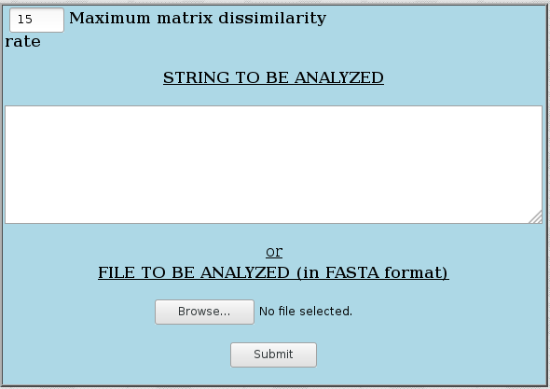
Figure S 17 One sequence can be analyzed...

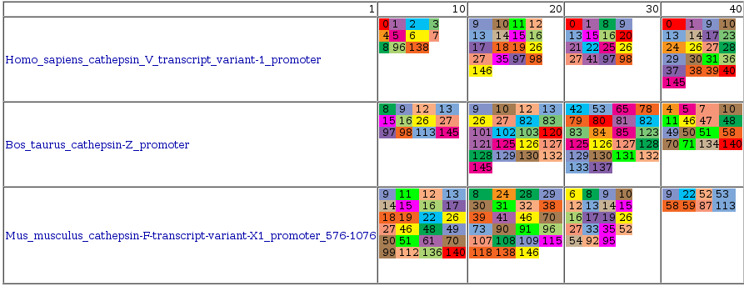
Figure S 18 The result from Promo show color encoded TFBSs.

ModuleMaster (18)
According to its website ModuleMaster allows to identify cis-regulatory modules using promoter analysis and microarray expression data regression. However, the authors of this paper were not able to start the WebStart application ModuleMaster on both Linux Mint 64bit and Windows 10 64bit. As the originating institute discontinued bioinformatics research there was no support. Furthermore, besides from not starting, at application start the user is confronted with a certificate warning.
The authors tried to start the Webstart App via
$ javaws mm.jnlp
and
$ javaws http://www.ra.cs.uni-tuebingen.de/software/ModuleMaster/downloads/start.php?fn=mm.jnlp
In both cases the error was
Caused by: java.lang.NoClassDefFoundError: javax/xml/soap/SOAPException
This error could not be resolved.

Prodoric® (19)
Prodoric® (PROcaryotICDatabase Of Gene Regulation) predicts TFBSs in prokaryotes using manually curated binding sites. This is done in the module Virtual Footprint (20) and in the submodule Promoter Analysis. There, the user can select a prokaryotic genome, then fixed matrices and begin the analysis (see Figure S 20).

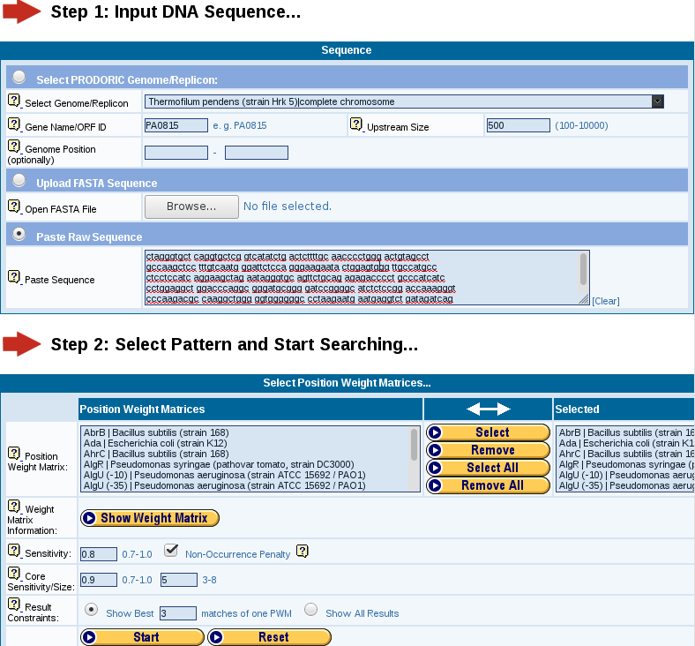
Figure S 19 Prodoric. Sequence and Matrix selection.

The result depicts found prokaryotic TFBSs (see Figure S 21).
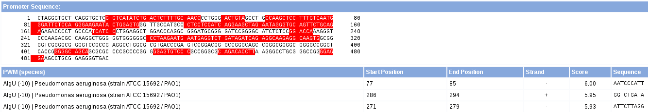
Figure S 20 Prodoric. Result of analysis. TFBSs are shown in a table.

Common Modules however, cannot be detected.

Softberry
Softberry, Inc. develops software tools for genomic research, amongst tools to search for functional and conserved TFBSs:
- PROMH(G): Promoter prediction using orthologous sequences (21)
- Nsite (22): Recognition of regulatory motifs (23) (24)
- NsiteH (25): Search for functional motifs conserved in orthologous sequences (24)
- NsiteM (26): Recognition of conserved regulatory motifs (23) (24)
All these tools produce text-style results without information about putative common modules. The user can insert one sequence at a time and another when comparing a sequence with an orthologous one.

TAIR (27)
Tair (The Arabidopsis Information Resource) (see Figure S 22) is a tool for promoter analysis, which allows for user input sequences. They are processed for TFBSs, which are common to at least three sequences. The TFBSs are constrained to 6-mers and the tool is made for the organism A. thaliana. Searches for common modules are not supported.
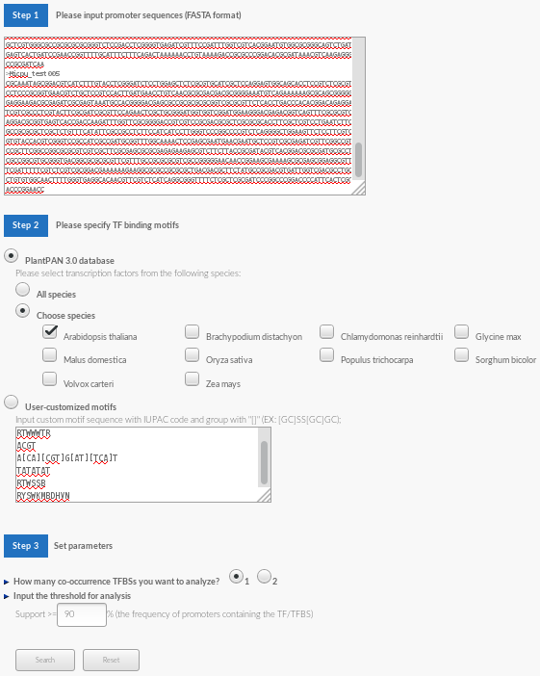
Figure S 21 PlantPan 3.0. The tool Gene Group Analysis allows for searching for TFBSs on a set of sequences.

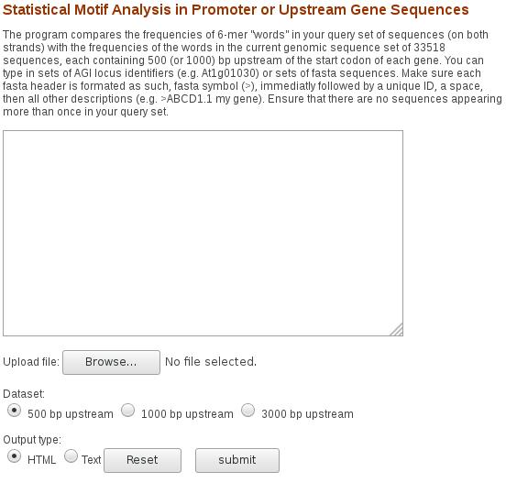
Figure S 22 Tair. A tool to search for 6-mer TFBSs from A. thaliana.

PlantPan 3.0 (28)
PlantPan 3.0 (The PlantPromoter Analysis Navigator) is a TFBS prediction tool for plant species. The user can input matrices as IUPAC code or can use predefined sets of matrices. The tool Gene Group Analysis (29) allows for scanning user provided sequences for TFBSs (see Figure S 22). Common Module discovery is not supported.

TESS - Transcription Element Search System
TESS (10) (11; 12) (According to the Software Licence this sentence has to be included in this document: „This product includes software developed by CBIL at the Center for Bioinformatics at the University of Pennsylvania.“) was a website for TFBSs prediction. According to the website, the tool itself is not available any more, as the author has left the group. The code for parts of the backend is provided and is used in AIModules for TFBS prediction.

Genomatix
Genomatix (1) (Owned by Intrexon Bioinformatics Germany GmbH) is a web service which is commercially available. After a free one-week trial period, it has to be licensed for further use. Furthermore, the trial version lacks some features. Available tools:
- MatInspector: Search sequence(s) for transcription factor binding sites, restriction sites, etc.
- Common TFs: Search multiple sequences for common transcription factor binding sites
- MatDefine: Create user-defined matrix from a set of short sequences
- FastM: Build user-defined models, i.e. modules, with spacers between them
- ModelInspector: Search sequence(s) for promotor co-cited modules or user-defined modules
The tool ModelInspector searches for modules that are found in each user-input sequence, but does not show modules that are common to the user input sequences.

TRANSFAC (30), (31)
TRANSFAC is another commercial product that can detect modules for eukaryotes. The Match algorithm can search for TFBSs and the Composite Search searches for modules (32). Genomes are available for eukaryotes, but sequences can be provided by the user as well. Matrices and modules are provided by TRANSFAC but custom ones can be inserted as well. There is a free version of TRANSFAC available that is outdated, from 2005 (33) and lacks functionalities (34). Furthermore, there is a trial access for TRANSFAC Professional available, which can be obtained via E-Mail (not tested by authors). The user may license TRANSFAC Professional. However, the service does not provide a functionality to search for common modules for the user input sequences.

ConTraV3 (35), (36)
ConTraV3 is a web application that allows for TFBS searches. For that model organisms can be chosen as well as a file with FASTA sequences. Matrices can be selected from the database or can be uploaded via a file upload (see Figure S 23). Common Module discovery is not supported.

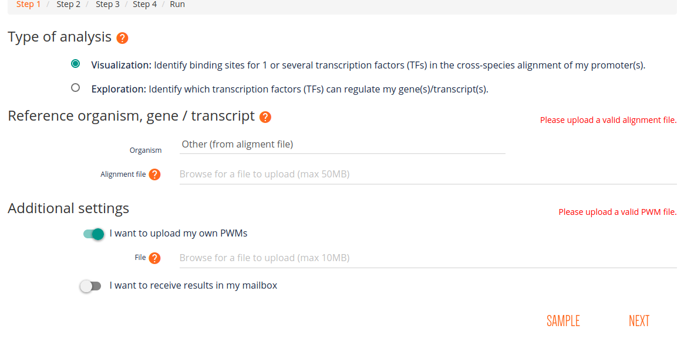
Figure S 23 ConTraV3. TFBSs can be searched for own sequences and with own matrices.

CisBP (37; 38)
CisBP offers a very large database of eukaryotic matrices and genomes. With this service the user can predict TFBSs (see Figure S 24). Moreover, matrices may be downloaded for many species or TF-families. Module discovery is not supported.

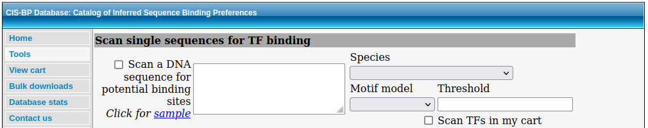
Figure S 24 CisBP. Prediction of TFBSs

UniPROBE (39; 40)
With this service the user may search for eukaryotic TFBSs. However, the service does not work reliably, so that the analysis did not work during the test (40). Module searches are not supported.
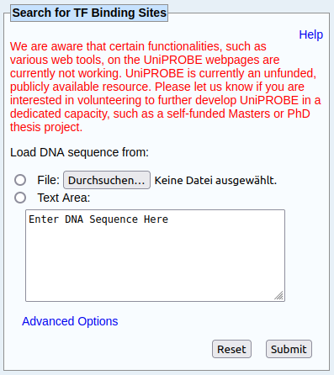
Figure S 25 UniPROBE. Search for eukaryotic TFBSs, however the search did not succeed, due to an internal error (40)

HOCOMOCO (41; 42)
HOMOCODO (HOmo sapiens COmprehensive MOdel COllection) is a collection of models for human and mouse. These models have their basis on ChiP-seq data. Via the “MoLoTool” the user may search for TFBSs (see Figure S 26). Module searches are not supported.
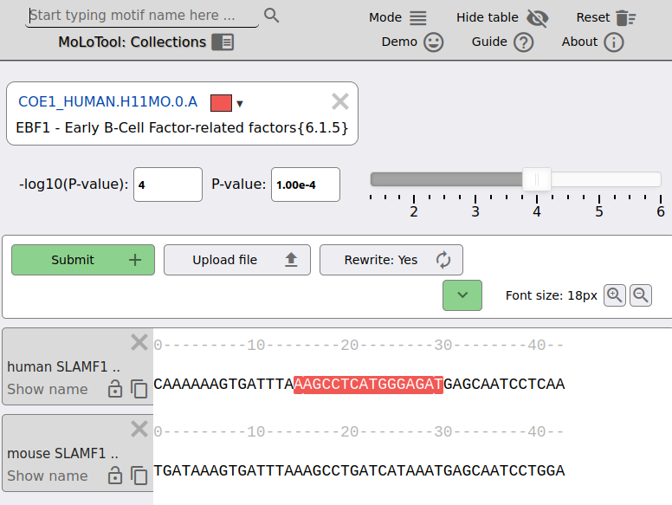
Figure S 26 HOMOCOCO MoLoTool. Search for TFBSs

FlyFactorSurvey (43)
FlyFactorSurvey provides genomes and matrices to predict TFBSs for Drosophila melanogaster (see Figure S 27). However, module searches are not possible via this service.

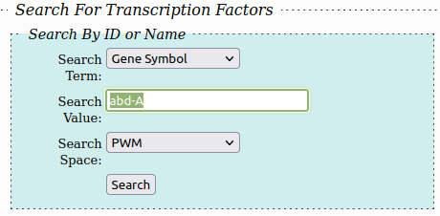
Figure S 27 FlyFactorSurvey. Search for TFBSs in Drosophila melanogaster

MEME Suite (44; 45)
The MEME Suite offers many tools as web services. One of which is “MEME”, that supports motif discovery in sequences (see Figure S 28). The suite, however, does not support to predict modules.

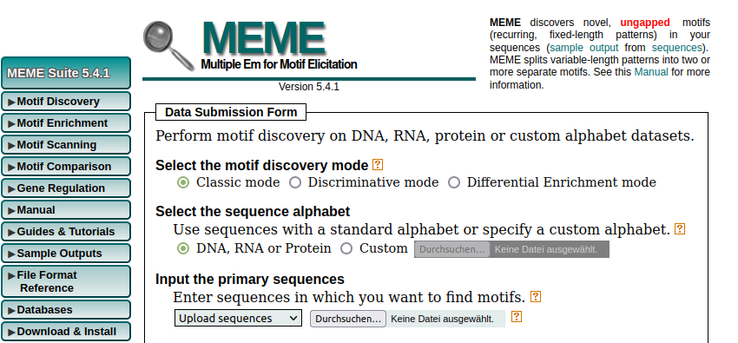
Figure S 28 MEME. Discovery of motifs on sequences

YeTFaSCo (46; 47)
YeTFaSCO (The Yeast Transcription Factor Specificity Compendium) allows the search for TFBSs via matrices for Saccharomyces cerevisiae (see Figure S 29). The search for modules is not supported.
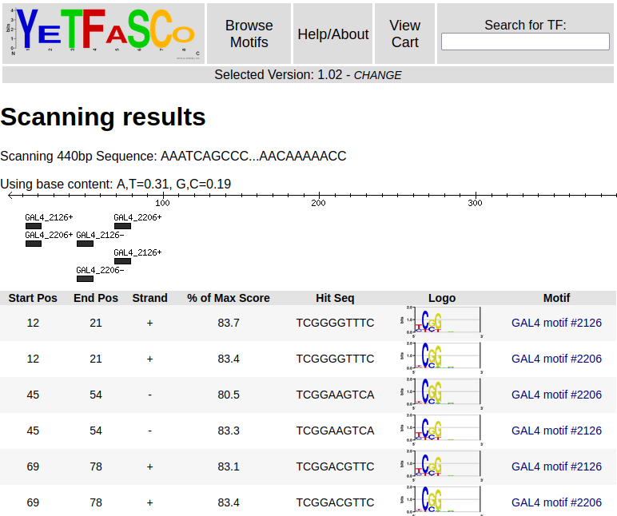
Figure S 29 YeTFaSCo. TFBSs searches in S. cerevisiae with matrices

Development
We used a three layered architecture where the frontend is developed using angularJS and yeoman with grunt and bower. The backend is implemented with Eclipse Mars and jdk_1.8.0_74. The executable for searching TFBS (tessWms) is called from the backend. JAXRS is used for the REST-Services and EclipseLink for the connection to the database. Storage of the matrices is done in a postgres database.

Build and Deploy
The sources of the tool are published via the URL depicted in the paper under the section Full availability of data and program. The front-end can be found in the folder Sources/frontend, the backend in the folder Sources/backend and the database in the folder Sources/postgres.
The front-end is built with yeoman (https://github.com/yeoman/generator-angular, accessed June, 13th 2021). For that, change the URL for the back-end first. This is done in the file tools.js. The line for that reads:
$scope.callURL = 'add URL of backend';
After adding the back-end URL the front-end is built by executing grunt build or grunt build --force. The resources that were build can be deployed on a webserver.
The back-end project is located in the folder pwm_rest and can be loaded into Eclipse (https://www.eclipse.org/downloads/, accessed June, 13th 2021). Then the URL and port of the postgres installation has to be changed as well as the credentials to this database. This is done in the file persistence.xml:
<property name="javax.persistence.jdbc.url" value="jdbc:postgresql://localhost:5432/docker" />
<property name="javax.persistence.jdbc.user" value="user" />
<property name="javax.persistence.jdbc.password" value="password" />
The project can then be build using Maven (https://maven.apache.org/guides/getting-started/maven-in-five-minutes.html, accessed June, 13th 2021). This generates a war archive which can be deployed on a Tomcat (http://tomcat.apache.org/, accessed June, 13th 2021) application server. When the application server is started the binary file located under api/WEB-INF/classes/Executable/tessWMS has to be made executable via the command:
chmod u+x tessWMS
The postgres (https://www.postgresql.org/, accessed June, 13th 2021) database has to be installed first. Then the database may be populated with the provided database backup or the SQL scripts. This will fill the database with the matrices from Jaspar 2022.
Furthermore, this solution can be started as individual docker (https://www.docker.com/, accessed June, 13th 2021) containers or a docker swarm (https://docs.docker.com/engine/swarm/, accessed June, 13th 2021). For that, the images first have to be build. First, into the folder docker/container/frontend/dist the updated build from the front-end may be copied and then the command to build the docker image is executed:
docker build -t scorepwm_frontend .
For the back-end change into the folder docker/container/backend. Here the war archive may be replaced to point to the postgres database. Then this command will build the image:
docker build -t scorepwm_backend .
The image for the database can be built in the folder docker/container/postgres-db by executing the command:
docker build -t eg_postgresql .
When all Docker images are build, they can be started individually by executing the commands:
docker run -v /tmp:/tmp -d -p 80:80 scorepwm_frontend
docker run -v /tmp:/tmp -v /tmp/tomcat-logs/:/usr/share/tomcat8/logs/ -v /tmp/tomcat-conf/:/usr/share/tomcat8/conf/ -d -p 8080:8080 scorepwm_backend
docker run -d eg_postgresql
The containers can also be started in a swarm. For that, the swarm has to be initialized:
docker swarm init
To populate the swarm, this command has to be executed in the folder Sources/docker:
docker stack deploy -c docker-compose.yml modules
To test, if the layers are executed and running go to http://localhost for the front-end, to http://localhost/8080/api/areyoualive for the back-end and connect to the database with pg-admin (https://www.pgadmin.org/, accessed June, 13th 2021).

Used sequences
Below are sequences that are used for analyses in this paper.

conTraV3 comparison
>AJ223836.1 Chionodraco hamatus mRNA for cathepsin
CAGACGGAGAGACAGACAGACGGAGAGACACACACACACACAGACACACACACACTCACAGACATGAGGT
CGGTGTTGCTGCTGCTGTGTATCTGGACATGCAGGAGCTCAGCGCTGATCAGGGTGCCTCTGAGGAAGGT
GCCCACGATCCGCTCTCAGCTCCGCTCTGAAGGTCTGCTGCAGGACTTCCTGGTGGAGAATCGGCCCGAC
ATGTTCAGTCGCCGCTACGCTCAGTGTTTCCCCGCCGGGACGCCCTCTCTGAGGCTGGGGCGCTCCAGTG
AGAAGATCTACAACTTCATGGACGCTCAGTATTACGGTGACATCGCGTTGGGGACCCCGGAGCAAAACTT
CTCTGTGGTCTTTGACACCGGATCGTCCGATCTGTGGGTGCCTTCGGCCTACTGCGTCACCGAAGCCTGT
GCGTTGCCAAAGCGCTTCAAGGCGTTTAAATCCACGTCTTTCCTCCATGACGGTCGGCAGTTTGGGATAA
ACTACGGATCAGGACACCTGCTGGGGGTCATGGGCCGAGACTACCTGATGGTGGCAGGTATGATGGTTAA
GAGGCAGGAGTTCCGGGAGTCGGTCTATGAGCCCGGCACTGCGTTTTTGAAGGCGAGGTTTGATGGCGTT
TTGGGCTTGGGTTACCCGGCCCTGGCAGAGATCCTGGGAAACCCCGTTTTCGACAACATGTTGGCGCAGA
ACTTGTTGGACAAGCCCATCTTCTCCTTCTACCTGAGCAGGAAATTAAATGGAAGCCCAGAGGGCGAGCT
GTTGCTGGGCGGAACAGACGAGAGGTTGTACGACTTACCAATCAACTGGCTCCCCGTGACTGCTAAGGCC
TACTGGCAGATCAAGATAGACAGCGTGGTGGTGCAGGGTGTGAATCCCTTCTGTCCCCACGGCTGTCAGG
CCATCGTCGACACGGGAACTTCTCTCATCACTGGACCCACTGACGACATCCTGGACATCCAGCAGCTGAT
CGGAGCCACGCCCACCAACTTCGGAGAGTTCATCGTCGACTGTGCCAGGTTGTCCAACTTTCCTCAACAT
CAACATTTCGTCCTCGGTGGGAAGGAGTACACTCTGACGTCCGACCAGTACATCAGGAAGGAGATGCTCG
GCGACAGGAAGTTATGCTTCAGTGGCTTCCAGGCCGTGGACATGATTTCCTCCGAAGGCCCCCTGTGGAT
TCTGGGAGATGTGTTTCTGACACAGTACTACAGCATTTTCGACAGAGGACAGGACCGGGTCGGCTTCGCC
ATCGCTAGATAACCAGTCGAAGTTTAACGATAATACGAGAGCTGAAAACTGCAATAAATTCTACACAATG
AC

Sequences for Poly(A) tail analysis
>NM_000600.5 Homo sapiens interleukin 6 (IL6), transcript variant 1, mRNA
ATTCTGCCCTCGAGCCCACCGGGAACGAAAGAGAAGCTCTATCTCCCCTCCAGGAGCCCAGCTATGAACT
CCTTCTCCACAAGCGCCTTCGGTCCAGTTGCCTTCTCCCTGGGGCTGCTCCTGGTGTTGCCTGCTGCCTT
CCCTGCCCCAGTACCCCCAGGAGAAGATTCCAAAGATGTAGCCGCCCCACACAGACAGCCACTCACCTCT
TCAGAACGAATTGACAAACAAATTCGGTACATCCTCGACGGCATCTCAGCCCTGAGAAAGGAGACATGTA
ACAAGAGTAACATGTGTGAAAGCAGCAAAGAGGCACTGGCAGAAAACAACCTGAACCTTCCAAAGATGGC
TGAAAAAGATGGATGCTTCCAATCTGGATTCAATGAGGAGACTTGCCTGGTGAAAATCATCACTGGTCTT
TTGGAGTTTGAGGTATACCTAGAGTACCTCCAGAACAGATTTGAGAGTAGTGAGGAACAAGCCAGAGCTG
TGCAGATGAGTACAAAAGTCCTGATCCAGTTCCTGCAGAAAAAGGCAAAGAATCTAGATGCAATAACCAC
CCCTGACCCAACCACAAATGCCAGCCTGCTGACGAAGCTGCAGGCACAGAACCAGTGGCTGCAGGACATG
ACAACTCATCTCATTCTGCGCAGCTTTAAGGAGTTCCTGCAGTCCAGCCTGAGGGCTCTTCGGCAAATGT
AGCATGGGCACCTCAGATTGTTGTTGTTAATGGGCATTCCTTCTTCTGGTCAGAAACCTGTCCACTGGGC
ACAGAACTTATGTTGTTCTCTATGGAGAACTAAAAGTATGAGCGTTAGGACACTATTTTAATTATTTTTA
ATTTATTAATATTTAAATATGTGAAGCTGAGTTAATTTATGTAAGTCATATTTATATTTTTAAGAAGTAC
CACTTGAAACATTTTATGTATTAGTTTTGAAATAATAATGGAAAGTGGCTATGCAGTTTGAATATCCTTT
GTTTCAGAGCCAGATCATTTCTTGGAAAGTGTAGGCTTACCTCAAATAAATGGCTAACTTATACATATTT
TTAAAGAAATATTTATATTGTATTTATATAATGTATAAATGGTTTTTATACCAATAAATGGCATTTTAAA
AAATTCA
>NM_000594.4 Homo sapiens tumor necrosis factor (TNF), mRNA
AGCAGACGCTCCCTCAGCAAGGACAGCAGAGGACCAGCTAAGAGGGAGAGAAGCAACTACAGACCCCCCC
TGAAAACAACCCTCAGACGCCACATCCCCTGACAAGCTGCCAGGCAGGTTCTCTTCCTCTCACATACTGA
CCCACGGCTCCACCCTCTCTCCCCTGGAAAGGACACCATGAGCACTGAAAGCATGATCCGGGACGTGGAG
CTGGCCGAGGAGGCGCTCCCCAAGAAGACAGGGGGGCCCCAGGGCTCCAGGCGGTGCTTGTTCCTCAGCC
TCTTCTCCTTCCTGATCGTGGCAGGCGCCACCACGCTCTTCTGCCTGCTGCACTTTGGAGTGATCGGCCC
CCAGAGGGAAGAGTTCCCCAGGGACCTCTCTCTAATCAGCCCTCTGGCCCAGGCAGTCAGATCATCTTCT
CGAACCCCGAGTGACAAGCCTGTAGCCCATGTTGTAGCAAACCCTCAAGCTGAGGGGCAGCTCCAGTGGC
TGAACCGCCGGGCCAATGCCCTCCTGGCCAATGGCGTGGAGCTGAGAGATAACCAGCTGGTGGTGCCATC
AGAGGGCCTGTACCTCATCTACTCCCAGGTCCTCTTCAAGGGCCAAGGCTGCCCCTCCACCCATGTGCTC
CTCACCCACACCATCAGCCGCATCGCCGTCTCCTACCAGACCAAGGTCAACCTCCTCTCTGCCATCAAGA
GCCCCTGCCAGAGGGAGACCCCAGAGGGGGCTGAGGCCAAGCCCTGGTATGAGCCCATCTATCTGGGAGG
GGTCTTCCAGCTGGAGAAGGGTGACCGACTCAGCGCTGAGATCAATCGGCCCGACTATCTCGACTTTGCC
GAGTCTGGGCAGGTCTACTTTGGGATCATTGCCCTGTGAGGAGGACGAACATCCAACCTTCCCAAACGCC
TCCCCTGCCCCAATCCCTTTATTACCCCCTCCTTCAGACACCCTCAACCTCTTCTGGCTCAAAAAGAGAA
TTGGGGGCTTAGGGTCGGAACCCAAGCTTAGAACTTTAAGCAACAAGACCACCACTTCGAAACCTGGGAT
TCAGGAATGTGTGGCCTGCACAGTGAAGTGCTGGCAACCACTAAGAATTCAAACTGGGGCCTCCAGAACT
CACTGGGGCCTACAGCTTTGATCCCTGACATCTGGAATCTGGAGACCAGGGAGCCTTTGGTTCTGGCCAG
AATGCTGCAGGACTTGAGAAGACCTCACCTAGAAATTGACACAAGTGGACCTTAGGCCTTCCTCTCTCCA
GATGTTTCCAGACTTCCTTGAGACACGGAGCCCAGCCCTCCCCATGGAGCCAGCTCCCTCTATTTATGTT
TGCACTTGTGATTATTTATTATTTATTTATTATTTATTTATTTACAGATGAATGTATTTATTTGGGAGAC
CGGGGTATCCTGGGGGACCCAATGTAGGAGCTGCCTTGGCTCAGACATGTTTTCCGTGAAAACGGAGCTG
AACAATAGGCTGTTCCCATGTAGCCCCCTGGCCTCTGTGCCTTCTTTTGATTATGTTTTTTAAAATATTT
ATCTGATTAAGTTGTCTAAACAATGCTGATTTGGTGACCAACTGTCACTCATTGCTGAGCCTCTGCTCCC
CAGGGGAGTTGTGTCTGTAATCGCCCTACTATTCAGTGGCGAGAAATAAAGTTTGCTTAGAAAAGAAA
>NM_020525.5 Homo sapiens interleukin 22 (IL22), mRNA
ACAAGCAGAATCTTCAGAACAGGTTCTCCTTCCCCAGTCACCAGTTGCTCGAGTTAGAATTGTCTGCAAT
GGCCGCCCTGCAGAAATCTGTGAGCTCTTTCCTTATGGGGACCCTGGCCACCAGCTGCCTCCTTCTCTTG
GCCCTCTTGGTACAGGGAGGAGCAGCTGCGCCCATCAGCTCCCACTGCAGGCTTGACAAGTCCAACTTCC
AGCAGCCCTATATCACCAACCGCACCTTCATGCTGGCTAAGGAGGCTAGCTTGGCTGATAACAACACAGA
CGTTCGTCTCATTGGGGAGAAACTGTTCCACGGAGTCAGTATGAGTGAGCGCTGCTATCTGATGAAGCAG
GTGCTGAACTTCACCCTTGAAGAAGTGCTGTTCCCTCAATCTGATAGGTTCCAGCCTTATATGCAGGAGG
TGGTGCCCTTCCTGGCCAGGCTCAGCAACAGGCTAAGCACATGTCATATTGAAGGTGATGACCTGCATAT
CCAGAGGAATGTGCAAAAGCTGAAGGACACAGTGAAAAAGCTTGGAGAGAGTGGAGAGATCAAAGCAATT
GGAGAACTGGATTTGCTGTTTATGTCTCTGAGAAATGCCTGCATTTGACCAGAGCAAAGCTGAAAAATGA
ATAACTAACCCCCTTTCCCTGCTAGAAATAACAATTAGATGCCCCAAAGCGATTTTTTTTAACCAAAAGG
AAGATGGGAAGCCAAACTCCATCATGATGGGTGGATTCCAAATGAACCCCTGCGTTAGTTACAAAGGAAA
CCAATGCCACTTTTGTTTATAAGACCAGAAGGTAGACTTTCTAAGCATAGATATTTATTGATAACATTTC
ATTGTAACTGGTGTTCTATACACAGAAAACAATTTATTTTTTAAATAATTGTCTTTTTCCATAAAAAAGA
TTACTTTCCATTCCTTTAGGGGAAAAAACCCCTAAATAGCTTCATGTTTCCATAATCAGTACTTTATATT
TATAAATGTATTTATTATTATTATAAGACTGCATTTTATTTATATCATTTTATTAATATGGATTTATTTA
TAGAAACATCATTCGATATTGCTACTTGAGTGTAAGGCTAATATTGATATTTATGACAATAATTATAGAG
CTATAACATGTTTATTTGACCTCAATAAACACTTGGATATCCTAA

Analyis on how well AIModules recognizes motifs shown with the example of NFAT (48)
>NC_000067.6:131019345-131019844 Mus musculus strain C57BL/6J chromosome 1, GRCm38.p6 C57BL/6J, Mus musculus interleukin 10 (Il10) promoter
AAATCAGCCCTCTCGGGGTTTCCTTTGGGTAACTGAGTGCTAAGGTGACTTCCGAGTCAGCAAGAAATAT
CGGACGTTCAACCCAGGTTGAGTGGAGGAAACAATTATTTCTCAATCCTAATATGTTCTGGAATAGCCCA
TTTATCCACGTCATTATGACCTGGGAGTGCGTGAATGGAATCCACAGATGAGGGCCTCTGTACATAGAAC
AGCTGTCTGCCTCAGGAAATACAACTTTTAGTATTGAGAAGCTAAAAAGAAAAAAAAATTAAAAGAGAGG
TAGCCCATACTAAAAATAGCTGTAATGCAGAAGTTCATTCCGACCAGTTCTTTAGCGCTTACAATGCAAA
AAAAAGGGAAAGGAAAAAAAAAAAGAAAGAAATTAAACTCAAAAATTGCATGGTTTAGAAGAGGGAGGAG
GAGCCTGAATAACAAAAACCTTTGCCAGGAAGGCCCCACTGAGCCTTCAGTATAAAAGGGGGACCAAGAA
CAGGAGGTCT
>NC_000074.6:c82403252-82402576 Mus musculus strain C57BL/6J chromosome 8, GRCm38.p6 C57BL/6J, Mus musculus interleukin 15 (Il15), transcript variant 2 promoter
ACCCAAGGTCCTTTTCCGTTTCCTCCCGGTACAGTCTCTGTCCAGATCTCCTCCGGGCTTCTATGGGGAA
GCCAAACTGCCTCCCTGCAAGGCCAGTTGCTGTAGATGCAAGCAACCTGTGAACTCAGGCCAACTCCTTG
AAACTTCACAGAGGCAAAGGCATTCCAGGACACACAGAGGCTGTGGCCAACTGCCCAGGGGGAGGAGACT
GCTCTCTGCTCTCAGTTGCCCTTCAGGTTCTGCGCCCTGGGGACCTGGCAGTGGCAGAATCATGTGGGCA
CCTGGTAAGGTGGCCGGGACCATGTGTTCCTCCCGCAACCTCCCCAGGGTGTTGATCTCCGCCTCAGCTT
GGGCTCTTTCTCTTTCACTTTTCTGTTAGCTGGGGTTGGGACTCCCCGGCTGGAAAGCACTGGGGGAAAC
CGGGGAAACCCCAGCTGATTCGCTCCTTGTGCCTTGATTGCTCCCGCTGGCTGCTGCCCTGCATCCTGCA
CCCTTCAACCAGAACCCGATGGAGGTACAGAATGGGAGGTGGTAGTGCTGGTGGTGGTGGATCAACAATG
GAATTTTTTTTTTTTCCGAAAGCCTACGCCCCGGGCCCCTCCCAGCTCTGGCTCTGCTCAGGCACCCTTT
TCCCCTCCAGCTGCCGGCCAGGCCGCCCCGCCCTCT
>NC_000077.6:c53635202-53634702 Mus musculus strain C57BL/6J chromosome 11, GRCm38.p6 C57BL/6J, Mus musculus interleukin 13 (Il13) promoter
CATGCATTGCTTTGGTGATTTATCAGATACGTTTGTTGAAATTAAGAAGAAAAAAAGAAAAGAAAGAAAG
AAGAAAGGAAGGAAGGGAGGAAGGAAGAAAGAAAGAAAGGAGAAAACTTCCCCAATTCTCACAGCTAATA
GACTGATACTCACCTGCCCAAAGGGTGACAAGTACTTAGTGATCAAGGGGTCAGCATTGGGCTGGCTGCT
CAGGAGCTTGGGGCGGTCAGCGGGTGGAATTACTGGGGCGGAAGTTAGCTTTGCTGATGCCCACCGTGGA
AATAAACCACCCAGAACCTGGAAACCCTGTCCCAGACCCTTCTCAATAAATCCACTAAATCAGACTCTTT
CCTTTAGCGGCCACTGGATTTTCCAAAAAAGAAAAAAAAAAATTCAAGATGAGTAAAGATGTGGTTTTCA
GATAATGCCCAACAAAGCAGAGACCAGGGGTGAGGCGTCATCACTTTGGTTTATAAAAGCTGCTTCAACA
GGCTAAGGCC

Genomatix vs AIModules: here IL-10
>X73536.1_H.sapiens_promoter_region_of_human_IL-10_gene
AGCTTTCAGCAAGTGCAGACTACTCTTACCCACTTCCCCCAAGCACAGTTGGGGTGGGGGACAGCTGAAG
AGGTGGAAACATGTGCCTGAGAATCCTAATGAAATCGGGGTAAAGGAGCCTGGAACACATCCTGTGACCC
CGCCTGTCCTGTAGGAAGCCAGTCTCTGGAAAGTAAAATGGAAGGGCTGCTTGGGAACTTTGAGGATATT
TAGCCCACCCCCTCATTTTTACTTGGGGAAACTAAGGCCCAGAGACCTAAGGTGACTGCCTAAGTTAGCA
AGGAGAAGTCTTGGGTATTCATCCCAGGTTGGGGGGACCCAATTATTTCTCAATCCCATTGTATTCTGGA
ATGGGCAATTTGTCCACGTCACTGTGACCTAGGAACACGCGAATGAGAACCCACAGCTGAGGGCCTCTGC
GCACAGAACAGCTGTTCTCCCCAGGAAATCAACTTTTTTTAATTGAGAAGCTAAAAAATTATTCTAAGAG
AGGTAGCCCATCCTAAAAATAGCTGTAATGCAGAAGTTCATGTTCAACCAATCATTTTTGCTTACGATGC
AAAAATTGAAAACTAAGTTTATTAGAGAGGTTAGAGAAGGAGGAGCTCTAAGCAGAAAAAATCCTGTGCC
GGGAAACCTTGATTGTGGCTTTTTAATGAATGAAGAGGCCTCCCTGAGCTTACAATATAAAAGGGGGACA
GAGAGGTGAAGGTCTACACATCAGGGGCTTGCTCTTGCAAAACCAAACCACAAGACAGACTTGCAAAAGA
AGGCATGCACAGCTCAGCACTGC
>AY486432.1_Macaca-mulatta_interleukin-10-(IL-10)_gene_promoter_region
TTTGGGAAGGGGAAGTAGGGATAGGTAAGAGGAAAGTAAGGGACCTCCTATCCAGCCTCCATGGAATCCT
GACTTCTTTTCCCTGTTATTACAACTTCTTCCTCCCCATCTTTTAAACTTTAGACTCCCGCCACAGAAGC
TTACAACTAAAAGAAACTCTAAGGCCAATTTAATCCAAGGTTTCATTCTATGTGTTGGAGATGGCATAGA
GTAGGGTGAGGGAACCAAATTCTCAGTTGGCACTGGTGTACCCTTGTACAGGTGATGTAATCGCTCTGTG
CCTCAGTTTGCTCACTATAAAATAGAGATGGTAGGGGTCATGGTGAGCACTACCTGACTAGCATATAACA
AGCTTTCGGCAAGTGCAGACTACTCTTACCCACTTCCCCCAAGCACAGTTGGGGTGGGGGACACCTGGGA
CAGCTGAAGAGGAGGAAATGTGTGCCTGAGAATCCAAATGAAATCAGGGTAAAGGAGCCTGGAGCACATC
CTGTGACCCTGCCTGTCCTGTAGGAAGCCGGTCTCTGGAAGGTAAAATGGAAGAGCTGCTTGGGAGCTTT
GAGGATATTTAGCCCACCCCCTCATTTTTACTTGGGGAAACTAAGGCCCACAGACCTAAGGTGACTGTCT
AAGTTAGCAAGAAGAAGTCTTGGGTATTCACCCTGGGTTGGGGGGACCCAATTATTTCTCAATCCCATTG
TATTCTGGAATGGGCAATTTGTCCACGTCACTGTGACCTAGGAACACGCGAATGGGAACCCACAACTGCG
GGCCTCTGCGCACAGAACAGCTGTTCTCCCCAGGAAATCAACTTTTTTTAATTGAGAAGCTAAAAAATTA
TTCTAAGAGAGGTAGCCCATCCTAAAAATAGCTGTGCAGAAGTTCATGTTCAACCAATCCTTTTTGCTTA
CGATGCAAAATTTGAAAACTAAGTTTATTAGAGAGGTTAGAGAAGGAGGAGCTCTAAGCAGAAAAAATCC
TGTGCCGGGAAACCTGTGATTGTGGCTTTTTATGAATGAAGAGGCCTCCCTGAGCTTACAATATAAAAGG
GGGACAGAGAGGTGAAGGTCTACACATCAGGGGCTTGCTCTTGCAAAACCAAACCACAAGACAGACTTGC
AAAAGAAGGCATGCACAGCTCAGCACTGCTCTGTTGCCTGGTCCTCC
>AF121965.1_Mus-musculus_interleukin-10-(IL10)_gene_promoter_partial_sequence
TTCCTGTTCTACCAGCCCTGGTGTGGTAACCCTCTCCAATGGGGCAGGCTTGGAACCCTGTGCCAACGAA
GATCCTCCCCCGTACTGATGCAGGAAGGACAGCCCGGGAGTGTACCCTCTACATGGGTCTACTTTTATTT
AAGCAAACATTCCCTGGTCAACAGGACGTGTAGCATTGCCCCCCCCCCTTGGGTCACACAGAAAACAGGT
ACCAGGAGGACAAGTAGTTGCTTGCCCAGGGTACAGAATGAAAGGCAATAGGGGACTCTAGGCGAATGTT
CTTCCCACCCAAACTGAGGTAGTAGGAGAAGTCCCTACTGAAGGGAAGGTCCAGACATAATCAAAGGACT
ACCAGAGATCTCCCAAT

Genomatix vs AIModules: here cathepsins
>Homo_sapiens_cathepsin_V_transcript_variant-1_promoter
cttctaaagccctgatgcacccacccttaagtggaaggtaatgcttctgctgggggctgt
gcgttcttccactccgtcccacctttgccgtggactaaacaggagccactgaacgagagt
accctggctcccggccctgcagattttcaccaaaaactctaggactaagttaaagtaggg
actgaaataccacacagagctcgctgtaaaccacccgctcagcgcagtaagtcgggatag
tcagtagatctgagcccttgagggaggcgcctccccctcctccgcgcagcccccgggcgc
ccggcccagcttcccgcagccagggtgtattgaggtaggcgcgcccagacctgagacggg
ttgggactgggctgcgtcacgcgcgggctctaagcgcccggggccccgcccagtggccgg
cacagccaatcgcagcgcgggaaggcggtgggggcggggaaggccgcctggaaacttaaa
tcccgaggcgggcgaacctg
>Bos_taurus_cathepsin-Z_promoter
ctagggtgctcaggtgctcggtcatatctgactcttttgcaacccctgggactgtagcct
gccaagctcctttgtcaatgggattctccagggaagaatactggagtgggttgccatgcc
ctcctccatcaggaagctagaatagggtgcagttctgcagagagacccctgcccatcatc
cctggaggctggacccaggcgggatgcggggatccggggcatctctccggaccaaagggt
cccaagacgccaaggctgggggtggggggccctaagaatgaatgaggtctgatagatcag
aggcaagaggcaagtggcggggtcggggcggggtccgccgaggcctggcgcgtgacccga
gtccggacgggccgggcagccgggcggggcggggccgggtcaccgggggcagcagcgcgc
cccgccccgggggagtgtcccgccgggcgcagacaccttaagggcctgcgggccggggag
gaagcctgcggaggggtgac
> Mus_musculus_cathepsin-F-transcript-variant-X1_promoter_576-1076
gagccaccttgcaatgatcccctggtgtgcccactgcctgagacgaagaaaacagtggtg
agtgaagaggtcagctattgttggccctagctggcaaacaattggaatggtgggtcctgt
cgaggcattggttactcctgagataccaagttagagaccaagatgctctgaaagggtggg
tgttggggtgctgggtgtctgctgctggcctccctctttcaccaagttatgactgccttc
catgtggctctcctttgaggaacttctagctgctcttgccaggaccttgtttcaaactgt
cccaagaccgtcttctttctatgcctccagctctgcagttttgaagtcctggaagagcta
aaagaacacttgctgctgaggagggactgtagcccagtgaatgccaaggtcacaggtgct
gggattgctcaaggagactgggagagcccagaccatacttgagtcagaatccagccttaa
ttacttctctgttccgaccct

Homo sapiens Immunglobulin
> Homo sapiens chromosome 14, GRCh38.p13 Primary Assembly IGH 105588394-105588894
tggggtgggg ctcatggagt ggtgggtgtt ggactgagac tctgaccagg gacaggggga
tggggtcaca gccaagccac tccaccccta ccccatgcac acagcactca gagcccaggc
cccctcctca gagcccccac caaaatcctc tctaggggca ggggaaagag caagacatgt
cccccaccca gagcaggaac tggggtcagg gagctcaggg gactcagcca ctccatggca
gagccctgtt taatataact tgtgtctggg atggcctggg tcagaggccc tatctaagga
gcatgttcag aaactgtgtc gctgggatga gacagctggg tccaaccgca ggcccatggt
gcaggagctg tgtaaccttg gggctgtcac caggcctctc tgtgctgggt tcctccagtg
tagaggagag gcaggtacag cctgtcctcc tggggacatg gcatgagggc cgcgtcctca
cagcgcattc tgtgttccag c
> Homo sapiens chromosome 2, GRCh38.p13 Primary Assembly IGKC 88857683-88858183
gggctcaggg cctgctctgc agggaggttt tagcccagcc cagccaaagt aacccccggg
agcctgttat cccagcacag tcctggaaga ggcacagggg aaataaaagc ggacggaggc
tttccttgac tcagccgctg cctggtcttc ttcagacctg ttctgaattc taaactctga
gggggtcgga tgacgtggcc attctttgcc taaagcattg agtttactgc aaggtcagaa
aagcatgcaa agccctcaga atggctgcaa agagctccaa caaaacaatt tagaacttta
ttaaggaata gggggaagct aggaagaaac tcaaaacatc aagattttaa atacgcttct
tggtctcctt gctataatta tctgggataa gcatgctgtt ttctgtctgt ccctaacatg
ccctgtgatt atccgcaaac aacacaccca agggcagaac tttgttactt aaacaccatc
ctgtttgctt ctttcctcag g
> Homo sapiens chromosome 1, GRCh38.p13 Primary Assembly PIGR 206946466-206946966
tataaggggc atttttgtcc aggctaagta acctagggag tcggagggga ttccagagca
actggggata tgagaccaag gactacgaca gccactcctg ccacctgtgc cccatcagat
gatgtcaact tcaaatcaag cattgggcca ggtattttag agctaatacc gggctatatc
ctctacctgt agatttggta ttaccatccc tcttttccag atgaaaagaa ataggaaggt
gacttgccaa aggtcttgca gctagaaagc gacagaacag catcttcacg cttgacattc
tgtccctcat cctgaagctg caacgatgga ggattcccaa gtaacagagt ctccccaagg
tcaaaggaaa ccaaatggag ccagccagga aggccaaaat gaaaggaaag caagggatct
gtgagagtca catgaccctg gctggccacg gtgcctgtgg gagagtggcc ctttaagagc
ccaggtgtgg gtcaaacact g

Interleukin module result table
Below is the list of the modules found for the interleukin promoters.
Table S 10 Interleukin module result table.
Sequence Name | Module | Module Start | Module End | Sense
NC_000067.6:131019345-131019844 Mus musculus strain C57BL/6J chromosome 1, GRCm38.p6 C57BL/6J, Mus musculus interleukin 10 (Il10) promoter | MA0868.2 SOX8::MA0152.1 NFATC2 | 98 | 148 | N
 | MA0868.2 SOX8::MA1525.1 NFATC4 | 98 | 183 | N
 | MA0152.1 NFATC2::MA1621.1 Rbpjl | 142 | 219 | N
 | MA0152.1 NFATC2::MA1620.1 Ptf1a(var.3) | 142 | 218 | N
 | MA1621.1 Rbpjl::MA1620.1 Ptf1a(var.3) | 206 | 218 | N
 | MA0868.2 SOX8::MA1100.2 ASCL1 | 98 | 217 | N
 | MA0152.1 NFATC2::MA1100.2 ASCL1 | 142 | 217 | N
 | MA1525.1 NFATC4::MA1100.2 ASCL1 | 174 | 217 | N
 | MA1621.1 Rbpjl::MA1100.2 ASCL1 | 206 | 217 | N
 | MA1620.1 Ptf1a(var.3)::MA1100.2 ASCL1 | 207 | 217 | N
 | MA0152.1 NFATC2::MA0868.2 SOX8 | 142 | 347 | N
 | MA1525.1 NFATC4::MA0868.2 SOX8 | 174 | 347 | N
 | MA1621.1 Rbpjl::MA0868.2 SOX8 | 206 | 347 | N
 | MA1620.1 Ptf1a(var.3)::MA0868.2 SOX8 | 207 | 347 | N
 | MA1100.2 ASCL1::MA0868.2 SOX8 | 208 | 347 | N
 | MA1621.1 Rbpjl::MA1525.1 NFATC4 | 206 | 368 | N
 | MA1620.1 Ptf1a(var.3)::MA1525.1 NFATC4 | 207 | 368 | N
 | MA1100.2 ASCL1::MA1525.1 NFATC4 | 208 | 368 | N
 | MA0868.2 SOX8::MA1525.1 NFATC4 | 338 | 368 | N
 | MA0152.1 NFATC2::MA0528.2 ZNF263 | 142 | 421 | N
 | MA1621.1 Rbpjl::MA0528.2 ZNF263 | 206 | 421 | N
 | MA1620.1 Ptf1a(var.3)::MA0528.2 ZNF263 | 207 | 421 | N
 | MA1100.2 ASCL1::MA0528.2 ZNF263 | 208 | 421 | N
 | MA0152.1 NFATC2::MA0528.2 ZNF263 | 142 | 424 | N
 | MA1621.1 Rbpjl::MA0528.2 ZNF263 | 206 | 424 | N
 | MA1620.1 Ptf1a(var.3)::MA0528.2 ZNF263 | 207 | 424 | N
 | MA1100.2 ASCL1::MA0528.2 ZNF263 | 208 | 424 | N
 | MA0528.2 ZNF263::MA0528.2 ZNF263 | 410 | 424 | N
 | MA1525.1 NFATC4::MA0868.2 SOX8 | 174 | 438 | N
 | MA1621.1 Rbpjl::MA0868.2 SOX8 | 206 | 438 | N
 | MA1620.1 Ptf1a(var.3)::MA0868.2 SOX8 | 207 | 438 | N
 | MA1100.2 ASCL1::MA0868.2 SOX8 | 208 | 438 | N
 | MA1525.1 NFATC4::MA0868.2 SOX8 | 359 | 438 | N
 | MA0528.2 ZNF263::MA0868.2 SOX8 | 410 | 438 | N
 | MA0528.2 ZNF263::MA0868.2 SOX8 | 413 | 438 | N
 | MA1525.1 NFATC4::MA0867.2 SOX4 | 174 | 439 | N
 | MA1621.1 Rbpjl::MA0867.2 SOX4 | 206 | 439 | N
 | MA1620.1 Ptf1a(var.3)::MA0867.2 SOX4 | 207 | 439 | N
 | MA1100.2 ASCL1::MA0867.2 SOX4 | 208 | 439 | N
 | MA0868.2 SOX8::MA0867.2 SOX4 | 338 | 439 | N
 | MA1525.1 NFATC4::MA0867.2 SOX4 | 359 | 439 | N
 | MA0528.2 ZNF263::MA0867.2 SOX4 | 410 | 439 | N
 | MA0528.2 ZNF263::MA0867.2 SOX4 | 413 | 439 | N
 | MA0868.2 SOX8::MA0867.2 SOX4 | 429 | 439 | N
 | MA0152.1 NFATC2::MA0597.1 THAP1 | 142 | 450 | N
 | MA1621.1 Rbpjl::MA0597.1 THAP1 | 206 | 450 | N
 | MA1620.1 Ptf1a(var.3)::MA0597.1 THAP1 | 207 | 450 | N
 | MA1100.2 ASCL1::MA0597.1 THAP1 | 208 | 450 | N
 | MA0528.2 ZNF263::MA0597.1 THAP1 | 410 | 450 | N
 | MA0528.2 ZNF263::MA0597.1 THAP1 | 413 | 450 | N
 | MA0868.2 SOX8::MA0816.1 Ascl2 | 98 | 217 | N
 | MA0152.1 NFATC2::MA0816.1 Ascl2 | 142 | 217 | N
 | MA1525.1 NFATC4::MA0816.1 Ascl2 | 174 | 217 | N
 | MA1621.1 Rbpjl::MA0816.1 Ascl2 | 206 | 217 | N
 | MA1620.1 Ptf1a(var.3)::MA0816.1 Ascl2 | 207 | 217 | N
 | MA0816.1 Ascl2::MA0868.2 SOX8 | 208 | 347 | N
 | MA0816.1 Ascl2::MA1525.1 NFATC4 | 208 | 368 | N
 | MA0816.1 Ascl2::MA0868.2 SOX8 | 208 | 438 | N
 | MA0816.1 Ascl2::MA0867.2 SOX4 | 208 | 439 | N
 | MA0868.2 SOX8::MA1472.1 BHLHA15(var.2) | 98 | 217 | N
 | MA0152.1 NFATC2::MA1472.1 BHLHA15(var.2) | 142 | 217 | N
 | MA1525.1 NFATC4::MA1472.1 BHLHA15(var.2) | 174 | 217 | N
 | MA0152.1 NFATC2::MA0624.1 NFATC1 | 129 | 183 | R
 | MA0152.1 NFATC2::MA0521.1 Tcf12 | 129 | 217 | R
 | MA0624.1 NFATC1::MA0521.1 Tcf12 | 174 | 217 | R
 | MA0152.1 NFATC2::MA0624.1 NFATC1 | 129 | 368 | R
 | MA0624.1 NFATC1::MA0624.1 NFATC1 | 174 | 368 | R
 | MA0521.1 Tcf12::MA0624.1 NFATC1 | 207 | 368 | R
 | MA0624.1 NFATC1::MA0152.1 NFATC2 | 174 | 367 | R
 | MA0521.1 Tcf12::MA0152.1 NFATC2 | 207 | 367 | R
 | MA0624.1 NFATC1::MA0152.1 NFATC2 | 359 | 367 | R
 | MA0152.1 NFATC2::MA0599.1 KLF5 | 129 | 421 | R
 | MA0624.1 NFATC1::MA0599.1 KLF5 | 174 | 421 | R
 | MA0521.1 Tcf12::MA0599.1 KLF5 | 207 | 421 | R
 | MA0624.1 NFATC1::MA0599.1 KLF5 | 359 | 421 | R
 | MA0152.1 NFATC2::MA0599.1 KLF5 | 361 | 421 | R
 | MA0152.1 NFATC2::MA0625.1 NFATC3 | 129 | 368 | R
 | MA0624.1 NFATC1::MA0625.1 NFATC3 | 174 | 368 | R
 | MA0521.1 Tcf12::MA0625.1 NFATC3 | 207 | 368 | R
 | MA0625.1 NFATC3::MA0152.1 NFATC2 | 359 | 367 | R
 | MA0625.1 NFATC3::MA0599.1 KLF5 | 359 | 421 | R
NC_000074.6:c82403252-82402576 Mus musculus strain C57BL/6J chromosome 8, GRCm38.p6 C57BL/6J, Mus musculus interleukin 15 (Il15), transcript variant 2 promoter | MA0152.1 NFATC2::MA0528.2 ZNF263 | 12 | 208 | N
 | MA0152.1 NFATC2::MA0597.1 THAP1 | 12 | 234 | N
 | MA0528.2 ZNF263::MA0597.1 THAP1 | 197 | 234 | N
 | MA0152.1 NFATC2::MA1621.1 Rbpjl | 12 | 288 | N
 | MA0528.2 ZNF263::MA1621.1 Rbpjl | 197 | 288 | N
 | MA0152.1 NFATC2::MA1620.1 Ptf1a(var.3) | 12 | 287 | N
 | MA0528.2 ZNF263::MA1620.1 Ptf1a(var.3) | 197 | 287 | N
 | MA1621.1 Rbpjl::MA1620.1 Ptf1a(var.3) | 275 | 287 | N
 | MA0152.1 NFATC2::MA1100.2 ASCL1 | 12 | 286 | N
 | MA0528.2 ZNF263::MA1100.2 ASCL1 | 197 | 286 | N
 | MA1621.1 Rbpjl::MA1100.2 ASCL1 | 275 | 286 | N
 | MA1620.1 Ptf1a(var.3)::MA1100.2 ASCL1 | 276 | 286 | N
 | MA0152.1 NFATC2::MA0597.1 THAP1 | 12 | 317 | N
 | MA0528.2 ZNF263::MA0597.1 THAP1 | 197 | 317 | N
 | MA1621.1 Rbpjl::MA0597.1 THAP1 | 275 | 317 | N
 | MA1620.1 Ptf1a(var.3)::MA0597.1 THAP1 | 276 | 317 | N
 | MA1100.2 ASCL1::MA0597.1 THAP1 | 277 | 317 | N
 | MA1621.1 Rbpjl::MA1100.2 ASCL1 | 275 | 478 | N
 | MA1620.1 Ptf1a(var.3)::MA1100.2 ASCL1 | 276 | 478 | N
 | MA0152.1 NFATC2::MA0597.1 THAP1 | 12 | 482 | N
 | MA1621.1 Rbpjl::MA0597.1 THAP1 | 275 | 482 | N
 | MA1620.1 Ptf1a(var.3)::MA0597.1 THAP1 | 276 | 482 | N
 | MA1100.2 ASCL1::MA0597.1 THAP1 | 277 | 482 | N
 | MA1100.2 ASCL1::MA0597.1 THAP1 | 469 | 482 | N
 | MA0528.2 ZNF263::MA0868.2 SOX8 | 197 | 561 | N
 | MA0597.1 THAP1::MA0868.2 SOX8 | 226 | 561 | N
 | MA1621.1 Rbpjl::MA0868.2 SOX8 | 275 | 561 | N
 | MA1620.1 Ptf1a(var.3)::MA0868.2 SOX8 | 276 | 561 | N
 | MA1100.2 ASCL1::MA0868.2 SOX8 | 277 | 561 | N
 | MA0597.1 THAP1::MA0868.2 SOX8 | 309 | 561 | N
 | MA1100.2 ASCL1::MA0868.2 SOX8 | 469 | 561 | N
 | MA0597.1 THAP1::MA0868.2 SOX8 | 474 | 561 | N
 | MA0528.2 ZNF263::MA0867.2 SOX4 | 197 | 562 | N
 | MA0597.1 THAP1::MA0867.2 SOX4 | 226 | 562 | N
 | MA1621.1 Rbpjl::MA0867.2 SOX4 | 275 | 562 | N
 | MA1620.1 Ptf1a(var.3)::MA0867.2 SOX4 | 276 | 562 | N
 | MA1100.2 ASCL1::MA0867.2 SOX4 | 277 | 562 | N
 | MA0597.1 THAP1::MA0867.2 SOX4 | 309 | 562 | N
 | MA1100.2 ASCL1::MA0867.2 SOX4 | 469 | 562 | N
 | MA0597.1 THAP1::MA0867.2 SOX4 | 474 | 562 | N
 | MA0868.2 SOX8::MA0867.2 SOX4 | 552 | 562 | N
 | MA0528.2 ZNF263::MA1525.1 NFATC4 | 197 | 566 | N
 | MA1621.1 Rbpjl::MA1525.1 NFATC4 | 275 | 566 | N
 | MA1620.1 Ptf1a(var.3)::MA1525.1 NFATC4 | 276 | 566 | N
 | MA1100.2 ASCL1::MA1525.1 NFATC4 | 277 | 566 | N
 | MA0597.1 THAP1::MA1525.1 NFATC4 | 309 | 566 | N
 | MA1100.2 ASCL1::MA1525.1 NFATC4 | 469 | 566 | N
 | MA0597.1 THAP1::MA1525.1 NFATC4 | 474 | 566 | N
 | MA0868.2 SOX8::MA1525.1 NFATC4 | 552 | 566 | N
 | MA0528.2 ZNF263::MA0152.1 NFATC2 | 197 | 578 | N
 | MA0597.1 THAP1::MA0152.1 NFATC2 | 226 | 578 | N
 | MA1621.1 Rbpjl::MA0152.1 NFATC2 | 275 | 578 | N
 | MA1620.1 Ptf1a(var.3)::MA0152.1 NFATC2 | 276 | 578 | N
 | MA1100.2 ASCL1::MA0152.1 NFATC2 | 277 | 578 | N
 | MA0597.1 THAP1::MA0152.1 NFATC2 | 309 | 578 | N
 | MA1100.2 ASCL1::MA0152.1 NFATC2 | 469 | 578 | N
 | MA0597.1 THAP1::MA0152.1 NFATC2 | 474 | 578 | N
 | MA0868.2 SOX8::MA0152.1 NFATC2 | 552 | 578 | N
 | MA1525.1 NFATC4::MA0152.1 NFATC2 | 557 | 578 | N
 | MA0528.2 ZNF263::MA0152.1 NFATC2 | 197 | 634 | N
 | MA0597.1 THAP1::MA0152.1 NFATC2 | 226 | 634 | N
 | MA1621.1 Rbpjl::MA0152.1 NFATC2 | 275 | 634 | N
 | MA1620.1 Ptf1a(var.3)::MA0152.1 NFATC2 | 276 | 634 | N
 | MA1100.2 ASCL1::MA0152.1 NFATC2 | 277 | 634 | N
 | MA0597.1 THAP1::MA0152.1 NFATC2 | 309 | 634 | N
 | MA1100.2 ASCL1::MA0152.1 NFATC2 | 469 | 634 | N
 | MA0597.1 THAP1::MA0152.1 NFATC2 | 474 | 634 | N
 | MA0868.2 SOX8::MA0152.1 NFATC2 | 552 | 634 | N
 | MA1525.1 NFATC4::MA0152.1 NFATC2 | 557 | 634 | N
 | MA0868.2 SOX8::MA1100.2 ASCL1 | 552 | 645 | N
 | MA1525.1 NFATC4::MA1100.2 ASCL1 | 557 | 645 | N
 | MA0152.1 NFATC2::MA1100.2 ASCL1 | 572 | 645 | N
 | MA0152.1 NFATC2::MA1100.2 ASCL1 | 628 | 645 | N
 | MA0528.2 ZNF263::MA0816.1 Ascl2 | 197 | 645 | N
 | MA0597.1 THAP1::MA0816.1 Ascl2 | 226 | 645 | N
 | MA1621.1 Rbpjl::MA0816.1 Ascl2 | 275 | 645 | N
 | MA1620.1 Ptf1a(var.3)::MA0816.1 Ascl2 | 276 | 645 | N
 | MA1100.2 ASCL1::MA0816.1 Ascl2 | 277 | 645 | N
 | MA0597.1 THAP1::MA0816.1 Ascl2 | 309 | 645 | N
 | MA1100.2 ASCL1::MA0816.1 Ascl2 | 469 | 645 | N
 | MA0597.1 THAP1::MA0816.1 Ascl2 | 474 | 645 | N
 | MA0868.2 SOX8::MA0816.1 Ascl2 | 552 | 645 | N
 | MA0867.2 SOX4::MA0816.1 Ascl2 | 553 | 645 | N
 | MA1525.1 NFATC4::MA0816.1 Ascl2 | 557 | 645 | N
 | MA0152.1 NFATC2::MA0816.1 Ascl2 | 572 | 645 | N
 | MA0152.1 NFATC2::MA0816.1 Ascl2 | 628 | 645 | N
 | MA0528.2 ZNF263::MA1472.1 BHLHA15(var.2) | 197 | 645 | N
 | MA0597.1 THAP1::MA1472.1 BHLHA15(var.2) | 226 | 645 | N
 | MA1621.1 Rbpjl::MA1472.1 BHLHA15(var.2) | 275 | 645 | N
 | MA1620.1 Ptf1a(var.3)::MA1472.1 BHLHA15(var.2) | 276 | 645 | N
 | MA1100.2 ASCL1::MA1472.1 BHLHA15(var.2) | 277 | 645 | N
 | MA0597.1 THAP1::MA1472.1 BHLHA15(var.2) | 309 | 645 | N
 | MA1100.2 ASCL1::MA1472.1 BHLHA15(var.2) | 469 | 645 | N
 | MA0597.1 THAP1::MA1472.1 BHLHA15(var.2) | 474 | 645 | N
 | MA0868.2 SOX8::MA1472.1 BHLHA15(var.2) | 552 | 645 | N
 | MA0867.2 SOX4::MA1472.1 BHLHA15(var.2) | 553 | 645 | N
 | MA1525.1 NFATC4::MA1472.1 BHLHA15(var.2) | 557 | 645 | N
 | MA0152.1 NFATC2::MA1472.1 BHLHA15(var.2) | 572 | 645 | N
 | MA0152.1 NFATC2::MA1472.1 BHLHA15(var.2) | 628 | 645 | N
 | MA0528.2 ZNF263::MA0816.1 Ascl2 | 197 | 478 | N
 | MA0597.1 THAP1::MA0816.1 Ascl2 | 226 | 478 | N
 | MA1621.1 Rbpjl::MA0816.1 Ascl2 | 275 | 478 | N
 | MA1620.1 Ptf1a(var.3)::MA0816.1 Ascl2 | 276 | 478 | N
 | MA1100.2 ASCL1::MA0816.1 Ascl2 | 277 | 478 | N
 | MA0597.1 THAP1::MA0816.1 Ascl2 | 309 | 478 | N
 | MA0816.1 Ascl2::MA0868.2 SOX8 | 469 | 561 | N
 | MA0816.1 Ascl2::MA0867.2 SOX4 | 469 | 562 | N
 | MA0816.1 Ascl2::MA1525.1 NFATC4 | 469 | 566 | N
 | MA0624.1 NFATC1::MA0152.1 NFATC2 | 399 | 407 | R
 | MA0624.1 NFATC1::MA0624.1 NFATC1 | 399 | 566 | R
 | MA0152.1 NFATC2::MA0624.1 NFATC1 | 401 | 566 | R
 | MA0152.1 NFATC2::MA0521.1 Tcf12 | 401 | 645 | R
 | MA0624.1 NFATC1::MA0521.1 Tcf12 | 557 | 645 | R
 | MA0624.1 NFATC1::MA0625.1 NFATC3 | 399 | 566 | R
 | MA0152.1 NFATC2::MA0625.1 NFATC3 | 401 | 566 | R
 | MA0625.1 NFATC3::MA0152.1 NFATC2 | 399 | 407 | R
NC_000077.6:c53635202-53634702 Mus musculus strain C57BL/6J chromosome 11, GRCm38.p6 C57BL/6J, Mus musculus interleukin 13 (Il13) promoter | MA0528.2 ZNF263::MA1621.1 Rbpjl | 82 | 160 | N
 | MA0528.2 ZNF263::MA1620.1 Ptf1a(var.3) | 82 | 159 | N
 | MA1621.1 Rbpjl::MA1620.1 Ptf1a(var.3) | 147 | 159 | N
 | MA0528.2 ZNF263::MA1100.2 ASCL1 | 82 | 158 | N
 | MA1621.1 Rbpjl::MA1100.2 ASCL1 | 147 | 158 | N
 | MA1620.1 Ptf1a(var.3)::MA1100.2 ASCL1 | 148 | 158 | N
 | MA0528.2 ZNF263::MA0597.1 THAP1 | 82 | 162 | N
 | MA1621.1 Rbpjl::MA0597.1 THAP1 | 147 | 162 | N
 | MA1620.1 Ptf1a(var.3)::MA0597.1 THAP1 | 148 | 162 | N
 | MA1100.2 ASCL1::MA0597.1 THAP1 | 149 | 162 | N
 | MA0528.2 ZNF263::MA0528.2 ZNF263 | 82 | 254 | N
 | MA1621.1 Rbpjl::MA0528.2 ZNF263 | 147 | 254 | N
 | MA1620.1 Ptf1a(var.3)::MA0528.2 ZNF263 | 148 | 254 | N
 | MA1100.2 ASCL1::MA0528.2 ZNF263 | 149 | 254 | N
 | MA0528.2 ZNF263::MA1525.1 NFATC4 | 82 | 284 | N
 | MA1621.1 Rbpjl::MA1525.1 NFATC4 | 147 | 284 | N
 | MA1620.1 Ptf1a(var.3)::MA1525.1 NFATC4 | 148 | 284 | N
 | MA1100.2 ASCL1::MA1525.1 NFATC4 | 149 | 284 | N
 | MA0597.1 THAP1::MA1525.1 NFATC4 | 154 | 284 | N
 | MA0528.2 ZNF263::MA0152.1 NFATC2 | 82 | 375 | N
 | MA1621.1 Rbpjl::MA0152.1 NFATC2 | 147 | 375 | N
 | MA1620.1 Ptf1a(var.3)::MA0152.1 NFATC2 | 148 | 375 | N
 | MA1100.2 ASCL1::MA0152.1 NFATC2 | 149 | 375 | N
 | MA0597.1 THAP1::MA0152.1 NFATC2 | 154 | 375 | N
 | MA1525.1 NFATC4::MA0152.1 NFATC2 | 275 | 375 | N
 | MA0528.2 ZNF263::MA0868.2 SOX8 | 82 | 438 | N
 | MA1621.1 Rbpjl::MA0868.2 SOX8 | 147 | 438 | N
 | MA1620.1 Ptf1a(var.3)::MA0868.2 SOX8 | 148 | 438 | N

Interleukin TFBS result table
Below is the complete table of the TFs that are included in the modules.
Table S 11 Interleukin TFBS result table.
Sequence Name | Sequence Length | Matrix Title | Matrix Length | Hit No. | Hit Sense | Hit Start | Hit Stop | Hit Score (La) | Hit Max log likelihood ratio score (Lm) | Difference (Ld) (maxscore(Lm) - score(La)) | Hit Oligo
NC_000067.6:131019345-131019844 Mus musculus strain C57BL/6J chromosome 1, GRCm38.p6 C57BL/6J, Mus musculus interleukin 10 (Il10) promoter | 500 | MA1100.2 ASCL1 | 10 | 1 | N | 208 | 217 | 11.290903 | 13.919985 | 2.629083 | AACAGCTGTC
 |  | MA0816.1 Ascl2 | 10 | 1 | N | 208 | 217 | 14.006852 | 16.538884 | 2.532033 | AACAGCTGTC
 |  | MA1472.1 BHLHA15(var.2) | 10 | 1 | N | 208 | 217 | 13.463911 | 13.956604 | 0.492693 | AACAGCTGTC
 |  | MA0599.1 KLF5 | 10 | 1 | R | 412 | 421 | 9.668823 | 15.543266 | 5.874443 | AGGGAGGAGG
 |  | MA0624.1 NFATC1 | 10 | 1 | R | 174 | 183 | 8.210574 | 12.519140 | 4.308567 | AATGGAATCC
 |  |  |  | 2 | R | 359 | 368 | 9.609372 | 12.519140 | 2.909768 | AAAGGAAAAA
 |  | MA0152.1 NFATC2 | 7 | 1 | N | 142 | 148 | 8.063484 | 12.341468 | 4.277985 | TTATCCA
 |  |  |  | 2 | R | 129 | 135 | 8.254006 | 12.341468 | 4.087463 | TGGAATA
 |  |  |  | 3 | R | 361 | 367 | 10.239107 | 12.341468 | 2.102362 | AGGAAAA
 |  | MA0625.1 NFATC3 | 10 | 1 | R | 359 | 368 | 10.362899 | 13.675168 | 3.312269 | AAAGGAAAAA
 |  | MA1525.1 NFATC4 | 10 | 1 | N | 174 | 183 | 8.090887 | 14.392408 | 6.301521 | AATGGAATCC
 |  |  |  | 2 | N | 359 | 368 | 8.522672 | 14.392408 | 5.869736 | AAAGGAAAAA
 |  | MA1620.1 Ptf1a(var.3) | 12 | 1 | N | 207 | 218 | 11.556983 | 15.503908 | 3.946925 | GAACAGCTGTCT
 |  | MA1621.1 Rbpjl | 14 | 1 | N | 206 | 219 | 11.141220 | 15.911069 | 4.769850 | AGAACAGCTGTCTG
 |  | MA0867.2 SOX4 | 10 | 1 | N | 430 | 439 | 9.728276 | 14.601566 | 4.873290 | TAACAAAAAC
 |  | MA0868.2 SOX8 | 10 | 1 | N | 98 | 107 | 8.181533 | 14.854627 | 6.673094 | GAAACAATTA
 |  |  |  | 2 | N | 338 | 347 | 8.322264 | 14.854627 | 6.532362 | CTTACAATGC
 |  |  |  | 3 | N | 429 | 438 | 8.402450 | 14.854627 | 6.452176 | ATAACAAAAA
 |  | MA0521.1 Tcf12 | 11 | 1 | R | 207 | 217 | 13.002089 | 15.776101 | 2.774012 | GAACAGCTGTC
 |  | MA0597.1 THAP1 | 9 | 1 | N | 442 | 450 | 8.693273 | 11.314089 | 2.620816 | TTGCCAGGA
 |  | MA0528.2 ZNF263 | 12 | 1 | N | 410 | 421 | 15.152542 | 16.915819 | 1.763277 | AGAGGGAGGAGG
 |  |  |  | 2 | N | 413 | 424 | 10.804723 | 16.915819 | 6.111095 | GGGAGGAGGAGC
NC_000074.6:c82403252-82402576 Mus musculus strain C57BL/6J chromosome 8, GRCm38.p6 C57BL/6J, Mus musculus interleukin 15 (Il15), transcript variant 2 promoter | 666 | MA1100.2 ASCL1 | 10 | 1 | N | 277 | 286 | 9.914553 | 13.919985 | 4.005432 | GGCACCTGGT
 |  |  |  | 2 | N | 469 | 478 | 9.582197 | 13.919985 | 4.337788 | GGCTGCTGCC
 |  |  |  | 3 | N | 636 | 645 | 10.315605 | 13.919985 | 3.604380 | TCCAGCTGCC
 |  | MA0816.1 Ascl2 | 10 | 1 | N | 469 | 478 | 9.355673 | 16.538884 | 7.183212 | GGCTGCTGCC
 |  |  |  | 2 | N | 636 | 645 | 9.632292 | 16.538884 | 6.906592 | TCCAGCTGCC
 |  | MA1472.1 BHLHA15(var.2) | 10 | 1 | N | 636 | 645 | 10.132307 | 13.956604 | 3.824296 | TCCAGCTGCC
 |  | MA0624.1 NFATC1 | 10 | 1 | R | 399 | 408 | 8.079574 | 12.519140 | 4.439567 | GCTGGAAAGC
 |  |  |  | 2 | R | 557 | 566 | 9.664478 | 12.519140 | 2.854663 | AATGGAATTT
 |  | MA0152.1 NFATC2 | 7 | 1 | N | 12 | 18 | 8.473572 | 12.341468 | 3.867896 | TTTTCCG
 |  |  |  | 2 | N | 572 | 578 | 8.473572 | 12.341468 | 3.867896 | TTTTCCG
 |  |  |  | 3 | N | 628 | 634 | 9.852084 | 12.341468 | 2.489385 | TTTTCCC
 |  |  |  | 4 | R | 401 | 407 | 8.323546 | 12.341468 | 4.017922 | TGGAAAG
 |  | MA0625.1 NFATC3 | 10 | 1 | R | 399 | 408 | 8.040663 | 13.675168 | 5.634504 | GCTGGAAAGC
 |  |  |  | 2 | R | 557 | 566 | 9.561851 | 13.675168 | 4.113317 | AATGGAATTT
 |  | MA1525.1 NFATC4 | 10 | 1 | N | 557 | 566 | 8.573176 | 14.392408 | 5.819232 | AATGGAATTT
 |  | MA1620.1 Ptf1a(var.3) | 12 | 1 | N | 276 | 287 | 9.691503 | 15.503908 | 5.812405 | GGGCACCTGGTA
 |  | MA1621.1 Rbpjl | 14 | 1 | N | 275 | 288 | 9.349614 | 15.911069 | 6.561456 | TGGGCACCTGGTAA
 |  | MA0867.2 SOX4 | 10 | 1 | N | 553 | 562 | 11.818057 | 14.601566 | 2.783508 | CAACAATGGA
 |  | MA0868.2 SOX8 | 10 | 1 | N | 552 | 561 | 11.378412 | 14.854627 | 3.476215 | TCAACAATGG
 |  | MA0521.1 Tcf12 | 11 | 1 | R | 635 | 645 | 13.813023 | 15.776101 | 1.963078 | CTCCAGCTGCC
 |  | MA0597.1 THAP1 | 9 | 1 | N | 226 | 234 | 8.221750 | 11.314089 | 3.092340 | TTGCCCTTC
 |  |  |  | 2 | N | 309 | 317 | 8.207882 | 11.314089 | 3.106207 | CCTCCCGCA
 |  |  |  | 3 | N | 474 | 482 | 8.355262 | 11.314089 | 2.958828 | CTGCCCTGC
 |  | MA0528.2 ZNF263 | 12 | 1 | N | 197 | 208 | 14.731682 | 16.915819 | 2.184136 | AGGGGGAGGAGA
NC_000077.6:c53635202-53634702 Mus musculus strain C57BL/6J chromosome 11, GRCm38.p6 C57BL/6J, Mus musculus interleukin 13 (Il13) promoter | 500 | MA1100.2 ASCL1 | 10 | 1 | N | 149 | 158 | 8.332904 | 13.919985 | 5.587081 | CTCACCTGCC
 |  | MA0816.1 Ascl2 | 10 | 1 | N | 475 | 484 | 9.583758 | 16.538884 | 6.955126 | AAAAGCTGCT
 |  | MA1472.1 BHLHA15(var.2) | 10 | 1 | N | 475 | 484 | 8.229655 | 13.956604 | 5.726949 | AAAAGCTGCT
 |  | MA0599.1 KLF5 | 10 | 1 | R | 447 | 456 | 11.424883 | 15.543266 | 4.118383 | GGGGTGAGGC
 |  | MA0624.1 NFATC1 | 10 | 1 | R | 233 | 242 | 8.219935 | 12.519140 | 4.299206 | GGTGGAATTA
 |  |  |  | 2 | R | 275 | 284 | 10.054376 | 12.519140 | 2.464765 | CGTGGAAATA
 |  | MA0152.1 NFATC2 | 7 | 1 | N | 369 | 375 | 12.341468 | 12.341468 | 0.000000 | TTTTCCA
 |  |  |  | 2 | R | 277 | 283 | 9.702058 | 12.341468 | 2.639410 | TGGAAAT
 |  |  |  | 3 | R | 299 | 305 | 9.171543 | 12.341468 | 3.169925 | TGGAAAC
 |  | MA0625.1 NFATC3 | 10 | 1 | R | 275 | 284 | 9.975994 | 13.675168 | 3.699174 | CGTGGAAATA
 |  | MA1525.1 NFATC4 | 10 | 1 | N | 275 | 284 | 9.930748 | 14.392408 | 4.461660 | CGTGGAAATA
 |  | MA1620.1 Ptf1a(var.3) | 12 | 1 | N | 148 | 159 | 10.008048 | 15.503908 | 5.495860 | ACTCACCTGCCC
 |  | MA1621.1 Rbpjl | 14 | 1 | N | 147 | 160 | 10.199248 | 15.911069 | 5.711821 | TACTCACCTGCCCA
 |  | MA0867.2 SOX4 | 10 | 1 | N | 430 | 439 | 11.560954 | 14.601566 | 3.040612 | CAACAAAGCA
 |  | MA0868.2 SOX8 | 10 | 1 | N | 429 | 438 | 8.156682 | 14.854627 | 6.697945 | CCAACAAAGC
 |  | MA0521.1 Tcf12 | 11 | 1 | R | 148 | 158 | 8.710154 | 15.776101 | 7.065947 | ACTCACCTGCC
 |  | MA0597.1 THAP1 | 9 | 1 | N | 154 | 162 | 9.368914 | 11.314089 | 1.945175 | CTGCCCAAA
 |  | MA0528.2 ZNF263 | 12 | 1 | N | 82 | 93 | 13.683952 | 16.915819 | 3.231867 | GAAGGGAGGAAG
 |  |  |  | 2 | N | 243 | 254 | 9.365203 | 16.915819 | 7.550616 | CTGGGGCGGAAG

Poly(A) results
Here are the complete results from the polyadenylation site search.
Table S 12 Complete result for Poly-(A) motifs.
Sequence Name | Sequence Length | Matrix Title | Matrix Length | Hit No. | Hit Sense | Hit Start | Hit Stop | Hit Score (La) | Hit Max log likelihood ratio score (Lm) or matrix possible | Difference (Ld) (maxscore(Lm) - score(La)) | Hit Oligo
NM_000600.5 Homo sapiens interleukin 6 (IL6), transcript variant 1, mRNA | 1127 | human-Poly-A | 6 | 1 | N | 1025 | 1030 | 9.889837 | 9.889837 | 0.000000 | AATAAA
 |  |  |  | 2 | N | 1103 | 1108 | 9.889837 | 9.889837 | 0.000000 | AATAAA
 |  |  |  | 3 | R | 842 | 847 | 9.889837 | 9.889837 | 0.000000 | TTTATT
NM_000594.4 Homo sapiens tumor necrosis factor (TNF), mRNA | 1678 | human-Poly-A | 6 | 1 | N | 1655 | 1660 | 9.889837 | 9.889837 | 0.000000 | AATAAA
 |  |  |  | 2 | R | 928 | 933 | 9.889837 | 9.889837 | 0.000000 | TTTATT
 |  |  |  | 3 | R | 1345 | 1350 | 9.889837 | 9.889837 | 0.000000 | TTTATT
 |  |  |  | 4 | R | 1352 | 1357 | 9.889837 | 9.889837 | 0.000000 | TTTATT
 |  |  |  | 5 | R | 1356 | 1361 | 9.889837 | 9.889837 | 0.000000 | TTTATT
 |  |  |  | 6 | R | 1363 | 1368 | 9.889837 | 9.889837 | 0.000000 | TTTATT
 |  |  |  | 7 | R | 1367 | 1372 | 9.889837 | 9.889837 | 0.000000 | TTTATT
 |  |  |  | 8 | R | 1387 | 1392 | 9.889837 | 9.889837 | 0.000000 | TTTATT
NM_020525.5 Homo sapiens interleukin 22 (IL22), mRNA | 1165 | human-Poly-A | 6 | 1 | N | 1144 | 1149 | 9.889837 | 9.889837 | 0.000000 | AATAAA
 |  |  |  | 2 | R | 824 | 829 | 9.889837 | 9.889837 | 0.000000 | TTTATT
 |  |  |  | 3 | R | 873 | 878 | 9.889837 | 9.889837 | 0.000000 | TTTATT
 |  |  |  | 4 | R | 991 | 996 | 9.889837 | 9.889837 | 0.000000 | TTTATT
 |  |  |  | 5 | R | 1015 | 1020 | 9.889837 | 9.889837 | 0.000000 | TTTATT
 |  |  |  | 6 | R | 1029 | 1034 | 9.889837 | 9.889837 | 0.000000 | TTTATT
 |  |  |  | 7 | R | 1043 | 1048 | 9.889837 | 9.889837 | 0.000000 | TTTATT
 |  |  |  | 8 | R | 1131 | 1136 | 9.889837 | 9.889837 | 0.000000 | TTTATT

Common TFBSs for AIModules vs Genomatix
The results from the crude TFBS search from AIModules and Genomatix were high in number, so we used a python script to find matches in TF families. The results are shown in the tables below for both cathepsins and IL-10.
Table S 13 Cathepsins. Common TFBSs 1
Homo_sapiens_cathepsin_V_transcript_variant-1_promoter
Genomatix TFBS | AIModules TFBS
V$AHRARNT.01 | MA0006.1 Ahr::Arnt
V$E2F6.01, V$E2F3.01, V$E2F2.01, V$E2F1.01, V$E2F6.01, V$E2F4.01, V$E2F4.01, | MA0471.2 E2F6
V$EGR1.04, V$EGR1.04, V$EGR1.04, V$EGR1.04, V$EGR1.02 | MA0162.4 EGR1
V$FOXP2.01 | MA0481.3 FOXP1
V$GCM1.01, V$GCM1.02 | MA0767.1 GCM2
V$MAZ.03, V$MAZ.03, V$MAZR.01, V$MAZ.01 | MA1522.1 MAZ
V$NFAT5.02 | MA0606.1 NFAT5, MA0624.1 NFATC1, MA0152.1 NFATC2, MA0625.1 NFATC3, MA1525.1 NFATC4
V$NKX31.03, V$NKX31.03, V$NKX31.01 | MA1645.1 NKX2-2, MA0063.2 NKX2-5, MA0673.1 NKX2-8, MA0124.2 Nkx3-1, MA0122.3 Nkx3-2, MA0674.1 NKX6-1
V$RFX1.01 | MA1554.1 RFX7
V$NRF1.02, V$NRF1.01 | MA0506.1 NRF1
V$SPIB.01, V$SP1.03, V$SP1.01 | MA0746.2 SP3, MA0747.1 SP8, MA1564.1 SP9
V$TCFAP2B.01, V$TCFAP2B.01, V$CTCF.01, V$TCFCP2L1.01, V$TCFAP2E.01, V$CTCF.01 | MA1648.1 TCF12(var.2), MA0522.3 TCF3, MA0632.2 TCFL5
V$ZFP57.01 | MA1583.1 ZFP57
V$ZKSCAN3.01 | MA1585.1 ZKSCAN1
V$ZNF282.01, V$ZNF263.01, V$ZNF263.01, V$ZNF219.01, V$ZNF263.02, V$ZNF444.01 | MA1653.1 ZNF148, MA0528.2 ZNF263, MA1630.1 Znf281, MA1655.1 ZNF341, MA1601.1 ZNF75D

Table S 14 Cathepsins. Common TFBSs 2
Bos_taurus_cathepsin-Z_promoter
Genomatix TFBS | AIModules TFBS
V$AHRARNT.02, V$AHRARNT.01 | MA0006.1 Ahr::Arnt, MA0259.1 ARNT::HIF1A, MA1464.1 ARNT2, MA0603.1 Arntl
V$CEBPE.02 | MA0837.1 CEBPE
V$E2F1.01, V$E2F1.01, V$E2F4.01, V$E2F4_DP1.01, V$E2F4_DP1.01, V$E2F1.01, V$E2F4.01, V$E2F2.01, V$E2F2.01, V$E2F2.01, V$E2F4.01, V$E2F1.01 | MA0471.2 E2F6
V$EBF1.01, V$EBF1.01 | MA0154.4 EBF1, MA1604.1 Ebf2, MA1637.1 EBF3
V$ETV1.02, V$ETV1.02 | MA0761.2 ETV1, MA0764.2 ETV4, MA0765.2 ETV5
V$GATA1.03, V$GATA.01, V$GATA3.02 | MA0035.4 GATA1, MA0036.3 GATA2, MA0037.3 GATA3, MA0766.2 GATA5
V$GCM1.02, V$GCM1.02 | MA0767.1 GCM2
V$HES1.01 | MA1099.2 HES1, MA0616.2 HES2
V$PBX_HOXA9.01, V$MEIS1B_HOXA9.01 | MA1497.1 HOXA6, MA0594.2 HOXA9
V$HOXB4.02, V$HOXB4.02 | MA1500.1 HOXB6
V$MAZR.01, V$MAZR.01, V$MAZR.01, V$MAZR.01, V$MAZR.01, V$MAZR.01 | MA1522.1 MAZ
V$PBX1_MEIS1.02, V$MEIS1B_HOXA9.01 | MA0498.2 MEIS1, MA0774.1 MEIS2, MA0775.1 MEIS3
V$MYCMAX.03 | MA0147.3 MYC
V$MZF1.01 | MA0056.2 MZF1
V$NFATC1.01, V$NFATC1.01 | MA0152.1 NFATC2
V$RFX4.01, V$RFX2.01 | MA0509.2 RFX1, MA0798.2 RFX3
V$OSR2.01 | MA1646.1 OSR2
V$RFX4.01, V$RFX2.01 | s. rfx
V$TCF11MAFG.01, V$CTCF.01, V$CTCF.01, V$CTCF.01, V$CTCF.01, V$TCFAP2A.01, V$TCFAP2A.01, V$TCFAP2A.02, V$TCFAP2B.01 | MA1648.1 TCF12(var.2), MA0522.3 TCF3, MA0830.2 TCF4, MA0769.2 TCF7, MA0632.2 TCFL5
V$VDR_RXR.05, V$VDR_RXR.04, V$VDR_RXR.01 | MA0693.2 VDR
V$ZBTB7.03, V$ZBTB7.03, V$ZBTB7.03, V$ZBTB7.03 | MA1649.1 ZBTB12, MA1650.1 ZBTB14
V$ZNF345.01, V$ZNF217.01, V$ZNF263.01, V$ZNF263.02, V$ZNF76_143.01, V$ZNF76_143.01, V$ZNF219.01, V$ZNF444.01, V$ZNF704.01, V$ZNF704.01, V$ZNF219.01, V$ZNF704.01, V$ZNF704.01, V$ZNF263.02 | MA1653.1 ZNF148, MA0528.2 ZNF263

Table S 15 Cathepsins. Common TFBSs 3
Mus_musculus_cathepsin-F-transcript-variant-X1_promoter_576-1076
Genomatix TFBS | AIModules TFBS
V$BATF.01 | MA1634.1 BATF, MA0462.2 BATF::JUN
V$JUNB.01 | MA0462.2 BATF::JUN , MA1132.1 JUN::JUNB, MA0490.2 JUNB
V$BATF.01 | MA1634.1 BATF, MA0462.2 BATF::JUN
V$RORA.01 | MA0071.1 RORA
V$EN1.02 | MA0027.2 EN1
V$ESRRA.02, V$ESRRA.01, V$ESRRA.03 | MA0592.3 ESRRA
V$JUNB.01 | s. jun
V$JUNB.01 | s.jun
V$JUNB.01 | s. jun
V$FOXP1_ES.01 | MA0047.3 FOXA2, MA1683.1 FOXA3, MA0042.2 FOXI1, MA0614.1 Foxj2, MA1103.2 FOXK2, MA0033.2 FOXL1, MA1489.1 FOXN3, MA0157.2 FOXO3, MA0848.1 FOXO4, MA0849.1 FOXO6, MA0481.3 FOXP1, MA0593.1 FOXP2, MA0850.1 FOXP3
V$MEIS1B_HOXA9.01, V$MEIS1B_HOXA9.01, V$HOXC6.01, V$HOXC9.01, V$HOXC8.01 | MA1495.1 HOXA1, MA0899.1 HOXA10, MA0900.2 HOXA2, MA1496.1 HOXA4, MA0158.2 HOXA5, MA1497.1 HOXA6, MA1498.1 HOXA7, MA0594.2 HOXA9, MA0902.2 HOXB2, MA0903.1 HOXB3, MA1499.1 HOXB4, MA0904.2 HOXB5, MA1500.1 HOXB6, MA1501.1 HOXB7, MA1502.1 HOXB8, MA0905.1 HOXC10, MA1504.1 HOXC4, MA1505.1 HOXC8, MA0912.2 HOXD3, MA1507.1 HOXD4, MA0910.2 HOXD8, MA0913.2 HOXD9
V$ISL2.01 | MA0914.1 ISL2
V$ISX.01 | MA0654.1 ISX
V$KLF12.01, V$KLF12.01, V$EKLF.01, V$KLF2.01, V$KKLF.01, V$GKLF.02 | MA1512.1 KLF11
V$LMX1A.02 | MA0702.2 LMX1A
V$LMX1B.01, V$LMX1B.01 | MA0703.2 LMX1B
V$MEIS1B_HOXA9.01, V$MEIS1.02, V$PBX1_MEIS1.02, V$MEIS1B_HOXA9.01 | MA0498.2 MEIS1, MA0775.1 MEIS3
V$MSX1.01 | MA0666.1 MSX1, MA0708.1 MSX2, MA0709.1 Msx3
V$NKX25.05, V$NKX29.01, V$NKX12.01, V$NKX61.01, V$NKX12.01, V$NKX61.03, V$NKX25.02 | MA0063.2 NKX2-5, MA0673.1 NKX2-8, MA0674.1 NKX6-1, MA0675.1 NKX6-2, MA1530.1 NKX6-3
V$RFX5.01 | MA1554.1 RFX7
V$OSR2.01 | MA1646.1 OSR2
V$PAX6.03, V$PAX6.03, V$PAX4.02, V$PAX4.02 | MA0068.2 PAX4
V$PRDM14.01, V$PRDM4.01, V$PRDM15.01 | MA0508.3 PRDM1, MA1647.1 PRDM4
V$PARAXIS.01 | MA0718.1 RAX, MA0717.1 RAX2
V$SNAI2.01 | MA1558.1 SNAI1, MA0745.2 SNAI2, MA1559.1 SNAI3
V$TEAD4.01 | MA0808.1 TEAD3, MA0809.2 TEAD4
V$ZNF771.01, V$ZNF217.01, V$ZNF263.01 | MA1593.1 ZNF317, MA1655.1 ZNF341, MA1657.1 ZNF652

Table S 16 IL10. Common TFBSs 1
X73536.1_H.sapiens_promoter_region_of_human_IL-10_gene
Genomatix TFBS | AIModules TFBS
V$BARX2.01, V$BARX2.02 | MA0875.1 BARX1, MA0875.1 BARX2
V$CEBPE.02, V$CEBPE.01, V$CEBPB.01, V$CEBPB.01, V$CEBPE_ATF4.02, V$CEBPE.02, V$CEBPE.02 | MA0102.4 CEBPA, MA0466.2 CEBPB, MA0836.2 CEBPD, MA0837.1 CEBPE
V$CREB.02 | MA0638.1 CREB3, MA0608.1 Creb3l2, MA1474.1 CREB3L4
V$RORA2.01, V$RORA.01 | MA0071.1 RORA
V$EN1.01 | MA0027.2 EN1, MA0642.1 EN2
V$ESRRA.02 | MA0592.3 ESRRA
V$FOXA1.01 | MA0148.4 FOXA1, MA0047.3 FOXA2, MA1683.1 FOXA3, MA1606.1 Foxf1, MA0479.1 FOXH1, MA0042.2 FOXI1, MA1103.2 FOXK2, MA1489.1 FOXN3, MA0157.2 FOXO3, MA0848.1 FOXO4, MA0481.3 FOXP1, MA0850.1 FOXP3
V$GBX1.01 | MA0889.1 GBX1, MA0890.1 GBX2
V$HOXA1.01 | MA1495.1 HOXA1, MA0899.1 HOXA10, MA0900.2 HOXA2, MA1496.1 HOXA4, MA0158.2 HOXA5, MA1497.1 HOXA6, MA1498.1 HOXA7, MA0594.2 HOXA9
V$HOXB3.01, V$HOXB3.01, V$HOXB8.01, V$HOXB3.01, V$HOXB4.01 | MA0902.2 HOXB2, MA0903.1 HOXB3, MA1499.1 HOXB4, MA0904.2 HOXB5, MA1500.1 HOXB6, MA1501.1 HOXB7, MA1502.1 HOXB8
V$HOXC4.01, V$HOXC13.02, V$HOXC13.01, V$HOXC4.01, V$HOXC9.01 | MA0905.1 HOXC10, MA1504.1 HOXC4, MA1505.1 HOXC8
V$INSM1.01, V$INSM1.01 | MA0155.1 INSM1
V$ISX.01 | MA0654.1 ISX
V$EKLF.01, V$KLF2.01, V$GKLF.01, V$KLF2.01, V$KLF6.01, V$GKLF.01, V$GKLF.02 | MA1515.1 KLF2, MA0039.4 KLF4, MA0599.1 KLF5, MA1517.1 KLF6
V$LHX2.01, V$LHX3.02, V$LHX3.02, V$LHX6.01 | MA1518.1 LHX1, MA0700.2 LHX2, MA0704.1 Lhx4, MA1519.1 LHX5, MA0658.1 LHX6, MA0705.1 Lhx8, MA0701.2 LHX9
V$LMX1A.02, V$LMX1A.02 | MA0702.2 LMX1A
V$MAX.03 | MA0058.3 MAX
V$MEF2A.01 | MA0052.4 MEF2A, MA0660.1 MEF2B, MA0497.1 MEF2C, MA0773.1 MEF2D
V$MNT.01 | MA0825.1 MNT
V$MSX.01, V$MSX1.01 | MA0666.1 MSX1, MA0708.1 MSX2, MA0709.1 Msx3
V$MYBL1.02 | MA0100.3 MYB
V$NKX25.02, V$NKX12.01, V$NKX61.02, V$NKX25.02, V$NKX31.01, V$NKX63.01 | MA0672.1 NKX2-3
V$MYOD.02, V$MYOD.02 | MA0499.2 MYOD1
V$MYOGENIN.03, V$MYOGENIN.03 | MA0500.2 MYOG
V$NFAT.01, V$NFAT5.02, V$NFAT5.01 | MA0606.1 NFAT5, MA0624.1 NFATC1, MA0152.1 NFATC2, MA0625.1 NFATC3, MA1525.1 NFATC4
V$NR2F6.01 | MA0017.2 NR2F1, MA1111.1 NR2F2
V$RFX1.01, V$RFX3.03, V$RFX1.01 | MA1554.1 RFX7
V$PRDM14.01, V$PRDM14.01, V$PRDM14.01 | MA1647.1 PRDM4
V$RBPJK.02 | MA1116.1 RBPJ
V$STAT.01, V$STAT6.01, V$STAT3.02, V$STAT6.01, V$STAT6.01, V$STAT3.02, V$STAT.01 | MA0137.3 STAT1, MA0144.2 STAT3, MA0518.1 Stat4, MA0519.1 Stat5a::Stat5b
V$TCF21.01, V$TCF21.01, V$TCF21.01 | MA0521.1 Tcf12, MA1648.1 TCF12(var.2), MA0832.1 Tcf21, MA0522.3 TCF3, MA0769.2 TCF7
V$TEAD4.01 | MA0090.3 TEAD1, MA1121.1 TEAD2, MA0808.1 TEAD3, MA0809.2 TEAD4
V$VDR_RXR.06, V$VDR_RXR.05, V$VDR_RXR.06 | MA0693.2 VDR
V$ZBTB7.01 | MA1649.1 ZBTB12, MA1579.1 ZBTB26
V$ZNF444.01, V$ZNF282.01, V$ZNF300.01, V$ZNF282.01 | MA0528.2 ZNF263, MA1630.1 Znf281, MA1593.1 ZNF317, MA1655.1 ZNF341, MA1125.1 ZNF384
O$ZSCAN4.01, V$ZSCAN10.01 | MA1602.1 ZSCAN29

Table S 17 IL10. Common TFBSs 2
AY486432.1_Macaca-mulatta_interleukin-10-(IL-10)_gene_promoter_region
Genomatix TFBS | AIModules TFBS
V$BARX2.01, V$BARX2.02 | MA0875.1 BARX1, MA1471.1 BARX2
V$CEBPB.01, V$CEBPE_ATF4.01, V$CEBPE.02, V$CEBPE.01, V$CEBPB.01, V$CEBPB.01, V$CEBPE_ATF4.02, V$CEBPE.02, V$CEBPE.02 | MA0102.4 CEBPA, MA0466.2 CEBPB, MA0836.2 CEBPD, MA0837.1 CEBPE, MA1636.1 CEBPG(var.2)
V$CREB1.02, V$CREB.02 | MA0018.4 CREB1, MA0638.1 CREB3, MA0608.1 Creb3l2, MA1474.1 CREB3L4, MA1475.1 CREB3L4(var.2), MA0840.1 Creb5
V$RORA2.01, V$RORA.01 | MA0071.1 RORA
V$E2F1.01, V$E2F7.02 | MA0471.2 E2F6
V$EN1.01, V$EN1.01 | MA0027.2 EN1, MA0642.1 EN2
V$ERG.02 | MA0474.2 ERG
V$ESRRA.02, V$ESRRA.04 | MA0592.3 ESRRA
V$ETS1.01 | MA0098.3 ETS1, MA1484.1 ETS2
V$ETV1.02 | MA0761.2 ETV1, MA0763.1 ETV3, MA0764.2 ETV4, MA0765.2 ETV5, MA0645.1 ETV6
V$JUNDM2.01 | MA0488.1 JUN, MA1132.1 JUN::JUNB, MA1133.1 JUN::JUNB(var.2), MA0492.1 JUND(var.2)
V$GATA1.01 | MA0035.4 GATA1, MA0037.3 GATA3, MA0482.2 GATA4
V$GBX1.01 | MA0889.1 GBX1, MA0890.1 GBX2
V$GFI1.01, V$GFI1.02 | MA0038.2 GFI1, MA0483.1 Gfi1b
V$GRHL1.01, V$GRHL2.01 | MA1105.2 GRHL2
V$HMBOX.01 | MA0895.1 HMBOX1
V$HOXB6.01, V$HOXD13.01, V$HOX1-3.01, V$HOXB8.01, V$HOXC4.01, V$HOXC13.02, V$PHOX2.01, V$HOXA1.01, V$HOXC13.01, V$HOXB3.01, V$MEIS1A_HOXA9.01, V$HOXB9.02 | MA1495.1 HOXA1, MA0899.1 HOXA10, MA0900.2 HOXA2, MA1496.1 HOXA4, MA0158.2 HOXA5, MA1497.1 HOXA6, MA1498.1 HOXA7, MA0594.2 HOXA9, MA0901.2 HOXB13, MA0902.2 HOXB2, MA0903.1 HOXB3, MA1499.1 HOXB4, MA0904.2 HOXB5, MA1500.1 HOXB6, MA1501.1 HOXB7, MA1502.1 HOXB8, MA0905.1 HOXC10, MA1504.1 HOXC4, MA1505.1 HOXC8, MA1507.1 HOXD4, MA0910.2 HOXD8, MA0913.2 HOXD9
V$INSM1.01, V$INSM1.01, V$INSM1.01 | MA0155.1 INSM1
V$ISX.01 | MA0654.1 ISX
V$JUNDM2.01 | MA0488.1 JUN, MA1132.1 JUN::JUNB, MA1133.1 JUN::JUNB(var.2), MA0492.1 JUND(var.2)
V$GKLF.01, V$KKLF.01, V$EKLF.01, V$KLF2.01, V$GKLF.01, V$EKLF.01, V$KLF2.01, V$KLF6.01, V$GKLF.01, V$GKLF.02 | MA1515.1 KLF2, MA0039.4 KLF4, MA0599.1 KLF5, MA1517.1 KLF6
V$LHX2.01, V$LHX3.02, V$LHX3.02, V$LHX6.01 | MA1518.1 LHX1, MA0700.2 LHX2, MA0704.1 Lhx4, MA1519.1 LHX5, MA0658.1 LHX6, MA0705.1 Lhx8, MA0701.2 LHX9
V$LMX1A.02 | MA0702.2 LMX1A
V$MEF2.01, V$MEF2A.01 | MA0052.4 MEF2A, MA0660.1 MEF2B, MA0497.1 MEF2C, MA0773.1 MEF2D
V$MEIS1A_HOXA9.01 | MA0498.2 MEIS1, MA0774.1 MEIS2, MA0775.1 MEIS3
V$MSX.01, V$MSX1.01 | MA0666.1 MSX1, MA0708.1 MSX2, MA0709.1 Msx3
V$VMYB.01, V$MYBL1.02, V$MYBL1.02, V$CMYB.01 | MA0100.3 MYB
V$NKX25.02, V$NKX25.02 | MA0672.1 NKX2-3
V$MYOD.02 | MA0499.2 MYOD1
V$MYOGENIN.03 | MA0500.2 MYOG
V$MZF1.02, V$MZF1.02, V$MZF1.02, V$MZF1.01 | MA0056.2 MZF1
V$NFAT.01, V$NFAT5.01, V$NFATC1.01, V$NFATC1.01, V$NFAT.01 | MA0606.1 NFAT5, MA0624.1 NFATC1, MA0152.1 NFATC2 , MA0625.1 NFATC3, MA1525.1 NFATC4
V$NR2F6.01 | MA0017.2 NR2F1, MA1111.1 NR2F2
V$RFX2.01, V$RFX1.01 | MA1554.1 RFX7
V$OTX2.01 | MA0711.1 OTX1, MA0712.2 OTX2
V$PRDM15.01, V$PRDM14.01, V$PRDM14.01, V$PRDM14.01 | MA0508.3 PRDM1
V$PROX1.01, V$PROX1.01 | MA0794.1 PROX1
V$SIX4.01, V$SIX2.02 | MA1118.1 SIX1
V$SNAI3.01 | MA1558.1 SNAI1, MA0745.2 SNAI2, MA1559.1 SNAI3
V$SRY.05 | MA0084.1 SRY
V$STAT1.01, V$STAT.01, V$STAT6.01, V$STAT6.01, V$STAT6.01, V$STAT3.02, V$STAT.01 | MA0137.3 STAT1, MA0144.2 STAT3, MA0518.1 Stat4, MA0519.1 Stat5a::Stat5b
V$TEAD4.01 | MA0090.3 TEAD1, MA1121.1 TEAD2, MA0808.1 TEAD3, MA0809.2 TEAD4
V$TEF.01, V$TEF_HLF.01 | MA0843.1 TEF
V$VDR_RXR.01, V$VDR_RXR.04, V$VDR_RXR.03, V$VDR_RXR.05, V$VDR_RXR.06 | MA0693.2 VDR
V$YY2.01 | MA0748.2 YY2
V$ZBTB3.01 | MA1649.1 ZBTB12, MA1579.1 ZBTB26, MA1581.1 ZBTB6
V$ZKSCAN3.01 | MA1585.1 ZKSCAN1
V$ZNF35.01, V$ZNF263.02, V$ZNF771.01, V$ZNF444.01, V$ZNF219.01, V$ZNF300.01, V$ZNF282.01 | MA0528.2 ZNF263, MA1630.1 Znf281, MA1593.1 ZNF317, MA1655.1 ZNF341, MA1125.1 ZNF384
O$ZSCAN4.01, V$ZSCAN10.01 | MA1602.1 ZSCAN29

Table S 18 IL10. Common TFBSs 3
AF121965.1_Mus-musculus_interleukin-10-(IL10)_gene_promoter_partial_sequence
Genomatix TFBS | AIModules TFBS
V$E2F7.02 | MA0471.2 E2F6
V$ETV1.02 | MA0761.2 ETV1, MA0764.2 ETV4, MA0765.2 ETV5
V$FOXO1.01, V$FOXP1_ES.01 | MA0148.4 FOXA1, MA0047.3 FOXA2, MA1683.1 FOXA3, MA0845.1 FOXB1, MA0032.2 FOXC1, MA0846.1 FOXC2, MA0847.2 FOXD2, MA0041.1 Foxd3, MA0042.2 FOXI1, MA0614.1 Foxj2, MA1103.2 FOXK2, MA0033.2 FOXL1, MA0480.1 Foxo1, MA0848.1 FOXO4, MA0849.1 FOXO6, MA0481.3 FOXP1, MA0593.1 FOXP2, MA0850.1 FOXP3
V$HOXD10.01 | MA1495.1 HOXA1, MA0594.2 HOXA9, MA1501.1 HOXB7
V$KLF6.01, V$IKLF.01, V$KLF2.01, V$GKLF.02 | MA0741.1 KLF16, MA1515.1 KLF2, MA0039.4 KLF4, MA0599.1 KLF5
V$LHX6.02 | MA1518.1 LHX1, MA0704.1 Lhx4, MA0705.1 Lhx8
V$SOX9.03 | MA1563.1 SOX18
V$RFX5.01 | MA1554.1 RFX7
V$PAX6.05, V$PAX3.02, V$PAX6.04 | MA0014.3 PAX5
V$PLAGL1.02 | MA1548.1 PLAGL2
V$PRDM4.01 | MA1647.1 PRDM4
V$RBPJK.02 | MA1116.1 RBPJ
V$SRY.05 | MA0084.1 SRY
V$CTCF.01 | MA0769.2 TCF7
V$TEAD4.01 | MA1121.1 TEAD2, MA0808.1 TEAD3, MA0809.2 TEAD4
V$ZNF652.02, V$ZNF263.02, V$ZNF217.01, V$ZNF444.01 | MA0528.2 ZNF263, MA1655.1 ZNF341, MA0116.1 Znf423, MA1601.1 ZNF75D

References
1. Genomatix. [Online] [Cited: 08 30, 2018.] http://www.genomatix.de/.
2. Stormo, G. D., Schneider, T. D., Gold, L., Ehrenfeucht, A. Use of the 'Perceptron' algorithm to distinguish translational initiation sites in E. coli. Nucleic Acids Res. 1982, 10(9), pp. 2997-3011.
3. Stormo, G. D. Dna binding sites: representation and discovery. Bioinformatics. 2000, 16(1), pp. 16-23.
4. Chen, X., Guo, L., Fan, Z., Jiang, T. Learning position weight matrices from sequence and expression data. Comput Syst Bioinformatics Conf. 2007, 6, pp. 249-60.
5. Gribskov, M., McLachlan, A. D., Eisenberg, D. Profile analysis: detection of distantly related proteins. Proc Natl Acad Sci U S A. 1987, 84(13), pp. 4355-8.
6. Guigo, R. An introduction to position specific scoring matrices. 2003.
7. Wikipedia. Position weight matrix. [Online] [Cited: 07 30, 2021.] https://en.wikipedia.org/wiki/Position_weight_matrix.
8. Fornes, O. et al. JASPAR 2020: update of the open-access database of transcription factor binding profiles. Nucleic Acids Research. Volume 48, Januar 8, 2020, Vol. Issue D1, pp. D87–D92.
9. DaveTang. [Online] 2019. [Cited: 12 23, 2019.] https://davetang.org/muse/2013/10/02/transcription-factor-binding-site-prediction/.
10. Schug, J. Using TESS to predict transcription factor binding sites in DNA sequence. Bioinformatics. 2008, Chapter 2:Unit 2.6.
11. Schug, Jo. Tess. [Online] [Cited: 07 30, 2021.] https://www.cbil.upenn.edu/tess.
12. Overton, G.C., Schug, J. Tess: Transcription element search software on the www. Laboratory, School of Medicine, University of Pennsylvania. 1997.
13. Wikipedia. Position weight matrix. [Online] 2018. [Cited: 08 31, 2018.] https://en.wikipedia.org/wiki/Position_weight_matrix.
14. Kenneth, D., Vishal, R. P., Paul, R., Xiaohui, X., Pierre, B. MotifMap: integrative genome-wide maps of regulatory motif sites for model species. BMC Bioinformatics. 2011, Vol. 12, p. 495. doi:10.1186/1471-2105-12-495.
15. Xie, X., Rigor, P., Baldi, P. MotifMap: a human genome-wide map of candidate regulatory motif sites. Bioinformatics. 2009, Vol. 25, pp. 167 - 174.
16. Messeguer, X. et al. PROMO: detection of known transcription regulatory elements using species-tailored searches. Bioinformatics. 2002, pp. 333-334.
17. Farré, D. et al. Identification of patterns in biological sequences at the ALGGEN server: PROMO and MALGEN. Nucleic Acids Res. 2003, 31(13), pp. 3651-3. http://alggen.lsi.upc.es/cgi-bin/promo_v3/promo/promoinit.cgi?dirDB=TF_8.3.
18. Wrzodek, C. et al. ModuleMaster: A new tool to decipher transcriptional regulatory networks. Biosystems. 2010, 99(1), pp. 79-81.
19. Münch, R. et al. PRODORIC: prokaryotic database of gene regulation. Nucleic Acids Res. 2003, 31(1), pp. 266-9.
20. —. Virtual Footprint and PRODORIC: an integrative framework for regulon prediction in prokaryotes. Bioinformatics. 2005, Vol. 21, pp. 4187-4189.
21. Solovyev, V. V., Shahmuradov, I. A. PromH: Promoters identification using orthologous genomic sequences. Nucleic Acids Res. 2003, Vol. 31(13), pp. 3540-3545.
22. Softberry NSITE. [Online] [Cited: 5 11, 2020.] http://www.softberry.com/berry.phtml?topic=nsite&group=programs&subgroup=promoter.
23. Solovyev, V. V., Shahmuradov, I. A., Salamov, A. A. Identification of promoter regions and regulatory sites. Methods Mol Biol. 2010, 674, pp. 57-83.
24. Shahmuradov, I., Solovyev, V. Nsite, NsiteH and NsiteM Computer Tools for Studying Transcription Regulatory Elements. Bioinformatics. 2015, 31(21), pp. 3544-5.
25. Softberry NSITEH. [Online] [Cited: 11 5, 2020.] http://www.softberry.com/berry.phtml?topic=nsiteh&group=programs&subgroup=promoter.
26. Softberry NSITEM. [Online] [Cited: 11 5, 2020.] http://www.softberry.com/berry.phtml?topic=nsitem&group=programs&subgroup=promoter.
27. TAIR. [Online] [Cited: 07 30, 2021.] https://www.arabidopsis.org/tools/bulk/motiffinder/index.jsp.
28. Chow, C. N. et al. PlantPAN3.0: a new and updated resource for reconstructing transcriptional regulatory networks from ChIP-seq experiments in plants. Nucleic Acids Res. 2019, pp. 1154–1160.
29. PlantPan 3.0. [Online] [Cited: 11 6, 2020.] http://plantpan.itps.ncku.edu.tw/gene_group.php?#multipromoters.
30. Kel, A. E. et al. MATCH: A tool for searching transcription factor binding sites in DNA sequences. Nucleic Acids Res. 31(13), July 1, 2003, pp. 3576-9. PMID: 12824369; PMCID: PMC169193.
31. Matys, V. et al. TRANSFAC: transcriptional regulation, from patterns to profiles. Nucleic Acids Res. 31(1), Jan 1, 2003, pp. 374-8. PMID: 12520026; PMCID: PMC165555.
32. TRANSFAC Match. [Online] [Cited: 11 7, 2020.] https://portal.genexplain.com/archive/videos/composite_elements_2014_1.mp4.
33. Public Transfac Database. [Online] [Cited: 10 22, 2020.] http://gene-regulation.com/pub/databases.html.
34. Transfac Profession vs. Public. [Online] [Cited: 11 12, 2020.] https://portal.genexplain.com/archive/documents/transfac_comparison.pdf.
35. Kreft, Ł. et al. ConTra v3: a tool to identify transcription factor binding sites across species, update 2017. Nucleic Acids Research. Volume 45, July 3, 2017, Vol. Issue W1, pp. W490–W494. https://doi.org/10.1093/nar/gkx376.
36. —. Website: ConTra v3: a tool to identify transcription factor binding sites across species, update 2017. ConTra v3. [Online] [Cited: 10 4, 2020.] http://bioit2.irc.ugent.be/contra/v3/#/step/1.
37. Weirauch, M. T. et al. Determination and inference of eukaryotic transcription factor sequence specificity. Cell. Sep 11, 2014, 158(6), pp. 1431-43.
38. CisBP. [Online] [Cited: 11 06, 2021.] http://cisbp.ccbr.utoronto.ca/TFTools.php .
39. Hume, M. A., Barrera, L. A., Gisselbrecht, S. S., Bulyk, M. L. UniPROBE, update 2015: new tools and content for the online database of protein-binding microarray data on protein-DNA interactions. Nucleic Acids Research. 2014.
40. UniPROBE. UniPROBE. [Online] [Cited: 10 31, 2021.] http://the_brain.bwh.harvard.edu/uniprobe/index.php?ncsg=1.
41. HOCOMOCO. [Online] [Cited: 11 06, 2021.] https://hocomoco11.autosome.ru.
42. Kulakovskiy, I. V. et al. HOCOMOCO: towards a complete collection of transcription factor binding models for human and mouse via large-scale ChIP-Seq analysis. Nucl. Acids Res. 11 11, 2017, Database issue, p. gkx1106.
43. FlyFactorSurvey. [Online] [Cited: 11 06, 2021.] https://pgfe.umassmed.edu/ffs/.
44. MEME Suite. [Online] [Cited: 11 06, 2021.] https://meme-suite.org/meme/tools/meme.
45. Bailey, T. L., Johnson, J., Grant, C. E., Noble, W. S. The MEME Suite. Nucleic Acids Research. 2015, 43(W1), pp. W39-W49.
46. YeTFaSCo. [Online] [Cited: 11 06, 2021.] http://yetfasco.ccbr.utoronto.ca/.
47. de Boer, C. G., Hughes, T. R. YeTFaSCo: a database of evaluated yeast transcription factor sequence specificities. Nucleic Acids Research. 01 01, 2012, Vol. Issue D1, Volume 40, pp. D169–D179.
48. Chow, C. W., Rincón, M., Davis, R. J. Requirement for transcription factor NFAT in interleukin-2 expression. Mol Cell Biol. 19(3), 1999, pp. 2300-2307. doi:10.1128/mcb.19.3.2300.
49. Chen, X., Guo, L., Fan, Z., Jiang, T. Learning position weight matricesfrom sequence and expression data. Comput Syst Bioinformatics Conf. 2007, 6, pp. 249-60.
50. Stormo, G. D., Schneider, T. D., Gold, L., Ehrenfeucht, A. Use of the 'Perceptron' algorithm to distinguish translational initiation sites in E. coli. Nucleic Acids Research. 1982, 10(9), pp. 2997-3011.
51. Xie, B., Jankovic, B. R., Bajic, V. B., Song, L., Gao, X. Poly(A) motif prediction using spectral latent features from human DNA sequences. Bioinformatics. 29(13), 7 1, 2013, pp. i316-25. doi: 10.1093/bioinformatics/btt218.

