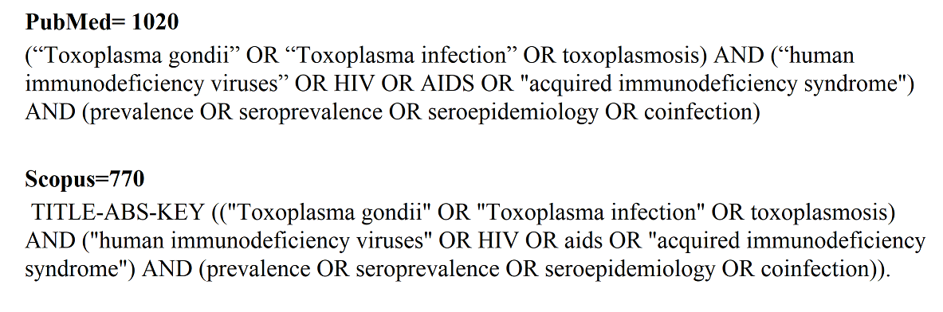

Supplementary Figure 1. Search strategy

Full-text articles excluded, with reasons
n = 108
Full-text articles assessed for eligibility
n = 258
Records excluded
n = 3058
Records screened
n = 3284
Records after duplicates removed
n = 3284

Identification
Records identified in databases: (n = 4024)
EMBASE (n = 1351); PubMed (n = 1020); Web of Science (n = 785); Scopus (n = 770); SciELO (n = 16); other sources (n = 82)

Screening

Eligibility

Included
Studies included in qualitative synthesis (n = 150)
155 data sets estimated latent toxoplasmosis
65 data sets estimated newly acquired toxoplasmosis

Supplementary Figure 2. Flow diagram of the study design process.

Supplementary Figure 3. Forest plots of pooled odds ratio (OR) for latent toxoplasmosis in people living with HIV with respect to consumption of raw/under-cooked meat. PLWH who did not consume raw/under-cooked meat were considered as the reference category to estimate OR.

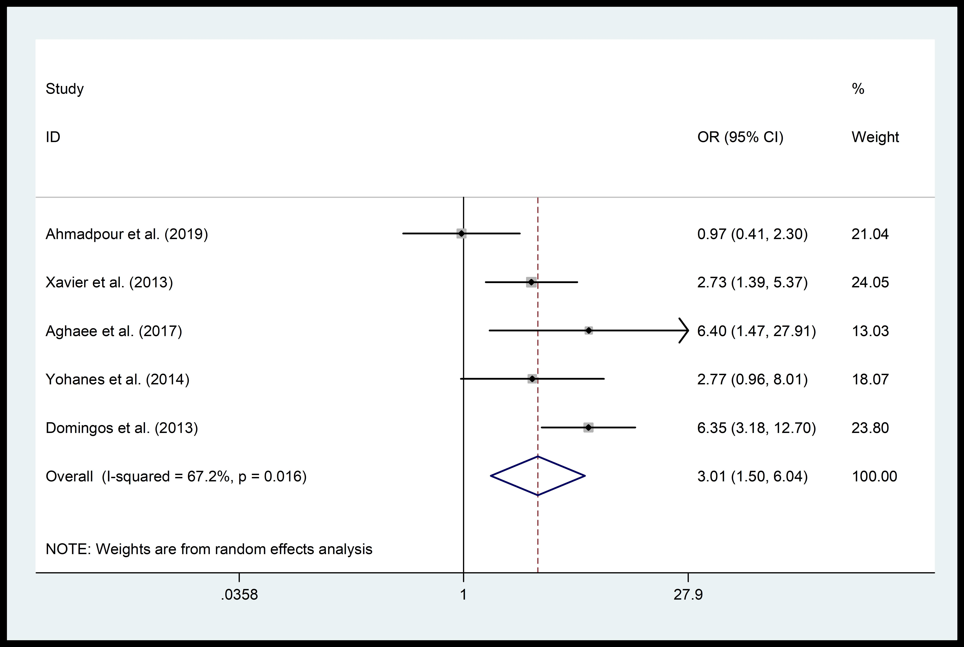
Supplementary Figure 4. Forest plots of pooled odds ratio (OR) for latent toxoplasmosis in people living with HIV with respect to contact with soil. PLWH without contact with soil were considered as the reference category to estimate OR.

Supplementary Figure 5. Forest plots of pooled odds ratio (OR) for latent toxoplasmosis in people living with HIV with respect to ages of 20-40 years compared to ages <20.

Supplementary Figure 6. Forest plots of pooled odds ratio (OR) for latent toxoplasmosis in people living with HIV with respect to ages of 40-60 years compared to ages <20.
Supplementary Figure 7. Forest plots of pooled odds ratio (OR) for latent toxoplasmosis in people living with HIV with respect to ages >60 years compared to ages <20.
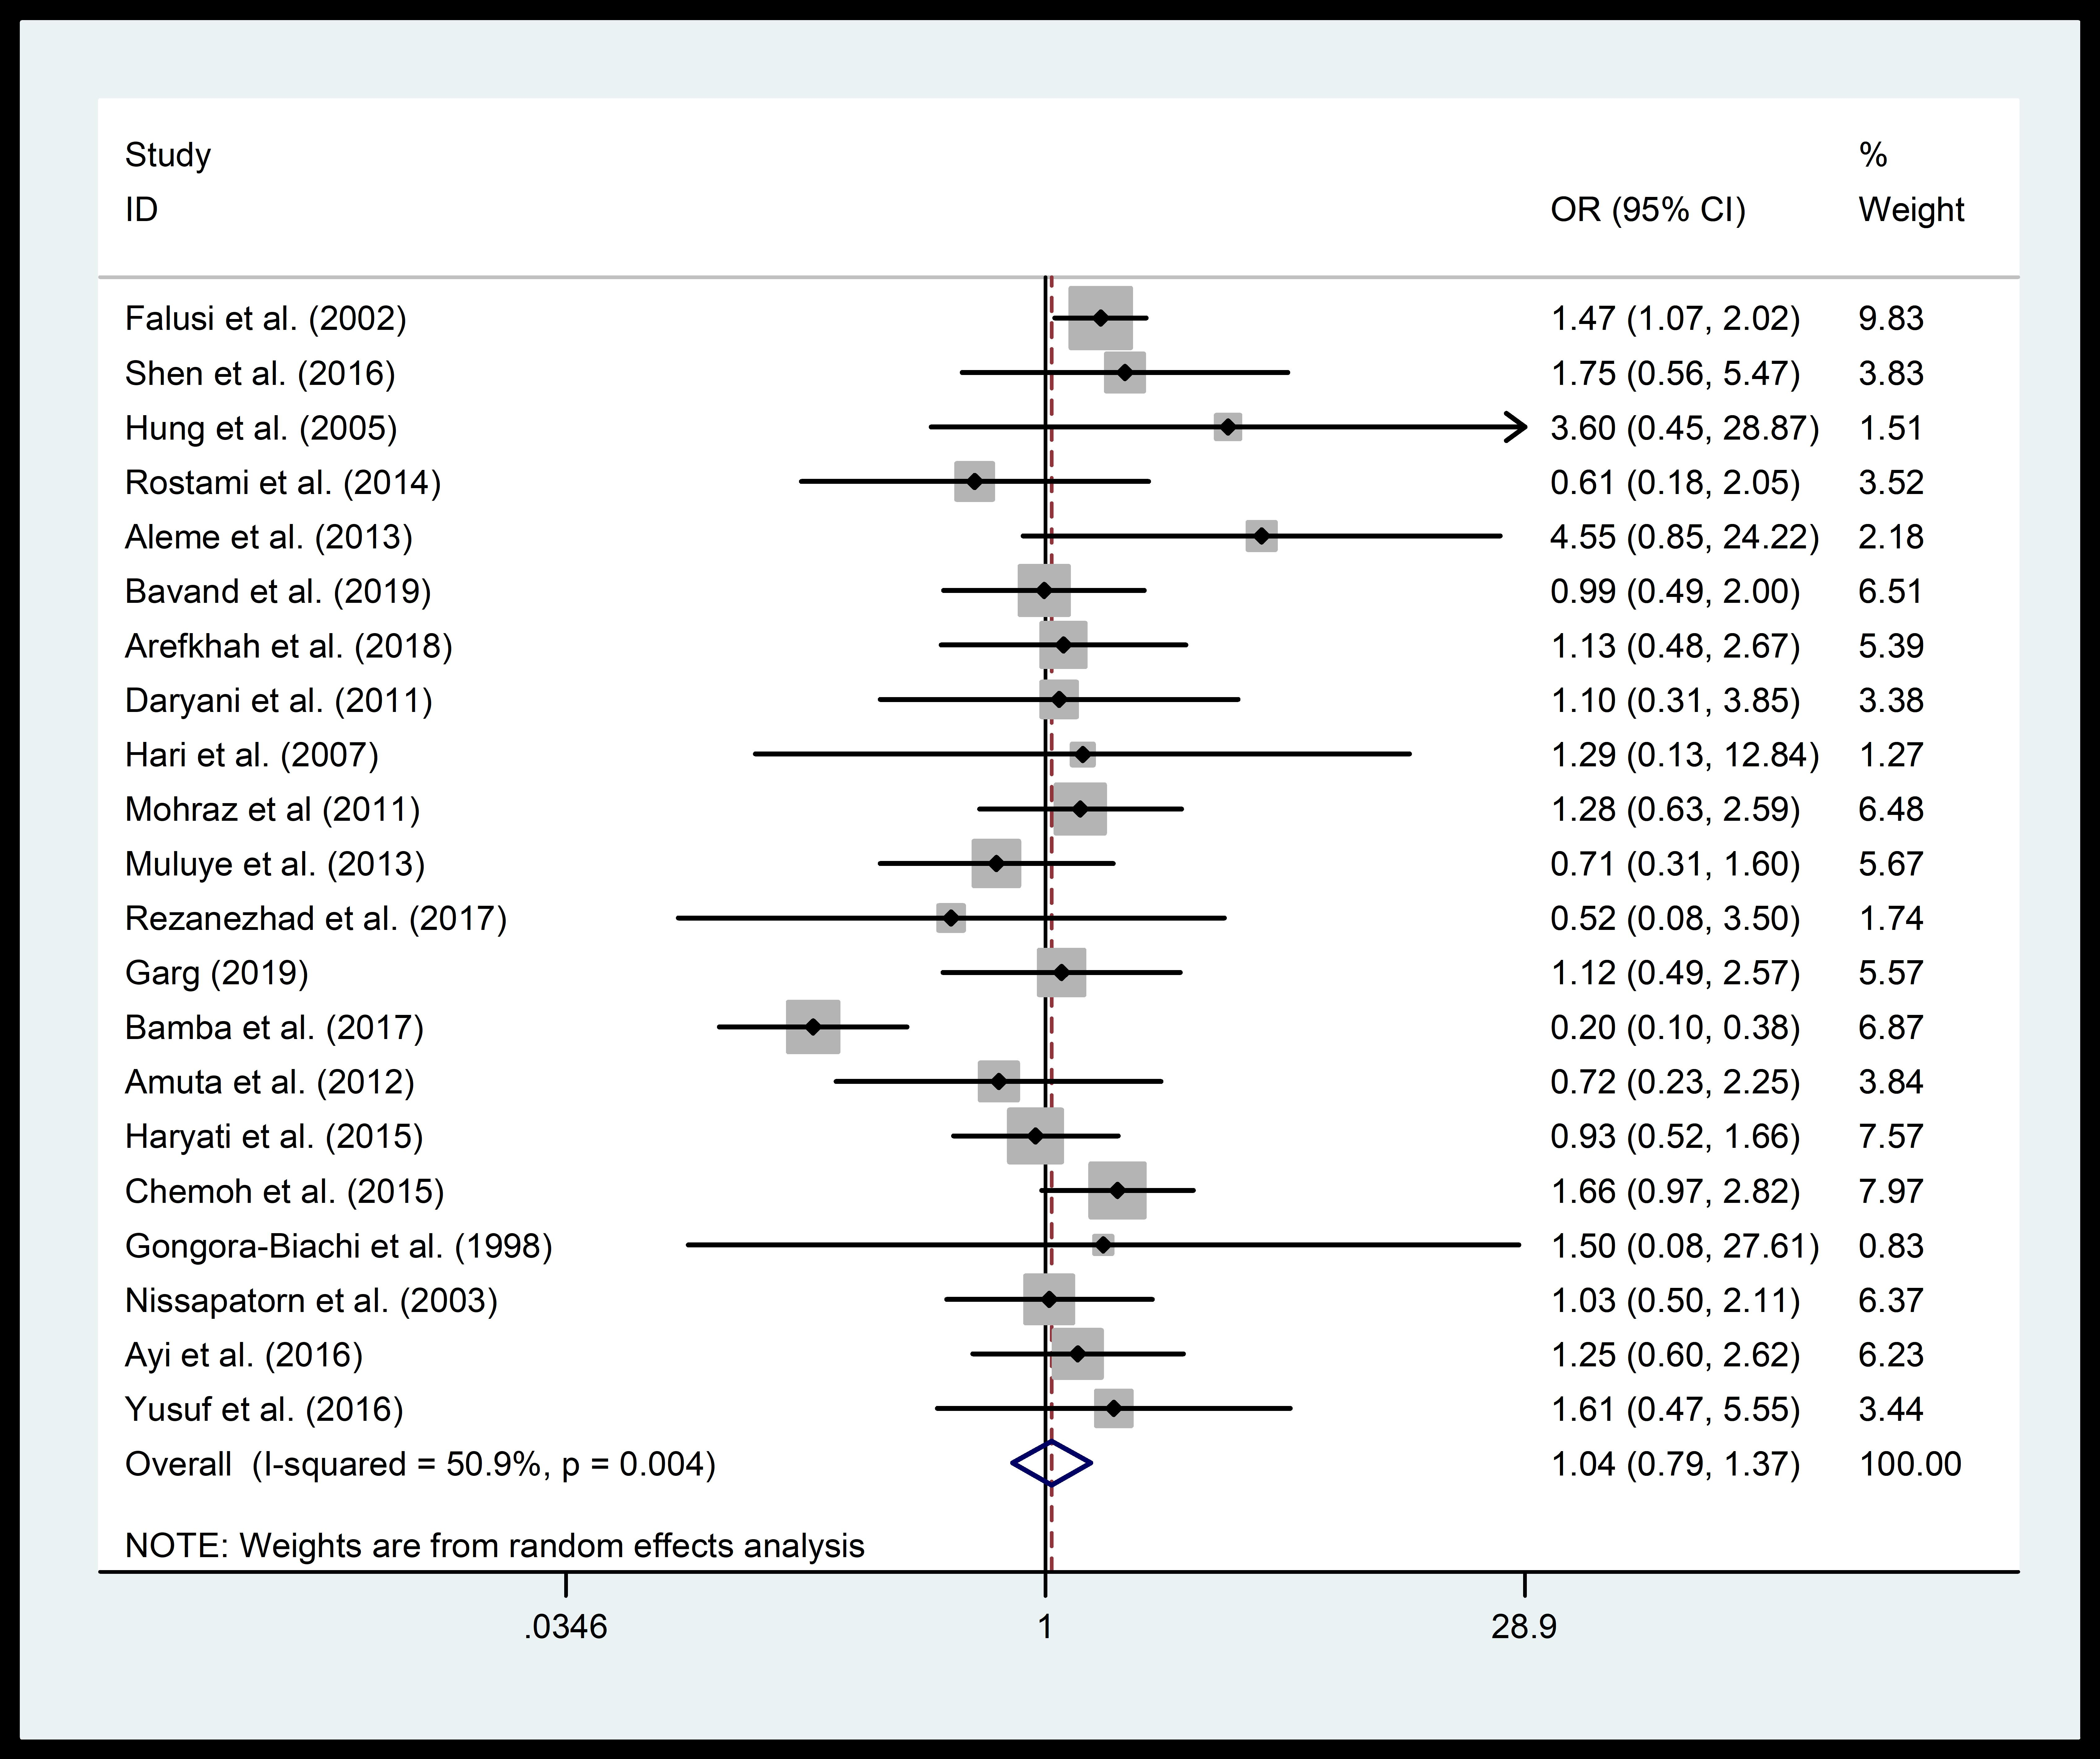
Supplementary Figure 8. Forest plots of pooled odds ratio (OR) for latent toxoplasmosis in people living with HIV with respect to age and number of CD4+ cells 200-500 compared to age and number of CD4+ cells >500.
Supplementary Figure 9. Forest plots of pooled odds ratio (OR) for latent toxoplasmosis in people living with HIV with respect to age and number of CD4+ <200 compared to age and number of CD4+ >500.

Supplementary Figure 10. Forest plots of pooled odds ratio (OR) for latent toxoplasmosis in people living with HIV with respect to gender (male and female). Female gender was considered as the reference category to estimate OR.

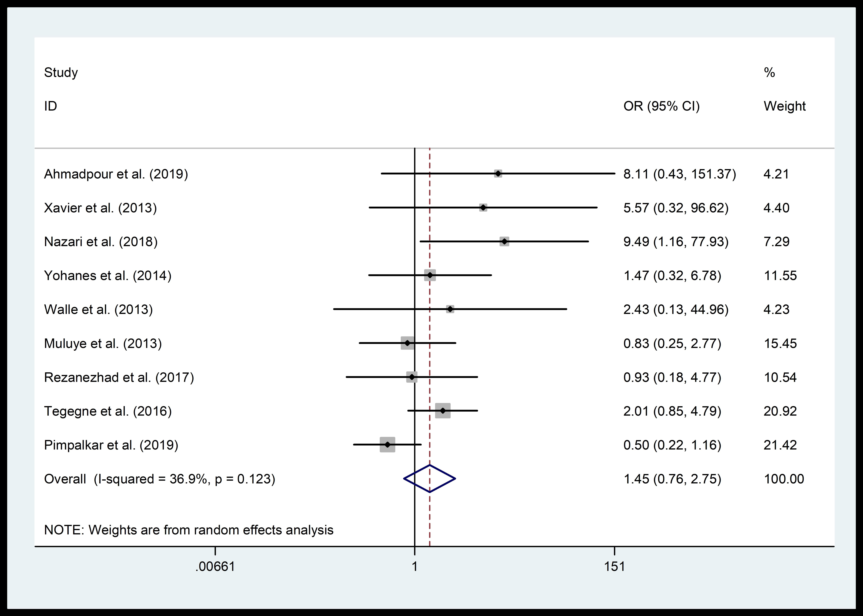
Supplementary Figure 11. Forest plots of pooled odds ratio (OR) for latent toxoplasmosis in people living with HIV with respect to type of residence (rural and urban). Living in an urban area was considered as the reference category to estimate OR.

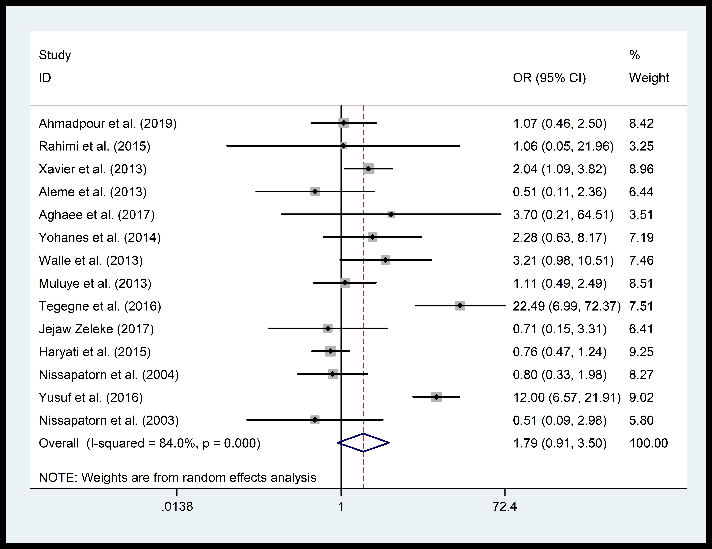
Supplementary Figure 12. Forest plots of pooled odds ratio (OR) for latent toxoplasmosis in people living with HIV with respect to cat ownership. people living with HIV who were not cat owners were considered the reference category to estimate OR.

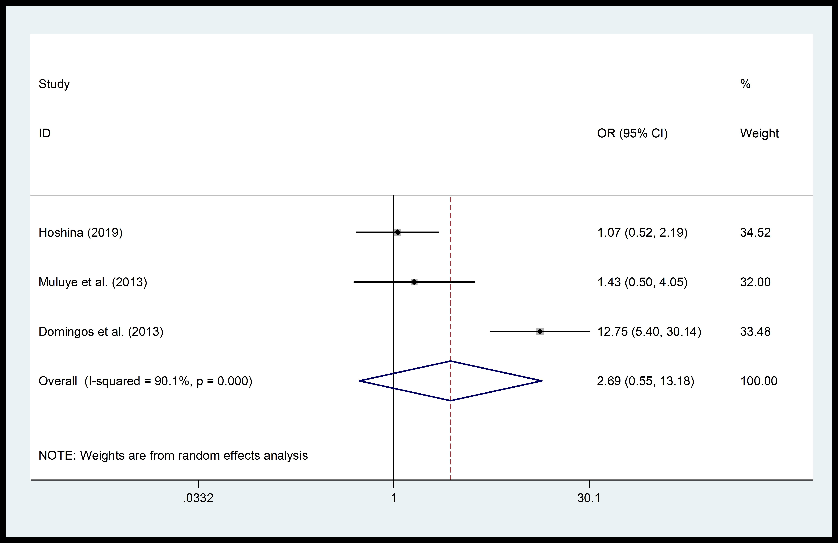
Supplementary Figure 13. Forest plots of pooled odds ratio (OR) for latent toxoplasmosis in people living with HIV with respect to dog ownership. People living with HIV who were not dog owners were considered the reference category to estimate OR.

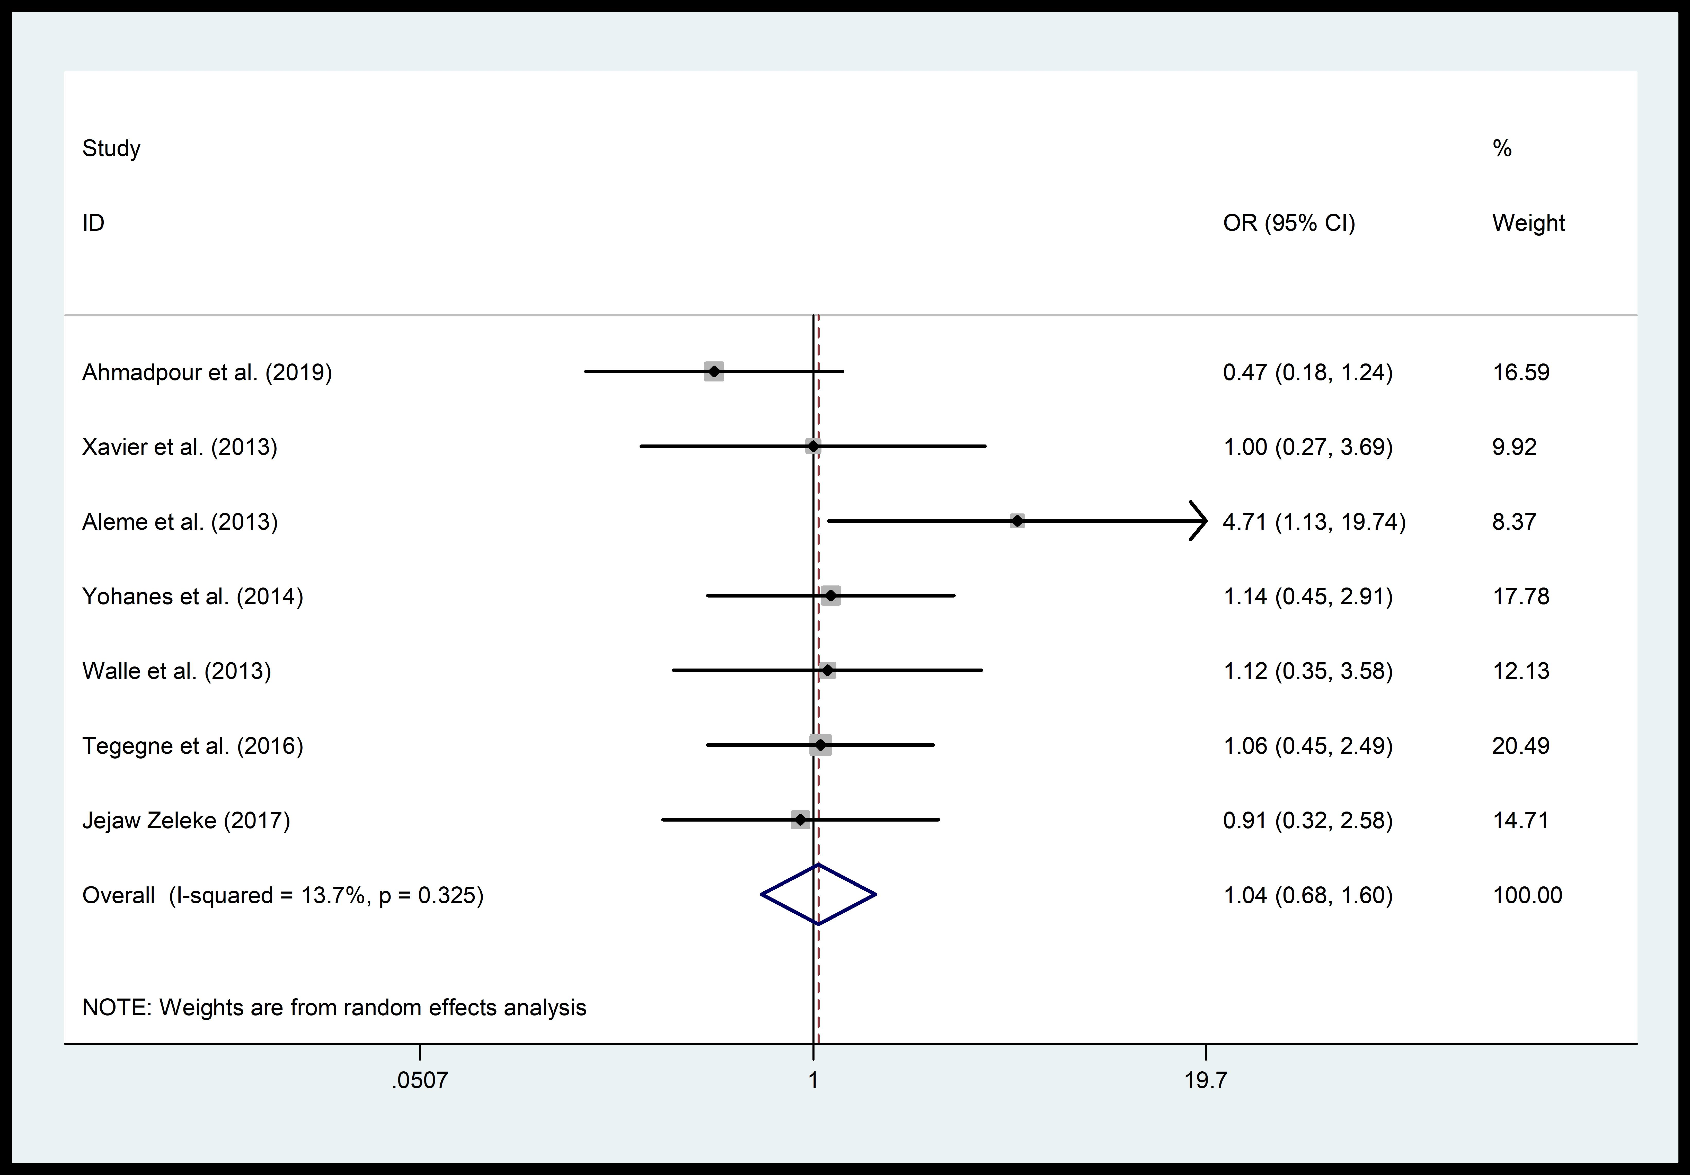
Supplementary Ffigure 14. Forest plots of pooled odds ratio (OR) for latent toxoplasmosis in people living with HIV with respect to consumption of raw/unwashed vegetables. People living with HIV who did not consume raw/unwashed vegetables were considered as the reference category to estimate OR.
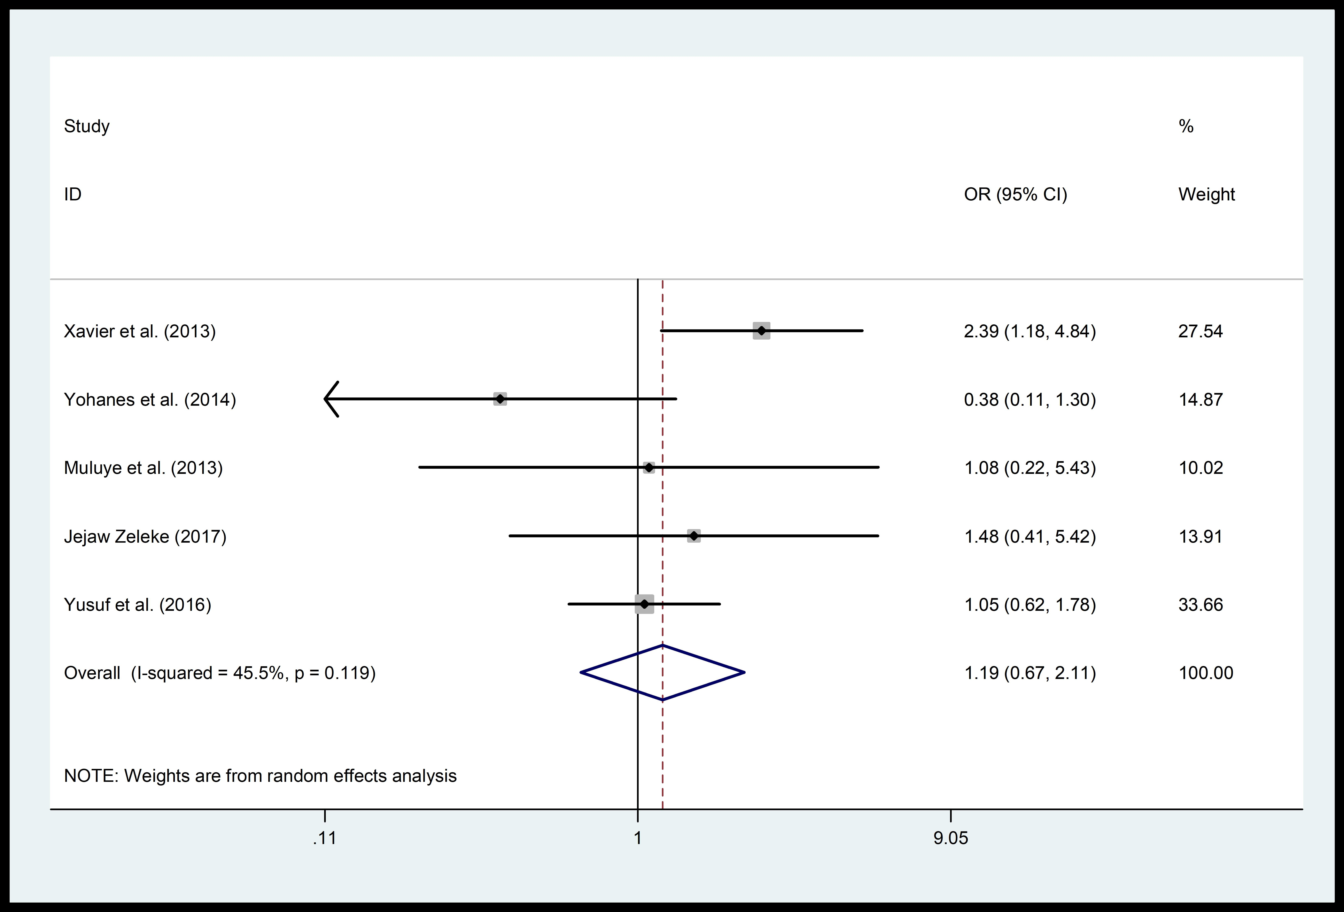
Supplementary Figure 15. Forest plots of pooled odds ratio (OR) for latent toxoplasmosis in people living with HIV with respect to drinking untreated water. People living with HIV who drank treated water were considered as the reference category to estimate OR.

