A 29-mRNA Host Response Test from Blood Accurately Distinguishes Bacterial and Viral Infections Among Emergency Department Patients

Asimina Safarika¹, James W. Wacker², Konstantinos Katsaros³, Nicky Solomonidi¹,
George Giannikopoulos⁴, Antigone Kostaki¹, Ioannis M. Koutelidakis⁵, Sabrina M. Coyle², Henry K. Cheng², Oliver Liesenfeld², Timothy E. Sweeney², Evangelos J. Giamarellos-Bourboulis¹

Affiliations:
¹4th Department of Internal Medicine, National and Kapodistrian University of Athens, Greece;
²Inflammatix Inc, Clinical Affairs, Burlingame, CA, United States;
³Department of Surgery, Nafplion General Hospital, Greece;
⁴Department of Internal Medicine, Syros General Hospital, Greece;
⁵2nd Department of Surgery, Aristotle University of Thessaloniki, Greece

* To whom correspondence should be addressed:
Evangelos J. Giamarellos-Bourboulis, MD, PhD, FISAC
Professor of Internal Medicine
4th Department of Internal Medicine
ATTIKON University Hospital
1 Rimini Str
12462 Athens
Greece
Supplementary Table S1 Linear Regression with InSep Bacterial Score as Dependent Variable.
Linear regression revealed that other than lactate the markers listed are not influencing the InSep score.

Coefficients: | Estimate | Std. Error | t | P
(Intercept) | -0.007 | 0.102 | -0.069 | 0.945
Consensus Adjudication: bacterial | 0.435 | 0.050 | 8.768 | 0.000 | ***
Age | 0.001 | 0.002 | 0.776 | 0.442
Sex - Male | 0.021 | 0.045 | 0.459 | 0.648
Immunocompromised - Yes | -0.066 | 0.047 | -1.391 | 0.171
Lactate | 0.062 | 0.024 | 2.614 | 0.012 | *

Supplementary Table S2 Linear Regression with InSep Viral Score as Dependent Variable. Linear regression revealed that other than lactate the markers listed are not influencing the InSep score.

Coefficients: | Estimate | Std. Error | t | P
(Intercept) | 0.227 | 0.154 | 1.473 | 0.148
Consensus Adjudication: viral | 0.438 | 0.070 | 6.257 | 0.000 | ***
Age | 0.001 | 0.002 | 0.291 | 0.772
Sex - Male | -0.022 | 0.062 | -0.355 | 0.724
Immunocompromised - Yes | -0.012 | 0.065 | -0.188 | 0.852
Lactate | -0.071 | 0.033 | -2.188 | 0.034 | *

Supplementary Figures

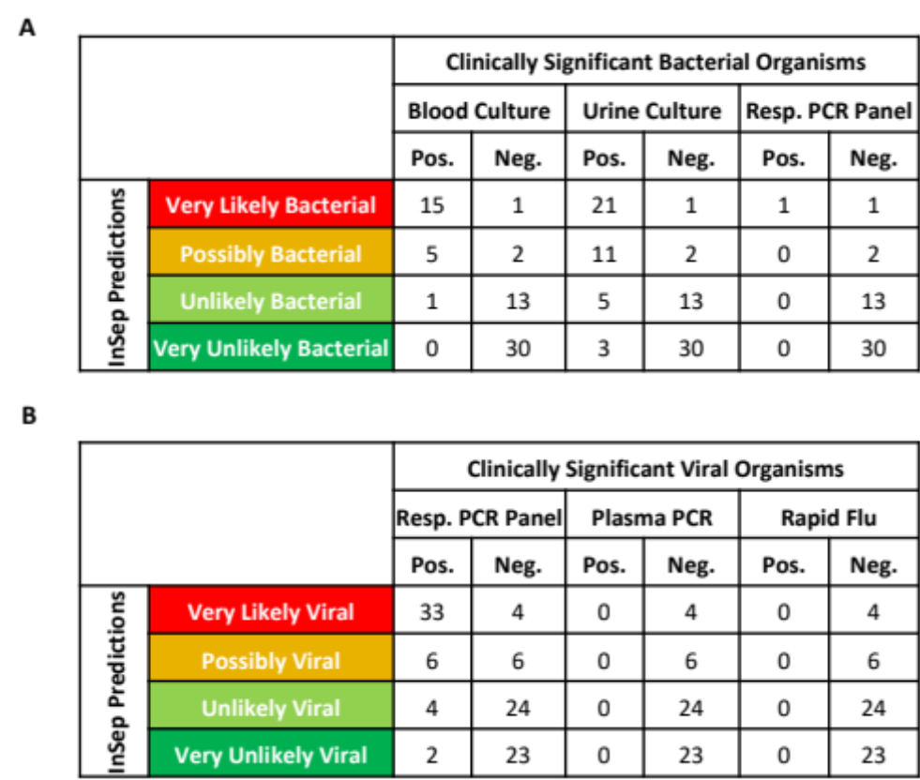

Supplementary Fig. S1 InSep concordance with results of bacterial and viral pathogen detection tests. InSep results segmented by interpretation bands compared to conventional diagnostic test results for the presence of (A) bacterial and (B) viral pathogens. When considering only ‘Very likely’ results, InSep showed a positive agreement of 94% and 89% compared to positive bacterial cultures and viral findings in respiratory syndromic panels, respectively.

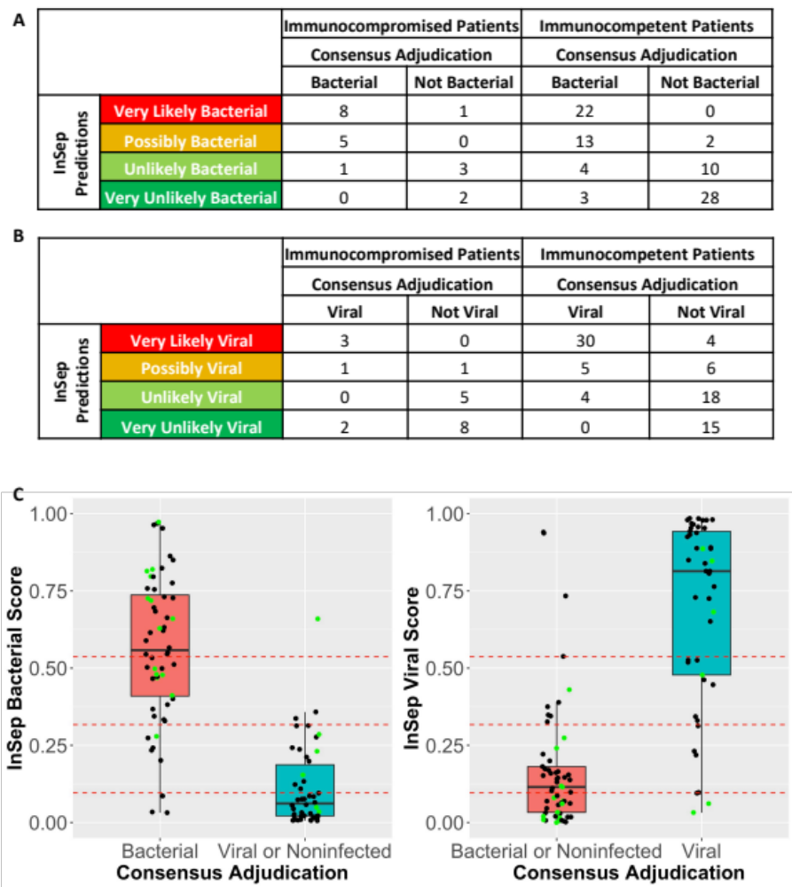
Supplementary Fig. S2 InSep performance in immunocompromised patients. InSep (A) bacterial scores and (B) viral score results segmented by interpretation bands and immune status in the 20 (out of 102) consensus adjudicated patients who are immunocompromised. (C) shows the same boxplots as in Fig. 2) but with immunocompromised patients colored in green and dotted red lines which separate the four interpretation bands.

