Title: Therapeutic effects of mesenchymal stem cells-conditioned medium derived from suspension cultivation or Silymarin on liver failure mice
Journal title: Molecular biology report
Sedigheh Molaei ª, Fatemeh Amiri ^{b*}, Rasoul Salimi ^{c}, Shirin Ferdowsi ^{d}, Marzie Bahadori ^{d}.
*Corresponding author E-mail address; amirif2012@gmail.com, Department of Medical Laboratory Sciences, School of Para Medicine, Hamadan University of Medical Sciences, Hamadan, Iran.

Table 1S. The designed specific primers for molecular assessment.

Gene | Forward | Revers
GSH-Px | 5′-CAGTTCGGACATCAGGAGAATG-3′ | 5′-AGCCATCACCAAGCCAATAC-3′
SOD | 5′-GGTCCACCTCGAACTACTTTATG-3′ | 5′-GGTGATCAGGAACATGGAATCT-3′
RIPK1 | 5′-GAAGACAGACCTAGACAGCGG-3′ | 5′-CCAGTAGCTTCACCACTCGAC-3′
FGL-1 | 5′-CTTCGTCCTGGTCGCCATT-3′ | 5′-TCCCGCAAGCAGTTCTCAC-3′
KGF | 5′-CGCAAATGGATACTGACACG-3′ | 5′-GGGCTGGAACAGTTCACACT-3′
Mir-122 | 5′-GGCTGTGGAGTGTGACAATG-3′ | 5′-CAATTGGAGGCTTCGAACAG-3′
Mir-122 | RT: 5′-GTCTCCTCTGGTGCAGGGTCCGAGGTATTCGCACCAGAGGAGCCAACA-3′
Mir-122: MicroRNA-122, GSH-Px: Glutathione peroxidase, SOD: Superoxide dismutase, RIPK1: Receptor interacting protein kinases 1, FGL-1: Fibrinogen-like protein 1, KGF: Keratinocyte growth factor.

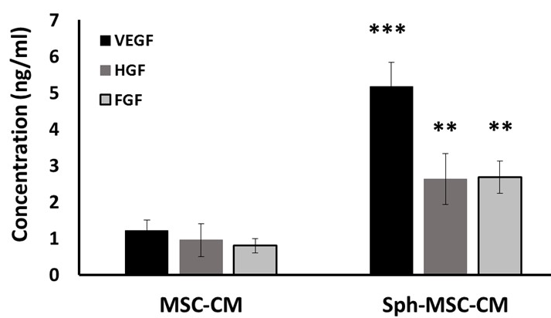
Figure 1S: Evaluation of VEGF, HGH and FGF levels in MSC-CM and Sph-MSC-CM with ELISA method. The concentration of growth factors were mesured in conditioned medium harvested from both adherent monolayer MSC culture (MSC-CM) and non-adherent spheroid MSC culture (Sph-MSC-CM). Significantly higher amounts of VEGF, HGF and FGF were detected in Sph-MSC-CM. Date was shown as mean ± SD.**p<0.01, ***p<0.001 Sph-MSC-CM vs MSC-CM. Sph-MSC-CM: Conditioned medium from spheroid culture of mesenchymal stem cell, MSC-CM: Conditioned medium from adherent monolayer culture of mesenchymal stem cell. VEGF: Vascular endothelial growth factor, HGF: Hepatocyte growth factor, FGF: Fibroblast growth factor.

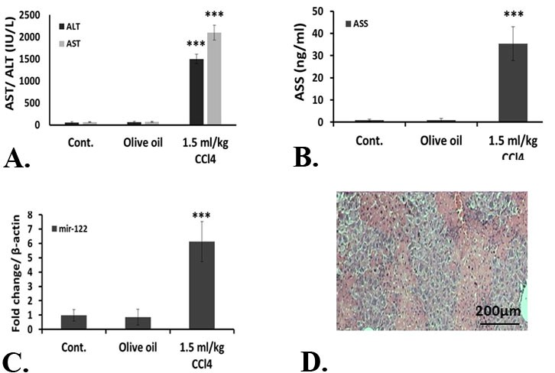
Figure 2S: Assessment of induced liver failure (LF) in mice 12 hours after injection of 1.5 mg/kg CCl₄. Liver injury was assayed with biochemical, molecular and histopathological methods. A. Aspartate aminotransferase (AST) and alanine aminotransferase (ALT) were evaluated in the blood of mice receiving 1.5 mg/kg CCl4 in comparison to mice without any injection and mice receiving olive oil only. CCl₄ receiving animals released much more amount of liver enzymes in blood stream. B. Argininosuccinate synthetase (ASS) level in subjected animals. Increased level of ASS was detected in CCl₄-induced-LF mice. C. MicroRNA-122 expression level was quantified in liver homogenates using real-time PCR method. MicroRNA-122 expression was upregulated in 1.5 mg/kg CCl₄-receiving mice. Date was shown as mean ± SD. ***p<0.001 CCl₄ receiving vs olive oil. D. Hematoxylin and Eosin (H& E) staining of LF-induced mice liver section. Interalobular necrotic bridges along with several necrotic and inflammatory cells were observed and confirmed liver failure (Magnification 400×, Scale bar 200µ).

