Supplementary data

Tables
Table S1: Slopes (m) and r² (in bracket) of the linear regression models without intercept (LRMs) developed for each hour of the day for the three species S. racemosa, E. acuminata, and C. hystrix used for estimating sap flow in replicate trees using equation 3.
Hours | S. racemosa  (m (r²)) | E. acuminata  (m (r²)) | C. hystrix  (m (r²))
0 | 0.59 (0.47) | 1.13 (0.92) | 0.96 (0.81)
1 | 0.53 (0.67) | 0.96 (0.98) | 0.86 (0.67)
2 | 0.55 (0.85) | 0.98 (0.99) | 0.6 (0.62)
3 | 0.66 (0.97) | 1.01 (0.99) | 0.7 (0.96)
4 | 0.74 (0.99) | 0.93 (0.99) | 0.78 (0.99)
5 | 0.79 (0.99) | 0.94 (0.99) | 0.82 (0.99)
6 | 0.87 (0.99) | 0.99 (0.98) | 0.83 (0.99)
7 | 0.9 (1) | 1.08 (0.97) | 0.84 (0.99)
8 | 0.91 (0.99) | 1.16 (0.98) | 0.86 (0.99)
9 | 0.86 (0.99) | 1.05 (1) | 0.86 (0.99)
10 | 0.76 (0.97) | 0.7 (0.9) | 0.78 (0.98)
11 | 0.77 (0.95) | 0.69 (0.89) | 0.83 (0.95)
12 | 0.87 (0.98) | 0.78 (0.86) | 0.92 (0.96)
13 | 0.96 (0.98) | 0.95 (0.81) | 0.96 (0.96)
14 | 1.07 (0.98) | 1.01 (0.97) | 0.95 (0.97)
15 | 1.09 (0.98) | 1 (0.99) | 0.92 (0.98)
16 | 1 (0.98) | 1.01 (0.98) | 0.96 (0.97)
17 | 0.89 (0.95) | 0.88 (0.98) | 0.96 (0.97)
18 | 0.61 (0.88) | 0.95 (0.72) | 0.96 (0.97)
19 | 0.63 (0.83) | 0.77 (0.59) | 0.92 (0.94)
20 | 0.61 (0.62) | 0.69 (0.53) | 0.86 (0.91)
21 | 0.66 (0.51) | 0.72 (0.52) | 0.8 (0.85)
22 | 1.02 (0.87) | 0.69 (0.5) | 0.76 (0.81)
23 | 1 (0.97) | 0.72 (0.46) | 0.74 (0.75)

Table S2: Results from multiple linear regression models (MLRs) for day (0600-1700 h) and night (1800-0500 h) to assess the drivers of radial variability in sap flow across the three species using correction factors (C_{h}) as response variable and Vapour pressure deficit (VPD, kPa), Incoming short-wave radiation (R_{s}, kW m⁻²) and Soil moisture (S, mm h⁻¹) as predictors (*P < 0.05, ** P < 0.01, *** P < 0.001). R_{s} and S were significant predictors of daytime radial variability (C_{h}, unitless) in S. racemosa, whereas none of the predictors were significant for E. acuminata and C. hystrix. Conversely, D was a strong negative predictor of night C_{h} in E. acuminata and a weak negative predictor in S. racemosa and C. hystrix.
Species | Model | Predictors | Estimate | Std. Error | t value | p-value (P) | r²
S. racemosa | Day | VPD | 0.083 | 0.268 | 0.309 | 0.759 | 0.43
S. racemosa | Day | R_{s} | -0.452 | 0.115 | -3.923 | <0.001*** | 0.43
S. racemosa | Day | S | 1.446 | 0.210 | 6.879 | <0.001*** | 0.43
S. racemosa | Night | VPD | -6.766 | 5.140 | -1.316 | 0.192 | 0.02
S. racemosa | Night | S | -0.024 | 1.213 | -0.020 | 0.984 | 0.02
E. acuminata | Day | VPD | -2.580 | 6.269 | -0.412 | 0.683 | 0.007
E. acuminata | Day | R_{s} | 0.693 | 1.846 | 0.376 | 0.710 | 0.007
E. acuminata | Day | S | 0.370 | 5.471 | 0.068 | 0.947 | 0.007
E. acuminata | Night | VPD | -61.94 | 13.280 | -4.664 | <0.001*** | 0.40
E. acuminata | Night | S | 2.683 | 7.110 | 0.377 | 0.708 | 0.40
C. hystrix | Day | VPD | 1.186 | 1.102 | 1.076 | 0.283 | 0.01
C. hystrix | Day | R_{s} | -0.634 | 0.437 | -1.452 | 0.148 | 0.01
C. hystrix | Day | S | 0.108 | 0.824 | 0.131 | 0.896 | 0.01
C. hystrix | Night | VPD | -1.429 | 3.359 | -0.425 | 0.671 | 0.001
C. hystrix | Night | S | -0.081 | 0.688 | -0.117 | 0.907 | 0.001

Table S3: Results from multiple linear regression models (MLRs) for day (0600-1700 h) and night (1800-0500 h) to assess the drivers of azimuthal variability across the three species using sap flow ratio (R_{NS}, unitless) as response variable and Vapour pressure deficit (VPD, kPa), Incoming short-wave radiation (R_{s}, kW m⁻²) and Soil moisture (S, mm h⁻¹) as predictors (*P < 0.05, ** P < 0.01, *** P < 0.001). The MLRs performed poorly. However, R_{s} was a significant positive predictor of R_{NS} at average D and S across the three species. Night-time R_{NS} was better predicted by D and S in S. racemosa, and by D in C. hystrix. S was a significant predictor of night R_{NS} in E. acuminata.
Species | Daytime | Predictors | Estimate | Std. Error | t value | p-value (P) | r²
S. racemosa | Day | VPD | -3.143 | 4.351 | -0.722 | 0.473 | 0.05
S. racemosa | Day | R_{s} | 3.299 | 1.872 | 1.762 | 0.083* | 0.05
S. racemosa | Day | S | -2.874 | 3.416 | -0.842 | 0.403 | 0.05
S. racemosa | Night | VPD | -25.142 | 13.612 | -1.847 | 0.069 | 0.09
S. racemosa | Night | S | 5.716 | 3.213 | 1.779 | 0.080* | 0.09
E. acuminata | Day | VPD | 15.209 | 19.143 | 0.795 | 0.433 | 0.18
E. acuminata | Day | R_{s} | 9.894 | 5.637 | 1.755 | 0.089 | 0.18
E. acuminata | Day | S | -21.078 | 16.705 | -1.262 | 0.216 | 0.18
E. acuminata | Night | VPD | 13.409 | 13.279 | 1.010 | 0.320 | 0.16
E. acuminata | Night | S | 15.501 | 7.110 | 2.180 | 0.037* | 0.16
C. hystrix | Day | VPD | 23.524 | 41.535 | 0.566 | 0.572 | 0.03
C. hystrix | Day | R_{s} | -34.519 | 16.551 | -2.086 | 0.038* | 0.03
C. hystrix | Day | S | 33.430 | 31.089 | 1.075 | 0.284 | 0.03
C. hystrix | Night | VPD | 4.454 | 1.517 | 2.937 | 0.004** | 0.05
C. hystrix | Night | S | 0.036 | 0.311 | 0.117 | 0.907 | 0.05

Table S4: Percentage contribution of day, night, evening and pre-dawn sap flow and stand transpiration to total daily sapflow and transpiration (values in %, standard deviation in parentheses). Nocturnal sap flow was dominated by pre-dawn flux in S. racemosa, whereas evening flux dominated in E. acuminata and C. hystrix.
Species | Day  (0600-1700) | Night  (1800-0500) | Evening  (1800-2300) | Pre-dawn  (0000-0500)
S. racemosa | 88.7 (7) | 11.3 (7) | 5.1 (5) | 6.2 (7)
E. acuminata | 82.8 (9) | 17.2 (9) | 9.5 (8) | 7.7 (7)
C. hystrix | 86.5 (5) | 13.5 (5) | 9.7 (5) | 3.8 (4)
Stand Transpiration | 86.2 (6) | 13.8 (5) | 8 (5) | 5.8 (5)

Table S5 Results from multiple linear regression models (MLRs) to assess the drivers of nocturnal sap flow across the three species measured as percentage fraction of daily sap flow as response variable and Vapour pressure deficit (VPD, kPa), Wind speed (U, m s⁻¹) and Soil moisture (S, mm h⁻¹) as predictors. S was a significant negative predictor of V_{night} in E. acuminata, whereas D was a significant negative predictor for C. hystrix. None of the predictors were significant for S. racemosa.
Species | Predictors | Estimate | Std. Error | t value | p-value (P) | r²
S. racemosa | VPD | -0.115 | 0.345 | -0.333 | 0.742 | 0.02
S. racemosa | S | -0.002 | 0.003 | -0.647 | 0.524 | 0.02
S. racemosa | U | 0.059 | 0.108 | 0.548 | 0.589 | 0.02
E. acuminata | VPD | 0.073 | 0.321 | 0.228 | 0.821 | 0.12
E. acuminata | S | -0.006 | 0.003 | -2.010 | 0.050 | 0.12
E. acuminata | U | 0.039 | 0.098 | 0.402 | 0.690 | 0.12
C. hystrix | VPD | -0.382 | 0.141 | -2.715 | 0.009 | 0.13
C. hystrix | S | 0.001 | 0.001 | 0.588 | 0.559 | 0.13
C. hystrix | U | 0.015 | 0.030 | 0.499 | 0.620 | 0.13

Figures
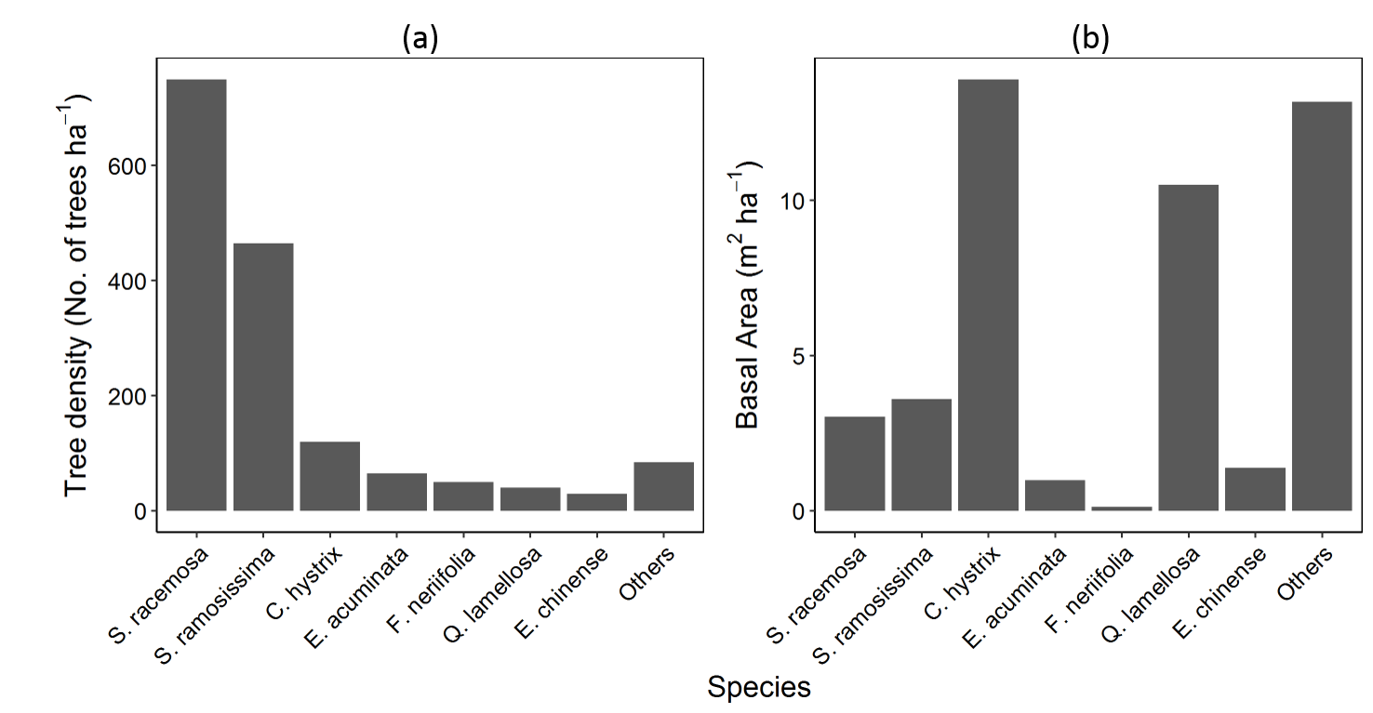
Figure S1: Barplots of vegetation distribution in FWS showing (a) tree density of top seven species per hectare and (b) basal area (m² ha⁻¹) of the same species. The selected species, S. racemosa and E. acuminata represent the fast-growing pioneer community, whereas C. hystrix represent the large-sized remnant individuals of Fagaceae family.
Figure S2. Time-series plots of the raw daily data of the SPAC variables from winters (December) to summers (May): (a) Incoming short-wave radiation (R_{s}, kW m⁻²), (b) Vapour Pressure Deficit (VPD, kPa), (c) Precipitation (P, mm d⁻¹), (d) Total Soil moisture (S, mm h⁻¹), (e) V_{S. racemosa}, (f) V_{E. acuminata}, and (g) V_{C. hystrix} are Volumetric sap flow rate (V) of S. racemosa, E. acuminata and C. hystrix, respectively, and (h) Stand Transpiration (T, mm d⁻¹).

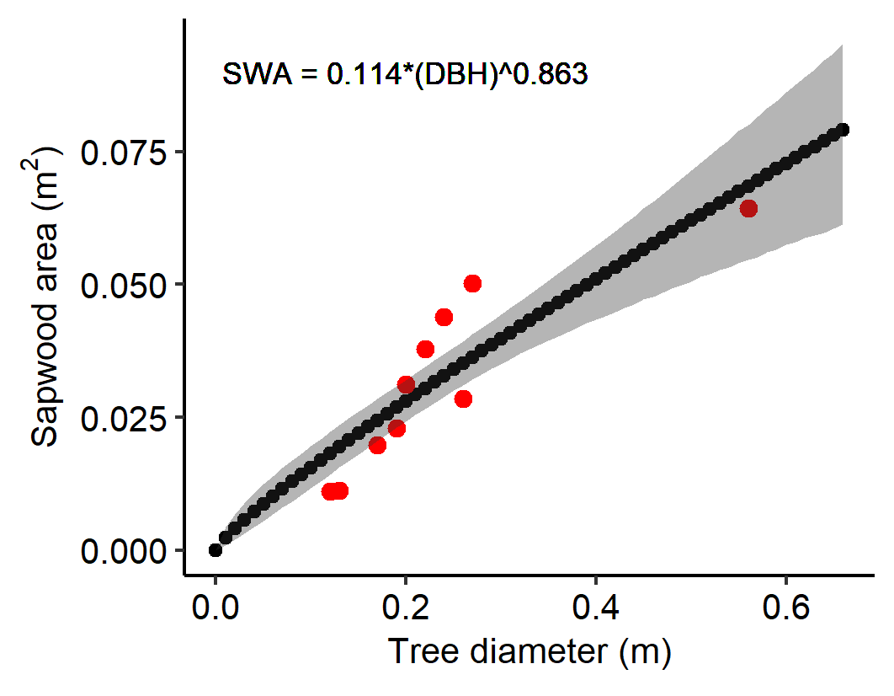
Figure S3. Non-linear least-squared (NLS) regression model between sapwood area (m₂) and tree diameter (m) of the 13 instrumented trees used for scaling whole-tree sap flow to stand transpiration.

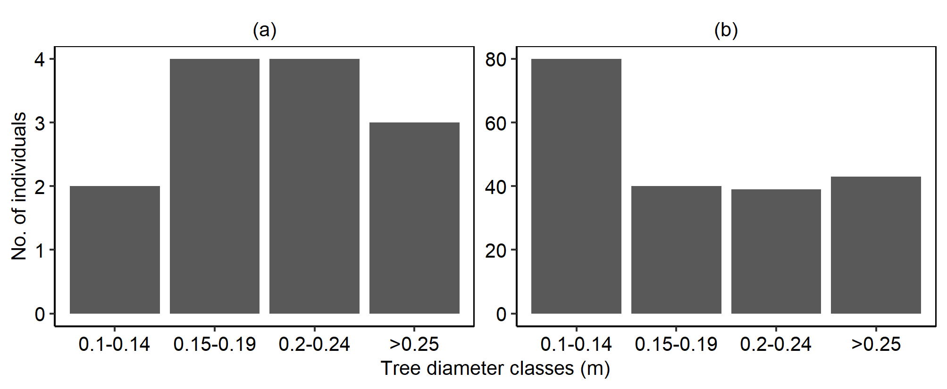
Figure S4. Frequency plot of trees categorized according to the diameter classes for: (a) Trees instrumented with the TDP probes, (b) All the trees above 10 cm DBH enumerated in the vegetation plots.

Figure S5. Variability in sapwood properties along the depth of xylem in terms of (a) Wood moisture (in %) and (b) Wood density (g cm⁻³) for the three species. Both, S. racemosa and E. acuminata show decline in wood moisture and increase in wood density from outer to inner xylems, except C. hystrix, which shows highest moisture and lowest wood density in inner xylem at 4th cm depth of sapwood.

Figure S6. Scatterplots showing relationship between sap flux density and (a) Wood moisture (in %) and (b) Wood density (g cm⁻³) for the three species. The three species, except E. acuminata, show weakly positive and negative relationships between sap flux density and wood moisture with wood density for a particular sapwood annulus ring, respectively.

Figure S7. Scatterplot between sap flow (V, kg hr⁻¹) and (a) Incoming short-wave radiation (R_{s}, kW m⁻²) and (b) Vapour pressure deficit (VPD, kPa) for the three species. Peak sap flow in S. racemosa and E. acuminata is concentrated at low R_{s} and VPD, whereas C. hystrix is unaffected by environmental extremes.

Figure S8. Scatterplot between nocturnal sap flow (V_{night} in % of V) and (a) Vapour pressure deficit (D), (b) Soil moisture and (c) Wind velocity (u) across the three species. Nocturnal sap flow was mainly concentrated around low D (< 0.1 kPa), low wind velocity (< 0.5 m s⁻¹) and moderately saturated soil moisture.

Figure S9. Seasonal patterns in bio-climatic parameters: (a) Evapotranspiration (ET₀) and (b) Leaf area Index (LAI). The LAI_4D values are extracted and averaged from MODIS remote sensing product, while the ET₀ values are estimated empirically from weather station data using FAO56PM method. Error-bars represent standard errors.

