Sfigure. Main characteristics of lesion types and sub-types

Type A component: Mainly based on the fundus photographs
A0 | No myopic retinal lesions | 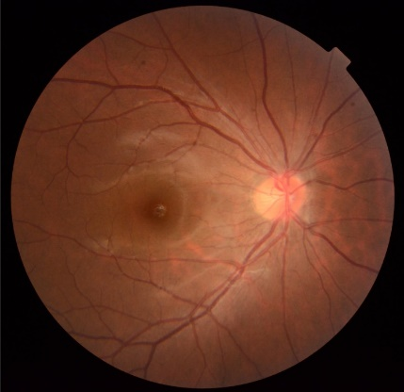
A1 | Tessellated fundus only | 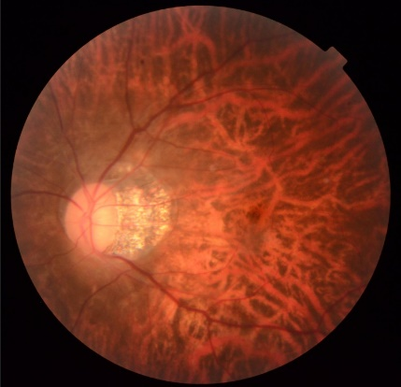
A2 | Diffuse chorioretinal atrophy | 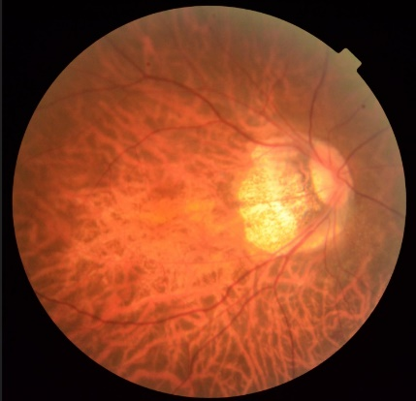
A3 | Patchy chorioretinal atrophy | 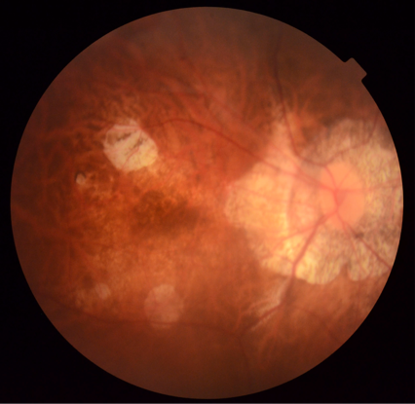
A4 | Complete macular atrophy | 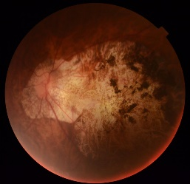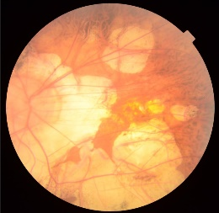
Type T component: mainly based on the OCT
T0 | No macular schisis | 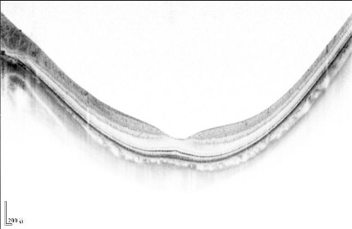
T1 | Inner or outer foveoschisis | 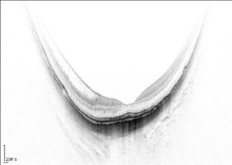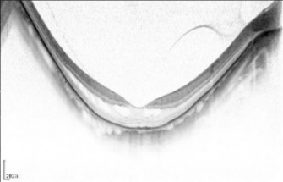
T2 | Inner + outer foveoschisis | 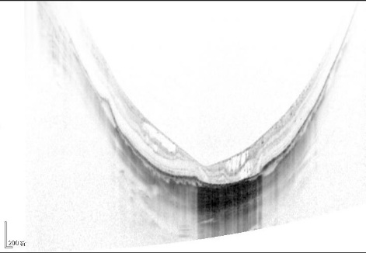
T3 | Foveal detachment | 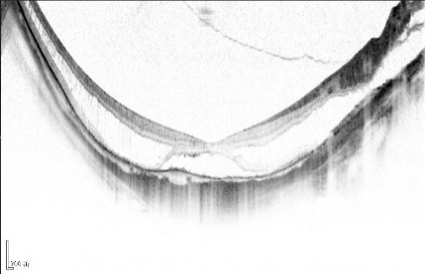
T4 | Full-thickness MH | 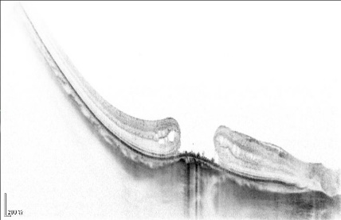
T5 | MH + Retinal detachment | 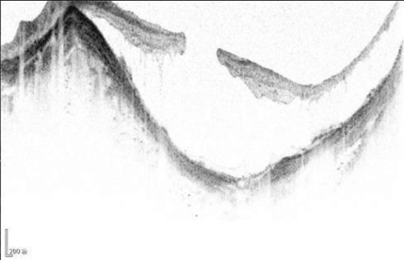
Type N component: based on the fundus and OCT
N0 | No Myopic CNV | 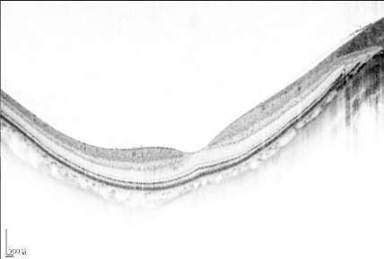
N1 | Macular lacquer cracks | 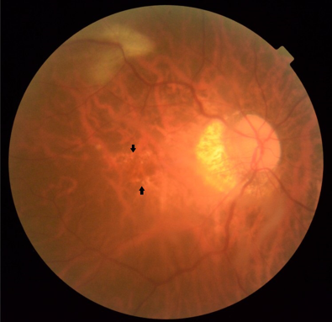
N2a | Active CNV | 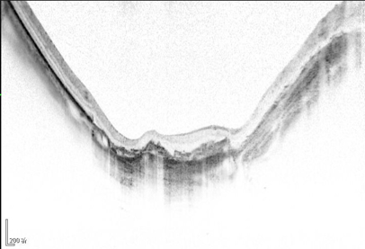
N2s | Scar / Fuch’s spot | 