Parasite life cycle

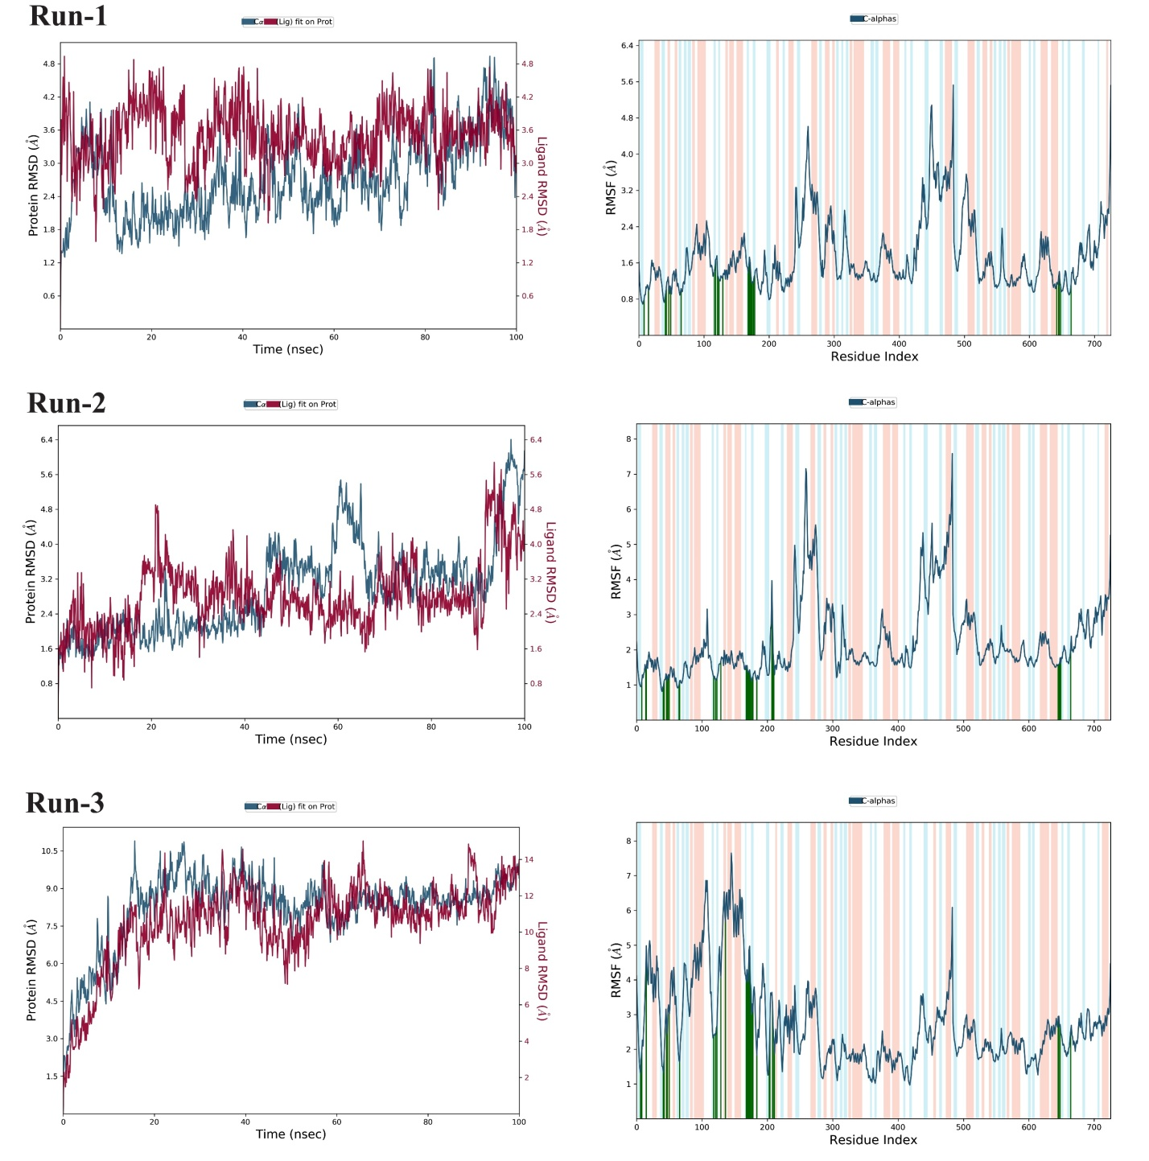
Figure A1. Triplicate RMSD and RMSF of 2I54-ZINC000026664090 complex for 100ns MD simulation
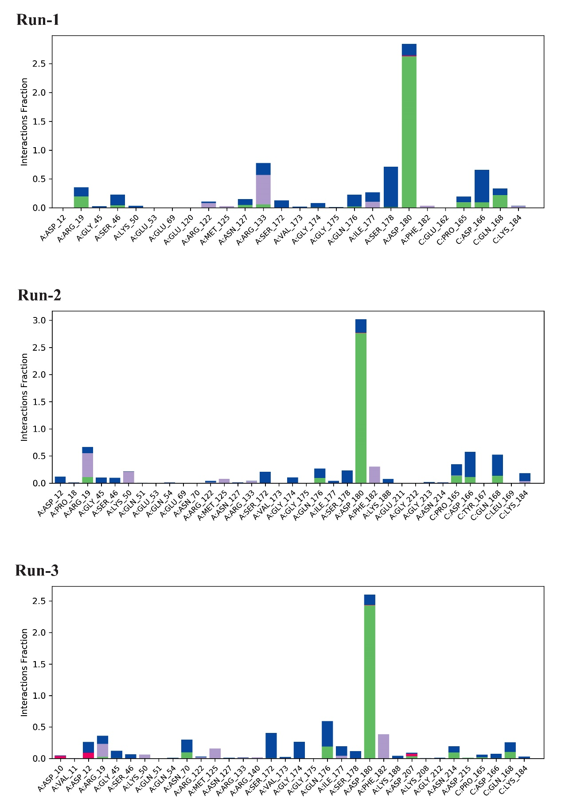
Figure A2. Ligand interactions with residues in 2I54-ZINC000026664090 complex for 100ns MD simulation

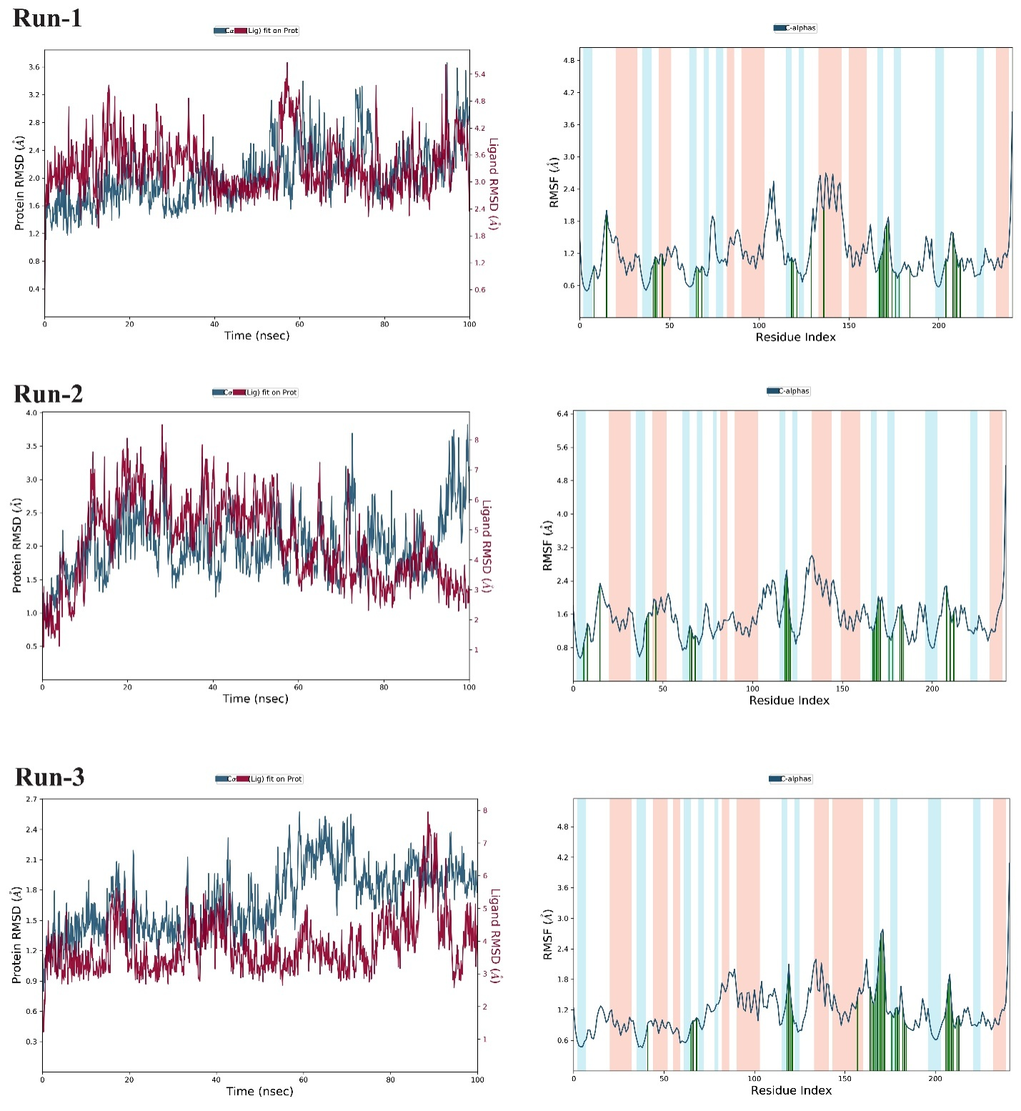
Figure B1. Triplicate RMSD and RMSF of 2I54-Grazoprevir complex for 100ns MD simulation

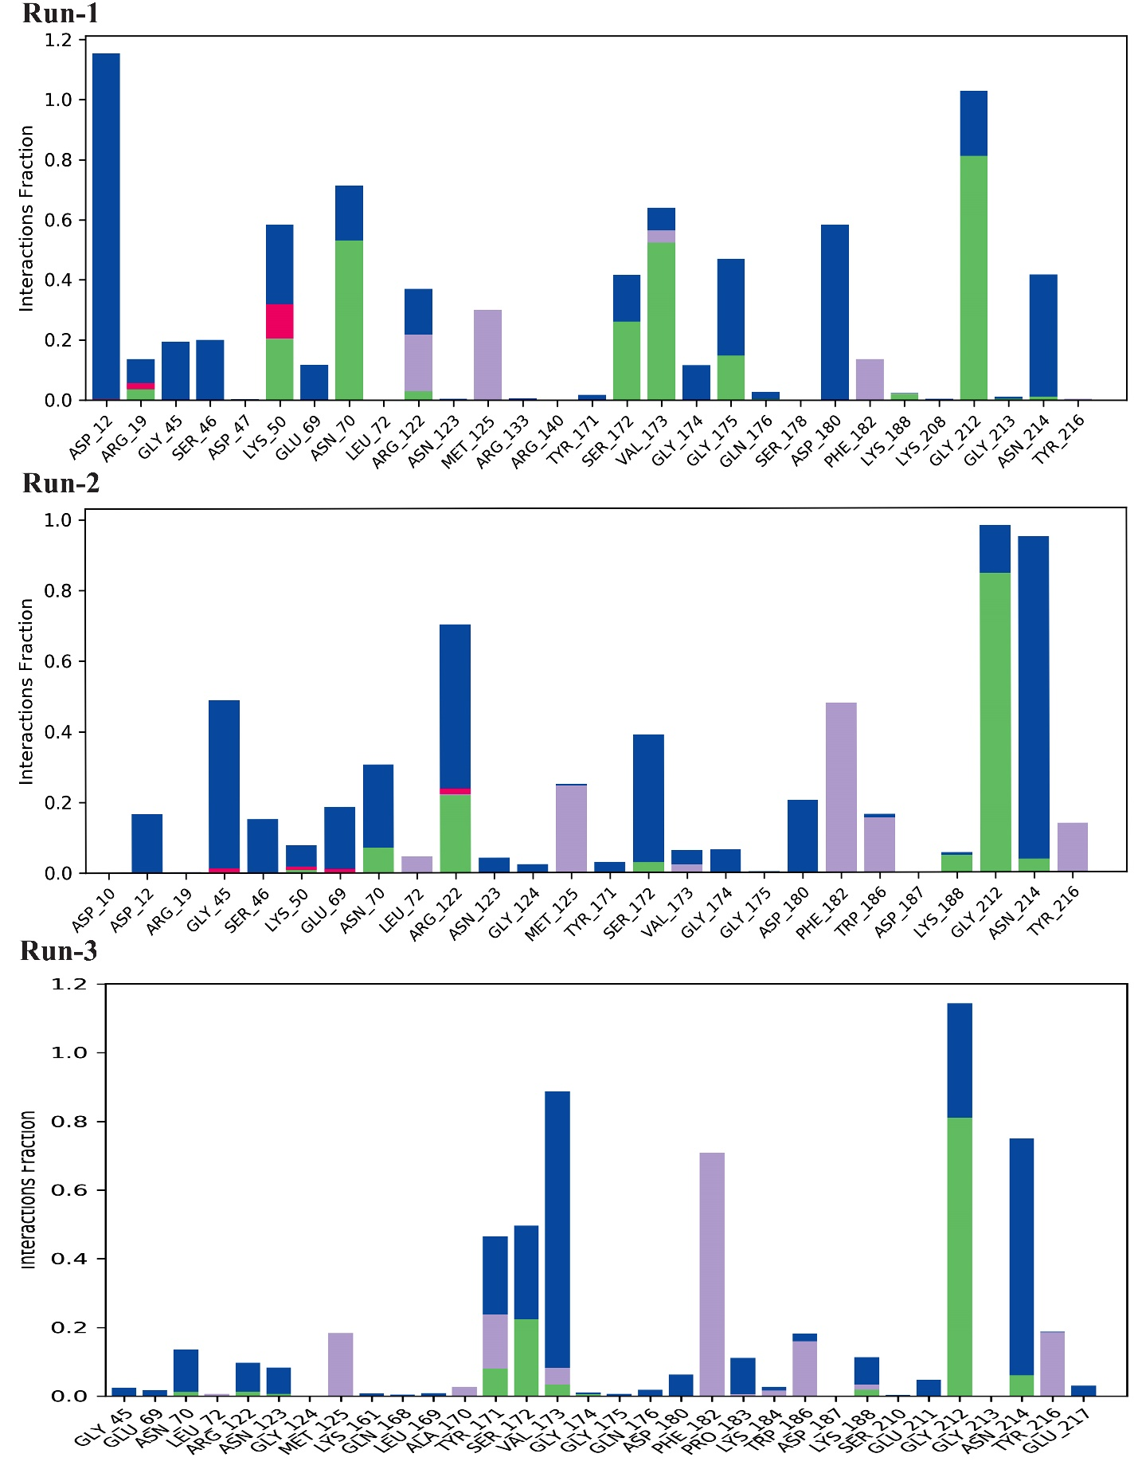
Figure B2. Ligand interactions with residues in 2I54-Grazoprevir complex for 100ns MD simulation

Mannose Pathway:

