Supplemental material
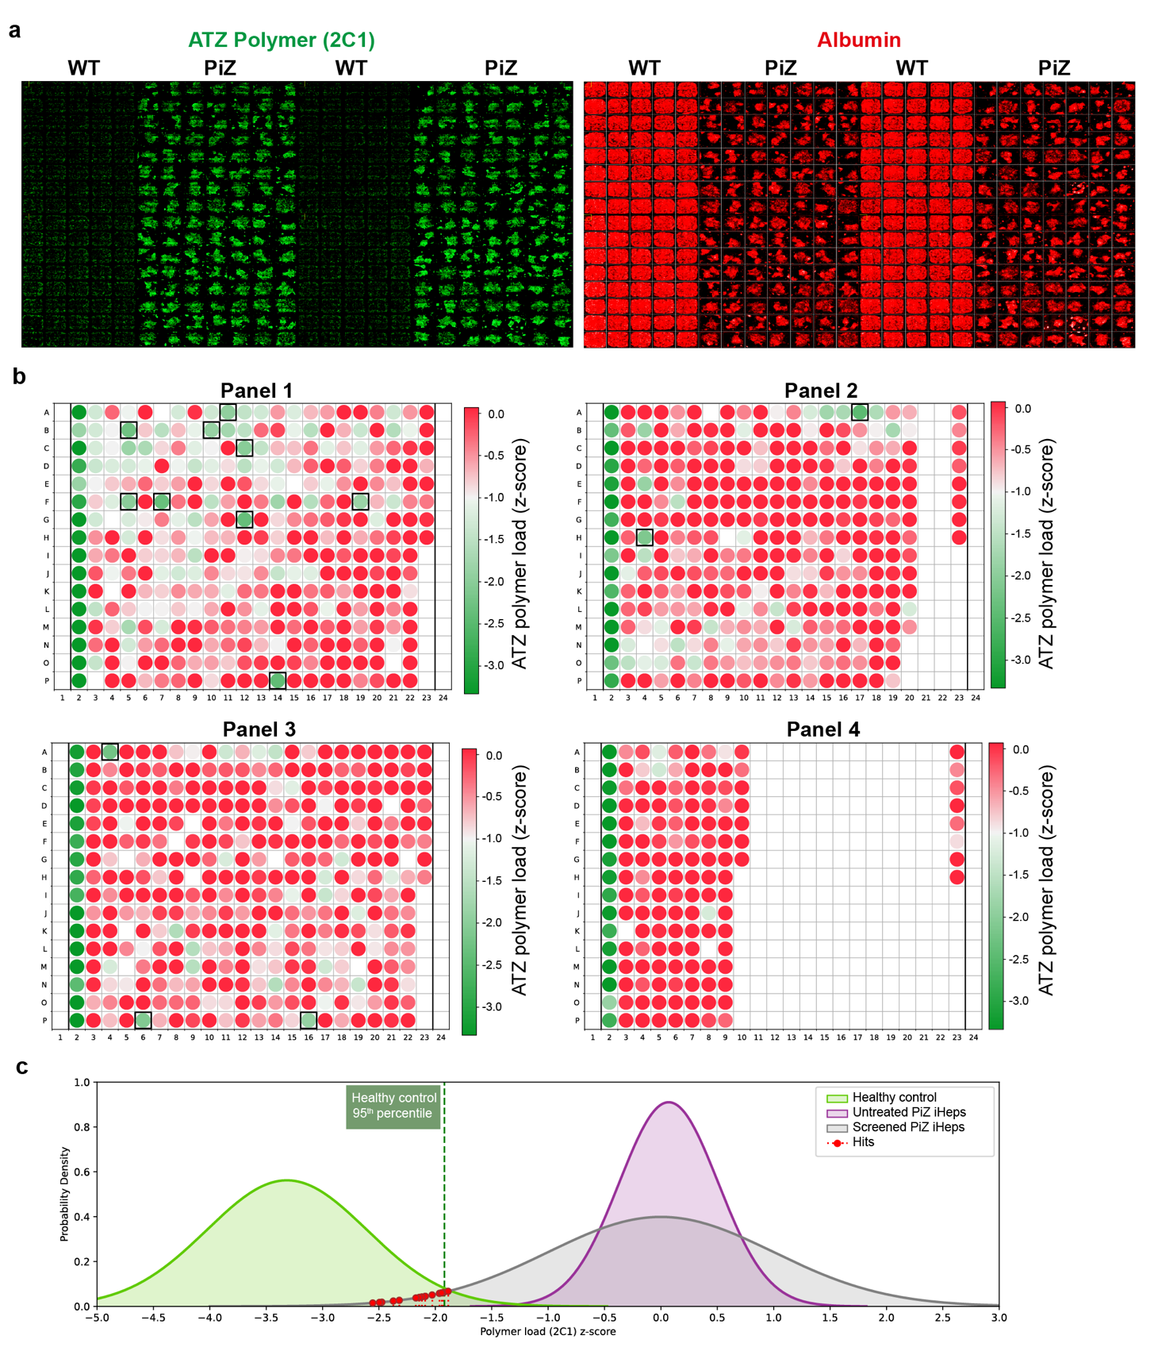
Supplementary Fig. 1. High-throughput screen approach. a Representative images from WT and PiZ hiPSC-derived hepatocytes in 384-well plate view showing the 2C1 (disease) and albumin (hepatic) expression. b Four panels of small molecules (1,041 in total) were used to screen A1ATD plated in a 384-well plate format in duplicates. Each well shown visualizes a mean 2C1 signal of two replicates in colour gradient with respect to the z-score derived from ATZ polymer load expression. Red colour represents a high expression of ATZ polymer and green color represents a low expression of ATZ polymer. Top hits (14) showing the lowest Z-scores were selected for further validation. c Gaussian curves were plotted to visualize the position of the hits relative to the healthy control (n=64; green) and untreated A1ATD iHeps (n=32; purple). The hits (red) appear to dramatically shift the 2C1 signal towards the range of the healthy control, thus restoring the healthy AAT phenotype in the A1ATD cells.

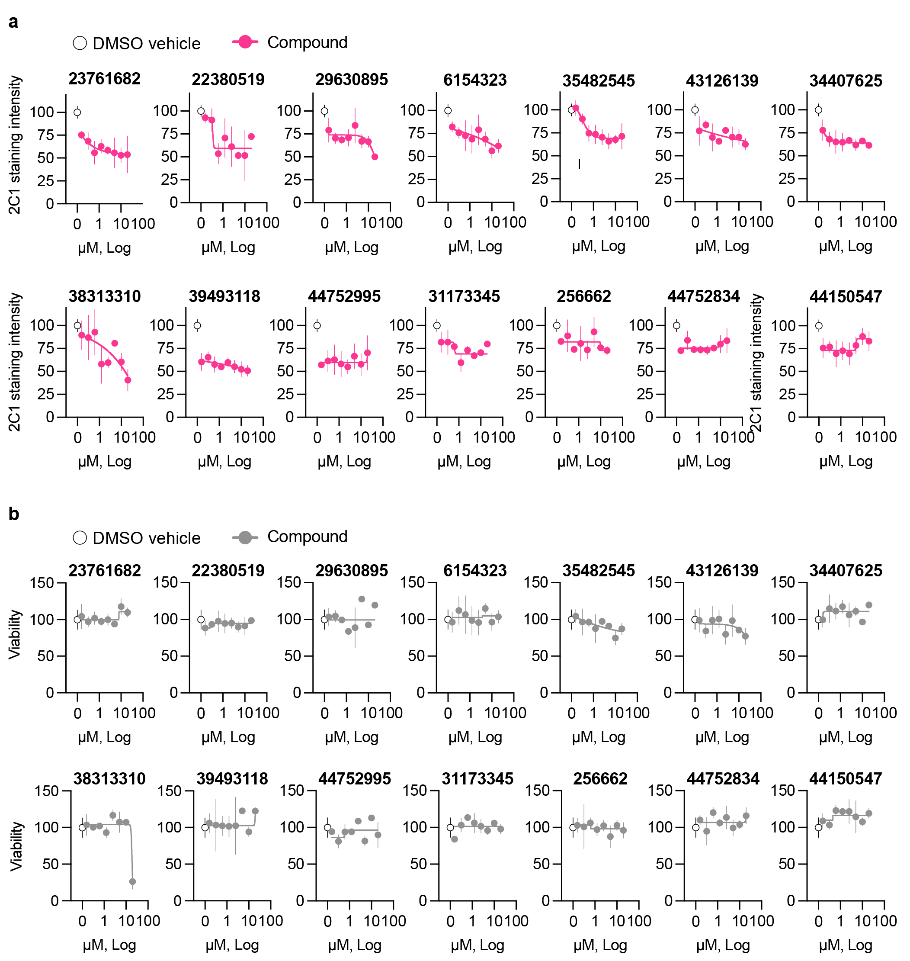
Supplementary Fig. 2 Confirmatory dose-dependent study on the top 14 hits. a The effectiveness of small molecules is determined by the reduction of the 2C1 staining signal (ATZ polymer). b The safety of small molecules is evaluated by the viability assay by Presto Blue.
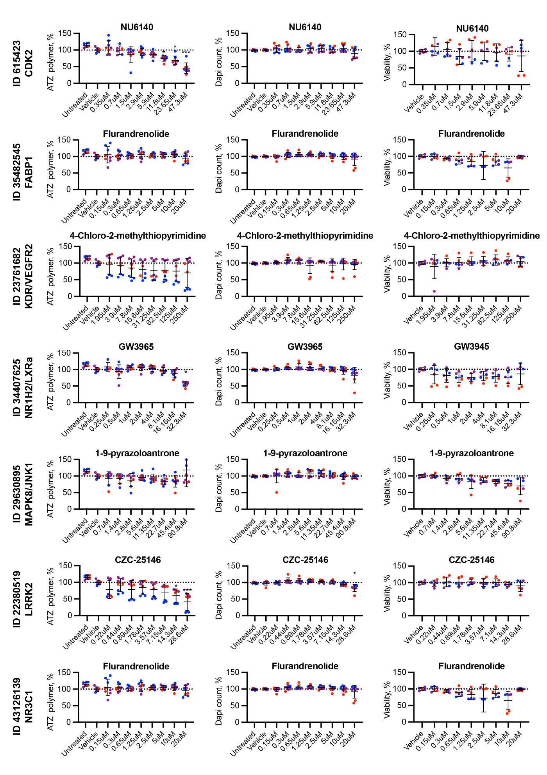
Supplementary Fig. 3. Top 7 putative targets validated using commercially available small molecules. The effectiveness of the small molecules is determined by the reduction of ATZ polymer (right column). The viability of the small molecules is evaluated by the DAPI + object counting (middle column) and the viability assay by Presto Blue (right column). The color of the dot represents each PiZ patient iPSC line. N= 3 different PiZ patient iPSC-hepatocytes. Statistical analysis involved a Kolmogorov- Smirnov test for normality, followed by Kruskal-Wallis test, followed by a Dunn’s multiple comparison test. *p<0.05, **p<0.01, ***p<0.001, ****p<0.0001.
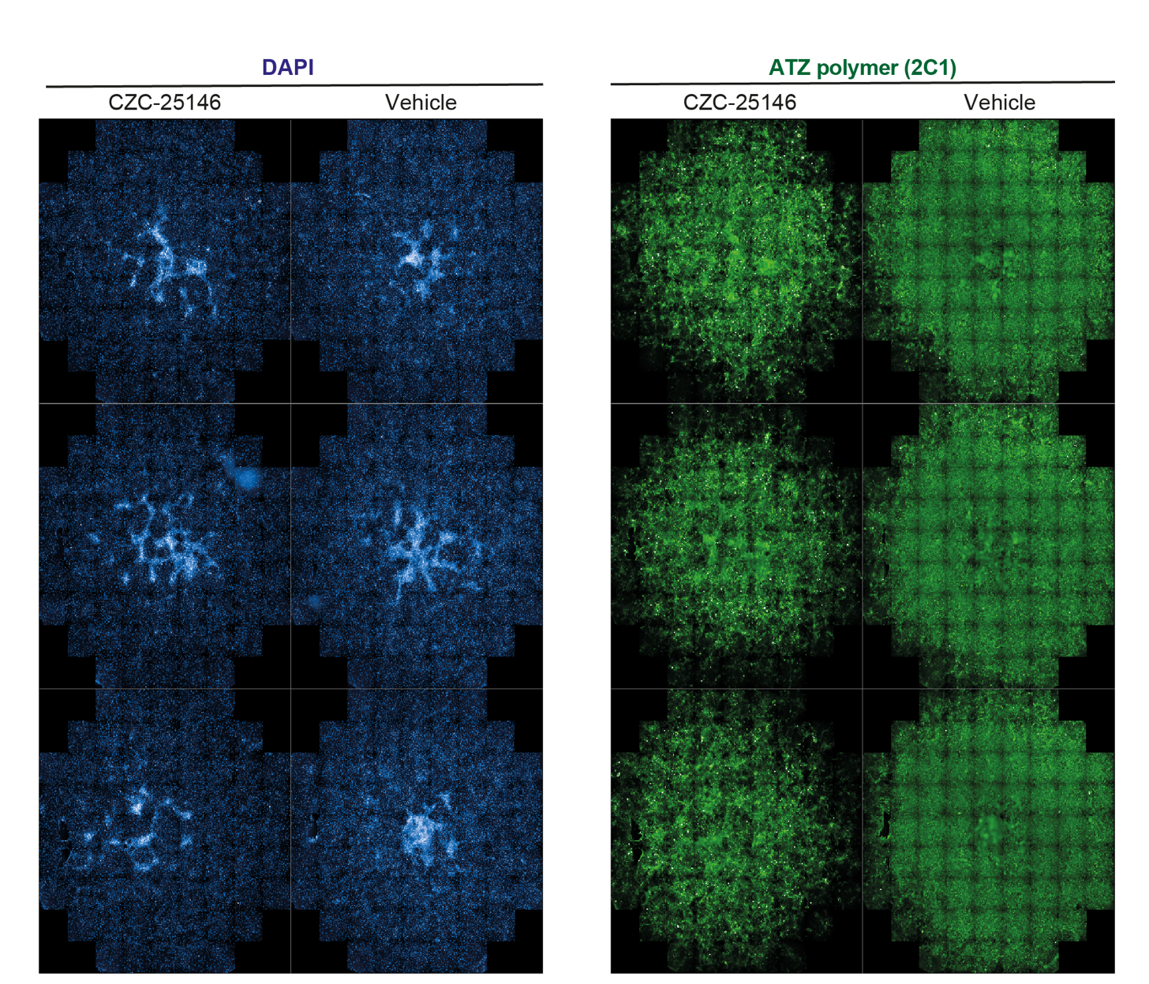
Supplementary Fig. 4. Whole-well views of CZC-25146 polymer-reduction phenotype in A1ATD patient-derived hiPSC-hepatocytes. Full 96-well views of CZC and control treatment after 48 hours of treatment. Each well contains approximately 50,000 PiZ hiPSC-derived hepatocytes. Images were taken on Perkin Elmer Operetta CLS.

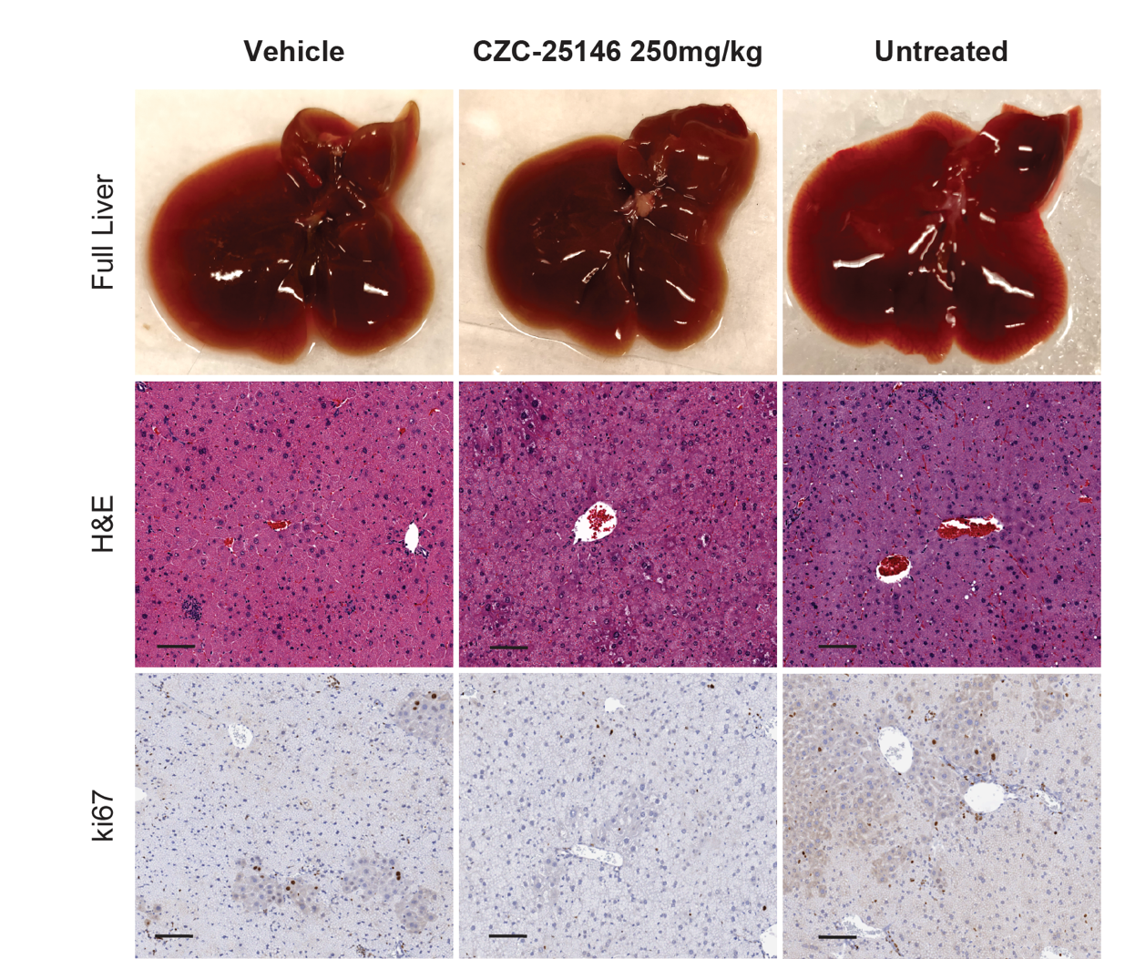
Supplementary Fig. 5: Gross anatomy and IHC staining of the liver treated with CZC-25146 and vehicle control DMSO at 250mg/kg for 14 consecutively days via oral gavage.
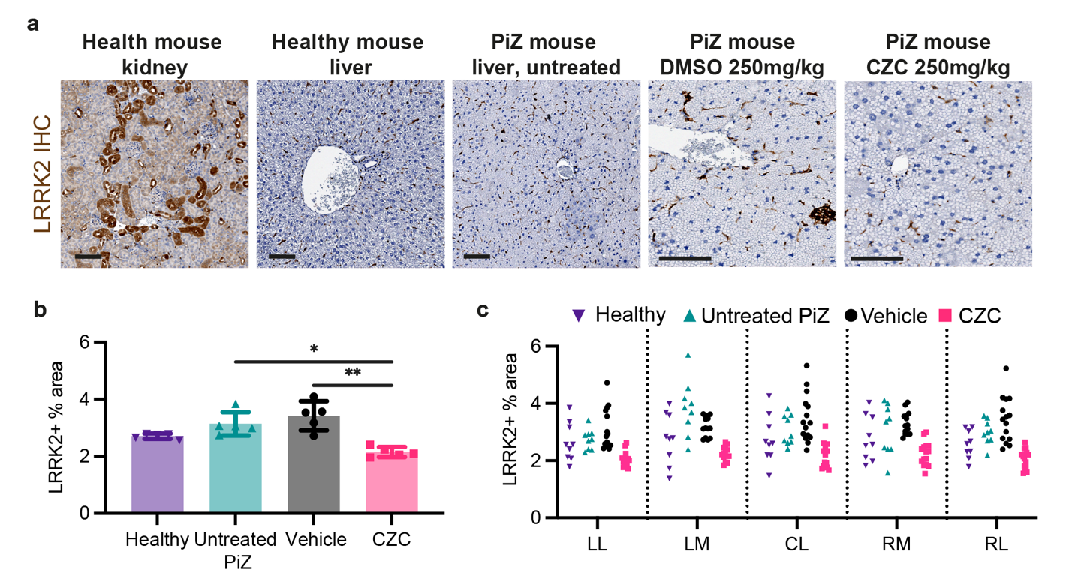
Fig. S6. Investigating the expression of LRRK2 in vivo. a Representative images of LRRK2 IHC in healthy mouse kidney used as a positive control for LRRK2 IHC staining, healthy and PiZ mouse livers, PiZ mouse livers treated with DMSO and CZC-25146 at 250mg/kg. All mice used were exactly 6 weeks old and all males. Scale bar, 100µm. LRRK2 IHC quantification in the liver, with all the data pooled b and the results of each lobe separated c. Quantification was conducted using ImageJ. N= 3 mice per group. Statistical analysis by Ordinary ANOVA test, followed by Dunnett’s multiple comparisons test. *p<0.05, **p<0.01, ***p<0.001, ****p<0.0001.

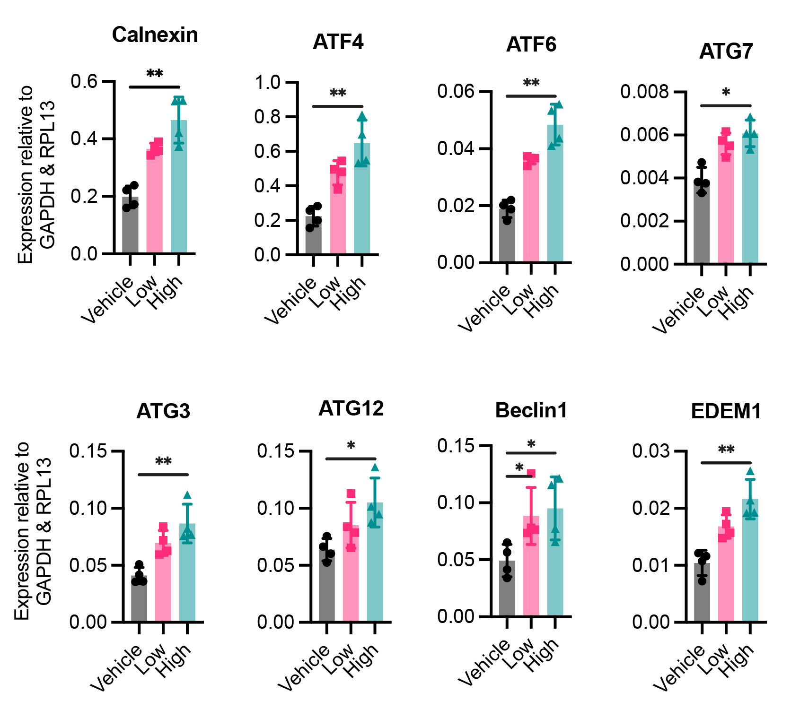
Fig. S7. Autophagy-related transcriptional expression following vehicle control DMSO and CZC-25146 low (14.3µM) and high dose (28.6µM) treatment for 24 hours.
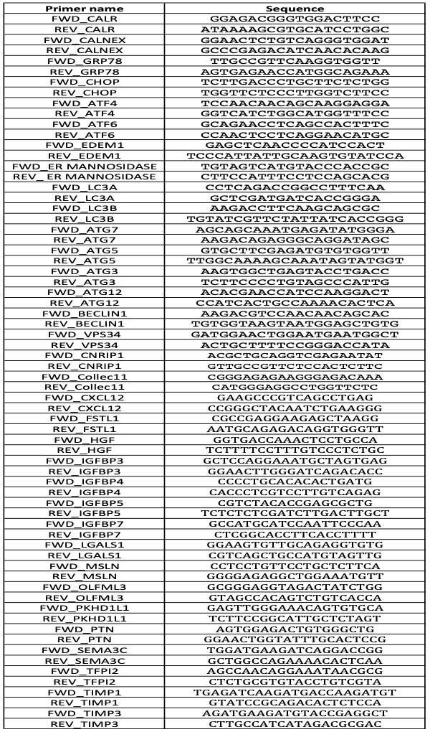
Table S1: Primer sequences for RT-qPCR assay.

