Supplementary material for:

Mechanisms behind the varying severity of Aleutian mink disease virus: comparison of three farms with a different disease status

Following items are in separate files

Fig. S10. Phylogenetic tree from nt 578–951 containing sequences from this study, previously published Finnish strains and selected strains from other countries from GenBank. Sequences from this study have been named as follows: farm id (1 or 2) - mink id (1-30 and A-F) -sample material (B=blood, K=kidney, and S=spleen) - sampling date. Branches with posterior values above 0.9 have been marked with *. Full three of Fig. 4.
Table S1. Detailed information about the mink and the samples
Table S2. Statistical tests
Table S4. Log₂FC-values from differential expression analysis (p-value treshold of 0.05).

Supplementary figures
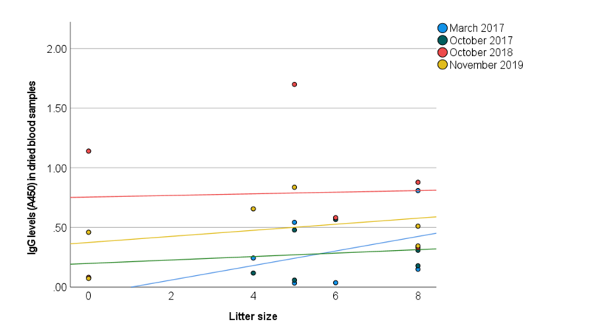
Fig. S1. Litter size in relation to IgG level (A450 in ELISA) of the same year. Reference lines from equation have been added to each of the pictures.

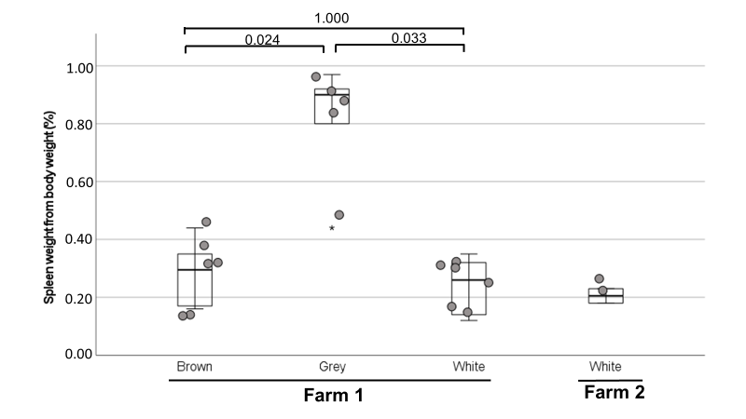

Fig. S2. Spleen weight as a proportion of body weight in mink from farms 1 and 3 separated by color type. Pairwise P-values from Independent-Samples Kruskal-Wallis-test are reported above the picture.

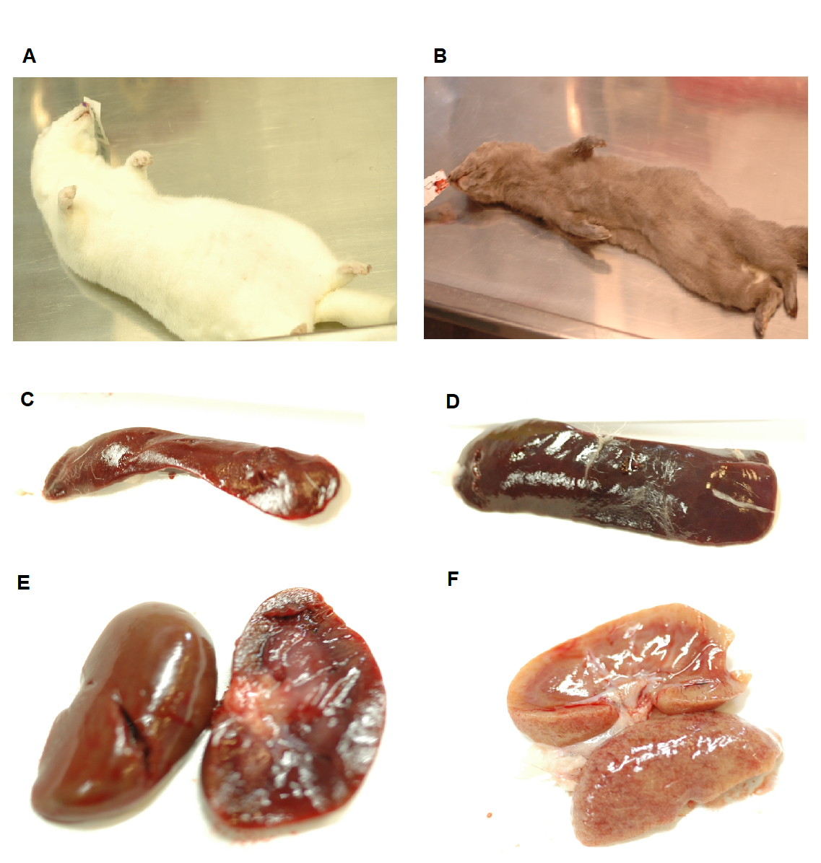
Fig. S3. Body shape, spleen, and kidneys of healthy AMDV negative mink from farm 2 (A, C, and E) and mink F1/D with clinical AD from farm 1 (B, D, and F).

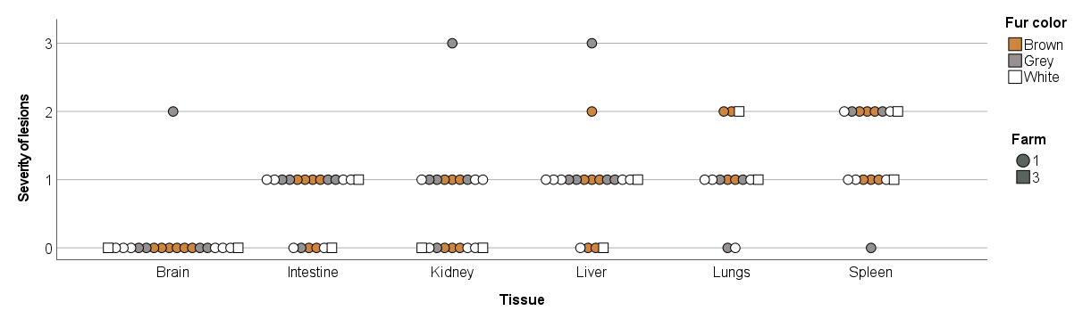

Fig. S4. Severity of histopathological lesions in tissues of mink from farms 1 and 3. 0=No lesions, 1=mild lesions, 2=moderate lesions, and 3=severe lesions.

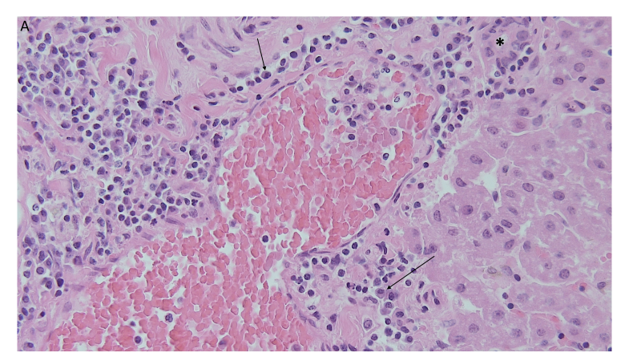
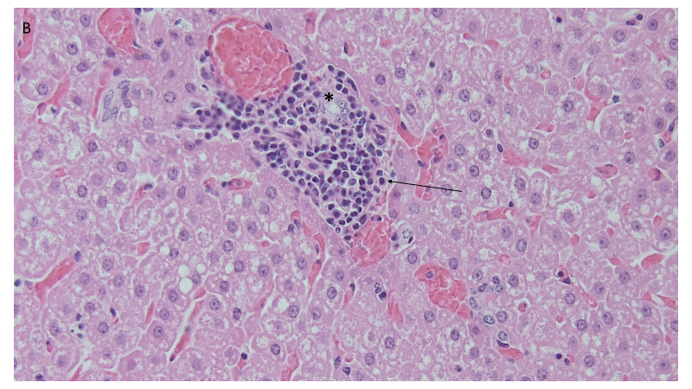
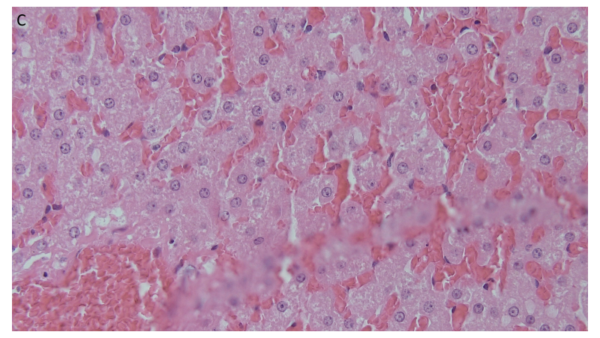
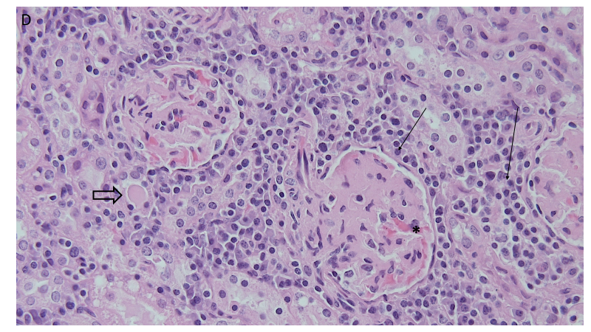
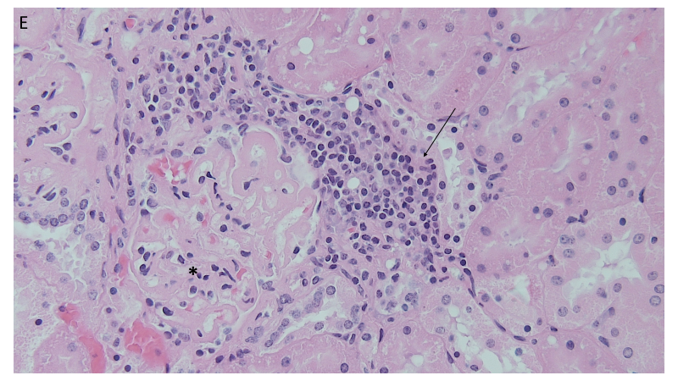
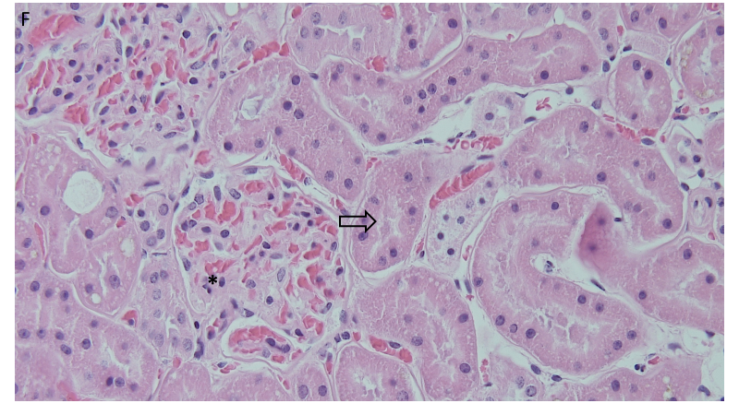
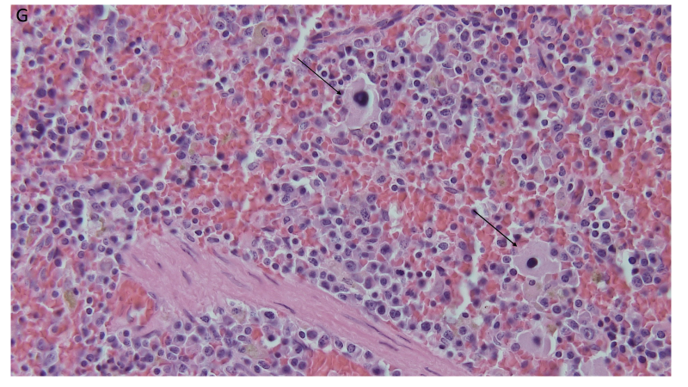
Fig. S5. Histology of a mink with clinical signs of AD (A, D, and G) and a clinically healthy AMDV-positive mink (B and E) from an infected farm (farm 1), and a non-infected mink from an AMDV-negative farm (C and F; farm 3): moderate to severe multifocal, perivascular and periportal plasma cell-rich (→) mononuclear cell infiltration and biliary duct (∗) hyperplasia in liver (A), mild focal infiltration of mononuclear cells (→) around blood vessel and bile duct (∗) and mild multifocal lipidosis in liver (B), normal liver parenchyma (C), moderate multifocal lymphoplasmacytic interstitial nephritis (→), proteinous exudate in the tubular lumen (⇒), and hyalinization of the glomerulus (∗) in kidney (D), focal periglomerular lymphoplasmacytic infiltration (→) and partial hyalinization of the glomerulus (∗) in kidney (E), normal kidney (∗=glomelurus, ⇒=tubulus). (F), and multifocal extramedullar hematopoiesis (→=megakaryocytes (G) (all pictures 400x H&E).

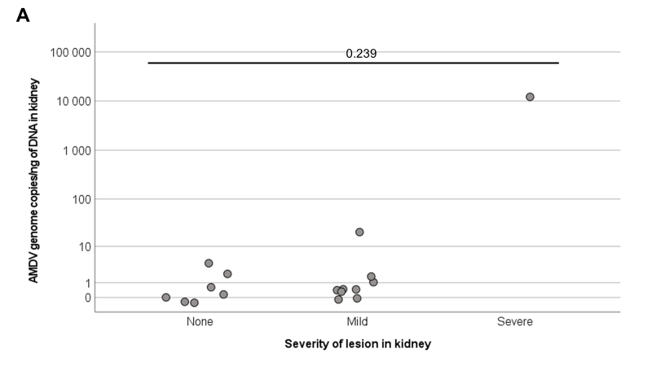
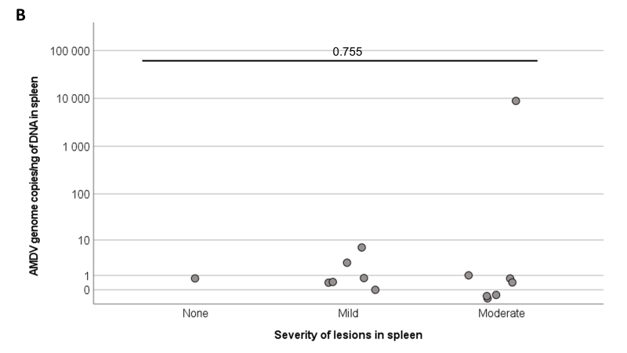

Fig. S6. Connections between AMDV copy number and histopathological lesions in kidney (A) and spleen (B). P-values of the Independent-Samples Kruskal-Wallis are shown in the picture.

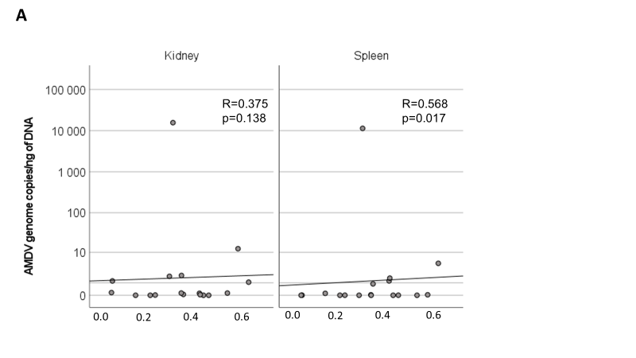
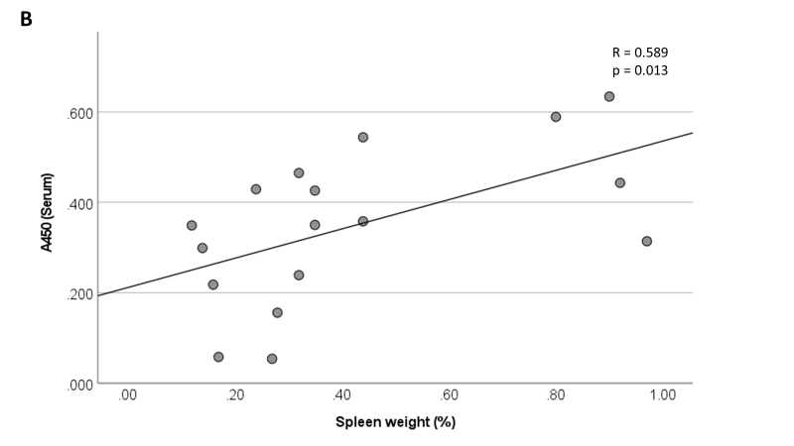
Fig. S7. Connections between IgG level in serum (A450 in ELISA) and AMDV genome copies in spleen and kidney (A) and spleen weight as proportion of body weight (B). Spearman’s rho -values along with p-values are reported in the pictures.

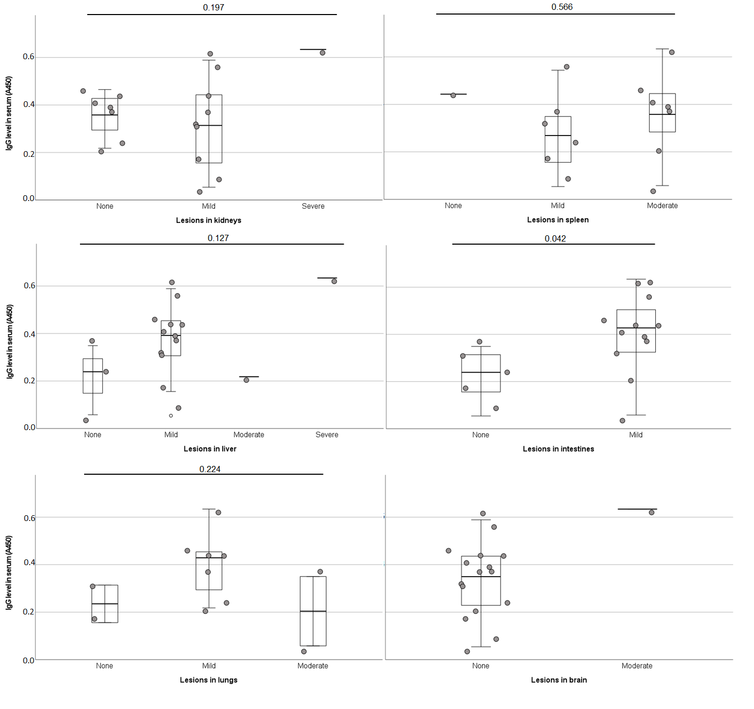
Fig. S8. Comparison between IgG levels in serum (A450 in ELISA) and tissue lesions. p-values on Independen-Samples T-test (intestines) or One-Way ANOVA (other tissues) are reported above the pictures.
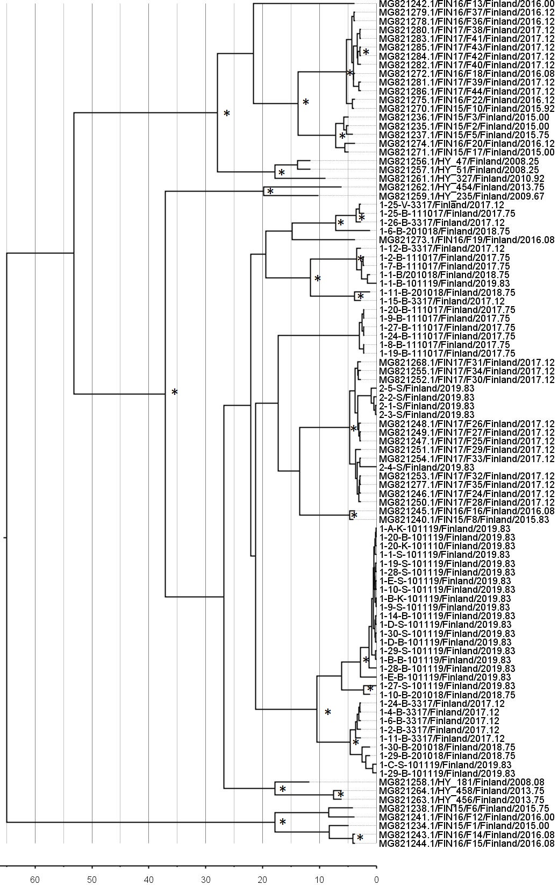
Fig. S9. Phylogenetic tree with molecular clock analysis from nt 578–951 containing sequences from this study, and previously published Finnish strains with known sampling months. Sequences from this study have been named as follows: farm id (1 or 2) - mink id (1-30 and A-E) -sample material (B = blood, K = kidney, and S = spleen) - sampling date. Time scale is shown under the tree, branches are labeled according to Fig. 5, and posterior probability values above 0.9 are marked with *.

Supplementary tables

Table S3. Average severity of histopathological lesions by tissue, fur color, and farm.
 | Farm 1: all |  |  | Farm 1: Brown |  |  | Farm 1: Grey |  |  | Farm 1: White |  |  | Farm 2
 | N | Average | SD | N | Average | SD | N | Average | SD | N | Average | SD | N | Average
Kidney | 17 | 0.71 | 0.77 | 6 | 0.50 | 0.55 | 5 | 1.17 | 1.10 | 6 | 0.50 | 0.55 | 2 | 0.00
Liver | 17 | 1.00 | 0.71 | 6 | 0.83 | 0.75 | 5 | 1.40 | 0.89 | 6 | 0.83 | 0.41 | 2 | 0.50
Brain and meninges | 17 | 0.11 | 0.49 | 6 | 0.00 | 0.00 | 5 | 0.40 | 0.89 | 6 | 0.00 | 0.00 | 2 | 0.00
Intestine | 17 | 0.71 | 0.47 | 6 | 0.67 | 0.52 | 5 | 0.80 | 0.45 | 6 | 0.67 | 0.52 | 2 | 0.50
Lung | 11 | 1.00 | 0.63 | 4 | 1.50 | 0.58 | 3 | 0.67 | 0.58 | 4 | 0.75 | 0.50 | 2 | 1.50
Spleen | 14 | 1.43 | 0.65 | 6 | 1.50 | 0.55 | 3 | 1.33 | 1.15 | 5 | 1.40 | 0.55 | 2 | 1.50
Combined | 17 | 0.80 | 0.73 | 6 | 0.79 | 0.73 | 5 | 0.96 | 0.87 | 6 | 0.67 | 0.60 | 2 | 0.67
0 = no lesions, 1 = mild lesions, 2 = moderate lesions, and 3 = severe lesions

