Web-based Supplementary Materials for
” Overlapping Group Screening for Detection of Gene-environment Interactions with Application to TCGA High-dimensional Survival Genomic Data”
by
Jie-Huei Wang, Kang-Hsin Wang and Yi-Hau Chen

Appendix S.1:
In Fig. S.1 and Fig. S.2, we analyzed TCGA clinical survival data for HNSCC and LUAD to show the long-tailed distribution phenomenon.

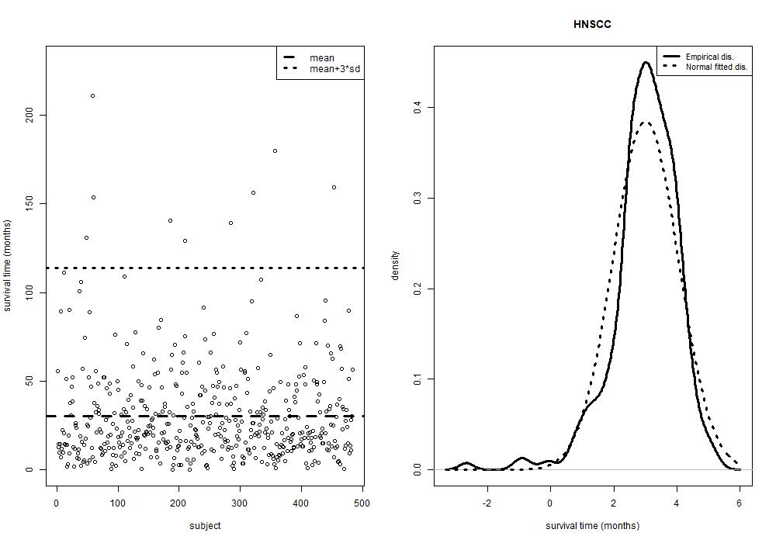
Fig. S.1 The long-tailed distribution of clinical survival data for the TCGA HNSCC

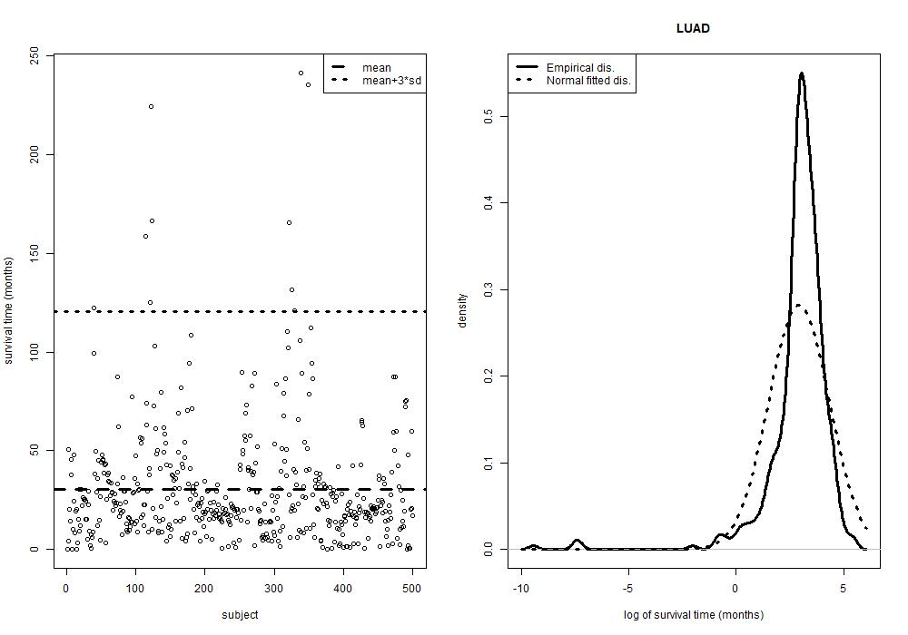
Fig. S.2 The long-tailed distribution of clinical survival data for the TCGA LUAD

Appendix S.2: Latent effect approach
Suppose that there are six genes that are involved in the five pathways, P1={g1, g2, g3}, P2={g2, g3, g4}, P3={g1, g3, g5}, P4={g3, g4, g5} and P5={g1, g6}, the original coefficient can be decomposed as
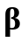$={\left[β_{1},β_{2},β_{3},β_{4},β_{5},β_{6}\right]}^{/}$
$$=\left[\begin{aligned}\begin{matrix}γ_{1}^{1} \\ γ_{2}^{1} \\ γ_{3}^{1} \\ γ_{4}^{1}\end{matrix} \\ γ_{5}^{1} \\ γ_{6}^{1}\end{aligned}\right]+\left[\begin{aligned}\begin{matrix}γ_{1}^{2} \\ γ_{2}^{2} \\ γ_{3}^{2} \\ γ_{4}^{2}\end{matrix} \\ γ_{5}^{2} \\ γ_{6}^{2}\end{aligned}\right]+\left[\begin{aligned}\begin{matrix}γ_{1}^{3} \\ γ_{2}^{3} \\ γ_{3}^{3} \\ γ_{4}^{3}\end{matrix} \\ γ_{5}^{3} \\ γ_{6}^{3}\end{aligned}\right]+\left[\begin{aligned}\begin{matrix}γ_{1}^{4} \\ γ_{2}^{4} \\ γ_{3}^{4} \\ γ_{4}^{4}\end{matrix} \\ γ_{5}^{4} \\ γ_{6}^{4}\end{aligned}\right]+\left[\begin{aligned}\begin{matrix}γ_{1}^{5} \\ γ_{2}^{5} \\ γ_{3}^{5} \\ γ_{4}^{5}\end{matrix} \\ γ_{5}^{5} \\ γ_{6}^{5}\end{aligned}\right]=\left[\begin{aligned}\begin{matrix}γ_{1}^{1} \\ γ_{2}^{1} \\ γ_{3}^{1} \\ 0\end{matrix} \\ 0 \\ 0\end{aligned}\right]+\left[\begin{aligned}\begin{matrix}0 \\ γ_{2}^{2} \\ γ_{3}^{2} \\ γ_{4}^{2}\end{matrix} \\ 0 \\ 0\end{aligned}\right]+\left[\begin{aligned}\begin{matrix}γ_{1}^{3} \\ 0 \\ γ_{3}^{3} \\ 0\end{matrix} \\ γ_{5}^{3} \\ 0\end{aligned}\right]+\left[\begin{aligned}\begin{matrix}0 \\ 0 \\ γ_{3}^{4} \\ γ_{4}^{4}\end{matrix} \\ γ_{5}^{4} \\ 0\end{aligned}\right]+\left[\begin{aligned}\begin{matrix}γ_{1}^{5} \\ 0 \\ 0 \\ 0\end{matrix} \\ 0 \\ γ_{6}^{5}\end{aligned}\right]$$
$$=\left[\begin{aligned}\begin{matrix}1,0,0,0,0,0,1,0,0,0,0,0,1,0 \\ 0,1,0,1,0,0,0,0,0,0,0,0,0,0 \\ 0,0,1,0,1,0,0,1,0,1,0,0,0,0 \\ 0,0,0,0,0,1,0,0,0,0,1,0,0,0\end{matrix} \\ 0,0,0,0,0,0,0,0,1,0,0,1,0,0 \\ 0,0,0,0,0,0,0,0,0,0,0,0,0,1\end{aligned}\right]{\left[γ_{1}^{1},γ_{2}^{1},γ_{3}^{1},γ_{2}^{2},γ_{3}^{2},γ_{4}^{2},γ_{1}^{3},γ_{3}^{3},γ_{5}^{3},γ_{3}^{4},γ_{4}^{4},γ_{5}^{4},γ_{1}^{5},γ_{6}^{5}\right]}^{/}$$
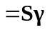.
On the basis of the coefficient decomposition, the original regression model can be transformed into a new model, that is, 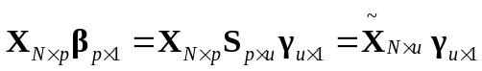. Equivalently, this new model can be constructed by duplicating the columns of overlapping variables in the original design matrix. For the new transformed model, the hazard function for subject in the Cox’s regression model is re-expressed as
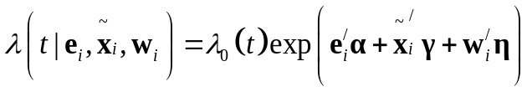.

Appendix S.3: Simulation studies
We consider survival data with a cohort size 300 as the training set, where each subject’s survival time follows the Cox’s proportional hazards model
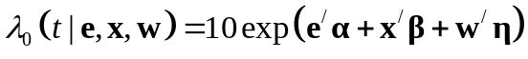,
with the covariates and jointly following a multivariate standard normal distribution with correlation 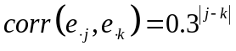 and 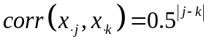, respectively. The censoring time distribution follows a uniform distribution. We then generate survival data, independent of the training data, with a cohort of size 100 as the test data to assess the prediction accuracy for different methods.

S.3.1: Simulation Setting 1: equal group size data
In this simulation study, we design 5 environmental variables and assume that the first 4 factors are related to the survival outcome, and the corresponding effects are 1.5, 2.25, 3, -1.5. The design matrix consists of 25 groups with each group having equal group sizes. The group size (number of genes in each group) and the overlapping structure (number of genes shared by two overlapping groups) are shown in Table S.1.

Table S.1 Data structure for equal group size data
Group | 1 | 2 | 3 | 4 | 5 | 6 | 7 | 8 | 9 | 10 | 11 | 12 | 13 | 14 | 15 | 16 | 17 | 18 | 19 | 20 | 21 | 22 | 23 | 24 | 25
Gene Size | 23 | 23 | 23 | 23 | 23 | 23 | 23 | 23 | 23 | 23 | 23 | 23 | 23 | 23 | 23 | 23 | 23 | 23 | 23 | 23 | 23 | 23 | 23 | 23 | 23
Overlapping | 3 3 0 3 3 0 3 3 0 3 3 0 0 3 0 0 3 0 3 3 0 0 3 0

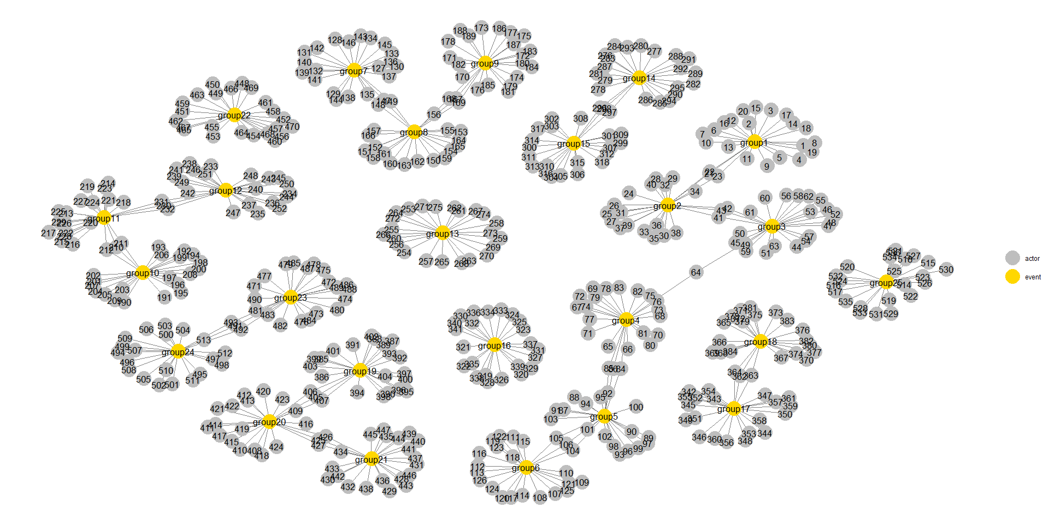
Fig. S.3 gene network structure for equal group size data

For example, group 1 contains 23 genes, as group 2 does, and the two groups contain 43 unique genes, and 3 genes are shared by the two groups. As a result, there are 536 genes and 575 latent effects in this example. Fig. S.3 shows the gene indices of the groups in this data. Groups 1, 7, 13, and 19 are effective, and genes in each of them have constant latent effects of 3, 3, 2, and -2, respectively. Also, effective interactions (E1*G130, E1*G135, E2*G140) with the corresponding effects $(4.5,4.5,6)$ and (E2*G255, E3*G260, E3*G265) with the corresponding effects $(-3, -4.5, -6)$ in group 7 and group 13, respectively. The number of effective environments, genes and G-E interaction pairs is 102 among the total 3,221 environments, genes and G-E interaction pairs. We examine performances of different methods under a censoring rate of 30%, 50%, and 70%.

S.3.2: Simulation Setting 2: small group size data
In this simulation study, we design 5 environmental variables and assume that the first 4 factors are related to the survival outcome, and the corresponding effects are 1.5, 2.25, 3, -1.5. The design matrix consists of 5 groups with each group having different group sizes. The group size (number of genes in each group) and the overlapping structure (number of genes shared by two overlapping groups) are shown in Table S.2.

Table S.2 Data structure for small group size data
Group | 1 | 2 | 3 | 4 | 5
Gene Size | 7 | 14 | 21 | 28 | 35
Overlapping | 3 5 7 9

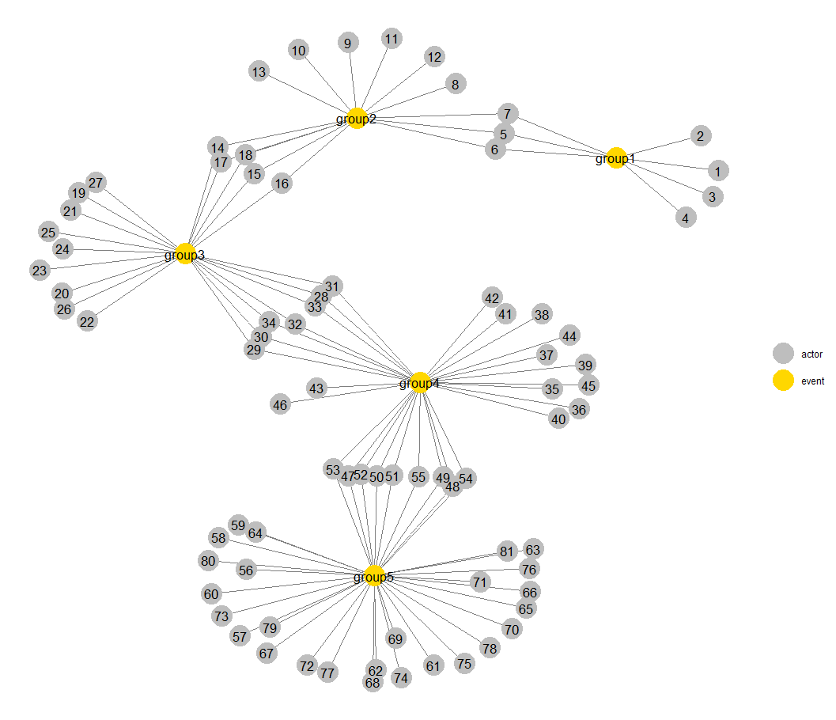
Fig. S.4 gene network structure for small group size data

For example, group 1 and group 2 contains 7 and 14 genes, respectively. The two groups contain 18 unique genes, and 3 genes are shared by the two groups. As a result, there are 81 genes and 105 latent effects in this example. Fig. S.4 shows the gene indices of the groups in this data. Groups 2 and 4 are effective, and genes in each of them have constant latent effects of 3 and -2, respectively. Also, effective interactions (E1*G9, E1*G11, E2*G13) the corresponding effects $(4.5,4.5,6)$ and (E2*G36, E3*G39, E3*G42) with the corresponding effects $(-3, -4.5, -6)$ in group 2 and group 4, respectively. The number of effective environments, genes and G-E interaction pairs is 52 among the total 491 environments, genes and G-E interaction pairs. We examine performances of different methods under a censoring rate of 30%, 50%, and 70%.
From the simulation results shown in Tables 1 and S.3, the gene structure is complex, the OGS method using the Lasso or Ridge penalty performs substantially better than the “Univariate Selection” and the “Ordinary Lasso” methods in variable selection, estimation, and survival prediction. It can be seen from Table S.4 that when the gene structure is simple and the censoring rate is 30% or 50%, the performance of OGS with Lasso or Ridge penalty is worse than that of the “Ordinary Lasso” method, while when the censoring rate is higher (70%), the OGS with the Lasso or Ridge penalty performs better than the “Ordinary Lasso” in variable selection, estimation, and survival prediction.

Table S.3
The average of the measures out of 200 simulation replications for different approaches with equal group size data
 | Oracle | Uni. Sel. | Ordinary Lasso | OGS Ridge | OGS Lasso
Censoring rate = 30%
RMSE | 0.4664 | 0.4800 | 0.4751 | 0.4686 | 0.4615
T.model | 1.0000 | 0.0000 | 0.0000 | 0.1550 | 0.0400
Tint.model | 1.0000 | 0.0000 | 0.0350 | 0.1750 | 0.1600
Sen. | 1.0000 | 0.2079 | 0.6030 | 0.9216 | 0.8115
Spe. | 1.0000 | 0.9985 | 0.9852 | 0.9565 | 0.9949
C.model | 102.0000 | 26.0150 | 107.7650 | 229.7100 | 98.6450
Deviance | -107.3225 | -25.3519 | -81.4242 | -118.5998 | -143.2994
C-index | 0.8517 | 0.7097 | 0.8263 | 0.8830 | 0.8837
Censoring rate = 50%
RMSE | 0.4550 | 0.4756 | 0.4745 | 0.4704 | 0.4680
T.model | 0.9950 | 0.0000 | 0.0000 | 0.1000 | 0.0000
Tint.model | 0.9950 | 0.0000 | 0.0050 | 0.1250 | 0.0400
Sen. | 0.9950 | 0.2385 | 0.4935 | 0.7909 | 0.6003
Spe. | 0.9950 | 0.9926 | 0.9805 | 0.9535 | 0.9909
C.model | 101.4900 | 31.8800 | 95.5100 | 210.1350 | 73.8750
Deviance | -78.7795 | -20.9440 | -53.0100 | -75.3773 | -77.8306
C-index | 0.8659 | 0.7312 | 0.8068 | 0.8607 | 0.8432
Censoring rate = 70%
RMSE | 0.5930 | 0.4795 | 0.4791 | 0.4761 | 0.4760
T.model | 1.0000 | 0.0000 | 0.0000 | 0.0050 | 0.0000
Tint.model | 1.0000 | 0.0000 | 0.0000 | 0.0450 | 0.0000
Sen. | 1.0000 | 0.1499 | 0.3487 | 0.5869 | 0.3644
Spe. | 1.0000 | 0.9980 | 0.9869 | 0.9639 | 0.9968
C.model | 102.0000 | 21.4800 | 76.3900 | 172.5400 | 47.2650
Deviance | 223.4546 | -5.1534 | -25.0288 | -35.8939 | -32.5564
C-index | 0.8241 | 0.7106 | 0.7826 | 0.8271 | 0.8050

Table S.4
The average of the measures out of 200 simulation replications for different approaches with small group size data
 | Oracle | Uni. Sel. | Ordinary Lasso | OGS Ridge | OGS Lasso
Censoring rate = 30%
RMSE | 0.8506 | 0.8627 | 0.6391 | 0.8749 | 0.6698
T.model | 1.0000 | 0.0000 | 1.0000 | 0.6500 | 0.6500
Tint.model | 1.0000 | 0.0000 | 1.0000 | 0.6500 | 0.6500
Sen. | 1.0000 | 0.7313 | 1.0000 | 0.9738 | 0.9583
Spe. | 1.0000 | 0.9695 | 0.8165 | 0.6352 | 0.8905
C.model | 52.0000 | 51.4300 | 132.5500 | 210.7750 | 97.9200
Deviance | -136.5171 | -96.2441 | -333.4151 | -82.5705 | -276.0023
C-index | 0.8964 | 0.8423 | 0.9789 | 0.8837 | 0.9468
Censoring rate = 50%
RMSE | 0.8328 | 0.8527 | 0.7484 | 0.8727 | 0.7416
T.model | 1.0000 | 0.0000 | 0.9050 | 0.6150 | 0.6150
Tint.model | 1.0000 | 0.0050 | 1.0000 | 0.6150 | 0.6150
Sen. | 1.0000 | 0.7135 | 0.9980 | 0.9720 | 0.9494
Spe. | 1.0000 | 0.9704 | 0.8833 | 0.6402 | 0.9232
C.model | 52.0000 | 50.1000 | 103.1100 | 208.4950 | 83.0700
Deviance | -123.4154 | -77.2704 | -210.0537 | -68.5496 | -190.5856
C-index | 0.9137 | 0.8564 | 0.9702 | 0.8958 | 0.9481
Censoring rate = 70%
RMSE | 0.6917 | 0.6697 | 0.6541 | 0.6740 | 0.6484
T.model | 1.0000 | 0.0000 | 0.0000 | 0.3150 | 0.0250
Tint.model | 1.0000 | 0.0100 | 0.3700 | 0.3150 | 0.2750
Sen. | 1.0000 | 0.4055 | 0.6100 | 0.7822 | 0.6260
Spe. | 1.0000 | 0.9833 | 0.9548 | 0.8074 | 0.9740
C.model | 77.0000 | 35.6500 | 77.2750 | 189.8900 | 57.7850
Deviance | 302.6345 | -19.5731 | -57.5044 | -42.1472 | -63.0615
C-index | 0.8570 | 0.7771 | 0.8579 | 0.8673 | 0.8687

Table S.5
The average of the measures out of 200 simulation replications for different approaches with varied group size data based on a small cohort size 150
 | Oracle | Uni. Sel. | Ordinary Lasso | OGS Ridge | OGS Lasso
Censoring rate = 30%
RMSE | 0.3928 | 0.4240 | 0.4235 | 0.4169 | 0.4163
T.model | 1.0000 | 0.0000 | 0.0000 | 0.0950 | 0.0000
Tint.model | 1.0000 | 0.0000 | 0.0000 | 0.1500 | 0.0050
Sen. | 1.0000 | 0.0359 | 0.1666 | 0.9342 | 0.4740
Spe. | 1.0000 | 0.9996 | 0.9950 | 0.9567 | 0.9973
C.model | 91.0000 | 4.4650 | 29.8750 | 211.2100 | 51.0550
Deviance | 100.8379 | 7.9839 | -3.0853 | -31.5505 | -24.9447
C-index | 0.7706 | 0.5870 | 0.6569 | 0.8342 | 0.7758
Censoring rate = 50%
RMSE | 0.4892 | 0.4236 | 0.4235 | 0.4181 | 0.4178
T.model | 1.0000 | 0.0000 | 0.0000 | 0.0750 | 0.0000
Tint.model | 1.0000 | 0.0000 | 0.0000 | 0.1500 | 0.0000
Sen. | 1.0000 | 0.0402 | 0.1504 | 0.8290 | 0.3710
Spe. | 1.0000 | 0.9992 | 0.9946 | 0.9573 | 0.9974
C.model | 91.0000 | 5.8650 | 29.4700 | 199.8900 | 41.3650
Deviance | 369.5928 | 8.7374 | -0.7313 | -20.5034 | -15.6855
C-index | 0.7095 | 0.6048 | 0.6579 | 0.8213 | 0.7669
Censoring rate = 70%
RMSE | 0.5217 | 0.4240 | 0.4238 | 0.4215 | 0.4217
T.model | 1.0000 | 0.0000 | 0.0000 | 0.0050 | 0.0000
Tint.model | 1.0000 | 0.0000 | 0.0000 | 0.0650 | 0.0000
Sen. | 1.0000 | 0.0320 | 0.1062 | 0.3840 | 0.1416
Spe. | 1.0000 | 0.9987 | 0.9944 | 0.9751 | 0.9983
C.model | 91.0000 | 6.6450 | 26.0700 | 107.5300 | 17.8150
Deviance | 709.6592 | 13.0677 | 1.9016 | -2.9440 | -0.2201
C-index | 0.7573 | 0.5914 | 0.6421 | 0.7048 | 0.6724

Table S.6
The average of the measures out of 200 simulation replications for different approaches with equal group size data based on a small cohort size 150
 | Oracle | Uni. Sel. | Ordinary Lasso | OGS Ridge | OGS Lasso
Censoring rate = 30%
RMSE | 0.4581 | 0.4837 | 0.4831 | 0.4766 | 0.4771
T.model | 1.0000 | 0.0000 | 0.0000 | 0.0550 | 0.0000
Tint.model | 1.0000 | 0.0000 | 0.0000 | 0.0950 | 0.0000
Sen. | 1.0000 | 0.0330 | 0.1583 | 0.8029 | 0.3890
Spe. | 1.0000 | 0.9997 | 0.9952 | 0.9614 | 0.9979
C.model | 102.0000 | 4.4550 | 31.2250 | 202.2000 | 46.2150
Deviance | 267.5596 | 5.3608 | -5.0440 | -31.0524 | -23.6053
C-index | 0.7192 | 0.5947 | 0.6679 | 0.8227 | 0.7690
Censoring rate = 50%
RMSE | 0.5193 | 0.4833 | 0.4832 | 0.4784 | 0.4784
T.model | 1.0000 | 0.0000 | 0.0000 | 0.0300 | 0.0000
Tint.model | 1.0000 | 0.0000 | 0.0000 | 0.0800 | 0.0000
Sen. | 1.0000 | 0.0353 | 0.1373 | 0.6692 | 0.2981
Spe. | 1.0000 | 0.9994 | 0.9947 | 0.9616 | 0.9977
C.model | 102.0000 | 5.4700 | 30.4000 | 188.0600 | 37.5050
Deviance | 563.7735 | 9.6463 | -1.3054 | -18.7117 | -13.4771
C-index | 0.7100 | 0.5973 | 0.6560 | 0.8067 | 0.7546
Censoring rate = 70%
RMSE | 0.5495 | 0.4837 | 0.4835 | 0.4796 | 0.4797
T.model | 1.0000 | 0.0000 | 0.0000 | 0.0050 | 0.0000
Tint.model | 1.0000 | 0.0000 | 0.0000 | 0.0250 | 0.0000
Sen. | 1.0000 | 0.0234 | 0.0999 | 0.4932 | 0.1997
Spe. | 1.0000 | 0.9990 | 0.9947 | 0.9733 | 0.9982
C.model | 102.0000 | 5.5050 | 26.5700 | 133.5950 | 25.8300
Deviance | 764.7621 | 10.0752 | 1.6289 | -8.0833 | -4.6206
C-index | 0.7344 | 0.6021 | 0.6426 | 0.7758 | 0.7328

Table S.7
The average of the measures out of 200 simulation replications for different approaches with small group size data based on a small cohort size 150
 | Oracle | Uni. Sel. | Ordinary Lasso | OGS Ridge | OGS Lasso
Censoring rate = 30%
RMSE | 0.8382 | 0.8783 | 0.8573 | 0.8783 | 0.8502
T.model | 1.0000 | 0.0000 | 0.0000 | 0.4100 | 0.0300
Tint.model | 1.0000 | 0.0000 | 0.3000 | 0.4100 | 0.3000
Sen. | 1.0000 | 0.3789 | 0.7413 | 0.9471 | 0.7735
Spe. | 1.0000 | 0.9847 | 0.9528 | 0.7251 | 0.9734
C.model | 52.0000 | 26.4000 | 59.2750 | 169.9150 | 51.9100
Deviance | -48.6138 | -13.6652 | -52.3749 | -32.2691 | -56.1917
C-index | 0.8523 | 0.7488 | 0.8626 | 0.8501 | 0.8658
Censoring rate = 50%
RMSE | 0.8073 | 0.8722 | 0.8669 | 0.8763 | 0.8626
T.model | 1.0000 | 0.0000 | 0.0000 | 0.3450 | 0.0000
Tint.model | 1.0000 | 0.0000 | 0.0900 | 0.3450 | 0.0900
Sen. | 1.0000 | 0.3771 | 0.6167 | 0.9157 | 0.6486
Spe. | 1.0000 | 0.9826 | 0.9558 | 0.7464 | 0.9792
C.model | 52.0000 | 27.2700 | 51.4900 | 158.9600 | 42.8650
Deviance | -22.9971 | -3.1743 | -31.8220 | -25.4566 | -33.7314
C-index | 0.8662 | 0.7593 | 0.8455 | 0.8522 | 0.8476
Censoring rate = 70%
RMSE | 2.9772 | 0.8796 | 0.8771 | 0.8784 | 0.8740
T.model | 1.0000 | 0.0000 | 0.0000 | 0.1900 | 0.0000
Tint.model | 1.0000 | 0.0000 | 0.0150 | 0.1900 | 0.0100
Sen. | 1.0000 | 0.2640 | 0.4456 | 0.7470 | 0.4294
Spe. | 1.0000 | 0.9845 | 0.9609 | 0.8118 | 0.9843
C.model | 52.0000 | 20.5500 | 40.3250 | 121.4750 | 29.2050
Deviance | 570.4379 | -0.1861 | -13.7687 | -13.4133 | -14.0606
C-index | 0.8162 | 0.7501 | 0.8243 | 0.8402 | 0.8188

Appendix S.4: Real data application
S.4.1 Real data application: TCGA HNSCC data
The TCGA HNSCC RNA-Seq expression data which were collected using the IlluminaHiseq RNAseq V2 platform, together with the phenotype data containing the survival time and censoring status data, can be downloaded from the R package ‘GEInter’. Data are available on 484 subjects. The response is overall survival, which is subject to right censoring. The censoring rate is about 58%. A total of 18,409 gene expression measurements are available. As the number of cancer-related genes is not expected to be large, we conduct prescreening using marginal Cox models, which can also improve stability. The top 2,000 genes with the smallest p-values are selected for downstream analysis. The five E effects analyzed including age, gender, AJCC pathologic stage nodes, AJCC pathologic stage tumor and ICD O3 site. The corresponding clinical variables information is reported in the Table 4.
The different annotated gene sets databases including (GO cellular component, GO molecular function, KEEG, Biocarter) are used for the OGS approach, we then take 10 random splits of the whole data into 387:97 training/test sets of data to evaluate the performance of all methods for survival prediction in the TCGA HNSCC data. The results are shown in Table S.8 From these results, the OGS approach still performs better than the other methods.
When applying the OGS with the Lasso penalty to the entire data based on the GO biological process database, we identified several major and interacting biomarkers and estimated the corresponding parameters, as shown in Table S.9. We find that clinical variable “AJCC pathological stage tumor” interacts with several genes, and most of these genes have been shown to be related to HNSCC.

Table S.8
Results (median of prediction accuracy of different methods with different annotated gene sets databases in the TCGA HNSCC data over 10 random splits of 387:97 training /test sets)
 | Uni. Sel. | Oridinary  Lasso | OGS  Ridge | OGS  Lasso | PTReg
GO cellular component
Cox-test | 0.2291 | 0.0638 | 0.0137 | 0.0401 | 0.0242
LR-test | 0.2228 | 0.0728 | 0.0244 | 0.0062 | 0.0663
Deviance | 1234.8436 | 11.4591 | 8.1062 | 10.9817 | 228.5151
C-index | 0.5558 | 0.6002 | 0.6501 | 0.6160 | 0.5599
GO molecular function
Cox-test | 0.4637 | 0.0450 | 0.0057 | 0.0135 | 0.3395
LR-test | 0.2662 | 0.0490 | 0.0172 | 0.0361 | 0.4642
Deviance | 1333.6403 | 9.5569 | 7.8051 | 8.4618 | 74.3801
C-index | 0.5268 | 0.6002 | 0.6355 | 0.6177 | 0.5457
KEEG
Cox-test | 0.3106 | 0.2523 | 0.0008 | 0.0108 | 0.2797
LR-test | 0.4033 | 0.1080 | 0.0103 | 0.0127 | 0.3211
Deviance | 977.8996 | 11.8283 | -0.5504 | 4.8576 | 52.2183
C-index | 0.5452 | 0.5842 | 0.6592 | 0.6227 | 0.5584
Biocarter
Cox-test | 0.4404 | 0.0748 | 0.0012 | 0.0296 | 0.0079
LR-test | 0.2048 | 0.1785 | 0.0111 | 0.0518 | 0.0188
Deviance | 979.5676 | 11.2177 | 1.2805 | 9.1249 | 167.3120
C-index | 0.5632 | 0.5903 | 0.6527 | 0.6058 | 0.5999

Table S.9
Analysis of the TCGA HNSCC data using the OGS approach: coefficients of identified main effects and interactions
 | Main:G | AJCC pathologic stage nodes | AJCC pathologic stage tumor | ICD O3 site
Main:E |  | 0.0506
ANO1 | 0.0149
OSR2 | -0.0403
AP2M1 | 0.0015
DEFA1B | 0.0219
HS6ST3 | 0.0185
AASDHPPT | 0.0146
EGFR | 0.0073
CAAP1 | 0.0016
LHX1 |  |  | 0.0389
SZT2 |  |  | -0.0230
GNAT1 |  |  |  | 0.0125
HPRT1 |  | 0.0162 | 0.0206
HK1 |  | 0.0228 | 0.0213
EFNB2 |  |  | 0.0098
IFT20 |  |  | 0.0248
PCARE |  |  | 0.0308
PGK1 |  |  | 0.0357
PGK2 |  |  | 0.0347
CDC14B |  |  | -0.0088
TRIB3 |  |  |  | 0.0338
MAP2K1 |  |  | 0.0190
EZR |  |  | 0.0250
PRKN |  |  | 0.0081
WNT7A |  |  | 0.0338
MEGF10 |  |  | -0.0028
CCBE1 |  |  | 0.0051 | 0.0509

S.4.2 Real data application: TCGA ESCA data
The TCGA ESCA RNA-Seq expression data, together with the phenotype data containing the survival time and censoring status data can be downloaded from the R package ‘TCGAbiolinks’, or ‘UCSCXenaTools’. After excluding patients with missing survival time data, our analysis is focused on the subset of the TCGA ESCA data with 368 patients and 20,501 gene expression variables. The censoring rate in the data is about 58%. The TCGA ESCA clinical information data can be obtained from the ‘FireBrowse’ database.
Due to the number of cancer-related genes is not expected to be large, the top 2,000 genes with the smallest p-values based on marginal Cox’s model are selected for downstream analysis. The seven E effects analyzed including age, gender, esophageal tumor central location, person neoplasm cancer status, rice, BMI, and AJCC pathologic stage. The corresponding clinical variables information is reported in the Table 5. However, several clinical variables we considered are missingness, so the multiple imputation approach based on sparse boosting method is utilized to accommodate missingness in clinical measurements. The multiple imputation approach can be performed by “GEInter” package friendly.
The different annotated gene sets databases including (GO-CC, GO-MF, KEEG, Biocarter) are also used for the OGS approach, we also take ten random splits of the whole data into 294:74 training/test sets of data to evaluate the performance of all methods for survival prediction in the TCGA ESCA data. The results are shown in Table S.10. From these results, the OGS approach still performs better than the other methods.
When applying the OGS with Lasso penalty for whole data based on the GO biological process database, we identify several main and interacting biomarkers and estimate the correspondence parameters, which are shown in Table S.11. We find that the two specific TSPYL2 (Testis Specific Protein Y-Linked 2) and TSPYL4 (Testis Specific Protein Y-Linked 4) genes interact with these clinical variables “BMI”, “AJCC pathologic stage”, and “age”.

Table S.10
Results (median of prediction accuracy of different methods with different annotated gene sets databases in the TCGA ESCA data over 10 random splits of 294:74 training /test sets)

 | Uni. Sel. | Oridinary  Lasso | OGS  Ridge | OGS  Lasso | PTReg
GO cellular component
Cox-test | 0.1661 | 8.9749E-09 | 9.3158E-10 | 4.9442E-09 | 0.0164
LR-test | 0.1981 | 1.2612E-05 | 4.7215E-08 | 8.5536E-07 | 0.0657
Deviance | 260.4628 | -16.8930 | -21.3154 | -21.1710 | 55.1813
C-index | 0.5863 | 0.7953 | 0.8803 | 0.8287 | 0.6968
GO molecular function
Cox-test | 0.0051 | 1.4173E-09 | 1.1429E-09 | 2.3320E-09 | 0.0001
LR-test | 0.0130 | 1.8229E-07 | 2.8737E-08 | 1.6399E-08 | 0.0195
Deviance | 233.0946 | -27.3469 | -33.0013 | -48.3726 | 53.8557
C-index | 0.6842 | 0.8440 | 0.8743 | 0.8960 | 0.7729
KEEG
Cox-test | 0.0023 | 1.6813E-08 | 1.1649E-09 | 4.4827E-09 | 0.0024
LR-test | 0.0260 | 3.3598E-07 | 5.8701E-09 | 6.4960E-08 | 0.0224
Deviance | 305.1178 | -17.4394 | -23.8575 | -29.1631 | 62.9552
C-index | 0.6236 | 0.8314 | 0.8500 | 0.8590 | 0.7644
Biocarter
Cox-test | 0.0599 | 2.5181E-08 | 3.2294E-09 | 2.4648E-10 | 0.0380
LR-test | 0.0392 | 1.3492E-06 | 5.1485E-08 | 1.7473E-08 | 0.1083
Deviance | 213.0825 | -19.8074 | -19.9450 | -31.1028 | 50.7035
C-index | 0.6044 | 0.8177 | 0.8422 | 0.8557 | 0.7067

Table S.11
Analysis of the TCGA ESCA data using the OGS approach: coefficients of identified main effects and interactions
 | Main:G | person neoplasm  cancer status | BMI | AJCC pathologic  stage | age
Main:E |  | 0.7176 | 0.0180 |  | 0.0348
ACE2 | 0.3070
ACVR1B | 0.8044
AGBL3 | -0.7723
AHSP | -0.1308
ANKFY1 | -0.4543
ATP2B3 | 0.1398
AZU1 | 0.5660
B2M | 0.3413
BCAR3 | -0.4003
CBR4 | -0.0121
CDK5R2 | 0.2948
CDT1 | 0.9688
CHP2 | 0.1268
CLN3 | 0.1071
CLPS | 0.1374
COQ3 | 0.0368
CTSC | 0.8244
CYP19A1 | 0.3588
CYP46A1 | 0.7521
CYP7A1 | -1.7734
DEFA5 | -0.0428
DEK | 0.5491
DHX58 | -0.6437
DLL1 | 0.8030
DNAJC15 | 0.6439
DVL1 | -0.3543
EPO  ESM1  ETV1  FDXACB1  FER1L5  FGF23 | -0.2686  0.1569  -0.2849  -0.1232  -1.0736  0.6715
FIS1 | -0.0529
FOLR3 | 0.3612
FSD1 | 0.2961
GALNS | 0.8616
GGCX | -0.6944
HCN1 | -0.4278
HMGB3 | 0.1937
HMX2 | -0.1161
HSD17B14 | 0.1265
HSD17B8 | -0.6662
IGFBP3 | 0.1469
IL17A | 0.6283
KAT2A | -0.2891
KDM4D | -0.6522
KLHL1 | 0.1410
MDM2 | 0.5818
MT1G | -0.3157
MYPN | 0.2559
NCAM2 | -0.0343
NINJ2 | 0.2778
NLGN4Y | 0.1665
NME2 | -0.1051
NME2P1 | -0.9208
PDIA2 | -0.1629
PGM1 | -0.2377
PICK1 | -0.1275
POP4 | -0.1437
PRMT8 | -0.0657
PTPRD | -0.1319
PUS10 | 0.9704
RAPGEF4 | -0.4596
RLIM | 0.2305
RUNX1 | -0.7263
SEMA3B | -0.1873
SLC34A3 | -0.2840
SLC38A1 | 0.3608
SLN | 0.1321
SRCIN1 | 0.2921
STC2 | 0.2760
SULT6B1 | 0.3709
SYT7 | 0.1795
TLR1 | -0.6161
TPM1 | 1.2458
TRIM11 | 0.7166
TRIM58 | 0.2328
TRIM9 | -0.2939
YAP1 | -0.2496
YIPF6 | 0.4114
ZNRF3 | -0.0639
TSPYL2 |  |  | 0.0897 |  | -0.0316
TSPYL4 |  |  | -0.3005 | 0.9033 | 0.0892

S.4.3 Real data application: TCGA LUAD data
The TCGA LUAD RNA-Seq expression data, together with the phenotype data containing the survival time and censoring status data can be downloaded from the R package ‘TCGAbiolinks’, or ‘UCSCXenaTools’. After excluding patients with missing survival time data, our analysis is focused on the subset of the TCGA LUAD data with 502 patients and 20,501 gene expression variables. The censoring rate in the data is about 64%. The TCGA LUAD clinical information data can be obtained from the ‘FireBrowse’ database.
Due to the number of cancer-related genes is not expected to be large, the top 2,000 genes with the smallest p-values based on marginal Cox’s model are selected for downstream analysis. The eight E effects analyzed including age at initial pathologic diagnosis, number pack years smoked, AJCC pathologic metastasis, AJCC pathologic nodes, AJCC pathologic stage, race, gender, AJCC pathologic tumor. The corresponding clinical variables information is reported in the Table S.12. However, several clinical variables we considered are missingness, so the multiple imputation approach based on sparse boosting method is utilized to accommodate missingness in clinical measurements. The multiple imputation approach can be performed by “GEInter” package friendly.
We note that whole 18,008 main and G-E interaction predictors are considered for the "Univariate Selection", "Ordinary Lasso", and "PTReg" methods. Based on the GO biological process database, prior pathway information for 1,481 genes among 2,000 genes mapped into 4,366 pathways are utilized for the OGS method, which leads to a total number of 13,337 main and G-E interaction covariates.
The different annotated gene sets databases including (GO-BP, GO-CC, GO-MF, KEEG, Biocarter) are also used for the OGS approach, we also take ten random splits of the whole data into 402:100 training/test sets of data to evaluate the performance of all methods for survival prediction in the TCGA LUAD data. The results are shown in Table S.13. From these results, the OGS approach still performs better than the other methods.
When applying the OGS with Lasso penalty for whole data based on the GO biological process database, we identify several main and interacting biomarkers and estimate the correspondence parameters, which are shown in Table S.14. We find that the four specific DKK1, VAX1, EPGN, and EREG genes interact with most of clinical variables we consider in this article. And based on one random split of the data, Figure S.5 displays the Kaplan-Meier survival curves for the "good" and "poor" prognosis groups in the test data. It is seen that the two survival curves are better separated by the OGS approach than other methods.

Table S.12
The selected clinical variables information of the TCGA LUAD
Variable | Coding | Missing  status | Continuous(EC)  /Discrete(ED)
age at initial pathologic diagnosis |  | Yes | EC
number pack years smoked |  | Yes | EC
AJCC pathologic  metastasis | m0=1, m1=2, mx=3 | Yes | ED
AJCC pathologic nodes | n0=1, n1=2, n2=3, nx=4 | Yes | ED
AJCC pathologic stage | (stage i, stage ia, stage ib)=1  (stage ii, stage iia, stage iib)=2  (stage iii, stage iiia, stage iiib, stage iiic)=3  (stage iv, stage iva)=4 | Yes | ED
race | white=1,  asian=2,  black or African american=3 | Yes | ED
gender | female=0 , male=1 | No | ED
AJCC pathologic tumor | t1, t1a, t1b(≦20mm)=1  t2, t2a, t2b (20-50mm)=2  t3(>50mm)=3  t4=4  tx=5 | No | ED

Table S.13
Results (median of prediction accuracy of different methods with different annotated gene sets databases in the TCGA LUAD data over 10 random splits of 402:100 training /test sets)

 | Uni. Sel. | Oridinary  Lasso | OGS  Ridge | OGS  Lasso | PTReg
GO biological process
Cox-test | 0.0142 | 0.0733 | 0.0015 | 0.0046 | 0.0754
LR-test | 0.1989 | 0.1383 | 0.0221 | 0.0252 | 0.1632
Deviance | 416.9968 | 16.7153 | 15.8907 | 16.0270 | 41.9248
C-index | 0.6187 | 0.6122 | 0.6470 | 0.6454 | 0.5863
GO cellular component
Cox-test | 0.0586 | 0.0607 | 0.0026 | 0.0012 | 0.0005
LR-test | 0.0451 | 0.2754 | 0.0344 | 0.0473 | 0.0930
Deviance | 558.6906 | 18.9341 | 15.6440 | 15.4942 | 57.4189
C-index | 0.6499 | 0.6212 | 0.6380 | 0.6466 | 0.6397
GO molecular function
Cox-test | 0.0586 | 0.0499 | 0.0002 | 0.0002 | 0.0005
LR-test | 0.0451 | 0.4084 | 0.0191 | 0.0253 | 0.0930
Deviance | 558.6906 | 19.9939 | 11.9833 | 12.2789 | 57.6189
C-index | 0.6499 | 0.6181 | 0.6568 | 0.6610 | 0.6372
KEEG
Cox-test | 0.0106 | 0.0142 | 0.0012 | 0.0013 | 0.0157
LR-test | 0.1422 | 0.1019 | 0.0032 | 0.0119 | 0.2749
Deviance | 590.6648 | 10.6665 | 5.8276 | 6.4104 | 47.3356
C-index | 0.6361 | 0.6431 | 0.6603 | 0.6696 | 0.6038
Biocarter
Cox-test | 0.0004 | 0.0244 | 1.648E-05 | 2.089E-06 | 0.0280
LR-test | 0.0058 | 0.0819 | 0.0050 | 0.0040 | 0.0983
Deviance | 443.5149 | 17.6906 | 4.2282 | 1.3883 | 45.5855
C-index | 0.7051 | 0.6440 | 0.7143 | 0.7173 | 0.6269

Table S.14
Analysis of the TCGA LUAD data using the OGS approach: coefficients of identified main effects and interactions
 | Main:G | Age at initial  Pathologic diagnosis | Number pack  years smoked | AJCC  pathologic  metastasis | AJCC  pathologicnodes | AJCC  pathologicstage | race | gender | AJCC  pathologictumor
Main:E |  | 0.0108 | 0.0045
BCAN | 0.0323
CCR2 | -0.1062
CLEC12B | -0.0633
CTCFL | 0.0490
CYP17A1 | -0.1238
FKBP6 | -0.0043
FUT4 | 0.0540
GDPD1 | -0.0600
GPR37 | 0.0170
KIR2DL1 | -0.1070
MPV17L | -0.1127
PITX3 | 0.0142
SPRR1B | 0.0507
TRIM6 | 0.0356
ZNF502 | -0.1039
DKK1 |  | -0.0007 | -0.0012 |  | 0.0361 | 0.0602 | -0.0261 |  | 0.0126
VAX1 |  | 0.0046 |  |  | -0.1285 | -0.0003
EPGN |  | -0.0003 | 0.0011 |  | 0.0638 |  |  | 0.0969
EREG |  | 0.0005 | 0.0004 | 0.0023 | -0.0118 |  |  |  | -0.0112

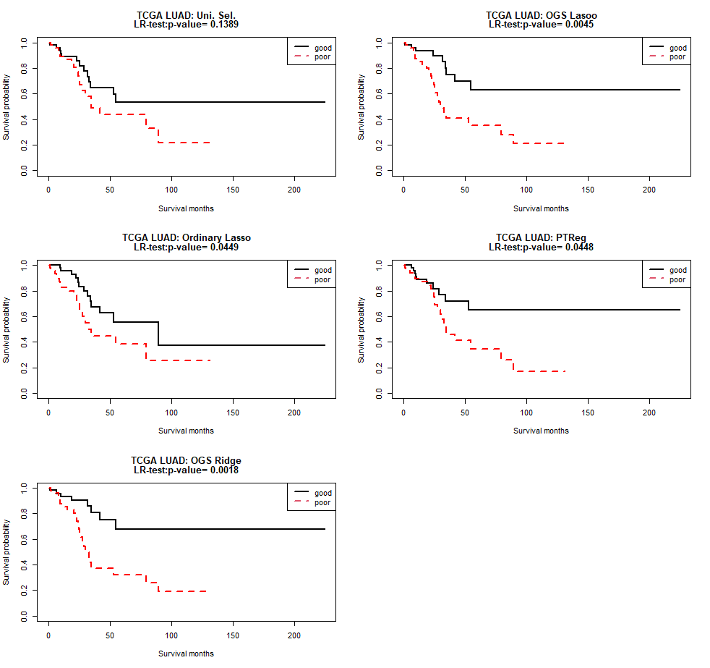
Fig. S.5. Kaplan-Meier curves for the 100 subjects in the TCGA LUAD testing data. Good and poor groups are identified by the median of the PI’s in the test dataset.

