Table S1. Characteristics of the sites
Site | Management | Coordinates | Pulse labelling date | Soil type | Altitude (m)
1 | Intensive | N 54°12.757' W 2°23.459' | 19/07/2016 | Humose loamy | 327
1 | Extensive | N 54°12.761' W 2°23.444' | 19/07/2016 | Humose loamy | 327
2 | Intensive | N 54° 15.190' W 2°19.134' | 18/07/2016 | Humose loamy | 496
2 | Extensive | N 54°15.219' W 2°19.093' | 18/07/2016 | Humose loamy | 496
5 | Intensive | N 54°20.385' W 2°19.252' | 17/07/2016 | Humose loamy | 339
5 | Extensive | N 54°20.389' W 2°19.242' | 17/07/2016 | Humose loamy | 339

Table S2. Statistical results of the monte carlo test of the soil fauna and microbial groups assessed by PLFA against the two PCoA dimensions (PCoA 1 and PCoA 2) presented in Fig. 2.
Variables | PCoA 1 | PCoA 2 | r² | P
ento_ag | -0.38312 | -0.9237 | 0.2248 | 0.001 ***
ento_bg | 0.97733 | 0.21174 | 0.1486 | 0.003 **
pod | -0.95376 | -0.30056 | 0.0671 | 0.044 *
sym | 0.21319 | -0.97701 | 0.0795 | 0.035 *
neel | -0.25827 | -0.96607 | 0.0855 | 0.018 *
decomp_mites | -0.9441 | 0.32966 | 0.1118 | 0.008 **
fungal_mites | 0.10846 | 0.9941 | 0.2913 | 0.001 ***
pred_oribatid | -0.25141 | 0.96788 | 0.2035 | 0.001 ***
mesostigmatid | -0.79439 | 0.6074 | 0.4932 | 0.001 ***
arachnid | -0.55808 | -0.82979 | 0.0239 | 0.368
pred_col_ad | -0.99987 | -0.01634 | 0.0338 | 0.225
pred_col_larv | -0.90724 | -0.42062 | 0.0047 | 0.81
detrit_col_ad | -0.89807 | -0.43986 | 0.0427 | 0.165
detrit_col_larv | -0.77072 | -0.63718 | 0.0397 | 0.151
diptera_larv | -0.98488 | -0.17324 | 0.1031 | 0.013 *
bactplfa | 0.91175 | -0.41075 | 0.0137 | 0.536
fungplfa | 0.93964 | -0.34215 | 0.0312 | 0.245
amfplfa | 0.68143 | -0.73189 | 0.034 | 0.23
actinoplfa | -0.22471 | 0.97442 | 0.0017 | 0.932
Ento_ag = epigeic entomobryomorpha, ento_bg = eudaphic entomorbyomorpha, pod = poduromorpha, sym= symphypleona, neel = neelipleona, decomp_mites = decomposer mites, fungal_mites = fungivorous mites, pred_oribatids = predatory oribatids, pred_col_ad = predatory coleoptera, pred_col_larv = predatory coleoptera larvae, detrit_col_ad = detritivorous coleoptera, detrit_col_larv = detritivorous coleoptera larvae, diptera_larv = diptera larvae, bactplfa= bacterial PLFA, fungplfa = fungal PLFA, amfplfa= AMF PLFA, actinoplfa = actinomycete PLFA

Table S3. Statistical results of the mixed model of the effect of time and management on the ¹³C relative enrichment and ¹⁵N enrichment of the different carbon and nitrogen pools (See Fig. 3 and 4)
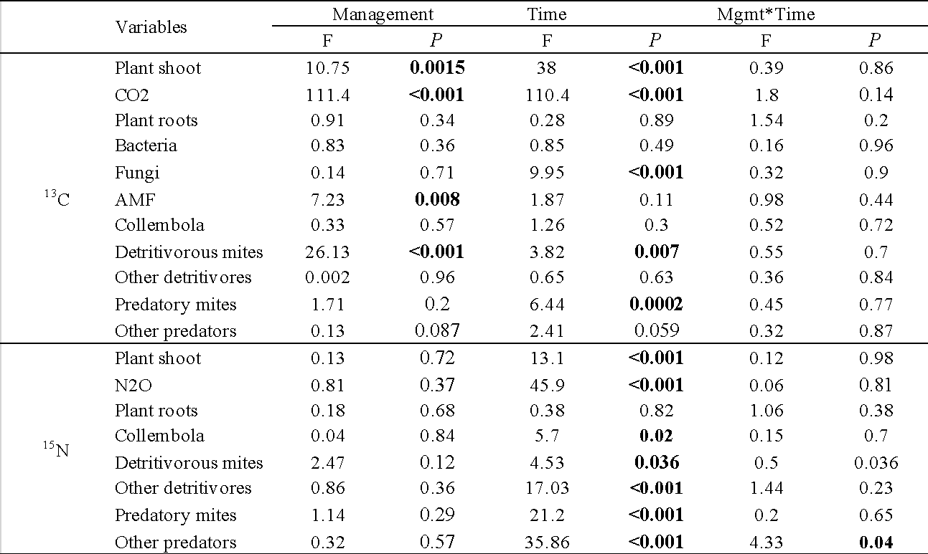

Table S4. Results of the t-test of the response ratio of the drought perturbation on the 13C and 15N enrichment of the different C and N pools in extensively or intensively managed grassland (Fig. 5) and the biomass or gas effluxes (Fig. S5)

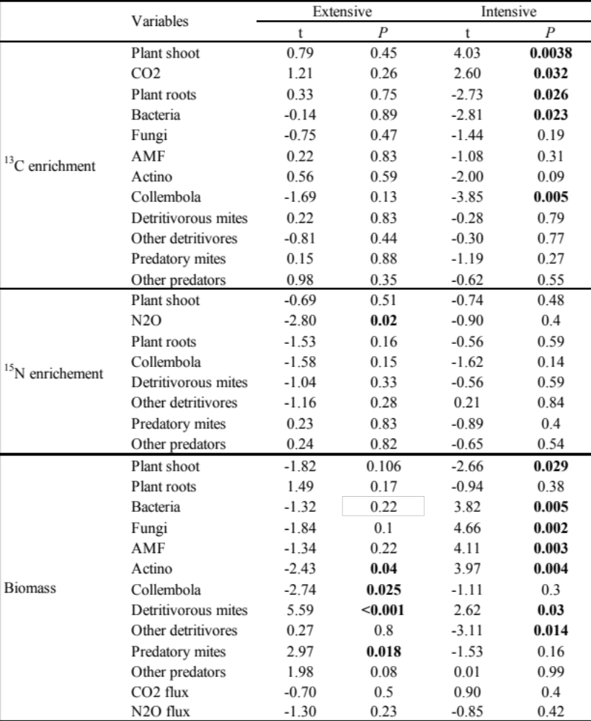

Table S5. Statistical results of the mixed model of the effect of treatment and management on the recovery of the ¹³C and ¹⁵N tracer in the different carbon and nitrogen pools (See Fig. S6)
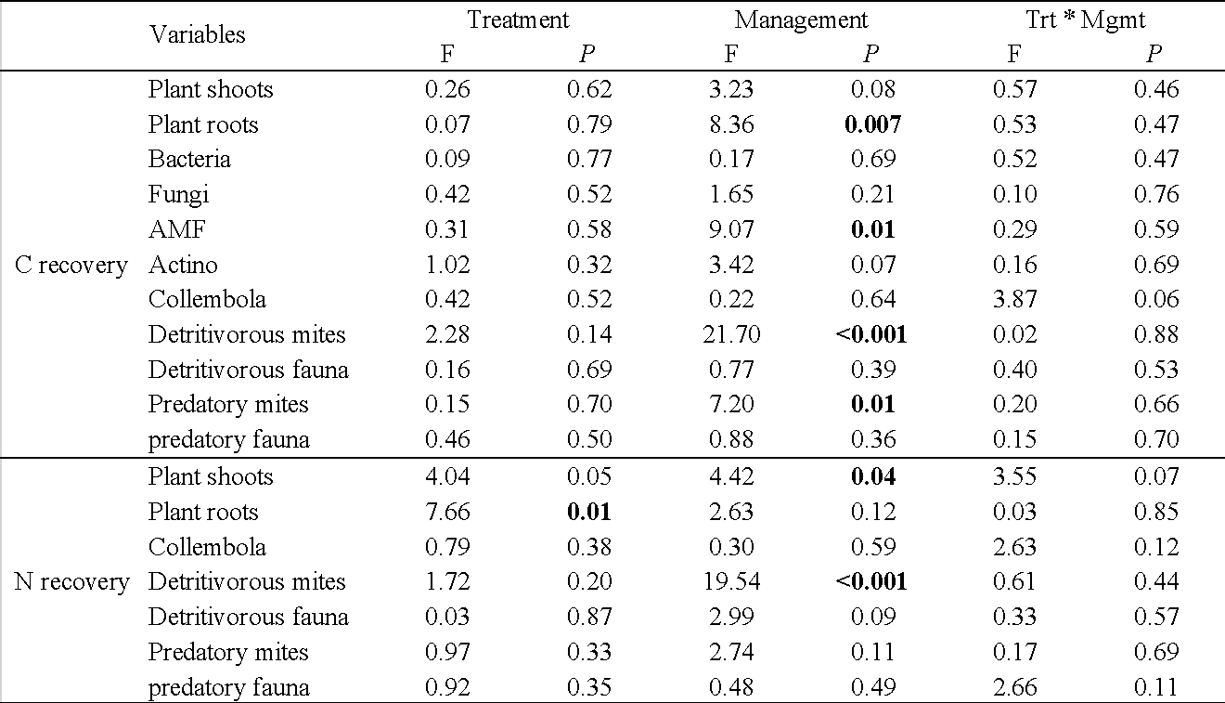

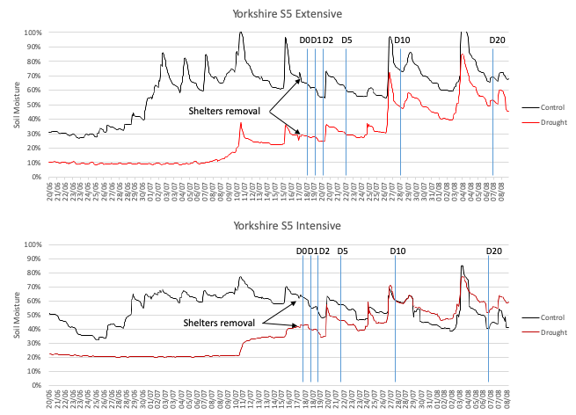
Figure S1. Soil moisture of control and droughted plots in one of the sites from the second half of the drought until the last sampling which occurred 20 days after the pulse labelling. Sampling dates are marked with a blue line

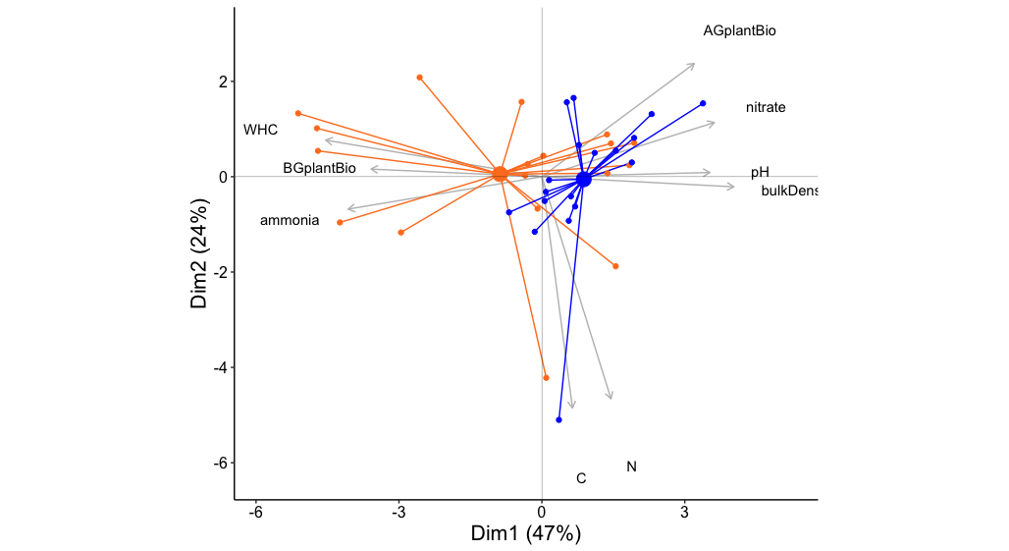Figure S2. Principal component analysis (PCA) from the soil properties and plant communities (extensive in orange, intensive in blue). Aboveground plant biomass (AGplantBio), belowground plant biomass (BGplantBio), water holding capacity (WHC)

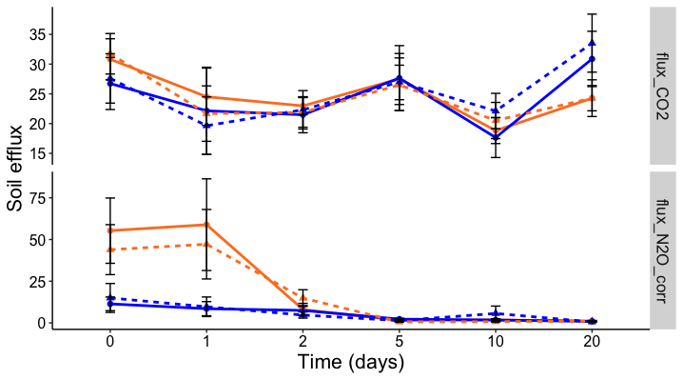
Figure S3. Soil CO₂ (upper panel) and N₂O (lower panel) efflux in response to land management (extensive in orange, intensive in blue) and drought (control in plain lines and drought in dotted lines). The effect of land management on soil CO₂ efflux differed on different sampling dates (management * time: F_{5,190} = 2.86, P = 0.0162), but there was no significant effect of land management in N₂O efflux at any time (management * time: F_{5,190} = 2.0, P = 0.08). N₂O efflux decreased over time (time: F_{5,190} = 16.7, P < 0.001). Means ± SE.

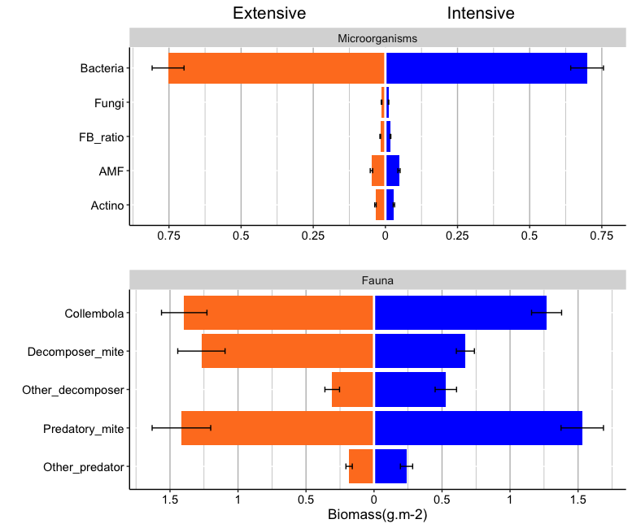
**
**
ns
ns
ns
ns
ns
ns
ns
ns
Figure S4. Biomass of soil organisms in response to land management (extensive in orange, intensive in blue). The microbial communities assessed by PLFA are in the upper panel, the soil mesofauna in the lower panel. Value are from control plots only and averaged over replicates and the 5 time points (n = 45 per fauna group and management). Mean ± SE, results of the mixed model are reported with *** P < 0.01, **P < 0.01, *P < 0.05

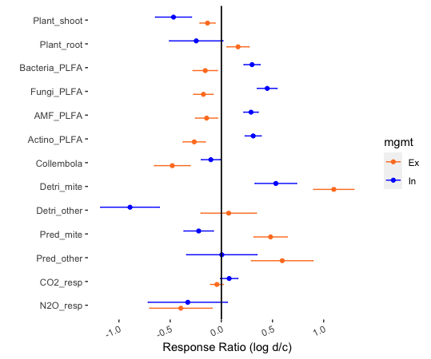
*
***
*
*
*
*
**
**
**
**
*
Figure S5. Response ratio of the drought on the biomass of plants and soil organisms, and soil CO2 and N2O as a function of grassland management (Ex = extensive, In = intensive). The direction (positive or negative) of the RR corresponds the direction of the drought effect on the 13C transfer, while a response ratio of zero indicates no drought effect. Results from the t-tests are reported with *** P < 0.01, **P < 0.01, *P < 0.05, see table S4 for details.

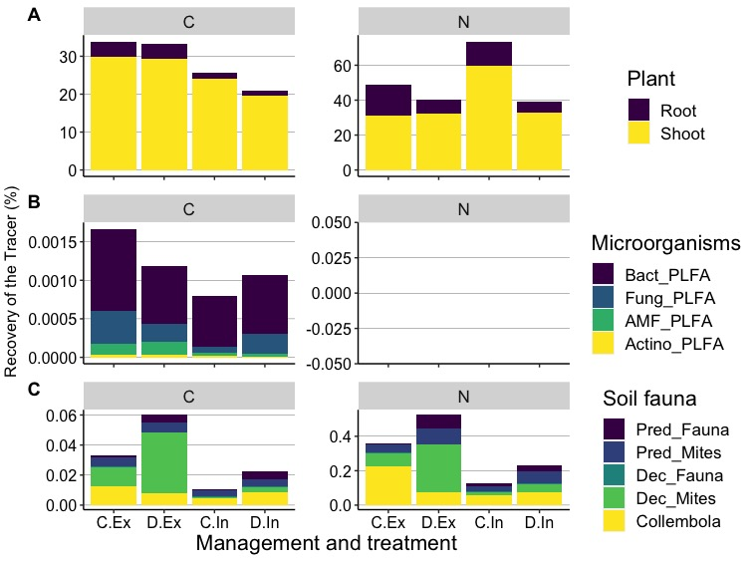
Figure S6. Allocation of the ¹³C and ¹⁵N tracer in plants (A), microbial PLFA biomarkers (B) and soil fauna (C) as a function of land management (Ex: extensive and In: intensive) and drought (C: control and D: drought). The C and N allocation are presented at the relevant time points for each group: at day 1 for the plant and microorganisms and at day 5 for the soil fauna. Note that the recovery of 13C in microorganisms is expressed in their PLFA, not the total biomass. 15N could not be measured for microbial communities.

Figure S7. ¹³C and ¹⁵N stock in soil fauna in grassland under intensive (In) or Extensive (Ex) management and after a drought perturbation (D) or under control conditions (C) along time after pulse labelling (days). Error bars represent standard errors across replicates (n = 9 per time point, management and treatment combination).

