Online supplement 3
A: Qualitative scoring method
Depiction of fissures | - Unacceptable (invisible interlobar fissure)  - Fair (blurred interlobar fissure)  - Good (visible interlobar fissure)
Depiction of intrapulmonary vessels | - Unacceptable (invisible peripheral pulmonary vessels)  - Poor (barely visible peripheral pulmonary vessels)  - Fair (visible peripheral pulmonary vessels)  - Good (visible peripheral pulmonary vessels with clear margin)  - Excellent (visible peripheral pulmonary vessels with clear margin)
Depiction of bronchi | - Unacceptable (indistinguishable lobar bronchial walls)  - Poor (visible lobar bronchial walls with <10 visible segmental bronchial walls)  - Fair (visible lobar bronchial walls with >10 visible segmental bronchial walls)  - Good (visible lobar bronchial walls with >10 visible segmental bronchial walls, with few visible sub/segmental bronchial walls)  - Excellent (visible sub-subsegmental bronchial walls)
Image noise/artifacts | - Unacceptable  - Above average noise/artifacts  - Average and acceptable  - Less than average noise/ artifacts  - Minimum of no noise/artifacts
Overall acceptability | - Unacceptable  - Suboptimal  - Satisfactory  - Above average  - Superior
Online supplement 3A: Qualitative scoring method adjusted from Bae et al. (European Radiology 2020)

B: Examples of artifacts
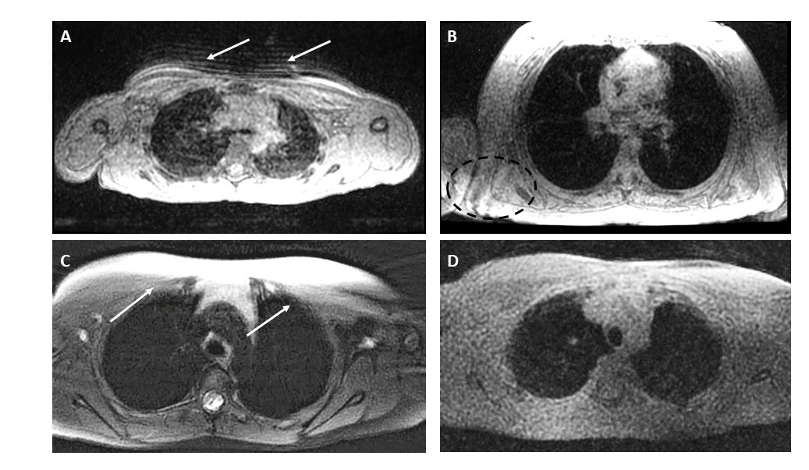
Online supplement 3B: Examples of artifacts. A) Blurring artifacts (arrows); seen as linear artifacts caused by breathing movement, B) Wrapping artifacts (circle); seen as projection of a body part on the other side of the image, caused by a field-of-view smaller than the thorax imaged, C) Streaking artifact (arrows); seen as dark or white streaks, these artifacts depend on the field-of-view (FOV) size and K-space reconstruction scheme. PROPELLER acquires K-space in rotating blades, which tend to be displaced within the imaged anatomical region, especially when FOV is small. D) low signal-to-noise ration; seen as a granulated appearance of the image, with poor distinguished structures in grey tones.

