Online supplement 5: Correlations between spirometry function outcome and total percentage of diseased lung on MRI
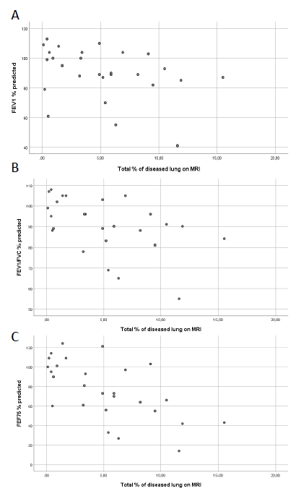

Online supplement 5: Correlations between spirometry outcome and total percentage of diseased lung on MRI. A) FEV₁ % predicted versus total % of diseased lung on MRI, B) FEV1/FVC % predicted versus total % of diseased lung on MRI, C) FEF₇₅ % predicted versus total % of diseased lung on MRI.

