1.Age (T-test)
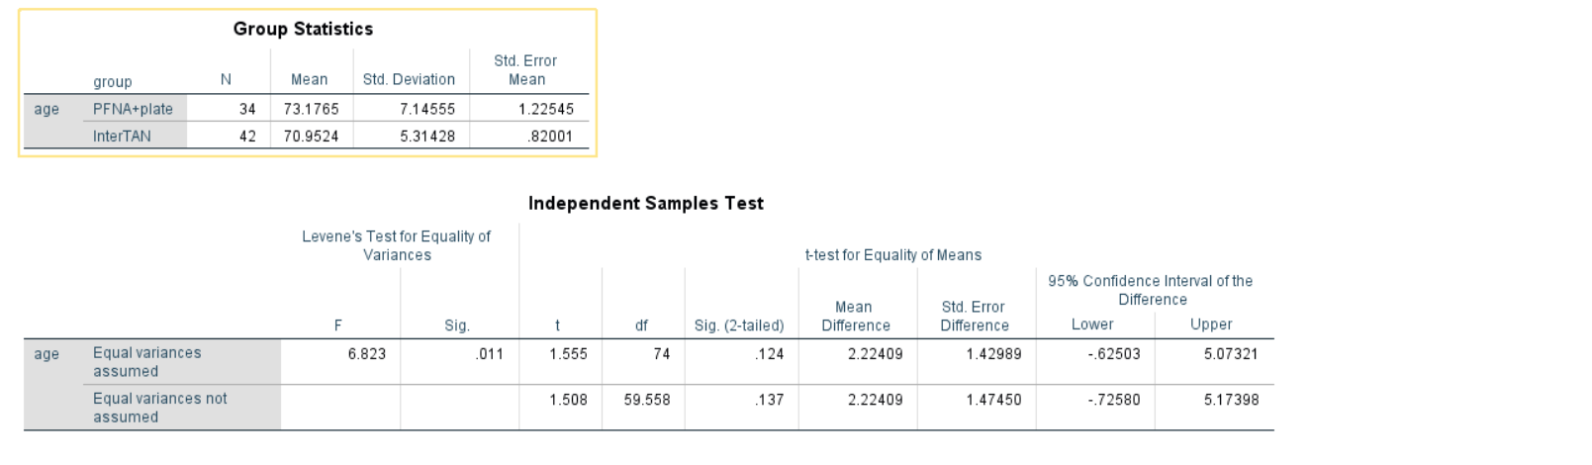

2.Gender( χ²test)
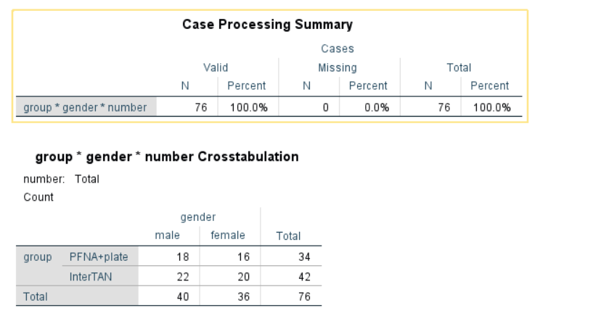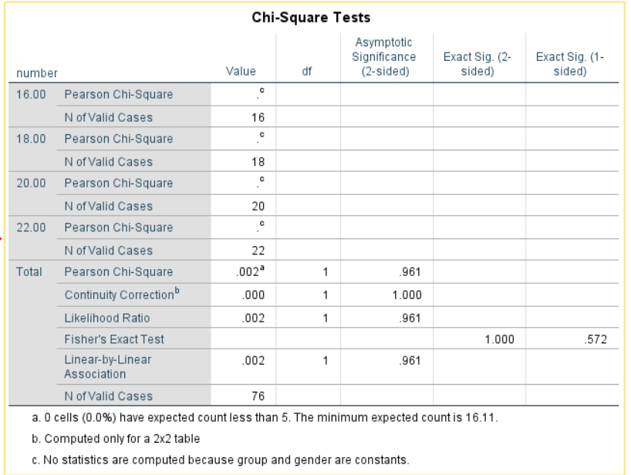

3.Side of injury (χ²test)
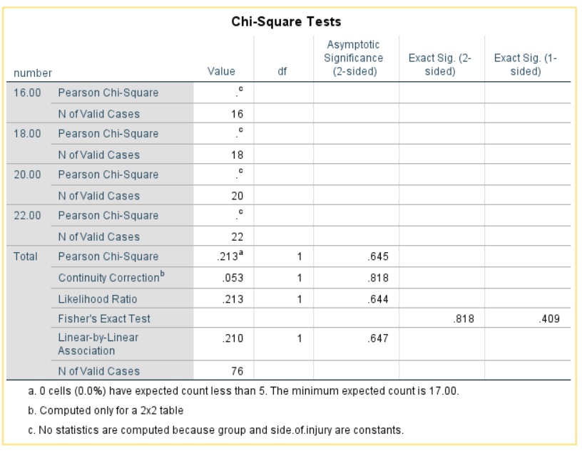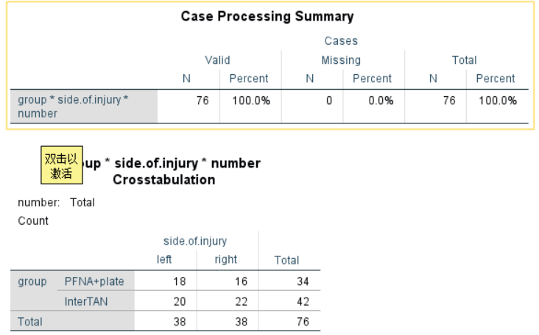

4 Combined medical diseases(χ²test)
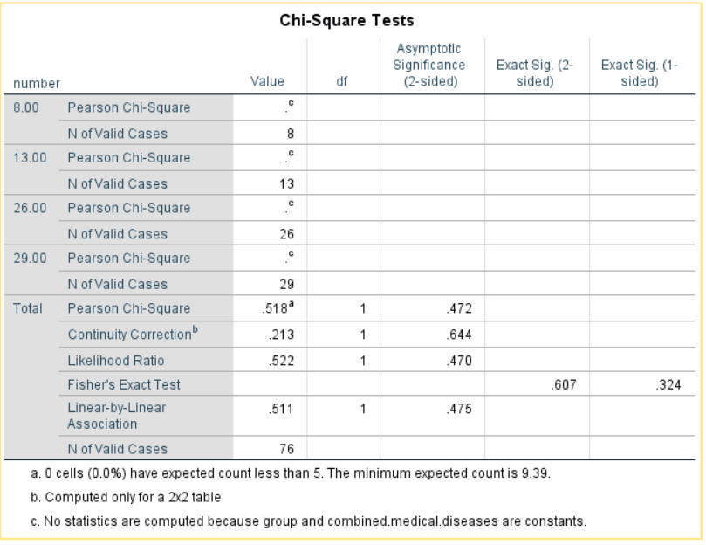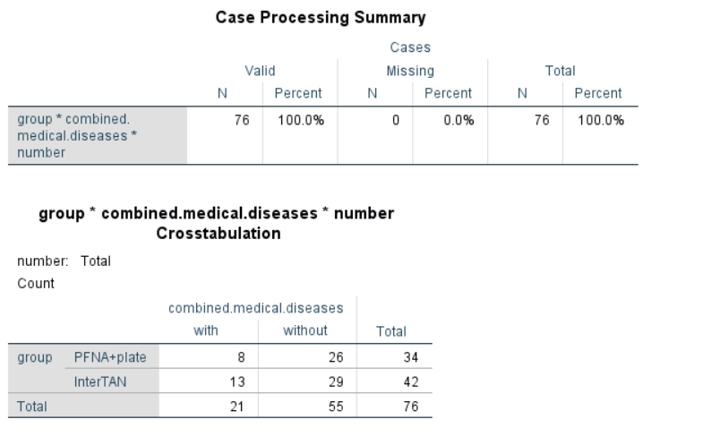

5.Cause of injury(χ²test)
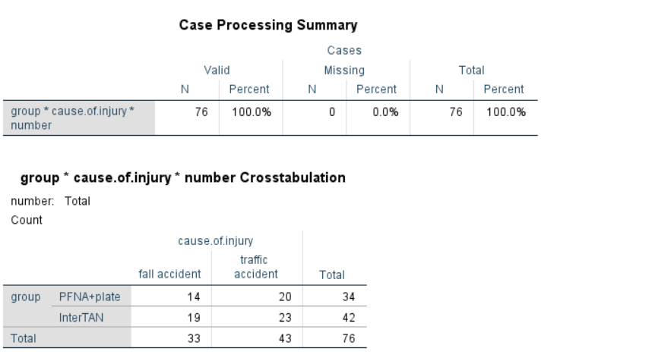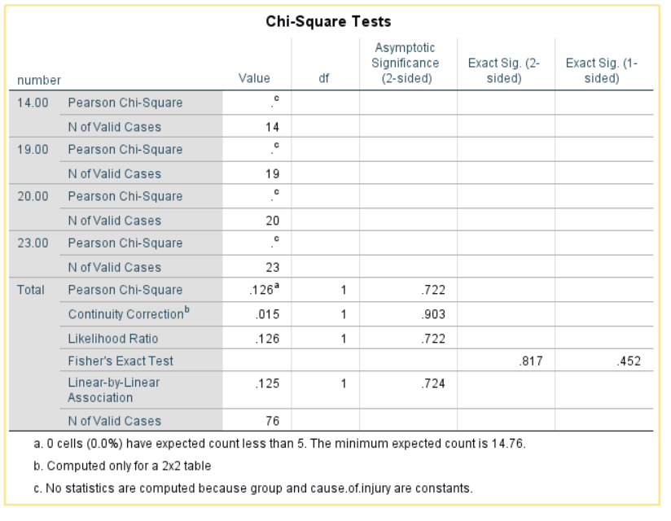

6. Follow-up time（month）
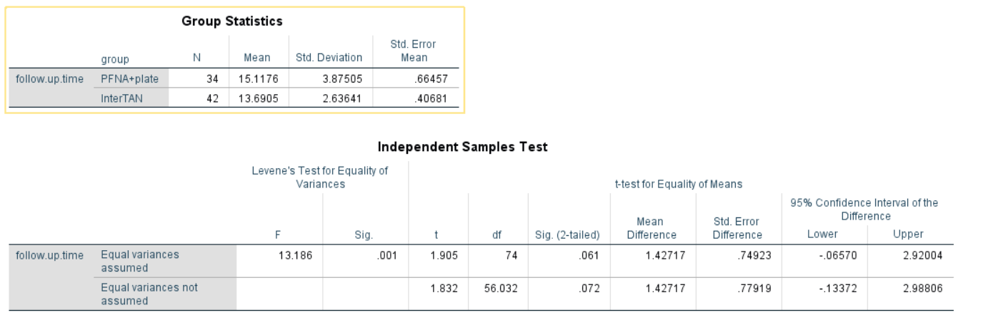
7. Operation time（min）
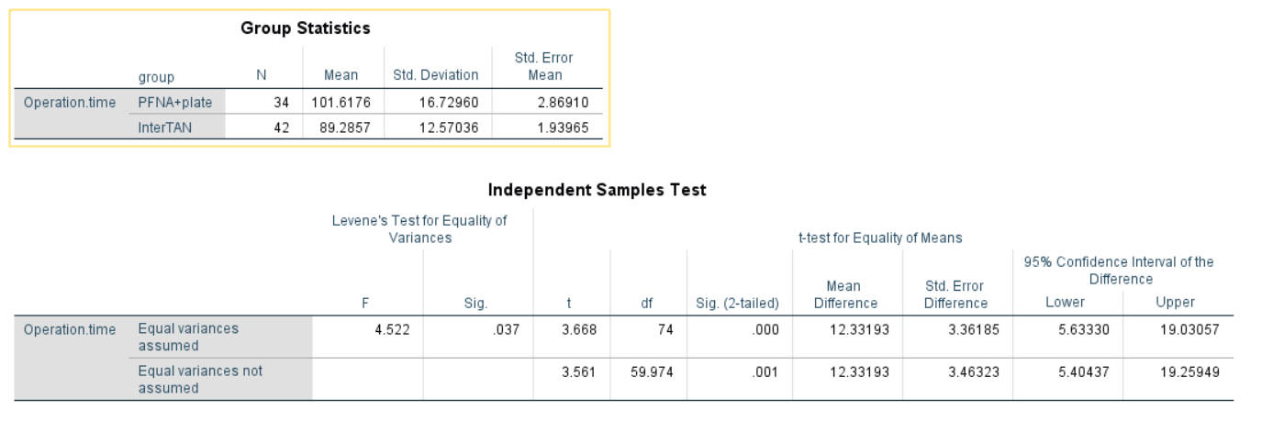

8. Intraoperative blood loss(ml)
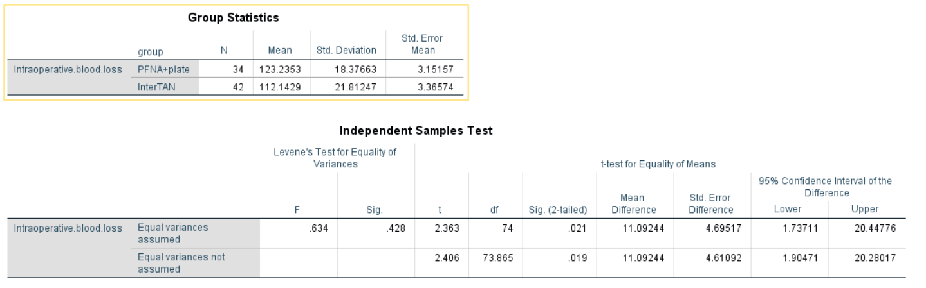
9. Time to weight-bearing（days）
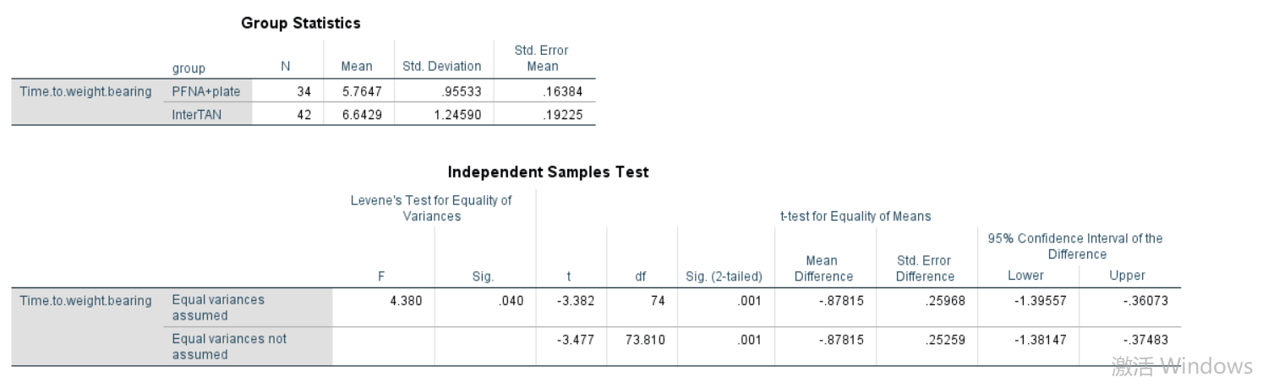

10. Fracture healing time（weeks）
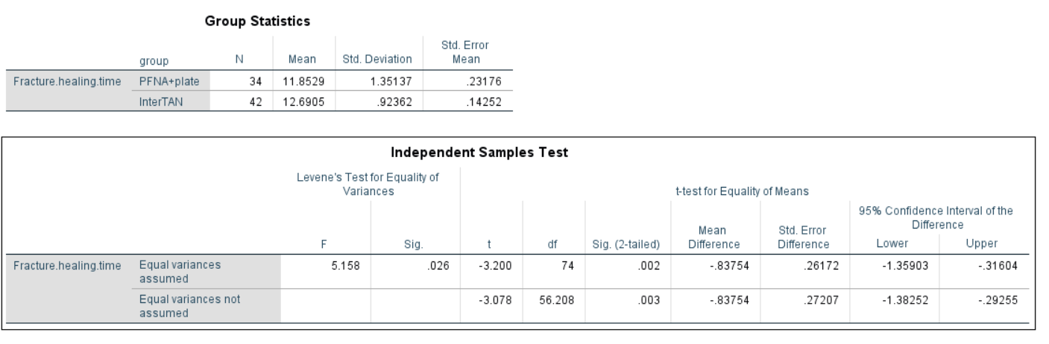
11.TAD Postoperative at 2 days(cm)
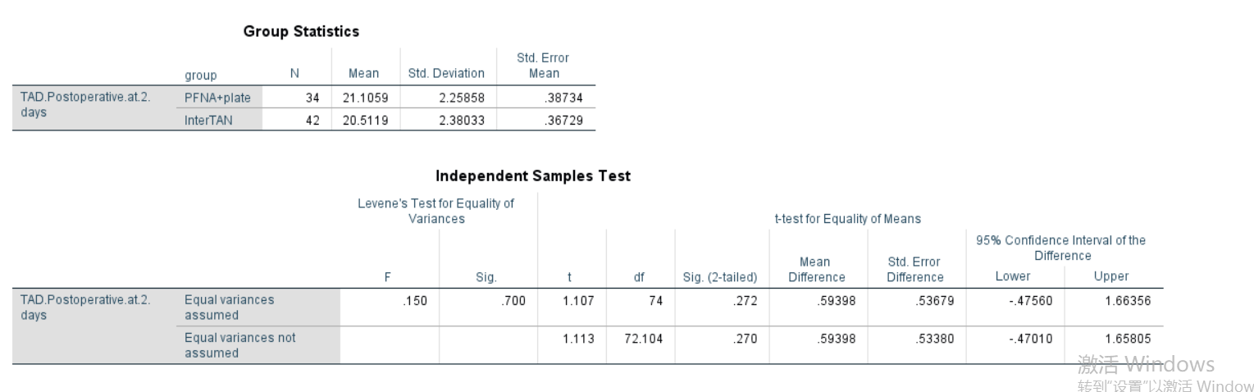
12. TAD Postoperative at 2 months(cm)
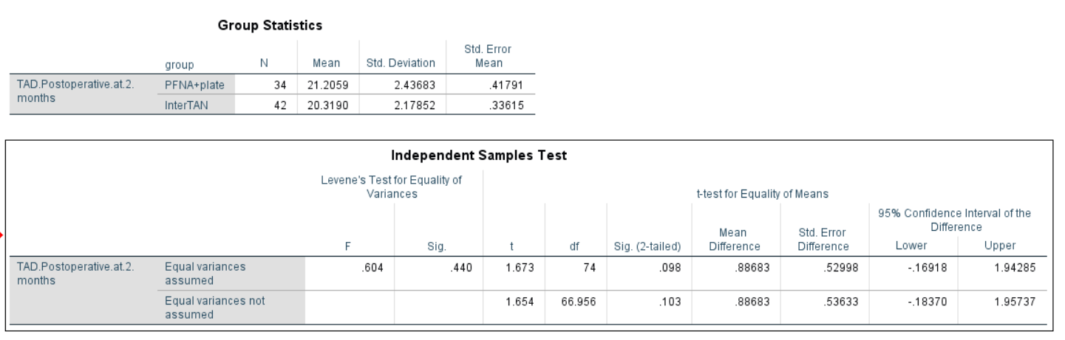
13.TAD Postoperative at 1 year(cm)
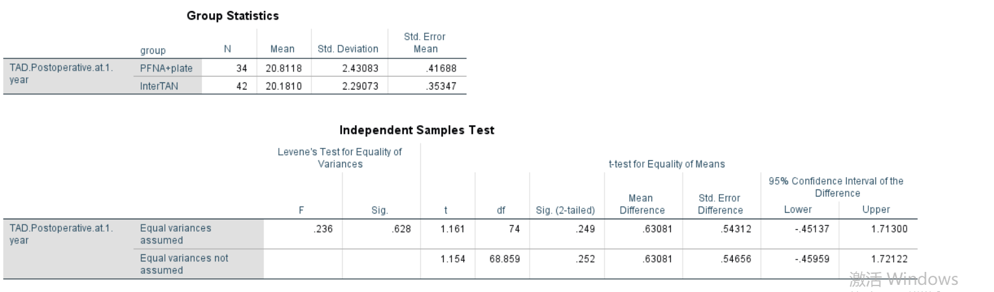
14 Pain
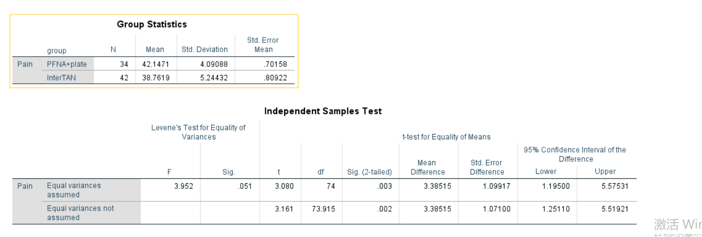
15.Malunion
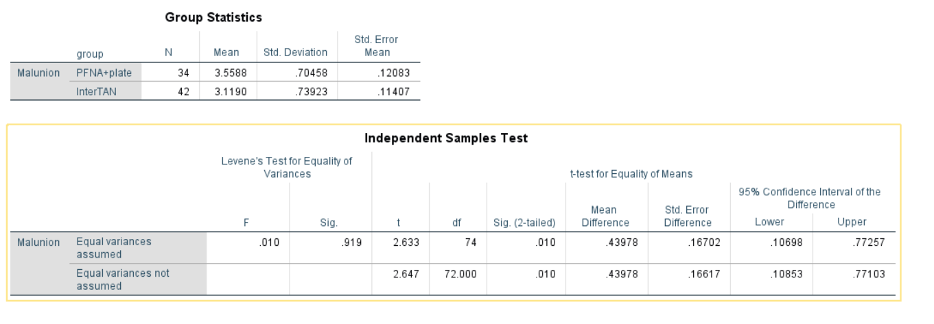
16.Range of motion
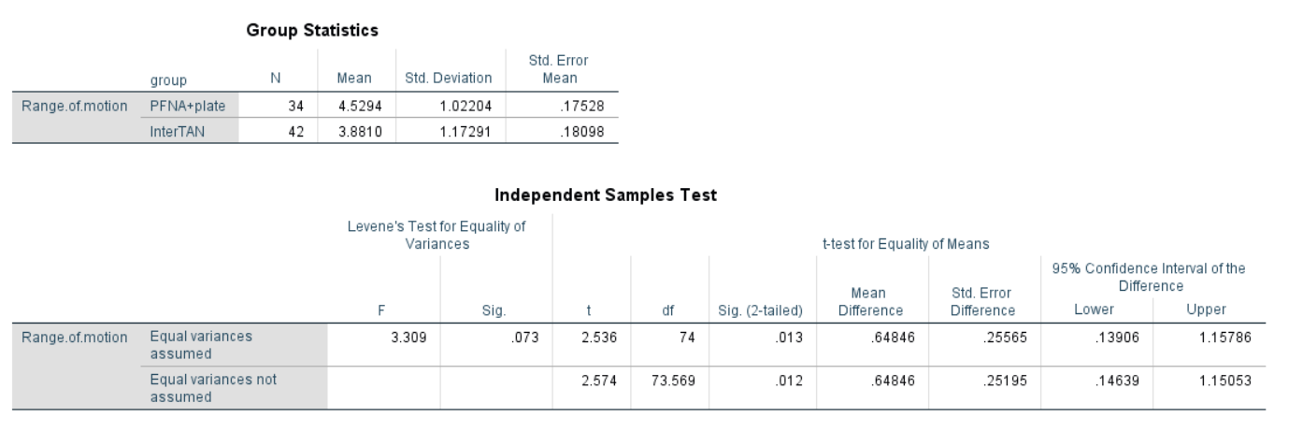
17.Function
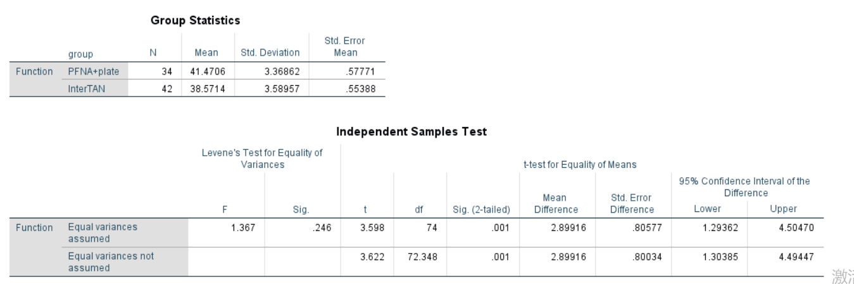
18.HHS percent of pass(χ²test)
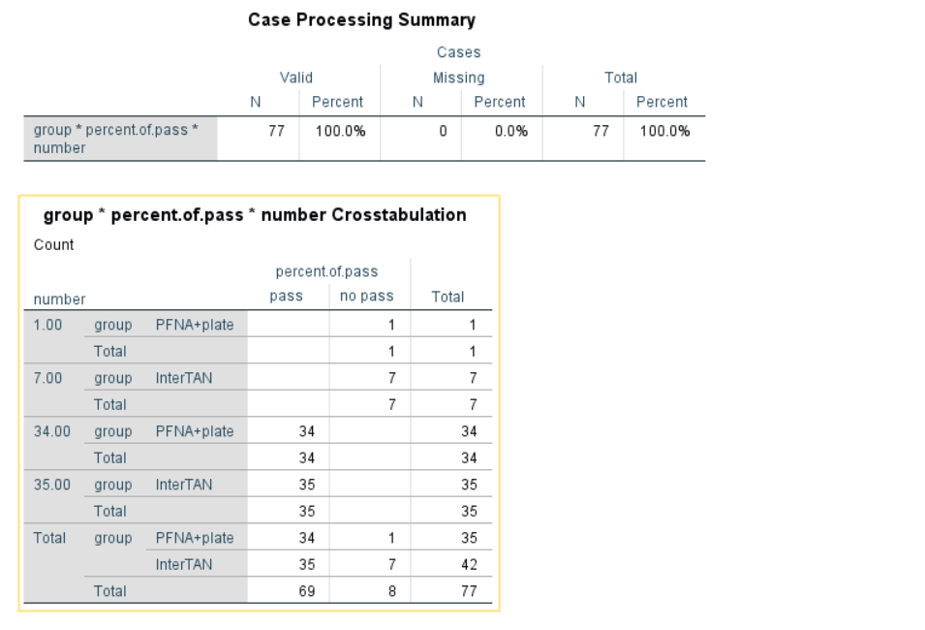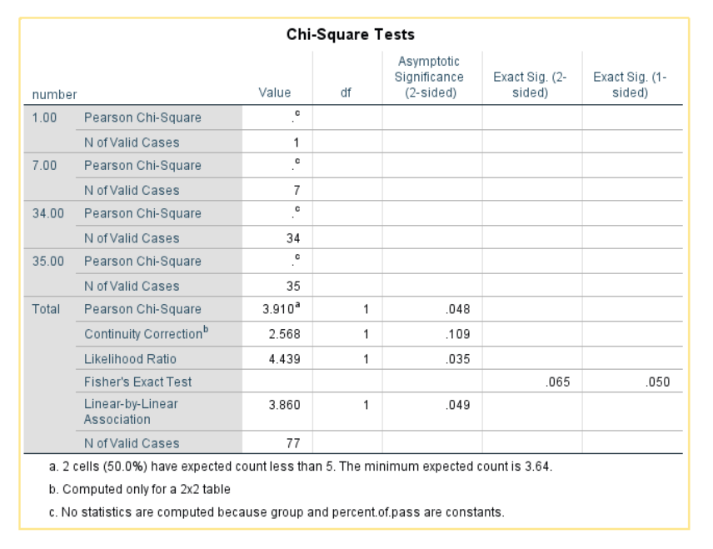

19.Harris total score
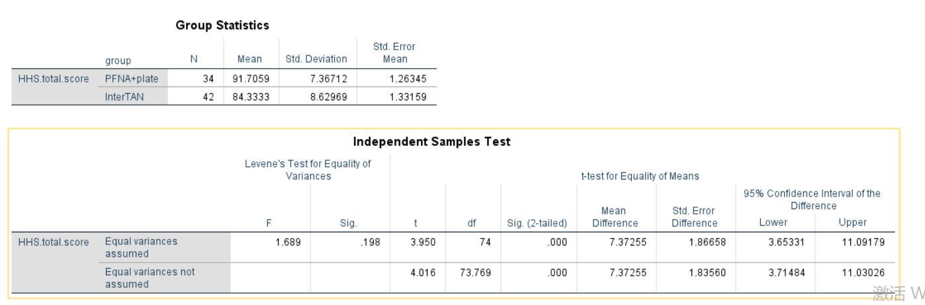
20.Intertan Intra-group F-test
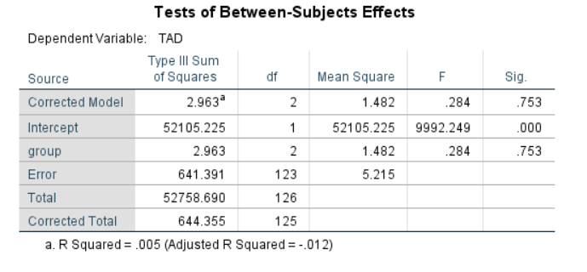

21. PFNA+ plate Intra-group F-test

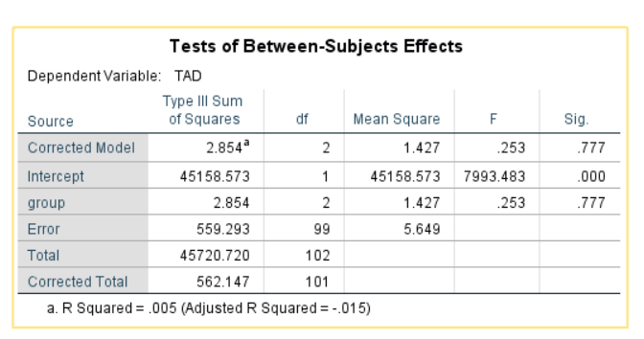
22. Postoperative complications
