Supporting Information
Table 1 Description,Time list and in process control of [¹¹C]CO₂ trapping and release.
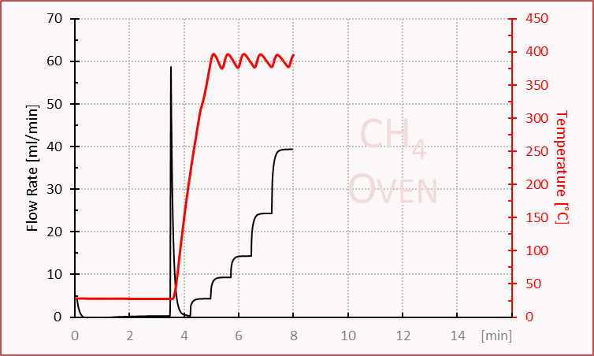

Time |  | Device |  | Value | Comment
0 | Set | Power | = | on | V.210416
2 | Set | Flow rate Set Point | = | 5
4 | Set | V28 | = | Open | Cooling on
6 | Set | V24 | = | a (down)
8 | Set | V25 | = | Open
10 | Set | V27 | = | Open
12 | Set | Process Control | = | Show Message and wait | System ready to receive activity
t1+2 | Set | V25 | = | Close
t1+3 | Set | V26 | = | Open | C11 activity release
t1+5 | Set | V27 | = | Open
t1+10 | Set | Select counter | = | 3B on, 3a Off
t1+11 | Get | Activity Product
t1+4’0 | Set | V25 | = | Open
t1+4’0 | Set | V26 | = | Close | C11 Activity stop
t1+4’1 | Set | V28 | = | Close | Cooling off
t1+4’2 | Set | V27 | = | Open
t1+4’3 | Set | Temp. Set Point CH4 | = | 300
t1+4’3 | Wait | Temp. Reg. Status CH4 | = | Temp OK
t2+0 | Set | VX | = | b (up)
t2+2 | Set | Temp. Set Point CH4 | = | 380
t2+3 | Wait | Temp. Reg. Status CH4 | = | Temp. OK
t3+1 | Set | Flow Rate Set point | = | 10
t3+45 | Set | Flow Rate Set Point | = | 15
t3+1’30 | Set | Flow Rate Set Point | = | 25
t3+2’15 | Set | Flow Rate Set Point | = | 40
t3+3’0 | Set | V27 | = | Close
t3+3’0 | Set | V28 | = | Open
t3+3’1 | Set | V25 | = | Reset
t3+3’1 | Set | V25 | = | Close

Table 2 Description, Time list and in process control of [¹¹C]CH₃I Production and release.
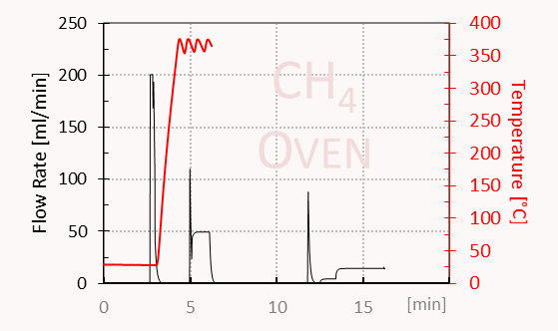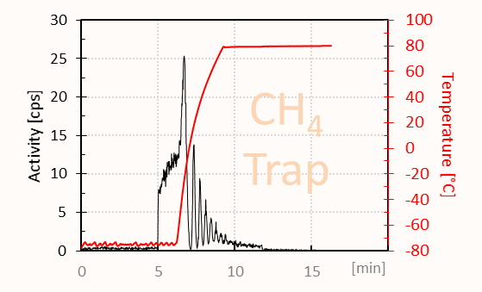
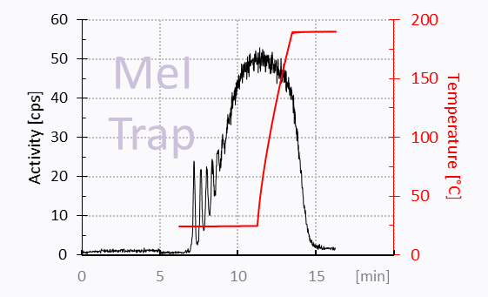
Time |  | Device |  | Value | Comment
0 | Set | Power | = | on | MeI for Choline Modified
0.4 | Set | Temp. Reg. Switch MeI | = | on
0.6 | Set | Flow Rate Set Point | = | 20
1 | Set | V25 | = | open
5 | Set | V28 | = | open
6 | Wait | Temp. CH4 | <= | 45
t1+0 | Set | Process Control | = | Show message and wait | Ready for CH4 trap cooling
t2+0 | Set | Temp. Set Point CH4 Trap | = | -75
t2+1 | Wait | Temp. Reg. Status CH4 Trap | = | Temp. OK
t3+0 | Set | Process Control | = | Show message and wait | System ready to receive activity
t4+0 | Set | Temp. Set Point I2 | = | 100
t4+1 | Get | Flow Rate Set Point | = | 0
t4+2 | Set | V25 | = | Close
t4+2.5 | Set | V26 | = | Open | C11 activity release
t4+3 | Set | V27 | = | Open
t4+4’9 | Set | V26 | = | Close | C11activity stop
t4+4’10 | Set | V24 | = | B (up) | H2 flow
t4+4’11 | Wait | Flow Rate Set Point | = | 200
t4+4’12 | Set | V25 | = | Open
t4+4’13 | Set | Flow Rate | >= | 45
t5+5 | Set | V27 | = | Close
t5+10 | Set | V28 | = | Close
t5+15 | Set | V25 | = | Close
t5+16 | Set | V24 | = | A (down) | Switch to He
t5+17 | Set | Flow Rate Set Point | = | 50
t5+18 | Set | Temp. Set Point CH4 | = | 360
t5+19 | Wait | Temp. Reg. Status CH4 | = | Temp. OK
t6+40 | Set | V10 Exhaust | = | Open
t6+41 | Set | V15 CH4 Trap Input | = | B (left)
t6+42 | Set | V29 | = | Open
t6+43 | Set | V25 | = | Open | Purge and transport with He
t6+1’40 | Set | V09 | = | B(right)
t6+1’41 | Set | V16 Exhaust | = | B(up)
t6+1’5 | Set | V25 | = | Close
t6+1’51 | Set | V29 | = | Close
t6+1’53 | Set | V15 CH4 Trap Input | = | A (right)
t6+1’54 | Set | V16 Exhaust | = | A(down)
t6+1’55 | Set | Gas Pump | = | On
t6+1’56 | Set | V16 Exhaust | = | B (up)
t6+1’56 | Set | Temp. Set Point CH4 Trap | = | 80
t6+1’56 | Set | Temp. Reg. Switch CH4 | = | Off
t6+1'58 | Set | Select Heater | = | 3B on, 3 A off
t6+1'58 | Set | V16 Exhaust | = | A (down)
t6+4'20 | Set | Process Control | = | Show message and wait | Press o.k. when activity on MeI-Trap constant
t7+0 | Set | Temp. Set Point MeI Trap | = | 190
t7+30 | Set | Gas Pump | = | Off | Circulation
t7+31.9 | Set | V15 CH4 Trap Input | = | B (left)
t7+32.9 | Set | V29 | = | Open
t7+33.9 | Set | V25 | = | Open
t7+34.9 | Set | V16 Exhaust | = | B (up)
t7+36 | Set | Flow Rate Set Point | = | 5
t7+40 | Set | V17 | = | B (down)
t7+41 | Set | V16 Exhaust | = | A (down)
t7+42 | Set | V08 | = | Open
t7+43 | Wait | Temp. MeI Trap | >= | 185
t8+1 | Set | Flow Rate Set Point | = | 15
t8+1'10 | Set | Process Control | = | Show message and wait | Press Okay when MeI has been transferred

