Supplementary information
Table of Contents
Supplemental Table 1. Public data sets for the meta-analysis
Supplemental Table 2. Top 10 candidate genes identified by the meta-analysis
Supplemental Table 3. The candidate genes through the literature review
Supplemental Table 4. Total quantity and purity of RNA extracted from urine samples
Supplemental Table 5. 18S rRNA normalized, log-transformed levels of mRNA in training set
Supplemental Table 6. ROC curve analysis of individual mRNA to differentiate AR from STA in training set
Supplemental Table 7. 18S rRNA normalized, log-transformed levels of mRNA in validation set
Supplemental Figure 1. Validation of six significant mRNAs in independent samples
Supplemental Figure 2 Gene set analysis of significant genes identified by meta-analysis
References

Supplemental Table 1. Public data sets for the meta-analysis
GEO dataset | Diagnosis of kidney transplant patients |  |  | Authors
GEO dataset | Stable graft function (STA) | Acute rejection (AR) | Total | Authors
GSE36059 | 281 | 130 | 411 | Halloran et al.[1]
GSE50058 | 58 | 43 | 101 | Khatri et al.[2]
GSE25902 | 96 | 24 | 120 | Naesens et al.[3]
GSE9489 | 7 | 15 | 22 | Raulf et al.[4]
Total | 442 | 212 | 654

Supplemental Table 2. Top 10 candidate genes identified by the meta-analysis
Probeset ID | Gene symbol | Gene name | FDR | FC
203915_at | CXCL9 | C-X-X motif chemokine 9 | 5.22E-04 | 5.74
204533_at | IP-10 | C-X-C motif chemokine 10 | 2.02E-05 | 4.59
229390_at | FAM26F | Family with sequence similarity 26, member F | 1.00E-09 | 3.75
210029_at | IDO1 | Indoleamine 2,3-dioxygenase I | 1.22E-03 | 3.16
212588_at | PTPRC | Protein tyrosine phosphatase, receptor type C | 2.11E-04 | 2.95
202953_at | C1QB | Complement C1q B chain | 6.80E-04 | 2.83
204279_at | PSMB9 | Proteasome subunit beta 9 | 2.78E-04 | 2.68
204891_s_at | LCK | Lymphocyte cell-specific protein tyrosine kinase | 2.77E-03 | 2.15
204698_at | ISG20 | Interferon-stimulated exonuclease gene 20 | 1.00E-09 | 2.14
202112_at | VWF | von Willebrand factor | 3.00E-04 | 2.05

Supplemental Table 3. The candidate genes through the literature review
Gene Symbol | Gene Name | Authors
CD3E | CD3e molecule | Suthanthiran et al.[5]
Foxp3 | forkhead box P3 | Muthukumar et al.[6]
OX40 | Tumor necrosis factor receptor superfamily, member 4 (TNFRSF4), also known as CD134 | Afaneh et al.[7]
Tim-3 | T-cell immunoglobulin and mucin-domain containing-3 | Renesto et al.[8]

Supplemental Table 4. Total quantity and purity of RNA extracted from urine samples
RNA quantity
Total RNA quantity (µg) | Total sample (N=494) | QC passed† (N=402) | QC failed (N=92) | P value‡  QC passed vs QC failed
Median | 0.738 | 0.653 | 1.550 | < 0.05
25th percentile | 0.245 | 0.250 | 0.177
75th percentile | 1.680 | 1.643 | 1.881
RNA Purity
RNA purity (A260/280 ratio) | Total sample (N=494) | QC passed † (N=402) | QC failed (N=92) | P value‡  QC passed vs QC failed
Median | 1.850 | 1.870 | 0.700 | < 0.001
25th percentile | 0.495 | 0.825 | 0.320
75th percentile | 2.005 | 2.020 | 1.980
The quantity (absorbance at 260 nm) and purity (ratio of the absorbance at 260 and 280 nm) of the RNA were measured using a NanoDrop® ND-2000 UV is spectrophotometer (Thermo Scientific).
† An RNA sample was considered to have passed QC if 18S rRNA and TGF-β1 mRNA levels were greater than or equal to 1x10⁴ and 1x10² copies per microgram of total RNA, respectively.
‡ Two-tailed P value based on the Mann-Whitney test.

Supplemental Table 5. 18S rRNA normalized, log-transformed levels of mRNA in training set (n=84)
Gene name | Stable (n=40) | Acute Rejection (n=44) | P Value†
Tim-3 | 2.220  (1.773, 2.538) | 2.870  (2.475, 3.353) | <0.001
CXCL9 | 1.435  (0.988, 1.948) | 2.555  (1.885, 2.895) | <0.001
LCK | 1.280  (0.698, 1.870) | 1.975  (1.655, 2.488) | <0.001
CD3ε | 1.540  (1.063, 1.973) | 2.235  (1.725, 2.780) | <0.001
C1QB | 1.645  (1.170, 2.275) | 2.765  (1.898, 3.278) | < 0.001
IP-10 | 2.145  (1.603, 2.648) | 2.810  (2.158, 3.143) | < 0.01
PSMB9 | 1.930  (1.328, 2.363) | 2.225  (1.760, 2.508) | < 0.05
FAM26F | -0.005  (-0.526, 0.694) | 0.402  (0.001, 0.925) | < 0.05
OX40 | 1.980  (1.623, 2.515) | 2.180  (1.883, 2.630) | 0.1692
IDO1 | 1.725  (1.275, 1.998) | 1.730  (1.493, 2.150) | 0.22
ISG20 | 2.065  (1.323, 2.665) | 1.980  (1.608, 2.395) | 0.904
PTPRC | 1.565  (0.876, 1.960) | 1.360  (0.982, 1.768) | 0.645
18S rRNA | 5.980  (5.125, 6.730) | 6.065  (5.665, 6.540) | 0.694
The levels of mRNA were absolutely measured without preamplification step by real-time quantitative PCR assays using gene specific oligonucleotide pairs and probes. If mRNA is undetected, the absolute value of the mRNA was calculated with standard curve by replacing 40 C_{t} value in the blank. Median value (lower, upper quartiles) of each mRNA measure normalized by 18s rRNA copy number (x10⁻⁶) and log₁₀-transformed are shown. Data are shown for QC-passed samples.
† Two-tailed P value is based on the Mann-Whitney test.
Supplemental Table 6. ROC curve analysis of individual mRNA to differentiate AR from STA in training set
Type of mRNA | Area Under the Curve | 95% Confidence Interval |  |  | P value
Tim-3 | 0.81 | 0.711 | 0.899 |  | < 0.001
CXCL9 | 0.78 | 0.685 | 0.881 |  | < 0.001
LCK | 0.76 | 0.660 | 0.867 |  | < 0.001
CD3ε | 0.76 | 0.653 | 0.860 |  | < 0.001
C1QB | 0.74 | 0.629 | 0.853 |  | < 0.001
IP-10 | 0.70 | 0.586 | 0.811 |  | < 0.01
PSMB9 | 0.64 | 0.515 | 0.755 |  | < 0.05
FAM26F | 0.64 | 0.516 | 0.763 |  | < 0.05
OX40 | 0.59 | 0.463 | 0.712 |  | 0.168
IDO1 | 0.58 | 0.454 | 0.702 |  | 0.218
ISG20 | 0.51 | 0.380 | 0.636 |  | 0.900
PTPRC | 0.47 | 0.343 |  | 0.598 | 0.641
18S rRNA | 0.52 | 0.395 |  | 0.653 | 0.707
Receiver-operating-characteristic (ROC) curve analyses of the urinary mRNA measures to differentiate AR from STA are shown. The AUC value of Tim-3 mRNA was best to differentiate the two groups.

Supplemental Table 7. 18S rRNA normalized, log-transformed levels of mRNA in validation set (n=318)
Gene name | Stable  (STA, n=122) | Acute Rejection (AR, n=57) | Borderline Changes  (BC, n=42) | BK Virus Nephropathy (BKVN, n=12) | Other Graft Injuries  (OGI, n=85) | P Value† | Compared between groups | P Value‡  STA Vs. | P Value‡  AR Vs.
Tim-3 | 1.470  (1.055, 1.925) | 2.410  (2.245, 2.810) | 1.680  (1.390, 2.173) | 2.335  (2.110, 2.895) | 2.040  (1.485, 2.420) | <0.001 | AR  BC  BKVN  OGI | <0.001  <0.05  <0.001  <0.001 | <0.001  0.728  <0.001
CXCL9 | 0.750  (0.022, 1.610) | 2.120  (1.390, 2.430) | 1.495  (0.713, 1.833) | 2.640  (2.150, 3.175) | 1.440  (0.696, 1.905) | <0.001 | AR  BC  BKVN  OGI | <0.001  <0.01  <0.001  <0.01 | <0.001  <0.01  <0.001
CD3ε | 1.380  (0.677, 1.853) | 2.170  (1.790, 2.535) | 1.820  (1.558, 2.330) | 1.965  (1.748, 2.385) | 1.680  (1.075, 2.130) | <0.001 | AR  BC  BKVN  OGI | <0.001  <0.001  <0.01  <0.05 | <0.05  0.375  <0.001
C1QB | 1.625  (0.898, 2.078) | 2.450  (2.120, 2.850) | 1.960  (1.423, 2.263) | 2.525  (2.285, 3.050) | 2.150  (1.475, 2.725) | <0.001 | AR  BC  BKVN  OGI | <0.001  <0.05  <0.001  <0.001 | <0.001  0.232  <0.01
IP-10 | 1.445  (0.993, 2.073) | 2.480  (1.930, 2.765) | 1.775  (1.315, 2.235) | 3.060  (2.535, 3.188) | 1.770  (1.200, 2.300) | <0.001 | AR  BC  BKVN  OGI | <0.001  0.103  <0.001  0.085 | <0.001  <0.01  <0.001
PSMB9 | 0.959  (0.442, 1.625) | 1.880  (1.625, 2.215) | 1.120  (0.749, 1.578) | 1.645  (1.320, 2.185) | 1.460  (1.003, 1.940) | <0.001 | AR  BC  BKVN  OGI | <0.001  0.545  <0.01  <0.001 | <0.001  0.429  <0.001
The levels of mRNA were absolutely measured without preamplification step by real-time quantitative PCR assays using gene specific oligonucleotide pairs and probes. Median value (lower, upper quartiles) of each mRNA measure normalized by 18s rRNA copy number (x10⁻⁶) and log₁₀-transformed are shown. Data are shown for QC-passed samples.
† P value is based on the Kruskal-Wallis test, and ‡ P value is based on the Mann-Whitney test between two groups.
Supplemental Figure 1. Validation of six significant mRNAs in independent samples
The absolute quantitative qPCR was performed to validate six significant mRNAs in 391 independent samples, which consist of STA (n=153), AR (n=68), BC (n=58) for TCMR, BKVN (n=15), and OGIs (n=97) including ATN (n=30), CNI (n=28) toxicity, GN (n=27), and IF/TA (n=12). Each mRNA level was log₁₀-transformed after each mRNA copy number was normalized with 18S rRNA copies (x10⁻⁶) in the QC-passed samples. The levels of CXCL9, IP-10, C1QB, PSMB9, CD3ε, and Tim-3 mRNAs were significantly elevated in AR compared to STA, BC, and OGIs. CXCL9 and IP-10 mRNA levels in BKVN were significantly higher than in AR. P values using pairwise comparisons by the non-parametric Mann-Whitney test were expressed as the mean±SE. * P<0.05, ** P<0.01, and *** P<0.001 versus STA; # P<0.05, ## P<0.01, and ### P<0.001 versus AR.

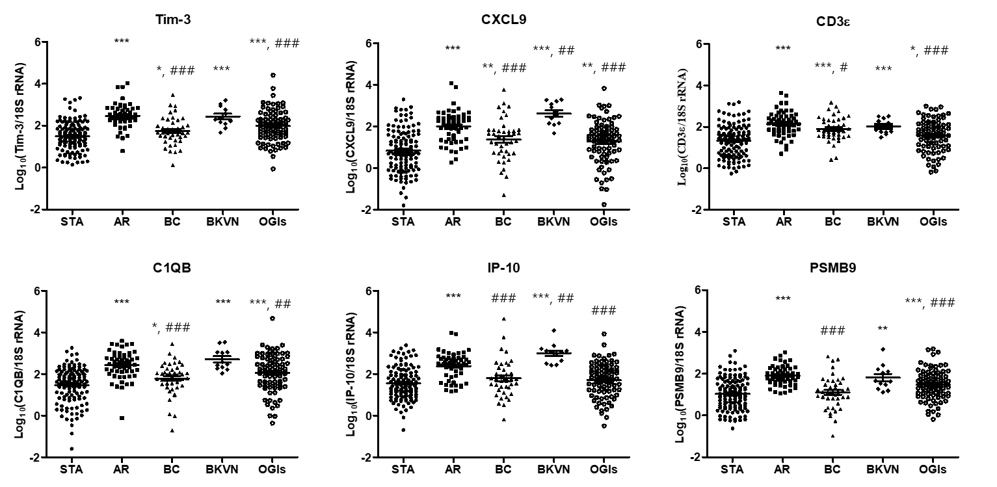
Supplemental Figure 2. Gene set analysis of significant genes identified by meta-analysis
Gene set enrichment analysis of top 100 significant genes identified by meta-analysis. Among 10 candidates identified by meta-analysis, 9 genes were associated to inflammatory response and immune system.

References
1. Reeve J, Sellares J, Mengel M, Sis B, Skene A, Hidalgo L, de Freitas DG, Famulski KS, Halloran PF: Molecular diagnosis of T cell-mediated rejection in human kidney transplant biopsies. Am J Transplant 2013, 13:645-655.
2. Khatri P, Roedder S, Kimura N, De Vusser K, Morgan AA, Gong Y, Fischbein MP, Robbins RC, Naesens M, Butte AJ, Sarwal MM: A common rejection module (CRM) for acute rejection across multiple organs identifies novel therapeutics for organ transplantation. J Exp Med 2013, 210:2205-2221.
3. Naesens M, Khatri P, Li L, Sigdel TK, Vitalone MJ, Chen R, Butte AJ, Salvatierra O, Sarwal MM: Progressive histological damage in renal allografts is associated with expression of innate and adaptive immunity genes. Kidney Int 2011, 80:1364-1376.
4. Saint-Mezard P, Berthier CC, Zhang H, Hertig A, Kaiser S, Schumacher M, Wieczorek G, Bigaud M, Kehren J, Rondeau E, et al: Analysis of independent microarray datasets of renal biopsies identifies a robust transcript signature of acute allograft rejection. Transpl Int 2009, 22:293-302.
5. Suthanthiran M, Schwartz JE, Ding R, Abecassis M, Dadhania D, Samstein B, Knechtle SJ, Friedewald J, Becker YT, Sharma VK, et al: Urinary-cell mRNA profile and acute cellular rejection in kidney allografts. N Engl J Med 2013, 369:20-31.
6. Muthukumar T, Dadhania D, Ding R, Snopkowski C, Naqvi R, Lee JB, Hartono C, Li B, Sharma VK, Seshan SV, et al: Messenger RNA for FOXP3 in the urine of renal-allograft recipients. N Engl J Med 2005, 353:2342-2351.
7. Afaneh C, Muthukumar T, Lubetzky M, Ding R, Snopkowski C, Sharma VK, Seshan S, Dadhania D, Schwartz JE, Suthanthiran M: Urinary cell levels of mRNA for OX40, OX40L, PD-1, PD-L1, or PD-L2 and acute rejection of human renal allografts. Transplantation 2010, 90:1381-1387.
8. Renesto PG, Ponciano VC, Cenedeze MA, Saraiva Camara NO, Pacheco-Silva A: High expression of Tim-3 mRNA in urinary cells from kidney transplant recipients with acute rejection. Am J Transplant 2007, 7:1661-1665.

