Evaluating the contribution of aestivation to the persistence of malaria mosquitoes through the Sahelian dry season using stable isotopes
Roy Faiman^{1 ◊}, Alpha S. Yaro^{2 ◊}, Adama Dao², Zana L. Sanogo², Moussa Diallo², Djibril Samake², Ousmane Yossi², Laura R. Veru¹, Leland C. Graber¹, Abigail R. Conte¹, Cedric Kouam¹, Benjamin J. Krajacich¹ and Tovi Lehmann¹
◊ Contributed equally to paper and share first authorship
^{1 ◊} Corresponding author email: roy.faiman@nih.gov
¹ Laboratory of Malaria and Vector Research, NIAID, NIH, Rockville, Maryland, USA
² Malaria Research and Training Center (MRTC)/ Faculty of Medicine, Pharmacy and Odonto-stomatology, University of Sciences, Techniques and Technologies, Bamako, Mali

Supplementary Information
Methods

Stable isotope marking
Stable isotopes (e.g., ¹³C, ¹⁵N in glucose and plant fertilizer most commonly) have previously been used through larval stage exposure to mark and track dispersal of Culex pipiens, C. quinquefasciatus, Aedes aegypti, Ae. albopictus and An. arabiensis over short spatio-temporal scales ^{1–3}. Stable isotope enrichment of mosquito larval sites enables large-scale, life-long marking of wild mosquitoes by continuously and non-invasively marking newly hatched larvae in-situ as long as the marking agent is present ^{2–6}. With possible residual effects of carbon and nitrogen assimilation into the local food webs as basic nutrients and metabolites⁷, we selected hydrogen (in the form of deuterium-oxide, ²H₂O) which holds qualities not unlike those of water and bears negligible influence when assimilated⁸.

Figure S1.
Figure S1. Stable isotope MRR timeline. Line graph (black) shows Sahelian An. coluzzii relative density (after Dao et al., 2014) by month. Rainy season depicted in light-green background, the dry season in light orange. Larval sites enriched with ²H during the end of the 2017 rainy season and until all water dried up in late November (dark orange arrow). Mosquito indoor sampling times throughout the experiment are depicted by mosquitoes. The first rain of 2018 fell on June 24 (blue arrow).

Although the MRR experiment was carried out in Thierola and M’Piabougou, our focal villages, we included samples from nearby villages: Zanga, Bako, Dougouguele and Dodougou all within 3-7 km from our focal villages. Additionally, to better understand regional variation in natural ²H levels we included samples from Sokourani, located in the Niono rice irrigated area (approximately 60 km long and 5 km wide in area) ~140 km NE of the focal villages, as well as Ballabougou, a village located ~25 km north of the focal villages (Fig. S2).

Figure S2. Map of study area including its location (orange rectangle) on a map of Mali (inset). Location of the focal villages (red) surrounded by nearby villages (green) and distant villages (blue) is shown. Maps plotted using SAS 9.4 which is licensed to include maps from Gfk GeoMarketing GmbH (inset) and Open Street map.
Enrichment larval sites in Thierola and M’Piabougou in relation to the village’s houses are shown in Fig. S3. In Thierola all larval sites, were sections of a single large seasonal pond that flanks the villages from the northwest (Fig. S3, inset), except TLV1, which was a separate puddle, and TLV4, TLV7, and TLV10 (top right), which were sections from a second large puddle located ~1.2 km northeast of the village.

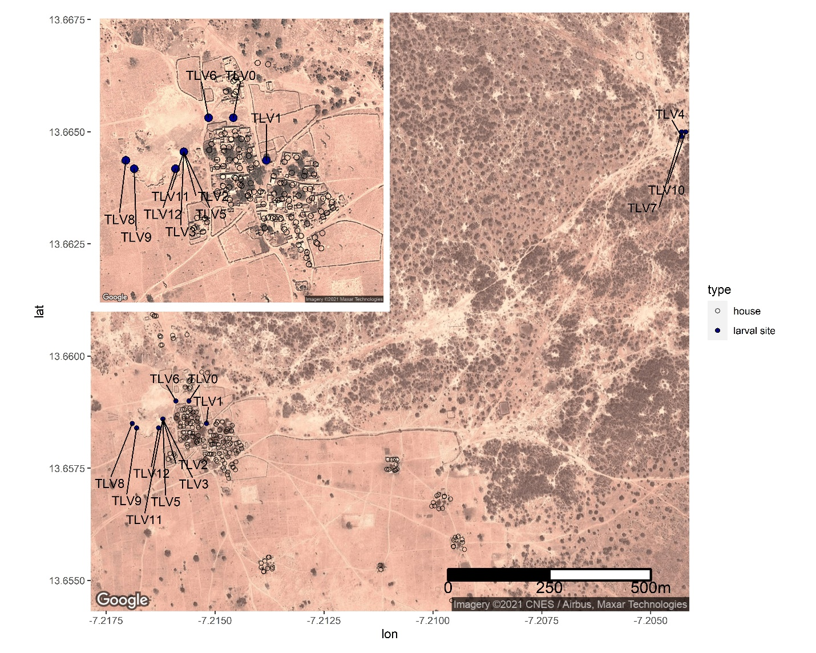
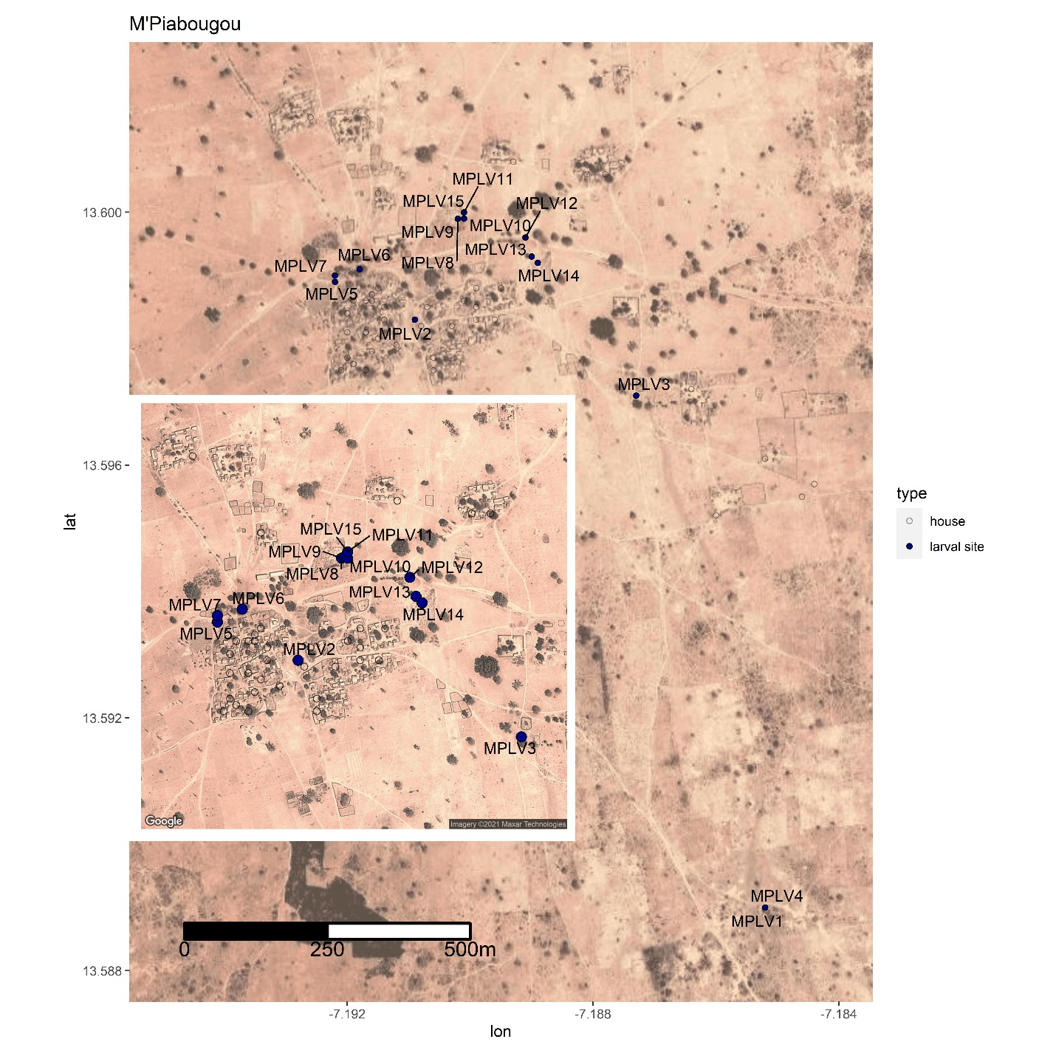
Figure S3. Thierola (top) and M’Piabougou (bottom) satellite images; houses (black empty circles) and larval sites (Navy-blue dots).

To test if larval site ²H-enrichment had a residual effect beyond the year of treatment, we sampled the first cohort of fourth-instar larvae as well as pupae from the same larval sites 11 days after the first rains (July 5-21, 2018) and compared their ²H levels with those of the previous year (collected indoors in September 2017) as well as fourth-instar larvae and pupae collected during the ²H-enrichment experiment from these larval sites (November 2017). As expected, the results revealed no statistical differences in ²H levels between pre-enrichment adults and those collected directly from larval sites the following rainy season but a large difference between them and the freshly enriched mosquitoes (Fig. S4 and Fig. 1). The results support that due to evaporation and possibly infiltration the lingering deuterium concentrations in the enriched larval sites are negligible.
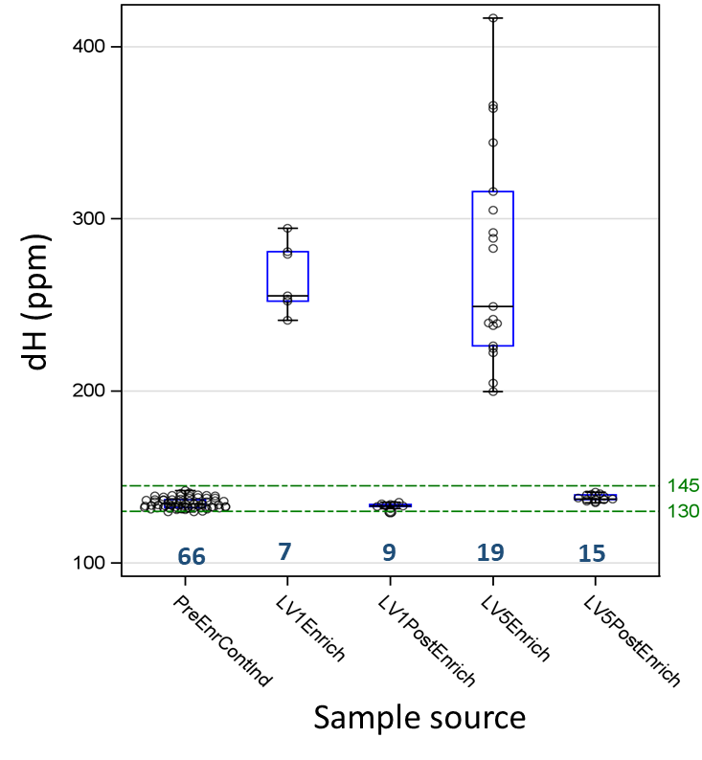

Figure S4. Differences between pre-enrichment mosquitoes from Thierola collected indoors (September 2017: PreEnrContInd), experimentally marked mosquitoes collected as pupae and stage-4 instar larvae from enriched larval sites during enrichment (LV1Enrich and LV5Enrich) and naturally occurring pupae and stage-4 instar larvae collected after the first rain the following year (July 2018: LV1PostEnrich and LV5PostEnrich). Sample size is shown in blue, and green reference lines show the range of natural ²H levels as in Fig. 1.

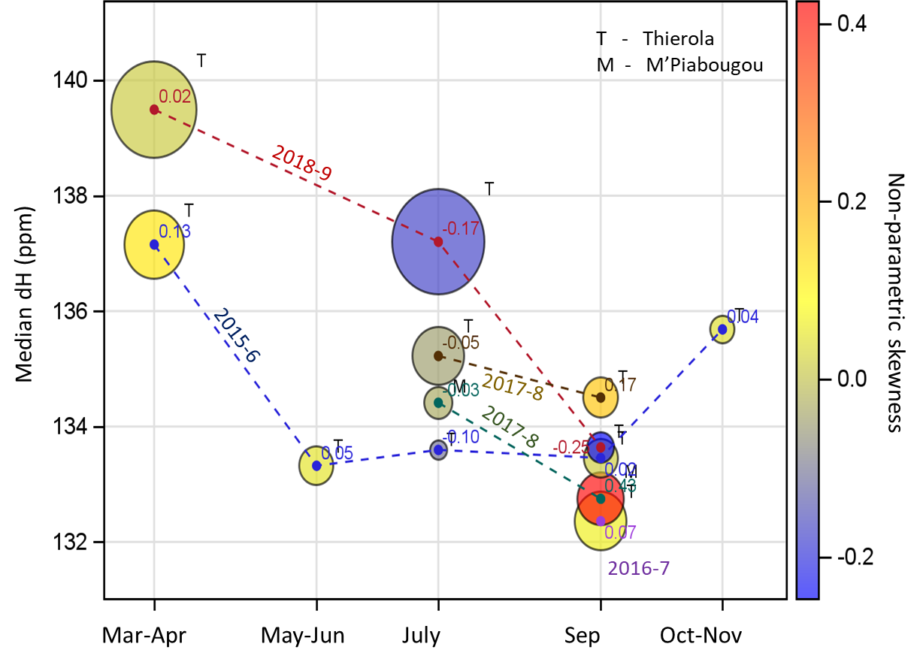

Figure S5. Natural temporal variation within and between population in median ²H (Y axis), spread of ²H as measured by the inter-quartile range (bubble size), and skewness measured by the non-parametric skewness (values inside bubbles; blue denotes negative skewness and yellow and red denote weaker and stronger positive skewness, respectively as seen in scale bar). Sampling years (August to July) are shown on each line and the letters T and M denote samples for Thierola and M’Piabougou.

Period | Population¹ | Enriched (%)² | 3rd quartile  Excess (%)³ | FMM: Enriched  Sub-Population (P value) | Est. A. coluzzii mean | Est. Aestivators
Late WS (2017) | Thierola | 56.4% (>160 ppm) | ND | ND
Late WS (2017) | M'Piabougou | 10% (>160 ppm) | ND | ND
Late WS (2017) | Pooled | 33% |  |  | 33% | 100%
Early DS (2017-8) | Thierola | 33% (>152 ppm) | ND | ND
Early DS (2017-8) | M'Piabougou | 0% (1 mosquito collected) | ND | ND | 29% | 87%
Early DS (2017-8) | Pooled | 29%
Late DS (2018) | Thierola | 24% (>142 ppm), 6.5% (Late DS 2016) | 33%* (pre-enrich), -2%^{ns} (Late DS 2016) | 19% (F,***)(M, ns)
Late DS (2018) | M'Piabougou | No samples available | No samples available
Late DS (2018) | Pooled |  |  |  | 16.5 | 50%
Rain Onset (2018) | Pooled | 6.5% (>142 ppm), 0% (Neighbor. Village: 2018) | 21%* (pre-enrich), 8.5%ns (Neighbor. Village: 2018) | 2.5% (***) | 6.1 | 18%
¹Pooled populations: values reflect means over Thierola and M'Piabougou
²Based on the maximum ²H value in the pre-enrichment sample, 142 ppm (see text). No additional tests were needed if ²H values of suspected enriched were much larger than the threshold, e.g., 160 ppm.
³Based on the 3rd quartile of the pre-enrichment or another reference population. Statistical significance is based on excess above the upper 95% CL of the 3rd quartile.
WS - wet season, DS - dry season, Pct - percent, ND - not done, F – females, M – males, ns - non-significant, * - P<0.05, *** - P<0.001
Table S1. Summary of the estimates of the fraction of mosquitoes with elevated ²H over the experiment.

1. Hamer, G. L. et al. Dispersal of Adult Culex Mosquitoes in an Urban West Nile Virus Hotspot: A Mark-Capture Study Incorporating Stable Isotope Enrichment of Natural Larval Habitats. PLoS Negl. Trop. Dis. 8, e2768 (2014).
2. Medeiros, M. C. I., Boothe, E. C., Roark, E. B. & Hamer, G. L. Dispersal of male and female Culex quinquefasciatus and Aedes albopictus mosquitoes using stable isotope enrichment. PLoS Negl. Trop. Dis. 11, e0005347 (2017).
3. Hood-Nowotny, R., Mayr, L. & Knols, B. Use of carbon-13 as a population marker for Anopheles arabiensis in a sterile insect technique (SIT) context. Malar. J. 5, 6 (2006).
4. Hamer, G. L. et al. Dispersal of Adult Culex Mosquitoes in an Urban West Nile Virus Hotspot: A Mark-Capture Study Incorporating Stable Isotope Enrichment of Natural Larval Habitats. PLoS Negl. Trop. Dis. 8, e2768 (2014).
5. Hood-Nowotny, R. & Knols, B. G. J. Stable isotope methods in biological and ecological studies of arthropods. Entomol. Exp. Appl. 124, 3–16 (2007).
6. Faiman, R. et al. Marking mosquitoes in their natural larval sites using 2H-enriched water: A promising approach for tracking over extended temporal and spatial scales. Methods Ecol. Evol. 10, 1274–1285 (2019).
7. M Begon, JL Harper, C. T. Ecology. Individuals, populations and communities. (Blackwell Science Ltd, 1996).
8. Atzrodt, J., Derdau, V., Kerr, W. J. & Reid, M. Deuterium- and Tritium-Labelled Compounds: Applications in the Life Sciences. Angew. Chemie Int. Ed. 57, 1758–1784 (2018).
9. Dao, A. et al. Signatures of aestivation and migration in Sahelian malaria mosquito populations. Nature 516, 387–390 (2014).

