SUPPLEMENTARY INFORMATION

Technical framework for wastewater-based epidemiology of SARS-CoV-2 based on relative quantification via qPCR

Jinyong Wu¹, Zizheng Wang², Yufei Lin¹, Lihua Zhang¹, Jing Chen¹, Panyu Li¹, Wenbin Liu¹, Yabo Wang¹, Changhong Yao¹, Kun Yang¹*

- Department of Pharmaceutical & Biological Engineering, School of Chemical Engineering, Sichuan University, Chengdu 610065, China.
- West China School of Stomatology, Sichuan University, Chengdu 610041, China.

*Correspondence to:
Kun Yang
cookyoung@scu.edu.cn

Supplementary Information Table of Contents

Supplementary Table
Supplementary Table S1. Information of RT-qPCR primer−probe sets analyzed in this work. | 3
Supplementary Figures
Supplementary Figure S1. Illustration of the positions of RT-qPCR primer−probe sets in the SARS-CoV-2 genome. | 4
Supplementary Datasets
Supplementary Dataset S1. Statistics of numbers of point mutation sequences (among analyzed 2257 sequences) in the target binding region of primer/probe sets.  Supplementary dataset S2. Calculated mutation rate for each site within the target binding region of primers/probes (n=2257). | 5  5
Other supplementary materials
FASTA file for genome sequence alignment of SARS-CoV-2.  Acknowledgement table for downloaded genome sequences from GISAID EpiCoV database. | 6  6
Supplementary References | 7

Supplementary Table S1. Information of RT-qPCR primer−probe sets analyzed in this work [1, 2].
Institutes | Target | Name | Sequence (5’-3’) | Reference
China CDC | ORF1ab | ORF1ab-F | CCC TGT GGG TTT TAC ACT TAA | [3]
 |  | ORF1ab-P | FAM−CCG TCT GCG GTA TGT GGA AAG GTT ATG G−BHQ1
 |  | ORF1ab-R | ACG ATT GTG CAT CAG CTG A
 | N | N-F | GGG GAA CTT CTC CTG CTA GAA T
 |  | N-P | FAM−TTG CTG CTG CTT GAC AGA TT−BHQ1
 |  | N-R | CAG ACA TTT TGC TCT CAA GCT G
France Pasteur | RdRP-IP2 | RdRp-IP2_F | ATG AGC TTA GTC CTG TTG | [4]
 |  | RdRp-IP2_P | FAM−AGA TGT CTT GTG CTG CCG GTA−BHQ1
 |  | RdRp-IP2_R | CTC CCT TTG TTG TGT TGT
 | RdRP-IP4 | RdRp-IP4_F | GGT AAC TGG TAT GAT TTC G
 |  | RdRp-IP4_P | FAM−TCA TAC AAA CCA CGC CAG G−BHQ1
 |  | RdRp-IP4_R | CTG GTC AAG GTT AAT ATA GG
 | E | Pasteur-E_F | ACA GGT ACG TTA ATA GTT AAT AGC GT
 |  | Pasteur-E_P | FAM−ACA CTA GCC ATC CTT ACT GCG CTT CG−BHQ1
 |  | Pasteur-E_R | ATA TTG CAG CAG TAC GCA CAC A
Germany Charité | RdRP | RdRp_SARSr-F | GTG ARA TGG TCA TGT GTG GCG G | [5]
 |  | RdRp_SARSr-P2 | FAM−CAG GTG GAA CCT CAT CAG GAG ATG C−BHQ1
 |  | RdRp_SARSr-R | CAR(A)ATG TTA AAS(A) ACA CTA TTA GCA TA (Mismatch)^{b}
 | E | E_Sarbeco_F | ACAGGTACGTTAATAGTTAATAGCGT
 |  | E_Sarbeco_P1 | FAM-ACACTAGCCATCCTTACTGCGCTTCG-BBQ
 |  | E_Sarbeco_R | ATATTGCAGCAGTACGCACACA
 | N | N_Sarbeco_F | CACATTGGCACCCGCAATC
 |  | N_Sarbeco_P | FAM-ACTTCCTCAAGGAACAACATTGCCA-BBQ
 |  | N_Sarbeco_R | GAGGAACGAGAAGAGGCTTG
HKU Med. | ORF1b | HKU-ORF1bnsp14F | TGG GGY TTT ACR GGT AAC CT | [6]
 |  | HKU-ORF1bnsp14P | FAM−TAG TTG TGA TGC WAT CAT GAC TAG−BHQ1
 |  | HKU-ORF1bnsp14R | AAC RCG CTT AAC AAA GCA CTC
 | N | HKU-NF | TAA TCA GAC AAG GAA CTG ATT A
 |  | HKU-NP | FAM−GCA AAT TGT GCA ATT TGC GG−BHQ1
 |  | HKU-NR | CGA AGG TGT GAC TTC CAT G
HKU SKL of EIDª | RdRp/Hel | RdRp/Hel_F | CGC ATA CAG TCT TRC AGG CT | [7]
 |  | RdRp/Hel_P | FAM−TTA AGA TGT GGT GCT TGC ATA CGT AGA C-BHQ1
 |  | RdRp/Hel_R | G(A)TG TGA TGT TGA WAT GAC ATG GTC (Mismatch) ^{b}
 | S | Chan-S_F | CCT ACT AAA TTA AAT GAT CTC TGC TTT ACT
 |  | Chan-S_P | FAM−CGC TCC AGG GCA AAC TGG AAA G−BHQ1
 |  | Chan-S_R | CAA GCT ATA ACG CAG CCT GTA
 | N | Chan-N_F | GCG TTC TTC GGA ATG TCG
 |  | Chan-N_P | FAM−AAC GTG GTT GAC CTA CAC AGS T−BHQ1
 |  | Chan-N_R | TTG GAT CTT TGT CAT CCA ATT TG
Japan NIID | N | NIID_2019-nCOV_N_F2 | AAA TTT TGG GGA CCA GGA AC | [8]
 |  | NIID_2019-nCOV_N_P2 | FAM−ATG TCG CGC ATT GGC ATG GA− BHQ1
 |  | NIID_2019-nCOV_N_R2 | TGG CAG(C) CTG TGT AGG TCA AC (Mismatch) ^{b}
Thailand NIH | N | WH-NIC N-F | CGT TTG GTG GAC CCT CAG AT | [9]
 |  | WH-NIC N-P | FAM−CAA CTG GCA GTA ACC A−BHQ1
 |  | WH-NIC N-R | CCC CAC TGC GTT CTC CAT T
US CDC | N | 2019-nCoV_N1-F | GAC CCC AAA ATC AGC GAA AT | [10]
 |  | 2019-nCoV_N1-P | FAM−ACC CCG CAT TAC GTT TGG TGG ACC−BHQ1
 |  | 2019-nCoV_N1-R | TCT GGT TAC TGC CAG TTG AAT CTG
 |  | 2019-nCoV_N2-F | TTA CAA ACA TTG GCC GCA AA
 |  | 2019-nCoV_N2-P | FAM−ACA ATT TGC CCC CAG CGC TTC AG−BHQ1
 |  | 2019-nCoV_N2-R | GCG CGA CAT TCC GAA GAA
 |  | 2019-nCoV_N3-F | GGG AGC CTT GAA TAC ACC AAA A
 |  | 2019-nCoV_N3-P | FAM−AYC ACA TTG GCA CCC GCA ATC CTG−BHQ1
 |  | 2019-nCoV_N3-R | TGT AGC ACG ATT GCA GCA TTG
ª: SKL of EID: State Key Laboratory of Emerging Infectious Diseases
^{b}: The underlined bold letters within these primers indicate mismatched sites to the PCR template NC_045112.

Supplementary Figure S1. Illustration of the positions of RT-qPCR primer−probe sets in the SARS-CoV-2 genome. Dots of different colors are used to distinguish different primer/probe sets close to each other.
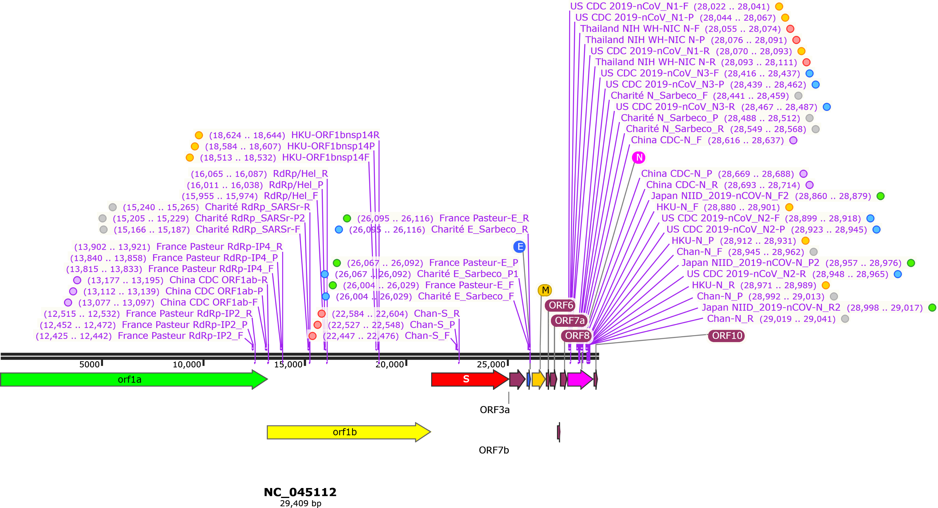

Supplementary datasets
Supplementary dataset S1. Statistics of numbers of point mutation sequences (among analyzed 2257 sequences) in the target binding region of primer/probe sets.

Supplementary dataset S2. Calculated mutation rate for each site within the target binding region of primers/probes (n=2257).

Two supplementary datasets are provided in separate excel spreadsheets (Supplementary Datasets.xlsx).

Other supplementary materials
- FASTA file for genome sequence alignment of SARS-CoV-2 (SARS-CoV-2 Align. fas).
- Acknowledgement table for downloaded genome sequences from GISAID EpiCoV database (gisaid_cov2020_acknowledgement_table.xls).
Other supplementary materials are provided as separated files.

Supplementary references
1. Jung, Y., et al., Comparative Analysis of Primer-Probe Sets for RT-qPCR of COVID-19 Causative Virus (SARS-CoV-2). ACS Infect Dis, 2020. 6(9): p. 2513-2523.
2. Gand, M., et al., Use of Whole Genome Sequencing Data for a First in Silico Specificity Evaluation of the RT-qPCR Assays Used for SARS-CoV-2 Detection. Int J Mol Sci, 2020. 21(15).
3. Prevention, N.I.f.V.D.C.a., Specific primers and probes for detection 2019 novel coronavirus. 2020.
4. WHO, WHO Coronavirus Disease (COVID-19) Technical Guidance: Laboratory Testing for 2019-nCoV in Humans. 2020.
5. Corman, V.M., et al., Detection of 2019 novel coronavirus (2019-nCoV) by real-time RT-PCR. Euro Surveill, 2020. 25: p. 2000045.
6. Chu, D.K.W., et al., Molecular Diagnosis of a Novel Coronavirus (2019-nCoV) Causing an Outbreak of Pneumonia. Clin Chem, 2020. 66(4): p. 549-555.
7. Chan, J.F., et al., Improved Molecular Diagnosis of COVID-19 by the Novel, Highly Sensitive and Specific COVID-19-RdRp/Hel Real-Time Reverse Transcription-PCR Assay Validated In Vitro and with Clinical Specimens. J Clin Microbiol, 2020. 58(5).
8. Naganori, N., et al., Detection of second case of 2019-nCoV infection in Japan. 2020.
9. Sciences, D.o.M. and M.o.P. Health, Diagnostic detection of Novel coronavirus 2019 by Real time RTPCR. 2020.
10. CDC, U., 2019-Novel Coronavirus (2019-nCoV) Real-time rRT-PCR Panel: Primers and Probes. 2020.

