Supplementary Information

Levosimendan prevents tau pathology by inhibiting disulfide-linked tau oligomerization posing as a promising anti-tau therapeutics

Figure S1. Dose-dependent inhibition of tau-BiFC response activated by FK
Figure S2. Dose-dependent inhibition of tau-BiFC response activated by tauK18^{P301L}
Figure S3. Levosimendan inhibits tau phosphorylation at Ser396 in tau-BiFC cells
Figure S4. Anti-tau aggregation effect of levosimendan treated at various time point after
tau aggregation
Figure S5. Disulfide-linked tau oligomers in wild type and Tau^{P301L} transgenic mice

Data S1. Characterization of ¹⁴C-Levosimendan
Data S2. ESI-MS analysis of tau peptides
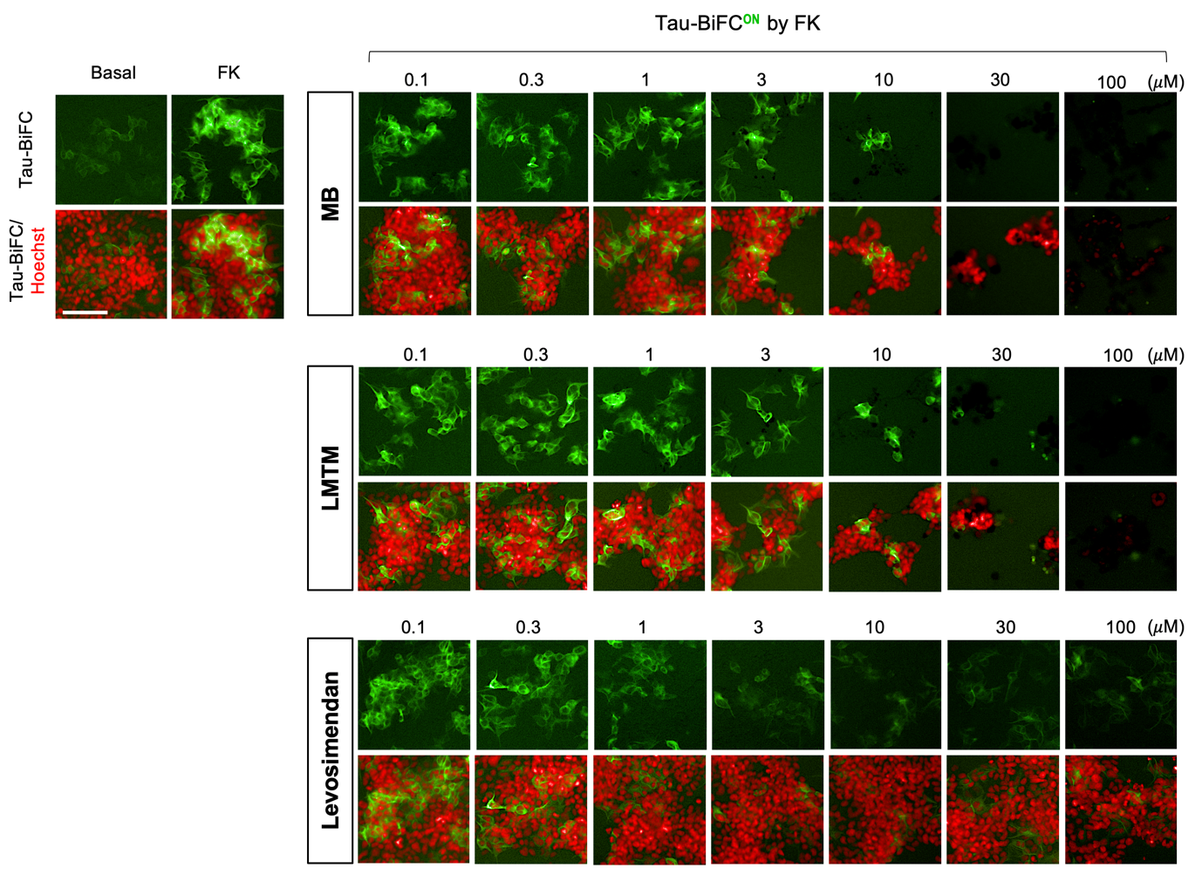

Fig. S1 Dose-dependent inhibition of tau-BiFC response activated by FK.
Tau-BiFC cells were incubated with MB, LMTM or levosimendan at various concentrations (0.1, 0.3, 1, 3, 10, 30, 100 μM) upon the activation with forskolin (30 μΜ) for 46 hrs. Nuclei were counterstained with Hoechst (red). Scale bar, 100 μm.
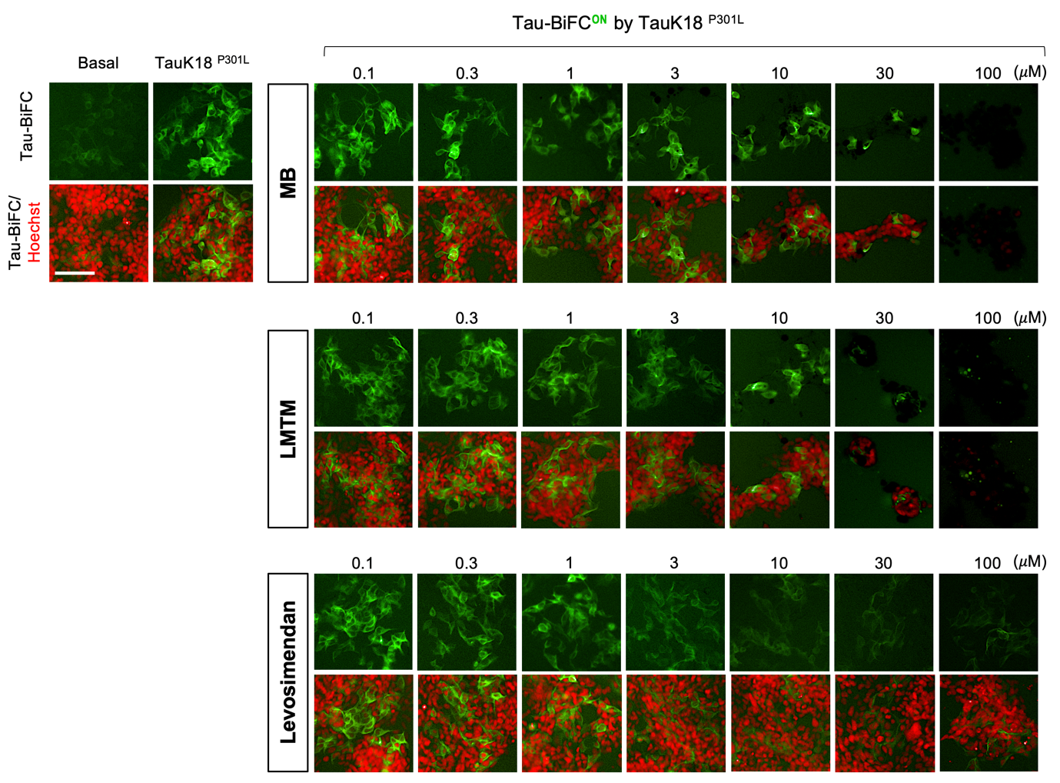

Fig. S2 Dose-dependent inhibition of tau-BiFC response activated by tauK18^{P301L}.
Tau-BiFC cells were incubated with MB, LMTM or levosimendan at various concentrations (0.1, 0.3, 1, 3, 10, 30, 100 μM) upon the activation with tauK18^{P301L} (5 μg/mL) for 46 hrs. Nuclei were counterstained with Hoechst (red). Scale bar, 100 μm.
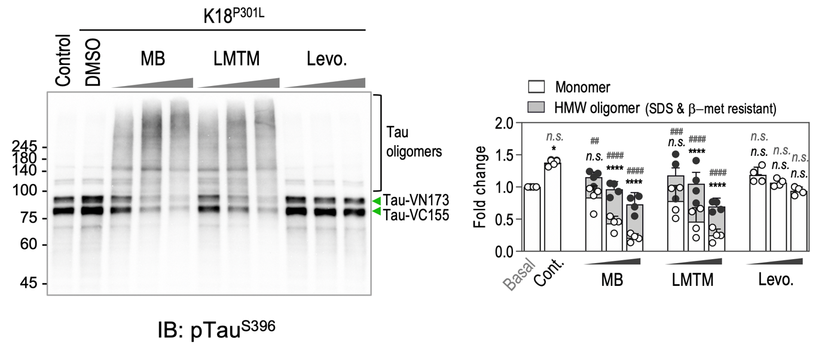

Fig. S3 Levosimendan inhibits tau phosphorylation at Ser396 in tau-BiFC cells.
Immunoblot analysis of phospho-tau. For the immunoblot analysis, tau-BiFC cells were treated with MB, LMTM (0.5, 1.5, 5 µM), or levosimendan (5, 15, 45 µM) in the presence of tauK18^{P301L}. Green arrows indicate monomer bands of hTau-VN173 and hTau-VC155. Bands above 100 kDa indicates tau oligomers. Relative amounts of monomeric tau (white bars) and oligomeric tau (grey bars) were quantified by Image J. Two-way ANOVA with Dunnett’s multiple-comparisons test was performed; ****p < 0.0001, compared with the level of monomer in basal. ##p < 0.01, ###p < 0.001, ####p < 0.0001, compared with the level of oligomers in basal. n.s., non-significant.
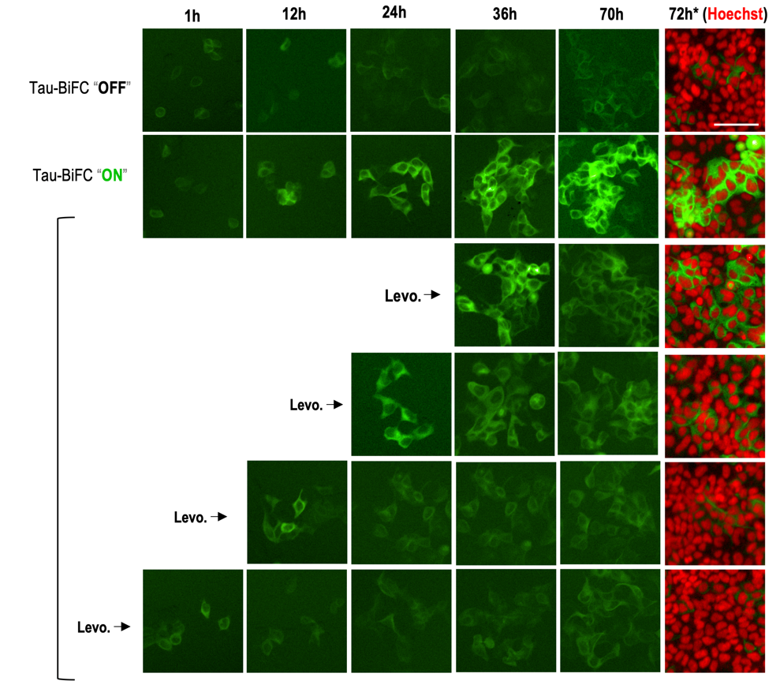

Fig. S4 Anti-tau aggregation effect of levosimendan treated at various time points after tau aggregation.
Tau-BiFC cells were treated with levosimendan at 1, 12, 24, and 36 hours after tauK18^{P301L} activation. After 72hrs, nuclei were counterstained with Hoechst (red). Scale bar, 100 μm.

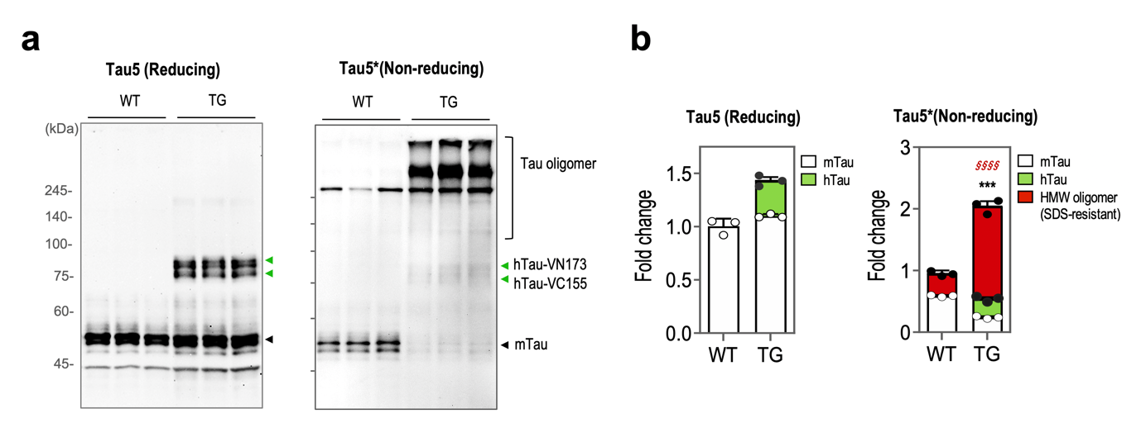

Fig. S5 Disulfide-linked tau oligomers in wild type and Tau^{P301L} transgenic mice.
a Tau-immunoblot analysis of WT- and TG- brain lysates. RIPA-soluble fractions of wild type and Tau^{P301L}-BiFC mice (14-month-old) were separated under reducing and non-reducing conditions. Green arrows indicate hTau-VN173 and hTau-VC155. Black arrows indicate endogenous murine tau (mTau). b Quantification of total tau protein (n=3 per group). Relative amounts of hTau (green bars), mTau (white bars) monomers, and oligomers (red bars) were quantified by Image J. A two-tailed t-test was performed; ***p < 0.001, compared with mTau monomer of wild type; §§§§p < 0.0001, compared with HMW oligomer of wild type mice.

Data file S1. Characterization of ¹⁴C-Levosimendan
a ¹H NMR spectrum of Levosimendan.
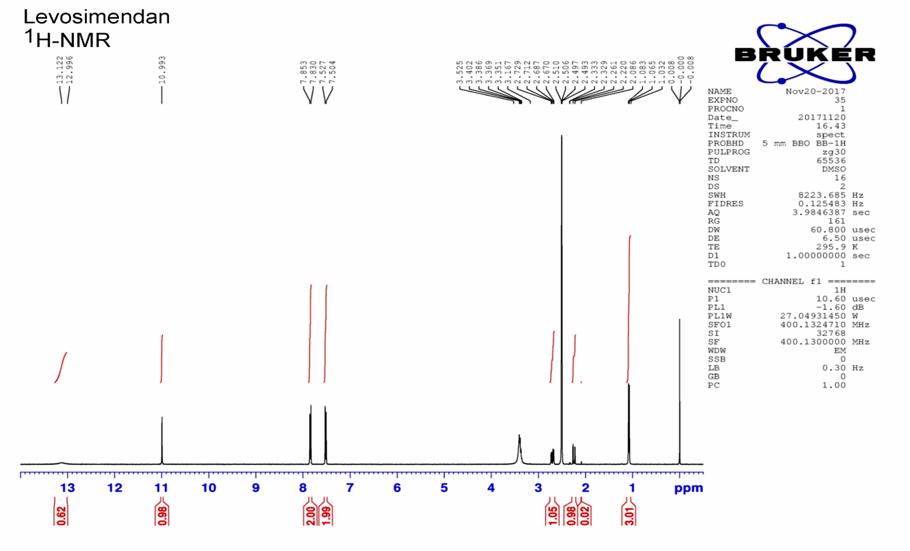
b ¹H NMR spectrum of ¹⁴C-Levosimendan.
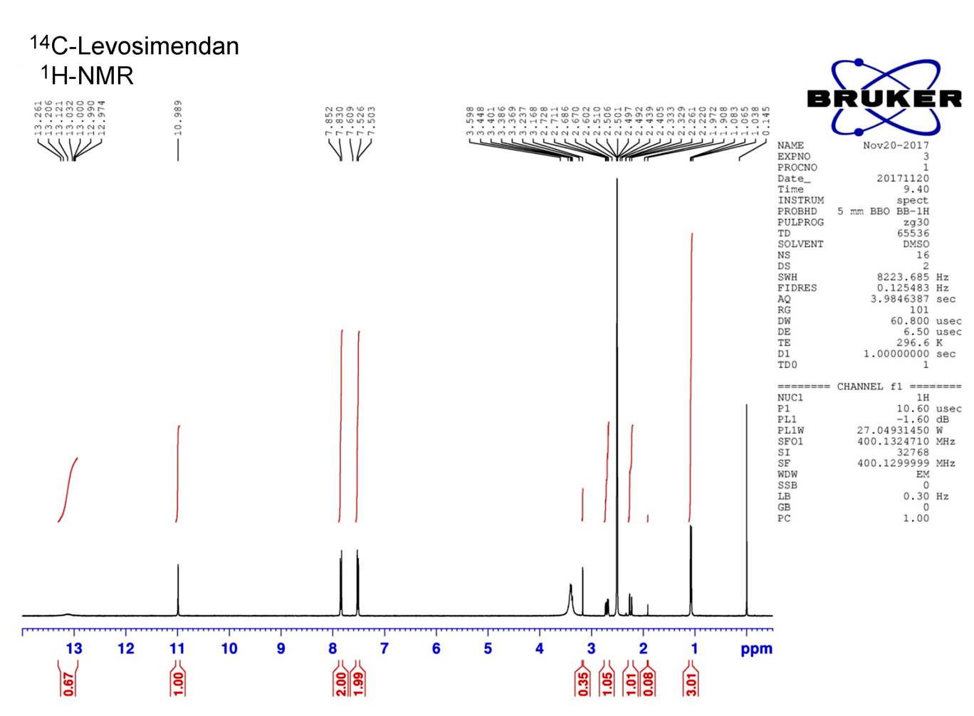
c LC/MS characterization of ¹⁴C-Levosimendan

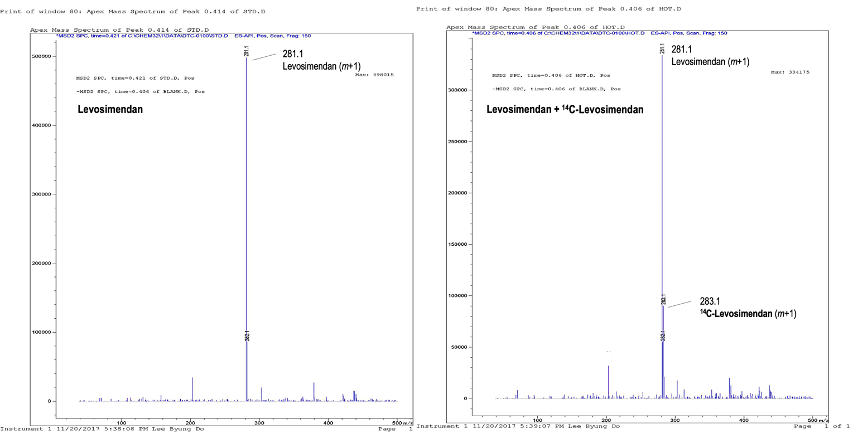

Data file S2. ESI-MS analysis of tau peptides
a ESI-MS analysis of tau repeat 1 domain (Tau R1).
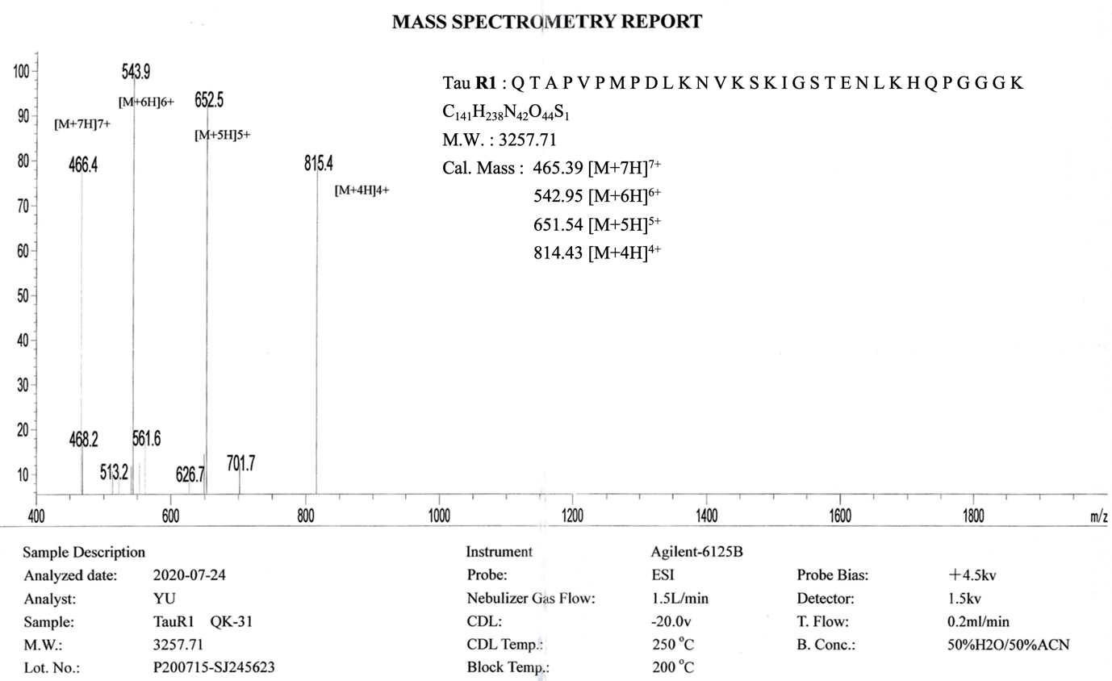

b ESI-MS analysis of tau repeat 2 domain (Tau R2).
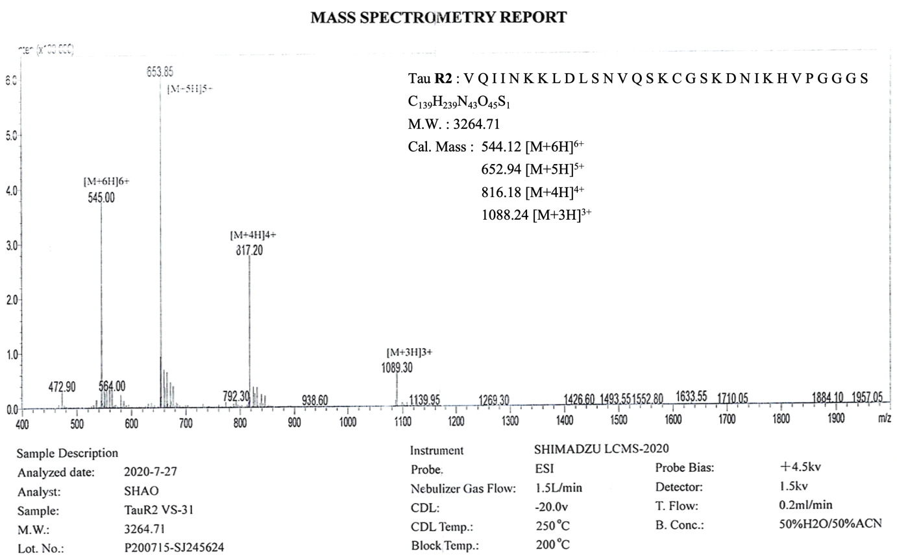

c ESI-MS analysis of tau repeat 3 domain (Tau R3).
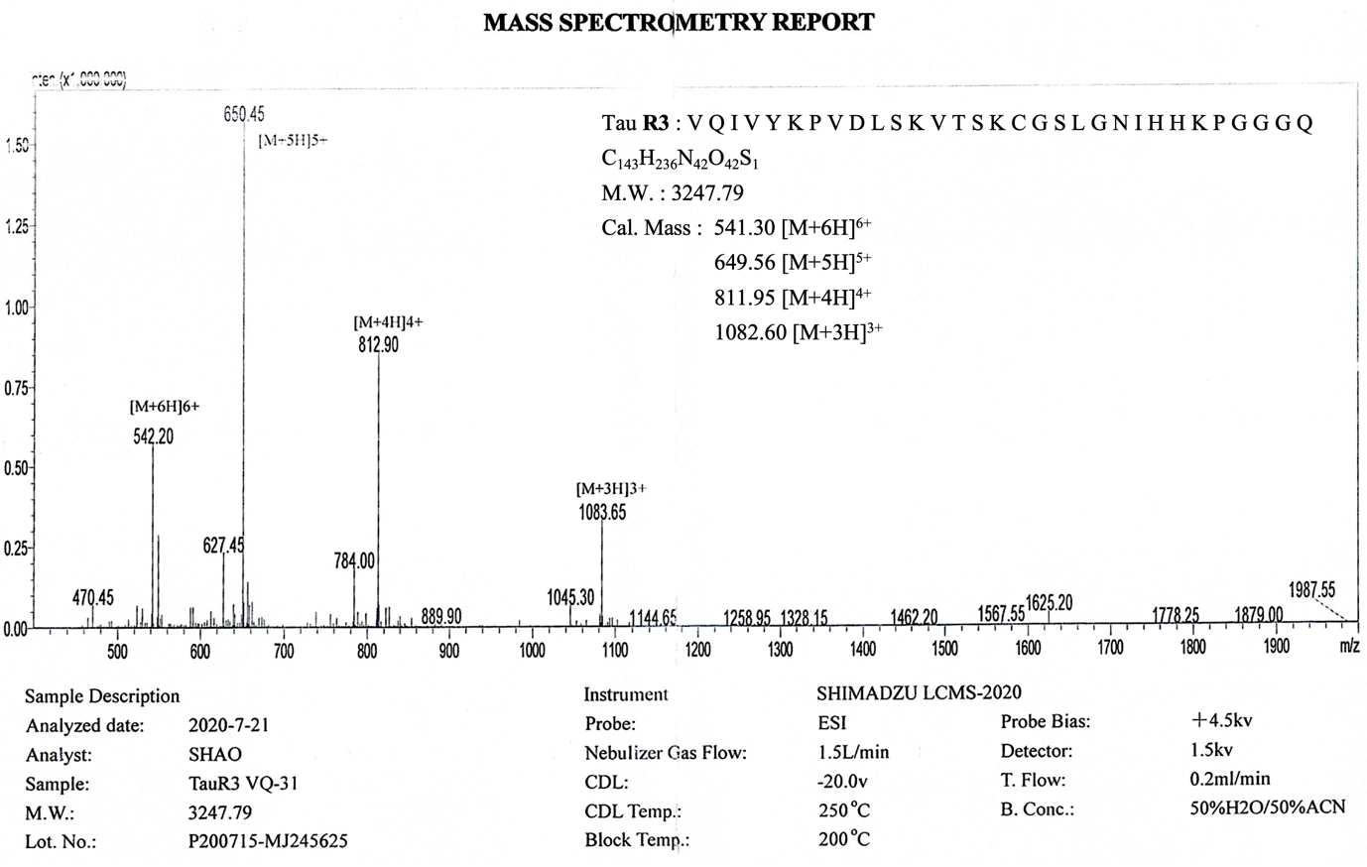

d ESI-MS analysis of tau repeat 4 domain (Tau R4).
