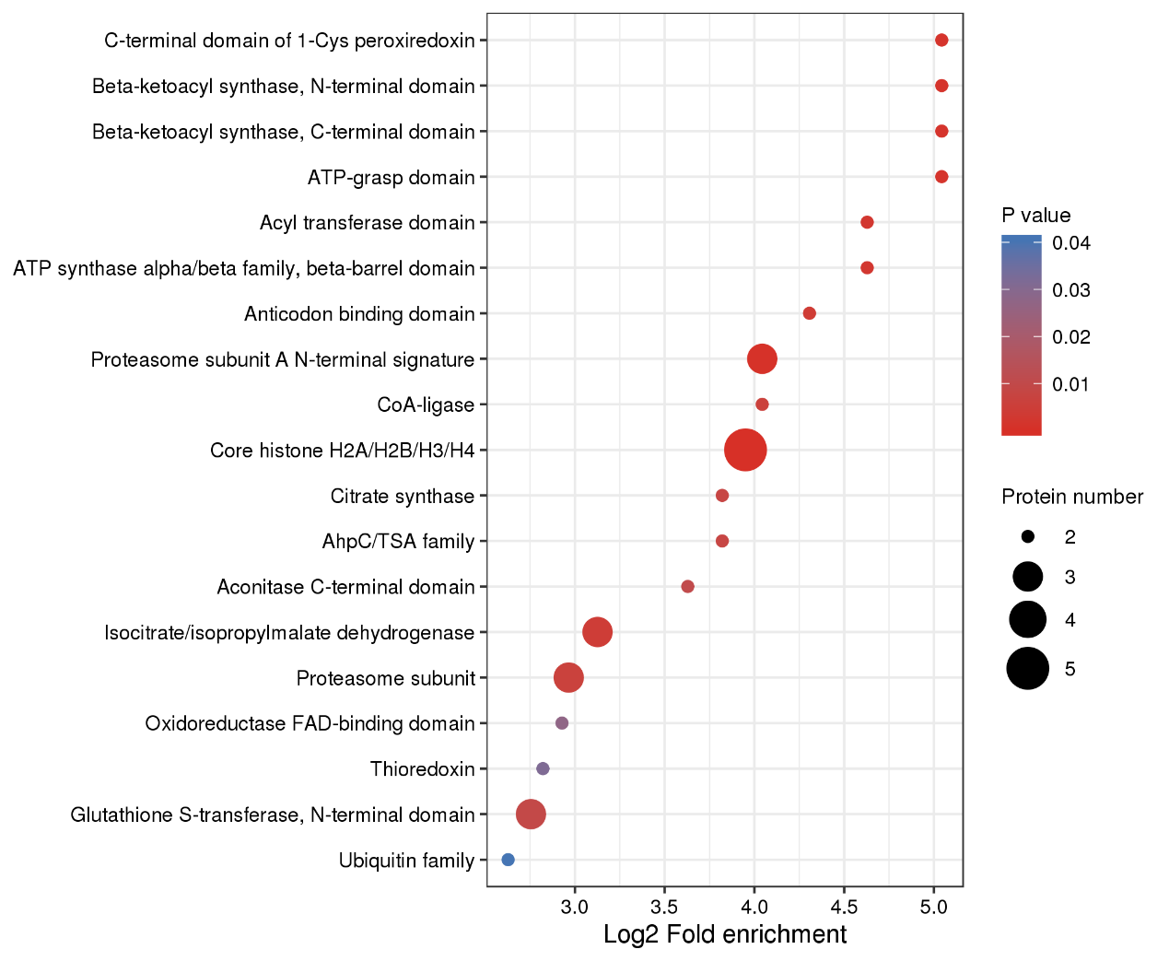
Figure S3. Domain enrichment analysis of the malonylproteins in S. sanghuang

