Supplementary Data
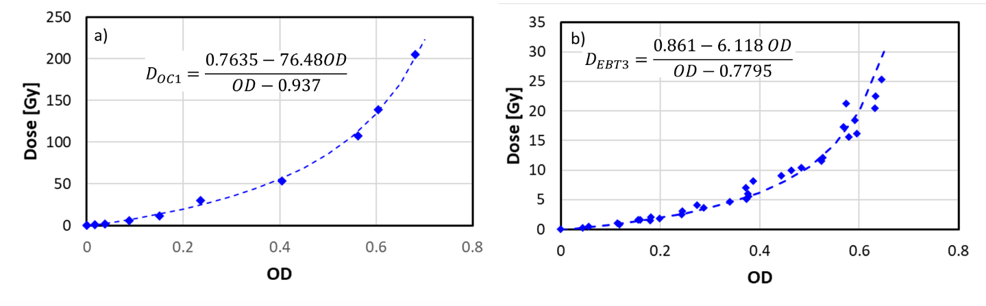
Figure S1: Calibration curves for the a) OC1 and b)EBT3 films.
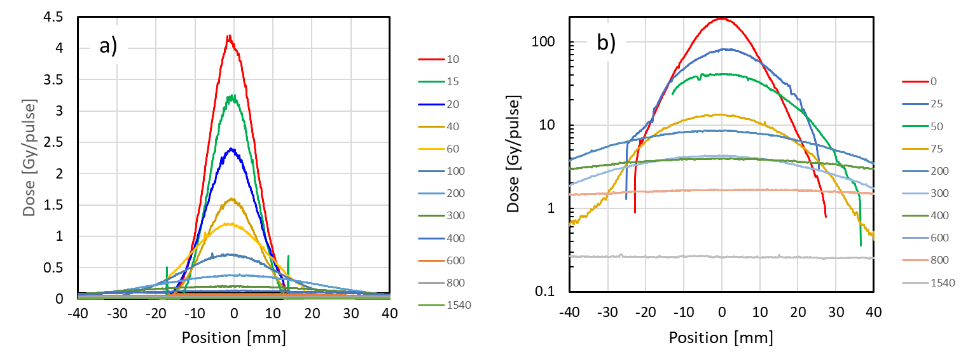
Figure S2: dose distribution at different heights for a) 9 meV beam and b) 6 MeV beam.

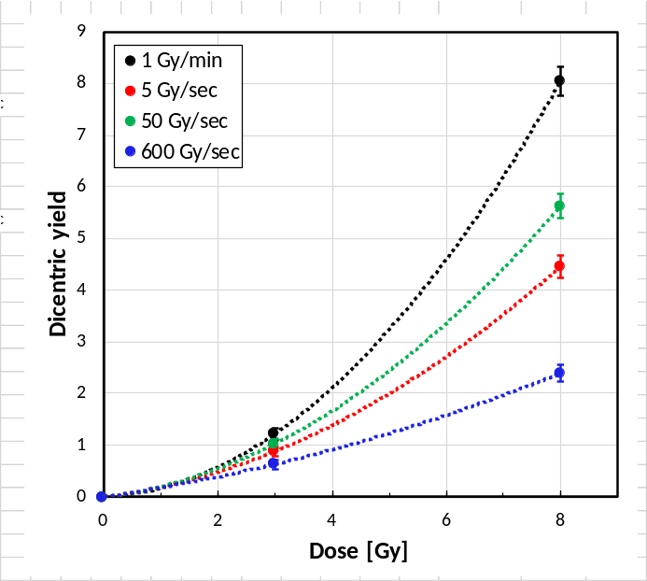
Figure S3: Dose-response curves for different dose rates (plotted using supplementary table 1).

Table S1. Yields and Intercellular Distribution of Dicentrics for Different Dose-Rates
Dose (Gy) | Dose rate | Cells |  | Distribution of dicentrics |  |  |  |  |  |  |  |  |  |  |  |  |  |  | Y ± SE | σ²/y | u test
Dose (Gy) | Dose rate | Cells | DC | D0 | D1 | D2 | D3 | D4 | D5 | D6 | D7 | D8 | D9 | D10 | D11 | D12 | D13 | D14 | Y ± SE | σ²/y | u test
0 |  | 100 | 0 | 100 | 0 | 0 | 0 | 0 | 0 | 0 | 0 | 0 | 0 | 0 | 0 | 0 | 0 | 0 | 0.00 ± 0.00
3.0 | 1 Gy/min | 100 | 122ª | 27 | 41 | 18 | 11 | 3 | 0 | 0 | 0 | 0 | 0 | 0 | 0 | 0 | 0 | 0 | 1.22 ± 0.11 | 0.92 | -0.57
3.0 | 5 Gy/sec | 100 | 88 | 32 | 51 | 15 | 1 | 1 | 0 | 0 | 0 | 0 | 0 | 0 | 0 | 0 | 0 | 0 | 0.88 ± 0.09 | 0.67 | -2.33
3.0 | 50 Gy/sec | 100 | 103 | 46 | 23 | 16 | 12 | 3 | 0 | 0 | 0 | 0 | 0 | 0 | 0 | 0 | 0 | 0 | 1.03 ± 0.10 | 1.34 | 2.4
3.0 | 600 Gy/sec | 100 | 63 | 58 | 25 | 13 | 4 | 0 | 0 | 0 | 0 | 0 | 0 | 0 | 0 | 0 | 0 | 0 | 0.63 ± 0.08 | 1.18 | 1.28
3.0 | 3 x 10⁵ Gy/sec | 100 | 78 | 47 | 34 | 14 | 4 | 1 | 0 | 0 | 0 | 0 | 0 | 0 | 0 | 0 | 0 | 0 | 0.78 ± 0.09 | 1.05 | 0.35
8.0 | 1 Gy/min | 100 | 805^{b} | 0 | 0 | 0 | 2 | 11 | 10 | 8 | 12 | 12 | 11 | 16 | 5 | 8 | 3 | 2 | 8.05 ± 0.28 | 0.95 | -0.35
8.0 | 5 Gy/sec | 100 | 446^{c} | 0 | 0 | 11 | 22 | 22 | 21 | 11 | 7 | 4 | 2 | 0 | 0 | 0 | 0 | 0 | 4.46 ± 0.21 | 0.65 | -2.46
8.0 | 50 Gy/sec | 100 | 562^{d} | 0 | 0 | 5 | 12 | 16 | 17 | 18 | 15 | 8 | 4 | 2 | 2 | 1 | 0 | 0 | 5.62 ± 0.24 | 0.82 | -1.27
8.0 | 600 Gy/sec | 100 | 239e | 3 | 30 | 27 | 17 | 16 | 4 | 2 | 0 | 1 | 0 | 0 | 0 | 0 | 0 | 0 | 2.39 ± 0.16 | 0.90 | -0.71
Notes:
DC: dicentric chromosomes; Y ± SE: yield ± standard error, calculated using Dose Estimate software[21]; σ²/y: dispersion index (σ: variance, y: mean); u: normalized unit of the dispersion index
Recorded multicentric aberrations before conversion to dicentrics:
ª 1 tricentric
^{b} 83 tricentrics, 10 tetracentrics, 2 pentacentrics
^{c} 30 tricentrics, 2 tetracentrics
^{d} 31 tricentrics, 7 tetracentrics, 1 pentacentric, 1 heptacentric
^{e} 7 tricentrics

