Aphid-ant relationships: the role of cuticular hydrocarbons and different chemical stimuli
Amged El-Harairy,*^{a,b} Csaba Borbély, ^{b} Júlia Katalin Jósvai,^{c} Ahmed El-Harairy,*^{d,e} and Viktor Markó ^{b}
- Unit of Entomology- Plant Protection Department- Desert Research Center, 1 Mathaf El-Matariya St., El-Matariya, Cairo 11753, Egypt.
- Department of Entomology- Faculty of Horticultural Science- Hungarian University of Agriculture and Life Sciences (volt SZIE), 1118 Budapest, Ménesi út 44., Hungary.
- Department of Applied Chemical Ecology, Plant Protection Institute, Centre for Agricultural Research, Hungarian Academy of Sciences, 1029 Budapest, Herman Ottó út 15, Hungary.
- Environmental, Energy and Green Chemistry Laboratory, Faculty of Agriculture, Damietta University, 34511, Damietta, Egypt.
- Department of Chemical and Biomolecular Engineering, University of Nebraska−Lincoln, 12, Lincoln, Nebraska, 68588-8286, USA.
.
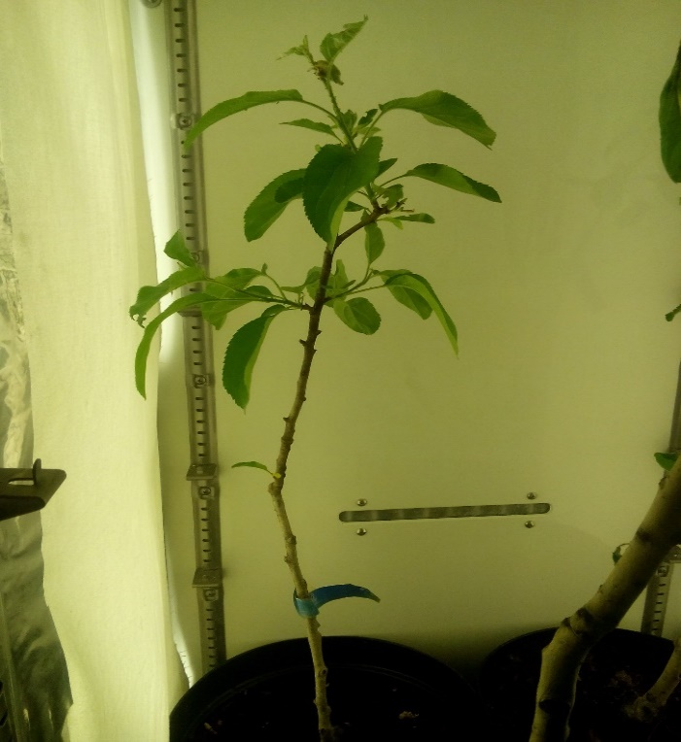
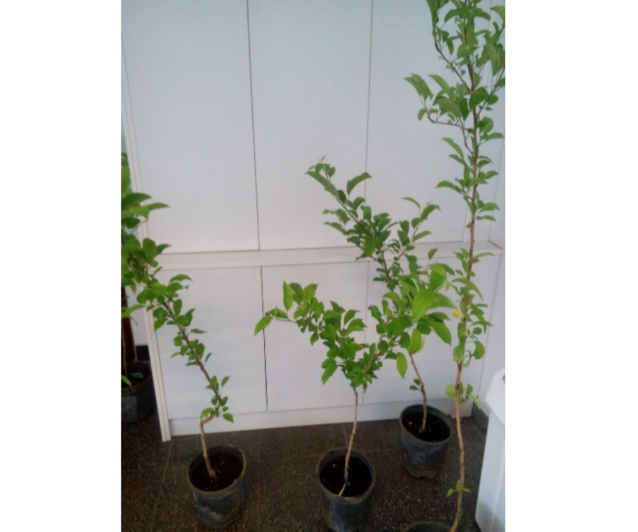
Plant Material

Study Organisms

Detection of the chemical composition of the cuticular extract of the aphid species by GC-MS

Figure 1: Apple trees (El-Harairy, 2018)
Table 1: List of the samples in the order of injection.
Number of samples | Samples | Concentration
1 | hexane 1 | 1 µL
2 | calibration 1 | 500ppb
3 | calibration2 | 1ppm
4 | calibration3 | 4ppm_a
5 | calibration 3 | 4ppm_b
6 | calibration 3 | 4ppm_c
7 | calibration 4 | 10ppm
8 | calibration 5 | 20ppm
9 | calibration 6 | 50ppm
10 | calibration 7 | 100ppm
11 | hexane2 | 1 µL
12 | hexane3 | 1 µL
13 | Ap1_2 (Aphis pomi 1-2 nymphs) | 25 aphid individuals were extracted with 200 µL hexane.
14 | Ap3_4 (Aphis pomi 3-4 nymphs) | 25 aphid individuals were extracted with 200 µL hexane.
15 | hexane4
16 | Apwad (Aphis pomi-winged adult) | 25 aphid individuals were extracted with 200 µL hexane.
17 | Apskin (Aphis pomi-skin) | 25 aphid individuals were extracted with 200 µL hexane.
18 | hexane5 | 1 µL to wash the machine
19 | calibration 3 | 4ppm QC
20 | Apada (Aphis pomi-adult 1st replicate) | 25 aphid individuals were extracted with 200 µL hexane.
21 | Apadb (Aphis pomi-adult 2nd replicate) | 25 aphid individuals were extracted with 200 µL hexane.
22 | Apadc (Aphis pomi-adult 3rd replicate) | 25 aphid individuals were extracted with 200 µL hexane.
23 | hexane6 | 1 µL to wash the machine
24 | ddad (Dysaphis devecta-adult) | 25 aphid individuals were extracted with 200 µL hexane.
25 | dpad (Dysaphis plantaginea-adult) | 25 aphid individuals were extracted with 200 µL hexane.
26 | asad (Aphis spiraecola-adult) | 25 aphid individuals were extracted with 200 µL hexane.
27 | hexane7 | 1 µL to wash the machine
28 | hexane8 | 1 µL to wash the machine

The sequence of the measurements is listed in Table 1. We used 4 n-alcane standards (nC25; nC27, nC29 and nC31) according to literature review (Hayashi, Nakamuta, and Nomura 2015; Lang and Menzel 2011; Sakata, Hayashi, and Nakamuta 2017) in an n-hexane solution mixture to calibrate the GC-MS and as a base of the comparison of the detectable peaks. From the 4 ppm calibration mixture and from Aphis pomi adult extracts we made three injections to appreciate the standard error of the device.
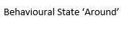
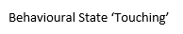
Behavioural tests
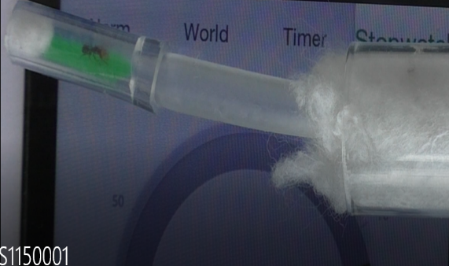
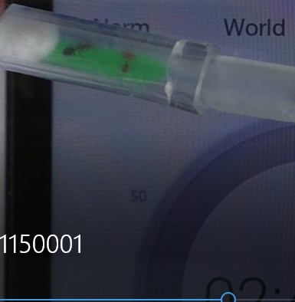
Fig. 3 Behavioural state ‘Around’ (Ant is in the arena and not touching the chemical stimuli)
Fig. 2 Behavioural state ‘Touching’ (Ant is in the arena and touching the stimuli chemical)

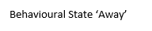
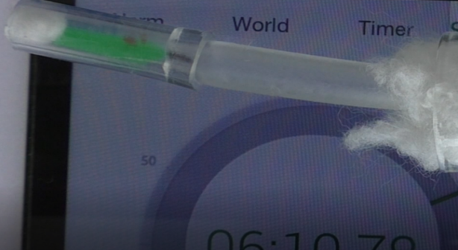

Fig. 4 Behavioural state ‘Away’ (Ant is not in the arena)

References:
Hayashi, Masayuki, Kiyoshi Nakamuta, and Masashi Nomura. 2015. “Ants Learn Aphid Species as Mutualistic Partners: Is the Learning Behavior Species-Specific?” Journal of chemical ecology 41(12): 1148–54.
Lang, Corsin, and Florian Menzel. 2011. “Lasius Niger Ants Discriminate Aphids Based on Their Cuticular Hydrocarbons.” Animal behaviour 82(6): 1245–54.
Sakata, Itaru, Masayuki Hayashi, and Kiyoshi Nakamuta. 2017. “Tetramorium Tsushimae Ants Use Methyl Branched Hydrocarbons of Aphids for Partner Recognition.” Journal of chemical ecology 43(10): 966–70.

