Terrestrial nutrient exports and environmental changes explain eutrophication trends in fifty large lakes of Yangtze Plain, China
Qi Guan ^{a, b}, Jing Tang ^{c, d}, Lian Feng ^{a,} *, Stefan Olin ^{c}, Guy Schurgers ^{b}
ª School of Environmental Science and Engineering, Southern University of Science and Technology, Shenzhen 518055, Guangdong, China.
^{b} Department of Geosciences and Natural Resource Management, University of Copenhagen, Copenhagen, Denmark.
^{c} Department of Physical Geography and Ecosystem Science, Lund University, Lund, Sweden.
^{d} Department of Biology, University of Copenhagen, Copenhagen, Denmark.
* corresponding author: fengl@sustech.edu.cn

Section S1:
Annual land cover fractions of urban, cropland, pasture and natural area were derived from the 37 land cover types in the Climate Change Initiative Land Cover (CCI-LC version 2.0) data set (Defourny et al. 2012) with a spatial resolution of 300m. For a given 0.1° grid cell, we determined all original land cover class pixels within this grid cell, which were then grouped into urban, cropland, pasture and natural area. Finally, annual land cover fractions of these four land cover types were calculated as input datasets for LPJ-GUESS.

Section S3:
The crop cultivation maps in Yangtze Plain were interpolated from station-based observations by using an adaptive inverse distance weighting method (AIDW) (Lu and Wong 2008). In this study, we assumed that the two nearest fields stations for a given grid cell provide critical information about crop types and corresponding planting fractions for gridded crop cultivation maps. The crop planting fractions were related to inverse-distance weights modified by optimal decay parameters, which were derived adaptively based on spatial distributions of field stations across Yangtze Plain. For a given point, the spatial pattern coefficient (R), representing spatial distributions, was determined as the ratio between the actual (r_{obs}) and expected (r_{exp}) nearest neighbor distance. The numbers of field stations (n) and the total area of Yangtze Plain (A) were used to calculate the expected nearest neighbor distance (r_{exp}) according to the following formula (Lu and Wong 2008).
r_{exp} = 1/(2(n/A)^{0.5}) (S.1)
Similarly, the nearest neighbor distance (r_{obs}) was also calculated based on the two nearest field stations. To assign the optimal decay parameters, the spatial pattern (R) was required to be normalized by using min-max normalization.
(S.2)
The optimal decay parameters () were then converted from normalized spatial pattern () based on Fig. 3 in (Lu and Wong 2008). Finally, the exponential function with the optimal decay parameters was used to derive inverse-distance weights as crop planting fractions, thus producing gridded crop types and planting fraction maps for Yangtze Plain (Fig. S4).

Table S1. Basic information (names and crop rotations) and relevant parameters (CFTs, hydrology, specific leaf area (SLA, unit: m²/kg C), empirical parameter expressing relationship between leaf N and maximum Rubisco capacity, p and harvest efficiency) of eleven studied crop types in agricultural ecosystems of Yangtze Plain, where three types of hydrological managements were used here, including irrigation till saturation (irrigated_sat), inundation (inundated) and rain-fed (rainfed).
CFTs | Crop names | Rotations | Hydrology | SLA | p | Harvest efficiency
TeCoWWi | summer maize, winter wheat | Yes | irrigated_sat | 45, 35 | 25, 25 | 0.9, 0.9
TeSoWWi | soybean, winter wheat | Yes | irrigated_sat | 35, 35 | 25, 25 | 0.9, 0.9
TrELRi | early-, late-season rice | Yes | inundated | 55, 70 | 4, 3 | 1.0, 1.0
TrSRi | single-season rice | No | inundated | 45 | 4 | 1.0
TrPe | peanut | No | irrigated_sat | 45 | 25 | 0.9
TeSWi | spring wheat | No | irrigated_sat | 35 | 25 | 0.9
TeSc | sugar cane | No | rainfed | 45 | 25 | 0.9
TeWWi | winter wheat | No | irrigated_sat | 35 | 25 | 0.9
TeRa | rapeseed | No | irrigated_sat | 35 | 25 | 0.9
TeCoSp | spring maize | No | irrigated_sat | 45 | 25 | 0.9
TeSo | soybean | No | irrigated_sat | 35 | 25 | 0.9

Table S2. Basic information (ID, names, locations, lake areas and catchment areas) and the mean PEO derived from satellite observation in fifty large lakes of Yangtze Plain.
ID | Name | Lon | Lat | Lake area (km²) | Catchment area (km²) | PEO (%)
L01 | Beimin | 111.87 | 29.71 | 14.25 | 919.08 | 88.52
L02 | Xihu | 111.94 | 29.36 | 40.00 | 2711.25 | 91.07
L03 | Shanpo | 112.03 | 29.43 | 18.83 | 2017.21 | 89.12
L04 | Changhu | 112.4 | 30.44 | 114.03 | 5771.52 | 87.01
L05 | Datong | 112.51 | 29.21 | 83.10 | 3638.43 | 75.43
L06 | Donghu (CD) | 112.64 | 29.37 | 24.85 | 232.47 | 89.48
L07 | Dongting | 113.12 | 29.34 | 2614.36 | 270662.3 | 69.73
L08 | Honghu | 113.34 | 29.86 | 340.05 | 4200.21 | 89.84
L09 | Longsai | 113.51 | 30.84 | 9.34 | 1443.24 | 87.64
L10 | Huanggai | 113.55 | 29.7 | 59.47 | 2510.91 | 94.81
L11 | Wuhu (XT) | 113.8 | 30.18 | 32.93 | 440.37 | 86.50
L12 | Yezhu | 114.07 | 30.86 | 25.88 | 1747.26 | 92.03
L13 | Xiliang | 114.08 | 29.95 | 28.58 | 918.27 | 90.53
L14 | Luhu | 114.2 | 30.22 | 47.33 | 790.83 | 83.38
L15 | Futou | 114.23 | 30.02 | 141.22 | 1494.63 | 87.58
L16 | Houhu | 114.28 | 30.74 | 12.61 | 876.63 | 85.61
L17 | Tangxun | 114.36 | 30.42 | 44.83 | 578.97 | 90.25
L18 | Donghu (WH) | 114.4 | 30.56 | 34.35 | 208.17 | 89.94
L19 | Wuhu (WH) | 114.49 | 30.81 | 27.5 | 3051.45 | 89.20
L20 | Liangzi | 114.51 | 30.23 | 351.77 | 3152.7 | 79.88
L21 | Baoxie | 114.58 | 30.38 | 17.75 | 2407.77 | 94.65
L22 | Zhangdu | 114.7 | 30.65 | 36.24 | 2413.44 | 91.88
L23 | Baoan | 114.71 | 30.25 | 38.71 | 512.01 | 84.87
L24 | Wusi | 114.71 | 30.45 | 12.00 | 599.04 | 91.71
L25 | Yaer | 114.72 | 30.46 | 12.64 | 3152.7 | 86.94
L26 | Sanshan | 114.77 | 30.31 | 17.83 | 662.4 | 89.96
L27 | Daye | 115.1 | 30.1 | 73.65 | 1247.31 | 89.09
L28 | Wanghu | 115.33 | 29.87 | 42.87 | 1258.11 | 81.86
L29 | Wushan | 115.59 | 29.91 | 15.11 | 1520.19 | 95.98
L30 | Chihu | 115.69 | 29.78 | 35.9 | 2069.23 | 91.44
L31 | Taibai | 115.81 | 29.97 | 27.42 | 1460.19 | 93.47
L32 | Saihu | 115.85 | 29.69 | 53.33 | 2523.69 | 87.68
L33 | Xiayao | 116.06 | 28.69 | 16.1 | 190.8 | 94.85
L34 | Longgan | 116.15 | 29.95 | 280.48 | 3233.07 | 83.85
L35 | Poyang | 116.67 | 29.14 | 3206.98 | 170502 | 78.12
L36 | Wuchang | 116.69 | 30.28 | 112.02 | 874.53 | 91.45
L37 | Caizi | 117.07 | 30.8 | 171.59 | 4015.98 | 90.26
L38 | Shengjin | 117.07 | 30.38 | 96.09 | 1639.98 | 92.76
L39 | Baidang | 117.38 | 30.81 | 38.69 | 1099.35 | 85.54
L40 | Chaohu | 117.53 | 31.57 | 786.01 | 12951.81 | 83.06
L41 | Shijiu | 118.88 | 31.47 | 178.04 | 1089 | 91.04
L42 | Gucheng | 118.92 | 31.28 | 27.9 | 1383.39 | 86.15
L43 | Nanyi | 118.96 | 31.11 | 197.83 | 4004.82 | 89.33
L44 | Changdang | 119.55 | 31.62 | 84.33 | 678.06 | 94.83
L45 | Xijiu | 119.8 | 31.37 | 11.18 | 567.45 | 93.36
L46 | Gehu | 119.81 | 31.6 | 139.56 | 1729.89 | 95.87
L47 | Taihu | 120.19 | 31.2 | 2537.17 | 18769.77 | 73.37
L48 | Yangcheng | 120.77 | 31.43 | 123.6 | 1556.1 | 83.95
L49 | Chenghu | 120.82 | 31.21 | 37.11 | 215.01 | 83.32
L50 | Dianshan | 120.96 | 31.12 | 63.71 | 2634.12 | 79.23

Table S3. N-P ratios of animal manure contained in global N manure products (Azeez and Van Averbeke 2010; Parham et al. 2003; Sheppard 2019).
 | Cattle | Pig | Goat and sheep | Chicken and duck
N-P ratio | 3.3:1 | 4.3:1 | 5.19:1 | 2.53:1

Table S4. Five terrestrial nutrient-relevant variables and two environmental variables used to explain PEO dynamics in studied lakes of Yangtze Plain.
Variables | Abbreviation | Data sources
Leached N from cropland | CLN | Simulation by LPJ-GUESS
Leached N from natural land | NLN | Simulation by LPJ-GUESS
Anthropogenic P exports | AP | Derived global P export products
N-P ratios of total N and P exports | NP | Global N and P export products
Industrial wastewater | IW | Statistical yearbook
Temperature | T | CMFD datasets
Total runoff | TR | Simulation by LPJ-GUESS

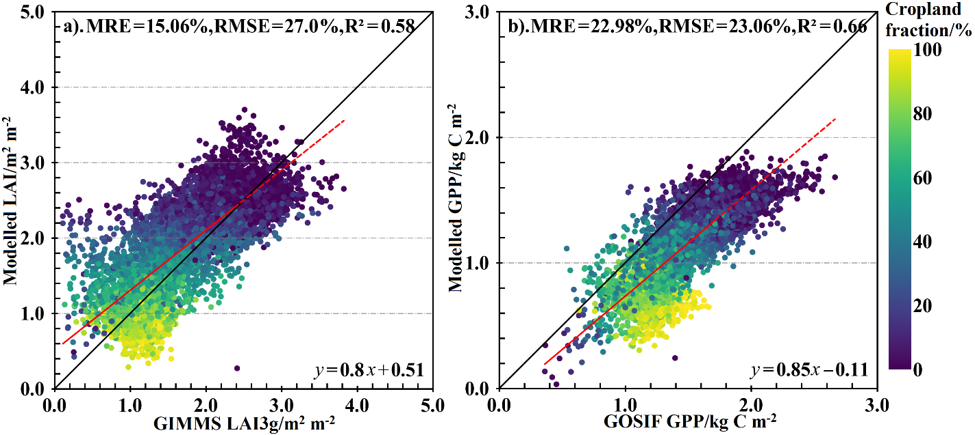
Figure S1. Comparison of the simulated LAI with GIMMS LAI3g from 1982 to 2011 (a) and modeled GPP against GOSIF GPP from 1992 to 2018 (b), respectively. The red dashed lines are the fitting lines for the modeled with satellite-derived values.

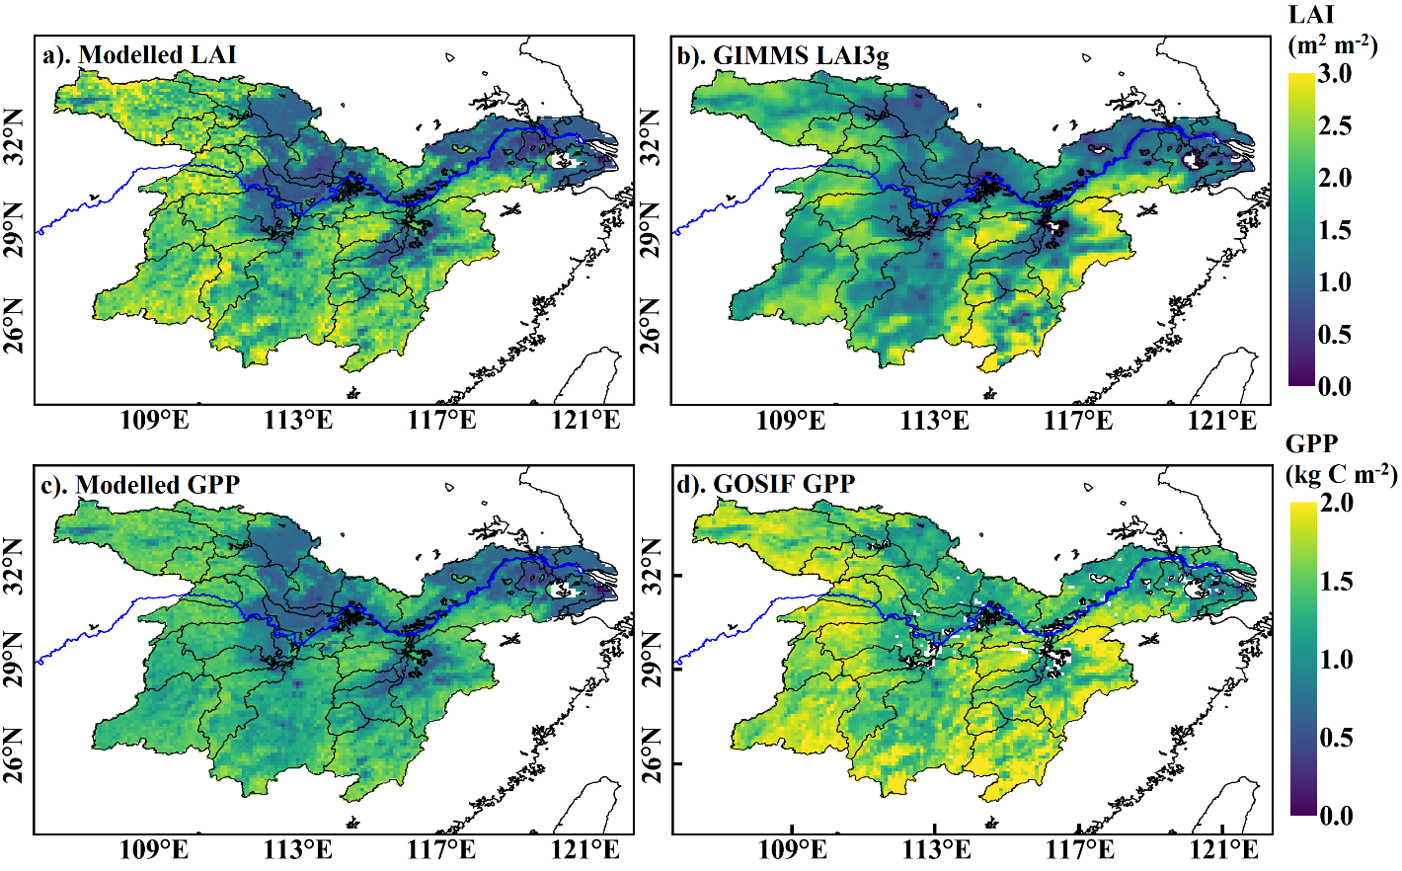
Figure S2. Comparison of spatial distributions for annual mean simulated LAI (a) v.s. LAI3g (b) for 1982-2011, and of simulated GPP (c) vs. GOSIF GPP (d) for 1992-2018.

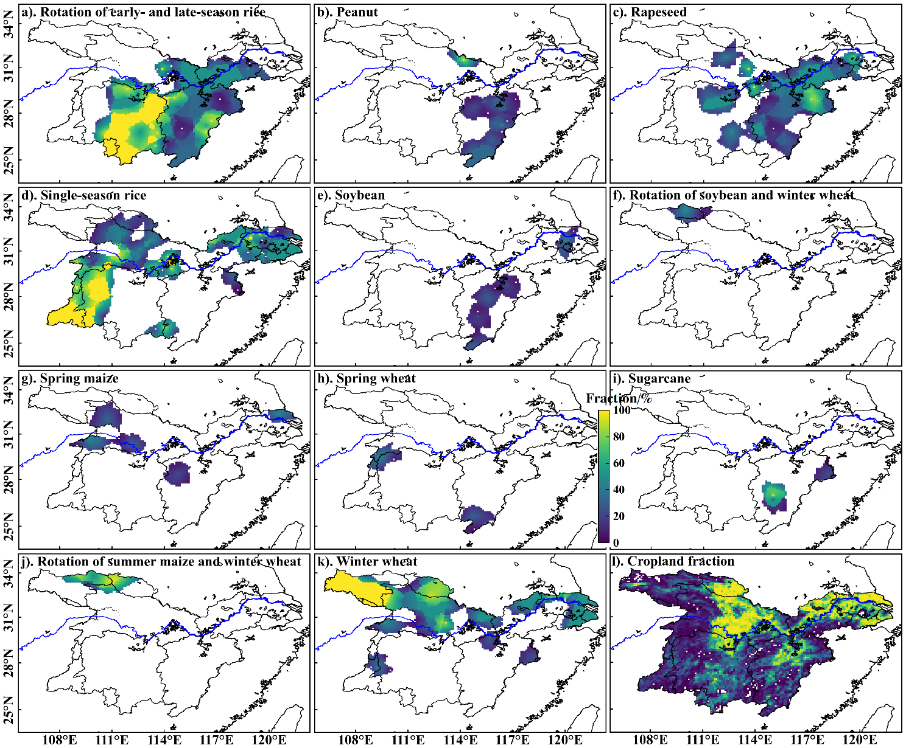
Figure S3. Spatial distributions of all studied cropland fraction for the crop types and crop rotations applied in the LPJ-GUESS simulation in Yangtze Plain.

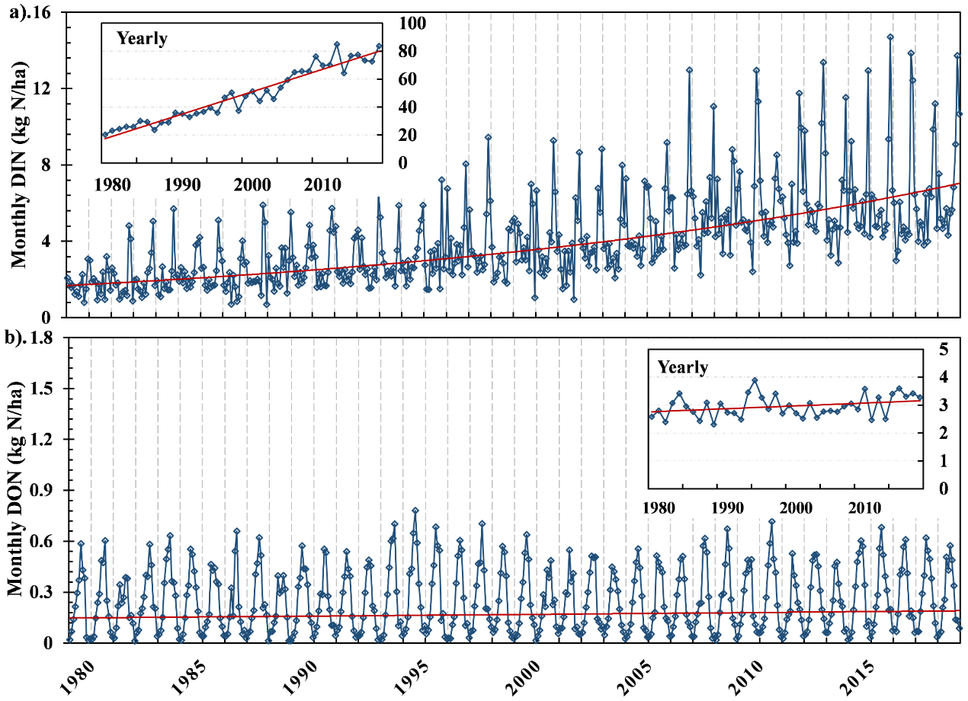
Figure S4. Monthly total dissolved inorganic nitrogen (DIN) (a) and dissolved organic nitrogen (DON) (b) for the whole Yangtze Plain from 1979 to 2018. Annual total DIN and DON were also calculated from monthly DIN and DON.

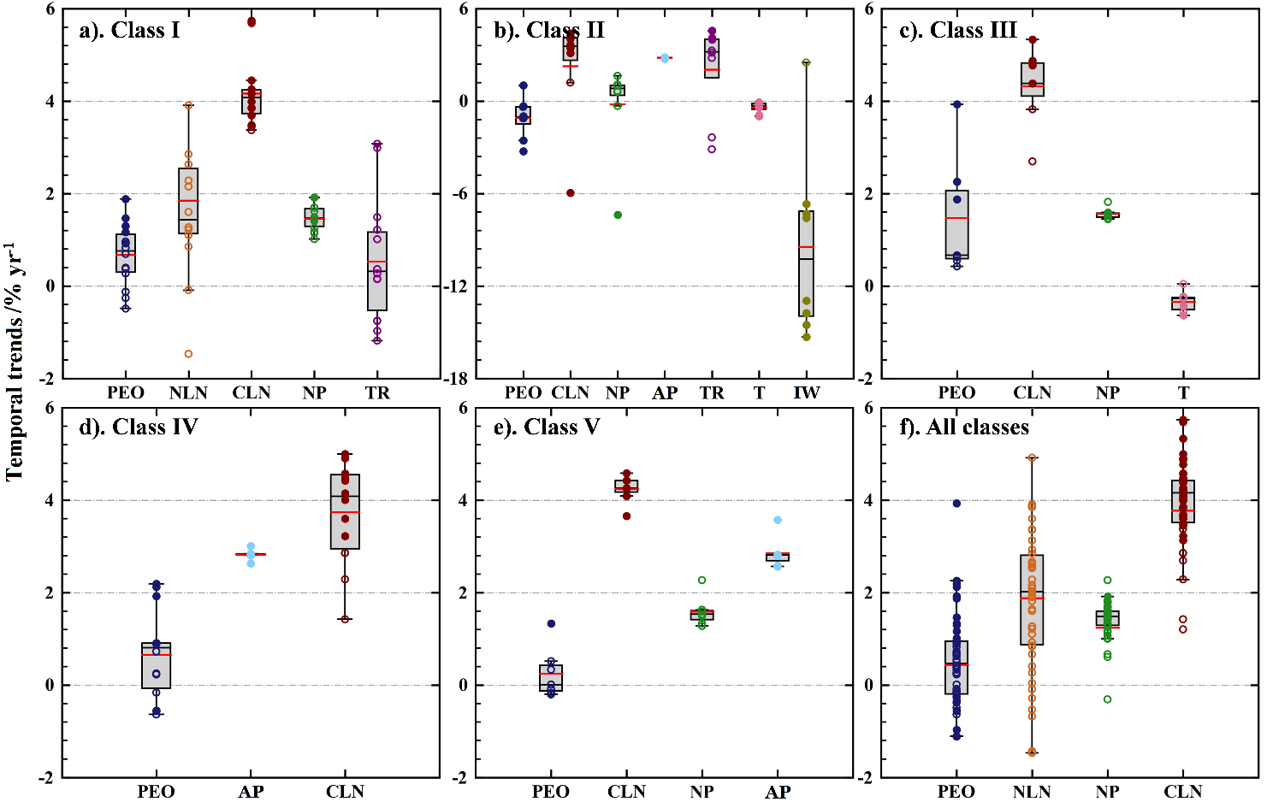
Figure S5. Relative change rate of PEO and explanatory variables significantly correlated with PEO in each lake class, where colored circles represent relative change rate of each studied lakes, with statistically significant trends as filled circles and non-significant trends as hollow circles. Red and black solid lines are the mean and median values of relative change rate, respectively. The bottom and top of the boxes represent first and third quartile, and error bars are the 95% confidence intervals.

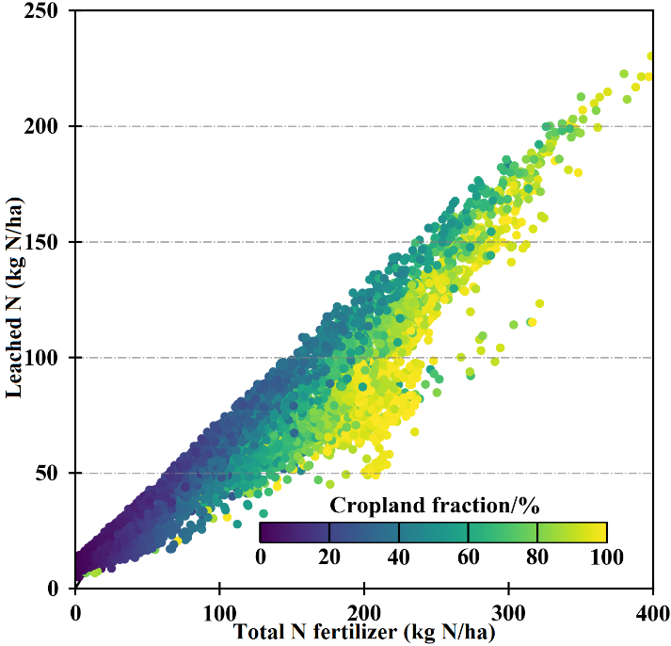
Figure S6. The relationship of total N chemical fertilizer against leached N from 1979 to 2018 over the entire Yangtze Plain.

References
Azeez, J.O., & Van Averbeke, W. (2010). Nitrogen mineralization potential of three animal manures applied on a sandy clay loam soil. Bioresour Technol, 101, 5645-5651
Defourny, P., Kirches, G., Brockmann, C., Boettcher, M., Peters, M., Bontemps, S., Lamarche, C., Schlerf, M., & Santoro, M.J.P.U.G.V. (2012). Land cover CCI, 2
Lu, G.Y., & Wong, D.W. (2008). An adaptive inverse-distance weighting spatial interpolation technique. Computers & Geosciences, 34, 1044-1055
Parham, J.A., Deng, S.P., Da, H.N., Sun, H.Y., & Raun, W.R. (2003). Long-term cattle manure application in soil. II. Effect on soil microbial populations and community structure. Biology and Fertility of Soils, 38, 209-215
Sheppard, S.C. (2019). Elemental Composition of Swine Manure from 1997 to 2017: Changes Relevant to Environmental Consequences. J Environ Qual, 48, 164-170

