Consolidated criteria for reporting qualitative studies (COREQ): 32-item checklist (Tong A., Sansbury P., Craig J. International Journal for Quality in Health Care v.19 n.6)
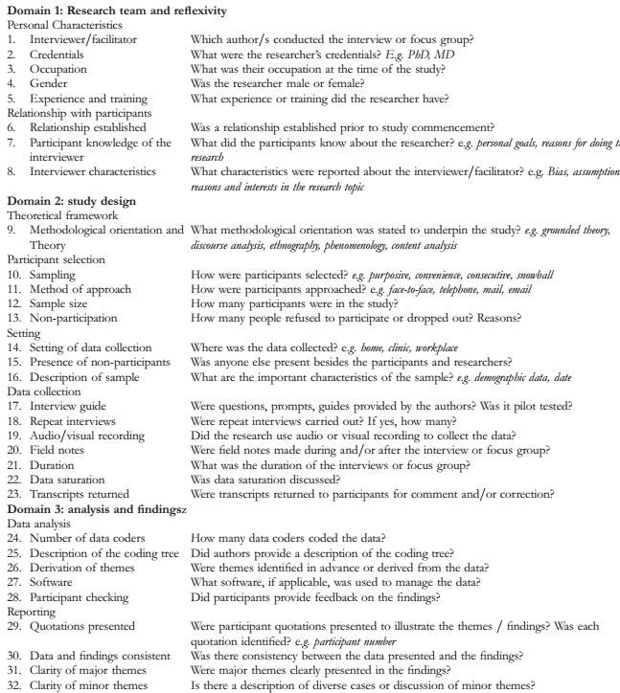
- Luize Fábrega Juskevicius
- PhD student, Nurse
- PhD student
- Female
- Specialist in infection control and teaching skills
- Yes
- They knew that the researcher was a PhD student and was there to observe the general routines of the ward
- Nothing was reported initially
- Content analysis
- Convenience
- They were approached in different ways throughout the study. In phase 1, non-participant observation was in person. Phase 3, workshop, was in person and in Phase 4, they were approached initially via email and later via telephone
- Phase 3: Nine Phase 4: Five
- Phase 4: 17 participants did not return the emails sent to schedule the interviews and did not justify the reasons
- In phase 1: at all locations in the ward. In phase 3: the workshops took place in the ward's nursing room. In phase 4: the interviews, which took place by telephone, were scheduled when the interviewees were at home
- No
- The workshops (phase 3) and interviews (phase 4) took place with ward nurses
- Both in Phase 3 and in Phase 4, a semi-structured script was used, based on the CFIR (consolidated framework for implementation science). Phase 4 interviews were tested in a pilot test conducted with fellow implementation research experts
- No
- Audio recording
- In phase 1, during data collection. In phases 3 and 4, the notes were made at the time of transcription
- In phase 1, the observations were carried out in steps of 2 hours, for 2 days. In phase 3, the workshops lasted 20 minutes each on average. In phase 4, the interviews lasted between 15 and 35 minutes
- It was discussed between the main researcher and the research supervisor
- In phase 1, the researcher completed the non-participant observation, with the intention of becoming familiar with the context due to the time limit. In phases 3 and 4, the saturation criterion was not discussed, as the research included all nurses in the wards in its data collection
- Two
- Coded categories are stored with the authors
- Derived from the data
- Not applicable
- Results will be presented to participants shortly
- Yes
- Yes
- Yes
- Yes

