Supporting Information.
Hydroxyapatite adsorbed at the surface of the byssus fibers of Pinna nobilis
Lorena C. Giannossa^{1,2}, Annarosa Mangone^{1,2}, Giovanni Lagioia³, Gerardo Palazzo^{1,4} and Luigi Gentile^{1,2,4*}
¹ University of Bari Aldo Moro, Department of Chemistry, Bari, 70126, Italy
² University of Bari Aldo Moro, Interdepartmental Centre “Research Laboratory for Diagnostics of Cultural Heritage”, Bari, 70126, Italy
³ University of Bari Aldo Moro, Department of Economics, Management and Business Law, Bari, 70126, Italy
⁴ Center for colloid and surface science (CSGI), Bari unit, Sesto Fiorentino, 50019, Italy
*luigi.gentile@uniba.it

Crystallinity determination from WAXS

There are several procedures to calculate the crystallinity index by wide-angle X-ray scattering (WAXS) mainly developed for polysaccharide-based fibers ^{1,2}. The WAXS Gaussian peak fitting without a linear background was selected for this purpose because it leads to more reasonable values of the crystallinity index. Consequently a line-interpolation background subtraction was adopted. To evaluate the change of byssus crystallinity during the stages of crafting the crystallinity index was calculated using eq. 1.

$$C_{i}=1-\frac{\int_{{2θ}_{1}}^{{2θ}_{2}}{I_{am}d2θ}}{\int_{{2θ}_{1}}^{{2θ}_{2}}{I_{TOT}d2θ}}=1-\frac{A_{am}}{A_{TOT}} (eq.1)$$

where I_{am} is the intensity of the fitted amorphous halo and I_{tot} is the total scattering intensity of the sample, including both amorphous and crystalline contributions including includes a larger scattering angle region between ${2θ}_{1}$= 5.6° and ${2θ}_{2}$ = 30.7°. Figure S1 reports the background subtraction and the Guassian peak fitting for the raw byssus at the first stage of crafting (sample 1). The wider and more intense peak is the amorphous peak located at 1.39 Å⁻¹.
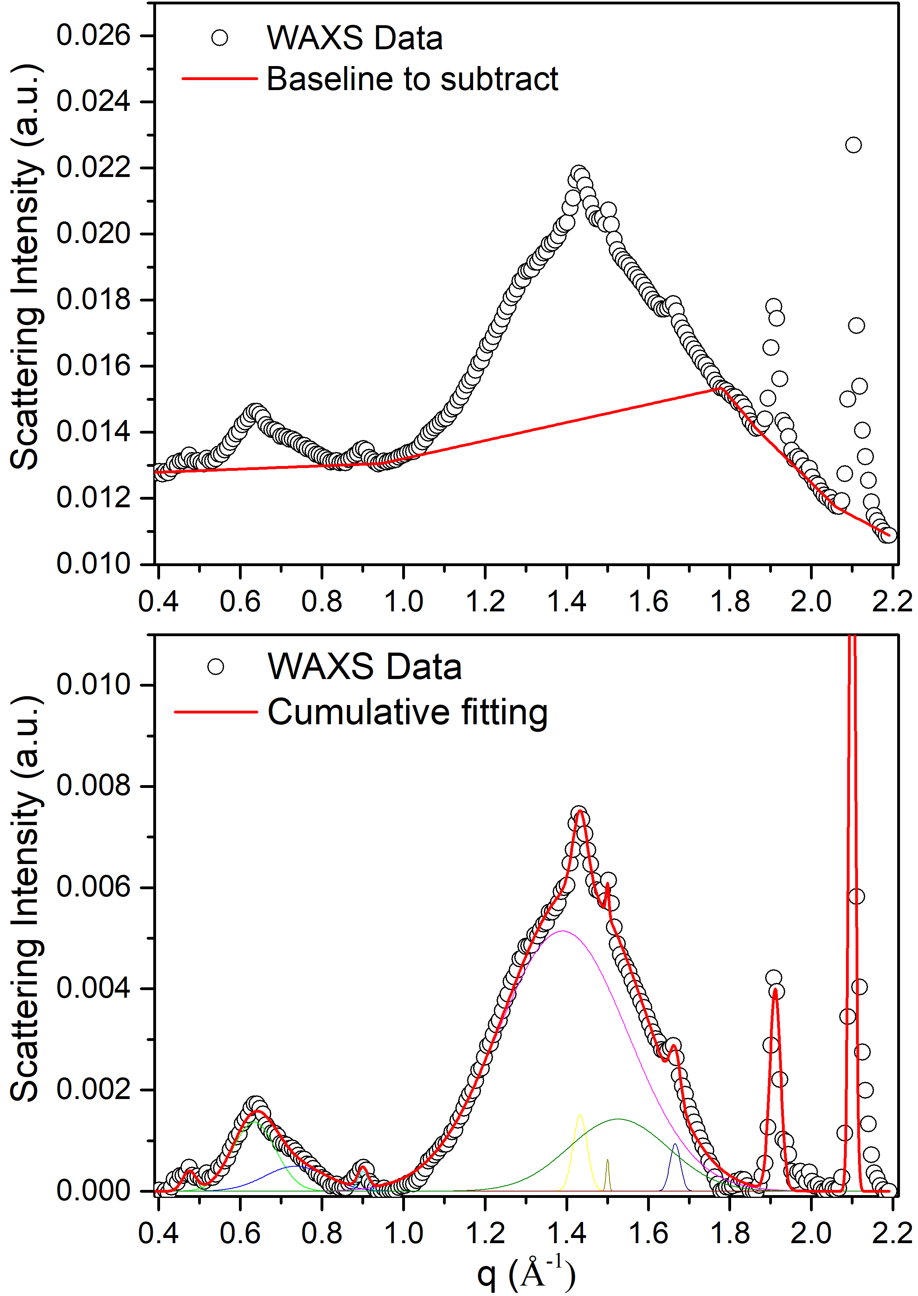
Figure S1. Background subtraction and Gaussian peak fitting of the 1D profiles obtained upon 0-to-360° (Azimuthal averaged) for the raw byssus (sample 1).

The Gaussian fitting of the byssus treated after a lemon bath (sample 9) is reported in Figure S2 in which the amorphous halo is located at 1.37 Å-1. In this case, the background subtraction is simple linear subtraction.

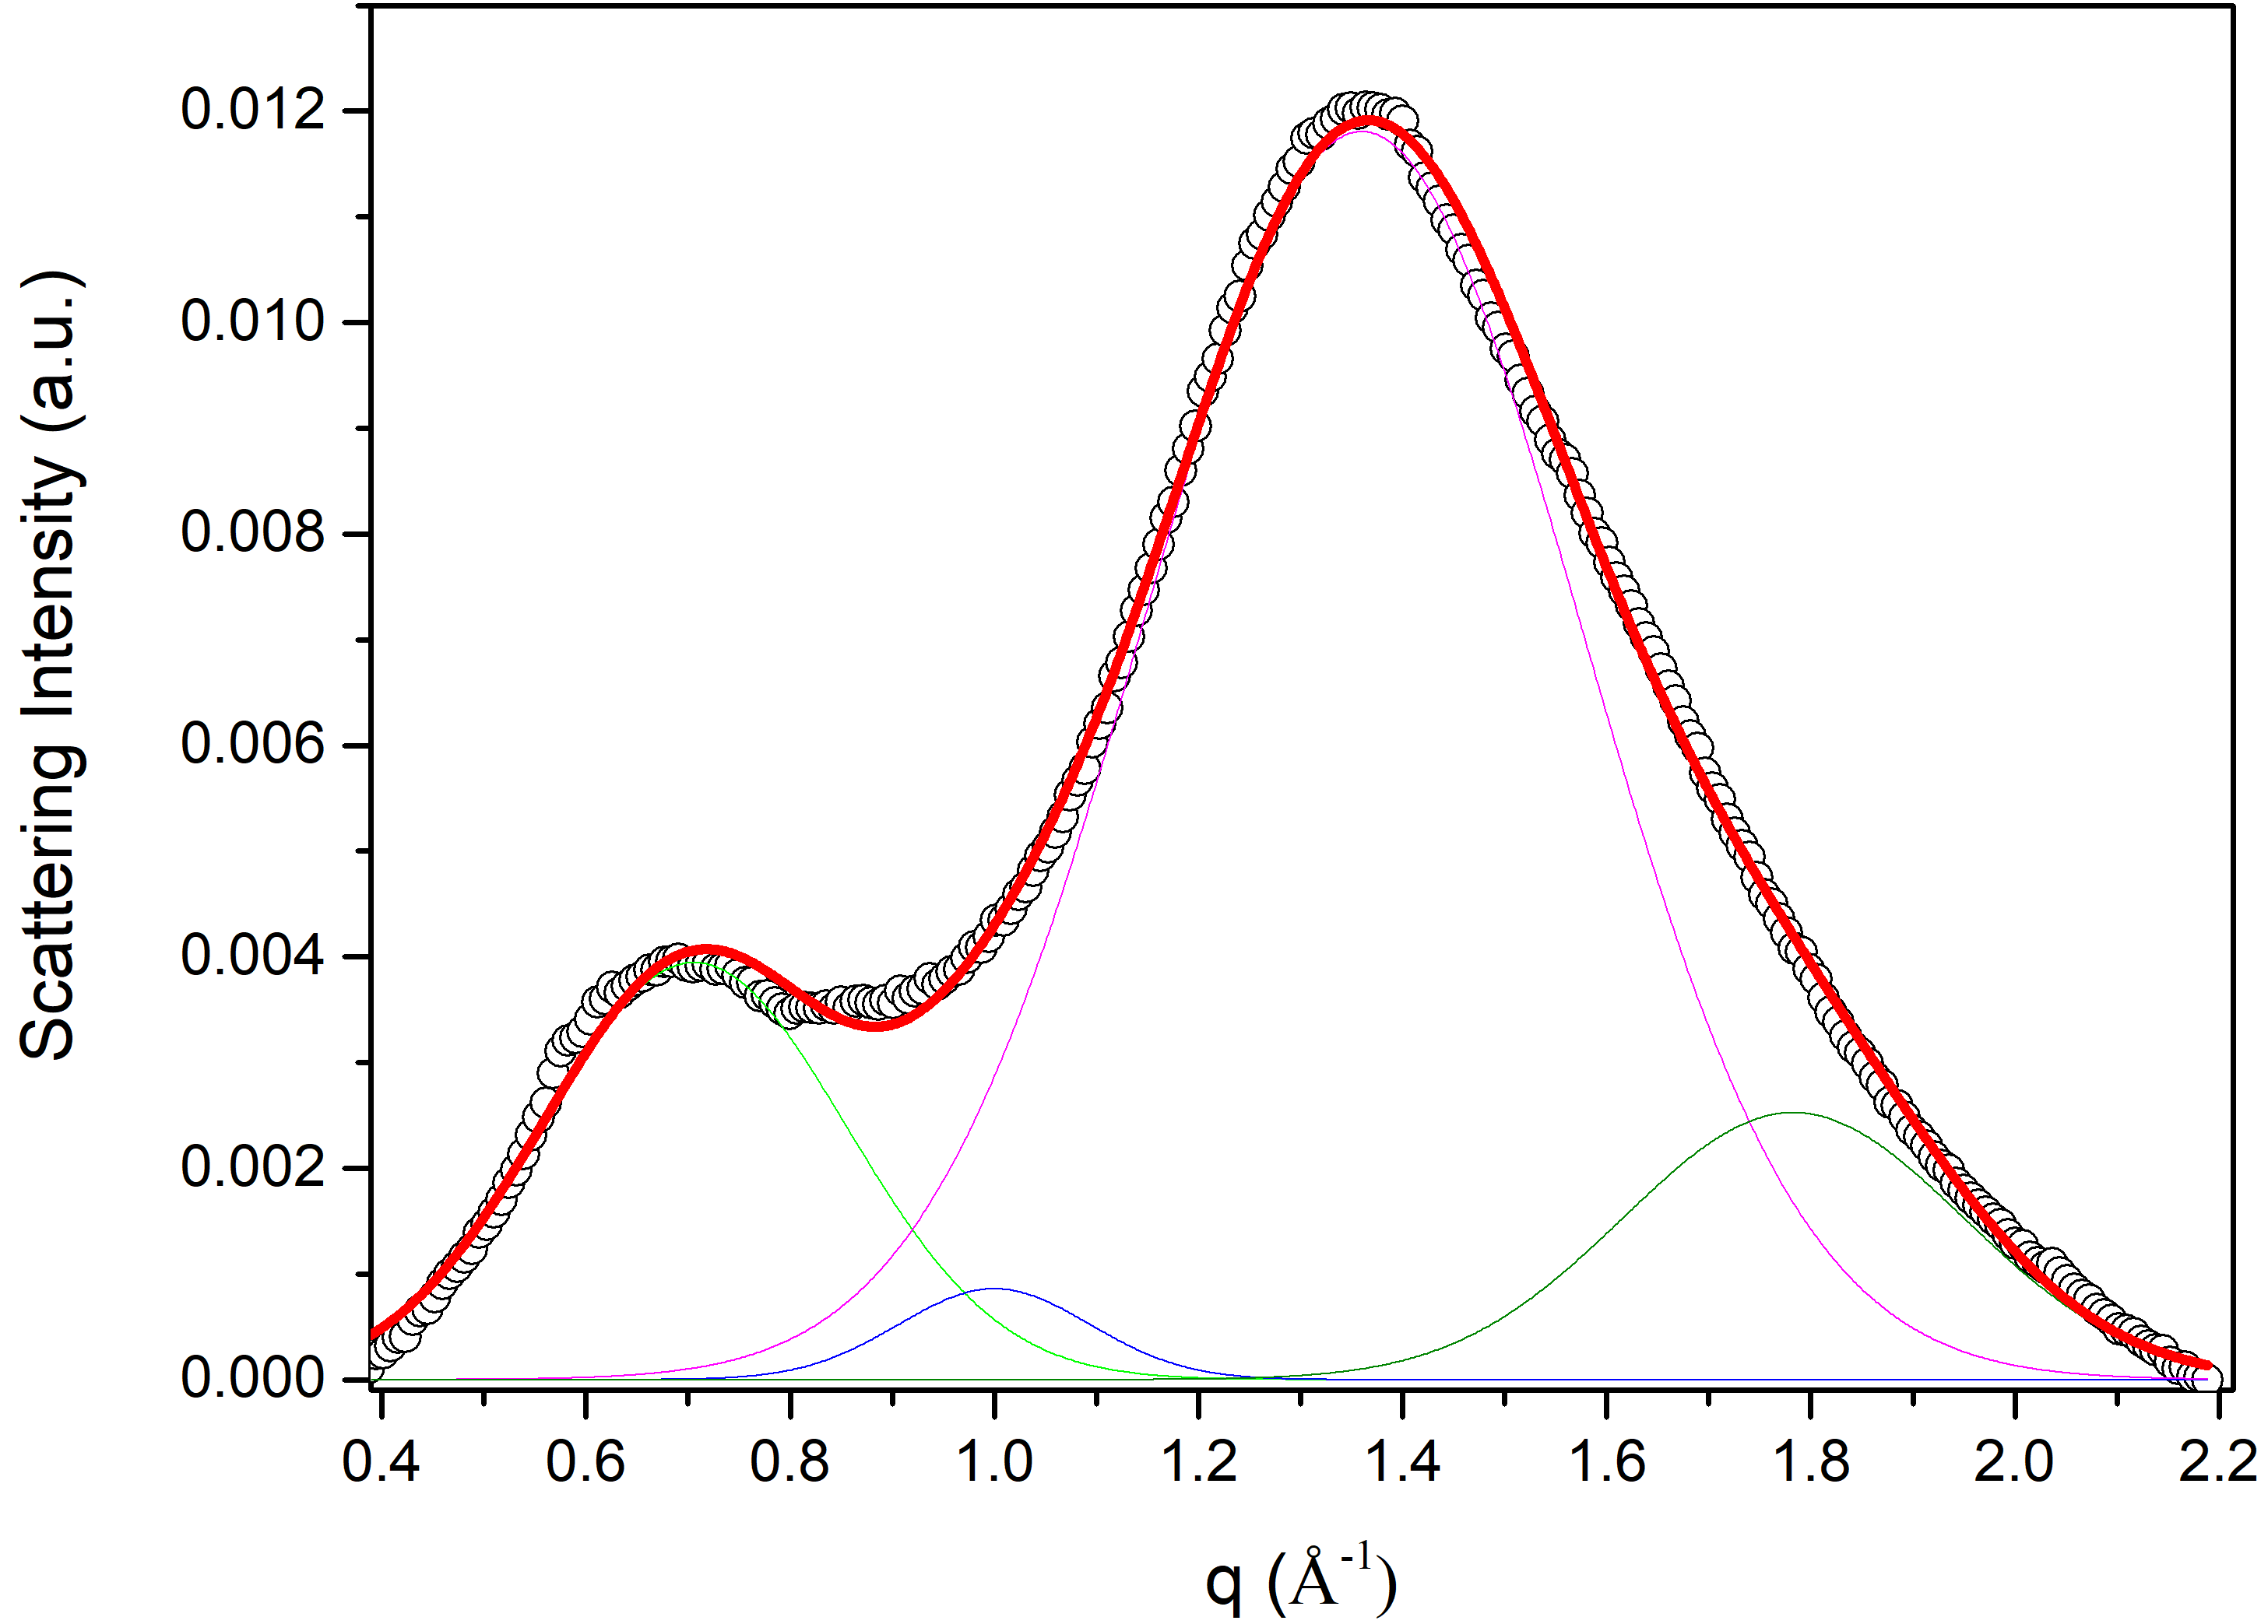
Figure S2. Gaussian peak fitting of the 1D profiles obtained upon 0-to-360° (Azimuthal averaged) for the byssus treated after lemon bath (sample 9).

References
1. Ahvenainen, P., Kontro, I. & Svedström, K. Comparison of sample crystallinity determination methods by X-ray diffraction for challenging cellulose I materials. Cellulose 23, 1073–1086 (2016).
2. Asaadi, S. et al. Structural analysis of Ioncell-F fibres from birch wood. Carbohydrate Polymers 181, 893–901 (2018).

