Supplementary Information

Learning noise explains away the choice hysteresis.
The model comparison confirmed our previous simulation results¹. In the exact setting, adding choice hysteresis parameter improved model fitting (P_{exc with bias}>0.97). However, adding the same parameter in the noisy model was not necessary: P_{exc no bias}>0.99 (SFig.1C). When the three models were compared together, the noisy model without choice hysteresis best explained the data (P_{noisy}>0.99). We found similar results in the complete feedback setting in the experiment 1 where both chosen and forgone outcomes were revealed (SFig.8E).

Redundant exploration is associated with compulsive traits
Previous work showed that in the context of fully available information (e.g., when both outcomes of the chosen and counterfactual option have been presented), observed variability in choices is solely driven by learning imprecision rather than active exploration of the alternatives¹. In computational terms, the model with just learning noise and argmax deterministic decision rule was sufficient to account for the data¹. We tested whether our observations from the partial feedback condition (see main manuscript) also hold in a complete feedback condition. We thus analysed the two additional sessions that our participants played in experiment 1, in which they received full feedback (i.e., both chosen and unchosen option were revealed) (SFig.8A). As in previous studies,¹ subjects performed better in the complete relative to the partial feedback condition (SFig.8B) and as in the partial feedback the model with update of both chosen and unchosen options was preferred (SFig.8D). However, in contrast to the previous results, we did not find a strong preference towards the model with just learning noise in our sample (i.e., argmax decision rule). Almost half of the users (N=190) favoured a model with both learning noise and softmax suggesting they were still exploring the options despite all the information being present (SFig.8C) with obtained posterior parameters being compatible with the estimates obtained in the partial feedback setting and in the previous studies¹ (SFig.9). To further investigate individual differences in these observed model preferences, we defined an exploration model bias as the difference in model evidence between the model with vs. without the choice stochasticity term.
Interestingly, this exploration bias positively correlated with the OCIR total score (R=0.15, p=0.0034) but not with the BIS total (R=0.05, p=0.35). This exploratory analysis thus suggests that obsessive-compulsive traits might increase subjects’ tendency to actively explore the environment even in situations when it is not informative. Importantly, in the complete feedback subjects learned similarly from the chosen and unchosen options: chosen learning rate 0.549±0.01, unchosen learning rate 0.547±0.01 (mean±s.e.m), difference: t(391)=0.32, p=0.75, confirming that observed correlations did not depend on the learning imbalances.
As in the partial feedback, choice stochasticity in the exact model was also positively associated with both BIS and OCI-R total scores: $β_{BIS total } =0.14 \left(SE =0.05\right), p =0.005,$ $β_{OCIR total } =0.07 \left(SE =0.02\right), p =0.008.$ The OCI-R remained a predictor of choice stochasticity after we have introduced learning imprecision while BIS total contributions was no longer significant: $β_{BIS total }= -0.03 \left(SE=0.03\right), p =0.48$, $β_{OCIR total } =0.06 \left(SE=0.02\right), p=0.008.$ Furthermore, the BIS but not OCI-R total score positively predicted increase in learning imprecision: $β_{BIS total } =0.06 \left(SE =0.02\right), p =0.008,$ $β_{OCIR total } =0.03 (SE =0.02), p =0.19$ (STable 5). Finally, motor impulsiveness subscale from the BIS remained a significant predictor of learning noise in the complete feedback: $β_{BIS mtor impulsiveness } =0.14 \left(SE =0.02\right), p<0.001$, (STable5). Finally, across subjects higher OCI-R scores translated into increased fraction of total behavioural variability explained by choice stochasticity in the complete feedback: R=0.12, p=0.02.

Compulsivity but not impulsivity is associated with exploratory decisions
Previous studies have linked excessive exploratory or ‘non-greedy’ decisions with both impulsive and compulsive traits^{2–4}, an effect also observed in the inverse temperature in our exact model. We further investigated this effect and found both compulsivity and impulsivity to positively correlate with the proportion of the ‘non-greedy’ choices relative to the total choices under the exact model formulation: $β_{BIS total }=0.18 \left(SE=0.05\right), p=0.0003, { β}_{OCIR total }=0.21 \left(SE=0.05\right), p=0.00004.$
When accounting for learning imprecisions, these ‘non-greedy’ choices have to be re-evaluated as learning noise explains more than 2/3 of choices that were initially labelled as ‘non-greedy’ under the exact model¹. We replicated this observation in our sample: introducing learning imprecision resulted in re-labelling of more than 70% (74.6±1.5%) (mean±s.e.m) of these ‘non-greedy’ choices (i.e., non-greedy choices under the exact model that become greedy under the noisy model) (Methods).
We next looked at whether this fraction of non-greedy trials explained by learning noise was associated with impulsive and compulsive traits. We found negative relationship with the OCI-R total score: $β_{OCIR total }=-0.11 \left(SE=0.05\right), p=0.04$ but no relationship with the BIS total (p=0.6).
When learning noise was taken into account, only about 6% (5.72±0.4%) of the trials were labelled as ‘non-greedy’ relative to the 19.3±0.5% (mean±s.e.m) in the exact learning setting. Finally, OCIR scores but not BIS scores positively correlated with this fraction of trials labelled as ‘non-greedy’ in the noisy learning model: $β_{OCIR total }=0.09 \left(SE=0.03\right), p=0.007,$ $β_{BIS total }=0.010 \left(SE=0.03\right), p=0.74.$ These results thus suggest that compulsivity (rather than impulsivity) leads to an increase in exploration during learning.

Parameter distributions for learning noise model between experiment 1 and experiment 2
In both experiments, the model with both learning noise and choice stochasticity better accounted for subjects’ choices (Fig.1F). When inspecting parameter distributions for the best fitting model between two experiments (SFig.2), we found that the smartphone sample had somewhat higher choice stochasticity (t(682.1)=3.82, p=0.0001) and learning noise values t(1049.2)=15.91, p<0.0001). In addition, we found that the users in the smartphone app had higher learning rates for the chosen (t(479.7)=8.51, p<0.0001) and the unchosen options (t(519.43)=16.24, p<0.0001). The parameters showed a similar correlation structure as in the experiment 1 (SFig.6B). This suggests that there are slight differences in the way users played the two tasks, which highlights the importance for examining individual-difference associations across contexts.

Association of impulsivity and learning imprecision in punishment domain (experiment 3)

We fitted the same exact and noisy learning models to the choice data in the Pirate Market game (Methods). As for the reward learning domain, the model with learning noise best fit the data (P_{exc}=0.99). As we had parameter estimates across both tasks from all participants (N=670), we could compare them across tasks. All parameters showed a positive association with their counterpart in the punishment domain (SFig.7A-D), especially so our key parameter of interest learning noise (r=0.54, p<0.001). This suggests that individual differences in learning (and their imprecisions) are to some extent preserved across valence domains, which encouraged us to further investigate the impulsivity effects.
When investigating the (worse fitting) exact model, we again found that general impulsivity was associated with choice stochasticity (Fig.5C; $β_{BIS total }=0.07 \left(SE=0.03\right), p=0.02$). As in the reward domain, this association disappeared when investigating the best-fitting noisy imprecision model (choice stochasticity: $β_{BIS total}=0.02 \left(SE=0.03\right), p=0.50$). However, in the latter model, general impulsivity was again associated with learning noise instead (Fig.5D; $β_{BIS total} =0.05 \left(SE=0.02\right), p=0.04$). This clearly suggests that the association between general impulsivity and learning noise was present across both valence domains.
Lastly, we investigated whether the specific motor impulsivity subscale was primarily linked to noisy learning in the punishment domain. We indeed could again replicate this effect (Fig.5D; $β_{BIS motor impulsiveness}=0.10 \left(SE=0.03\right), p=0.0002$), and we did not observe any link with any other impulsivity domain (Fig.5D; STable4). In sum, this suggests that motor impulsiveness is reliably associated with learning noise, across diverse tasks formats and samples as well as across different valence domains.

Association of compulsivity and choice stochasticity in punishment domain (experiment 3)
As for the reward learning game (exp 2), the association between the compulsivity measures and choice stochasticity in the noisy model was weaker and only observed when not controlling for covariates:$β_{OCIR total} =0.091 \left(SE = 0.04\right), p=0.018,$ $β_{OCIR washing } =0.093 \left(SE = 0.04\right), p=0.016$.

Noise-driven but not exploratory decisions are associated with motor impulsivity
Across both experiments, we found a positive relationship between BIS motor impulsiveness and the fraction of non-greedy decisions driven by the learning noise: experiment 1 $β_{BIS motor impulsiveness }=0.11 \left(0.05\right), p=0.02$, experiment 2 $β_{BIS motor impulsiveness }=0.04 \left(0.003\right), p<0.001$.

References
1. Findling, C., Skvortsova, V., Dromnelle, R., Palminteri, S., and Wyart, V. (2019). Computational noise in reward-guided learning drives behavioral variability in volatile environments. Nature Neuroscience 22, 2066–2077.
2. Hauser, T.U., Moutoussis, M., Dayan, P., Dolan, R.J., and Consortium, N. (2017). Increased decision thresholds trigger extended information gathering across the compulsivity spectrum. Translational Psychiatry 7, 1296.
3. Dubois, M., and Hauser, T.U. (2022). Exploring too much? The role of exploration in impulsivity . Nature Communications XX, XX–XX.
4. Kanen, J.W., Luo, Q., Yellowlees, R., Arntz, F.E., Christmas, D.M., Sahakian, B.J., Apergis-Schoute, A.M., Cardinal, R.N., and Robbins, T.W. Perseverative behavior under uncertainty is enhanced by tryptophan depletion but diminished with subclinical obsessive-compulsive symptoms.

Supplementary Figures
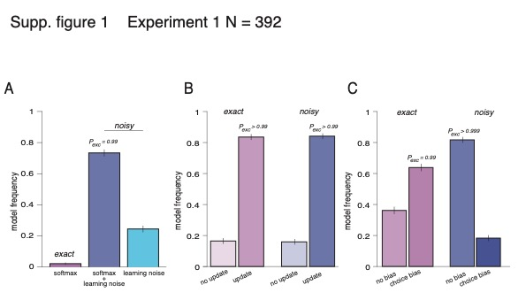
Supp.Figure 1. Model comparisons for experiment 1 (N = 392).

A. Bayesian model selection (BMS) results for testing the presence of learning variability in addition to the choice variability. Bars represent estimated model frequencies for exact model (just softmax decision rule, left bar), noisy learning model with softmax decision rule (middle bar), and noisy learning model with argmax decision rule (right bar) (replication of Figure1E). Model with two sources of variability (in learning update and at the moment of choice) better explained data. B. Bayesian model selection (BMS) results testing whether subjects use counterfactual update in addition to the factual update in exact (left) and noisy learning (right) models. Model with counterfactual learning better explains choice data in both model specifications. C. Bayesian model selection (BMS) results testing whether explicit account for choice hysteresis (e.g., repetition bias) is needed. In the exact model setting (left) addition of choice repetition bias to the model improved model predictions while it was not necessary in the noisy learning model (right). Error bars are s.d. for model frequencies based on Dirichlet distribution.

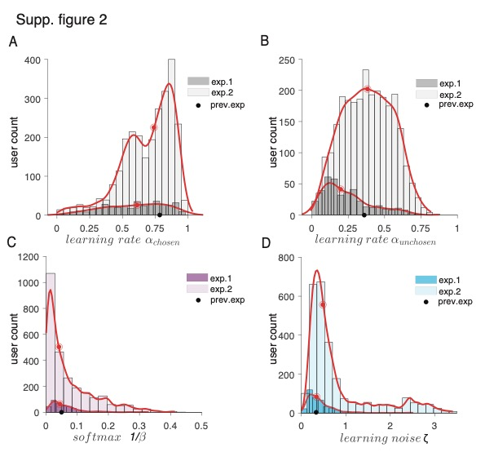

Supp.Figure 2. Parameter estimates from the noisy learning model in experiment 1 (N = 392) and experiment 2 (N = 2610).

A-D. Histograms (bars) and empirical densities (red lines) for learning rate for the chosen option (A), learning rate for the unchosen option (B), softmax inverse temperature parameter (choice stochasticity) (C), and scaling parameter for the noise added at the update (learning noise) (D). Red dots are the medians for each of the parameter. Black dots are the medians from previous laboratory experiment.¹

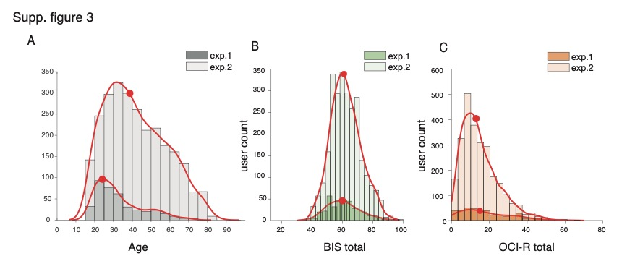
Supp.Figure 3. Age, Impulsivity (BIS) and compulsivity (OCI-R) total scores in experiment 1 (N = 392) and experiment 2 (N = 2610).

A-C. Histograms (bars) and empirical densities (red lines) for age (A), BIS impulsivity scale total score (B) and compulsivity OCI-R total scores (C). App users were older on average than the prolific sample: t(600.2)=13.13, p<0.001, with a trend towards more male users (Chi-squared=3.82, p=0.051). Red dots are the medians of the distributions.

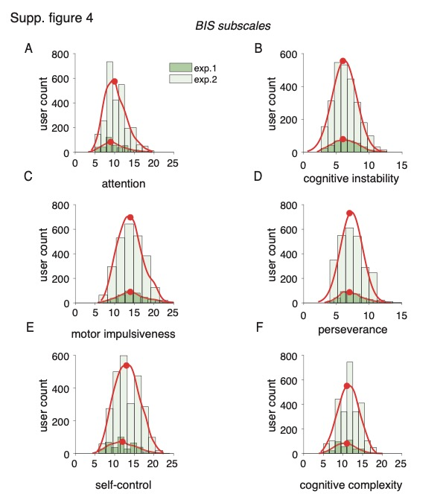

Supp.Figure 4. Distributions of different impulsivity dimensions measured using BIS subscales in experiment 1 (N = 392) and experiment 2 (N = 2610).

A-F. Histograms (bars) and empirical densities (red lines) for BIS impulsivity scores from six subscales in experiment 1 and experiment 2. Red dots are the medians of the distributions.

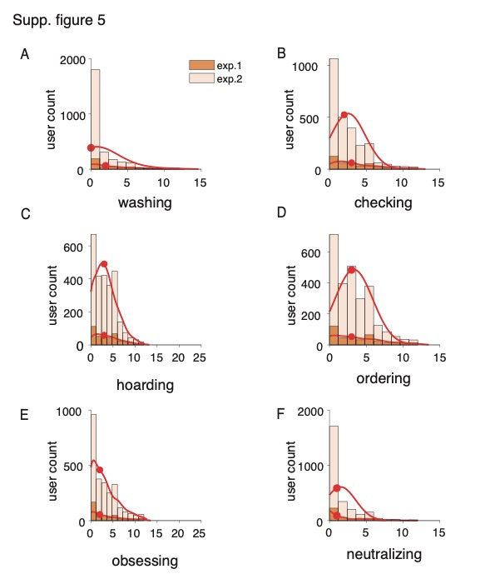
Supp.Figure 5. Distributions of different compulsivity dimensions measured using OCI-R subscales in experiment 1 (N = 392) and experiment 2 (N = 2610).

A-F. Histograms (bars) and empirical densities (red lines) for OCI-R compulsivity scores from six subscales in experiment 1 and experiment 2. Red dots are the medians of the distributions.

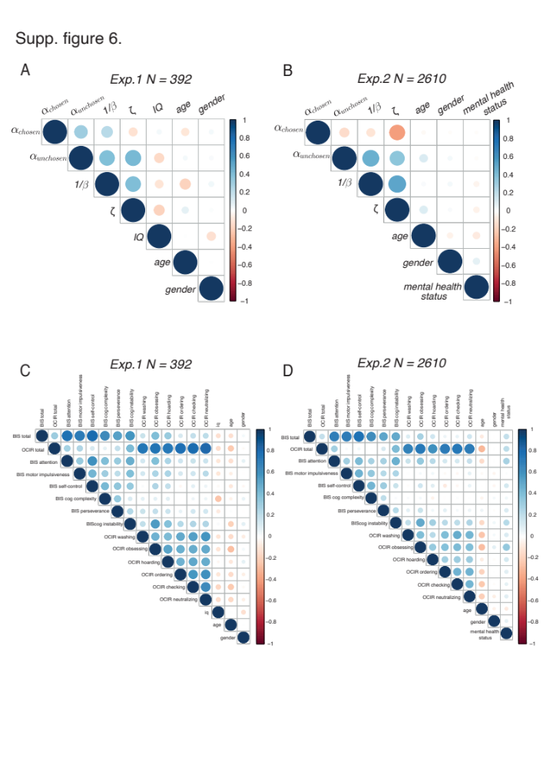

Supp.Figure 6. Pair-wise correlations between reward learning task parameters and self-report impulsivity (BIS) and compulsivity (OCI-R) in experiment 1 (N = 392) and experiment 2 (N = 2610).

A-B. Correlograms showing pair-wise correlations between best fitted parameters form the noisy learning model in experiment 1 (A) and experiment 2 (B). Additionally, are shown pair-wise correlation of task parameters with age and IQ (experiment 1) as they are included as covariates in all the regression models. C-D. Correlograms showing pair-wise correlations between impulsivity (BIS) total score and subscores and compulsivity (OCI-R) total score and scores from the subscales in experiment 1 (C) and experiment 2 (D). Additionally, are shown pair-wise correlation of task parameters with age and IQ (experiment 1) as they are included as covariates in all the regression models. In all plots colour code indicates the sign of the correlation while the areas of circles show the absolute value of corresponding correlation coefficients.

Supp. figure 7
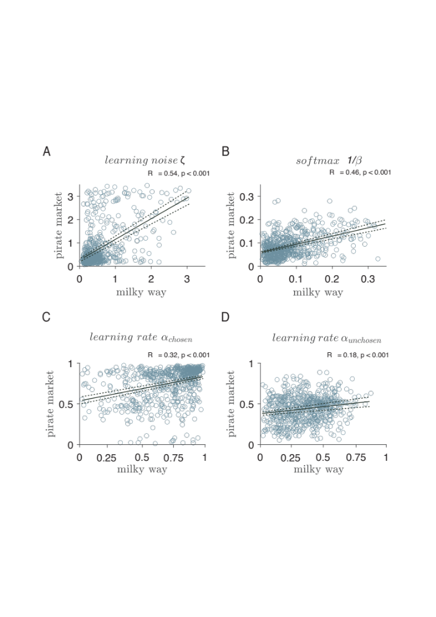

Supp.Figure 7. Experiment 2 & 3 (N = 670). Correlations between parameters for reward (i.e., Milky Way game) and punishment (i.e., Pirate Market game) for users who played both games.

A-D. Correlation plots between parameter estimates from the noisy learning model in Milky way reward game (x-axis) and Pirate Market loss game (y – axis). All four parameters in the model were correlated across subjects between two valence domains.

Supp. figure 8

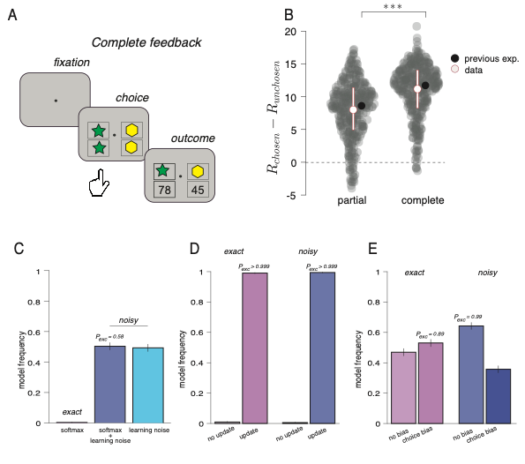
Supp.Figure 8. Complete feedback condition in experiment 1.
A. Trial structure for the reversal learning game with the complete feedback condition in experiment 1. On every trial, participants choose between two bandits presented via coloured shapes. hat will steal least from them. In contrast to the partial feedback condition (Fig.1A), they next observe the outcomes of both chosen and foregone options. In this design settings, participants receive full information about the two bandits on each trial which makes exploration redundant. B. Relative average rewards (chosen – unchosen) cumulated in the partial (left) and complete (right) feedback conditions. As expected, subjects won more rewards in the complete feedback when more information was available. *** - p < -0.001, paired t-test. C. Bayesian model selection (BMS) results for testing the presence of learning variability in addition to the choice variability. Bars represent estimated model frequencies for exact model (just softmax decision rule, left bar), noisy learning model with softmax decision rule (middle bar), and noisy learning model with argmax decision rule (right bar). Models with the learning noise better account for subjects’ choice data relative to the exact model. In contrast to the partial feedback condition, where choice stochasticity remained necessary even when learning noise has been added to the mode, in the complete feedback both noisy models with and without choice stochasticity seem to be equally likely. D. Bayesian model selection (BMS) results testing whether subjects use counterfactual update in addition to the factual update in exact (left) and noisy learning (right) models. Model with counterfactual learning better explains choice data in both model specifications. E. Bayesian model selection (BMS) results testing whether explicit account for choice hysteresis (e.g., repetition bias) is needed. While in the exact model setting (left) addition of choice repetition bias to the model might improve model predictions in some subjects, it is not necessary in the noisy learning model (right). Error bars are s.d. for model frequencies based on Dirichlet distribution.

Supp. figure 9

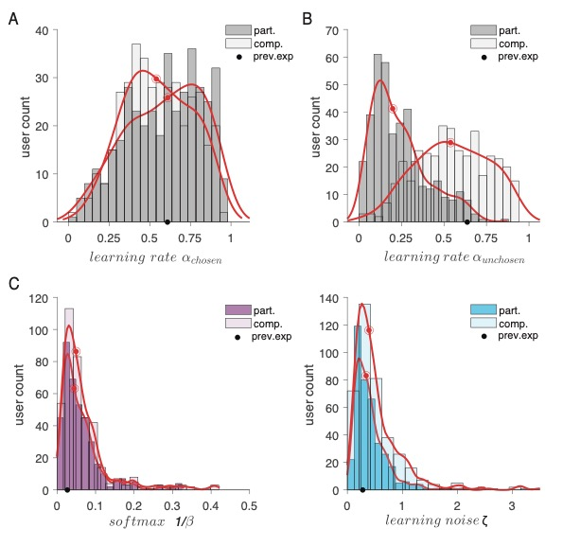
Supp.Figure 9. Parameter estimates from the noisy learning model in experiment 1 (N = 392) in the complete and partial feedback conditions.

A-D. Histograms (bars) and empirical densities (red lines) for learning rate for the chosen option (A), learning rate for the unchosen option (B), softmax inverse temperature parameter (choice stochasticity) (C), and scaling parameter for the noise added at the update (learning noise) (D). Red dots are the medians for each of the parameter. Black dots are the median parameter values in the complete feedback from previous laboratory experiment.¹

Supplementary tables
Supplementary Table 1
 | Experiment 1 | Experiment 2 | Experiment 3
N | 392 | 2610 | 670
Age (M ± SD) | 32.6 (12.4) | 41.8 (15.9) | 42.8 (17.3)
Gender (F/M) | 204/188 | 1499/1111 | 415/255
IQ (M ± SD) | 6.8 (3.2) | N/A | N/A
Mental health disorder  (current or past) (No/Yes) | N/A | 2231/379 | 501/169
BIS total (M ± SD) | 60.7 (11.1) | 62.3 (10.0) | 61.3 (10.3)
BIS Attention (M ± SD) | 9.8 (2.8) | 10.2 (2.7) | 10.3 (2.8)
Cognitive instability (M ± SD) | 6.4 (1.9) | 6.2 (1.9) | 6.4 (1.9)
Motor impulsiveness (M ± SD) | 14.4 (3.6) | 14.0 (3.2) | 13.4 (3.3)
Perseverance (M ± SD) | 7.3 (1.8) | 7.3 (1.7) | 7.4 (1.7)
Self-control (M ± SD) | 12.1 (3.3) | 13.2 (3.1) | 13.0 (3.2)
Cognitive Complexity (M ± SD) | 10.7 (2.6) | 11.4 (2.6) | 10.7 (2.5)
OCI-R total (M ± SD) | 18.7 (13.8) | 15.2 (10.1) | 15.7 (10.4)
OCI-R Washing (M ± SD) | 2.5 (2.8) | 1.4 (2.1) | 1.3 (2.1)
OCI-R Obsessing (M ± SD) | 3.3 (3.4) | 3.1 (2.9) | 3.3 (3.0)
OCI-R Hoarding (M ± SD) | 3.7 (3.2) | 3.3 (2.5) | 3.7 (2.6)
OCI-R Ordering (M ± SD) | 3.7 (3.2) | 3.3 (2.6) | 3.4 (2.6)
OCI-R Checking (M ± SD) | 3.4 (2.9) | 2.5 (2.3) | 2.4 (2.3)
OCI-R Neutralizing (M ± SD) | 2.1 (2.6) | 1.5 (2.1) | 1.5 (2.1)

Demographic characteristics and summary statistics of the Barratt Impulsiveness scale (BIS) and its subscales, obsessive-compulsive revised inventory OCI-R and its subscales for participants in experiment 1 (Prolific online study, N = 392), experiment 2 (Brain Explorer app, N = 2610) and experiment 3 (Brain Explorer app, N = 670). Experiment 3 (Pirate market game, punishment learning) was a sub-sample of participants who also played the Milky Way reward game (experiment 2). M - mean, SD - standard deviation.
Supplementary Table 2

 | Choice stochasticity |  | Learning noise
OCI-R subscales | Regression coefficient  (SE) | p-value | Regression coefficient  (SE) | p-value
Total | 0.115 (0.036) | 0.002 ** | 0.026 (0.037) | 0.489
Washing | 0.12 (0.035) | < 0.0001 *** | 0.017 (0.036) | 0.33
Obsessing | 0.081 (0.036) | 0.029 * | 0.009 (0.036) | 0.813
Hoarding | 0.105 (0.035) | 0.003 ** | -0.019 (0.035) | 0.596
Ordering | 0.038 (0.035) | 0.288 | 0.035 (0.036) | 0.322
Checking | 0.076 (0.036) | 0.036 * | 0.008 (0.036) | 0.832
Neutralizing | 0.079 (0.036) | 0.031 * | 0.066 (0.036) | 0.071
BIS subscales
Total | 0.023 (0.035) | 0.512 | 0.081 (0.035) | 0.021*
Attention | -0.004 (0.036) | 0.91 | 0.030 (0.035) | 0.392
Cognitive instability | 0.059 (0.036) | 0.953 | -0.003 (0.035) | 0.925
Motor impulsiveness | -0.010 (0.036) | 0.775 | 0.171 (0.033) | < 0.001 ***
Perseverance | 0.064 (0.032) | 0.053 | 0.010 (0.035) | 0.783
Self-control | 0.022 (0.035) | 0.532 | 0.048 (0.035) | 0.167
Cognitive Complexity | -0.006 (0.036) | 0.867 | 0.003 (0.036) | 0.926

Experiment 1: Coefficient estimates with standard error (SE in parentheses) from separate robust regression models with the covariates for choice stochasticity (left) and learning noise (right) parameters (N = 392). * - p < 0.05, ** - p < 0.01, *** - p < 0.001.

Supplementary Table 3
 | Choice stochasticity |  | Learning noise
OCI-R subscales | Regression coefficient  (SE) | p-value | Regression coefficient  (SE) | p-value
Total | -0.009 (0.014) | 0.546 | 0.011 (0.008) | 0.217
Washing | 0.028 (0.011) | 0.020* | 0.012 (0.008) | 0.153
Obsessing | -0.003 (0.015) | 0.834 | 0.007 (0.009) | 0.424
Hoarding | -0.011 (0.014) | 0.434 | -0.006 (0.008) | 0.486
Ordering | -0.015 (0.013) | 0.273 | 0.008 (0.008) | 0.32
Checking | 0.008 (0.014) | 0.564 | 0.008 (0.008) | 0.322
Neutralizing | -0.014 (0.014) | 0.30 | 0.015 (0.008) | 0.07
BIS subscales
Total | 0.0065 (0.014) | 0.635 | 0.103 (0.014) | < 0.0001 ***
Attention | -0.016 (0.014) | 0.237 | 0.048 (0.014) | 0.776
Cognitive instability | -0.004 (0.014) | 0.748 | 0.035 (0.014) | 0.013 *
Motor impulsiveness | -0.007 (0.013) | 0.58 | 0.102 (0.013) | < 0.001 ***
Perseverance | 0.017 (0.013) | 0.212 | 0.034 (0.013) | 0.015 *
Self-control | 0.013 (0.013) | 0.315 | 0.06 (0.013) | < 0.001 ***
Cognitive Complexity | 0.020 (0.013) | 0.142 | 0.088 (0.013) | < 0.001 ***

Experiment 2: Coefficient estimates with standard error (SE in parentheses) from separate robust regression models with the covariates for choice stochasticity (left) and learning noise (right) parameters (N = 2610). * - p < 0.05, ** - p < 0.01, *** - p < 0.001.

Supplementary Table 4
 | Learning noise
OCI-R subscales | Regression coefficient (SE) | p-value
Total | -0.014 (0.033) | 0.66
Washing | 0.007 (0.027) | 0.804
Obsessing | 0.041 (0.029) | 0.153
Hoarding | 0.031 (0.026) | 0.221
Ordering | 0.034 (0.024) | 0.154
Checking | 0.035 (0.026) | 0.186
Neutralizing | 0.042 (0.024) | 0.08
BIS subscales
Total | 0.050 (0.024) | 0.038 *
Attention | 0.010 (0.027) | 0.68
Cognitive instability | 0.011 (0.027) | 0.68
Motor impulsiveness | 0.098 (0.025) | 0.0001 ***
Perseverance | 0.019 (0.026) | 0.45
Self-control | 0.034 (0.026) | 0.2
Cognitive Complexity | 0.0002 (0.026) | 0.99

Experiment 3: Coefficient estimates with standard error (SE in parentheses) from separate robust regression models with the covariates for learning noise parameter (N = 670). * - p < 0.05, ** - p < 0.01, *** - p < 0.001.

Supplementary Table 5
 | Choice stochasticity |  |  | Learning noise
OCI-R subscales | Regression coefficient  (SE) | p-value |  | Regression coefficient  (SE) |  | p-value
Total | 0.060 (0.03) | 0.059 |  | 0.035 (0.02) |  | 0.17
Washing | 0.049 (0.03) | 0.08 |  | 0.019 (0.02) |  | 0.44
Obsessing | 0.023 (0.03) | 0.41 |  | 0.019 (0.02) |  | 0.44
Hoarding | 0.058 (0.03) | 0.078 |  | 0.008 (0.02) |  | 0.75
Ordering | 0.023 (0.03) | 0.41 |  | 0.032 (0.02) |  | 0.19
Checking | 0.078 (0.03) | 0.005** |  | 0.025 (0.02) |  | 0.31
Neutralizing | 0.052 (0.03) | 0.51 |  | 0.05 (0.02) |  | 0.042*
BIS subscales
Total | -0.03 (0.03) | 0.48 |  |  | 0.062 (0.02) | 0.008**
Attention | -.038 (0.03) | 0.24 |  |  | 0.009 (0.023) | 0.69
Cognitive instability | 0.019 (0.03) | 0.57 |  |  | 0.024 (0.02) | 0.32
Motor impulsiveness | -0.07 (0.03) | 0.048* |  |  | 0.14 (0.021) | 0.0001 ***
Perseverance | 0.034 (0.03) | 0.3 |  |  | 0.008 (0.02) | 0.75
Self-control | 0.01 (0.03) |  | 0.77 |  | 0.031 (0.02) | 0.18
Cognitive Complexity | -0.027 (0.03) |  | 0.42 |  | 0.0007 (0.02) | 0.76

Experiment 1, complete feedback condition: Coefficient estimates with standard error (SE in parentheses) from separate robust regression models with the covariates for learning noise parameter and choice stochasticity, model with both learning noise and choice stochasticity (N = 392). * - p < 0.05, ** - p < 0.01, *** - p < 0.001.

