Supplementary Information
UV-cured coatings for highly efficient passive daytime radiative cooling
Heng Luo, Meng Yang, Jing Guo, Weizhi Zou, Jian Xu, and Ning Zhao*

H. Luo, M. Yang, J. Guo, W. Zou, Prof. N. Zhao
Beijing National Laboratory for Molecular Sciences, Laboratory of Polymer Physics and Chemistry, Institute of Chemistry, Chinese Academy of Sciences, Beijing, 100190, P. R. China
E-mail: zhaoning@iccas.ac.cn

H. Luo, M. Yang, W. Zou, Prof. N. Zhao
University of Chinese Academy of Sciences, 100049, Beijing, P. R. China

Prof. J. Xu
Institute of Low-dimensional Materials Genome Initiative, College of Chemistry and Environmental Engineering, Shenzhen University, Guangdong, 518060, P. R. China.

Materials
Trimethylolpropane triacrylate (TMPTA) and butyl acrylate (BA) were purchased from Alfa. Vinyltriethoxysilane (VTES) was bought from Adamas. Tetraethyl orthosilicate (TEOS) and methyltriethoxysilane (MTES) were purchased from Acros. Diphenyl(2,4,6-trimethylbenzoyl)-phosphine oxide (TPO) was supplied by J&K. Acetone and ethanol of analytical grade were obtained from Beijing Chemical Works. All chemicals were used as received. Commercially available copper plate, polyethylene glycol terephthalate (PET) film, black plastic piece, stainless steel plate, glass sheet, ceramic tile, and deionized water were used. Glass slides (CAT. no. 7101) were purchased from Sail Brand. All coated substrates were cleaned by ultrasonic before utilizing.
Characterization
Composition characterization: ¹³C Nuclear magnetic resonance (NMR) spectra of monomers were recorded on a Bruker Fourier 400 MHz spectrometer using acetone (chemical shifts: 206.4 and 29.7 ppm) as solvent. Solid-state ¹³C cross-polarization magic angle spinning with total suppression of sidebands (CPTOSS) NMR spectra of the cured polymer were recorded on a Bruker Avance III 400 spectrometer at a spinning rate of 8 kHz, operating at resonance frequency of 100.38 MHz. The probe was 4 mm with adamantane (chemical shifts: 38.48 ppm) as an external reference material. Contact time for CP was 2 ms, with a recycle delay of 2 s. Fourier transform infrared spectroscopy (FTIR) investigation was performed on a Bruker TENSOR-27 using the KBr pellet at a resolution of 4 cm⁻¹ and total of 32 scans. The conversion of vinyl groups was monitored using a real time FTIR instrument (Thermal Fisher Nicolet 5700) with a mercury cadmium telluride (MCT) detector. UV light (365 nm, 15 mW cm⁻²) was irradiated on solutions between KBr plates to initiate the polymerization. The scanning of the real time FTIR ranged from 4000 to 650 cm⁻¹ with a resolution of 4 cm⁻¹ and an average collection rate of 3 scans s⁻¹. As for the conversion of acrylic vinyl groups, the absorption band of carbonyl group (between 1765 and 1700 cm⁻¹) was set as internal standard, and the conversion of double bond was calculated by the characteristic band between 824 and 802 cm⁻¹. For the conversion of siloxane vinyl groups, one of the absorption peaks of Si-O-C-C group (between 993 and 915 cm⁻¹) was set as internal standard, and the conversion was calculated by the band between 802 and 730 cm⁻¹. Thermogravimetric analysis (TGA) was performed on TA instruments Q600 Simultaneous Thermal Analyzers at 10 °C min⁻¹ from 40 to 700 °C under a N₂ atmosphere. X-ray photoelectron spectroscopy (XPS) measurements were performed on a Thermo Scientific ESCALab250Xi using 200 W monochromatic Al Kα radiation.
Photorheological characterizations: Real time photorheological measurements were carried out using an Anton Paar rheometer (Physica MCR 302) in parallel plate mode. The light source used was a Omnicure S1500A lamp with the light wavelength between 320 and 500 nm (1-50 mW cm⁻²). This set-up has a lower plate in quartz, the gap between plates was set as 0.1 mm and the operating temperature was kept at room temperature (~25 °C). A constant shear frequency was set to 10 rad s⁻¹, and light was turned on after the system was stable for 30 s. The measurements were carried out in the linear viscoelastic region (strain amplitude 0.1%).
Measurement of porosity and pore size distribution: Mercury porosimetry (AUTOPORE IV 9520, Mike Company) was conducted to obtain the porosity and pore size distribution with a max pressure of 60000 Psi, and pore sizes were calculated using a cylindrical pore model.
Morphological characterization: The morphology of samples was observed by field emission scanning electron microscope (FESEM, S8020, Hitachi Company) under an acceleration voltage of 10 kV. Globule size statistics was conducted using the ‘Local thickness’ plug-in of ImageJ.
Reflectance measurement: Total reflectance was measured in UV/VIS/NIR (0.3-2.5 μm) and MIR (2.5-25 μm) ranges with integrating spheres. UV/VIS/NIR spectrometer (Lambda 950, Perkin Elmer, with a standard white board (SRS-99-020, Labsphere, USA) for the calibration and a 150 mm integrating sphere), and Fourier transform infrared spectrometer (FTIR, INVENIO S, Bruker, with a gold integrating sphere) were used, respectively. For object at thermal equilibrium, the spectral absorptivity and emissivity should be equal according to Kirchhoff’s law. And the measurement of R(λ) in the long wave infrared region was set in the lower sample position. Thus, ε(λ) can be calculated as ε(λ)=1-R(λ).
Angular-resolved measurement: An angle-resolved photonic spectral system (R1, Ideaoptics Technology Ltd., China) was applied to measure angular-resolved reflectance intensity. The light source was fixed at 0° and the detector was rotated from 20° to 90° in the scattering mode (300 to 1700 nm wavelength). Angular measurement was taken in step of 5 degrees.
Thermal analysis: Infrared images were taken using Fluke TiS65 Infrared Camera (7-14 μm wavelength), and the transmittance and emittance were set to be 1 and 0.95, respectively.
Characterization of surface wettability: Static water contact angles were measured by a drop shape analysis instrument (KRÜSS DSA 100, Germany). The sliding angles were characterized using a tilting stage. A water droplet of 5 μL was used, and each value was an average of five measurements on different parts of the coating.
UV and moisture exposure test: The samples were illuminated by UV light (365 nm) and placed in the environment with high relative humidity recorded with a hygrometer (TH20R-EX, Inste Technology Co., Ltd., China). Intensity of the illumination was measured by a photo power meter equipped with a 919P thermopile sensor (Newport Corporation, CA). The UV intensity was 2.05 ± 0.10 mW cm⁻² and exposure periods were cycled up to 50 days. The static water contact angle measurements were conducted every five days.
Thermal resistance: Thermal aging test of the coatings was performed in the oven of 80 °C for 20 days. Then the solar reflectance was measured.
Chemical stability: Coatings were soaked in acid (0.1 M HCl), or alkali (0.1 M KOH) at 25 °C for 7 days, respectively, and then were taken out for reflectance measurement.

Supplementary Figures and Tables
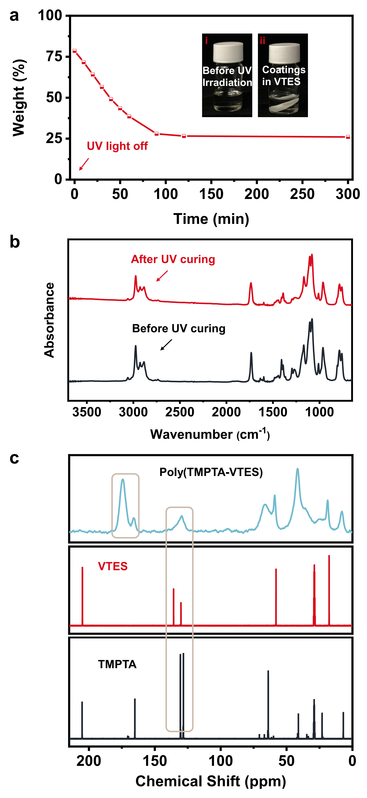
Supplementary Fig. 1 (a) Weight change of the monomers after the UV exposure at room temperature. Insets exhibit the homogeneous mixture of TMPTA and VTES, and the generated poly(TMPTA-VTES) that cannot be swelled by VTES, indicating a poor miscibility. (b) FTIR spectra of the monomers before UV curing, and the resultant coating after UV curing. (c) NMR spectra of TMPTA, VTES, and poly(TMPTA-VTES). FTIR and NMR spectra both demonstrated the high conversion degree of vinyl groups.
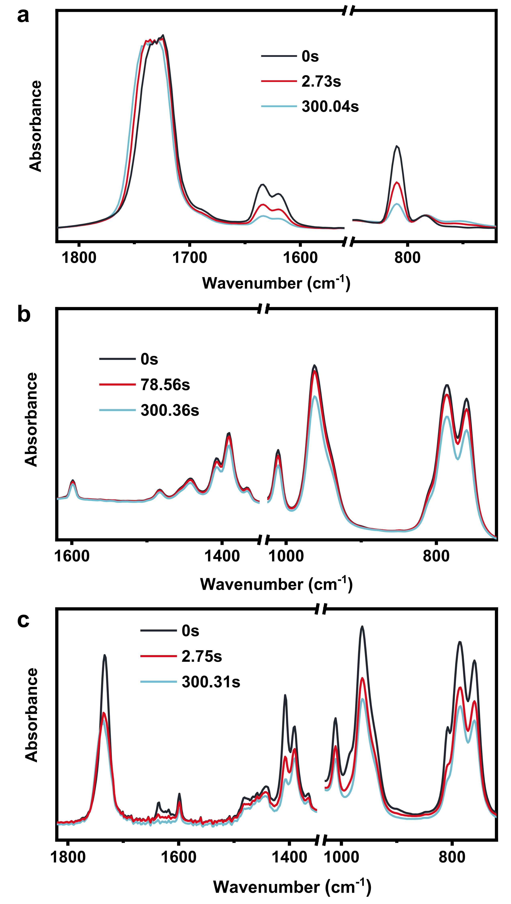
Supplementary Fig. 2 The real time FTIR spectra of TMPTA (a), VTES (b), and mixture of TMPTA and VTES (mass ratio of 1:4) (c).

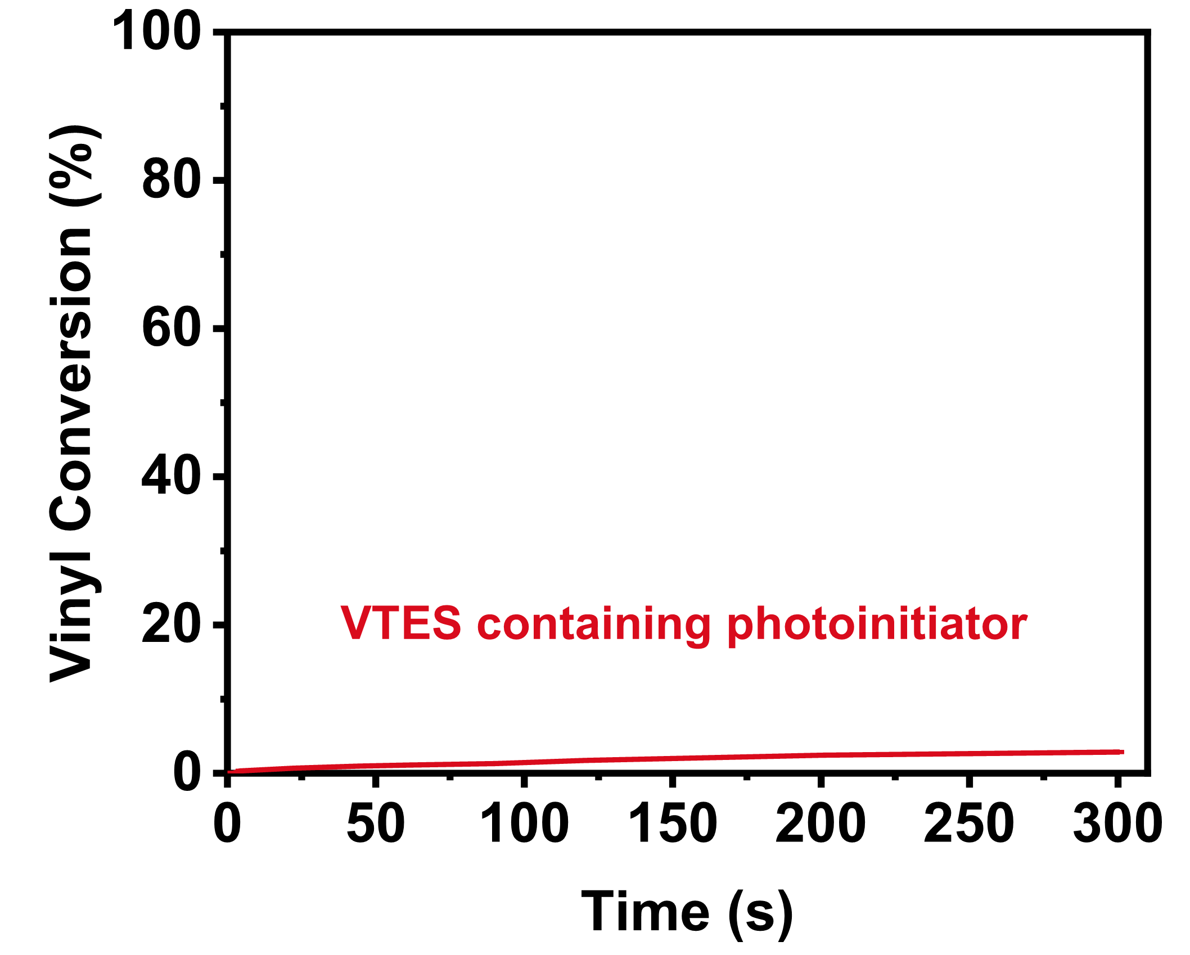
Supplementary Fig. 3 Conversion of vinyl groups of VTES as a function of illumination time (TPO as photoinitiator), showing that VTES didn’t polymerize alone.
The characterization of formation of poly(TMPTA-VTES) coatings
In our case, TMPTA (20wt%), VTES (80wt%), and TPO (photoinitiator) were mixed, coated on substrates, UV cured and dried. Herein VTES functioned as both diluent monomer and porogen. As can be seen from Supplementary Fig. 1a, ~26wt% of the reactants remained after the polymerization. Because TMPTA did not lost during the reaction, the percentage of VTES involved in the final poly(TMPTA-VTES) coating is ~23wt% ((26wt%-20wt%)/26wt%). The evolution of chemical structure during the UV curing process was detected by real time FTIR spectra (Fig. 1c and Supplementary Fig. 2) and the regular FTIR spectra (Supplementary Fig. 1b). The absorption peaks of the acrylic vinyl groups at 1634 cm⁻¹, 1619 cm⁻¹ and 810 cm⁻¹, exhibited large decrease after UV irradiation for 300 s and a fast conversion efficiency of double bond. The reaction progress of the VTES monomer was deduced from the bands between 802 and 730 cm^{–1}. The siloxane vinyl carbon of VTES usually cannot undergo polymerization alone (Supplementary Fig. 3), but it could copolymerize with TMPTA at ~60s and achieved an equalization at ~120s after the self-polymerization of TMPTA. In addition, the characteristic absorption peak of Si-O-C-C groups was observed in 960 cm⁻¹ due to the copolymerization. NMR spectra also revealed the conversion of double bond. Signals at 130.1 ppm and 135.7 ppm were assigned to siloxane vinyl carbons (Si–CH=CH₂). Acrylic carbons (OC–CH=CH₂) were observed at 128.3 ppm and 130.6 ppm. As for poly(TMPTA-VTES), a certain extent of remaining vinyl groups could be found between 126 and 136 ppm. Further by comparing the signal intensities of carbonyl groups in the neighbourhood of aliphatic and olefinic carbons at 174.3 and 166.1 ppm, respectively, we could conclude that most of the double bonds were converted (Supplementary Fig. 1c). This is in line with the incomplete conversion proved by the results of the real time FTIR. The TGA curves show that the residuals of poly(TMPTA-VTES) exhibit a ~7.6% weight difference compared to that of poly(TMPTA) at 600 °C. The TGA results correspond with the weight loss data (23wt% VTES would turn into ~7.3wt% SiO₂). These characterizations corroborate that the copolymerization between TMPTA and VTES occurred and the resultant poly(TMPTA-VTES) contains 77wt% TMPTA and 23wt% VTES.

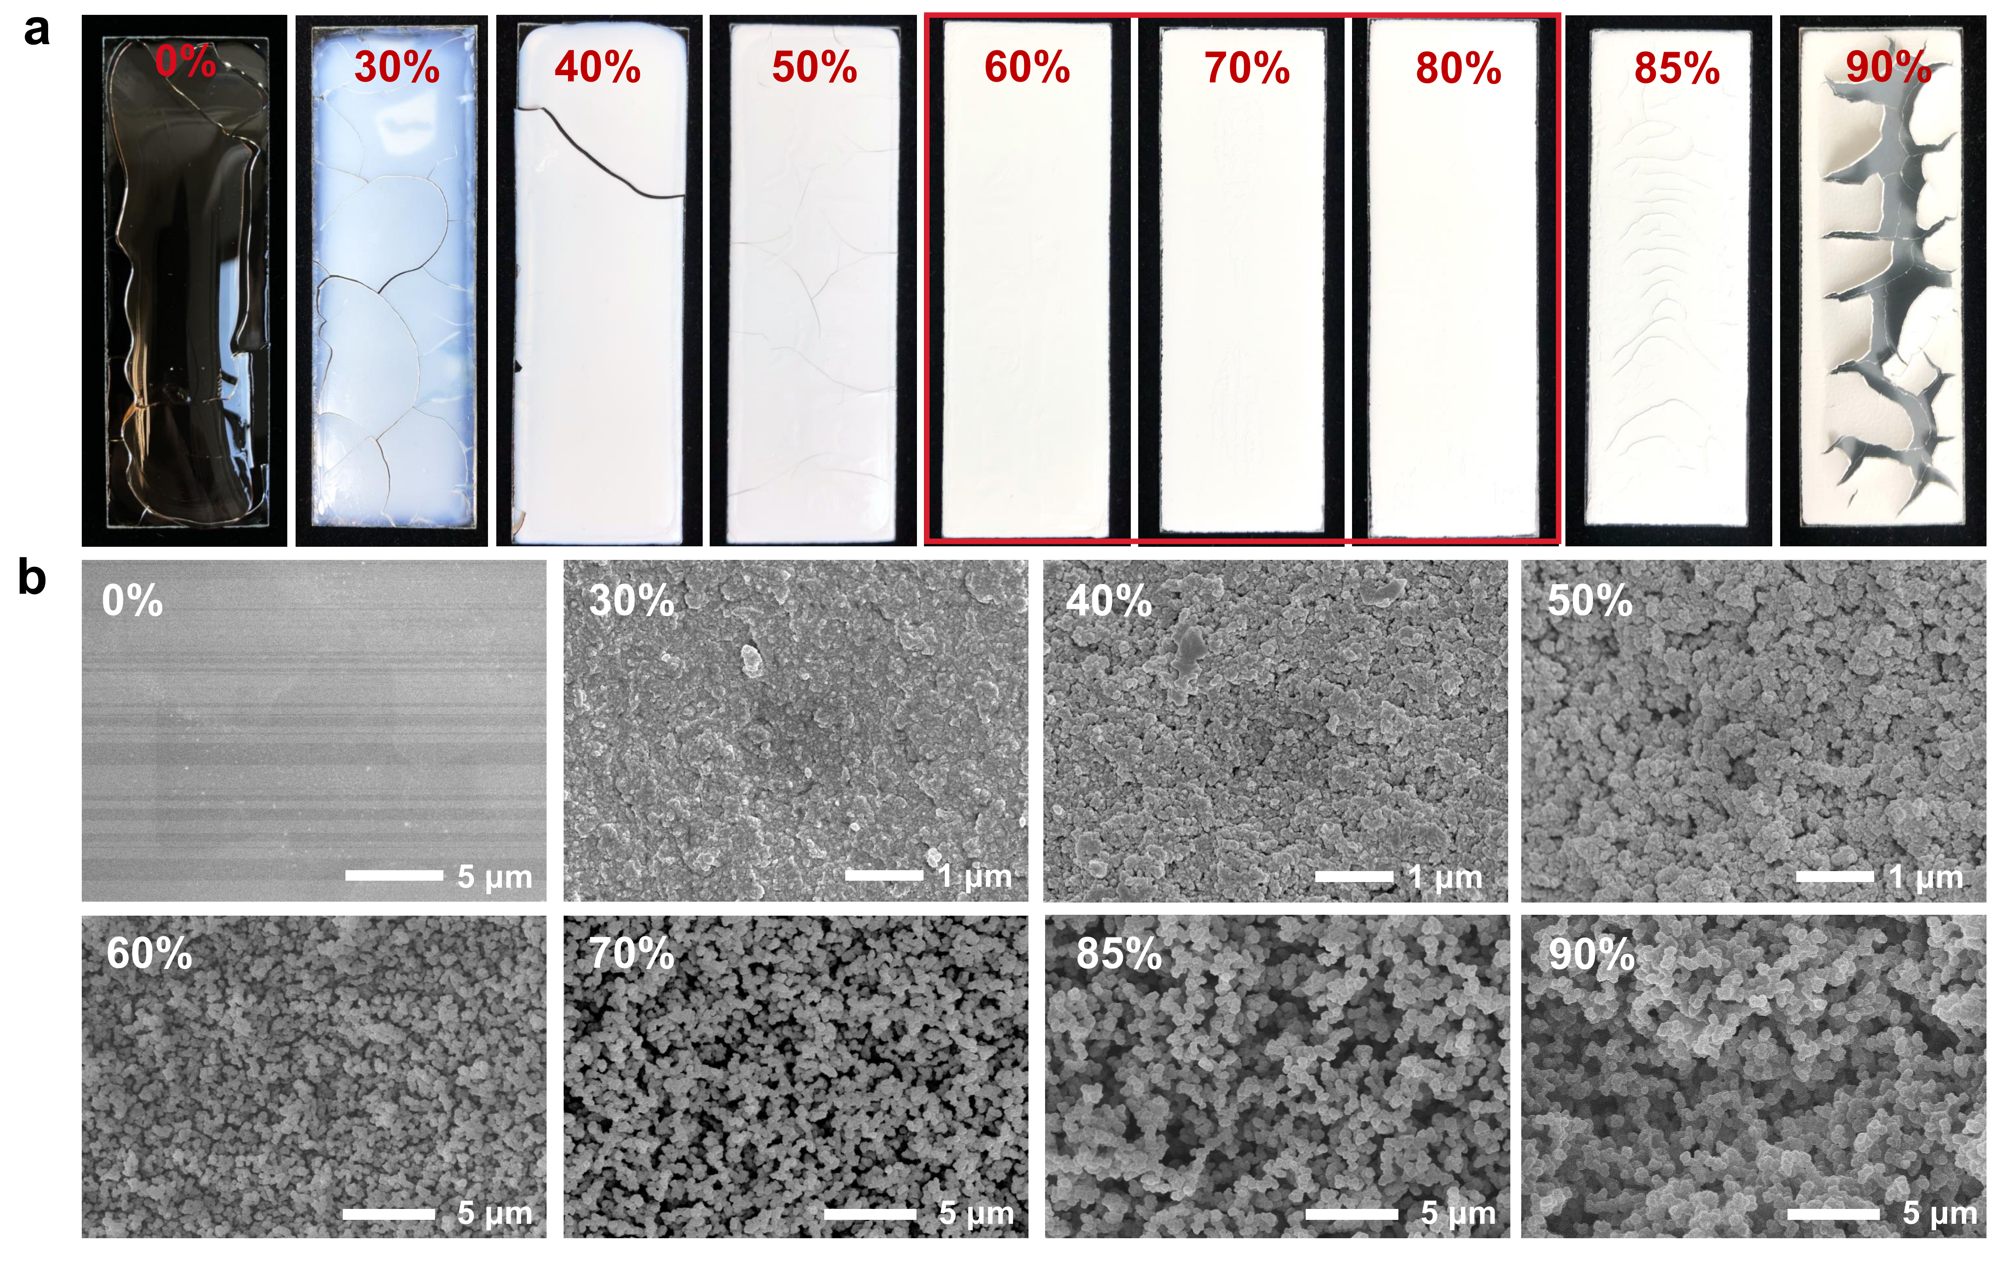
Supplementary Fig. 4 Photographs (a) and SEM images (b) of the obtained coatings based on the mixtures containing 0, 30, 40, 50, 60, 70, 80, 85, 90 wt% VTES in the preparation of poly(TMPTA-VTES).

Table S1. Film formation features of poly(TMPTA-VTES) coatings with various ratios of VTES.
Coating  VTES (wt%) | Phase separation | Appearance | Cracks
0 | No | Dense and transparent | Yes
30 | Yes | Dense and translucent | Yes
40 | Yes | Porous and white | Yes
50 | Yes | Porous and white | Yes
60 | Yes | Porous and white | No
70 | Yes | Porous and white | No
80 | Yes | Porous and white | No
85 | Yes | Porous and white | Yes
90 | Yes | Porous and white | Yes
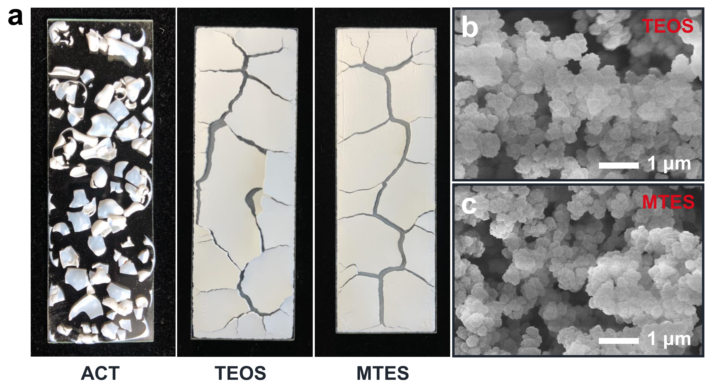
Supplementary Fig. 5 (a) Photographs of the obtained coatings when replacing VTES with acetone (ACT), tetraethyl orthosilicate (TEOS) and methyltriethoxysilane (MTES) in the preparation of the coatings. SEM images of the top views of the obtained coatings when replacing VTES with TEOS (b) and MTES (c). In these cases, phase separation occurred but the crosslinking density of the polymer networks from TMPTA alone. The rigidity of the network lead to the formation of cracks.

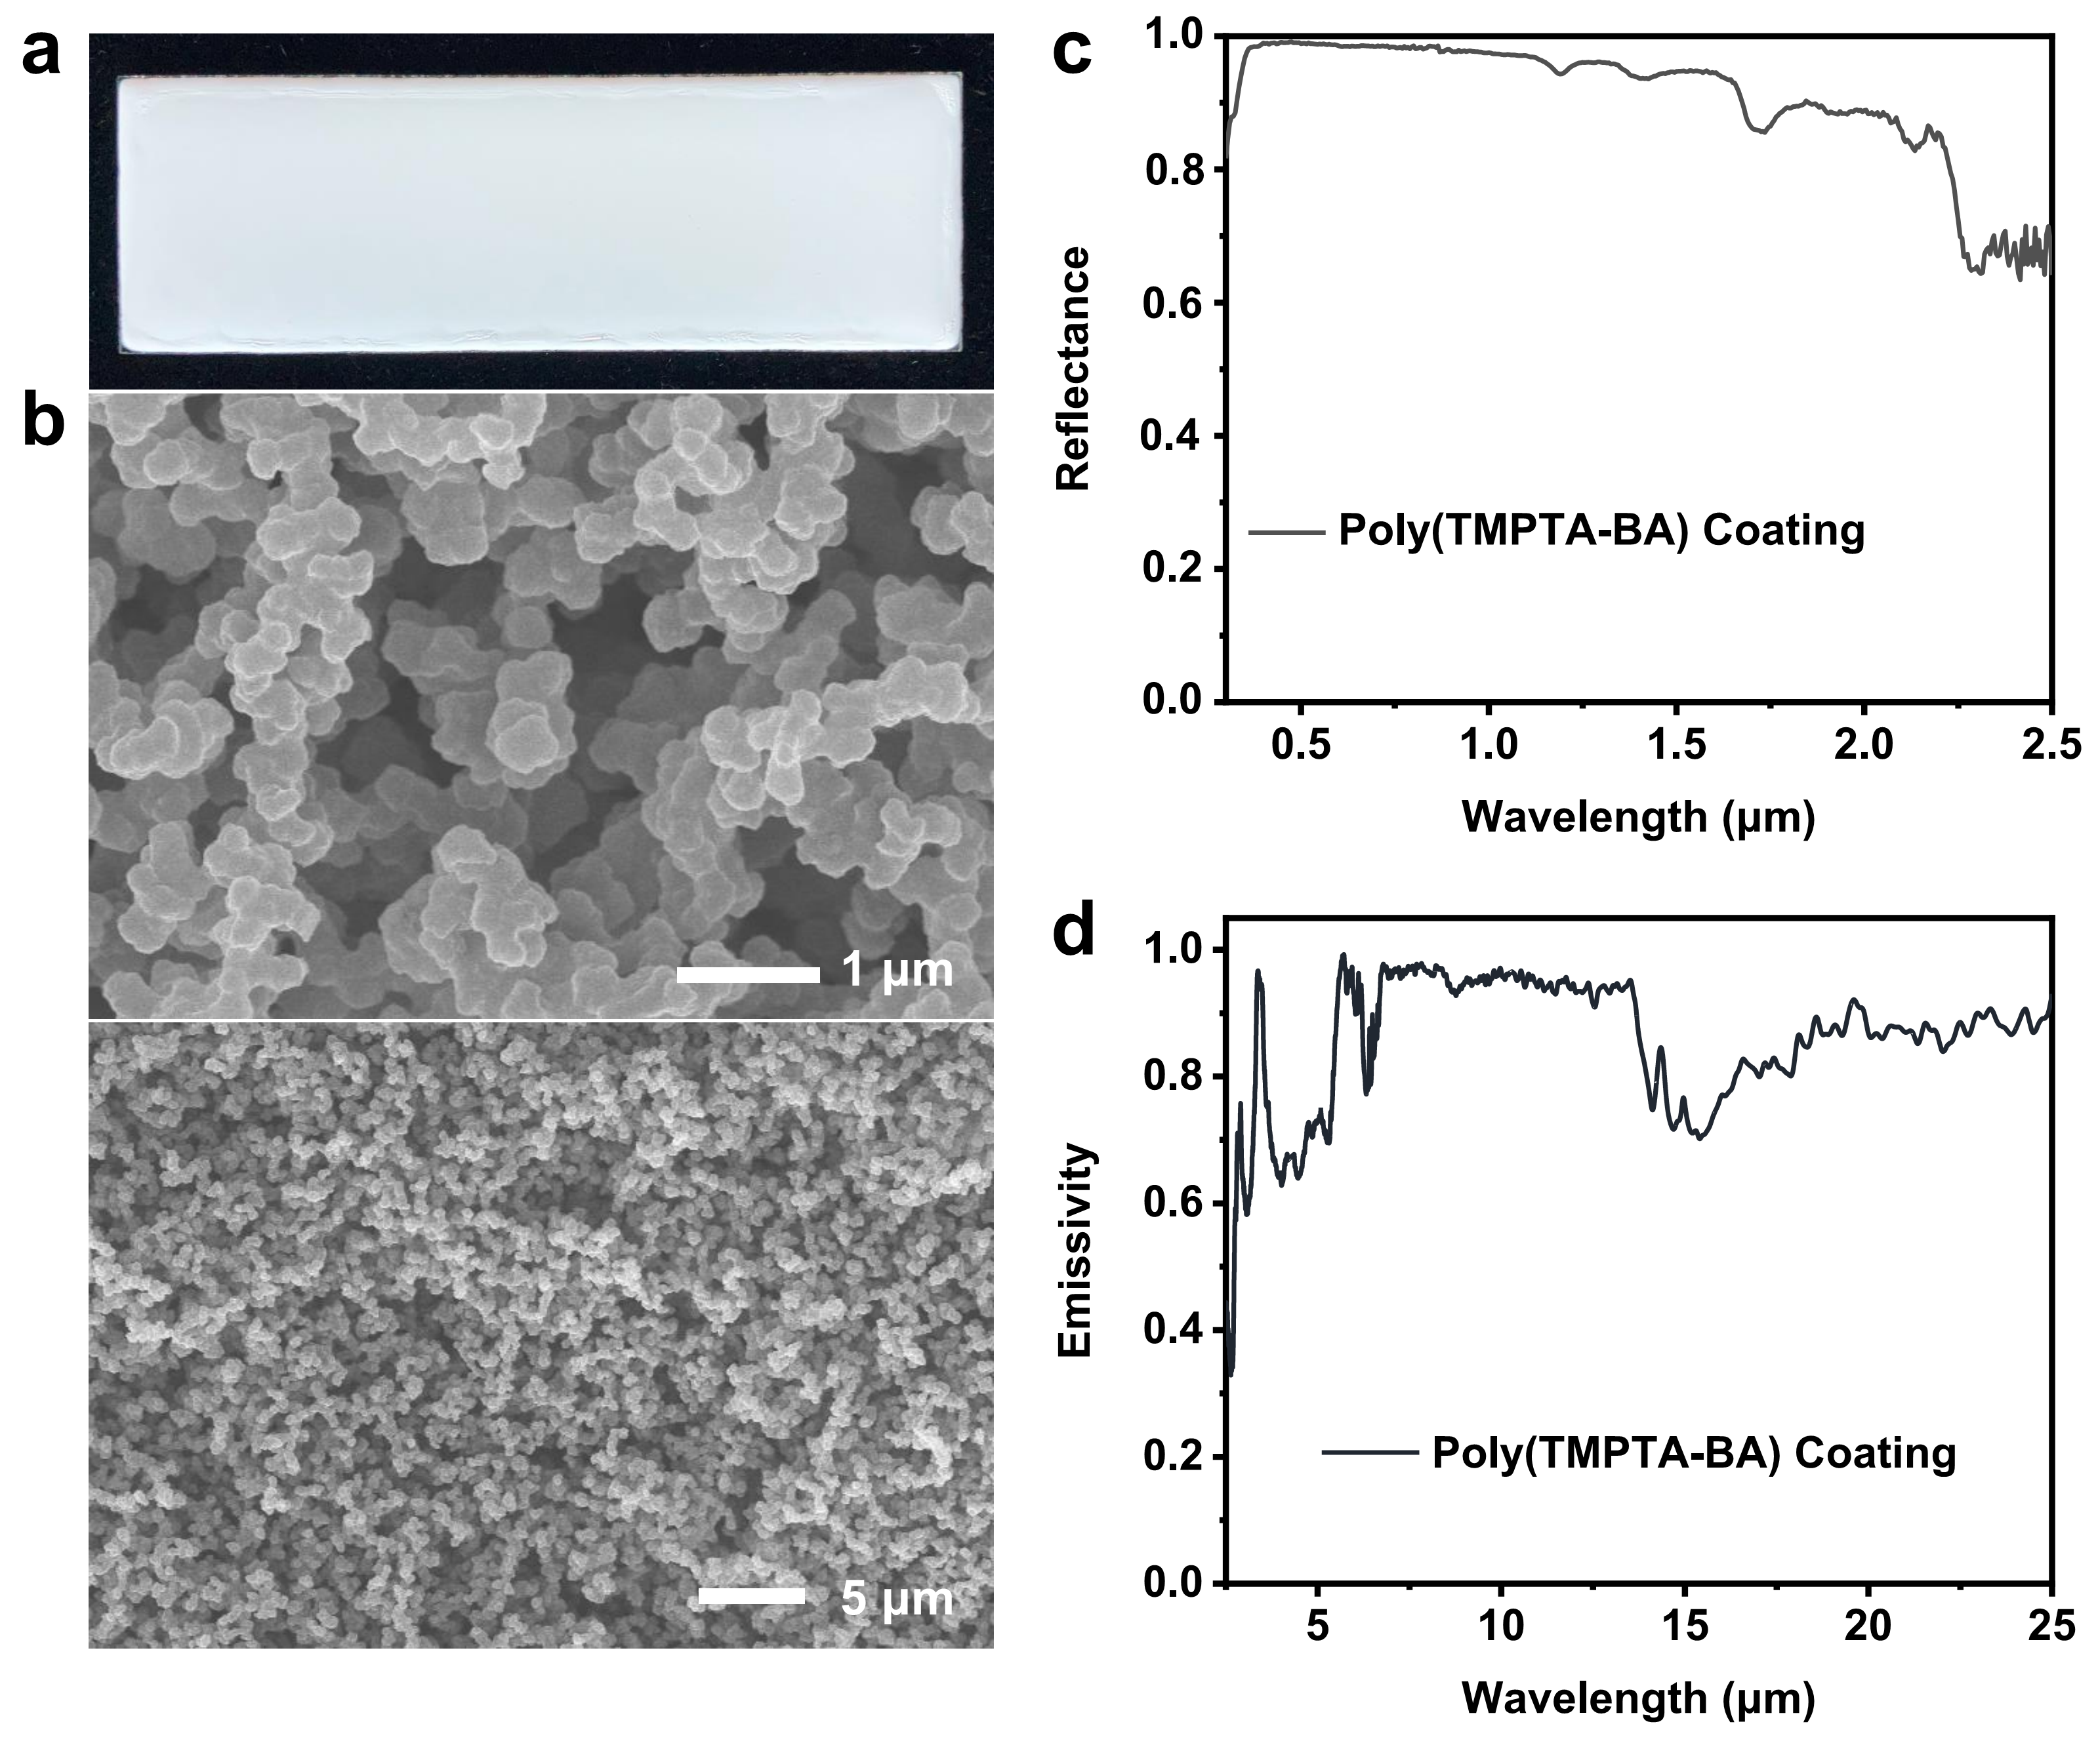
Supplementary Fig. 6 Photograph (a), and SEM images (b) of poly(TMPTA-BA) coating and its reflectance (c) and LWIR emissivity (d) spectra. In this formulation, TMPTA, BA, and ethanol were mixed with a mass ratio of 2:1:7, and then the photoinitiator (TPO) was added (0.75wt% of the mixture).

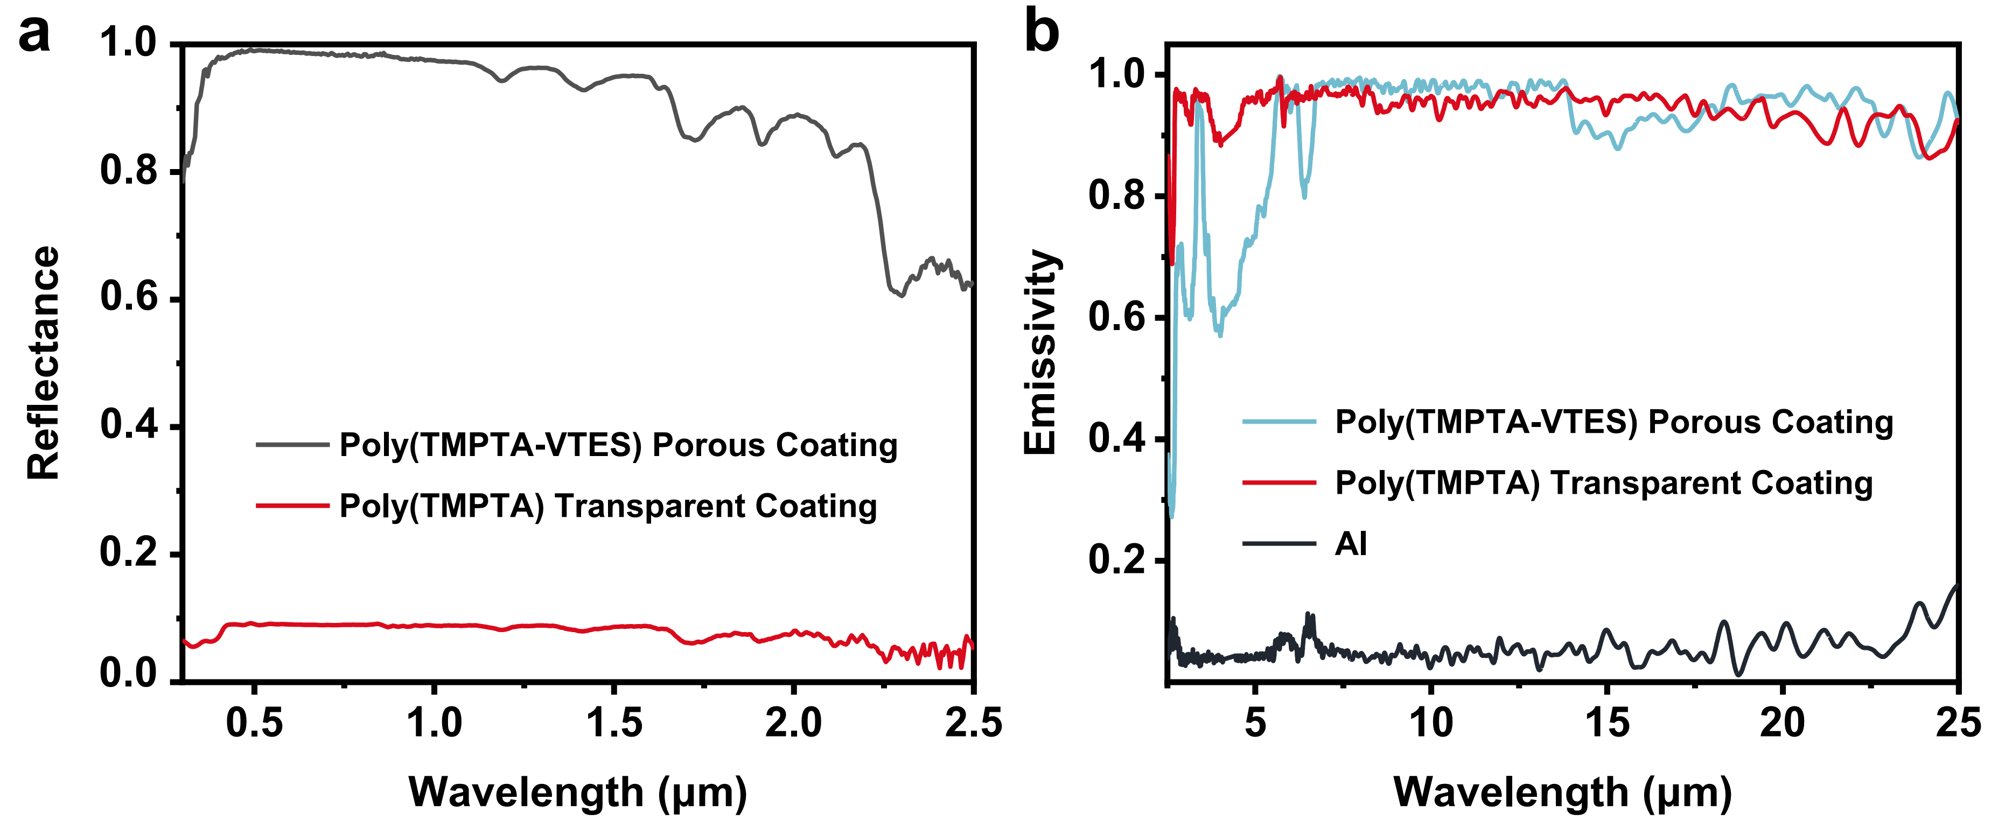
Supplementary Fig. 7 (a) Reflectance spectra of poly(TMPTA-VTES) and poly(TMPTA) coatings. (b) LWIR emissivity spectra of Al, poly(TMPTA), and poly(TMPTA-VTES).

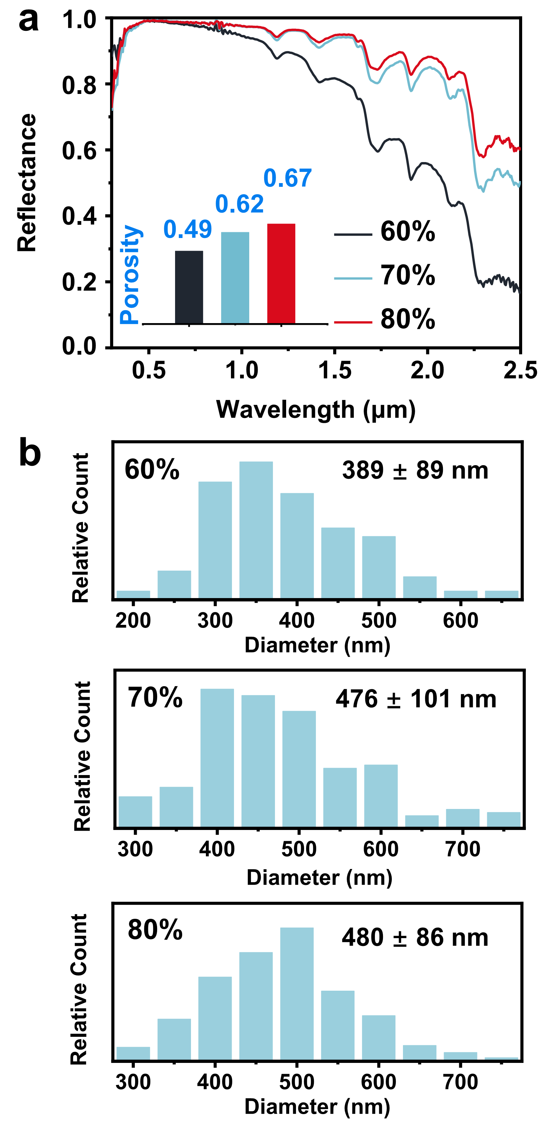
Supplementary Fig. 8 (a) Solar reflectance spectra and (b) diameter distributions of the globules of poly(TMPTA-VTES) coatings made from VTES mass ratios of 60, 70, 80%, respectively. Inset in (a) is the porosity of the coating.
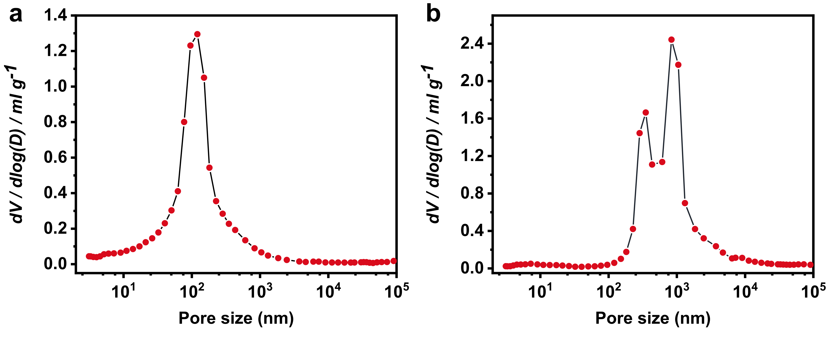
Supplementary Fig. 9 Pore size distributions from mercury porosimetry of poly(TMPTA-VTES) coating with mass ratios of VTES of 60% (a) and 70% (b), respectively.

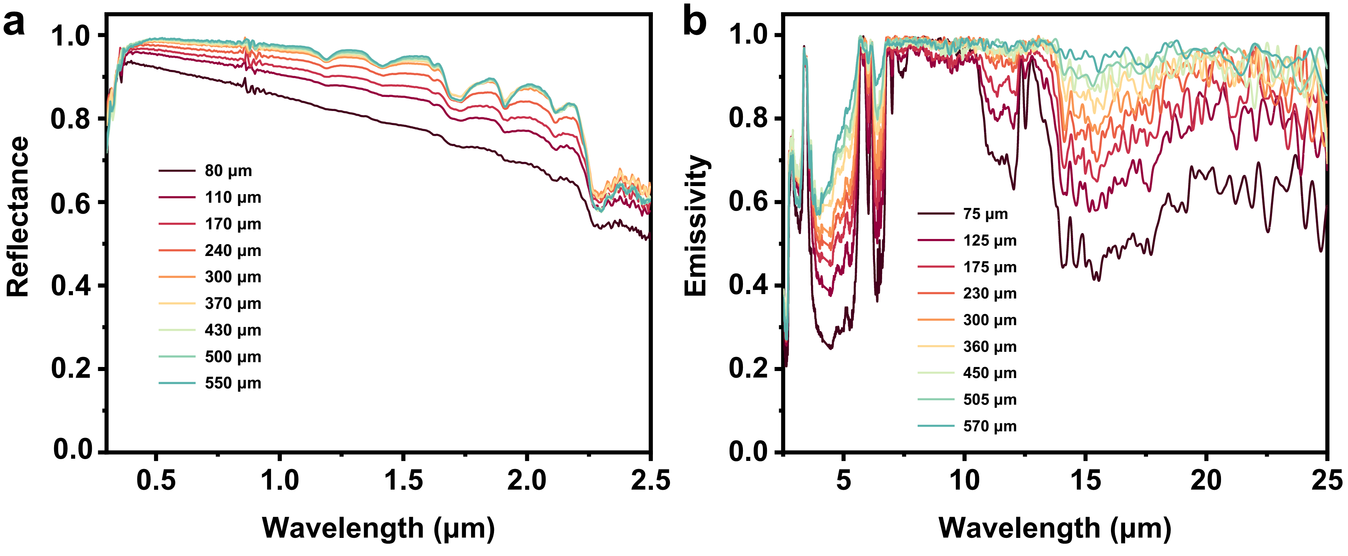
Supplementary Fig. 10 (a) Reflectance spectra across the solar wavelengths and (b) LWIR emissivity spectra of poly(TMPTA-VTES) coatings with different thicknesses.

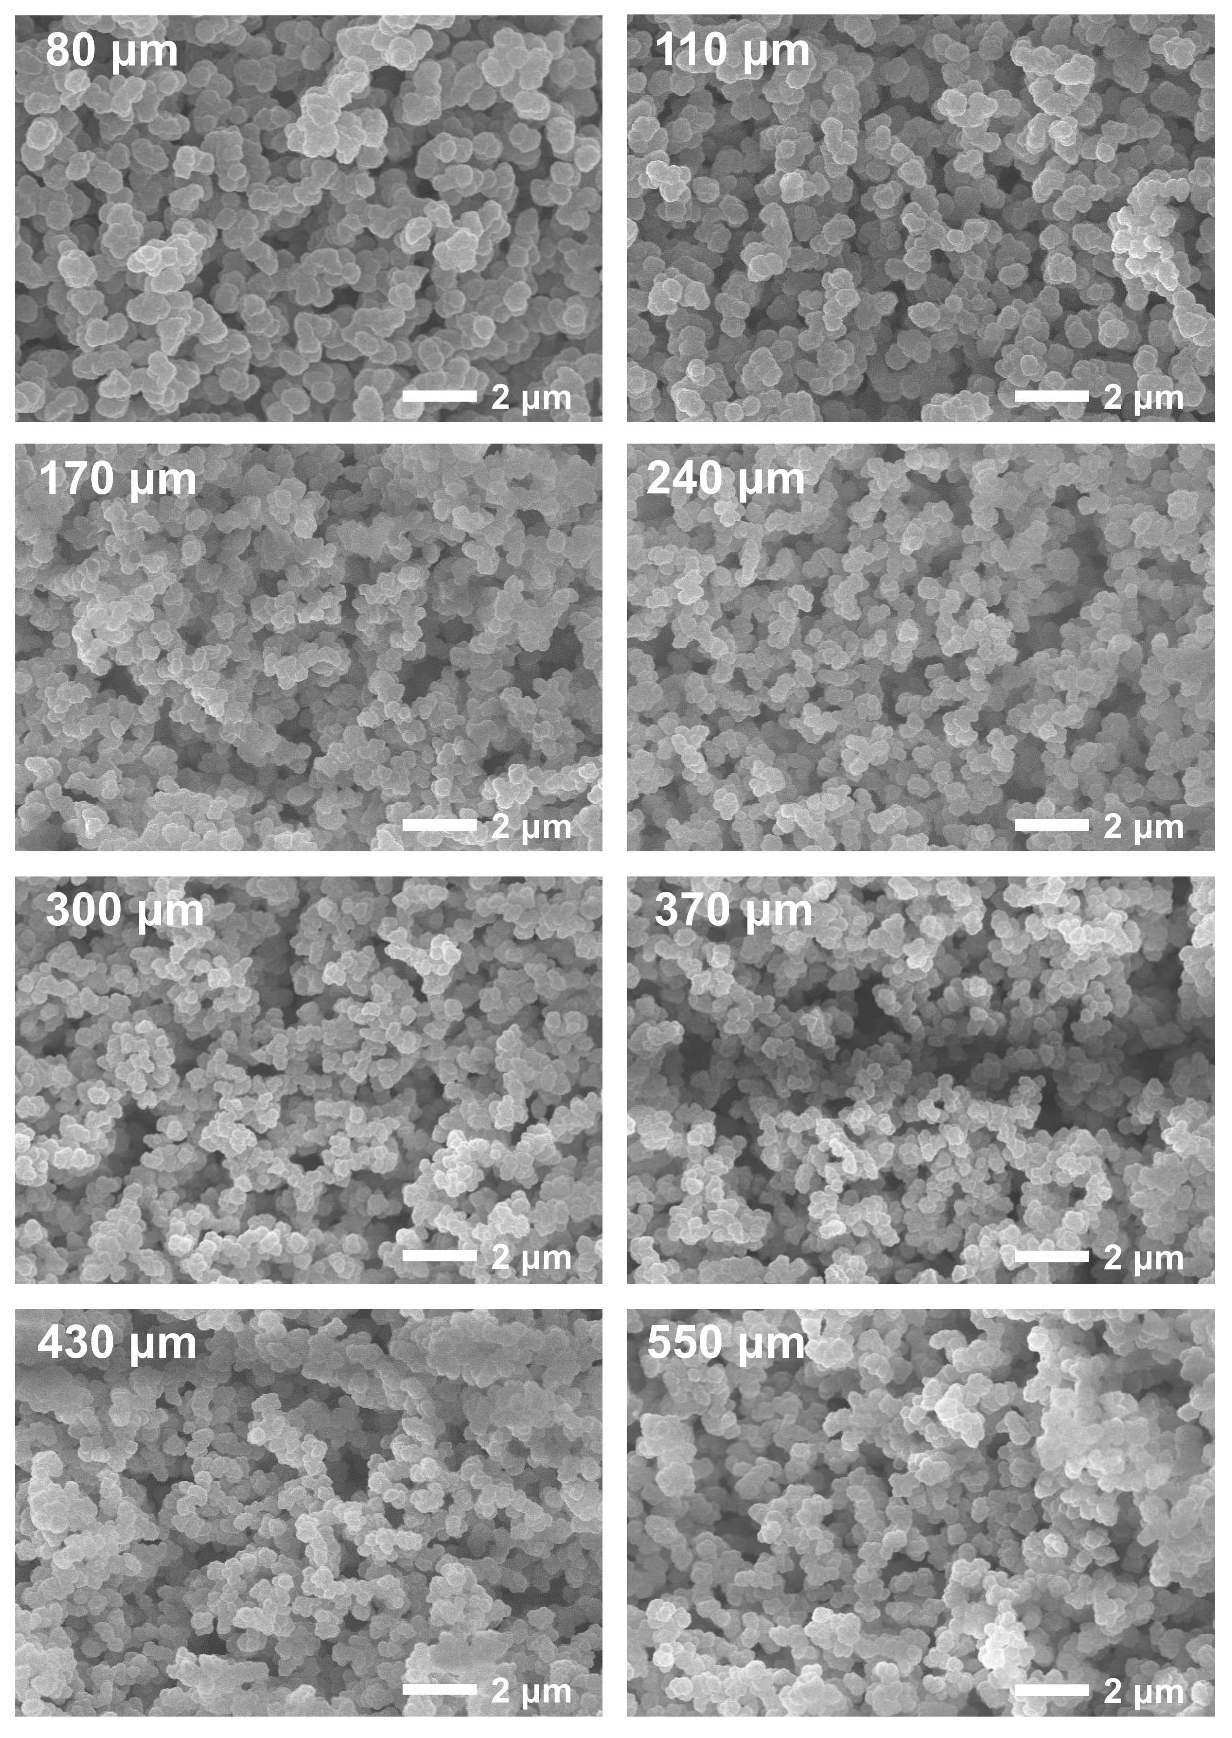
Supplementary Fig. 11 SEM images of poly(TMPTA-VTES) coatings with different thicknesses.

Table S2. $∆T_{cool}$ measured in different weather conditions in Beijing.
Date | Time | Weather | $$I_{sun}$$  (W m⁻²) | RH% | WS  (m s⁻¹) | Air  Quality | $$∆T_{cool}$$  (°C)
2021.06.20 | 11:00-13:00 | Sunny | ~960 | ~14 | 1-2 | PM_{2.5} 39 O₃ 48 | ~5.7
2021.08.27 | 12:00-14:00 | Sunny | ~800 | ~28 | 1-2 | PM_{2.5} 26  O₃ 55 | ~8.4
2021.09.11 | 11:00-13:00 | Sunny with haze | ~750 | ~46 | 0-1 | PM_{2.5} 105  O₃ 101 | ~4.9
2021.09.23 | 11:00-13:00 | Clear to cloudy | ~720 | ~47 | 2-3 | PM₁₀ 52  O₃ 61 | ~4.0
2021.10.14 | 12:00-14:00 | Overcast | ~200 | ~58 | 0-1 | PM_{2.5} 97  PM₁₀ 41 | ~4.2
2021.06.19-20 | 19:30-05:00 | Clear | - | ~19 | 1-2 | PM₁₀ 28  O₃ 53 | ~9.8
2021.08.26-27 | 22:30-05:30 | Clear | - | ~60 | 1-2 | PM_{2.5} 24  O₃ 36 | ~9.0
2021.09.23 | 0:00-06:00 | Clear to cloudy | - | ~75 | 2-3 | PM₁₀ 52  O₃ 61 | ~7.2
2021.10.14-15 | 18:00-06:00 | Overcast | - | ~70 | 1-4 | PM_{2.5} 91  PM₁₀ 33 | ~6.5

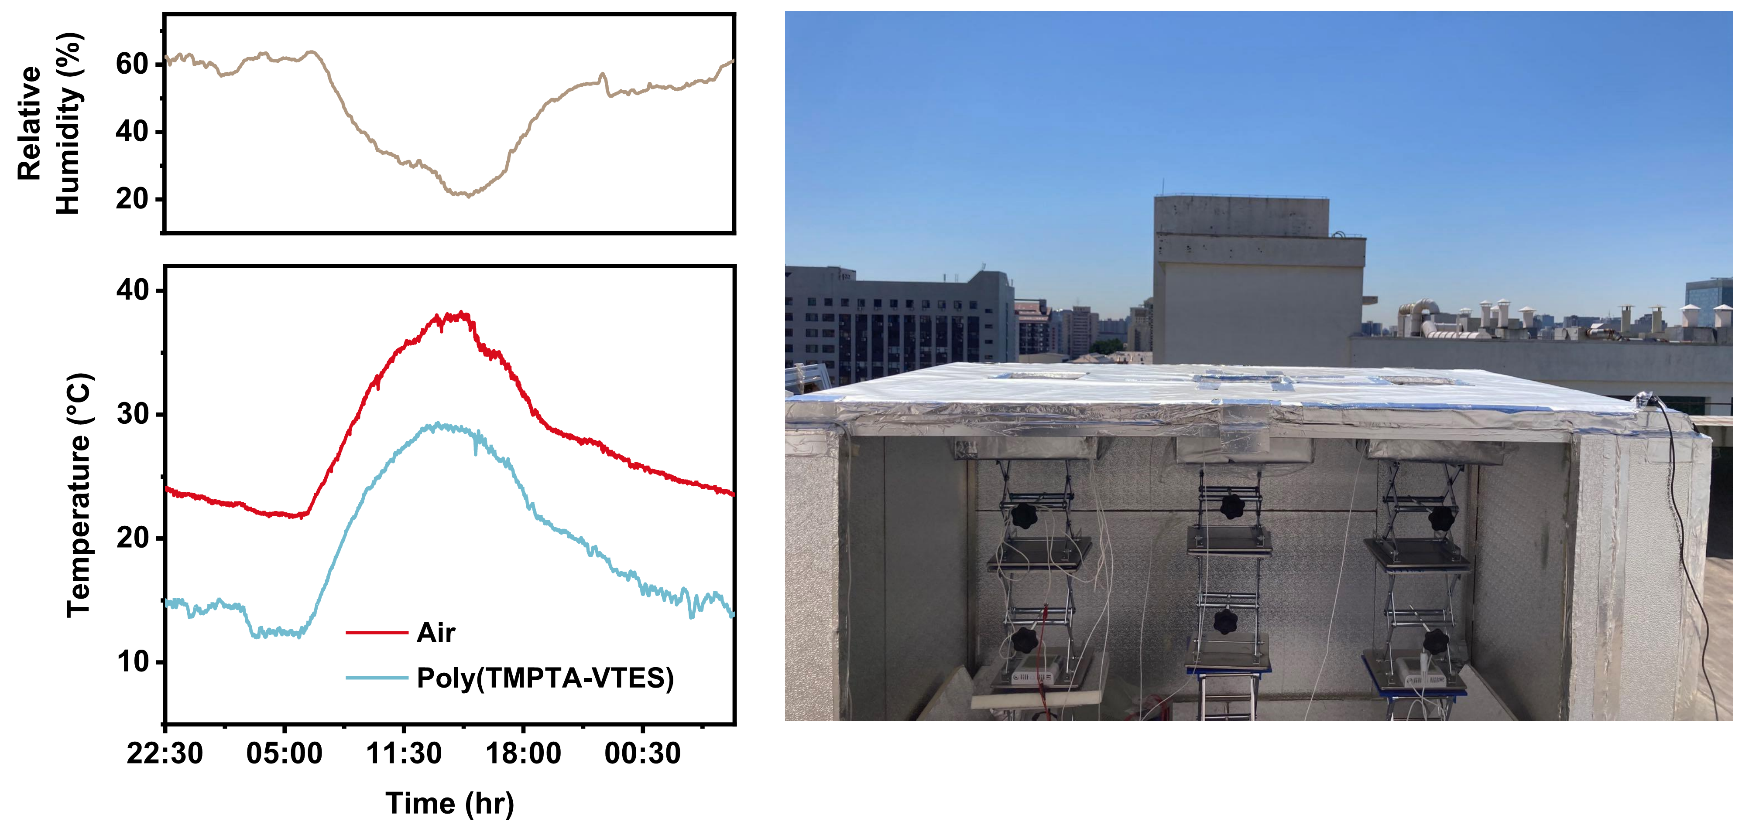
Supplementary Fig. 12 Passive all-day radiative cooling performance of poly(TMPTA-VTES) measured on a clear day ($I_{sun}$ of ~800 W m⁻² at noon, 27 Aug. 2021).

Table S3. Weather conditions for radiative cooling power measurements.
Date | Time | Weather | $$I_{sun}$$  (W m⁻²) | RH% | WS  (m s⁻¹) | Air  Quality | $$P_{cool}$$  (W m⁻²)
2021.09.08 | 12:00-14:00 | Sunny | ~780 | ~45 | 1-2 | PM_{2.5} 55  O₃ 82 | ~67
2021.09.10 | 00:00-06:00 | Clear | - | ~77 | 1-2 | PM_{2.5} 97  O₃ 94 | ~92

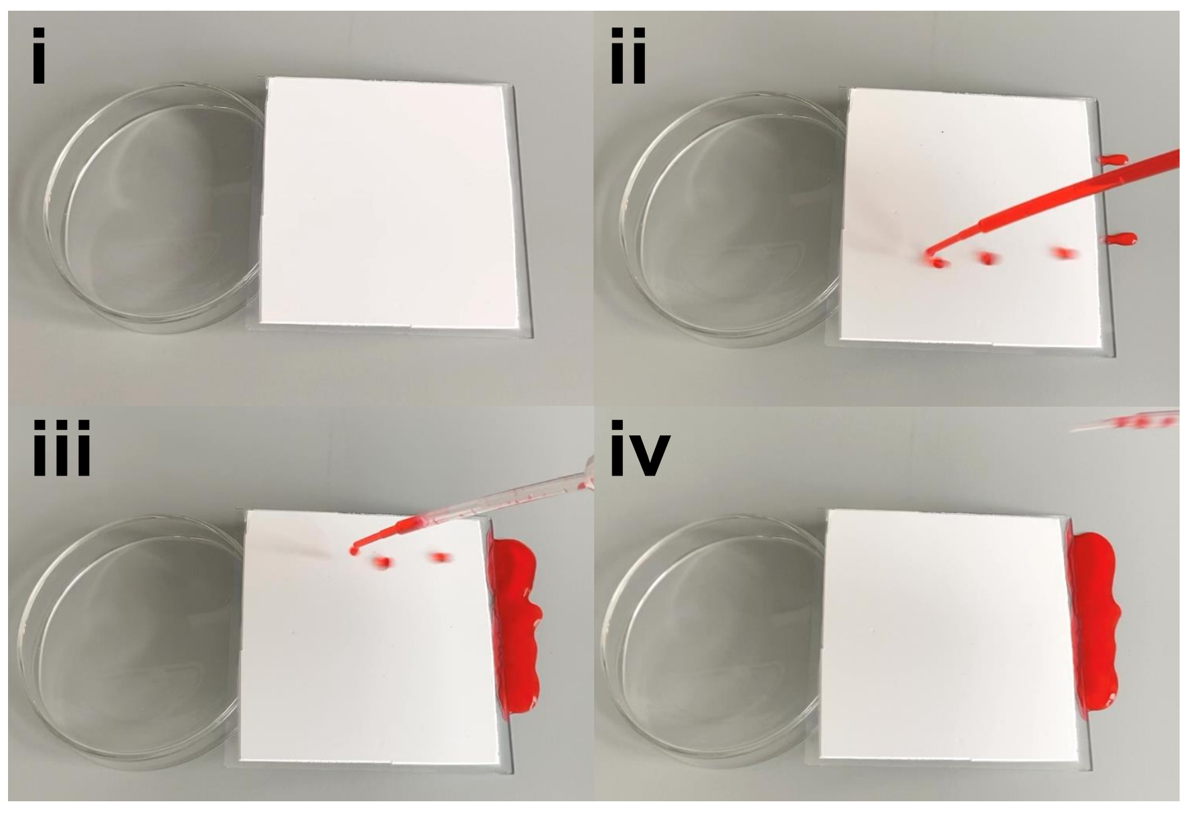
Supplementary Fig. 13 Snapshots showing water droplets (dyed red) rolling off the tilted coating, revealing a low water sliding angle.

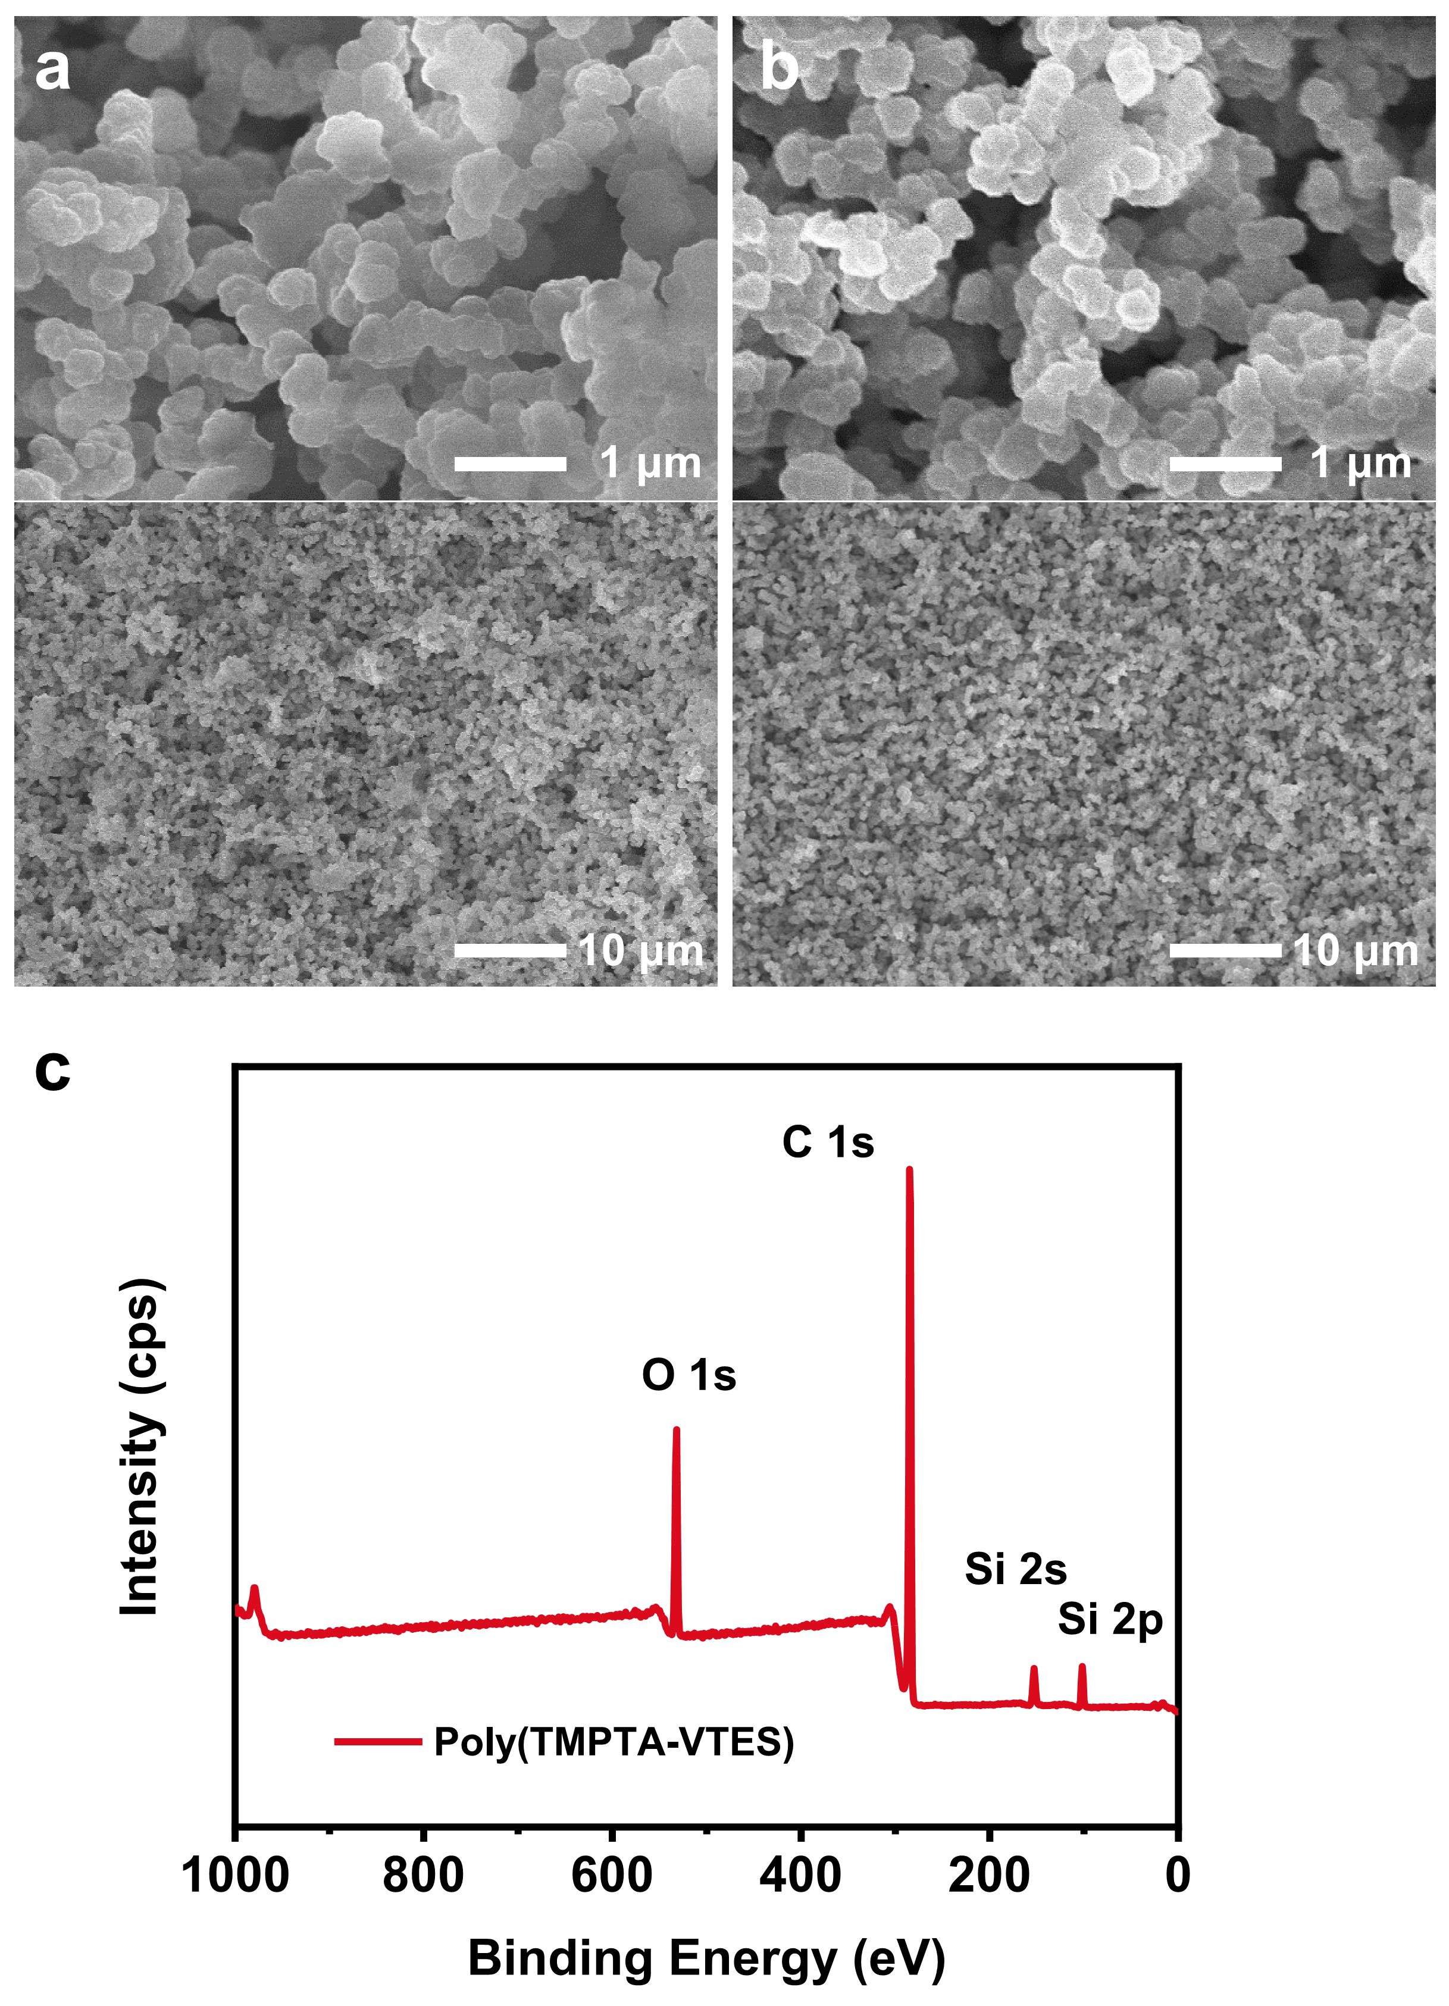
Supplementary Fig. 14 SEM images of the bulk (a) and bottom (b) of poly(TMPTA-VTES) coating, showing the uniform morphology obtained from the UV-curing based method. (c) XPS spectrum of the surface of poly(TMPTA-VTES) coating.
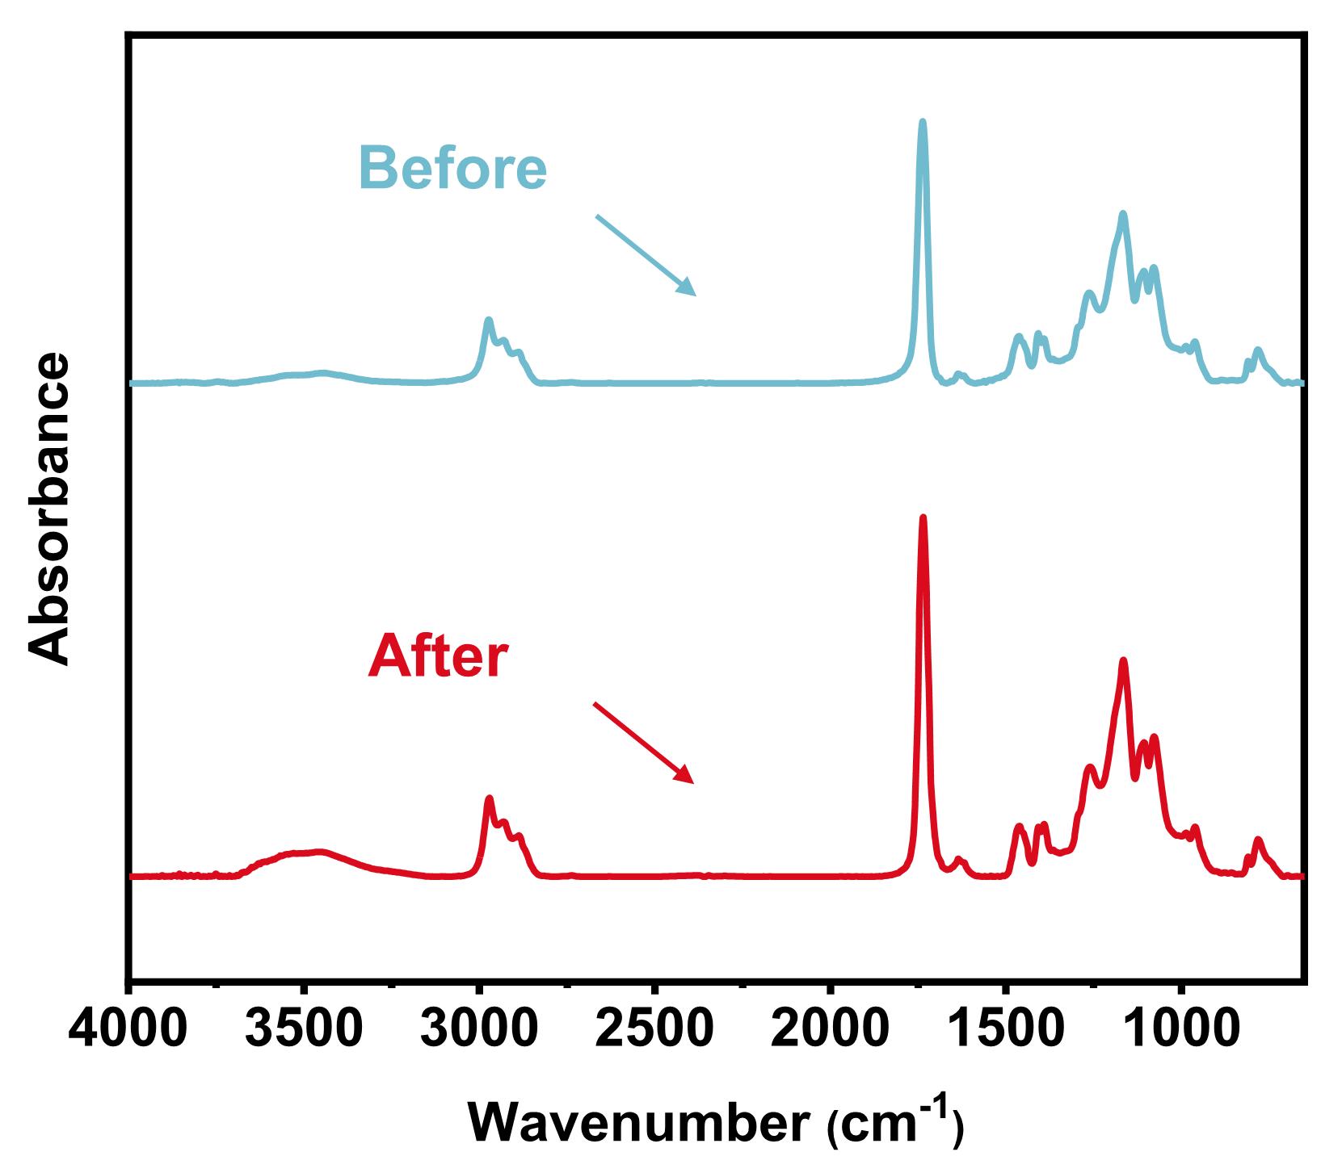
Supplementary Fig. 15 FTIR spectra of poly(TMPTA-VTES) coating before and after UV and moisture exposure for 50 days.

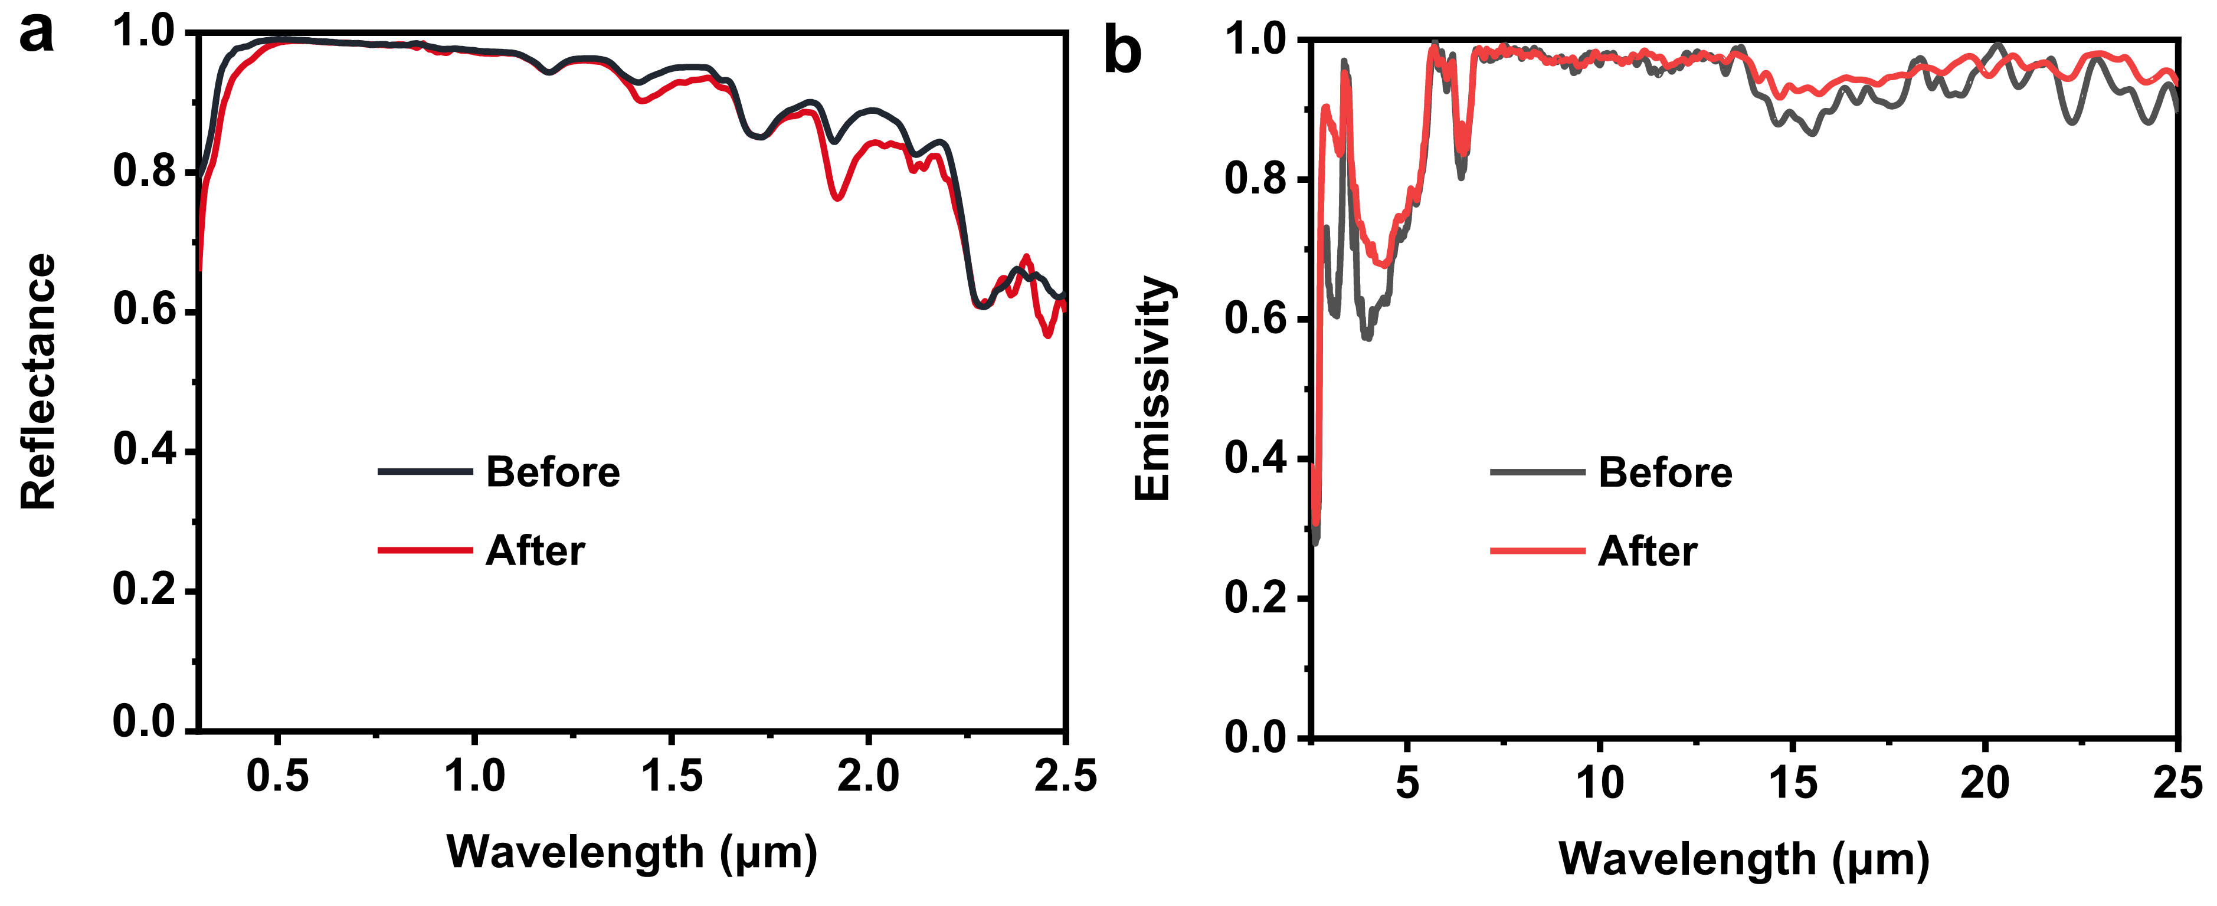
Supplementary Fig. 16 Reflectance spectra across the solar wavelengths (a) and LWIR emissivity spectra (b) of poly(TMPTA-VTES) coatings before and after UV and moisture exposure for 50 days.
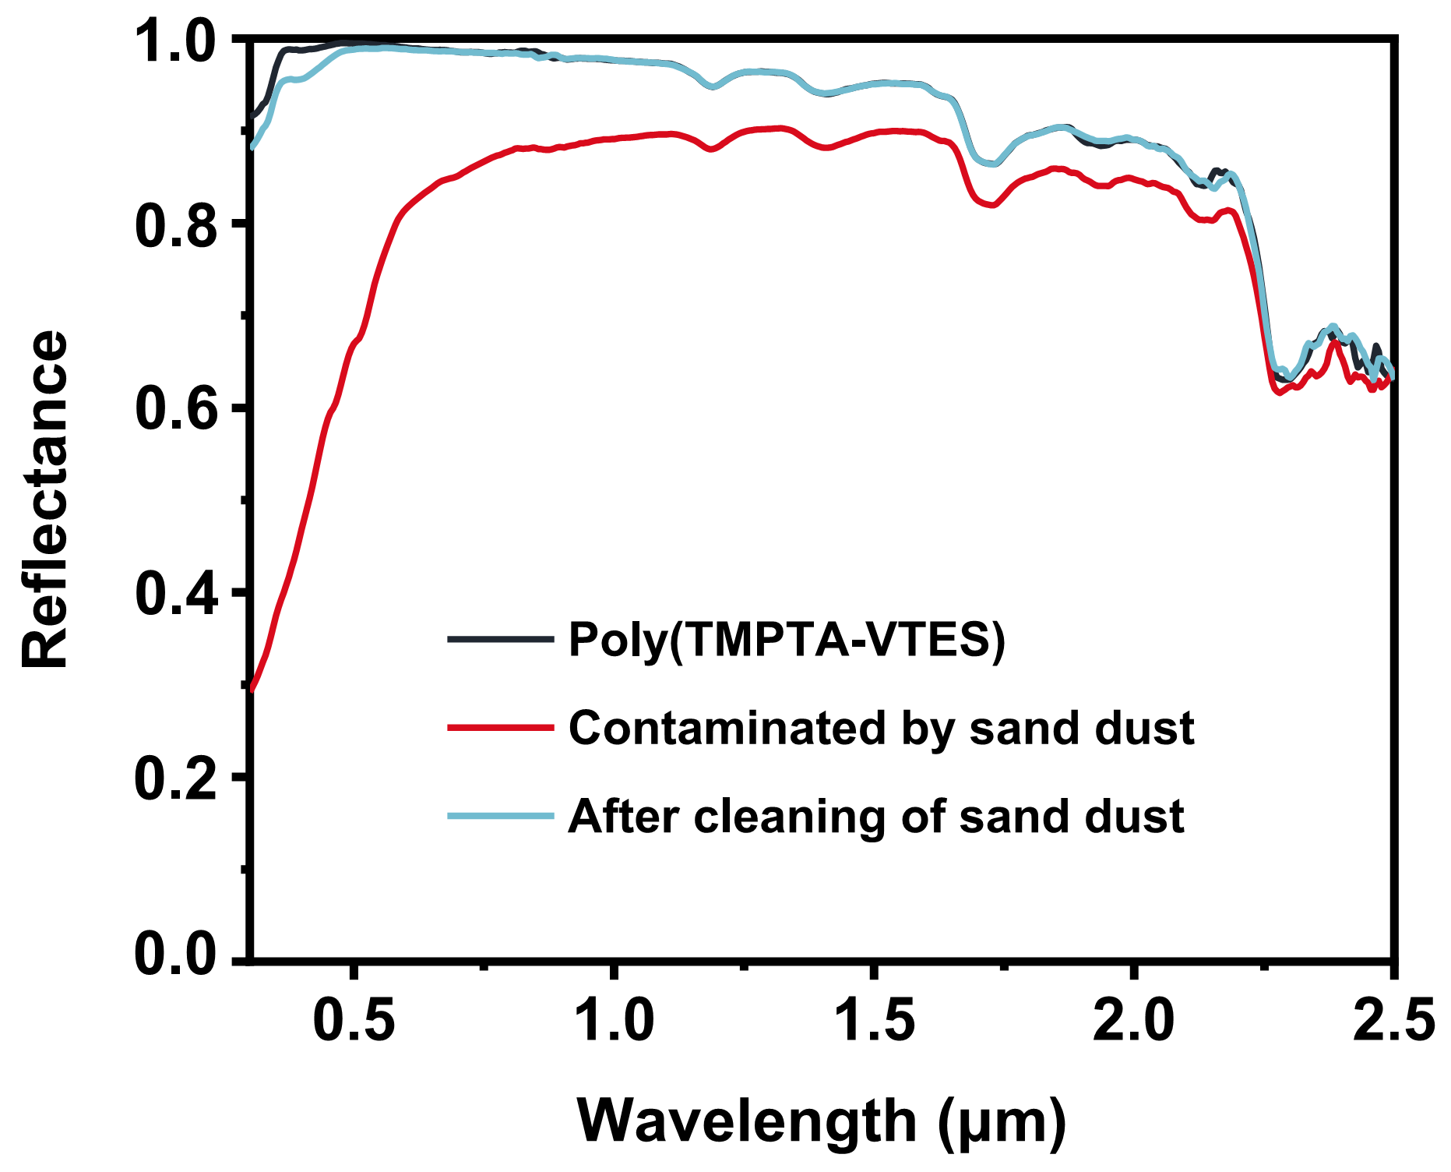
Supplementary Fig. 17 The solar reflectance spectra of the original, the sand dust contaminated and the water cleaned poly(TMPTA-VTES) coating.

Table S4. Summary of reported radiative cooling coatings or films and corresponding performance.
Materials | Methods | ${\overline{R}}_{sun}$ / ${\overline{ε}}_{LWIR}$ | $$I_{sun}$$  (W m⁻²) | $$∆T_{cool}$$  (°C) | CA/  SA (°) | Crosslinked  or not | Weather resistance  (Before/after) of ${\overline{R}}_{sun}$ | Year^{[Ref.]}
SiO₂/HfO₂/Ag | Electron beam evaporation | 0.97/0.65 | 850 | 4.9 | - | N.A. | - | 2014^{[1]}
P(VDF-HFP) | Phase-inversion-based method | 0.96/0.97 | 890 | 6 | CA~110° | No | 80 ℃ at 100% RH for 14 days (0.96/0.93) | 2018^{[2]}
PDMS/Al | Blade coating | ＞0.9/0.94 | ＜853.5 | 2-6 | - | Yes | - | 2019^{[3]}
PVDF/TEOS/Silica | Electrospinning | 0.97/0.96 | ＜1000 | 6 | - | No | - | 2019^{[4]}
SiO₂/TiO₂/Acrylic emulsion | Mechanical co-mixing | 0.898/0.96 | 735 | 6 | CA~110° | - | Accelerated weathering for 40 days (0.90/0.86) | 2020^{[5]}
PDMS/Al₂O₃ | Soft lithography and dual-spin coating | 0.95/＞0.96 | 862 | 5.1 | CA~138° | Yes | - | 2020^{[6]}
PE/PDMS | Thermally induced phase separation | 0.96/0.8 | 800-865 | 6-7 | 15 | No | - | 2020^{[7]}
PAN | Electrospinning | 0.95/＜0.7 | 960 | 3 | - | No | - | 2020^{[8]}
PVF/Ag | Stretching and thermal annealing | -/- | 950 | 2 | - | No | - | 2020^{[9]}
SEBS | Phase separation-based  method | 0.92/0.85 | 840 | 6 | CA~125° | No | - | 2020^{[10]}
ePTFE/Ag/Glass | Pressing | 0.98/0.90 | 700-1000 | 2-3 | - | No | - | 2020^{[11]}
Polysilazane/Ag | Dip-coating and 400 ℃ thermal treatment | 0.97/- | ＜761 | 6 | - | Yes | - | 2021^{[12]}
P(VDF-HFP) | Ball milling method | 0.94/0.97 | 950 | 9.5 | - | No | 80 ℃ at 70% RH for 10 days (0.94/0.92) | 2021^{[13]}
PTFE/Paper | Spray coating | 0.93/＞0.9 | 834 | 5 | CA~165° | No | - | 2021^{[14]}
CA/SiO₂ | Phase-inversion-based method | 0.96/0.95 | ＜900 | 6.2 | - | No | - | 2021^{[15]}
PVDF | Coaxial electrospinning | 0.94/0.94 | 900 | 9 | - | No | - | 2021^{[16]}
PMMA | Rubbing assembly method | 0.95/0.98 | 930 | 5.5 | CA~156° (post-treated) | No | Accelerated weathering for 20 days (0.95/0.95) | 2021^{[17]}
PEO | Roll-to-roll electrospinning | 0.96/0.78 | ＜900 | 5 | - | No | - | 2021^{[18]}
Acrylate copolymer | UV curing based phase separation | 0.96/0.98 | 960  800 | 5.7  8.4 | CA~158°  SA~4° | Yes | UV exposure (RH 70%) for 50 days  80 ℃ for 20 days (0.96/0.96) | This work
-: no related data or test was shown in the papers.

Supplementary References
1. Raman, A. P., Anoma, M. A., Zhu, L., Rephaeli, E. & Fan, S. Passive radiative cooling below ambient air temperature under direct sunlight. Nature 515, 540-544 (2014).
2. Mandal, J. et al. Hierarchically porous polymer coatings for highly efficient passive daytime radiative cooling. Science 362, 315-319 (2018).
3. Zhou, L., et al. A polydimethylsiloxane-coated metal structure for all-day radiative cooling. Nat. Sustain. 2, 718-724 (2019).
4. Wang, X. et al. Scalable flexible hybrid membranes with photonic structures for daytime radiative cooling. Adv. Funct. Mater. 30, 190756 (2019).
5. Xue, X. et al. Creating an eco-friendly building coating with smart subambient radiative cooling. Adv. Mater. 32, e1906751 (2020).
6. Zhang, H. et al. Biologically inspired flexible photonic films for efficient passive radiative cooling. Proc. Natl. Acad. Sci. U. S. A. 117, 14657-14666 (2020).
7. Yang, M., et al. Bioinspired "skin" with cooperative thermo-optical effect for daytime radiative cooling. ACS Appl. Mater. Interfaces 12, 25286-25293 (2020).
8. Kim, H., McSherry, S., Brown, B. & Lenert, A. Selectively enhancing solar scattering for direct radiative cooling through control of polymer nanofiber morphology. ACS Appl. Mater. Interfaces 12, 43553-43559 (2020).
9. Meng, S. et al. Scalable dual-layer film with broadband infrared emission for sub-ambient daytime radiative cooling. Sol. Energy Mater. Sol. Cells 208, 110393 (2020).
10. Xu, Y. et al. Multiscale porous elastomer substrates for multifunctional on-skin electronics with passive-cooling capabilities. Proc. Natl. Acad. Sci. U. S. A. 117, 205-213 (2020).
11. Zhong, H. et al. Highly solar-reflective structures for daytime radiative cooling under high humidity. ACS Appl. Mater. Interfaces 12, 51409-51417 (2020).
12. Banik, U. et al. Efficient thin polymer coating as a selective thermal emitter for passive daytime radiative cooling. ACS Appl. Mater. Interfaces 13, 24130-24137 (2021).
13. Huang, W. et al. Scalable aqueous processing-based passive daytime radiative cooling coatings. Adv. Funct. Mater. 31, 2010334 (2021).
14. Tian, Y. et al. Superhydrophobic and recyclable cellulose-fiber-based composites for high-efficiency passive radiative cooling. ACS Appl. Mater. Interfaces 13, 22521-22530 (2021).
15. Xiang, B. et al. 3D porous polymer film with designed pore architecture and auto-deposited SiO₂ for highly efficient passive radiative cooling. Nano Energy 81, 105600 (2021).
16. Zhong, H. et al. Hierarchically hollow microfibers as a scalable and effective thermal insulating cooler for buildings. ACS Nano 15, 10076-10083 (2021).
17. Wang, T. et al. A structural polymer for highly efficient all-day passive radiative cooling. Nat. Commun. 12, 365 (2021).
18. Li, D. et al. Scalable and hierarchically designed polymer film as a selective thermal emitter for high-performance all-day radiative cooling. Nat. Nanotechnol. 16, 153-158 (2021).

